
UNIVERSITY OF GREENWICH
COMP1844 – Information Analysis and Visualisation
Coursework Report
Student Name: Nguyen Minh Tri
Student ID: GCS230332
Professor Instruction: Le Tran Ngoc Tran
Submission Date: 12/08/2026
Deadline: 12/08/2026

Table of Contents
Contents
Table of Contents 2
1. Introduction 3
2. Task 1 3
2.1 Data Collection 3
2.2 Code 4
2.3 Generated Image 6
3. Task 2 7
3.1 Data Collection 8
3.2 Code 9
3.3 Generated Image 14
4. Task 3 15
4.1 Code 15
4.2 Data 15
References 16
Appendix 16

1. Introduction
This report presents the design, implementation and analysis of a graph-based model of a section of the London Underground network, developed in Python as part of the COMP1844 Information Analysis and Visualisation coursework. The network is represented using the NetworkX graph data structure, in which stations are modelled as nodes and the direct connections between adjacent stations are modelled as edges, each carrying a real-world distance in kilometres.
The report is organised around the three tasks set out in the coursework brief. Task 1 reproduces the sample three-line diagram supplied in the brief, replacing the lettered edge labels with actual distances between stations. Task 2 extends this model into a larger, five-line network of thirty connections between twenty-five stations, laid out to reflect the approximate real geography of central London and rendered with a consistent, TfL-style colour scheme. Task 3 extracts quantitative statistics from the Task 2 graph, namely the total length of the network, the average distance between connected stations, and the standard deviation of those distances.
All code was written using only the four libraries permitted by the coursework brief: NumPy, pandas, NetworkX and Matplotlib. For each task, the report presents the source code, the resulting visualisation and/or generated data, followed by a short discussion of the results.

2. Task 1

2.1 Data Collection
The sample diagram provided in the coursework brief shows five stations Oxford Circus, Piccadilly Circus, Charing Cross, Leicester Square and Covent Garden connected by five edges belonging to three lines (Piccadilly, Northern and Bakerloo). The lettered edge labels (a–e) in the original diagram were replaced with real-world walking distances between each pair of adjacent stations.
Distances were approximated using walking-route data aggregated from TfL journey-planner information (via londondrum.com) and cross-checked against Google Maps walking directions, rather than straight-line ("as the crow flies") distance. A straight-line measurement would ignore the actual street layout between two stations and understate how far apart they really are, so walking-route distance was used throughout for consistency and realism. Distances originally sourced in miles were converted to kilometres using 1 mile = 1.60934 km and rounded to two decimal places. The resulting distances are summarised below:
- Oxford Circus – Piccadilly Circus: 0.80 km (≈ 1/2 mile, 9–10 min walk)
- Piccadilly Circus – Charing Cross: 0.80 km (≈ 1/2 mile, 9–10 min walk)
- Piccadilly Circus – Leicester Square: 0.54 km (≈ 1/3 mile, 6–7 min walk)
- Leicester Square – Charing Cross: 0.40 km (≈ 1/4 mile, < 5 min walk)
- Leicester Square – Covent Garden: 0.40 km (≈ 1/4 mile, < 5 min walk)
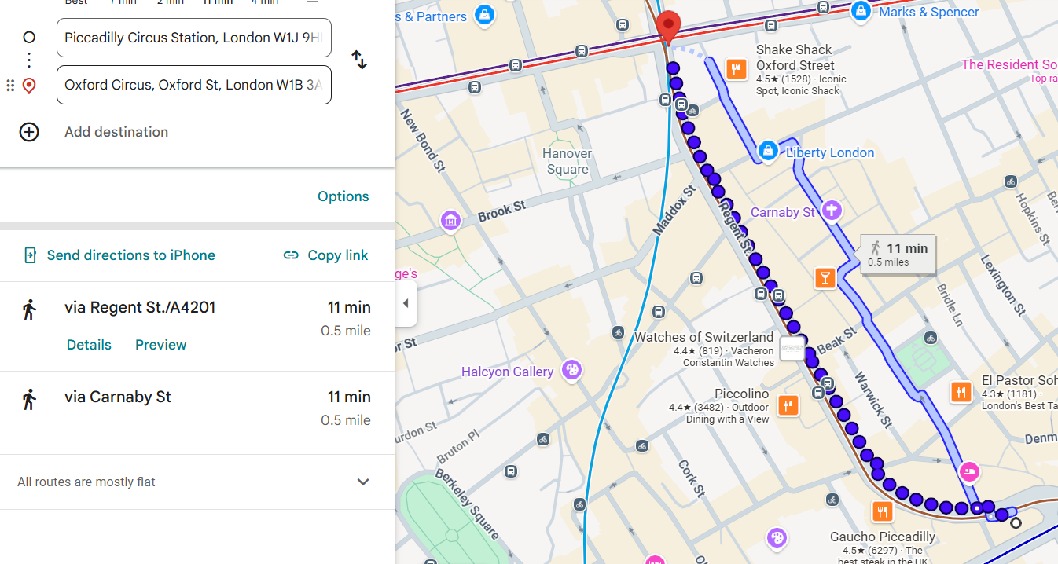
Figure 1: Distance measurement between stations for Task 1 using Google Maps.

2.2 Code
import numpy as np
import pandas as pd
import networkx as nx
import matplotlib.pyplot as plt

plt.rcParams.update({
'font.size': 10,
'figure.dpi': 120,
})

def draw_graph(G, pos, line_definitions, title, label_offsets=None):
"""Reusable renderer for the schematic-style transport diagrams used in
Task 1 and Task 2, so both tasks share one consistent visual style.

label_offsets: optional dict {station_name: (dx_pts, dy_pts, ha, va)}
to control where each station's name label sits relative to its node
(dx/dy in points, ha/va = horizontal/vertical text alignment). Stations
not listed fall back to the default diagonal (upper-right) placement.
"""
fig, ax = plt.subplots(figsize=(12, 9))

for line_name, (edges, color) in line_definitions.items():
nx.draw_networkx_edges(
G,
pos,
edgelist=edges,
width=4,
edge_color=color,
alpha=0.85,
ax=ax,
label=line_name,
)

nx.draw_networkx_nodes(
G,
pos,
node_size=280,
node_color='lightgray',
edgecolors='black',
linewidths=1,
ax=ax,
)

if label_offsets is None:
label_offsets = {}
default_offset = (8, 8, 'left', 'bottom') # diagonal, upper-right

for node, (x, y) in pos.items():
dx, dy, ha, va = label_offsets.get(node, default_offset)
ax.annotate(
node,
xy=(x, y),
xytext=(dx, dy),
textcoords='offset points',
ha=ha,
va=va,
fontsize=9,
fontweight='bold',
bbox=dict(boxstyle='round,pad=0.15', fc='white', alpha=0.85, edgecolor='none'),
zorder=6,
)

edge_labels = nx.get_edge_attributes(G, 'distance')
formatted_edge_labels = {edge: f"{dist:.2f} km" for edge, dist in edge_labels.items()}
nx.draw_networkx_edge_labels(
G,
pos,
edge_labels=formatted_edge_labels,
font_size=8,
label_pos=0.5,
bbox=dict(fc='white', alpha=0.85, edgecolor='none'),
ax=ax,
)

ax.margins(0.18, 0.15)

ax.legend(loc='lower right', title='Key', fontsize=10, title_fontsize=11,
frameon=True, edgecolor='black', fancybox=False, borderpad=1)

ax.set_title(title, fontsize=16, fontweight='bold')
ax.axis('off')
fig.tight_layout()
plt.show()

G = nx.Graph()

edges_data = [
# (station_u, station_v, distance_km)
("Oxford Circus", "Piccadilly Circus", 0.80), # a - 1/2 mile walking route
("Piccadilly Circus", "Charing Cross", 0.80), # b - 1/2 mile walking route
("Leicester Square", "Charing Cross", 0.40), # c - 1/4 mile walking route
("Piccadilly Circus", "Leicester Square", 0.54), # d - 1/3 mile walking route
("Leicester Square", "Covent Garden", 0.40), # e - 1/4 mile walking route
]

for u, v, dist in edges_data:
G.add_edge(u, v, distance=dist)

pos = {
"Oxford Circus": (0, 4),
"Piccadilly Circus": (1, 2),
"Charing Cross": (2.5, 0),
"Leicester Square": (2.5, 2),
"Covent Garden": (3.5, 3),
}

task1_lines = {
"Piccadilly": ([("Piccadilly Circus", "Leicester Square"),
("Leicester Square", "Covent Garden")], "blue"),
"Northern": ([("Leicester Square", "Charing Cross")], "black"),
"Bakerloo": ([("Oxford Circus", "Piccadilly Circus"),
("Piccadilly Circus", "Charing Cross")], "peru"),
}

task1_label_offsets = {
"Charing Cross": (0, -12, "center", "top"),
"Leicester Square": (12, 0, "left", "center"),
"Piccadilly Circus": (-12, 0, "right", "center"),
}

draw_graph(G, pos, task1_lines, "London Underground Network (Task 1)",
label_offsets=task1_label_offsets)

2.3 Generated Image
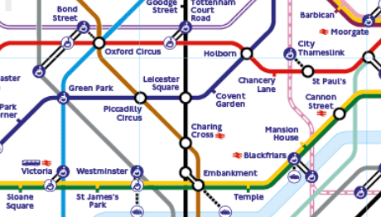

Figure 2: London Underground Network (TfL)

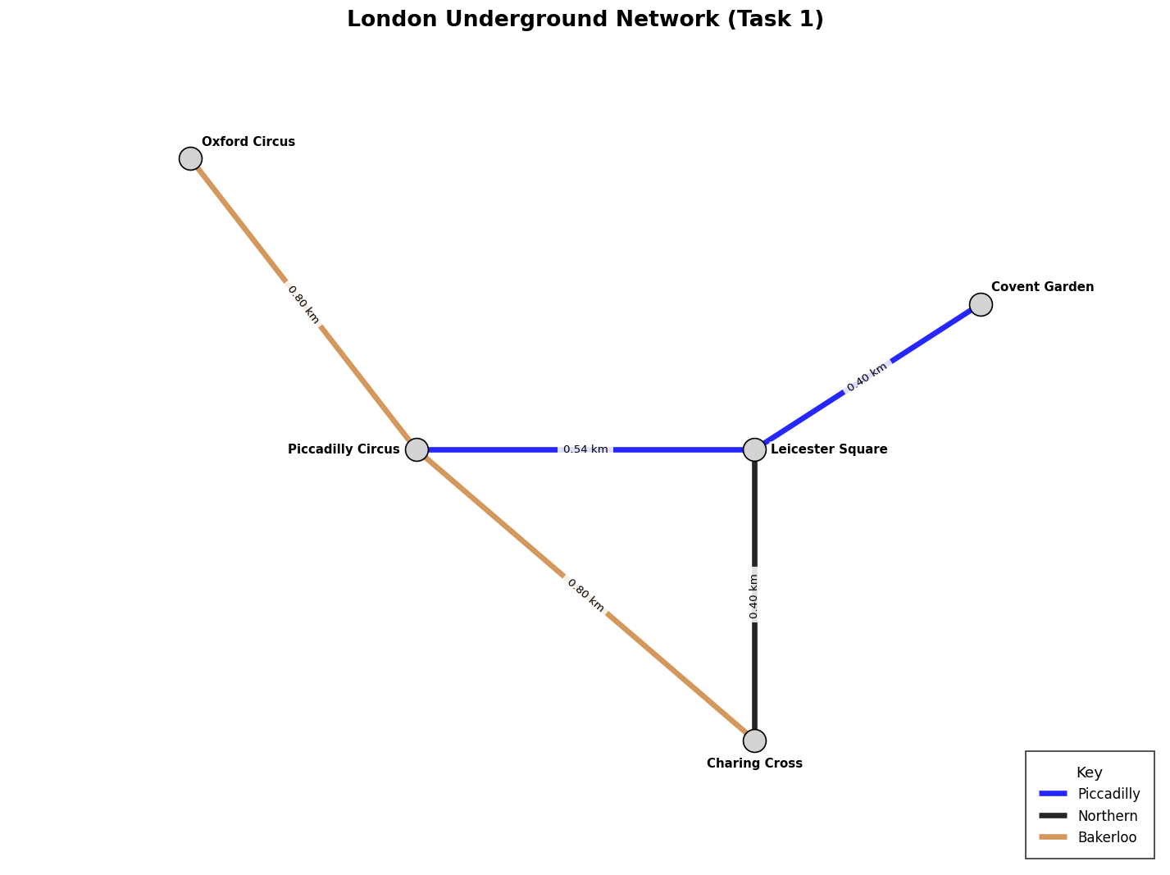
Figure 3. London Underground Network (Task 1)

3. Task 2
The Task 1 model was expanded into a larger network covering five London Underground lines Central, Northern, Piccadilly, Jubilee and Victoria with a minimum of six stations on each line, including interchange stations shared between lines. The resulting graph contains 25 stations and 30 edges and was verified programmatically to be fully connected (nx.is_connected(G) returns True), meaning a route exists between any two stations in the network. Station coordinates were approximated by inspecting the real relative positions of the stations in Google Earth, so that the generated map represents an accurate section of the actual Underground network rather than an arbitrary schematic layout. Each line uses its official TfL colour (e.g. red for Central, black for Northern, navy blue for Piccadilly) for a consistent colour scheme across the whole diagram, and interchange stations are drawn as hollow white circles while single-line stations are filled coloured dots, both explained in the Key.

3.1 Data Collection

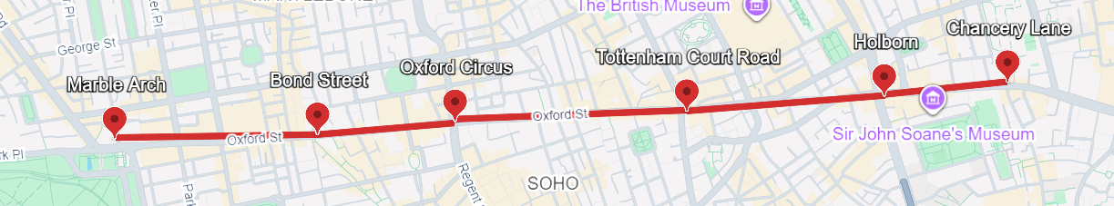
Figure 4: Google Maps/Earth view of the Marble Arch – Chancery Lane corridor (Central line), used to approximate relative station positions for the diagram layout (Google Earth, 2026).
Note on Figure 3: the red line shown was produced with Google Maps’ straight-line “measure distance” tool, which connects two points directly rather than following the pavement, so the length it reports is a straight-line (as-the-crow-flies) distance rather than a walking-route distance. Figure 3 is therefore used only as evidence of the stations’ relative geographic positions for the diagram layout, and was not used as the source of the edge-distance figures reported in the graph or in Section 4.2 — those figures come from the walking-route sources described above, consistent with the approach already applied in Task 1.
Example walking-route distances used for the Central line (full data for all five lines is listed in Section 4.2):
- Marble Arch – Bond Street: 0.60 km
- Bond Street – Oxford Circus: 0.70 km
- Oxford Circus – Tottenham Court Road: 0.80 km
- Tottenham Court Road – Holborn: 0.90 km
- Holborn – Chancery Lane: 0.70 km
- Chancery Lane – Bank: 0.90 km

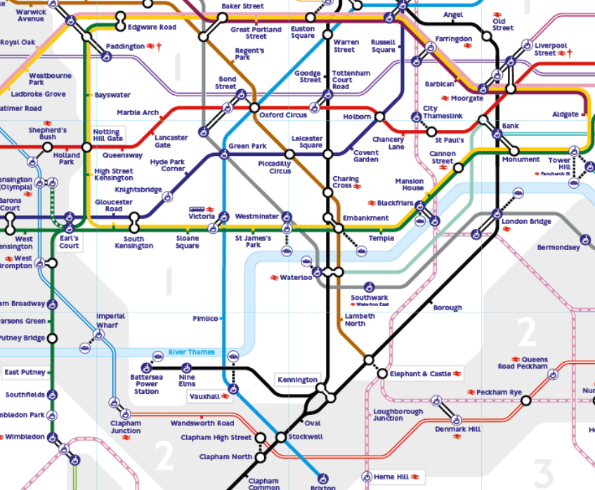
Figure 5: . Official TfL Tube map, central London section, used to verify station order, line membership and interchange points for the Task 2 network (Transport for London, 2026).
The relative geographic layout used for node placement (the pos2 coordinates in the code) was approximated from a Google Earth / Google Maps view of the same area (Figure 3), so that the compass direction and spacing between stations in the generated diagram echoes their real-world arrangement rather than being placed arbitrarily.
Edge distances were obtained using the same walking-route methodology as Task 1 (Section 2.1): values were taken from TfL Journey Planner walking-route data (via londondrum.com) and cross-checked against Google Maps walking directions between each pair of adjacent stations, then converted to kilometres. This on-street, routed distance was used deliberately in place of the straight-line (“as-the-crow-flies”) distance a simple ruler/measure-distance tool would give between two coordinate points, because a straight line ignores the street layout and buildings between stations and can understate, or otherwise misrepresent, the distance a passenger actually travels.

3.2 Code
line_definitions = {
"Central line": [
("Marble Arch", "Bond Street", 0.6),
("Bond Street", "Oxford Circus", 0.7),
("Oxford Circus", "Tottenham Court Road", 0.8),
("Tottenham Court Road", "Holborn", 0.9),
("Holborn", "Chancery Lane", 0.7),
("Chancery Lane", "Bank", 0.9),
],
"Northern line": [
("Euston", "Warren Street", 0.5),
("Warren Street", "Tottenham Court Road", 0.8),
("Tottenham Court Road", "Leicester Square", 0.5),
("Leicester Square", "Charing Cross", 0.4),
("Charing Cross", "Waterloo", 0.7),
("Waterloo", "Kennington", 1.8),
],
"Piccadilly line": [
("King's Cross", "Russell Square", 0.8),
("Russell Square", "Holborn", 0.7),
("Holborn", "Covent Garden", 0.3),
("Covent Garden", "Leicester Square", 0.3),
("Leicester Square", "Piccadilly Circus", 0.4),
("Piccadilly Circus", "Green Park", 0.6),
("Green Park", "Hyde Park Corner", 0.8),
],
"Jubilee line": [
("Baker Street", "Bond Street", 1.2),
("Bond Street", "Green Park", 0.9),
("Green Park", "Westminster", 1.0),
("Westminster", "Waterloo", 0.8),
("Waterloo", "Southwark", 0.6),
("Southwark", "London Bridge", 0.9),
],
"Victoria line": [
("King's Cross", "Euston", 0.8),
("Euston", "Warren Street", 0.5),
("Warren Street", "Oxford Circus", 1.1),
("Oxford Circus", "Green Park", 0.9),
("Green Park", "Victoria", 1.3),
("Victoria", "Pimlico", 0.9),
]
}

line_colors = {
"Central line": "#E32017",
"Northern line": "#000000",
"Piccadilly line": "#003688",
"Jubilee line": "#7A868C",
"Victoria line": "#0098D4",
}

pos2 = {
"Marble Arch": (-1.16, -0.20),
"Bond Street": (-0.52, -0.11),
"Oxford Circus": (0.00, 0.00),
"Tottenham Court Road": (0.75, 0.14),
"Holborn": (1.49, 0.24),
"Chancery Lane": (2.10, 0.33),
"Bank": (3.69, -0.21),
"Baker Street": (-1.05, 0.82),
"Warren Street": (0.25, 1.06),
"Euston": (0.57, 1.43),
"King's Cross": (1.25, 1.73),
"Russell Square": (1.21, 0.87),
"Covent Garden": (1.22, -0.26),
"Leicester Square": (0.88, -0.43),
"Piccadilly Circus": (0.53, -0.57),
"Green Park": (-0.06, -0.95),
"Hyde Park Corner": (-0.75, -1.38),
"Charing Cross": (1.01, -0.87),
"Westminster": (1.14, -1.58),
"Victoria": (-0.19, -2.08),
"Pimlico": (0.59, -2.88),
"Waterloo": (1.88, -1.33),
"Southwark": (2.54, -1.22),
"London Bridge": (3.67, -1.06),
"Kennington": (2.50, -2.98),
}

station_label_offsets = {
"King's Cross": (6, 4, "left", "bottom"),
"Euston": (0, 8, "center", "bottom"),
"Warren Street": (-10, 0, "right", "center"),
"Baker Street": (0, 6, "center", "bottom"),
"Russell Square": (6, 0, "left", "bottom"),
"Oxford Circus": (-6, 6, "right", "bottom"),
"Bond Street": (-10, -12, "center", "top"),
"Marble Arch": (0, 6, "center", "bottom"),
"Tottenham Court Road": (4, 10, "left", "bottom"),
"Holborn": (4, 10, "left", "bottom"),
"Chancery Lane": (0, 6, "center", "bottom"),
"Bank": (0, 6, "center", "bottom"),
"Covent Garden": (6, -4, "left", "top"),
"Leicester Square": (-10, 13, "right", "top"),
"Piccadilly Circus": (15, -13, "right", "top"),
"Green Park": (-10, 4, "right", "center"),
"Hyde Park Corner": (-6, 0, "right", "center"),
"Charing Cross": (9, 10, "left", "top"),
"Westminster": (-10, -9, "left", "top"),
"Victoria": (-6, 0, "right", "center"),
"Pimlico": (6, 0, "left", "center"),
"Waterloo": (-4, 10, "left", "bottom"),
"Southwark": (0, 6, "center", "bottom"),
"London Bridge": (6, -4, "left", "top"),
"Kennington": (6, 0, "left", "center"),
}

station_display_labels = {
"Tottenham Court Road": "Tottenham\nCourt Road",
"Leicester Square": "Leicester\nSquare",
"Piccadilly Circus": "Piccadilly\nCircus",
"Charing Cross": "Charing\nCross",
"London Bridge": "London\nBridge",
"King's Cross": "King's Cross\nSt. Pancras",
"Warren Street": "Warren\nStreet",
"Oxford Circus": "Oxford\nCircus",
"Green Park": "Green\nPark",
"Marble Arch": "Marble\nArch",
"Bond Street": "Bond\nStreet",
"Chancery Lane": "Chancery\nLane",
"Baker Street": "Baker\nStreet",
"Hyde Park Corner": "Hyde Park\nCorner",
"Covent Garden": "Covent\nGarden",
"Russell Square": "Russell\nSquare",
}

def build_station_lines(line_definitions):
station_lines = {}
for line_name, edges in line_definitions.items():
for start, end, _ in edges:
station_lines.setdefault(start, set()).add(line_name)
station_lines.setdefault(end, set()).add(line_name)
return station_lines

def build_task2_graph():
G = nx.Graph()
for line_name, edges in line_definitions.items():
for start, end, distance in edges:
G.add_edge(start, end, distance=distance, line=line_name)
return G

def draw_medium_tube_route():
station_lines = build_station_lines(line_definitions)
G = build_task2_graph()
fig, ax = plt.subplots(figsize=(11, 8), dpi=130)

ax.set_title("London Underground - Geographic Network Map", fontsize=13, fontweight="bold", pad=15)

for line_name, edges in line_definitions.items():
path = [edges[0][0]] + [end for _, end, _ in edges]
xs = [pos2[station][0] for station in path]
ys = [pos2[station][1] for station in path]
ax.plot(
xs, ys,
color=line_colors[line_name],
linewidth=2.2,
solid_capstyle="round",
solid_joinstyle="round",
zorder=1,
label=line_name,
)

for start, end, distance in [(u, v, d) for edges in line_definitions.values() for u, v, d in edges]:
x1, y1 = pos2[start]
x2, y2 = pos2[end]

angle = np.degrees(np.arctan2(y2 - y1, x2 - x1))
if angle > 90:
angle -= 180
elif angle < -90:
angle += 180

ax.text(
(x1 + x2) / 2,
(y1 + y2) / 2,
f"{distance:.1f} km",
fontsize=6.2,
ha="center",
va="center",
rotation=angle,
rotation_mode="anchor",
bbox=dict(facecolor="white", edgecolor="none", alpha=0.9, pad=0.12),
zorder=6,
)

# (Interchange vs Normal)
for station, (x, y) in pos2.items():
lines_at_station = list(station_lines[station])
station_color = line_colors[lines_at_station[0]]

if len(lines_at_station) > 1:
ax.scatter([x], [y], s=150, facecolors="white", edgecolors="black", linewidths=1.5, zorder=5)
else:
ax.scatter([x], [y], s=55, facecolors=station_color, edgecolors="none", linewidths=0, zorder=5)

for station, (x, y) in pos2.items():
dx, dy, ha, va = station_label_offsets[station]
ax.annotate(
station_display_labels.get(station, station),
xy=(x, y),
xytext=(dx, dy),
textcoords="offset points",
ha=ha,
va=va,
fontsize=6.2,
fontweight="bold",
bbox=dict(facecolor="white", edgecolor="none", alpha=0.8, pad=0.10),
zorder=7,
)

#Key
line_handles = [
ax.plot([], [], color=line_colors[line_name], linewidth=2.2, label=line_name)[0]
for line_name in line_definitions
]

normal_key = ax.scatter([], [], s=55, facecolors="#000000", edgecolors="none", linewidths=0, label="Normal station")
interchange_key = ax.scatter([], [], s=150, facecolors="white", edgecolors="black", linewidths=1.5, label="Interchange station")

ax.legend(
handles=line_handles + [normal_key, interchange_key],
title="Key",
loc="center left",
bbox_to_anchor=(1.01, 0.62),
frameon=True,
fontsize=6.4,
title_fontsize=7.4,
borderpad=0.50,
labelspacing=0.86,
handlelength=1.5,
handleheight=2.0,
handletextpad=0.7,
)

ax.set_xlim(-1.8, 4.2)
ax.set_ylim(-3.5, 2.3)
ax.set_aspect("equal")
ax.axis("off")
fig.tight_layout(rect=[0, 0, 0.82, 1], pad=0.12)
plt.show()
return G

G2 = draw_medium_tube_route()

3.3 Generated Image
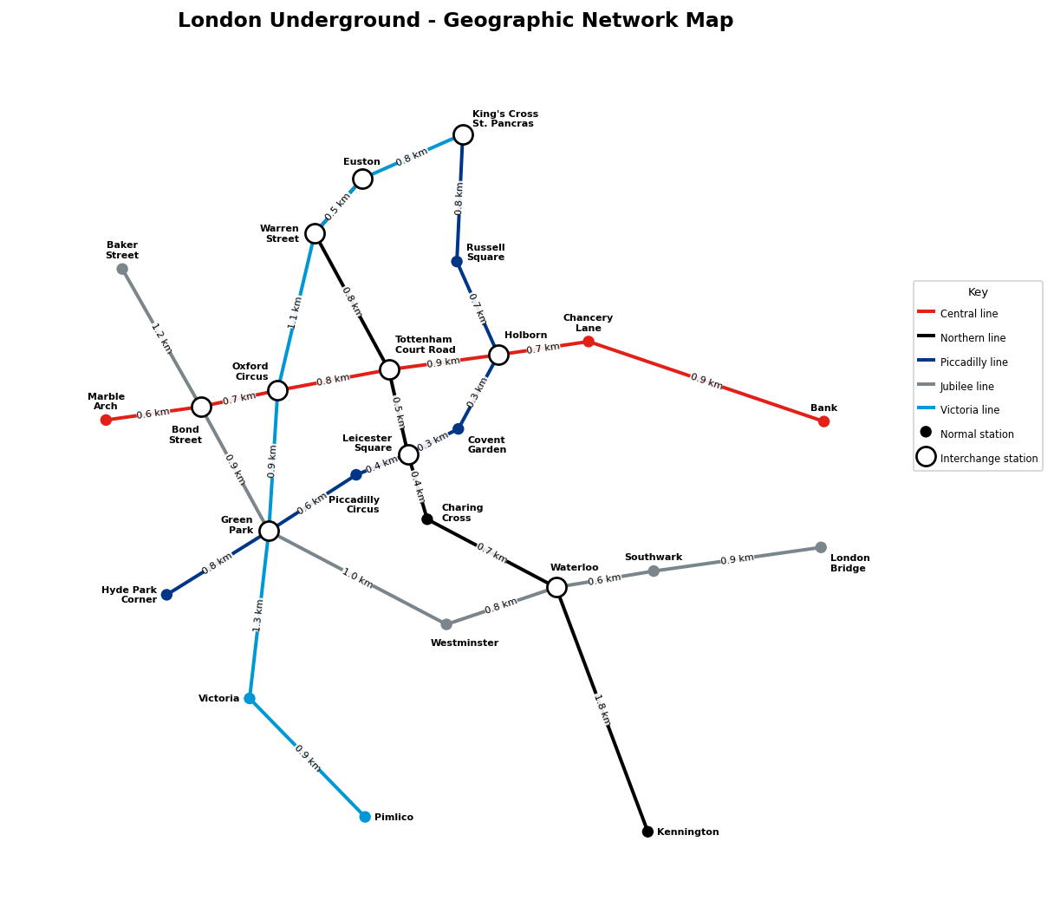
Figure 2. London Underground – Geographic Network Map (Task 2)

4. Task 3
Using the graph built in Task 2, the edge data (station pairs, line and distance) was extracted into a pandas DataFrame, from which three summary statistics were computed: the total length of the network (sum of all edge distances), the average distance between connected stations (mean edge distance), and the standard deviation of edge distances (population standard deviation, ddof = 0).

4.1 Code
edge_data = [
{'Station 1': u, 'Station 2': v, 'Line': d['line'], 'Distance (km)': d['distance']}
for u, v, d in G2.edges(data=True)
]

edge_df = pd.DataFrame(edge_data).sort_values('Distance (km)').reset_index(drop=True)

metrics = pd.Series(
{
'Total network length (km)': round(edge_df['Distance (km)'].sum(), 3),
'Average distance between stations (km)': round(edge_df['Distance (km)'].mean(), 3),
'Standard deviation of distances (km)': round(edge_df['Distance (km)'].std(ddof=0), 3),
}
)

print('Task 3 metrics:')
print(metrics.to_string())

print('\nEdge distance data for Task 3:')
print(edge_df.to_string())

4.2 Data
Summary statistics computed from the Task 2 network:
Metric | Value
Total network length (km) | 23.600
Average distance between stations (km) | 0.787
Standard deviation of distances (km) | 0.303

Full edge distance data (sorted by distance, ascending):
Station 1 | Station 2 | Line | Distance (km)
Holborn | Covent Garden | Piccadilly line | 0.3
Leicester Square | Covent Garden | Piccadilly line | 0.3
Leicester Square | Charing Cross | Northern line | 0.4
Leicester Square | Piccadilly Circus | Piccadilly line | 0.4
Euston | Warren Street | Victoria line | 0.5
Tottenham Court Road | Leicester Square | Northern line | 0.5
Waterloo | Southwark | Jubilee line | 0.6
Marble Arch | Bond Street | Central line | 0.6
Piccadilly Circus | Green Park | Piccadilly line | 0.6
Holborn | Chancery Lane | Central line | 0.7
Charing Cross | Waterloo | Northern line | 0.7
Bond Street | Oxford Circus | Central line | 0.7
Holborn | Russell Square | Piccadilly line | 0.7
Tottenham Court Road | Warren Street | Northern line | 0.8
Euston | King's Cross | Victoria line | 0.8
Oxford Circus | Tottenham Court Road | Central line | 0.8
Green Park | Hyde Park Corner | Piccadilly line | 0.8
Waterloo | Westminster | Jubilee line | 0.8
King's Cross | Russell Square | Piccadilly line | 0.8
Victoria | Pimlico | Victoria line | 0.9
Tottenham Court Road | Holborn | Central line | 0.9
Bond Street | Green Park | Jubilee line | 0.9
Chancery Lane | Bank | Central line | 0.9
Oxford Circus | Green Park | Victoria line | 0.9
Southwark | London Bridge | Jubilee line | 0.9
Green Park | Westminster | Jubilee line | 1.0
Oxford Circus | Warren Street | Victoria line | 1.1
Bond Street | Baker Street | Jubilee line | 1.2
Green Park | Victoria | Victoria line | 1.3
Waterloo | Kennington | Northern line | 1.8

References
Google Earth (2026) Satellite and map imagery of central London, used to approximate the relative geographic positions of stations for Task 2. Available at: Google Earth (Accessed: 12 August 2026).

Google Maps (2026) Walking directions, central London. Available at: Google Maps (Accessed: 12 August 2026).

Hagberg, A., Schult, D. and Swart, P. (2008) ‘Exploring network structure, dynamics, and function using NetworkX’, Proceedings of the 7th Python in Science Conference (SciPy2008), pp. 11–15.
Harris, C.R. et al. (2020) ‘Array programming with NumPy’, Nature, 585, pp. 357–362.
Hunter, J.D. (2007) ‘Matplotlib: A 2D graphics environment’, Computing in Science & Engineering, 9(3), pp. 90–95.

londondrum.com (2026) London Underground station distances. Available at: London Underground station distances (Accessed: 12 August 2026).

pandas development team (2024) pandas documentation. Available at: pandas documentation (Accessed: 12 August 2026).

Transport for London (TfL) (2026) Journey Planner. Available at: TfL Journey Planner (Accessed: 12 August 2026).

Appendix
The complete Jupyter notebook containing all source code, cell outputs and this coursework is available at the following GitHub repository:

