Lab 1 - CS3262 Embedded Networks

Wickramaarachchi N.M.

210697D

Brief explanations of client and server programs
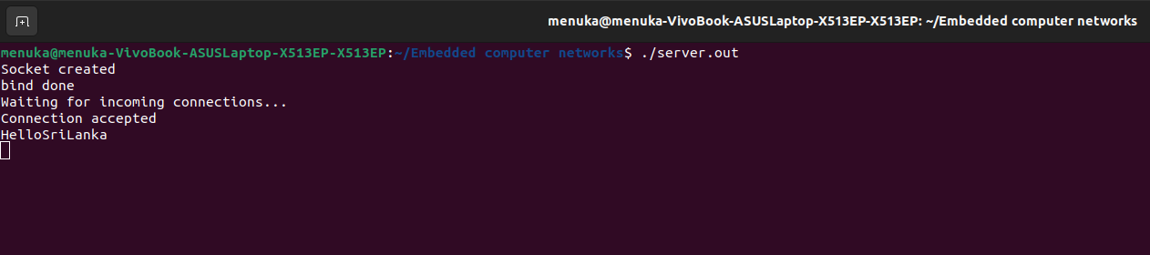
Figure 1(Screenshot of terminal when server is running)

Lets go through what happens in each step when we execute Server.c as shown in Figure 1.
- Socket Creation - The program starts by creating a socket using the socket() function. It creates an endpoint for communication. In the terminal, you'll see "Socket created" printed if the socket creation is successful.
- Binding - The program then binds the socket to a specific IP address and port number on the local machine using the bind() function. In the terminal, you'll see "bind done" printed if binding is successful.
- Listening - The program listens for incoming connections on the socket using the listen() function. The listen(socket_desc,3) specifies the socket and maximum number of connections that can be waiting while the server is handling a particular connection. In the terminal, you'll see "Waiting for incoming connections..." printed.
- Accepting Connections - The server waits until a client tries to connect. When a connection request is received, the server accepts the connection using the accept() function. In the terminal, you'll see "Connection accepted" printed.
- Receiving and Sending Data – When the connection is established, the server receives messages(data) from the client using the recv() function. It reads the data into the "client_message" buffer. Then, it sends the same message back to the client using the write() function. This will continue until client is disconnected. You can see the received message prints on the terminal. In this case its “HelloSriLanka”.

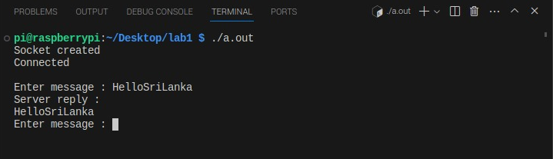
Figure 2(Screenshot of terminal when client is running)
Lets go through what happens in each step when we execute Client.c as shown in Figure 2.
- Socket Creation - Client program also starts by creating a socket using the socket() function. It creates an endpoint for communication. In the terminal, you'll see "Socket created" printed if the socket creation is successful.
- Server Connection – Using the connect() function, Client tries to connect to the server. Where we have to specify the server's IP address, port number, and address family. In the terminal, you'll see "Connected" printed if the connection is successful.
- Sending & Receiving data(messages) - The client prompts the user to enter a message. It reads the message from the user using scanf() and sends it to the server using the send() function. Then, it waits to receive a reply from the server using the recv() function. In the terminal, you'll see "Enter message :" prompting for input, and then it will display the server's reply. In this case its “HelloSriLanka”. This will continue until the client is disconnected.

Explanation of TCP packets traced by Wireshark
Now let’s see what happens when we capture the Server Client connection using Wireshark.

