Noah Meeker
821272563
CS 420
Assignment 3 Write-Up
For this assignment, we were task to write a program in Fortran that reads in two matrices and perform multiplication on them. The main requirements were the matrices were to be read from a file and two functions were to be used. All else was on the table as to how we would go about the final implementation. This current code reads in the file name of two text files. Each text file houses on matrix with the size of the matrix. After the multiplication, the final matrix is then written to a separate output file labeled “lab3_output.txt.”
The read function reads in the size of the matrix on the first line. It then allocates a matrix based on the size parameters given. Once the matrix is read in, it returns it back to the main function.
The multiplication function takes in the two matrices after the program checks they are of the same size. The function allocates the final matrix based on the row size of matrix1 and the column size of matrix2. After the multiplication, the final matrix is returned to the main program.
There are checks to make sure each file is opened properly and the two matrices are of the correct sizes. The program prints the size of each input matrix and then print a completed statement to indicate the program finished. Below are screenshot examples.

TestFiles:
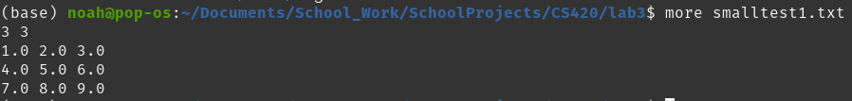

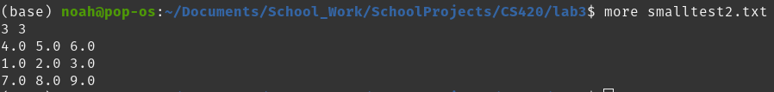

Run:
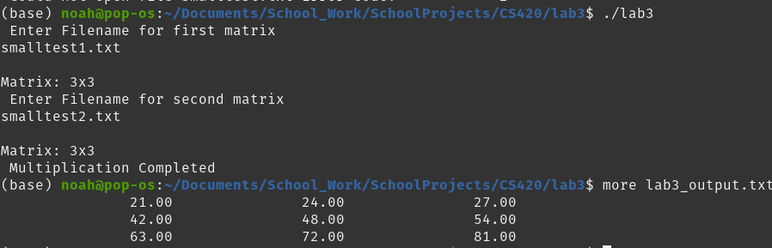

TestFiles:
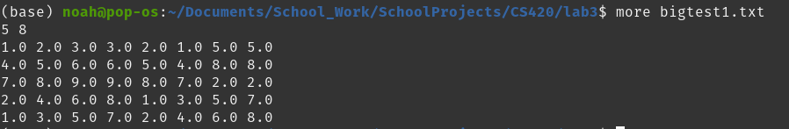

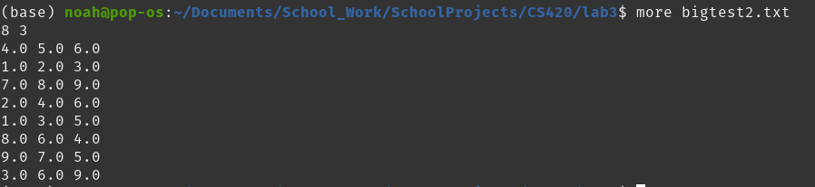

Run:
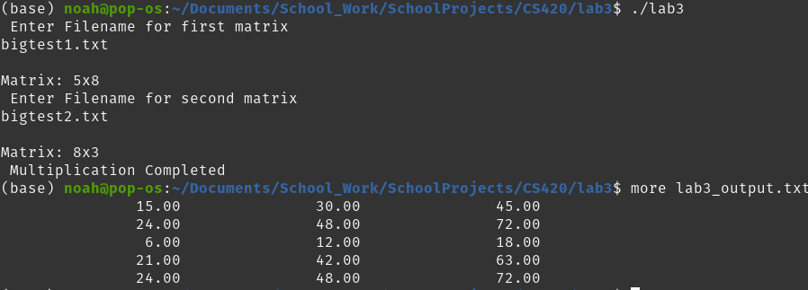

Proper matrix sizing for multiplication error handling:
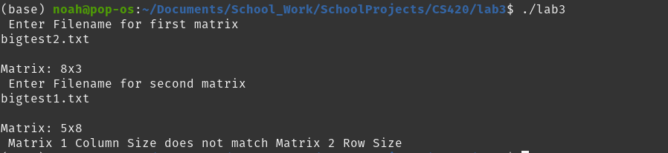
Current Code:

! PROGRAM LAB_3.F95
!
! Noah Meeker
! Assignment 3

PROGRAM LAB_3

IMPLICIT NONE

CHARACTER(20) :: filename
REAL, ALLOCATABLE :: matrix1(:,:), matrix2(:,:), matrix_final(:,:)
INTEGER, DIMENSION(2) :: size_arr
INTEGER :: idx, jdx, ios, count

! Grab first file name from user
PRINT *, "Enter Filename for first matrix"
READ *, filename

matrix1 = READ_MATRIX(filename)

! grab matrix size
PRINT *
WRITE(*, FMT=300) size(matrix1,1), size(matrix1,2)

! Grab second file name from user
PRINT *, "Enter Filename for second matrix"
READ *, filename

matrix2 = READ_MATRIX(filename)
PRINT *
WRITE(*, FMT=300) size(matrix2,1), size(matrix2,2)

! Check matrix sizes are correct
IF (size(matrix1,2) /= size(matrix2,1)) THEN
PRINT *, "Matrix 1 Column Size does not match Matrix 2 Row Size"
STOP
ENDIF

! Multiply the two matrices
matrix_final = MULT_MATRIX(matrix1, matrix2)

! Open output file
OPEN(UNIT=10, FILE="lab3_output.txt", ACTION="WRITE", STATUS="NEW", IOSTAT=ios)

! Check output file opened successful
IF (ios /= 0) THEN
PRINT *, "Could not open output file"
STOP
ENDIF

! Print final matrix
DO idx = 1, size(matrix_final, 1)
DO jdx = 1, size(matrix_final, 2)
write(10, 100, ADVANCE="NO") matrix_final(idx, jdx)
END DO
write(10,*)
END DO

PRINT *, "Multiplication Completed"

100 FORMAT (f20.2)
300 FORMAT ("Matrix: ", i1, "x", i1)

CONTAINS

FUNCTION READ_MATRIX(filename) RESULT(matrix)
IMPLICIT NONE
CHARACTER(*), intent(in) :: filename
INTEGER :: ios, row, col
INTEGER, DIMENSION(2) :: matrix_size
REAL, ALLOCATABLE :: matrix(:,:)

! Open file
OPEN(UNIT=9, FILE=filename, ACTION="READ", STATUS="OLD", IOSTAT=ios)

! Check if file properly opened
IF(ios /= 0) THEN
PRINT *, "Could not open file ", TRIM(filename), " Error code: ", ios
STOP
ENDIF

! Grab matrix size
!
! matrix_size(1) = row
! matrix_size(2) = col
READ (9, *) matrix_size

ALLOCATE(matrix(matrix_size(1),matrix_size(2)))

! Read in matrix from file
DO row = 1, matrix_size(1)
READ(9, *) (matrix(row, col), col = 1, matrix_size(2))
END DO

CLOSE(9)

END FUNCTION READ_MATRIX

! Function to mulitply two matrices
FUNCTION MULT_MATRIX(matrix_a, matrix_b) RESULT(matrix_final)
IMPLICIT NONE
REAL, INTENT(IN) :: matrix_a(:,:), matrix_b(:,:)
REAL, ALLOCATABLE :: matrix_final(:,:)
INTEGER :: idx, jdx, kdx
INTEGER :: m, n, p

! m = matrix1 row size
! n = matrix1 col size
! p = matrix2 row size
m = size(matrix1, 1)
n = size(matrix1, 2)
p = size(matrix2, 2)

! Allocate final matrix size
ALLOCATE(matrix_final(m,p))

! Multiply
DO idx = 1, m
DO jdx = 1, p
DO kdx = 1, n
matrix_final(idx, jdx) = matrix_a(idx, kdx) * matrix_b(kdx, jdx)
END DO
END DO
END DO

END FUNCTION MULT_MATRIX
END PROGRAM LAB_3

