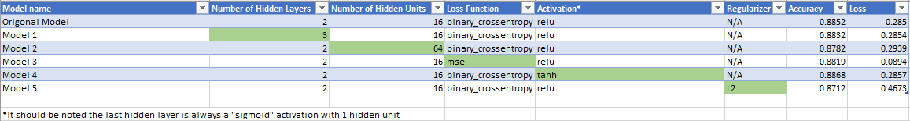

With the original model set up from class the validation accuracy is 0.8852 and the validation loss is 0.2850 we will use those two numbers as a baseline for understanding how changes in the model affect its performance. In order to isolate what each change to the model does to its validation accuracy and validation loss the approach I have chosen is keeping the model the same as the set up from class with one change per model. In the graph above you can see the all the choices made in the creation of the model and the ones highlighted in green are the parts that are different from the original model.

As can be seen in the graph above the majority of the changes had very light effects on the accuracy of the model except for the model with regularization included which had a .014 decrease in accuracy. The only change that had a positive impact on the accuracy was the change of the activation to “tanh”, but due to the fact that the increase was only by .0016 the increase could be within the margin for error and might decrease or even become less then the original model if the test was run again. The loss statistic on the other had appears to be able to be significantly affected by two changes. The one for the better is changing the Loss Function to “mse” which appears to have had a significant lowering of the loss statistic. The one for the worse is the regularization appears to have increased the loss statistic significant ally.

It should also be noted that the introduction of the Regularizer appears to have made the model less accurate as well as increasing loss, but it does allow for more epocs to be ran before the validation step then the other models. Which might not have allowed for more accuracy in this case but could positively impact the accuracy of models I work on in the future.

All that being said it appears to me that keeping all things the same as the original model except for changing the loss function to “mse” seems to be the best way to have a model that is significantly better at least in regards to the loss statistic and appears to be very close with accuracy.