SHEIN Data Cleaning Assignment — Automated Report
Nicky Melville
May 18, 2026
Table of Contents

1. Dataset Overview
This report documents the data quality pipeline applied to the SHEIN product dataset. All figures and summary statistics are generated programmatically from the cleaned dataset — no values have been manually entered.
Dataset overview
Item | Value
Source | SHEIN US product scrape (shein_sample.csv / shein_sample_all_rows.xlsx)
Raw file | ../Raw_data/shein_sample.csv
Rows (raw) | 111,189
Columns (raw) | 8
Rows (after deduplication) | 103,202
Columns (after cleaning) | 20
Columns (after imputation) | 20
Date of download | Not recorded in dataset — no scraped_at timestamp detected
The raw dataset contains 8 columns: url, name, sku, price, size, brand, description, images.
After cleaning and imputation, the final dataset contains 20 columns: size_system, sku, url, name, price, price_flag, brand, color, size_count, size_labels, size_us, size_eu, dimensions_raw, waist, inseam, has_petite, has_tall, has_plus, images_n, images_clean.

2. Data Quality Diagnostics Before Cleaning
The exploratory diagnostics (produced by 02_diagnosis.R) identified the following issues in the raw data prior to any cleaning.

2.1 Missingness
Missingness in raw data (before cleaning)
Variable | Missing (n) | Missing (%)
brand | 55195 | 49.6
size | 5513 | 5.0
url | 0 | 0.0
name | 0 | 0.0
sku | 0 | 0.0
price | 0 | 0.0
description | 0 | 0.0
images | 0 | 0.0

2.2 Duplicates
The raw dataset contained 0 exact duplicate rows. These were removed during SKU deduplication in 03_clean.R.

2.3 Other Issues Identified
The following data quality issues were documented during the diagnostic phase:
- Price: Stored as a character string with a leading “$” symbol. Required stripping and numeric coercion.
- Brand: Contained mojibake (corrupted encoding) with category breadcrumbs appended after a garbled character (e.g. QingSang?Accessories Apparel Accessories). Required transliteration and regex extraction.
- Description: A serialised Python-style key-value string (e.g. [{'Color': 'Black'}, {'Material': 'Woven Fabric'}]). Not directly usable; required parsing to extract individual attributes.
- Size: A multi-value string encoding several different size systems (standard letter, US numeric, shoe international, bedding dimensions, etc.) in a single column. Required classification and splitting.
- Images: Contains raw Python-style list syntax with single-quoted URLs. Cleaning deferred to a later pipeline stage.

3. Cleaning Decisions
Each cleaning operation is documented below with the rationale for the approach taken.

3.1 SKU — Prefix Stripping and Deduplication
Issue: Raw SKU values contain a "SKU: " prefix. Multiple rows may exist per product due to repeated scraping sessions.
Action: Stripped the prefix with str_remove(sku, "^SKU:\\s*"), then deduplicated rows using unique(dt, by = "sku").
Rationale: The SKU is the natural primary key. The prefix is a display artefact and adds no information. Deduplication ensures one row per product.
Result: 111,189 raw rows → 103,202 unique products (7,987 duplicates removed).

3.2 Price — Numeric Coercion and Flagging
Issue: Price stored as character with leading "$" (e.g. "$7.25").
Action: Stripped non-numeric characters and coerced to numeric. Created a price_flag column with values: ok, missing, invalid (≤ 0), outlier_high (> $10,000).
Rationale: Price must be numeric for any downstream analysis. The flag preserves provenance — analysts can filter on price_flag to include or exclude problematic rows.
Price flag distribution (after cleaning, before imputation)
Price Flag | Count
ok | 103198
missing | 4

3.3 Brand — Mojibake Repair
Issue: Brand field contains encoding corruption followed by a category breadcrumb (e.g. QingSang?Accessories Apparel Accessories). Many products have no brand at all.
Action: Applied stri_trans_general(brand, "latin-ascii") to transliterate encoding, then extracted the brand name before the first corrupted character with str_extract(brand, "^[^?]+"). Empty or unrecoverable values set to NA.
Rationale: The breadcrumb is scraper noise, not part of the brand name. Setting empty values to NA (rather than a placeholder) preserves honest missingness for downstream analysis.

3.4 Color — Extraction from Description
Issue: Colour is embedded inside a serialised key-value string in the description column, not available as a standalone field.
Action: Extracted the Color value using str_extract(description, "(?<='Color':\\s')[^']+"). Dropped the description column entirely.
Rationale: Only the Color attribute had sufficient coverage to justify extraction as a standalone variable for imputation. Other attributes (Material, Style, Pattern Type, etc.) were below threshold. Dropping description reduces the dataset to analytically useful columns.

3.5 Size — System Classification and Column Splitting
Issue: The size column encodes multiple incompatible sizing systems in a single comma-separated string (e.g. XS(2),S(4),M(6),L(8/10) for clothing vs. 135*200,160*220 for bedding vs. CN35(US5.5),CN36(US6) for shoes).
Action: Classified each row’s size system using a priority-ordered fcase() chain with 15 categories. Split the original column into five derived columns: size_system, size_labels, size_us, dimensions_raw, size_count.
Rationale: A single column cannot represent fundamentally different measurement systems. The classification allows downstream grouping (e.g. for price imputation by product type). All size columns are present in every row, with NA for non-applicable systems, to preserve the single-file structure needed for imputation workflows.
Size system distribution in final dataset
Size System | Count
us_clothing | 60668
one_size | 11787
plus | 7315
standard | 7055
shoe_intl | 6247
missing | 5494
dimensions | 2250
shoe_us | 1252
bra | 368
us_letter | 271
unknown | 219
kids | 139
jeans | 85
volume_length | 52

3.6 Drop Log
All column drops and replacements are recorded in the pipeline’s clean_drop_log.
Column drop/replace log from 03_clean.R
column | action | reason
price | replaced | Stripped currency symbol; coerced to numeric as ‘price’; price_flag added for missing/invalid/outlier rows
description | dropped | Serialised key-value string. Only ‘Color’ value retained as standalone column for missing data imputation. All other attributes (Material, Style, etc.) dropped — below coverage threshold for imputation use.
size | replaced | Multi-value string spanning multiple size systems. Replaced by: size_system (classification), size_labels (letter labels), size_us (US numeric), size_eu (EU numeric), dimensions_raw (bedding), waist/inseam (jeans), size_count (option count), has_petite/has_tall/has_plus (modifier flags). Columns for non-applicable systems left NA intentionally to preserve one-file structure for imputation.
images | replaced | Raw scraped string with brackets/quotes. Replaced by: images_clean (deduplicated pipe-separated URLs), images_n (count of unique image URLs per product).

4. Imputation Applied

4.1 Price — Grouped Median Imputation
Variable: price
Method: Median imputation, grouped by size_system.
Justification: Retail product prices are right-skewed — the mean is pulled upward by expensive items, making median a more robust central estimate. Grouping by size_system ensures that products in different price bands (e.g. one-size accessories vs. multi-size clothing) receive group-appropriate fill values rather than a single global value.
All missing prices were concentrated in the one_size group. These were filled with the one_size group median. Imputed rows are flagged with price_flag = "imputed".
Alternatives considered and rejected:
- Mean imputation — inappropriate given right-skewed price distribution; would systematically overestimate.
- Mode imputation — designed for categorical variables, not continuous prices.
- Hot-deck imputation — adds stochastic variation that is harder to reproduce and justify.
- Constant/flag imputation — filling with 0 or “Unknown” would distort numeric analysis.
- Leave missing — rejected because price is a core analytic variable; NAs would propagate through every price-dependent calculation.

4.2 Variables Left as Missing
The following variables were not imputed, with justification:
- brand — High-cardinality categorical variable with a dominant missing class. Most SHEIN products are unbranded; missingness is informative, not random. Mode imputation would create false brand associations.
- color — Structurally absent where the raw description field lacked a Color key. Imputation would require predicting colour from product names or images, which is beyond the scope of tabular imputation.
- size_labels, size_us, dimensions_raw — These are structural NAs by design. The column is not applicable to certain product types (e.g. dimensions_raw is only for bedding). These are not missing data; they are intentional nulls.
- size_system — Products classified as "unknown" could not be matched by any regex pattern. Imputing a system would propagate a guess into every derived size column, compounding the error.
Imputation log from 04_impute.R
variable | method | group | fill_value | rows_imputed | reason
price | median | one_size | 2.4 | 4 | Group median applied

4.3 Observed vs. Imputed Comparison
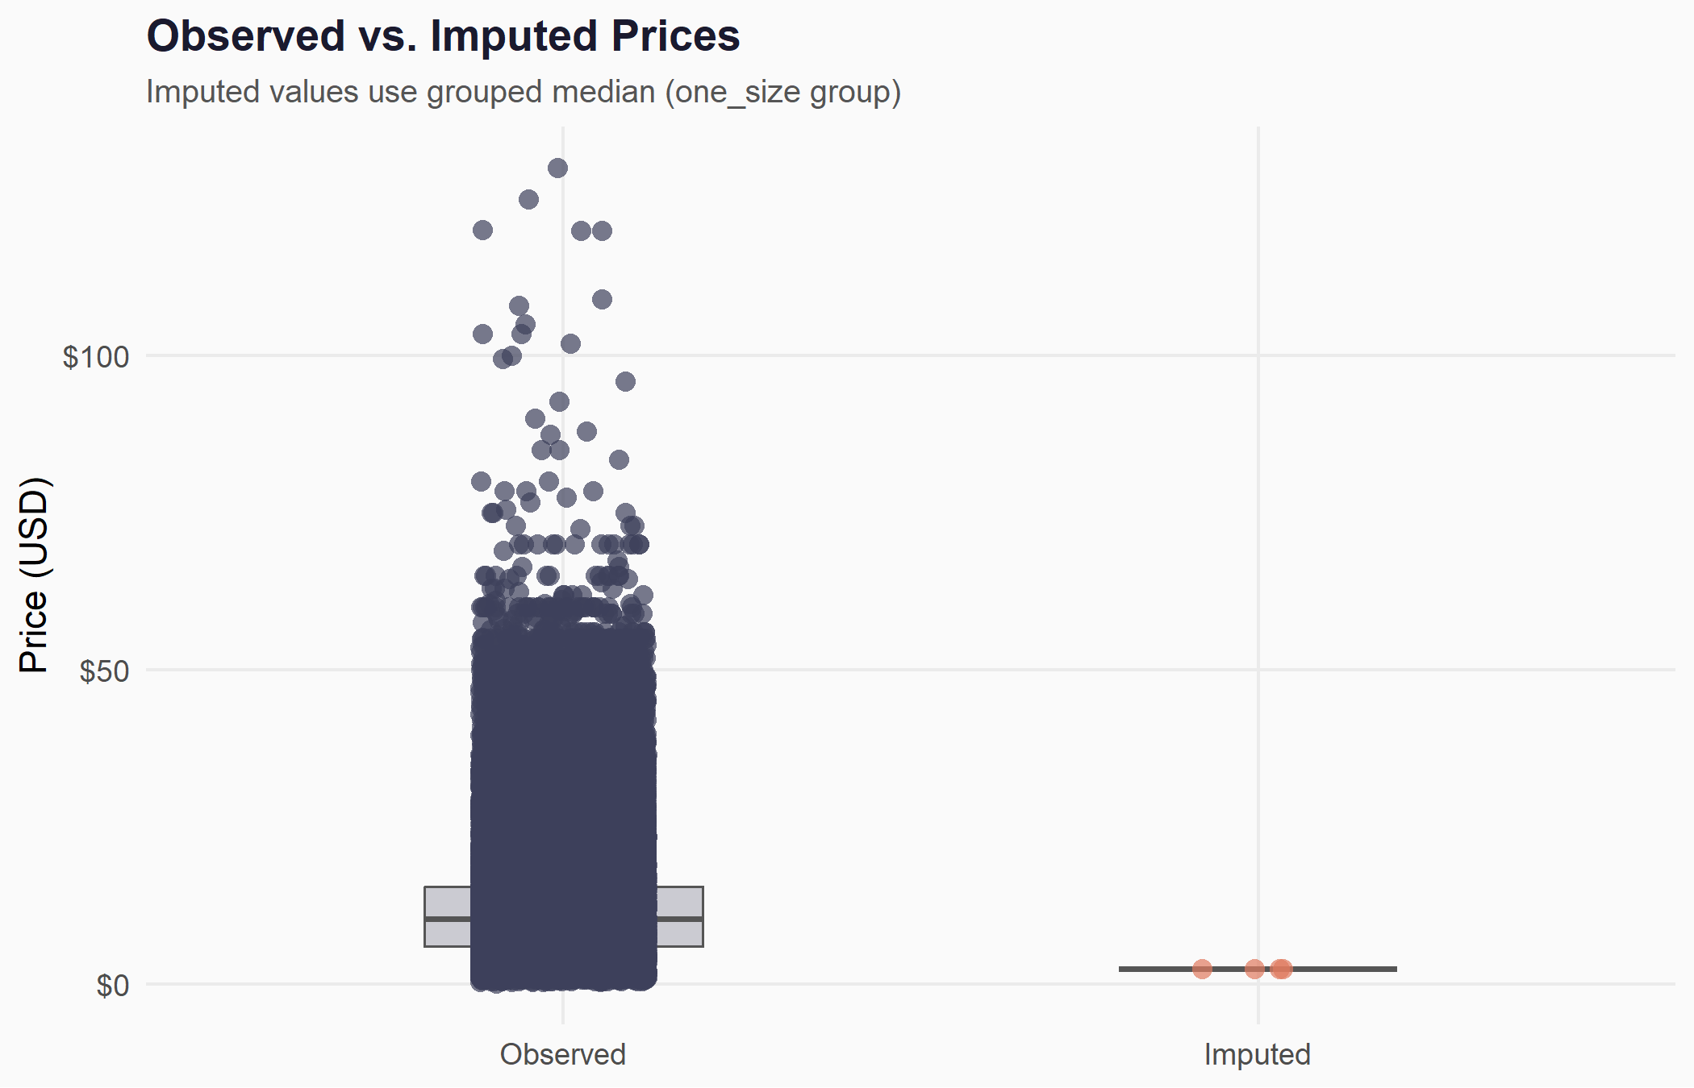
Comparison of observed and imputed price values

5. Post-Cleaning Summary

5.1 Final Dataset Dimensions
Final dataset dimensions (after cleaning and imputation)
Metric | Value
Rows | 103,202
Columns | 20

5.2 Summary Statistics for Numeric Variables
Summary statistics for numeric variables
Variable | N | Min | Q1 | Median | Mean | Q3 | Max | SD
price | 103202 | 0.05 | 6 | 10.39 | 12.19 | 15.49 | 129.99 | 8.88
size_count | 91694 | 1.00 | 3 | 4.00 | 3.95 | 4.00 | 36.00 | 1.77
images_n | 103202 | 1.00 | 5 | 5.00 | 5.55 | 6.00 | 20.00 | 1.44

5.3 Final Missingness
Missingness in final dataset (after cleaning and imputation)
Variable | Missing (n) | Missing (%)
waist | 103117 | 99.9
inseam | 103117 | 99.9
dimensions_raw | 100952 | 97.8
size_eu | 96955 | 93.9
brand | 50867 | 49.3
size_us | 31477 | 30.5
size_labels | 28833 | 27.9
size_count | 11508 | 11.2
color | 332 | 0.3
size_system | 0 | 0.0
sku | 0 | 0.0
url | 0 | 0.0
name | 0 | 0.0
price | 0 | 0.0
price_flag | 0 | 0.0
has_petite | 0 | 0.0
has_tall | 0 | 0.0
has_plus | 0 | 0.0
images_n | 0 | 0.0
images_clean | 5 | 0.0

5.4 Missingness Before vs. After
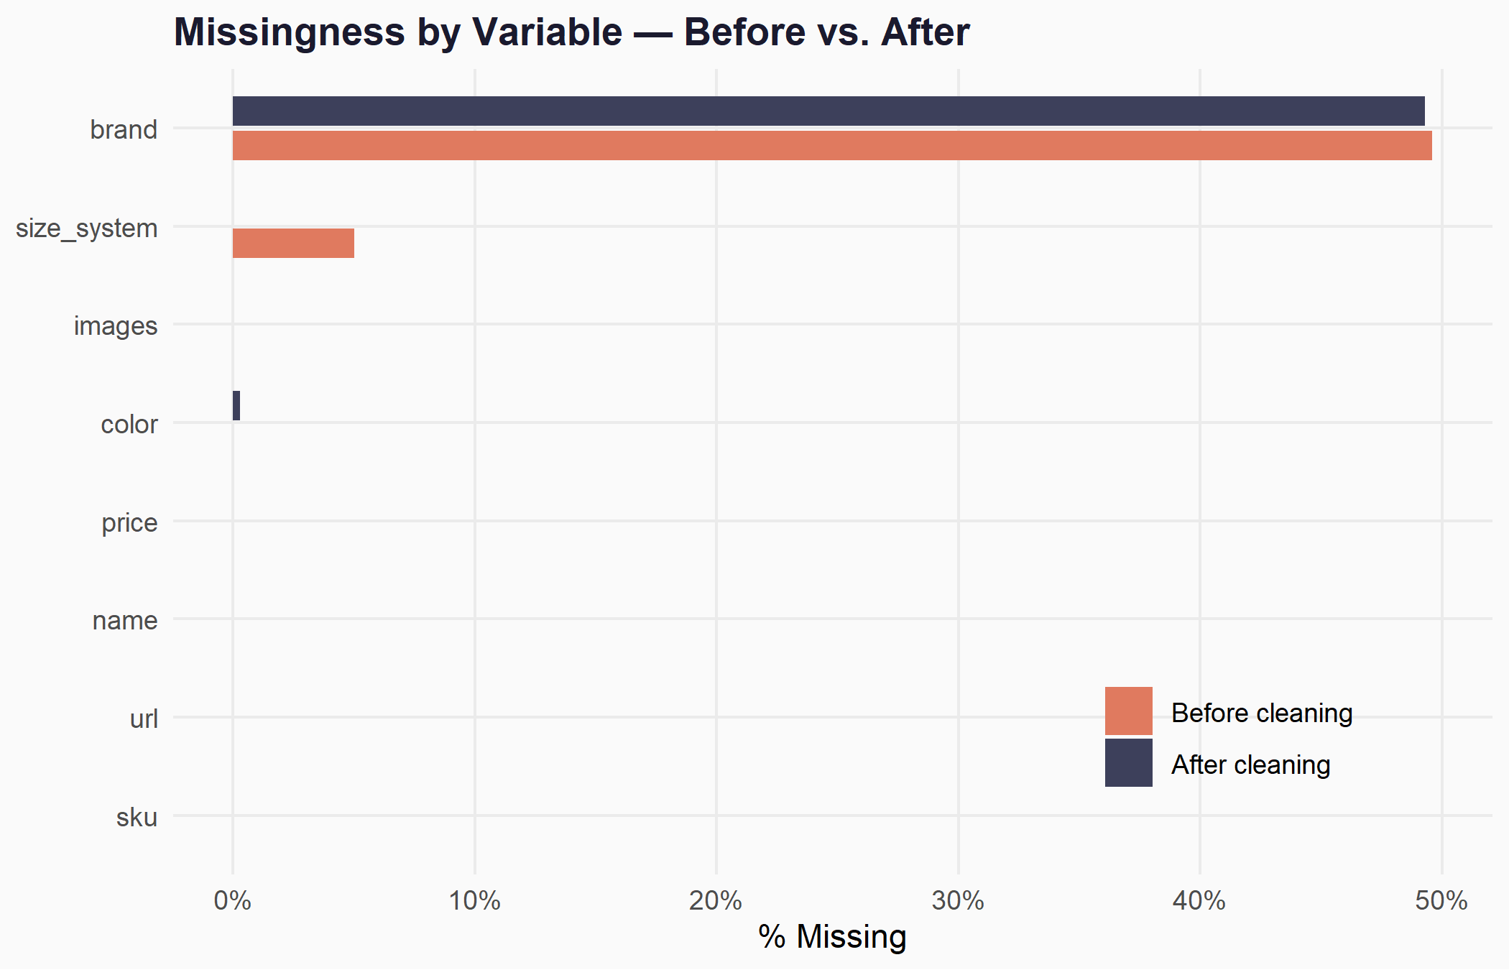
Missingness comparison before and after cleaning

5.5 Price Distribution
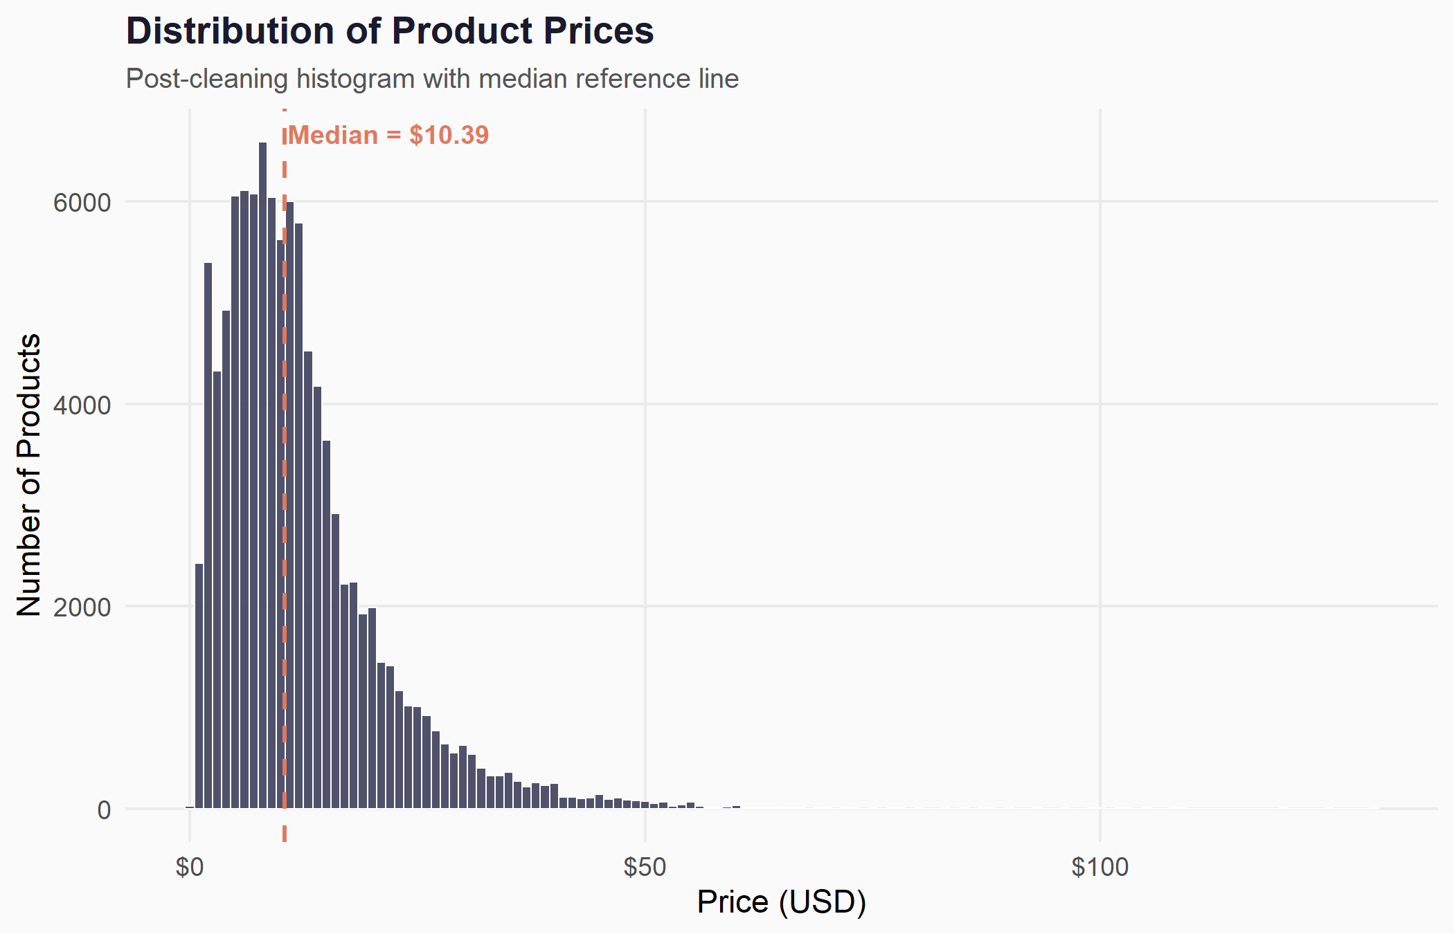
Post-cleaning price distribution

6. Limitations and Known Risks
- No scrape timestamp. The diagnostics did not detect a scraped_at column. Without it, the pipeline cannot verify data freshness or identify stale records from older scraping sessions.
- Brand missingness is high. Approximately 49.3% of products have no brand after cleaning. This is a structural feature of the SHEIN platform (most items are unbranded), not a data collection failure, but it limits any brand-level analysis.
- Image column uncleaned. The images column was carried forward in raw form (Python-style list syntax). It has not been deduplicated, validated, or split into individual URL columns. Downstream image analysis will require an additional cleaning step.
- Size system “unknown” cases. Products classified as size_system = "unknown" could not be matched by any of the 14 regex patterns. These may represent edge-case formats not anticipated by the classification rules. The derived size columns (size_labels, size_us, size_count) are NA for these rows.
- Price imputation is deterministic. The grouped median approach produces a single fill value per size system group. This means all imputed rows within a group receive the same price, which artificially reduces variance in that group. For analyses sensitive to distributional shape (e.g. price dispersion studies), this is a known distortion.
- Sample size sensitivity. If the pipeline is run on a small sample (e.g. the 9-row shein_sample_data.xlsx), group medians may be based on very few observations, making the imputed values unstable. The pipeline is designed for the full dataset.
- Single-imputation limitation. Only one imputation pass is performed. Multiple imputation (e.g. via the mice package) would produce more statistically valid uncertainty estimates but was not required by the assignment scope.
- Regex classification is heuristic. The size system classification relies on pattern matching against known formats. New or unusual size formats introduced by SHEIN after the scrape date may be misclassified.

Report generated automatically by the Shein Data Quality Pipeline (06_report.rmd). All figures and statistics are computed from pipeline objects — no values were manually entered.

