# UI Screenshots — GitHub Issues Mock API

# Container running (docker compose ps)



# GET /issues — 200 OK

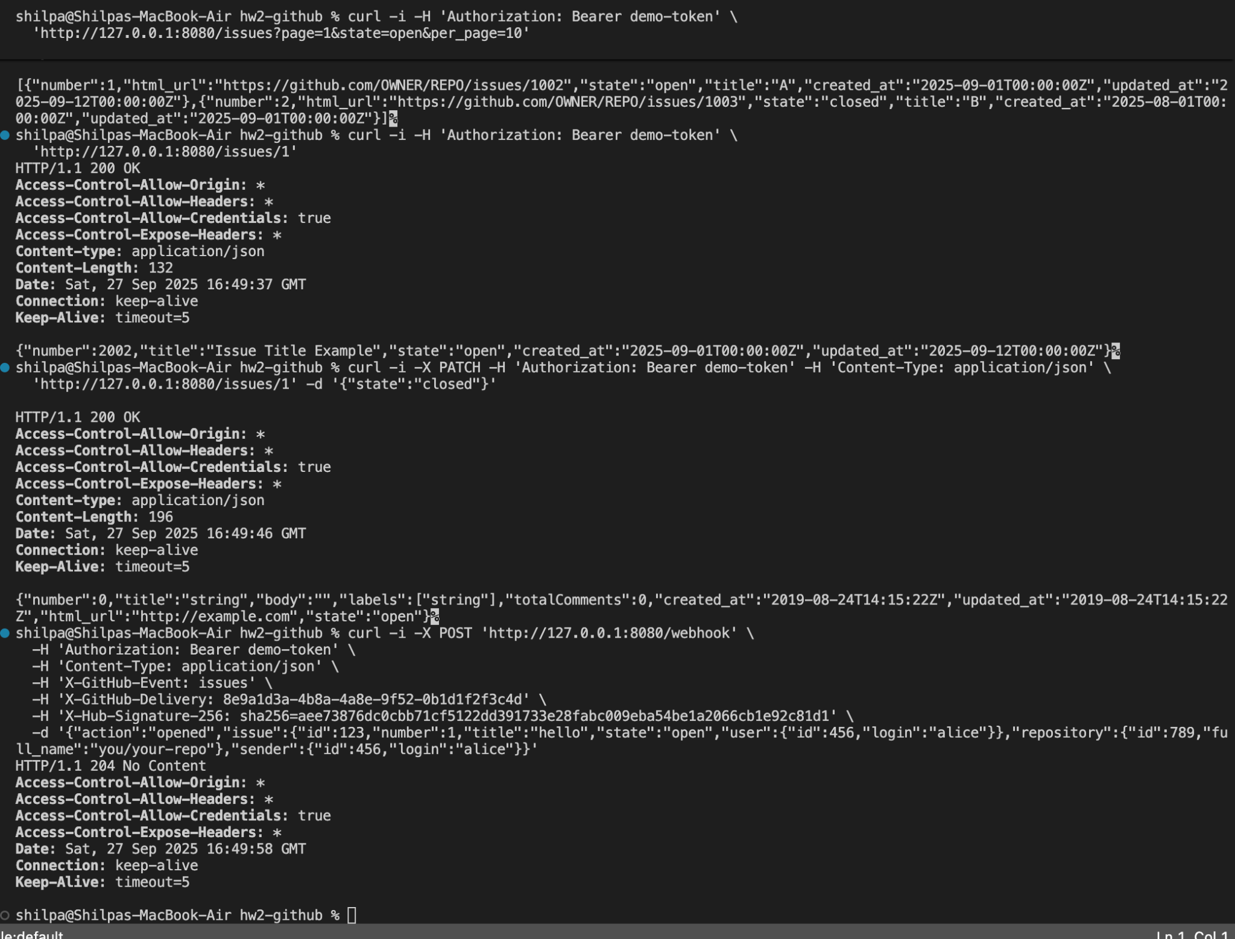

# POST /webhook — 204 No Content

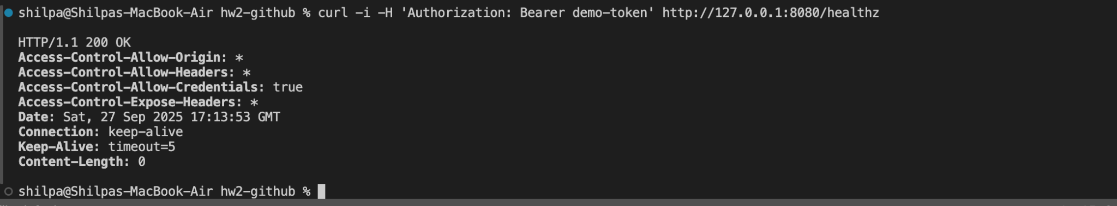

# Composite terminal output (issues, patch, webhook)



# Additional terminal snapshot

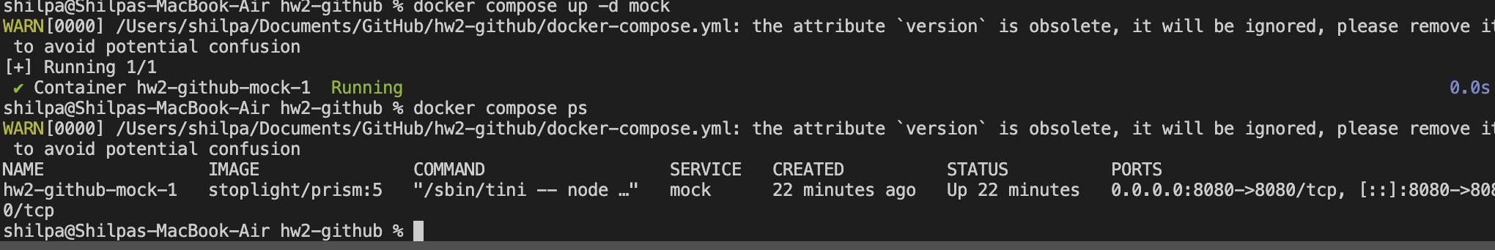

# Comments (Swagger-UI)

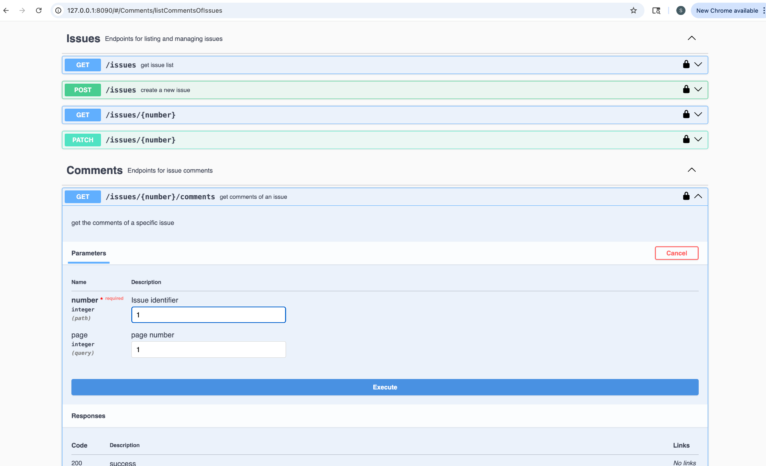

C1 — GET /issues/{number}/comments (filled, before Execute)

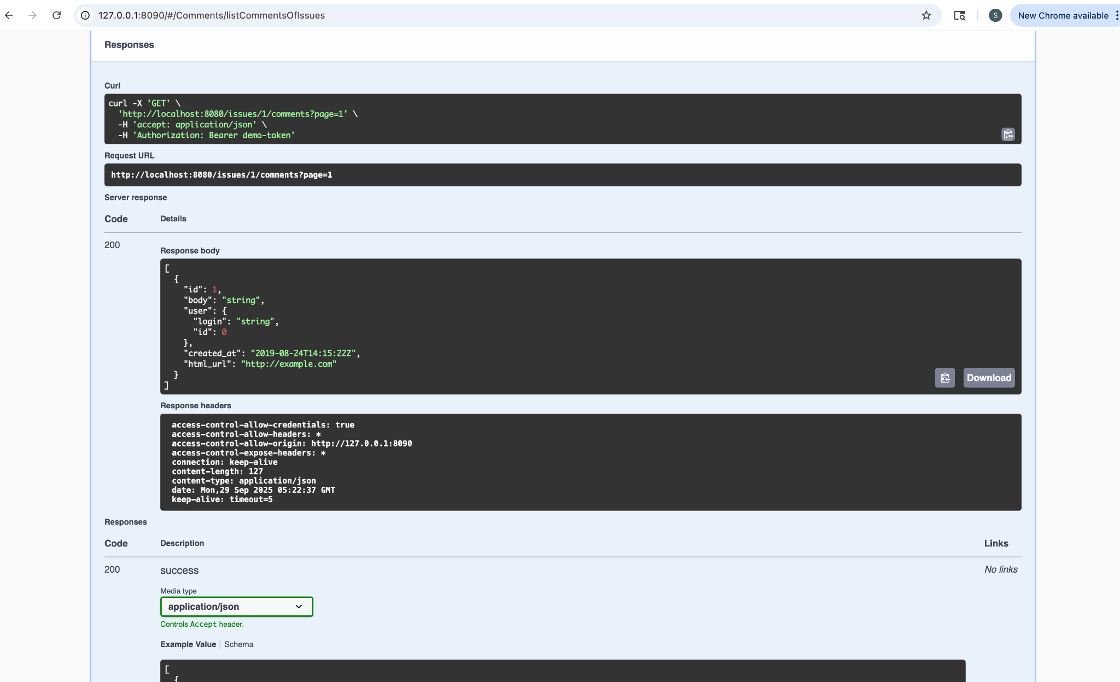

C2 — GET /issues/{number}/comments — 200 OK (response)

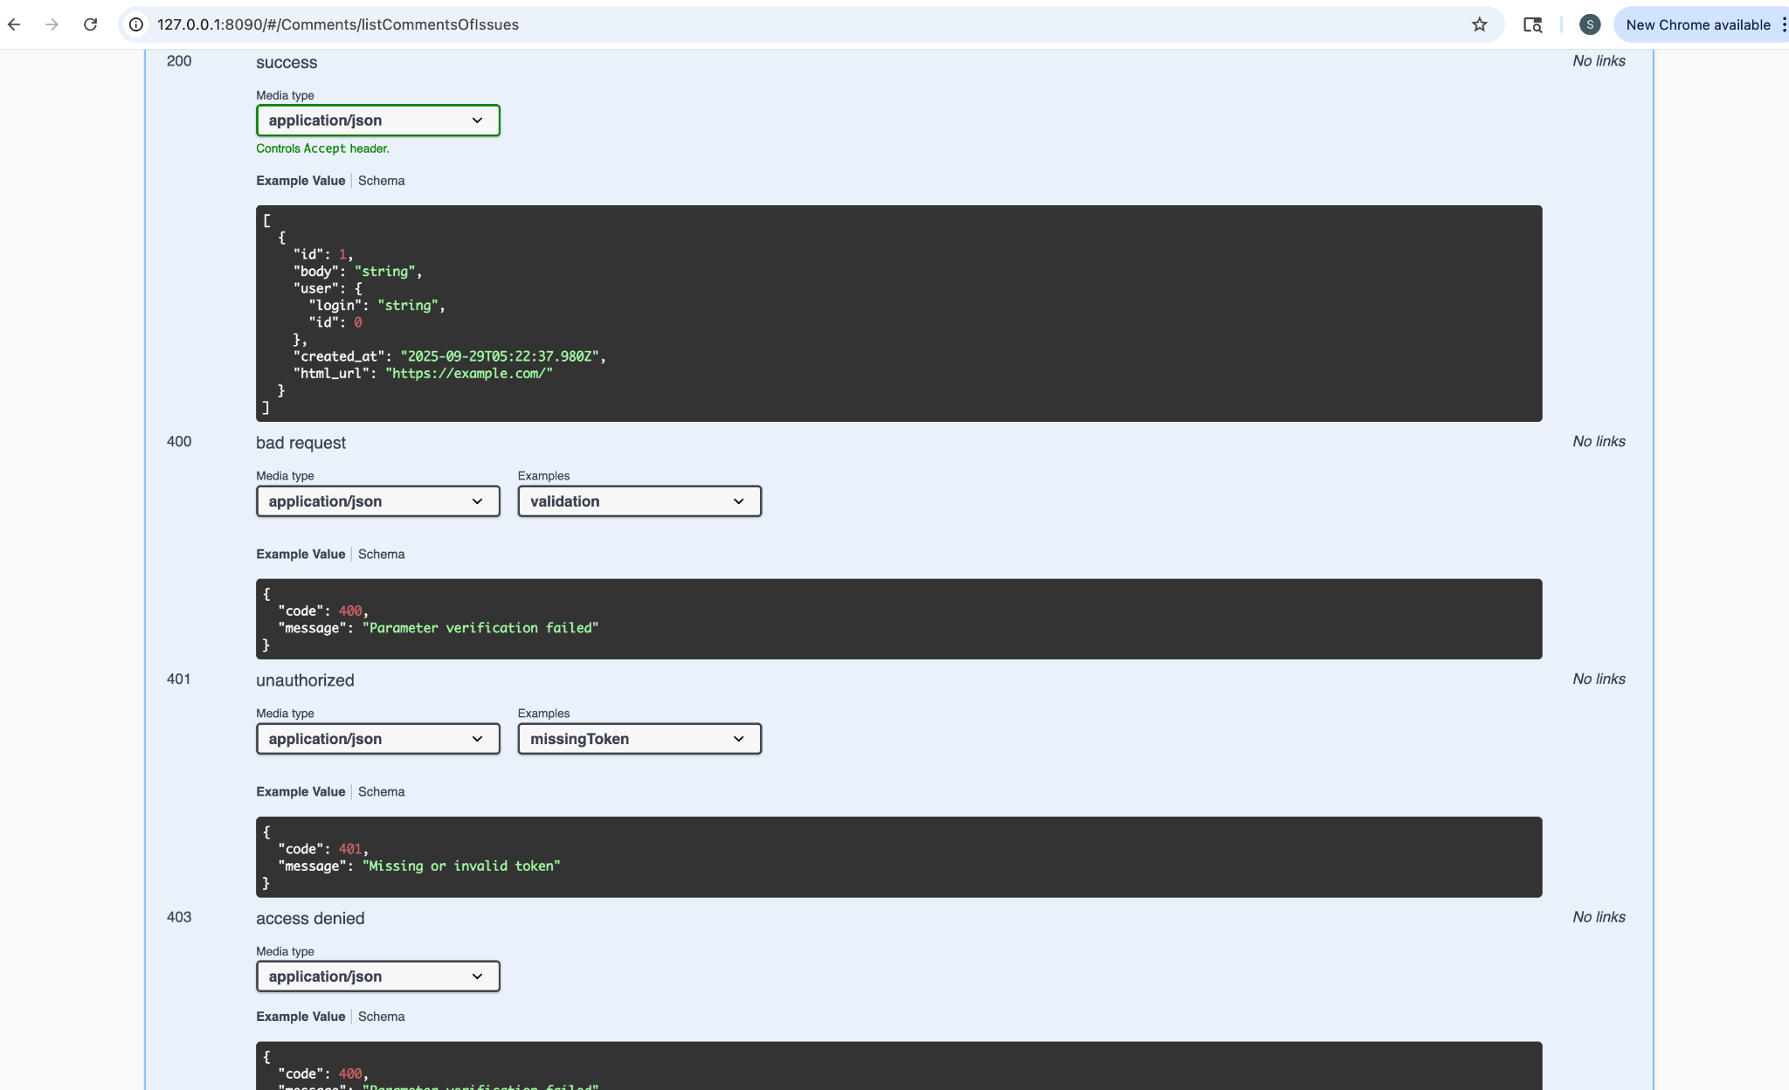

C2b — GET /issues/{number}/comments — response details

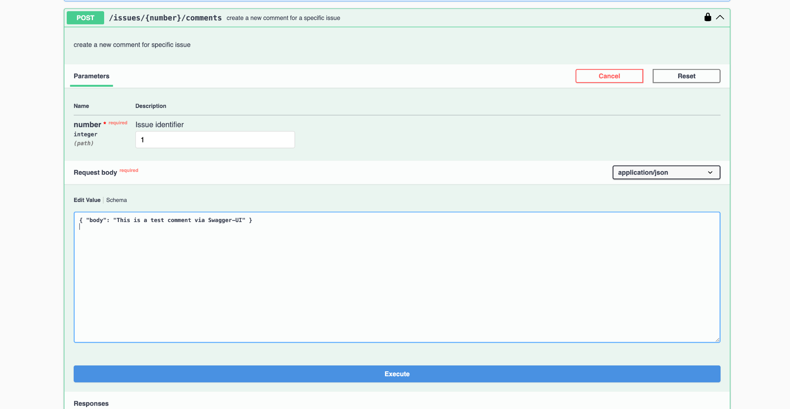

C3 — POST /issues/{number}/comments (filled, before Execute)

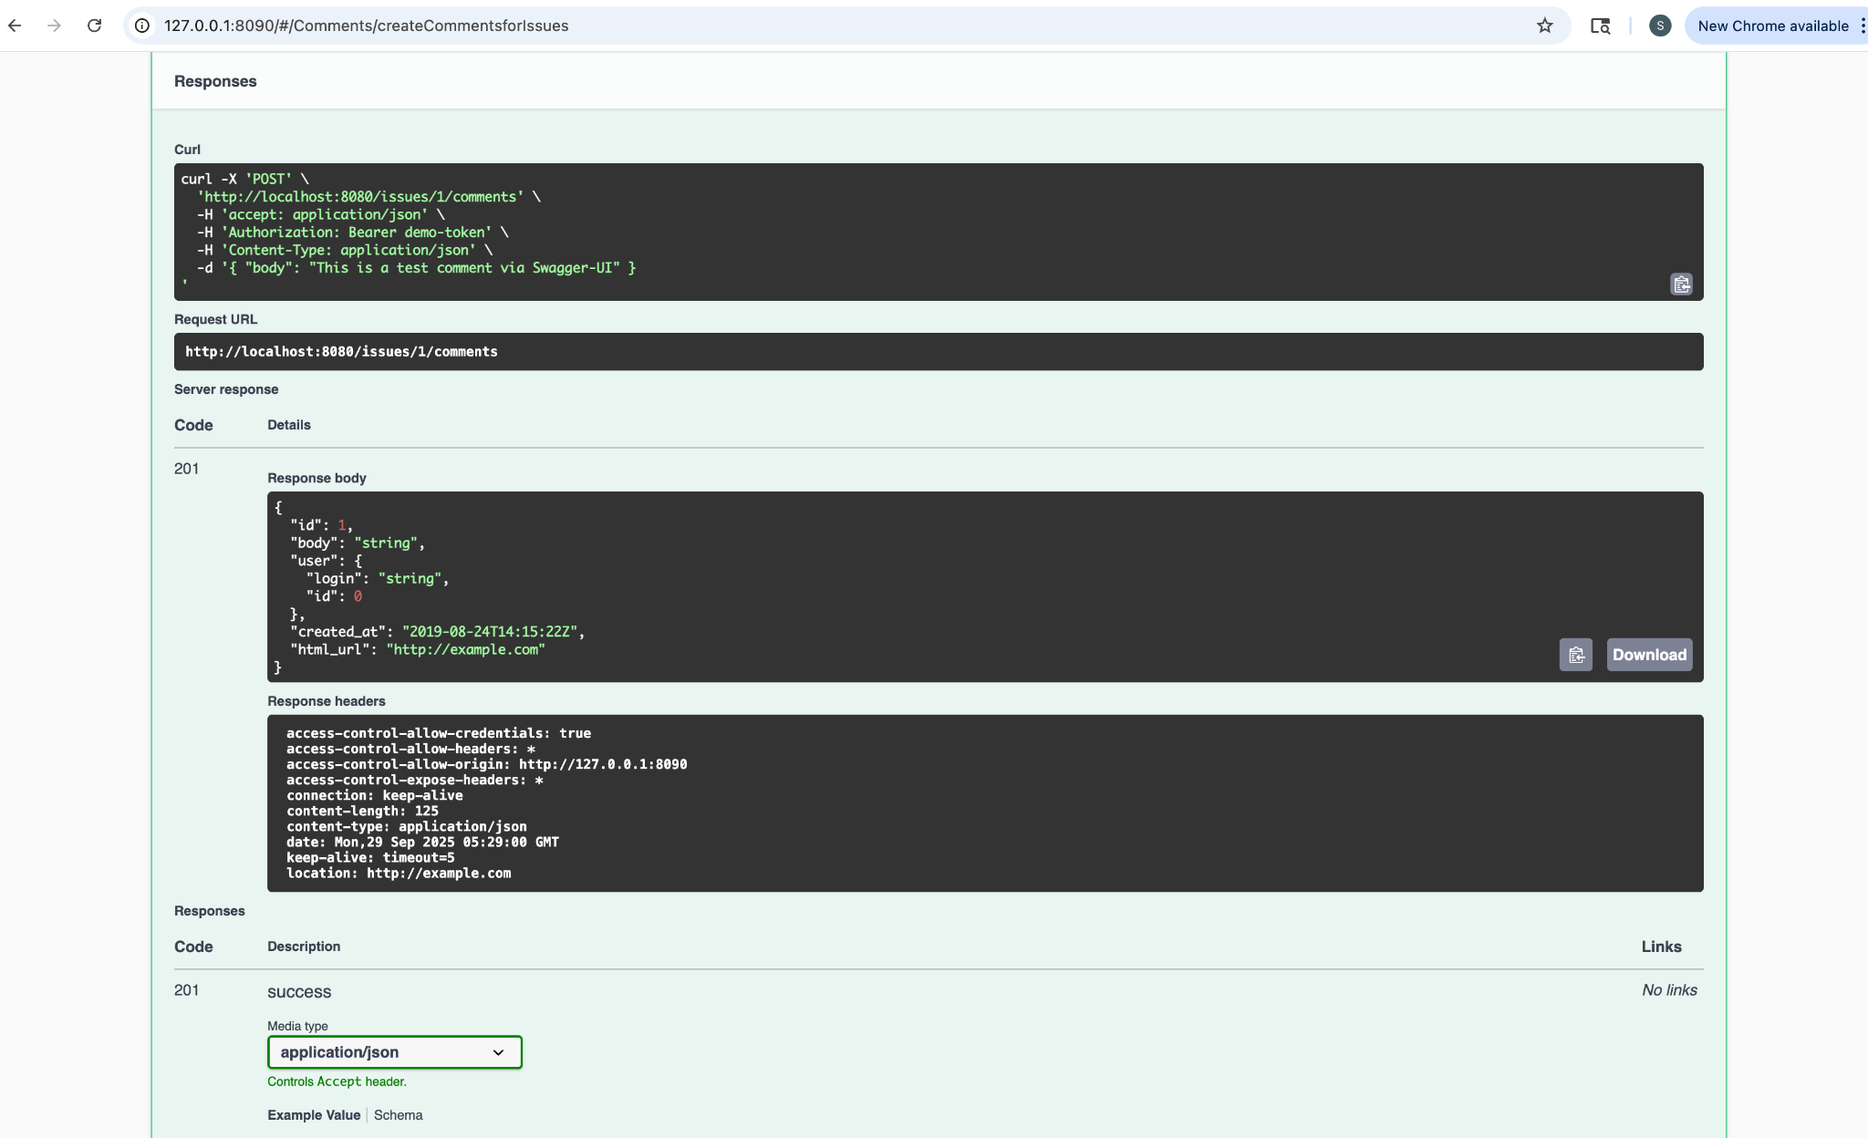

C4 — POST /issues/{number}/comments — 201 Created (response)