# NMFC Leadership + Business Structure (Explained Like You're a Neighbor)

Document authored by Northern Michigan Firewood Company (NMFC). Licensed under CC BY-NC-SA 4.0.

Burn Bright. Stay Free.

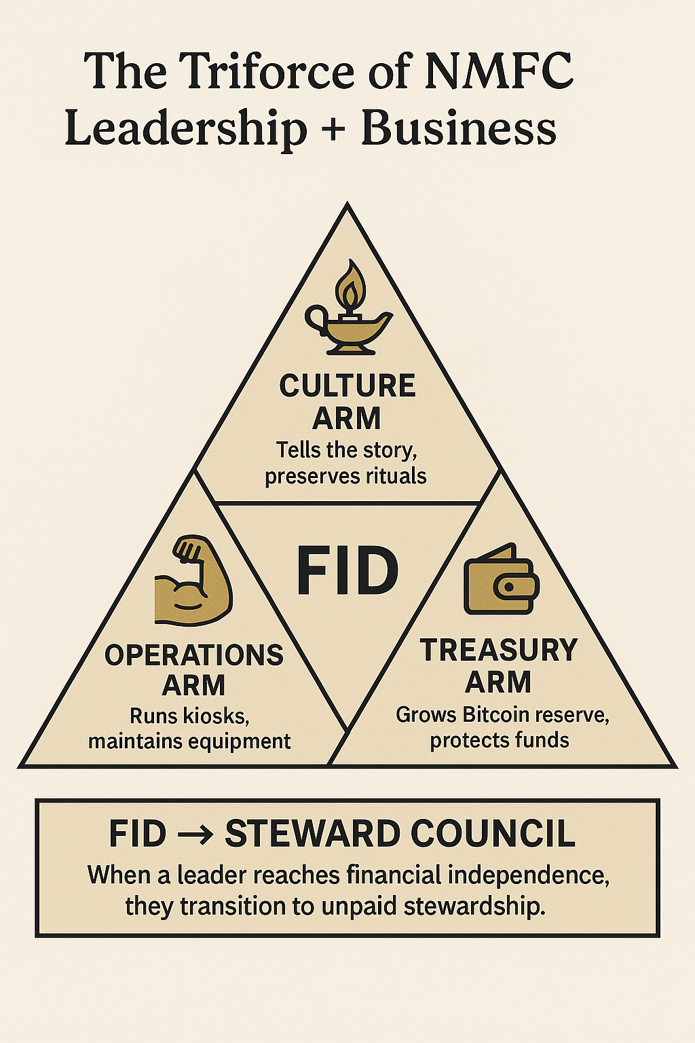

## Imagine NMFC is built like a Triforce—three strong, connected pillars that hold the whole thing up. Here's what each piece does:

* • Operations Arm (Strength): Runs the kiosks, stocks supplies, maintains the gear. Rotating jobs, no burnout.
* • Culture Arm (Wisdom): Keeps the story alive. Murals, rituals, radio, and the Codex. Makes sure we stay us.
* • Treasury Arm (Courage): Grows the BTC reserve, protects bonuses, keeps things sustainable long-term.

## Financial Independence Day (FID) & The Steward Council

* • When a leader hits their BTC goal (enough to safely withdraw $100K/year), they step down from power.
* • They don’t retire rich. They become part of the unpaid Steward Council—watching the mission, not running it.
* • Council members only step in to protect values or handle succession—not for control.

## This Isn’t Just a Business—It’s a Bonfire

* • The business is designed to last 20 years and hand off power.
* • We grow care, not scale. We serve people, not profit.
* • If we’ve done this right, you’ll feel the warmth even if you never buy a single stack of wood.