Core-GeoNetwork – OpenWIS v4 User interface differences
European Dynamics team

Core-GeoNetwork – OpenWIS v4 User interface differences 1
European Dynamics team 1
User views 3
Home 3
Search 4
Map 7
Admin console 8
Metadata and templates 9
Harvesting 14
Statistics and status 14
Standards 16

User views
Home

(Minor context differences)
Core –GeoNetwork:

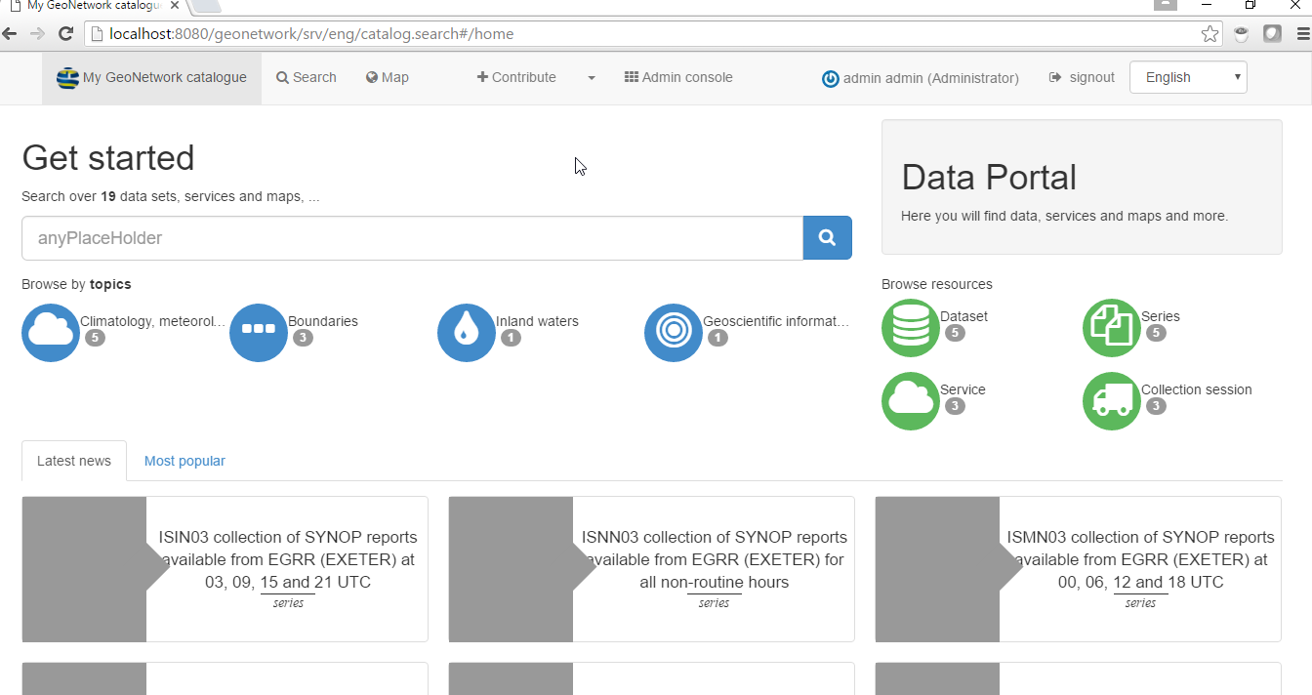

OpenWIS v4:
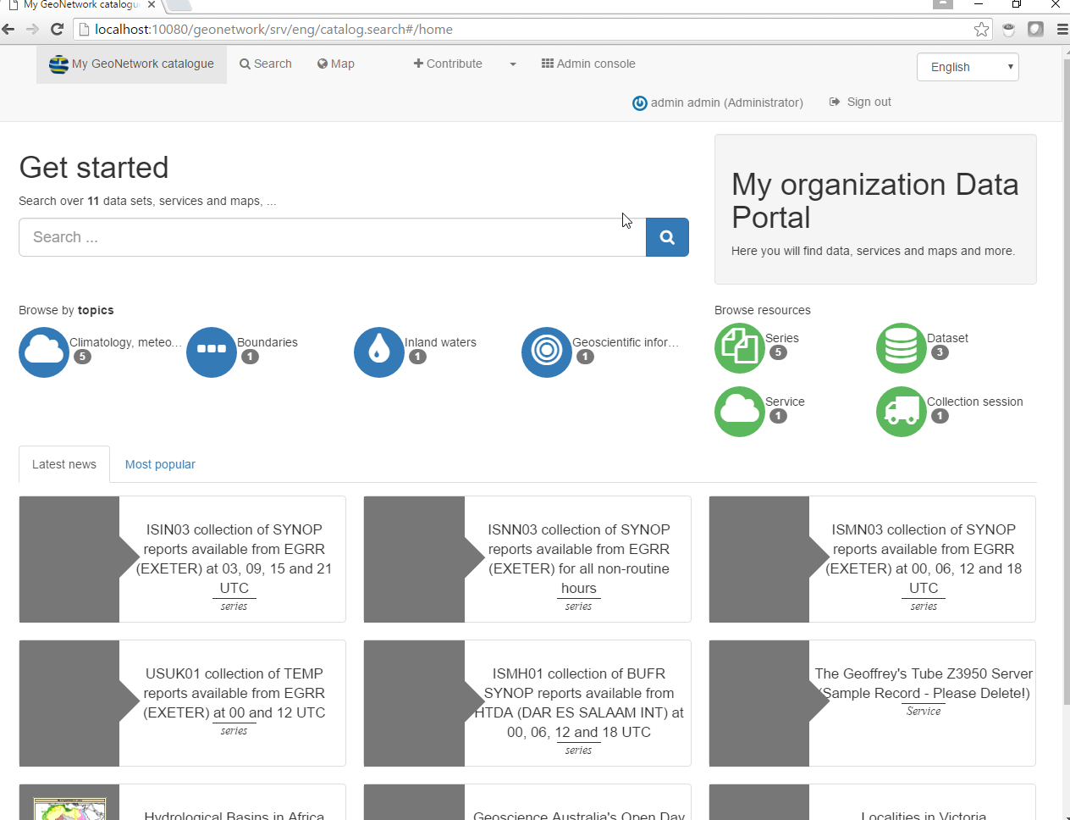

Search

OpenWIS v4 introduces new search options: Edit and subscribe

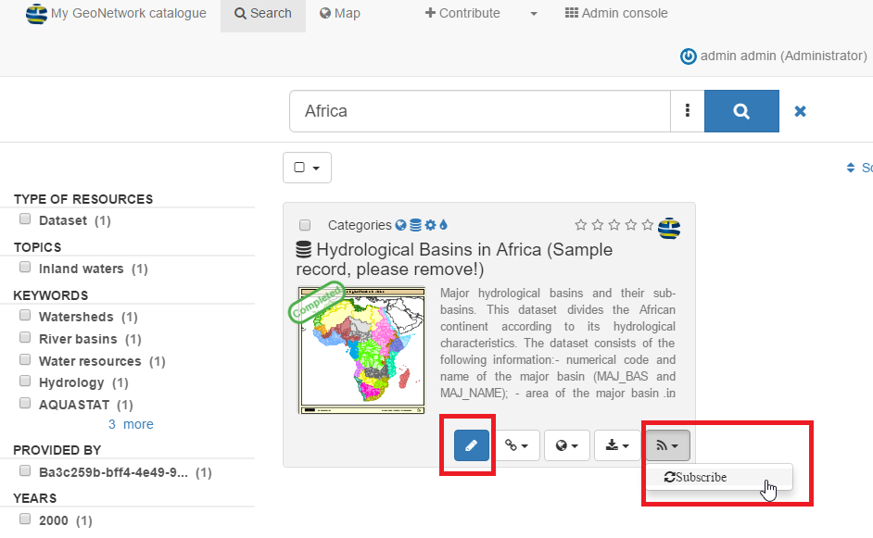

Edit metadata (OpenWIS v4 only)
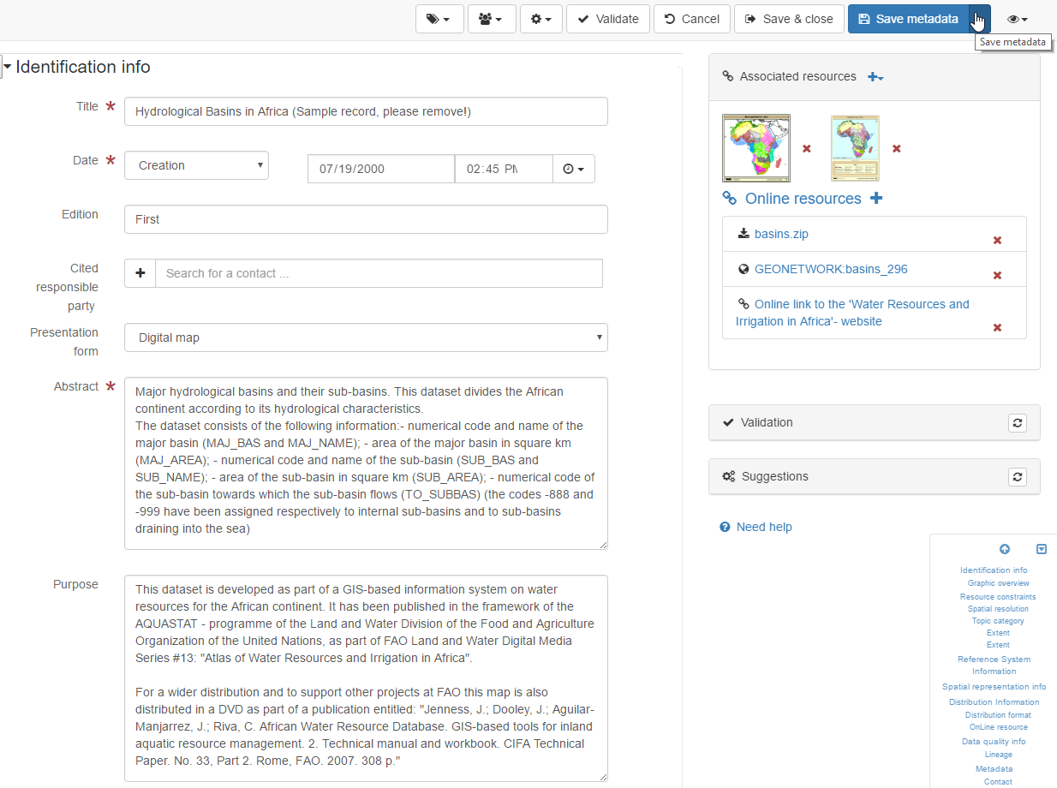
Subscribe request (OpenWIS v4 only)

Option 1

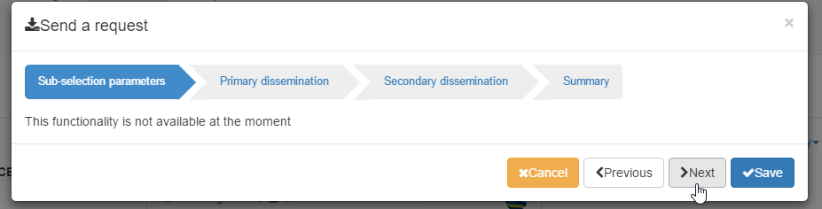

Option 2

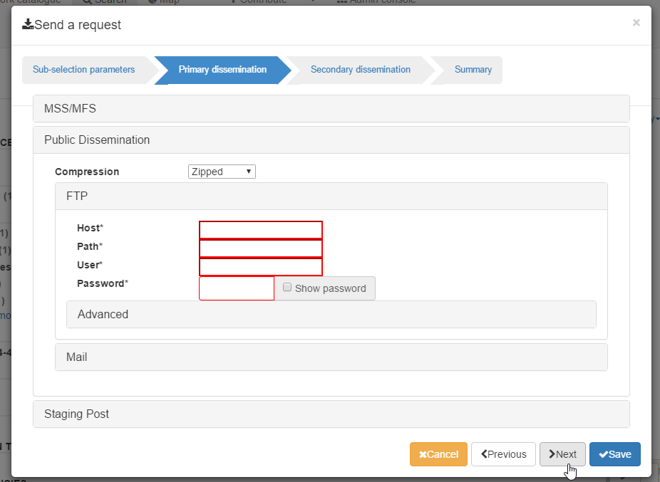

Option 3

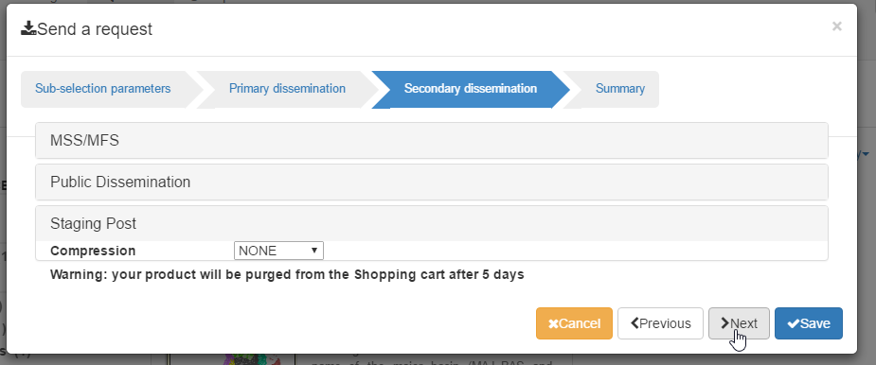

Summary

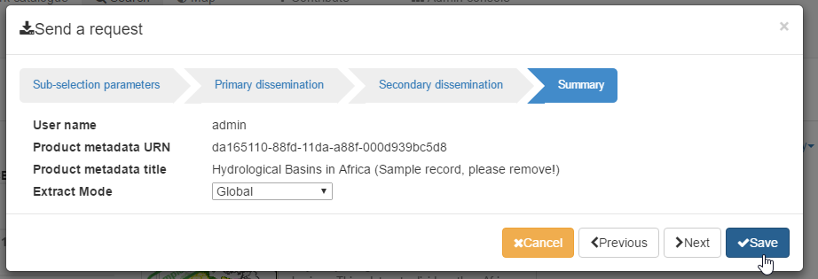

Map

Core-GeoNetwork:
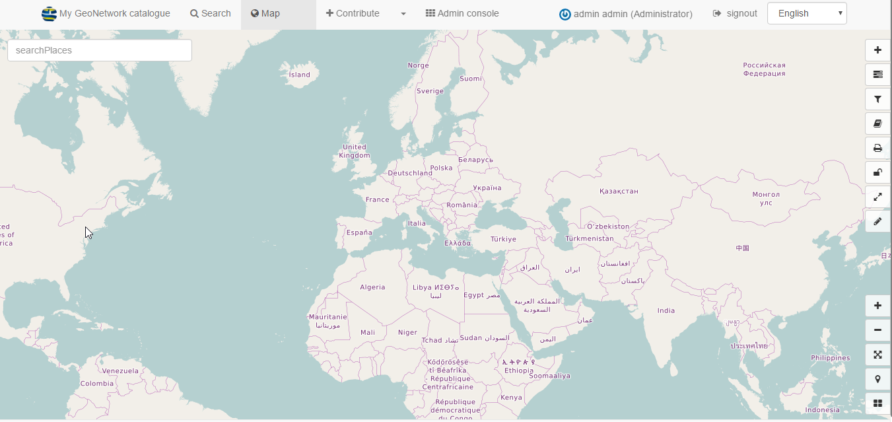

OpenWIS v4:

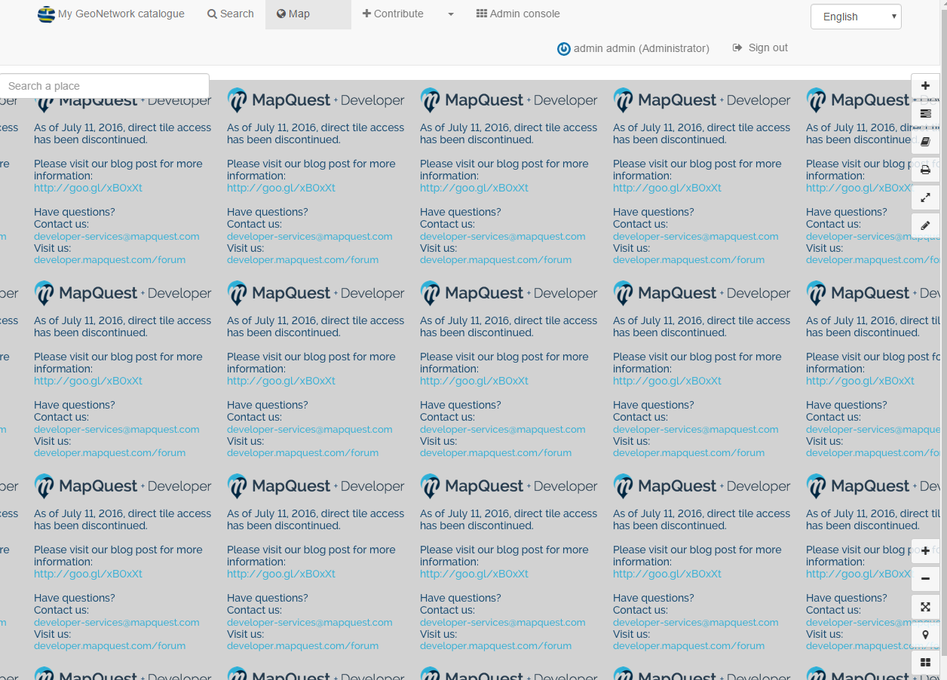

Admin console

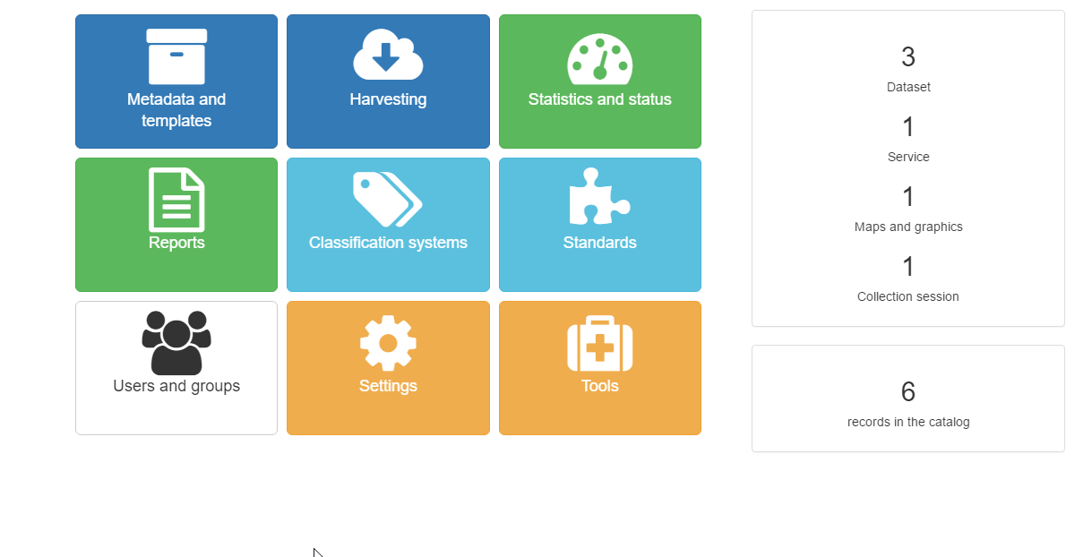

Metadata and templates

Core-GeoNetwork metadata and templates options:

OpenWIS v4 metadata and templates options:
Similar UI metadata & templates:

Core-GeoNetwork :
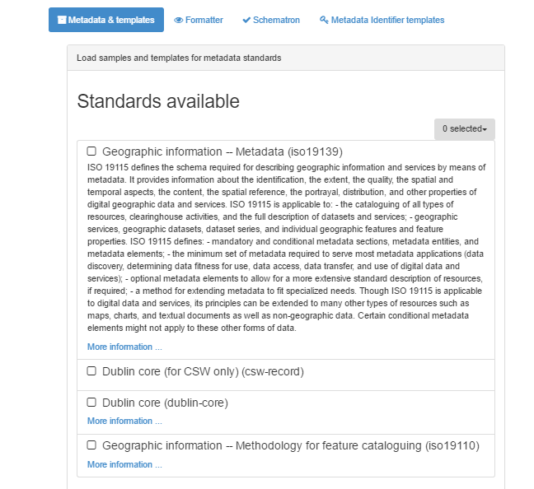

OpenWIS v4:
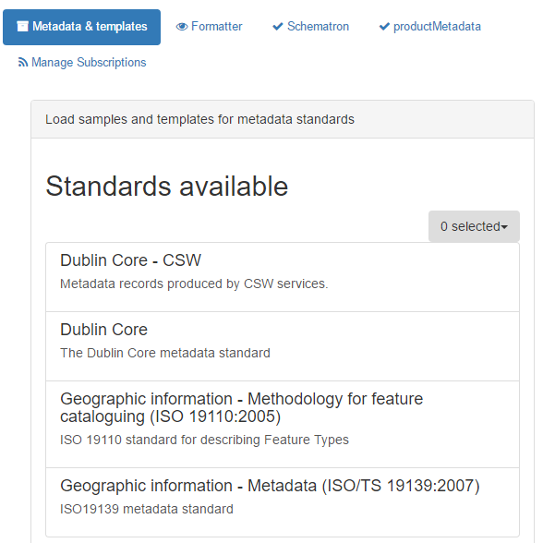

Scheimatron:
Core-GeoNetwork:
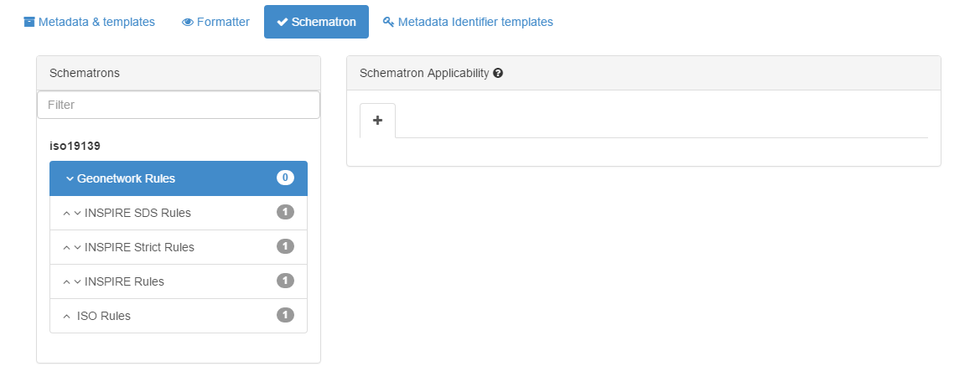
At Sceimatron when user deletes the last record sometimes there is no option to create new one any more (possible Core-GeoNetwork Bug)
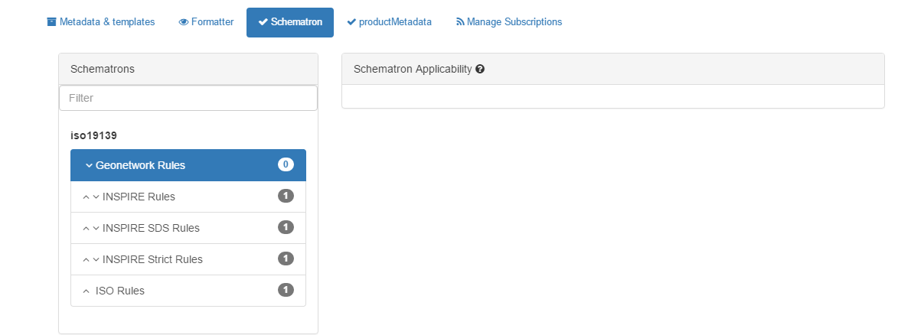
productMetadata (OpenWIS v4 only)

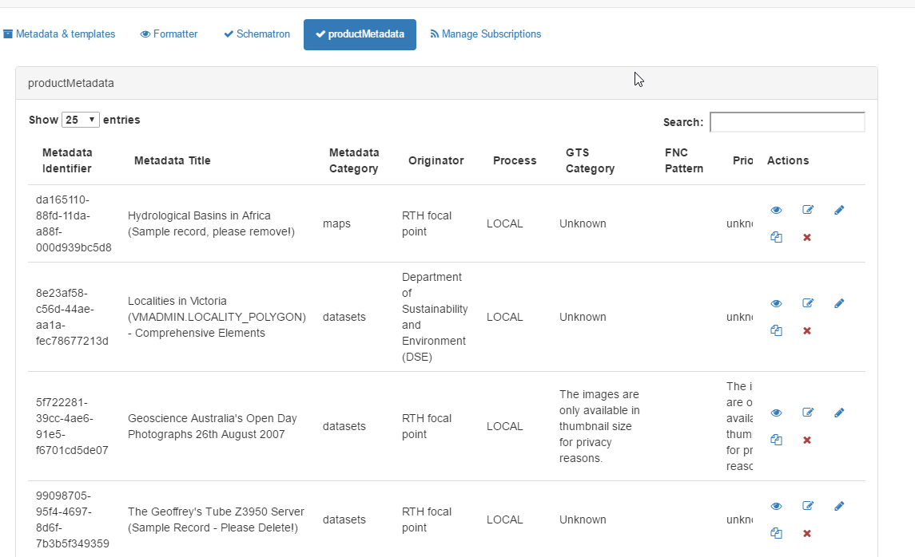


View:
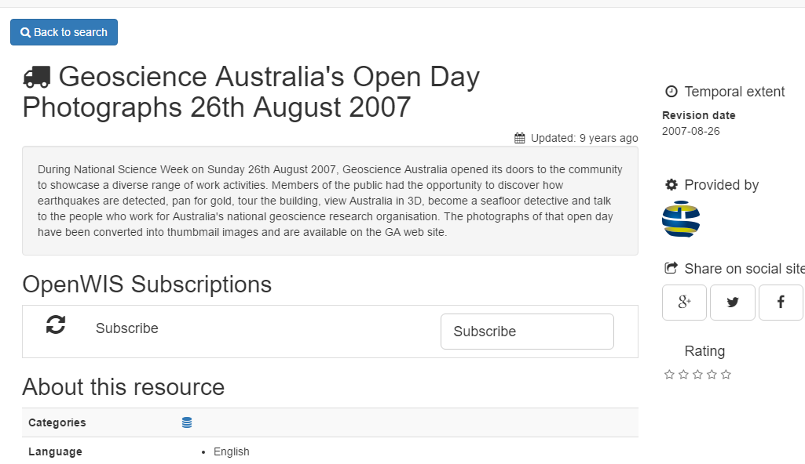
Edit product info:
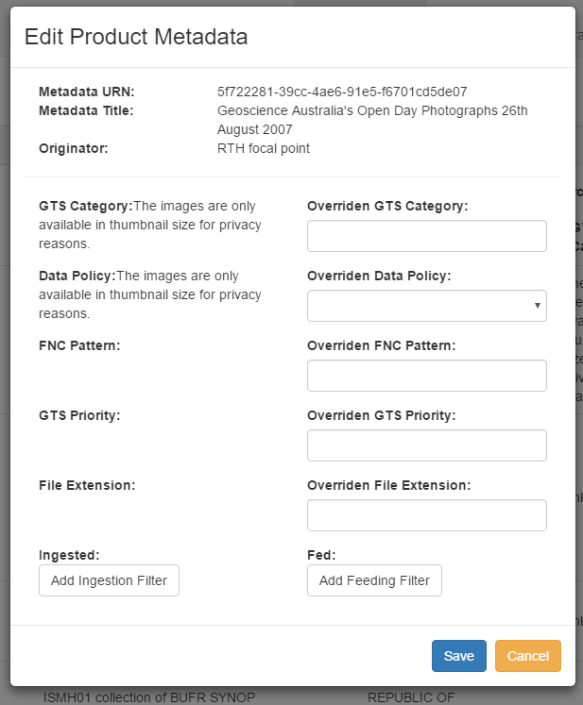

Edit metadata:

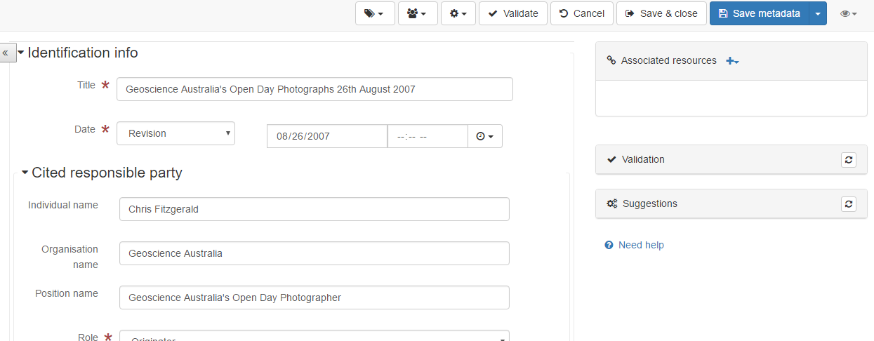

Duplicate:
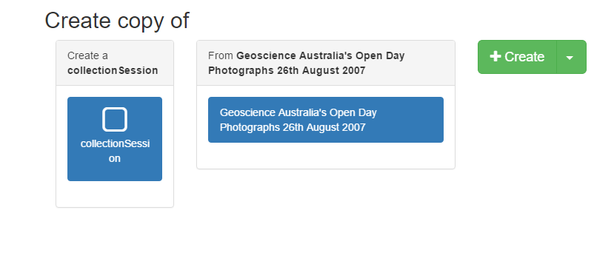
Delete
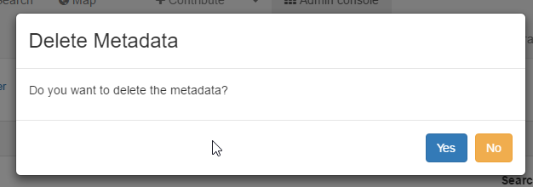

Manage Subscriptions (OpenWIS v4 only)

View- edit -suspend/resume –delete Subscription:
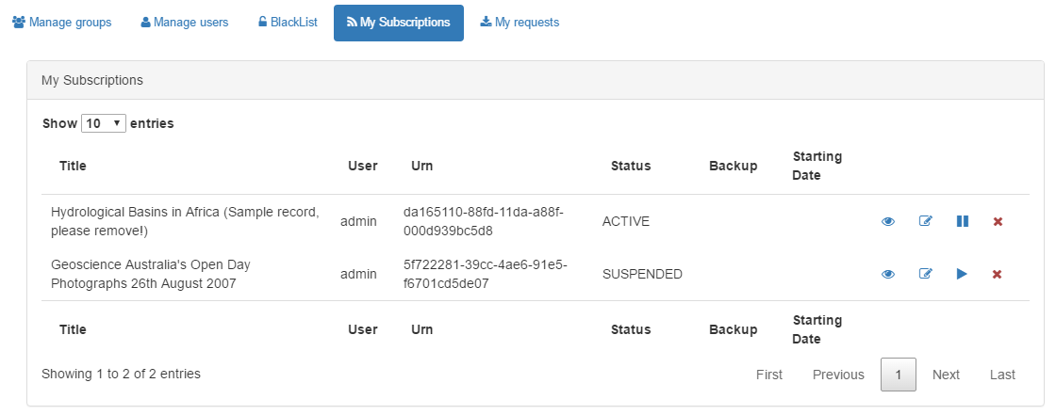

Harvesting
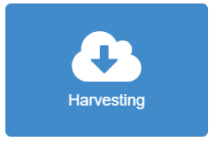

OpenWIS v4 (Additional supports Z2950)
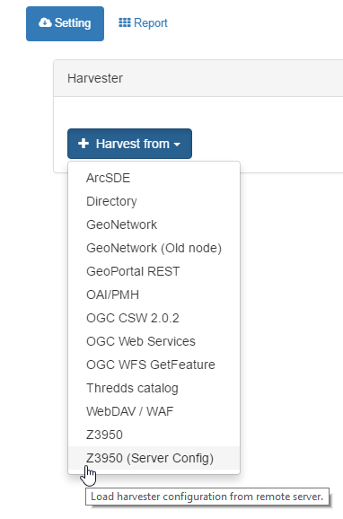

Statistics and status
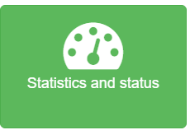

Core-GeoNetwork options:

OpenWIS v4 options:

OpenWIS statistics (only OpenWIS v4)

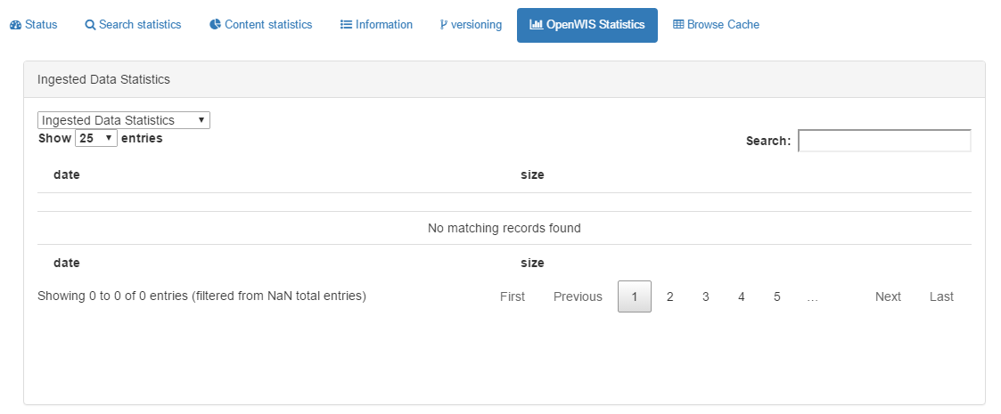

Browse Cache (only OpenWIS v4)

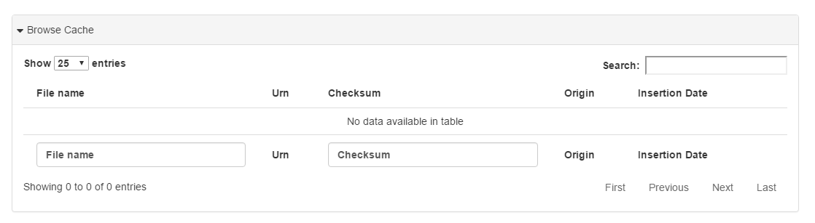

Standards

Core-GeoNetwork:
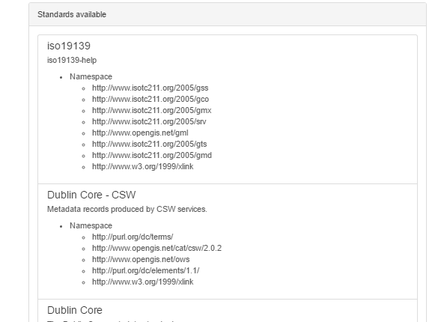

OpenWIS v4 (different UI and Add or update standards new feature)
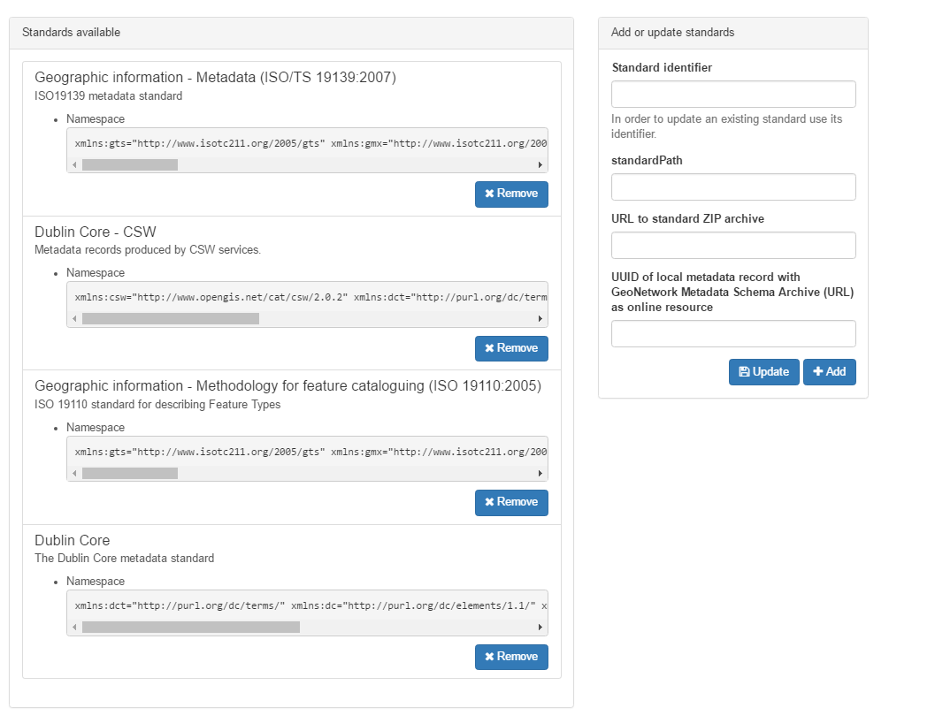



Core-GeoNetwork options:


OpenWIS v4 options:

Blacklist (OpenWIS v4 only)
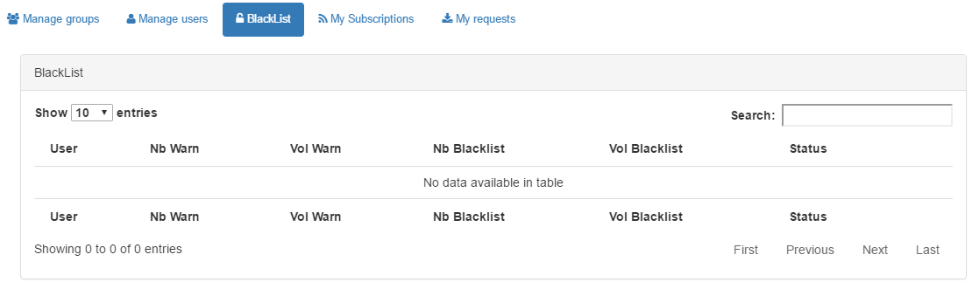

My Subscriptions (OpenWIS v4 only same as above)

View- edit -suspend/resume –delete Subscription:

My requests (OpenWIS v4 only)
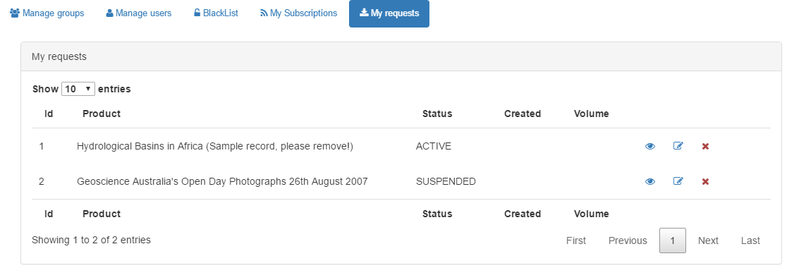



Core-GeoNetwork options:

OpenWIS v4 options:

Metadata identifier templates (OpenWIS v4)

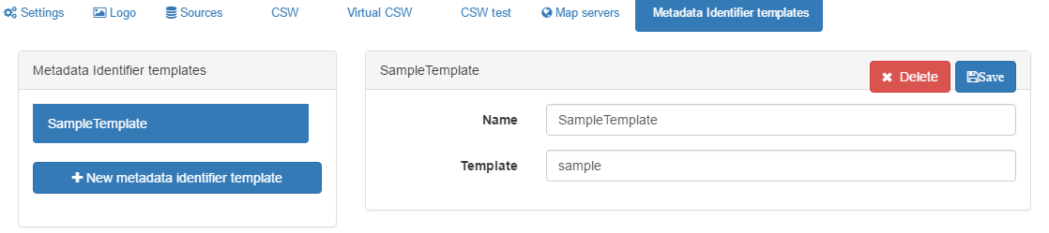



Tools options:

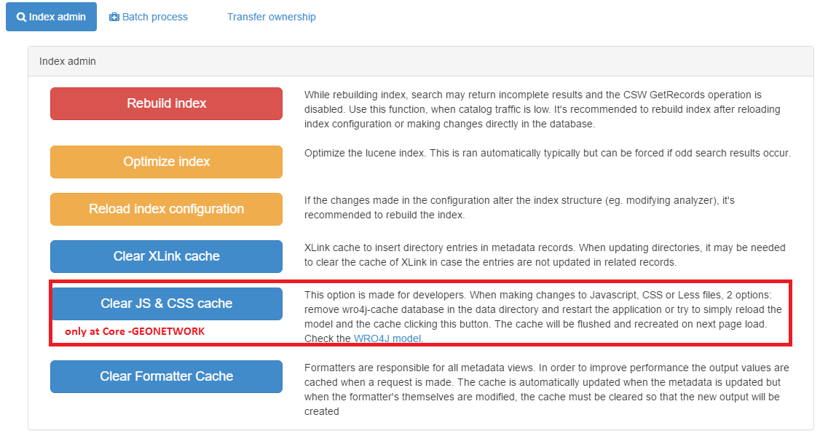

Batch process misc context differences same UI

