LAB 5 Report

Location Data, Maps Implementation

Nafis Mobassher (100587562)

Kabilan Sivagnanasundaram (100591487)

Musadiq Soso (100584158)

**OBJECTIVE:**

The objective in this lab was to learn how to use google maps in android studio and create methods to get the direction between two locations on the map. We did this by using an API key for google maps.

Task:

The first method we created is the initMap() method which initializes the map. The Main Activity just contains a button which directs us to the Map. It also checks google service connectivity and connects the API. The Map Activity is the main part of the Lab. First thing the Map activity does is makes sure to have permission to turn on location by using the getLocationPermission() method. By using this method, it then locates the current device location by using the getDeviceLocation() method which checks if location permission is granted and if it is then the users current location will be shown. The onRequestPermissionResult() method displays the current location of the user. We used the moveCamera() method to be able to move the map using the latitude and longitude of the object. We also used the object addMarker() to add the marker onto the current location. Finally, the method geoLocate() takes the users input which is an address and located the address given.

Using the object addMarker(), the marker is placed. All these methods are called in the onMapReady method which initializess the map if the permission is granted and the onCreate method grants permission

Some problems we faced were that we could not use an API key through UOIT email because it showed us an error telling us to contact admin. The way we fixed it is by using our own personal email opposed the UOIT email.

CONCLUSION:

In conclusion, we learned how to use google maps in android studio. It is easy to understand (even though it takes a while to understand), and it is a very useful tool to know/have when creating android apps using android studio. Google Maps are used in almost every navigation app nowadays which makes it a key point in any app where the user requires a map and with more practice it will become easier to use.

Nafis Mobassher – Did steps 1,2 and 3 on the lab manual

Kabilan Sivagnanasundaram – Did steps 4,5 and helped SoSo with step 6 on the lab manual

Musadiq Soso – Did the report portion and helped with steps 6 and 7 on the lab manual

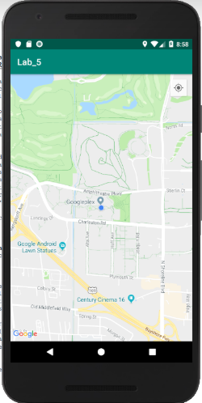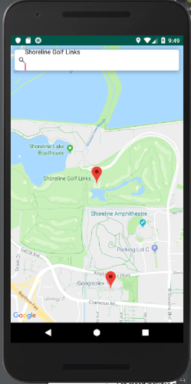

The first picture provides the user with their location while the second picture places a marker on the users current location and on the location searched.