# CS 255 Business Requirements

[Nathalie Morales]

[Nathalie.Morales@snhu.edu]

## System Components and Design

## Purpose

* The objective of this endeavor is to construct a tool in DriverPass that maximizes comprehension with the assistance of online practice tests and on-the-road driving practice in order to fulfill the requirements for passing the driving test.
* Client: DriverPass

Client's System Requirements:

* Opportunity to attend virtual lectures and learning aids.
* Instead of just relying on weekend practices, we will offer personalized in-car training whenever the schedule allows.
* User visibility control both on the web world and the physical world.

### System Background

DriverPass is focused on delivering comprehensive training programs to allow test takers to pass their driving tests, which is the core problem in the market today.

Components Needed:

* Learning online and exam sessions.
* Scheduling meetings for in-car teaching.
* The data could be accessed securely from any location

### Objectives and Goals

Upon completion, the system should:

* Teach the theory through web-based classes and assess your progress with practice tests.
* Enable field learning based on the established schedule with users.
* Secure data both in context and content as well.
* Allow trainees to choose what they would like to be trained.

## Requirements

### Nonfunctional Requirements

#### Performance Requirements

* The system should be integrated into the web platforms.
* System speed: The immediate response time for a great user experience.
* Regular updates: Accordingly, the system should be reformed constantly to keep pace with facts

#### Platform Constraints

* Platforms: Web-based platform reachable from a phone, tablet, or laptop.
* Backend tools: The database is essential to the app`s features

#### Accuracy and Precision

* User distinction: Every user shall be identified by one.
* Input: Capability of data input to be typed in the correct case memory type.
* Problem notification: The system must send the admin a quick call within a few minutes, in case, any error is found

#### Adaptability

* User changes: Drive people to the web-based apps by allowing customers to change their personal information without coding.
* Platform updates: The system should follow the work processes of the platforms that are associated with it.
* IT admin access: System administration is in full control by the administration team for efficient functioning

#### Security

* User login: A secure login procedure must be developed so that the user can authenticate his or her identity.
* Data exchange: Secure communication channels through SSL, TLS, or other types of encryptions.
* Brute force protection: Locking one's account after entering the wrong PIN for times.
* Password recovery: Granting the use of password reset to the users who forgot their passwords.

### Functional Requirements

The system shall:

* Validate user names and passwords when users try to log in.
* Give people the possibility to book a driving course. Listen to the given audio and repeat the given sentence.
* Conduct virtual classes instead. Do a test to measure the progress.
* Log user activity reports and other statistics.
* Show driving course details in To Do list which includes time, instructor name, and car information.
* Follow up with cancellation and/or modification notices about the lessons.

### User Interface

User Interface Needs

* Users: Boss, IT Officer, Secretary, Students.
* Interface Needs:
  + Boss: Harmonize reports, and update invoices.
  + IT Officer: Manage systems, configure email notifications, and reset passwords.
  + Secretary: Schedule the dates, and client info going in.
  + Students: Attend classes and see your placement as well as the past lessons under your profile information.
  + Interface Interaction: Web-based interface that would allow anyone to easily access it from any smart device

### Assumptions

* End-users possess the rudimentary computer knowledge.
* Stability of internet connection in terms of online access.
* Regulation and Compliance with DMV Laws and Regulations.
* Either availability of a reasonable share of resources for development of the systems

### Limitations

* Developmental time for system development.
* Necessity of a division into chapters. In this phase, the line art designer shall be in charge of the budget management for the additional features.
* In the first launch, the product might not come with all functionalities.

### Gantt Chart

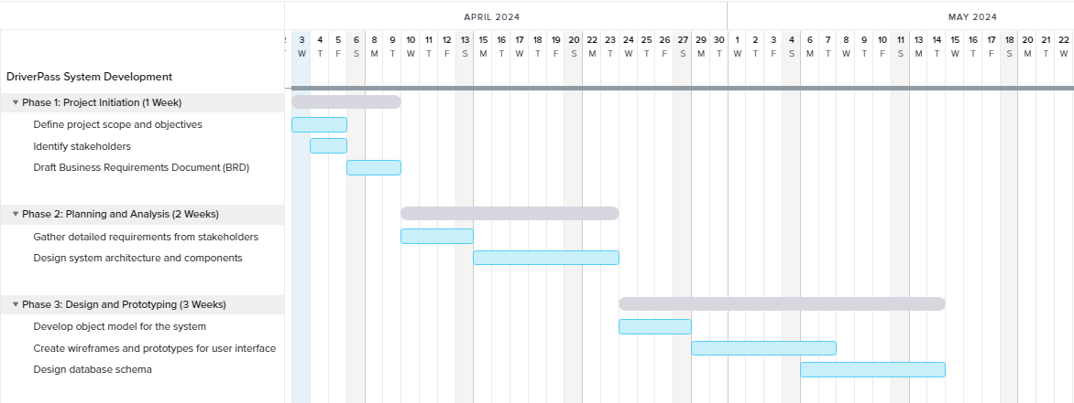

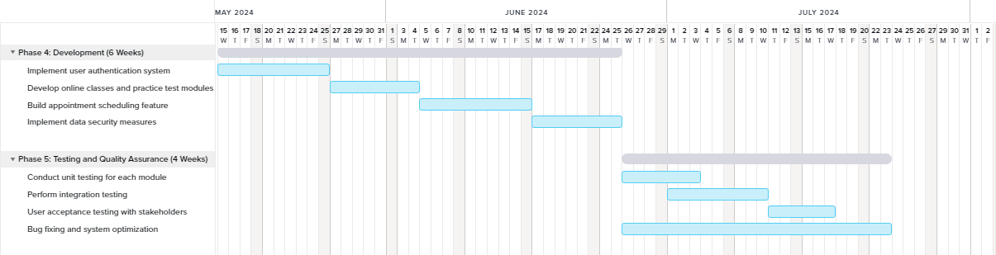

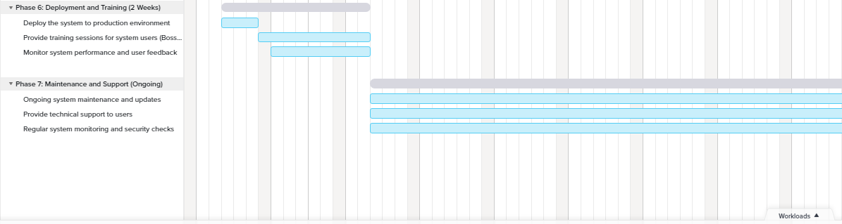

# Appendix

## Gantt Chart Description

**Phase 1: Project Initiation (1 Week)**

* **Tasks:**
  + Define project scope and objectives
  + Identify stakeholders
  + Draft Business Requirements Document (BRD)
* **Duration:** 1 week
* **Start Date:** April 3, 2024
* **End Date:** April 9, 2024

**Phase 2: Planning and Analysis (2 Weeks)**

* **Tasks:**
  + Gather detailed requirements from stakeholders
  + Design system architecture and components
* **Duration:** 2 weeks
* **Start Date:** April 10, 2024
* **End Date:** April 23, 2024

**Phase 3: Design and Prototyping (3 Weeks)**

* **Tasks:**
  + Develop object model for the system
  + Create wireframes and prototypes for user interface
  + Design database schema
* **Duration:** 3 weeks
* **Start Date:** April 24, 2024
* **End Date:** May 14, 2024

**Phase 4: Development (6 Weeks)**

* **Tasks:**
  + Implement user authentication system
  + Develop online classes and practice test modules
  + Build appointment scheduling feature
  + Implement data security measures
* **Duration:** 6 weeks
* **Start Date:** May 15, 2024
* **End Date:** June 25, 2024

**Phase 5: Testing and Quality Assurance (4 Weeks)**

* **Tasks:**
  + Conduct unit testing for each module
  + Perform integration testing
  + User acceptance testing with stakeholders
  + Bug fixing and system optimization
* **Duration:** 4 weeks
* **Start Date:** June 26, 2024
* **End Date:** July 23, 2024

**Phase 6: Deployment and Training (2 Weeks)**

* **Tasks:**
  + Deploy the system to production environment
  + Provide training sessions for system users (Boss, IT Officer, Secretary, Students)
  + Monitor system performance and user feedback
* **Duration:** 2 weeks
* **Start Date:** July 24, 2024
* **End Date:** August 6, 2024

**Phase 7: Maintenance and Support (Ongoing)**

* **Tasks:**
  + Ongoing system maintenance and updates
  + Provide technical support to users
  + Regular system monitoring and security checks
* **Duration:** Ongoing
* **Start Date:** August 7, 2024 (and ongoing)