WEB DEVELOPMENT (INTRODUCTION)
Module Code: WEDE5020
WEBSITE PROJECT PROPOSAL
Part 1 — Building the Foundation: Project Initiation and Planning
Chosen Organisation: Pharoah Group (Luxury Vehicle Dealership)
Full Name: [Insert Your Full Name]
Student Number: [Insert Your Student Number]
Group: [Insert Group, if applicable]
Lecturer: [Insert Lecturer's Name]
Date: 2026

Table of Contents

1. Organisation Overview
Name: Pharoah Group

Brief History
Pharoah Group is a luxury and performance vehicle dealership based in Sandton, Johannesburg, with a satellite showroom in Cape Town. Founded in 2014 by a team of automotive enthusiasts, the dealership has grown from a single showroom into a multi-brand facility representing marques such as Bentley, Rolls-Royce, Lamborghini, Aston Martin, and Porsche. Over the past decade, Pharoah Group has built a reputation among South Africa's high-net-worth community for sourcing rare, limited-edition, and bespoke vehicles, backed by a concierge service that includes import assistance, detailing, and after-sales maintenance.

Mission Statement
To deliver an unrivalled ownership experience for discerning clients by combining access to the world's most prestigious vehicle brands with white-glove personal service.

Vision Statement
To become the most trusted and sought-after name in luxury and exotic vehicle sales across Southern Africa.

Target Audience
High-net-worth individuals aged 35–65, business executives, entrepreneurs, and private collectors, located primarily in Gauteng and the Western Cape, as well as a growing segment of international buyers looking to import vehicles into South Africa.

2. Website Goals and Objectives

Goals
- Establish a premium, trustworthy online presence that reflects the brand's exclusivity and heritage.
- Showcase current vehicle stock through an accessible, filterable online inventory.
- Generate qualified leads through test-drive bookings, valuation requests, and sales enquiries.
- Provide clear information on financing, trade-ins, and after-sales services.
- Support the sales team by pre-qualifying serious buyers before they visit the showroom.

Key Performance Indicators (KPIs)
- Increase enquiry form submissions by at least 20% within the first 6 months of launch.
- Achieve an average session duration of 2+ minutes on vehicle detail pages.
- Reduce the homepage bounce rate to below 45%.
- Grow organic search traffic for branded and vehicle-model search terms by 25% within 12 months.

3. Current Website Analysis
Pharoah Group currently operates a basic, template-based website that has not been substantially updated in several years. The analysis below identifies its strengths and weaknesses to inform the redesign.

Strengths
- An established domain name and basic brand identity (logo, colour references) already exist.
- An existing library of vehicle photography that can be reused and repurposed.

Weaknesses
- The site is not mobile responsive, despite a large proportion of visitors browsing on smartphones.
- Inventory is presented as static images with no searchable or filterable detail pages.
- There is no clear enquiry or contact pathway, resulting in lost leads.
- Slow page load times and poor on-page SEO are harming search visibility.
- Inconsistent typography and colour use undermine the dealership's premium positioning.

Areas for Improvement
- Rebuild the site on a responsive, mobile-first HTML/CSS foundation.
- Introduce a structured, filterable vehicle catalogue with individual detail pages.
- Redesign the visual identity to align with the brand's luxury positioning.
- Add clear calls to action and a streamlined enquiry process.
- Optimise images, code structure, and metadata for search engines and page speed.

4. Proposed Website Features and Functionality
- Homepage: hero banner/slideshow of the latest arrivals, a brief brand introduction, clear navigation, and prominent calls to action.
- About Us: dealership history, mission and vision statements, team profiles, and brand partnerships.
- Inventory/Services: a filterable listing of current stock by make, price, and body type, linking through to individual vehicle detail pages.
- Enquiry: a form for sales enquiries, vehicle valuation/trade-in requests, and finance pre-approval, with conditional fields depending on enquiry type.
- Contact: showroom addresses (Sandton and Cape Town), embedded maps for both locations, operating hours, and a general contact form.
- Responsive design that adapts cleanly across desktop, tablet, and mobile devices.
- Newsletter sign-up for new stock alerts and exclusive previews.

5. Design and User Experience

Colour Scheme
Deep matte black and charcoal will form the primary palette, accented with a metallic gold/champagne tone and set against an off-white background. This combination is widely used in luxury automotive branding to convey exclusivity, heritage, and sophistication.

Typography
A refined serif typeface (e.g., Playfair Display) will be used for headings to convey elegance, paired with a clean, highly legible sans-serif (e.g., Lato or Montserrat) for body text.

Layout and Design
A minimalist, image-led layout with generous white space, full-width hero imagery, and a grid-based vehicle catalogue. Navigation will remain fixed and unobtrusive so that vehicle imagery stays the visual focus.

User Experience Considerations
- Simple, shallow navigation — no more than two clicks from the homepage to any vehicle listing.
- Fast-loading, compressed high-resolution imagery to balance visual quality with performance.
- A mobile-first responsive layout, tested across common breakpoints.
- A consistent visual hierarchy that guides users toward enquiry and contact actions.

Low-Fidelity Wireframes
The wireframes below visualise the layout and information hierarchy for the homepage and a representative interior page (the inventory listing).
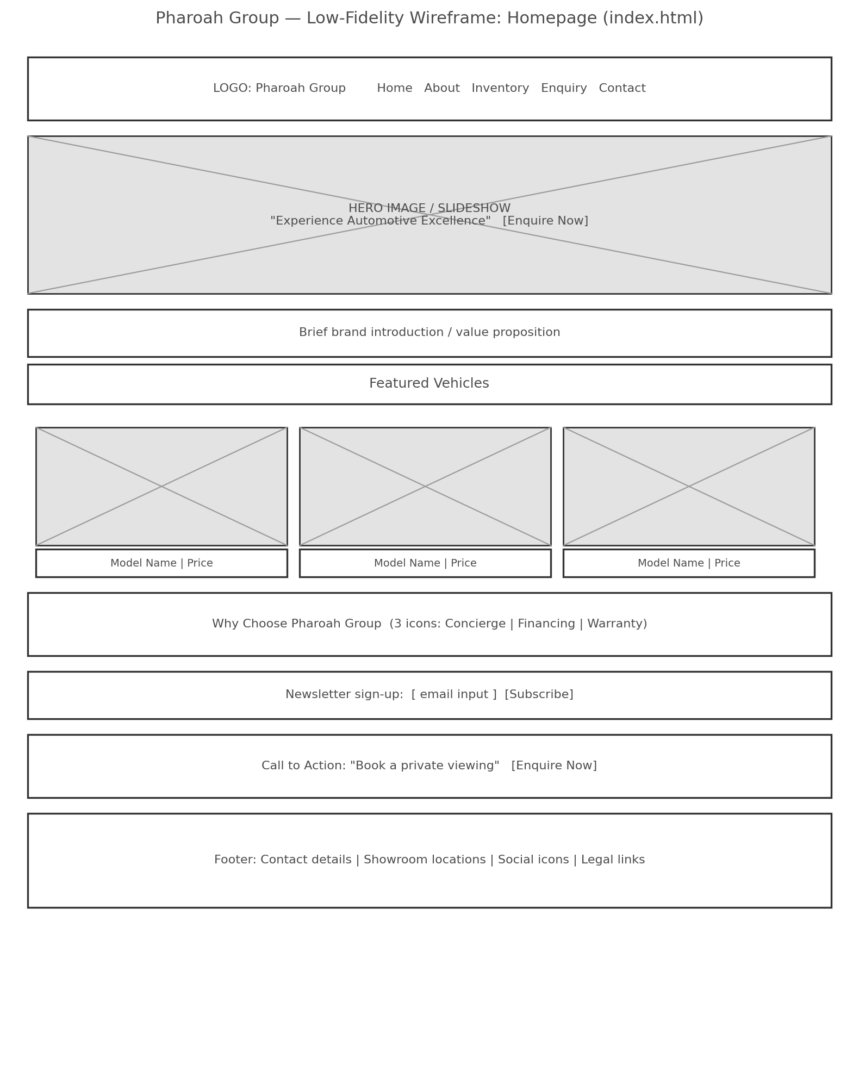
Figure 1: Low-fidelity wireframe — Homepage (index.html)
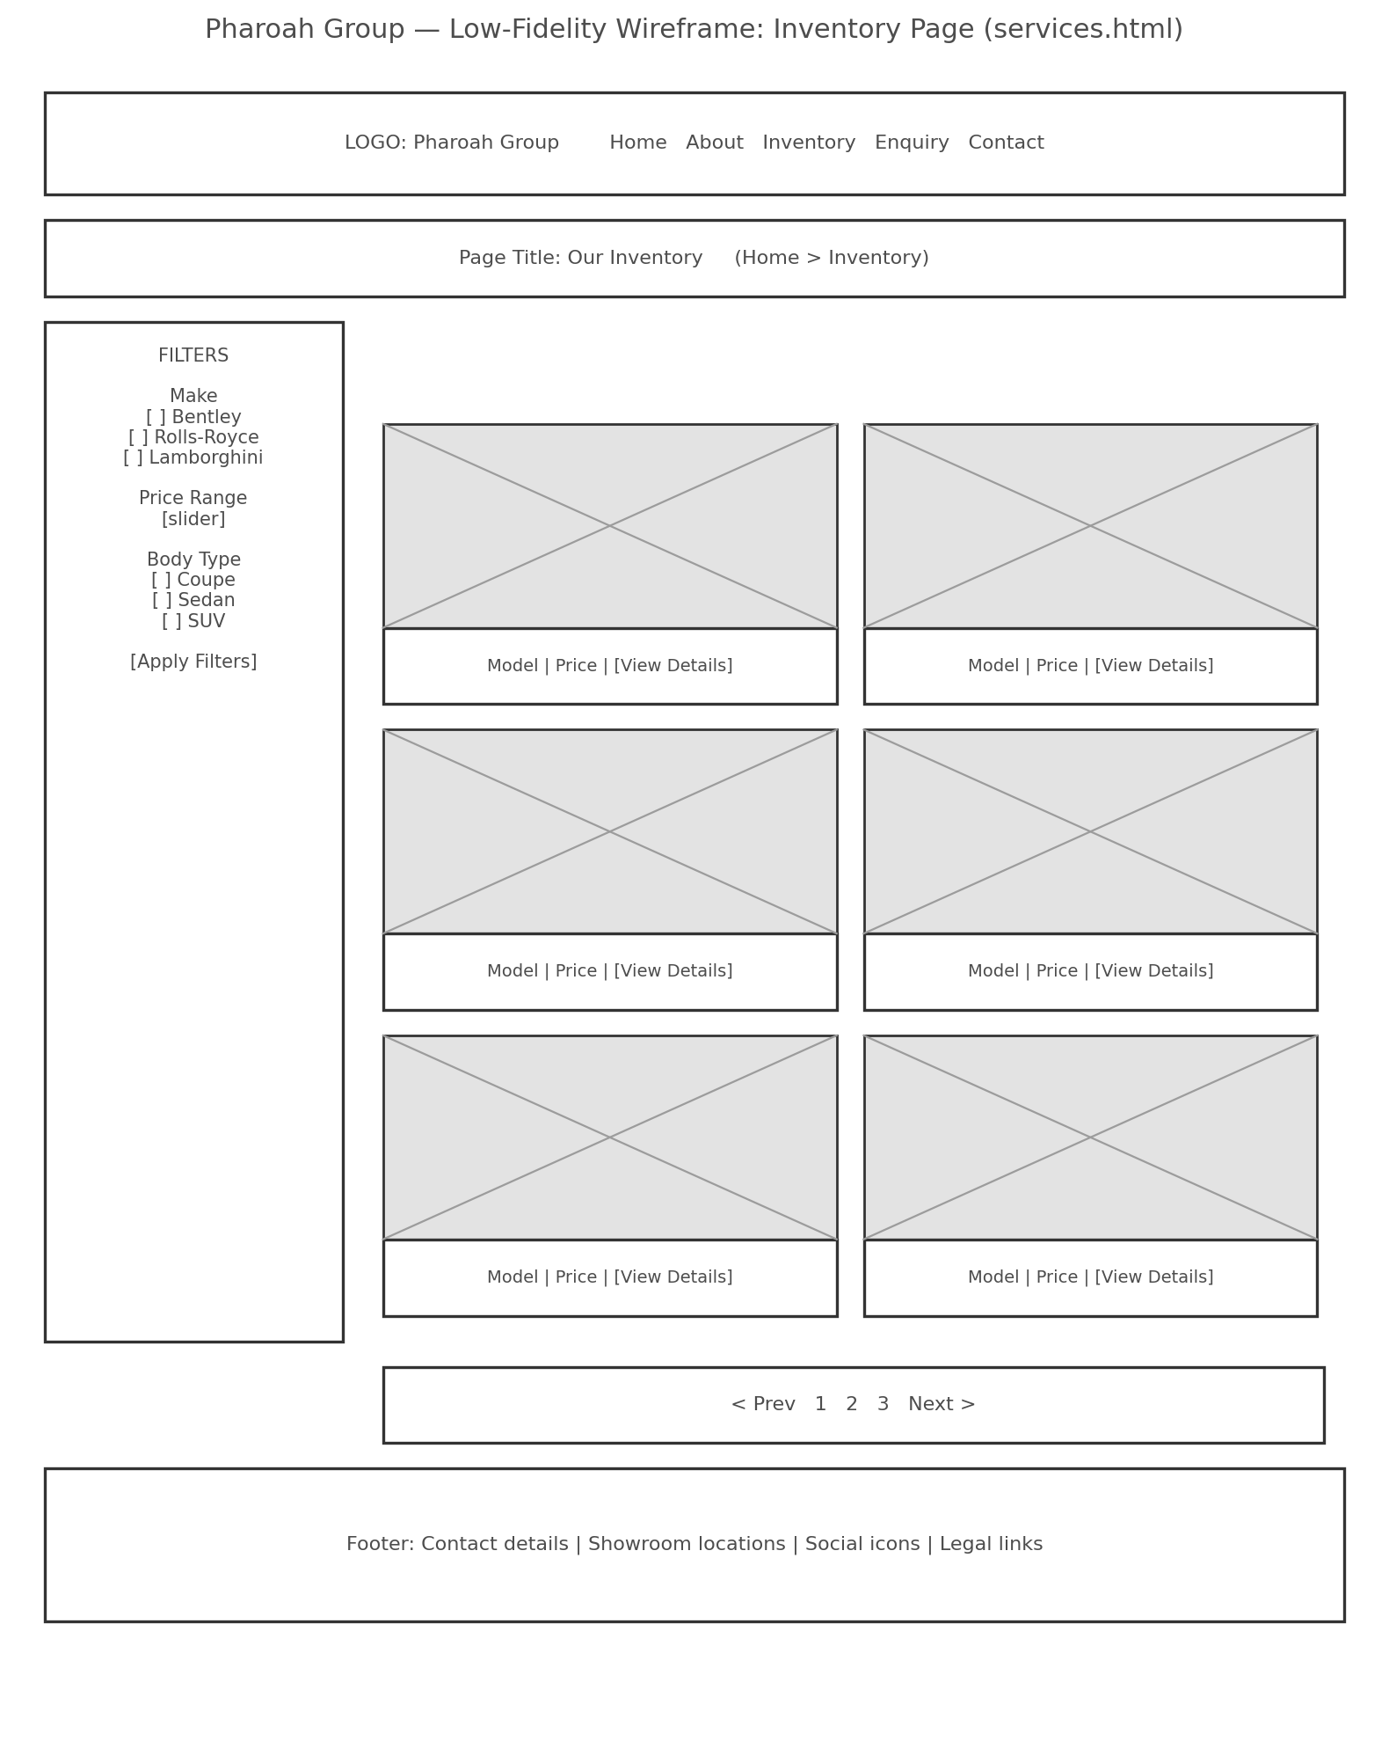
Figure 2: Low-fidelity wireframe — Inventory page (services.html)

6. Technical Requirements

Hosting and Domain
A locally hosted South African hosting plan (e.g., Afrihost, Hetzner, or HOST AFRICA) is proposed, paired with a .co.za domain (pharaohgroup.co.za). Local hosting improves latency for South African visitors and .co.za domains receive a measurable preference in South African search results. An SSL certificate will be included to secure the enquiry and contact forms.

Programming Languages and Frameworks
For Part 1 of this project, the website will be built using:
- HTML5 — for the semantic page structure of each web page.
- CSS3 — for styling, using Flexbox/Grid for responsive layout (Part 2).
- JavaScript — for navigation behaviour and interactive functionality such as the inventory filters (Part 3).
This mirrors the module's three-part structure: Part 1 establishes the HTML foundation, Part 2 introduces advanced CSS styling, and Part 3 adds JavaScript functionality to produce a fully responsive, SEO-optimised website.

7. Timeline and Milestones
The timeline below sets out a realistic 12-week schedule with key milestones aligned to the three-part submission structure of this module. Exact calendar dates should be adjusted to match the official dates published on the LMS.
Phase | Activities | Timeframe
Planning & Proposal | Organisation research; two project proposals drafted and submitted for lecturer approval. | Week 1
Content Research & Sourcing | Gather/organise content, images and assets; set up file and folder structure and GitHub repository. | Week 2
Website Structure & Planning | Create the sitemap; plan navigation and page hierarchy. | Week 2 – 3
HTML Foundation (Part 1) | Build HTML structure for all 5 pages; integrate content; build navigation; test across browsers. | Week 3 – 4
Part 1 Submission | Submit Website Project Proposal, researched content, HTML files, and GitHub repository link. | Week 4 (Part 1 due date)
CSS Styling (Part 2) | Apply advanced CSS styling, responsive layout, and design aesthetic to all pages. | Week 5 – 7
Part 2 Submission | Submit styled, responsive website with updated documentation. | Week 8 (Part 2 due date)
JavaScript Functionality (Part 3) | Add interactivity (e.g., filters, form validation); final testing, debugging, and SEO optimisation. | Week 9 – 11
Part 3 Submission | Final submission of the fully functional, responsive, SEO-optimised website. | Week 12 (Part 3 due date)

8. Budget
The budget below estimates development, hosting, and maintenance costs for the Pharoah Group website, based on current South African market research for domain registration, local hosting, custom website design, and ongoing maintenance.
Item | Description | Estimated Cost (ZAR)
.co.za Domain Registration | pharaohgroup.co.za — annual registration via a ZACR-accredited registrar | R 150 / year
Web Hosting | Local South African business hosting plan (shared/managed) including SSL | R 200 / month (R 2,400 / year)
SSL Certificate | Secures enquiry and contact forms (often bundled with hosting) | R 0 – R 300 / year
Website Design & Development | Custom-designed 5-page brochure-style website (Parts 1–3 scope) | R 25,000 once-off
Photography & Licensing | Supplementary professional/stock imagery for vehicles and branding | R 1,500 once-off
Ongoing Maintenance & Updates | Content updates, security patches, stock listing updates | R 1,200 / month (R 14,400 / year)
Estimated Total (Year 1) | Domain + hosting + SSL + development + photography + maintenance | R 43,750

Note: figures reflect typical 2026 South African market ranges for a custom-designed, 5-page business website with local hosting. Actual costs may vary depending on the final choice of hosting provider and developer/agency.

9. Website Sitemap
The sitemap below is a visual representation of the proposed website's structure, showing the main pages and their hierarchical relationship to the homepage. A minimum of five web pages will be created, as required.
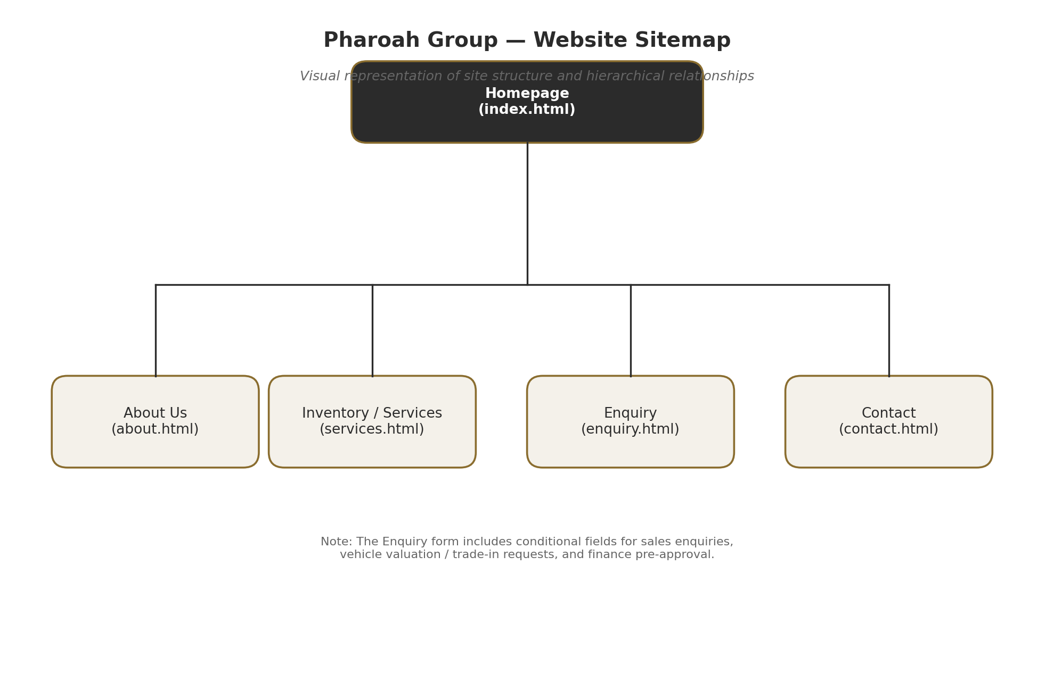
Figure 3: Pharoah Group website sitemap

Common Page Structure
- Homepage (index.html): hero image, brief introduction, call to action, navigation menu.
- About Us (about.html): organisation's history, mission, vision, and team members.
- Inventory/Services (services.html): detailed information about vehicles for sale.
- Enquiry (enquiry.html): form for sales, valuation/trade-in, and finance enquiries.
- Contact (contact.html): contact information, maps for more than one location, and a contact form.

10. References
References below follow the Harvard referencing style and relate to the research used to inform the budget and technical requirements sections of this proposal. General references for Part 1 as a whole will also be compiled in the README.md file in the GitHub repository.
CJX Studios (2026) Website Registration Cost in South Africa. Available at: https://cjxstudio.co.za/website-registration-cost-south-africa-2026.html (Accessed: 10 August 2026).
HOSTAFRICA (2026) How much does a website cost in South Africa? Available at: https://hostafrica.co.za/blog/websites/website-basics/how-much-does-a-website-cost-in-south-africa/ (Accessed: 10 August 2026).
Owl Media (2026) How Much Does a Website Cost in South Africa? (2026 Pricing Guide). Available at: https://owlmedia.co.za/how-much-does-a-website-cost-in-south-africa-2026-pricing-guide/ (Accessed: 10 August 2026).
Syniq Solutions (2026) How Much Does a Website Cost in South Africa? (2026 Price Guide). Available at: https://www.syniqsolutions.co.za/blog/how-much-does-a-website-cost-south-africa (Accessed: 10 August 2026).
Wired Web Services (2026) How Much Does a Website Cost in 2026? Available at: https://wiredwebservices.co.za/how-much-does-a-website-cost-in-2026/ (Accessed: 10 August 2026).
YCIK Digital (2026) How Much Does a Website Cost in South Africa? — 2026 Pricing Guide. Available at: https://ycik.co.za/blog/how-much-does-a-website-cost-in-south-africa-2026-pricing-guide/ (Accessed: 10 August 2026).

