Some images after processing the data using a Rolling average algorithm and Sample Standard Deviation.

Iterating through the data, I check a number of values before and after the current point, calculate the average and then calculate the standard deviation, using this I compare the current points standard deviation with the previous and check if its above a certain threshold, if it is it gets removed. The data is then written to a CSV file and compared against the original data.

Multiple passes can also be performed to ensure that the removed points didn’t alter the remaining points standard deviations.

Here are some of the results with different threshold values, multiple. Blue being the original data, and orange being the filtered dataset.

Original Dataset.

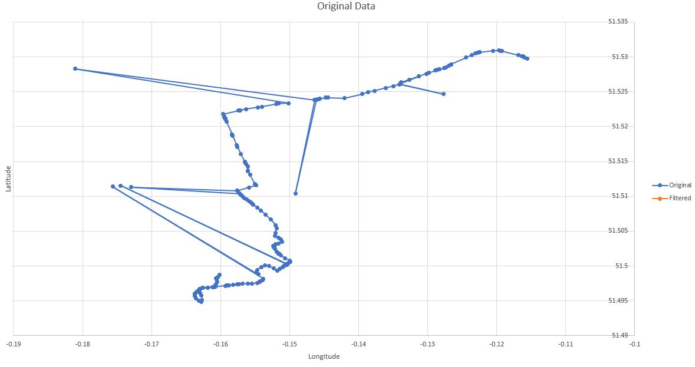

With a relatively large threshold of 0.005, you can see some points are incorrect.

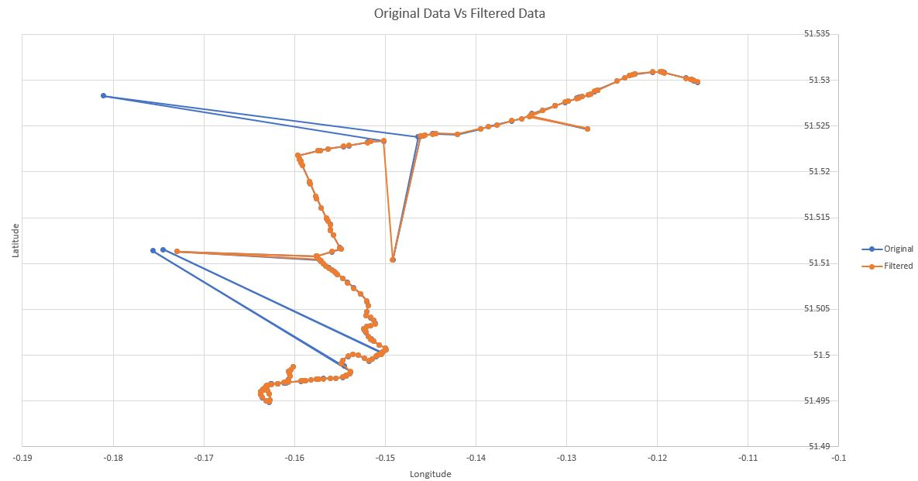

Using a threshold of 0.001, can see compared to 0.005 a number of points are now excluded.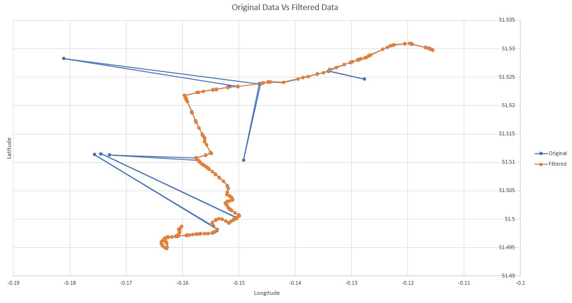

Using a threshold of 0.001 with multiple passes, a number of points are removed but visual identical to the graph above.

