|  |  |  |
| --- | --- | --- |
|  |  | |
| Student Name: NNAMDI OBINNA OSUAGWU | Matriculation Number: 1013007 | |
| Supervisor: Dr. MARK ZARB | Second Marker: INES ARANA | |
| Course: ITBI | | |
| Project Title: Development of a Continuing Professional Development (CPD) App | | |
| Project Investigation [CMM512]  X  MSc Project [CMM013]  (Tick as appropriate) | Start Date: 13th June 2021 | |
| Submission Date: 22ND June 2021 | |
| **CONSENT**  X  I agree  I do not agree  That the University shall be entitled to use any results, materials, or other outcomes arising from my project work for the purposes of non-commercial teaching and research, including collaboration.  **DECLARATION**  **I confirm:**   * **That the work contained in this document has been composed solely by myself and that I have not made use of any unauthorised assistance.** * **That the work has not been accepted in any previous application for a degree.** * **All sources of information have been specifically acknowledged and all verbatim extracts are distinguished by quotation marks.** | | |
| Student Signature: Nnamdi. O | | Date Signed: 29/06/2021 |

|  |
| --- |
| **MSc Computing:**  **Information Technology With Business Intelligence** |



MSc Project Investigation Report

**Development of a CPD Application**

A report submitted as part of the requirements for the degree of

MSc in Computing: Information Technology With Business Intelligence at

Robert Gordon University, Aberdeen, Scotland

# Declaration

I hereby declare that this MSc project investigation and research entitled “**DEVELOPMENT OF A CPD APPLICATION**” submitted as part of the requirement for the Award of an **MSC IN COMPUTING** is my original work to the best of my knowledge and has not been accepted in any previous application for a degree. All sources of Information and authors have all been given credit and acknowledgment, including citations, quotation marks, and references.

29/06/2021

Nnamdi. O

Signed ............................................................... Date....................................

# Acknowledgment

I would like to express gratitude towards my supervisor Dr. Mark Zarb who guided me to ensure I was doing the right thing. He also pointed me in the right direction and always very helpful when I needed insights. I would also like to thank my brother Uzoma Osuagwu for acting as a perfect critic and proof-reader to ensure I was really on point. Dr. Moira Bailey and Professor Heather Fulford were very supportive and very well explained every troubling question concerning the project.

# Abstract

In the past 8 years, students at Aberdeen Business School, Robert Gordon University have been utilizing a Continuing Professional Development (CPD) system that has a paper-based postcard functionality. These students are either enrolled in a part-time or full-time degree program. This report gives a clear picture and statement that RGU designed this system to help students to build, maintain competence, and also keep their professional development. The CPD system enables students to maintain lifelong continuous skills, profession, and career upgrades by recording and reflecting on their experience in both a formal and informal learning environment.

This project focuses on building software that encourages students in RGU to reflect what they learn during the process of their professional development both in school(classroom), online classes, self-study, collaboration with the team, workplace, seminars, training, and other forms of learning in all professions. In the past CPD applications have been utilized by the Medical Profession and Health practice. For this CPD app, we are targeting multiple management professionals using the two-sided postcard format introduced by Fulford and Bailey.

The CPD system is a tried and tested concept. RGU Business school students are given two-sided post-cards by their module coordinator during their industrial attachment program. On one side of the postcard, students record their work experience based on the 4 types of learning which are explained in chapter 1 of this report. On the other side of the postcard is to reflect on their experience.

This report describes other reasons why maintaining CPD’s important. To provide RGU students with better interaction using the postcard format current system, a software application is a better solution knowing that students are better at utilizing their mobile phones, computer, and Laptops than keeping paper logs. This project develops software called a CPD application as new technology to be relevant for students throughout their professional life and practice.

The software to be developed from this investigation incorporates the element of the current system with a User Interface that performs the same recording and reflection of the triggers (Event, Enactment, Encounter, and Experience) designed in the paper postcard format. JavaScript is the programming language to be used for the development with Visual Studio Code IDE as the integrated Development Environment.

# Table of Contents

Declaration 4

Acknowledgment 5

Abstract 6

Table of Contents 7

Table of figures 9

List of Tables 10

1. INTRODUCTION 11

1.1 Chapter Summary 12

1.2 Background 13

1.2.1 Reflective CPD in RGU 13

1.2.2 Aims 15

1.2.3 Objectives 15

2 LITERATURE REVIEW 16

2.1   What is CPD? 16

2.2   The Relevance of CPD 16

2.2.1 Analysis 18

2.2.2 Conclusions 20

2.3 Research on Reflective Learning System 21

2.4 Background Research on Postcards for Reflective learning 22

2.4.1 Existing Concept 22

2.5 Models for Reflective Learning 23

2.5.1 Boud’s triangular representation 23

2.5.2 Atkins and Murphy cyclical model 24

2.5.3 Gibbs’ reflective cycle model 25

2.5.4 Hilsdon’s Critical thinking model 26

2.6 Reason for Hilsdon’s Reflective Model 26

2.7 Digital Tools for Reflective Practice 27

2.7.1 Alternative Digital Documents, Note-taking apps for Recording and Reflecting 28

2.7.2 Strength of the note-taking app. 29

2.7.3 Weakness of the note-taking app. 29

2.7.4 Comparison of CPD App 29

2.7.5 Evaluation. 31

3 METHODOLOGY 32

3.1. Research Approach 32

3.2 Problem Analysis 33

3.3 Scope And Process of Project 35

3.4 Database design 36

3.5 Wireframe Design 38

3.6 Constraints 39

3.7 Software Methodology 40

3.7.1 Waterfall Methodology 40

3.7.2 Spiral Model 40

3.7.3 Agile Methodology 40

3.8 Technology and System Architecture 43

3.8.1 Software Architecture 43

3.8.2 Architecture Advantages and Disadvantages 43

3.8.3 Software Tools / Web Stack 44

4 PROJECT REQUIREMENTS AND SPECIFICATION 46

4.1 Functional Requirements 46

4.2 Non-Functional Requirements 48

5 LEGAL ETHICAL SOCIAL AND PROFESSIONAL IMPACT 49

6 CONCLUSION 50

# Table of figures

Figure 1.0 A Two-sided Postcard (Fulford and Bailey 2014) 12

Figure 2: (Boud’s triangular representation 1985, p. 19) 21

Figure 3: Atkins and Murphy cyclical model 22

*Figure 4: Gibbs' reflective cycle (1998 p.49) (adapted from Dye 2011)* 23

*Figure 5: Hilsdon’s Critical thinking model* (Bailey 2013, slide 14) 24

Figure 6: Feature comparison of existing CPD applications 28

Figure 7: Reflection model 31

Figure 8: User-interaction 33

Figure 9: DataBase Design (ER Diagram) 34

Figure 10: logical and physical schema 35

Figure 11: Wireframe and mockup 36

Figure 12: Gantt Bar Chart 38

Figure 13: scrum structure 38

Figure 14: First Sprint 38

Figure 15: Monolithic Architecture 39

# List of Tables

Table 1:CPD policies and types of compliance requirements 15

Table 2: Summary of PARN surveys of professional Bodies 16

Table 3: comparison as of November 2018 26

Table 4: Constraint identified with the project 38

Table 5: Functional Requirements 41

Table 6: Non-Functional requirements 42

**Chapter 1**

# **INTRODUCTION**

CPD is an abbreviation for Continuing Professional Development. It is all about learning and growth, and it should be a personal goal of one to maintain professional knowledge up to date and to increase capabilities throughout one’s working life. It must contain information, skills, attitudes, traits, behaviours, and morals in addition to technical talents.

How many professionals today participate in Continuing Professional Development. Placing value on CPD did not necessarily translate into participating in it (Rothwell 2006). CPD is essential for all professionals today, to stay up to date with the latest trends and new skills, so they can not only remain competitive but for professional body evidence and, for promotions or new positions (Bailey 2014). This research includes guiding students to become professionals by engaging actively in CPD. Professional bodies are rapidly changing in knowledge, skills, and practice due to the competence expectations required in specific areas and departments. RGU wants to provide students a tool and process for CPD that they could take with them to the workplace (Bailey 2020).

Organizational learning, classroom learning, teamwork learning, seminars, self-study, collaboration learning, networking colleagues, attending conferences, certification training and, small group discussions are all forms of learning activities required to consolidate a student and will improve their practice prospectively. All these forms of learning are recorded as part of their curriculum.

This CPD app is software with the main aim of allowing RGU students to document their CPD as a reflective practice by uploading evidence of their learning type (Trigger) to prove their attendance, Input the hours of learning, record their learning, submit a report of reflections and how the student handled situations or challenges at work if experienced, upload an attachment/documents, upload photos and images of the experience, input the timestamp of when the learning occurred and create a summary or report of their experience. We shall discuss more in detail in this report.

## 1.1 Chapter Summary

Chapter 1 gives a background review of the reflective postcard system and CPD concept developed for students on various management and business courses to help RGU students develop reflective skills. Also, the aim and objectives were stated with description of reflective CPD and why this application reinforces the existing system in RGU today.

Chapter 2 provides a critical analysis of the problem we are trying to solve using a software-aided tool. Also, this report will compare and analyse four models for reflections and how they contribute to the art (skill) of critical reflection and thinking (Bailey 2020). A description of CPD in general, evaluate all the approaches used past till present and, justify the gaps in the research. Digital tools were discussed as alternative tools for recording students' experiences and also making notes of their reflections. These digital tools were considered but were not matching the specification for this project. Many CPD applications are currently being used but knowing the difference in what we are building is discussed in detail.

Chapter 3, covers the solution design that encapsulates the scope of the application, the user interaction design as it increases student’s level of interactivity, the database design, the reason for choosing the technologies (web stack) and system architecture after considering critically other alternatives. The methodology is also discussed as the process and pattern to which the solution is carried out. Agile methodology which allows the project to be developed, tested and deployed in phases called sprint due to the nature of the project.

Chapter 4, covers the functional and non-functional requirements that explains what is required to build and maintain the system for user-friendly interaction.

In Chapter 5, the legal, ethical, social, and professional (LESP) issues and considerations are discussed.

Finally, a conclusion to the report is presented in the last chapter.

## 1.2 Background

The “reflective postcard” is a concept and platform that enables RGU students to plan, record, and reflect on their learning (formal and informal). This learning is categorised into 4 types called triggers:

* Events
* Enactment
* Encounters
* Experiences

**Events** refer to reflection by participation in training sessions like classroom-based learning, professional development events, and personal/private study.

**Enactment** refers to reflection triggered by performing tasks during an enterprise or entrepreneurship project such as setting up a business as a student, also performing market research, upskill, and practice.

**Encounters** refer to reflection triggered by networking and team discussions whether organized, Adhoc meetings, or scheduled professional groups.

**Experiences** refer to reflections that occur during incidents whether positive or negative of any kind. Also, challenges and problems encountered during industry experience or in the field.

The key idea here is reflection. Bailey (2020) discussed how the higher education academy sees reflection as the backup concept of the reflective postcard. Reflection deepens knowledge. It is one of the most advanced ways of taking advantage of your ability to think and use the human brain (Bailey 2020). So, the idea of the postcard was to tell students the difference between description and reflection. Also, that it takes more effort to develop reflective skills than just describing a learning experience. We discuss more on the postcard in the next section

### **Reflective CPD in RGU**

Research in reflective learning and professional development shows that a number of tools that supports reflection have been developed, with learning logs, diary and journal discussed more often (Moon 2006) and (Moon 1999). RGU Business school has supplied the usage of postcards to students and graduate interns on residential training programs (Fulford, Marcella and Levie 2013). This was inspired by the “Lefthand Column” technique outlined in Senge et al. (1994) in which students drew line down the middle of a page in a book. The left side of the page used to transcribe the recording of a training session while the right-side used to write what they feel and think.

Fulford and Bailey (2014) devised the postcard as visual resource to aid the development of reflective fluency. So, RGU students were introduced to the postcard concept by discussing with them using typical holidays postcards and to respond to each of the four triggers outlined above (events, enactment, experiences, and encounters) by recording what happened (descriptive) and then reflecting on it (analytical). A sample is printed for them below in fig 1.0

**Figure 1.0 A Two-sided Postcard (Fulford and Bailey 2014)**



**Postcard: the “recording side”**

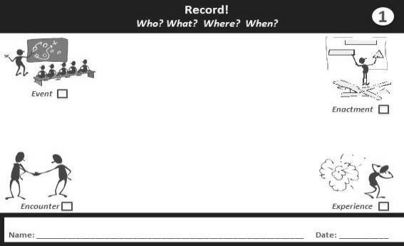

**Postcard: the “reflecting side”**

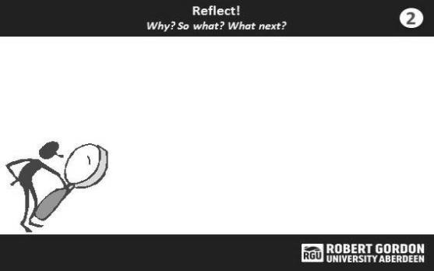

RGU entrepreneurship modules make use of these postcards within the curriculum for mentoring students. The modules form an integral part of the students’ experiential learning projects. RGU MSc degree students typically work in small group and are given copies of the postcards each week by their module coordinator. The students are instructed to return to their tutorial session the following week prepared to give feedback about the progress of their business start-up project with their mentor/tutor.

Part of the feedback session requires they bring their completed postcards, with the assumption that they have recorded their experiences and reflected them on both sides of the postcard during the week. If you take a look at the postcard in fig 1.0. There are questions to be answered by the students during their start-up project. The who? the what? the where? and the when? They are meant to also answer the questions at the reflecting side of the postcard. Through these questions, it becomes much easier to differentiate between recording and reflecting. Consequently, knowledge is passed across to RGU students.

Experience to date has shown that as RGU Masters student continue to take the entrepreneurship module, they become more aware of this distinction between description and reflection, and so reflection starts to become a more natural and habitual activity (Moon 1999). This project is to develop an App so that the elements in the postcard will be incorporated into a software. The design and structure of the software will align with the same purpose of reflective learning in this project; hence it becomes a digital system.

### **Aims**

This project aims to develop a CPD app that incorporates the currently used RGU business school postcard format (fig1.0). RGU business school students are currently using the postcard for CPD, so this application is just the digital type of the postcard but this time in a user-friendly manner. This application is to be used by all professions which ultimately documents and archives the process of the reflective learning that students could take with them to the workplace. This will enable the student to review their learning as they grow in career and life. Also, many professional bodies require students to attach a CPD portfolio as part of the membership and registration process. To effectively communicate and achieve this, students will do two things. One, record their learning which is descriptive learning based on the 4 trigger types mentioned in fig 1.0, and then reflect them which is analytical learning (Fulford and Bailey 2014).

### **Objectives**

We are to investigate existing CPD apps in other higher educations and professions to see if the application is already in existence. Also, to investigate the current postcard paper-based design and integrate the idea into the CPD software app.

To investigate the data type, design and structure in tandem with the postcard format and CPD requirements. To also ascertain the potential benefits this software could have in the RGU educational system across all profession and improve on features that implements reflective learning.

Investigate the strength and weaknesses of CPD app.

Develop, Design, implement, test and document a software solution that can register students in RGU, record their learning, upload files and images of their learning environment, document their CPD and generate a CPD portfolio. This solution is to be utilized by students during their lifelong professional practice and career (Fulford and Bailey 2014).

Investigate the Integrated Development Environment (IDE) that best suits the CPD application.

**Chapter 2**

# **LITERATURE REVIEW**

## 2.1   What is CPD?

There are several pieces of literature from different perspectives that define Continuing Professional Development in the past and present today.  Andrew Friedman and Mary Phillips (2004) suggested that there is a conflict of definition and the reason for CPD in both academic and practitioner literature, which depends on the professionals themselves. Somantri (2020) in a recent International Conference on research also agreed with the concept that CPD is ambiguous in the aspect of how it is defined, as well as in its goals after carrying out desk-based research that reviews empirical findings from the last 10 years. Furthermore, Friedman et al. (2000) noted that the definition most commonly used by professional associations in the UK was presented by the Construction Industry Council (CIC) in 1986, which states that:

“CPD is the systematic maintenance, improvement and broadening of knowledge and skill, and the development of personal qualities necessary for the execution of professional and technical duties throughout the member’s working life”.

CPD is about formal, informal, planned, unplanned learning events (PARN 2015). CPD is described as "the purposeful development of professional knowledge and personal skills throughout an individual's working life" (CIPD, 2007). Collin (2012) also stated that lifelong learning or CPD is how people establish themselves in knowledge and skills related to their professional lives. Day and Sachs (2004) stated that CPD simply implies learning and teachers have a better understanding of what CPD stands for knowing they attach continuous learning in order to deliver knowledge to students. However, professional associations claim CPD to be part of lifelong learning; A process of securing one’s career in any field by being up-to-date with professional competence (Friedman and Phillips 2004).

All of the definitions above have one thing in common, which is learning and the goal of being professionally relevant.

## 2.2   The Relevance of CPD

The notion of continuing professional development (CPD) has been around for a while, but it has recently gained popularity, owing to the present fast-changing and competitive work environment. (Friedman and Woodhead 2008).

Simply having a certificate stating that someone is a professional like a school teacher, a doctor, a physiotherapist, an accountant, or a human resources practitioner does not automatically suggest that they are competent and trustworthy (Andrew 2013).

Andrew (2013) suggests that they may have been up to date on the day they qualified, but who can ensure that ten, twenty, or even forty years later, that individual will still be up to date and have the expected range of skill.

CPD is now required for all professions to maintain and improve their abilities. Many professions, notably those in the health industry, need proof of continuous professional development (CPD) for professionals to be registered as practitioners on an ongoing basis (Muji and Lindsay 2008). This is because recent studies show that CPD seeks to improve patient outcomes by increasing physician knowledge and skills and changing behaviors (Sargeant et al. 2018).

Continuing professional development (CPD) is seen as a vital component of all professionals' career growth, which is a joint duty with their employers because it serves the interests of both parties (Madden and Mitchell 1993).

This represents the notion that CPD should encompass both formal and informal learning activities, rather than only traditional training sessions (Eraut 2001).

To highlight the importance of CPD, in 2003, 2006, and 2007, Professional Association Research Network (PARN) researched professional bodies on a variety of topics related to their activities, including governance, member relations, income and operations, initial professional qualifications, and CPD, ethics, and external relations. This extensive research showed that almost two-thirds of professional bodies in three of the four countries studied in 2006/07 have CPD policies, with the UK having the highest percentage at 85 percent, followed by Australia and last on the list to be Canada (Friedman and Mason 2007). See a summary of CPD policies and requirement for compliance below

|  |  |  |  |  |
| --- | --- | --- | --- | --- |
| **Topics** | **Australia** | **Canada** | **UK** | **Ireland** |
| Have CPD policy | 71% | 66% | 85% | 67% |
| *No reply* | 0% | 4% | 0% | 5% |
| *Base* | 49 | 56 | 110 | 21 |
| Compliance type of those with policy: |  |  |  |  |
| Compulsory | 26% | 54% | 20% | 43% |
| Obligatory | 26% | 0% | 20% | 7% |
| Voluntary | 37% | 24% | 43% | 36% |
| Mixed | 11% | 22% | 14% | 14% |
| *No reply* | 0% | 0% | 2% | 0% |
| *Base* | 35 | 37 | 93 | 14 |

(Friedman and Woodhead 2008 Table B.2)

**Table 1:CPD policies and types of compliance requirements**

PARN utilized a qualitative approach to gathering evidence on reaching their conclusion above.

With PARN's history and substantial membership in the United Kingdom, the UK survey population is believed to be the most representative of the real population (Friedman and Mason 2004; 2007).

See below a summary of survey.

|  |  |  |  |
| --- | --- | --- | --- |
| Country | Questionnaires Sent | Useable responses | Survey period |
| Australia | 336 | 49 | May-July 2007 |
| Canada | 406 | 75 | Oct 2006-Jan 2007 |
| Ireland | 114 | 21 | June-Dec 2006 |
| UK | 334 | 110 | April-July 2006 |
| Ireland | 114 | 26 | Sept-Dec 2003 |
| UK | 299 | 129 | June-Sept 2003 |

(Friedman and Woodhead 2008 Table B.1)

**Table 2: Summary of PARN surveys of professional Bodies**

Also, the element that was evaluated during the survey are items in the table below

|  |  |  |  |  |
| --- | --- | --- | --- | --- |
| **Items** | **Australia** | **Canada** | **UK** | **Ireland** |
| Record of CPD activities | 77% | 89% | 88% | 86% |
| Evidence of planning | 17% | 32% | 47% | 36% |
| Evidence of reflection | 26% | 32% | 39% | 29% |
| No evidence | 23% | 8% | 11% | 7% |
| *No reply* | 0% | 0% | 0% | 0% |
| *Base* | 35 | 37 | 93 | 14 |

(Friedman and Woodhead 2008 Table B.6)

### **Analysis**

* In comparison to the other nations, professional bodies in the UK were more likely to collect evidence of planning and reflection from the results.
* Obligatory methods often revolve around a statement in the organization's code of practice requesting members to stay current on advancements in their field (Friedman and Woodhead 2008).
* The results places emphasis on that it is the professional duty of the member to maintain and enhance their competence. (Friedman et al. 2000).
* The items in the table above; evidence of reflection, a record of CPD activities, and evidence of planning had to be collected for a better evaluation of CPD. This report is intended to design a software application that incorporates these elements as a model that allows students to improve on their learning.

Professional bodies are described in the content of this work as organisations active in the growth of professional knowledge and practice by creating, supporting, regulating, and promoting professional standards for ethical and technical competence (PARN 2015). Professional body registration generally refers to a person who joins a professional organisation based on a set of criteria. Registration into the professional body might be optional or mandatory.

The umbrella phrase ‘professional body' refers to three different sorts of organisations.

• Professional organisations that represent professionals and strive to promote professional standards and the prestige of its members, also known as membership professional bodies;

• Regulatory entities that enforce (and may also set) norms;

• Educated societies connected with professions that develop knowledge that translates to professional practice (PARN 2015)

Also, there have been recent findings on Professional Association Research Network (2015), whether professional body registration and membership are integrated in internship development / apprenticeship process. Furthermore, a case study was carried out on how collaboration between universities, companies, professional bodies to develop academically accredited programmes that are strongly integrated in the workplace is already long established, and it precedes the development of apprenticeships by 10 years (Nixon et al. 2006) and (Lester and Costley 2010).

Taking it further, Bravenboer and Lester (2010) performed a research how this sort of integrated approach may be put into action. He discovered the degree in surveying and building was purposefully created to meet professional body as well as university requirements, allowing it to lead to formal recognition without the need for additional examination (Bravenboer and Lester 2010). In the aviation example, the degree criteria comprised a set of professional requirements that included extremely specific expectations for competence, with the remaining academic requirements firmly linked to the initial year of practice as a professional pilot (Bravenboer and Lester 2010). The last example demonstrates unequivocally that the transdisciplinary criteria used for the academic work-based learning programme corresponds to the general competence required in professional and management occupations. (Bravenboer and Lester 2010).

Bravenboer and Lester (2010) concludes in his findings that a model that is gaining traction across industries involves collaboration between an employer (or group of employers), a university, and a professional body to create work-based pathways that lead to both higher education qualifications and qualified status in a profession or registration in a regulated occupation. (Bravenboer and Lester 2010).

According to Barnett (1994), emphasizes limitations of academic competence in the university are related to its concentration on mastery within a certain discipline knowledge field, whereas the limitations of occupational competence in the workplace are associated with its emphasis on results and skill performance. Therefore, Bravenboer and Lester's (2010) and PARN's (2015) approach to obtaining professional competence through the collaboration of university programs and the workplace skill requirement must adhere to the concept of Barnett (1994) called "reflective knowing." Similarly, Barnett (1994) sees ‘meta-learning as resolving the limits of ‘experiential learning' and ‘propositional learning' in the workplace and academic competence.

“Meta-learning for the life-world is a willingness critically to examine one’s learning. Putting it grandly, what is indicated here is a form of continuous action learning, where one’s projects and practices are ruthlessly evaluated by oneself, and jettisoned where appropriate.” (Barnett 1994 p182).

From this definition above, Meyer et al (2004) in his edition discussed how various authors in seven different papers used meta-learning to demonstrate how encouraging students to reflect on their learning approaches and conceptions in the context of subject demands can have significant implications for curriculum design, student support, and personal development planning.

Meyer et al (2004) in his final paper developed Reflection on learning Inventory ROLI as a metalearning model, a work built upon seven papers and research as a means to tackle the best form of learning.

### **Conclusions**

In this literature, many professional bodies build upon research on developing a reflective learning system for CPD. This is “Reflection on learning Inventory” according to Meyer et al (2004) is metalearning procedure that this project builds upon to encourage RGU undergraduates and postgraduate’s student build a successful career in their management professions and also have a model for learning delivered to them as a resource in the future.

## 2.3 Research on Reflective Learning System

Reflection may be traced back to John Dewey's (1933) work, which said that experience alone does not constitute learning; rather, an event must be cognitively realised before it can really become a source of learning. According to Dyment and O'Connell (2011), reflective continuous professional development of formal or informal learning encourages students to engage in critical reflection and higher order thinking; they demand students to be more open-ended and less prescriptive; and they allow students to be creative and inquisitive. Reflecting on one's learning is an admirable technique that should be incorporated into all learning experiences! Both instructors and students will benefit from this. Jack and Anderson (1999) stated that colleges should capitalize on their strengths of “developing higher level abilities and cultivating analytic ability” (1999:111).

*… It is critical to encourage students to reflect on their experiences and to recognise the skills they are acquiring and how they may be used or developed. (QAA 2012:14).*

In contrast, reflection is viewed as a difficult endeavor by some (Moon 1999:173), with the “difference between a descriptive narrative and a reflective or analytical one” commonly missed (Thompson 2008:148). Reflecting on one's experiences is a good approach to make the most of them, which is the difficult part (Barclay 1996). Reflection broadens comprehension, that is why it is challenging (Hartog 2002). Furthermore, some may be skeptical about the value of reflective practice. Senge et al. (1994), in their well-known book on organisational learning, "The Fifth Discipline," claim that:

*“If someone is reflecting, it’s considered perfectly acceptable to interrupt them, because “they’re not doing anything.” (Senge et al. 1994:60)*

However, the major consequences of these issues are undoubtedly that in order to integrate reflective practice into our education programmes and system. Despite references to the relevance of encouraging reflective practice in education programme, such as those mentioned above, there is relatively little detail in the research about how educators can develop an approach to assist students understand the clear distinction between description and reflection.

Given this gap in the research, Bailey and Fulford (2014) established a project to investigate the design and development of learning resources to assist students in making sense of the complexities of an entrepreneur's learning environment and developing effective reflection habits as a means of improving their own entrepreneurial practice. This project was dedicated to showing students the importance of dedicating time and effort to contemplation during their action-oriented learning and encouraging a user-friendly approach as which is a software application that can run on mobile and a web device.

This investigation turns to Bailey and Fulford’s (2014) literature and project as a case study on the existing reflective practice approach already developed using postcard tool as a base to build upon and how to incorporate the elements of the postcard into a software application to be consumed by RGU students. A background summary of that literature is provided in the next section, and acts as a basis for the development of the core resources explored and to be developed in this project. Presentation of a digital tool (web and mobile app) as a framework to reflective practice form the focus of the remainder of the paper.

## Background Research on Postcards for Reflective learning

### **Existing Concept**

An exploratory project was reported in which seven primary teachers in England shared their experiences of mentoring students through small data visualized on postcards. Two of the

reasons why they used data during the data sharing discussion between the student and the teachers were; reflection on practice and reviewing professional lives.(Burnett, Merchant and Guest, 2020). From the report, they proposed the project worked. However, still temporary.

Burnett’s report of sharing on postcards to students was focused primarily on the teacher’s experience of how literacy education would be beneficial to teachers more than the students. They obtained feedback on the students learning experience and how they performed during their projects. (Burnett 2020). David and Eytan (2010) discussed a medicine rotation by medical student using postcard to reflect upon the way medicine is practice and taught just after recording the professionalism and ethics during medical visits. (David, Eytan and Kathy, 2010).

In contrast Fulford and Bailey (2014) developed a short-term and long-term reflections system using a postcard carried by RGU business school students in a venture creation project for entrepreneurial learning to recognize where and how to become a successful business owner. However, no considerable literature has been published on using a postcard reflective system for pan professionals and also digitalized. These studies are very well covering record and reflect learning system already existing by RGU business school and adapting it for students on their technological device as opposed to carrying around paper cards discussed more in Chapter 3. Also, this project is to be utilized by students from different backgrounds like Human resources, Project management professionals, Procurement and supply chain, Health and safety, General management and all professions governed or not governed by a professional body which is the gap to be filled. The next section discussed the models this solution is built upon.

## 2.5 Models for Reflective Learning

Reflection is the process of taking a step back from an experience in order to thoroughly and

regularly analyze its relevance to oneself through inference formation while learning is the development of meaning from past or present experiences that serves as a guide for future occurrences (Daudelin 1996). In this report, a model of reflection is a structured process or a framework that is used to guide personal development and improvement. It is described as a CPD cycle that has an end-to-end process of achieving reflections during learning.

We are already in an era where our higher education systems are not just encouraging, but also requiring students to demonstrate their reflection (Bailey 2011). This reflection is required to be evidenced which becomes the essence of selecting a model that is best fit for the solution design in chapter 3. The academic literature on different types of models for reflective learning has been developed over time and has revealed the emergence of several contrasting activities and concept based on learning outcomes and what has worked in terms of evaluated experiences. This paper will identify models investigated in chronological order, analyzing, explaining the gaps and the limitations.

### **Boud’s triangular representation**

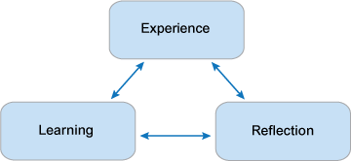

**Figure 2: (Boud’s triangular representation 1985, p. 19)**

Boud et al. (1985, p. 19) provides a literature of learning from reflection which takes place when People relive their experiences, reflect on them, linger over them, and analyze them, which result in learning. The goal of this process is not just to reflect and announce that you will do things

differently next time, but also to change what you do because your understanding of how the world works has changed as a result of disciplined thought about the experience you have had. In contrast, there remain several aspects of this model which relatively is not clear. The model is weakened by the fact that it does not specify what reflection should include or how learning should be used in the real world (OpenLearn 2020).

### **Atkins and Murphy cyclical model**

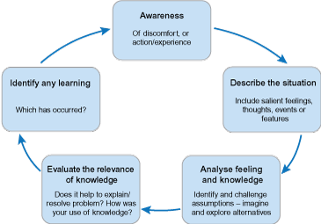

**Figure 3: Atkins and Murphy cyclical model**

Fig 3 depicts a number of text-filled boxes connected by arrows. The boxes display the following text from top to bottom (clockwise) are:

* Awareness of discomfort- or action/experience.
* Describe the situation- Include saliant feelings, thoughts, events or features.
* Analyze feeling and knowledge- Identify and challenge assumptions - imagine and explore alternatives.
* Evaluate the relevance of knowledge. Does it help to explain/resolve the problem? How was your use of knowledge?
* Identify any learning. Which has occurred?

In According to Atkins and Murphy (1993), an examination of the stages of the reflection process revealed that important cognitive and emotional abilities were required for reflection.

Many of these concerns are addressed by this cycle model. This model may be regarded as facilitating a deeper degree of introspection, which is not to suggest that the other models aren't beneficial, but it is necessary to be aware of the risk of providing shallow replies since the critical, questioning, and challenging components of critical reflection aren't as evident.

The capacity to assess the relevance of learning was also crucial, and Atkins and Murphy (1993) suggested that the best approach to enable reflective practitioners was to build the abilities needed to reflect within practice contexts which later developed in 1994.

### Described image**Gibbs’ reflective cycle model**

***Figure 4: Gibbs' reflective cycle (1998 p.49) (adapted from Dye 2011)***

According to Gibbs’ reflective cycle (Figure 4), the model is subdivided into several tiers. Gibbs’ (1998) notion acknowledges that your emotions have an influence on the situation and how you have begun to think about it. The model extends on Boud's method by breaking reflection down into event evaluation and analysis, and there is a clear link between what was learned and what will be done in the future. The paradigm for organized reflection arose as an extension of the reflective stage of Kolb's experiential learning cycle which cannot be discussed in this chapter. (Rees 2007). However, Rolfe and Freshwater and Jasper (2001) made two important objections of the model. The first is that, while the model looks to be cyclical, it lacks a reflexive way back to the current state. Secondly, it raises two more questions: how does this model help the practitioner handle a present practice challenge, and will the practitioner have the same experience again? (Rees 2007).

There are many other models that helps one reflect, and to deepen understanding in different stages like below

* Kolb's experiential learning cycle (1984)
* John’s Model of Reflection (1994)
* Hartog’s 3 stage model (2002)
* Holm and Stevenson’s prompts

### **Hilsdon’s Critical thinking model**

According to Hartley et al. (2011) development provides a solid foundation for creating a community of practise focused on how students experience learning is well suited to the twenty-first century. Learning development, in other words, is a multi-disciplinary collection of academic duties and activities that include teaching, tutoring, research, and the design and provision of learning materials. (Hartley et al. 2011). Hilsdon’s Critical thinking model(2008) structures the learning development viewpoint which encourages students to analyse and evaluate their own progress by encouraging them to engage in reflective activities.

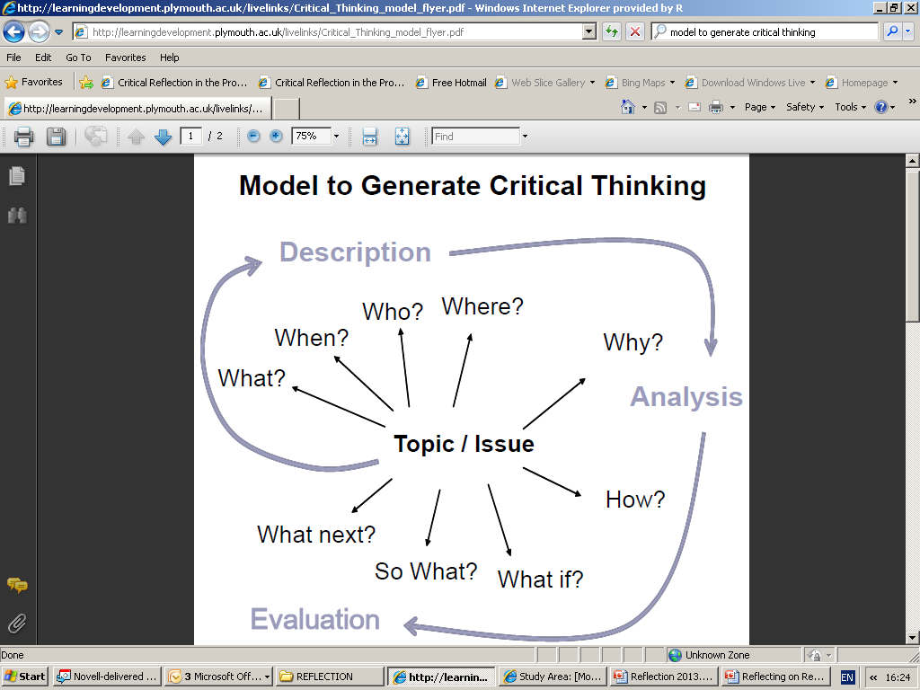

***Figure 5: Hilsdon’s Critical thinking model*** (Bailey 2020, slide 14)

Reflective models according to Gibbs’ (1998) and Boud (1985) in fig 4 and fig 2 showed that focus on active learning by students was required for every student except that the model excludes emphasis on student’s participation and involvement in their own assessment.

## 2.6 Reason for Hilsdon’s Reflective Model

According to Hilsdon (2008) reasons for choosing this model instead of the other models is the “**Why, How, What If “:** - If a student is analyzing an experience when carrying out team work within university. To analyse the incident in greater depth and with theory, you would need to think about it and ask yourself questions about **why** am I studying this topic? **how** does the part fit into the plan? and What if the variables are altered? (Bailey 2020)

For the evaluation part of the model, illustrating from the above example you could use the **so what** or **what next** questions to incorporate theory such as team task theory. You may decide at the planning stage of any prospective group work to establish what duties the members would be happy to do depending on their natural team role. To avoid lurking, assign each member of the group specific duties and deadlines. assign each member of the group specific duties and deadlines (Bailey 2020)

There are more specific reasons for a Hilsdon’s reflective model which are below detailed by Bailey (2020):

* It must be structured to encourage reflection to happen.
* Theory might be incorporated into the analysis and assessment sections of the learning and reflection diaries.
* It must be encouraged for it to happen.
* It needs to be institutionalized.
* It needs to be designed so that the experience is recorded.
* By assigning, it will promote the value of personal observation and knowledge.
* It allows for student ownership.
* It can improve problem solving skills.
* It can be used as an assessment in a work/university setting. Hence RGU module
* It will deepen the learning.

## 2.7 Digital Tools for Reflective Practice

Using technology tools like an app to support teaching, Mentoring and learning make things move fast. Any institution involve in teaching would come to terms with the concept of reflective practice. It is key to professions integrating Continuing Professional Development (CPD).

The Higher Education Authority (now part of AdvanceHE) explored how professional reflection

Is thinking about what you are doing or learning rather than fussing over what is been learnt. (Warwick 2007). Their primary intention was to make obvious that between notions of reflection and the attributes practiced by those in the educational sector.

Bailey and Fulford (2014) proposed this idea of using a digital tool to extend the already used postcard concept for RGU students, believes there is a connection between thinking criticallyand reflecting on what has been taught, and also it is a must skill for undergraduate and post graduate student who wants to keep up with the trends of the profession they seek to participatein.

Meanwhile, reflection can easily be limited especially with students finding it tasking to carry bunch of postcards every time they want to record and reflect their learning either informal or formal. Also, the postcard is limited in space to convey their thoughts and reflections.

Using digital tools for reflection can also enhance more general [digital capabilities](https://www.jisc.ac.uk/building-digital-capability), which are increasingly valued in the workplace. (Hole 2018). This forms part of the reasons why digital tools that can make it easier can bring benefits for learning and professional development.

From research, the fact that technology is much popular and plays a vital role in this era than it did for previous generations has made today’s generation to demand and desire the need for digital tools and literacy. “From the millennial to Gen-Z, these are the generations that are coming into the classroom today and they share unique characteristics that define their generations.  These generations expect to be engaged in their learning and they do not do well being passive learners. Also, paper-based system are not acceptable with professionals. Hence, technology has to be embraced in today’s education and teachers have to apply technology as part of the students learning.” (Harwati, 2018).

This study highlights alternative digital equivalents in the next section that can help students record and reflect their learning and achieve the concept of paper-based postcard used by RGU students.

### **Alternative Digital Documents, Note-taking apps for Recording and Reflecting**

Note-taking apps such as OneNote, Evernote, Google Keep, Google docs offer possibilities to students in writing down their reflections. Meeting, lecture notes, reminders and assigning task can be carried out. With these apps you can add images or photos as evidence of CPD learning and publish to the web. They can also synchronize across all your devices whether mobile or web. This can be useful as student’s virtual notebook.

|  |  |  |  |
| --- | --- | --- | --- |
|  | **OneNote** | **Evernote** | **Google Docs** |
| **User Devices** | Windows, MacBook, iOS, Android and web | Windows, MacBook, iOS, Android and web | Windows, MacBook, iOS, Android and web |  |
| **Content type and features that can be used** | Text, images, web content, emails, tables, Audio recording and video recordings. | Text, images, web content, Audio recording and checklist | Text, web content, No audio recordings, arts and drawing, photos and list |
| **Sharing notes with other digital tools** | yes | yes | yes |

**Table 3: comparison as at November 2018** (HOLE 2018)

OneNote outperforms Evernote and GoogleDocs through the video capturing feature. Also, OneNote has tools for dictation but Evernote lacks it. However, Evernote has a good user experience and collaboration functionality than Google Docs and OneNote but they both do the same. The most difference between Evernote and OneNote is that the full potential of Evernote comes with the paid version, while you can access all features in the advanced version of One Note when it is free (Pierke, 2016).

### **2.7.2 Strength of the note-taking app.**

* Digital notebook is used instead of Microsoft word in order to create one or more files where students can write their reflections, add image files and hyperlinks.
* They can be use on smartphones, PC, laptops and tablets.
* RGU students are each entitled to sign in to used Microsoft Office and store file up to 1TB with office 365.

### **2.7.3 Weakness of the note-taking app.**

* The aim of the CPD application is not to follow inbuilt tools available on the note-taking apps
* Rather, we are building features that enhances students reflective learning ranging from the formal through the informal (Fulford and Bailey 2014).
* The note-taking app does not have structure for mentoring like in Fig 1.0. An interface for long-term reflections will need a free-text journaling tool so students can aggregate their reflective jottings over the life of a project like a summary or reflection statement.
* The note-taking app does not have a database to help students plan their CPD activities like reflective journals database for the students based on weekly, monthly and yearly plans.
* There will be a need for a calendar feature mapping to each students learning period.
* Note-taking apps does not have the postcard reflection system, cv repository, facility for recording contacts, audiovisual guide and a profession skills questionnaire

### **Comparison of CPD App**

The comparison of existing CPD applications allows you to evaluate the support features and functionalities side by side, as well as narrow down the list of viable solutions to the target market and clients for the product. The CPD apps fully and popularly found on Google playstore and Apple store are listed below:

Ausmed - CE Portfolio App - This app is designed for American nurses to adhere to continuous professional education in 50 states (“Ausmed - CE Portfolio App” 2021).

CPD App for HCPC Professionals. - This app is used to record and manage CPD for Health and Care Professions Council.  Registered healthcare practitioner like dietician, ODP, OT, Paramedic, or any other HCPC certified staff group in between utilizes this CPD app (“CPD App for HCPC Professionals V2” 2021).

Physicians’ CPD - It was created to supplement the existing web-based CPD diary system used by approximately 17,000 Consultant and SAS grade physicians (“Physicians’ CPD” 2021).

CPD Health Courses Dry Needling Training - This app is a Dry Needling training Health class for Clinical professionals that is registered for the course. The registered professional may use this app to access the online training modules (“CPD Health Courses Dry Needling Training” 2021).

Fig 6 below is a comparison of their features on google playstore and some on Apple store namely:

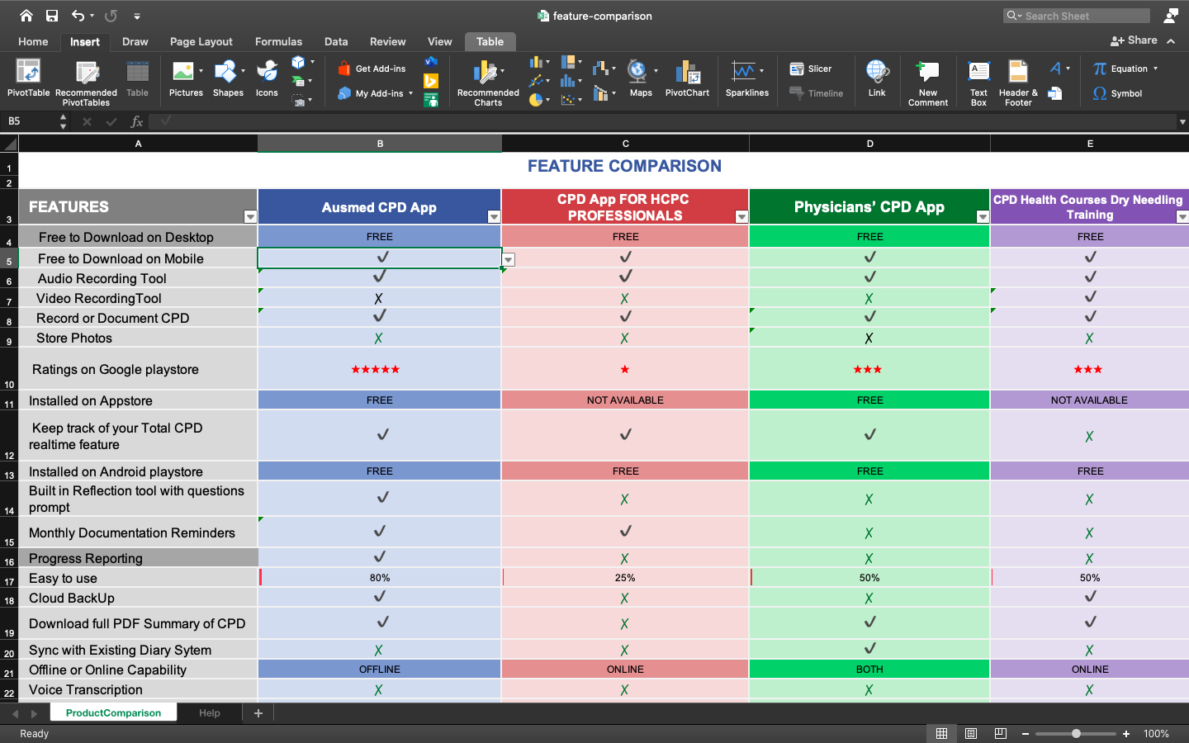

**Figure 6: Feature comparison of existing CPD applications**

### **2.7.5 Evaluation.**

With respect to the current comparison, user experience varies according to context and problem. In this paper, we proposed a holistic quality approach for evaluating and user experience of CPD apps based on the case study of RGU students currently and successfully utilizing a postcard system one with features designed to meet the student’s outcome. The audio and video features for recording CPD in fig 6, are available. However, the gaps lie in the fact that CPD apps popularly known in fig 6, are mainly medical and health profession specific apps, hence the need for a generic one to cover multiple management professions is the aim of this project.

**Chapter 3**

# **METHODOLOGY**

## 3.1. Research Approach

The contextualized case study presented as a research approach in this investigation was obtained from an extensive combination of several papers and interview with the two module coordinators for the undergraduate and post graduate students at RGU business school. The module coordinators represented the focus group/ clients to demonstrate a range of possibilities and student’s requirement for developing the CPD app based on the existing reflective postcard system. This method is particularly useful in this investigation due to the students are the users of the application and the module coordinators are Product owners. The case study involves how an entrepreneurship and enterprise programme was developed in RGU business school to encourage students possess reflective skills during their learning and, how the students responded with feedback concerning the reflective postcard system.

RGU’s enterprise and entrepreneurship professors and staff are responsible of creating and delivering modules and units to undergraduate and postgraduate students enrolled in a variety of faculties and departments, including business and management, law, art and design, and commercial photography. This modules and units combine learning for entrepreneurship, including case studies, theory debates, presentations by local entrepreneurs, and a variety of practical venture start-up initiatives (Fulford and Bailey 2014).

The entrepreneurial modules integrate the usage of these cards, as mentoring-style tutorial sessions which are an important component of the students' experiential learning projects. RGU Students usually work in small groups and are handed postcards every week. They are urged to return to their tutorial the following week, prepared to discuss the development of their business start-up initiative with their mentor/tutor (Fulford and Bailey 2014).

As part of this conversation, they present their completed postcards identifying the topics or concerns on which they have been reflecting over the week. The contrast between recording and reflecting becomes much clearer to students as a result of these discussion. The use of the two-sided postcard technique meetings with potential suppliers or clients, whether planned or unexpected, fresh possibilities or offers of help that were not anticipated, difficulties (incidents) or setbacks in their projects, collaboration challenges, and so on are common instances that students bring to these conversations (Fulford and Bailey 2014).

Current experience by the module coordinators has shown that through this reflective postcard system, student require less support in understanding the distinction between description and reflection, and reflection becomes a more natural and frequent action (Fulford and Bailey 2014). The phase for this project is to produce an App that is in a state to be piloted with plan of student testing out the app further down the line. We have to give the students something to try and with their feedback develop and build features that meet the project specification. The next section focuses on the user requirement after several discussions with the product owners (module coordinators).

## 3.2 Problem Analysis

Based on study of the existing system, the development of CPD App requires identifying and analyzing the user’s problem and requirement. The title of the App is the **“4E App”**. This App was created to offer students with an easily accessible tool for carrying out your CPD procedure in an organised, theoretically supported manner (record and reflect on your learning). It is a generic, user friendly App that can be used by a wide range of different professionals.

According to Fulford and Bailey (2014), “It has been identified that generally the 4E’s represent 4 triggers from which these learning opportunities emerge”

**Events** - A learning opportunity may be triggered by your participation in training sessions, which are often classroom-based learning activities or professional development events, as well as personal / private study.

**Enactment** – An enactment is a learning opportunity that occurs while you are doing tasks in the course of your professional or daily life, including social and recreational activities. They are all potential learning opportunities.

**Encounter** - A meeting, whether organised and scheduled professional networking events or more ad hoc meetings or talks with individuals or groups of individuals, can result in a learning opportunity, such as a networking activity. These interactions might happen as a result of your personal and social activities, as well as your professional ones.

**Experiences** – An experience can trigger a learning opportunity, and the experience – which can be positive or negative – can occur during the execution of your professional entrepreneurial process, such as things that go wrong, mistakes made, or opportunities that arise, as well as similar situations that arise in the course of your day-to-day and social activities.

What is required of the users are described in the “**4E App”.** The“**4E App”** should incorporate the CPD process which is:

1. **Recognise** – The CPD process begins with the ability to identify Learning Opportunities, which allows you to begin your CPD journey. The selection of learning opportunities is important if true learning is to take place; the chances must be relevant and appropriate to you, as well as link with your development needs.
2. **Record CPD** – record selected learning opportunities the process

* Title - Who was involved/affected in the learning opportunity?

What happened and how did it come about?

Where did the opportunity occur?

did it occur?

* Date of Learning Opportunity – Period space for the user to record the time

(Usually a year)

* Type of Learning Opportunity – Boxes to allow for ticking of which is applicable
* An Event?
* An Enactment?
* An Experience?
* An Encounter?
* Description of Learning Opportunity – Space for the user to type in the description, upload a photograph or upload a video or upload a recorded message

1. **Reflect on learning opportunities** – reflect on selected learning opportunities that were described on the CPD recording.

* questionnaire of CPD – questions must be answered below:

Why did this learning opportunity come about?

Why were the actions taken?

Why were other actions not taken?

Why were the actions successful or unsuccessful?

What does all of this mean?

What is significant about this?

What are the implications?

What are you actually saying about all of this?

What next? What can be learned from this? What else could have been done? What could be done in the future – the same actions or different actions and why?

You can describe your reflection using either text or a recorded message

Any additional evidence if you want to upload to support this entry?

* Evidence of CPD – upload additional evidence (upload resource)
* Voice your reflections – voice recording to document your reflection which you then upload to the App.

1. **Review** - which will decide how the learning will affect practice and professional life as part of reflection.

* Create a summary or report of CPD – upload additional evidence (upload resource)

## Scope And Process of Project

This is process breakdown of the web/mobile pages in terms of the user interaction flow. The scope of this project takes account of the user requirement in section 3.2. The investigation of the scope is still progressive and we envisage there might be changes in the process flow as the user interacts with the user interface and features. We will employ the Agile methodology to develop the application as this will give room for changes during the execution phase. This will be discussed this in section 3.7.

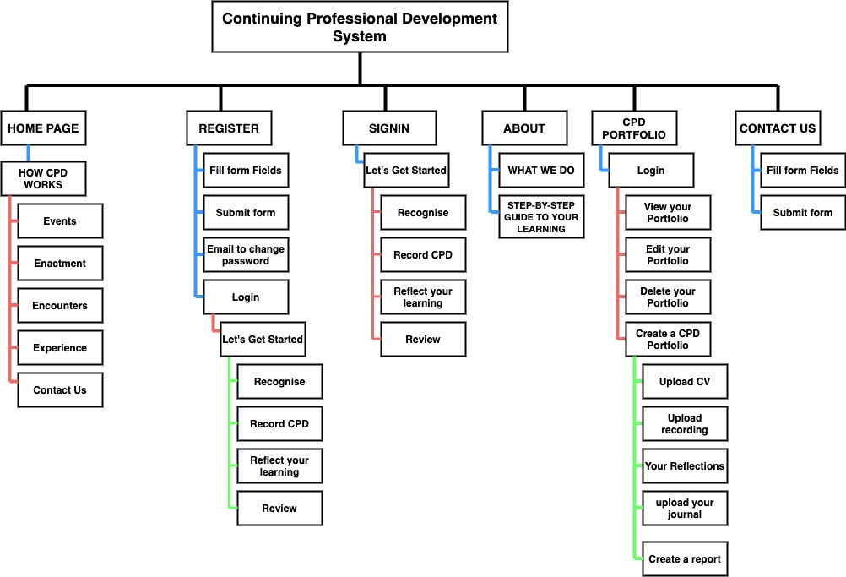

**Figure 8: User-interaction**

## Database design

The database design concept was drafted from the problem analysis in section 3.2 In fig 9 Entities (Table) and attributes are stated below:

1. CPDPortfolio (id, cv_file, report, dataCreated, studentId)
2. Student (id, name, username, email, password)
3. Learning (id, title, type_of_learning, date_of_learning, dataCreated, studentId)
4. MyReflections (id, content, resource, dataCreated, studentId)
5. Voice (id, url, caption, dataCreated, studentId)
   * 1. User Story

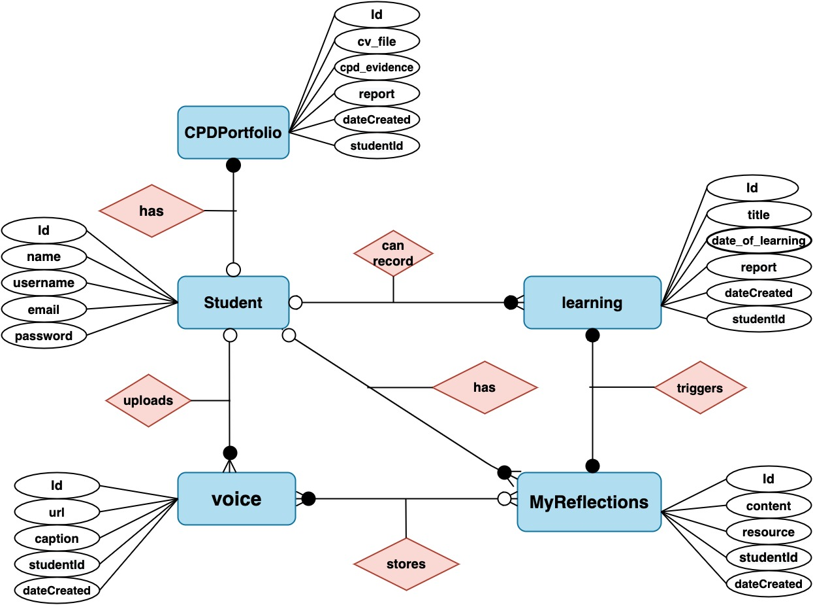A student will first register into the application with his credentials(attributes) by filling a form on the app. The form field is saved into the student table. After successful registration by the backend server, he is given login details (Username and password) to sign in so as to start a process of documenting his CPD. On the app, student can record learning by filling a form (title of his learning, type of learning (the triggers), date of learning (period) and either upload a photo, see section 3.2. The content of the form will be saved in the Learning table of the database mapped to the student that initially signed in through his studentId (primaryKey). After the student has recorded his learning, he then reflects on what he has learnt by filling a form on the app, which is the content and resource he used to learn and the date he reflected (date Created). The studentId of the student in the learning table is mapped to the studentId of MyReflections table as primary and foreignkeys for unique identification. The date of the learning is also mapped to the date of his reflection as primary and foreign keys see fig 10. The student can also record his CPD (learning) through voice (Voice table). A junction table is used to map the reflections from MyReflections table and the voice recording in the Voice table through the reflectionId and voiceId as primary key and foreign key.

**Figure 9: Database Design (ER Diagram)**

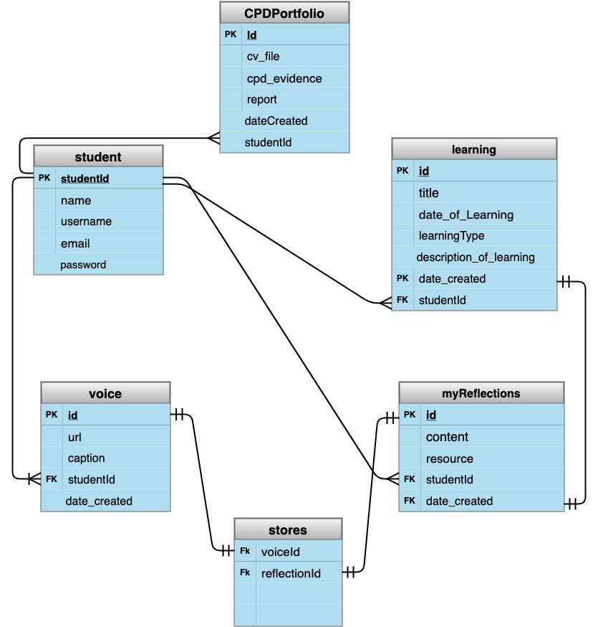

**Figure 10: logical and physical schema**

## 3.5 Wireframe Design

Figure 11. below is the Wireframe and Mockup for the CPD app homepage

**Figure 11: Wireframe and mockup**

## 3.6 Constraints

This is a list of the major constraints identified with the project.

|  |  |
| --- | --- |
| **CONSTRAINT** | **PROBLEM/SOLUTION** |
| Server Deployment | CPD app is intended to satisfy the demands of users (students), but in order to be successful and functioning, the client-side and server-side scripts must be deployed and hosted on a server (remote cloud). For this project, the serving Host will be Heroku, which is selected since it is versatile and simple to use. Git, the popular version control system, will be used to maintain this application on Heroku. Heroku command line interface offers Pipelines, which allow it simple to maintain the CPD app in distinct staging and production environments. Later, we shall consider AWS for better cloud service. |
| GitHub Repository for Code Hosting | CPD App project will utilize the GitHub repository. GitHub is a platform for version control and collaborative hosting. This project will have its own GitHub repository, with a default branch called Master. Then, based on the various features, new branches will be formed. If you're working on the login page, for example, the branch name will be feature_login. |
| Client-Side Scripting | This application's users must be able to interact with an interface. They must be able to view all of the pages. |
| Sever-Side Scripting | This application necessitates the use of a server to receive and reply to requests. It understands the browser's language and can respond to a client-side (web interface) over Hypertext Transfer Protocol. A controller function on the server connects to the database and transmits data to the front end. |
| Login system | The technique for logging in users will go through several stages.  A username and password will be required on the form. Both the front-end and the back-end will authenticate this credential. |
| Roles and Permission | Two users exist in the CPD app. Logged-in users and general users. Logged-in users can access a CPD portfolio and, a general user cannot. |
| File/Image Upload | The logged-in user will be permitted to upload resources as part of his CPD representing the materials of his learning. The file upload input will be displayed after he has logged in using a login credential (username and password), and the database will store a reference to this material. |
| Audio/ Video feature | The logged-in user will be permitted to upload audio or video of his learning as part of his CPD. This feature is difficult to maintain due to large audio and video packets and will require cloud storage and maintenance |

**Table 4: Constraint identified with the project**

## Software Methodology

Methodologies impose a structured approach on software development with the goal of making it more predictable and efficient (Islam and Ferworn 2020).

The software methodology that can be used in this project are:

1. Waterfall Methodology
2. Spiral Model
3. Agile Methodology

### **3.7.1 Waterfall Methodology**

It is a traditional and fundamental method to software development. It starts with stage one and proceeds in a cascade fashion, so you never go back or offer feedback (Chandra 2015).

Limitation

* The main disadvantage is that there is no feedback from one level to the next, thus problems cannot be discovered until all phases have been completed.
* One cannot proceed to the next stage until the previous one has been accomplished. Not appropriate for complex or mission-critical operation, that is to say it is not flexible (Chandra 2015).

Benefits

* It works well for projects with basic and well-defined goals.

### **3.7.2 Spiral Model**

Spiral model comes with many variations of the waterfall model when applied to large software projects (Chandra 2015). It plans the next iteration and define the iteration's objectives, options, and restrictions. It also creates and validate iteration deliverables, then recognize and address hazards (Islam and Ferworn 2020).

Limitation

* It is really complex. The objectives must be clearly defined.
* Developers that are both certified and skilled with this sort of work (Chandra 2015).

Benefits

* Ideal for mission-critical software development.

### **3.7.3 Agile Methodology**

It is a truncated version of the traditional waterfall model. It can provide feedback to the previous stage with this capacity, it is straightforward to rectify problems before moving on to the next level (Chandra 2015).

Limitation

* Not suitable for complicated or mission-critical tasks (Chandra 2015)
* Time consuming.

Due to extensive research, the Agile Methodology will be employed for this project. It has lots of benefits. It has a framework called SCRUM.

SCRUM makes it possible for the project to be broken down into items based on priority (hierarchy of functional features starting from what is most important). These items are called Product Backlog Items (PBI’s or PBL). So, there is a choice from the items (features) to build and deliver as an MVP (Most Viable product) in a sprint (first cycle). Each sprint will have its items to be shipped and deployed called Sprint Backlog (SBL). The SBL is a subset of the BPL based on what can be developed in a sprint. Fig 12, 13 and 14, gives the procedure of SCRUM.

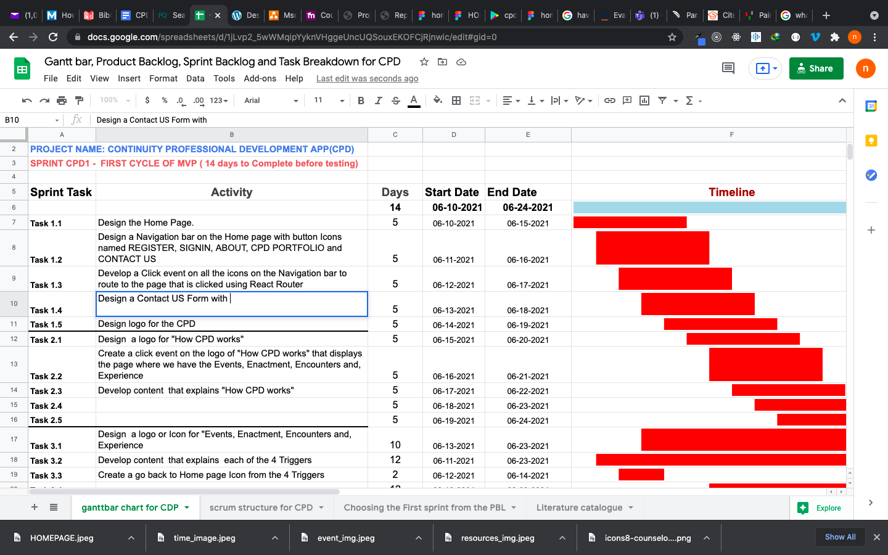

**Figure 12: Gantt Bar Chart**

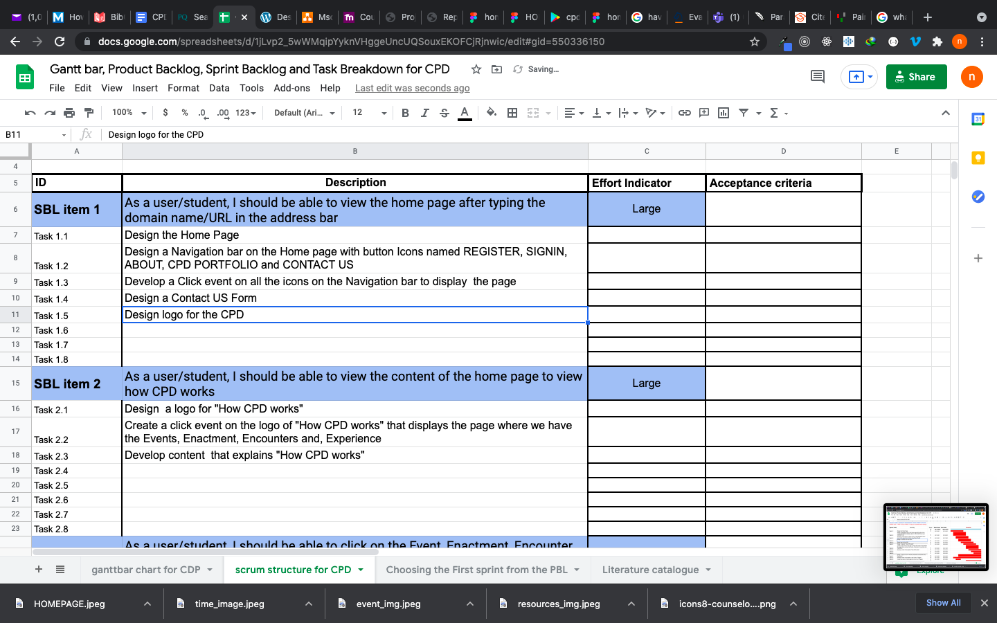

**Figure 13: scrum structure**

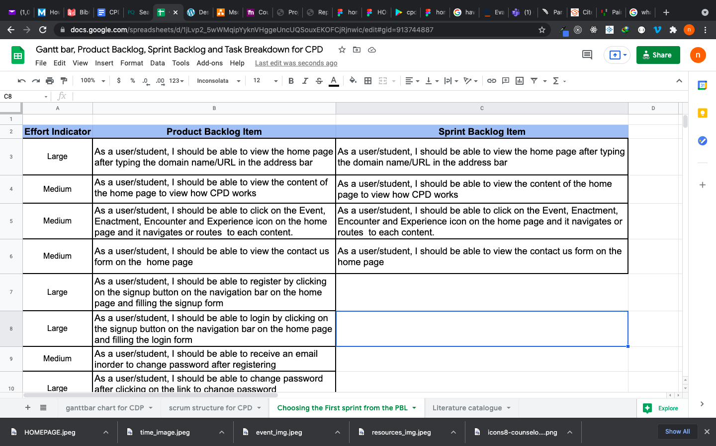

**Figure 14: First Sprint**

## Technology and System Architecture

### **Software Architecture**

Software architecture refers to the underlying structure of software [1] that defines technical and operational needs. It is in charge of optimising every aspect of a programme, such as efficiency, manageability, scalability, reliability, modifiability, and deployability (Gos and Zabierowski 2020). There are two types of architecture namely: Monolithic and Microservice.

Monolithic Architecture

In recent years, software developers have effectively used monolithic architecture. A monolithic application is a piece of software that integrates many components (such as authentication, business logic, and notification modules) into a single programme that runs on a single platform

(Gos and Zabierowski 2020). A monolithic component is one that is deployed with all of the modules and libraries required to enable its operation (Sotomayor et al. 2019).

Microservice Architecture

It is a design strategy in which an application is organised as a collection of services. Each microservice had to provide a piece of the business logic (Gos and Zabierowski 2020).

### **Architecture Advantages and Disadvantages**

Monolithic Architecture – pros and cons

* Scaling is quite difficult.
* On each update, the complete application is redeployed.
* It is simple to develop and deploy.
* Complex maintenance
* Reliability (a single defect may bring the entire application down).

Microservice Architecture – pros and cons

* Maintenance is easy.
* Scaling is simple.
* Complex deployment.
* Independence which is it is a positive aspect. However, with data integration on the fly is a huge constraint.
* Reliability which is fault within one microservice affects only that microservice alone.

In this project, we will employ the Monolithic architecture pattern. The whole system in each sprint is simple to develop and deploy.

U

SER

I

NTERFACE

BUSINESS

LOGIC

DATA

LAYER

DATAB

ASE

**Figure 15: Monolithic Architecture**

### **Software Tools / Web Stack**

This project used software tools to design the functionalities of the application. From the user interface to the server script. The software tools researched and considered to be one of the top 15 programming tools for this project are JavaScript, Python, PHP, SQL Action Script and mongoDb (“15 Best Programming Languages for Mobile App Development 2021” 2021).

**JavaScript – pros and cons**

* Versatile and adaptable language that may be utilised in a variety of ways through Node. Js framework.
* Client-side browsing is faster, and no compilation is required.
* In rare situations, you may face browser support difficulties.
* Is susceptible and, in some circumstances, can be used for malevolent purposes.
* Excellent and wide community that contribute to codes updates, bug and fixes

**Python – pros and cons**

* Execution time is slow.
* Not very good at developing contemporary mobile applications.
* There are several downsides to data access.
* Has a large range of frameworks that make programming versatile.
* An interactive language for creating scalable programmes that also supports GUI applications.

**PHP – pros and cons**

* Is great for apps with a lot of content and loads rapidly even with a poor internet connection.
* Security measures added in to guard against sophisticated security threats.
* Large applications are not recommended.
* It lacks modularity and is tough to maintain.
* Better error handling is required for the framework.

**Choice of Database Tools**

Relational database management systems (RDBMS) and non-relational NoSQL databases are the two major categories of database systems. Based on the number of users and data required to satisfy the criteria of this project. It is recommended to use a NoSQL database such as MongoDB. It uses key-value to store the data and maintains a flexible schema that may evolve over time. In contrast to RDBMS (SQL), which has non-flexible schemas for audio and video data. Also, mongodb has optimized migrations on the fly for data than the RDBMS.

In this project, the web stack to be used for the development of the application is the MERN stack will be used which makes JavaScript the programming language. The front end includes ReactJs, Back-end is NodeJS and the database is NoSQL which is MongoDB. My choice of this web stack stems out from the fact that NodeJS has a cross-platform run-time environment that makes mobile, web, and desktop able to consume the same endpoint (data) through REST API (Representational State Transfer). ReactJs is also most suitable JavaScript framework for the client-side due to its inbuilt style of modularity, supports single-page applications, makes page routing easy, and flexibly handles state(data). The database chosen is MongoDB, a NoSQL database system with its ability to handle large unstructured data in a flexible way. Queries are faster and have great performance.

**Chapter 4**

# **PROJECT REQUIREMENTS AND SPECIFICATION**

## 4.1 Functional Requirements

This section details how the system and features should be developed in terms of priority. This project will employ the MOSCOW Method to categorise the features in terms of what must be developed, what should be developed, what could be developed and what would not be developed. “M” represents Must, “S” represents Should, “C” represents Could, “W” for Won’t.

|  |  |  |  |
| --- | --- | --- | --- |
| **Item** | **Component** | **Method**  **(MOSCOW)** | **Description** |
| User  Management | Register | S | A user/student can register by entering his name, email, and password. The user waits for approval by the application’s backend. |
| Login | M | A user will enter his email and password to access the admin dashboard. |
| Logout | M | A user can log out through the navigation bar and he won’t be able to access the CPD portfolio except he logs back into the system. |
| Role | Logged-in User | M | This user has access to the CPD portfolio with Admin rights and can create a CPD portfolio, view his portfolio, report his reflections, and more. |
| General User | M | This user can only visit the home page, see how the CPD works. He can also visit the about page and view step by step process of learning. He can also contact us through the contact us form for inquiry. |
| Authentication | Login | M | The system will check the username and password of the user exist in the database as approved by the system. If not, he is redirected to the homepage to register. |
| Authorization | User role check with session or cookies | C | The system check for the user role after logging if the user is a general user or logged-in user through his session. |
| User  Interaction | Search | C | A logged-in user can search for a CPD based on the date he created one. From the CPD search bar, the user will input a keyword and the database will dynamically recall the last date of the document by filtering the search. |
|  | Resource upload | M | Resources include e-books, images, and files for students to upload while documenting their learning. It is a feature that can upload an image file, e-book and others. |
| Audio | C | Logged-in users can access the feature of recording their learning and also recording their reflection through audio. The voice packet will be appended to a URL and a caption as the header, then at the click of a submit button, the voice is saved to the server and a reference in the database. This feature could be developed in the future. It is quite expensive to maintain |
| Video | C | Logged-in users can access the feature of recording their learning and also recording their reflection by making a video. The video packet will be appended to a URL and a caption as the header, then at the click of a submit button, the video data is saved to the cloud server and a reference in the database. This feature could be developed in the future. It is quite expensive to maintain. |
| Profile/ Portfolio | C | A logged-in user shall be able to create a profile by filling a form in the CPD Portfolio area after log-in. see database design in Chapter 3. |
|  | Hyperlinks | M | Links will be created on every page for easy navigation. |
| Navigation bar | M | The Homepage, register page, Login page, about us page, CPD portfolio page, and contact us page will have icons on the navigation bar that routes to its direct page |
| Database | CRUD | M | The database shall be able to perform a create, read/write, update and delete the user and a portfolio |

**Table 5: Functional Requirements**

## 4.2 Non-Functional Requirements

These are quality attributes the product should have to give the user good experience.

|  |  |  |
| --- | --- | --- |
| **DOCUMENT NAME** |  | **DESCRIPTION** |
| Software Requirements | • | This is a web and mobile application. Internet connection must be established. |
| Hardware Requirements | • | CPD is intended to work on any computer and mobile with any operation system of WINDOWS or MAC or LINUX |
| Security | • | Password shall be viewable at the point of input for now. |
|  | • | The system will approve admin rights to users that have logged in. |
| Performance | • | The programming language should be updated to a more performant version. |
|  | • | The version of NodeJs should provide significant speed gains and, as a result, optimise server response time. |
|  | • | To decrease network latency, the server should be located close to the client.  To keep track of changes, such as configuration/library stack updates and new deployments, the cloud service must utilise a system alert. |
| Reliability | • | Links that load a page and a resource from the database automatically and dynamically should display them to the user on his page of request. |
|  | • | The database type causes no data loss, and the data type is appropriately picked for every input. |
| Scalability | • | When the programme begins to receive more requests per second than the server limit, A need for scaling is required owing to the nature of acquiring CPU, memory space, and Hard drive, servers, and databases per scaling. |
| Ease of Use | • | Users with little technology expertise would go to the main page to watch a demo on how to navigate the website, create a CPD, edit and manage their learning process and content online. |
| Testing | • | The CPD App must be testing on several browsers to ensure browser compatibilities. A test plan and case must be designed to ensure the front-end inputs work perfectly . |

**Table 6: Non-Functional requirements**

# **LEGAL ETHICAL SOCIAL AND PROFESSIONAL IMPACT**

Ethical, legal and social issues surrounding the use of technology and how it applies to a person’s attitude and character is very important. In this project, there are key ethical and legal issues that needs to be considered below:

**Privacy in Data**

The CPD app is developed and designed for educational system and purposes. The prototype developed at first will be used and tested locally not deployed for public consumption. No personal data or information will be stored publically on the application server or cloud server. So ethical concerns with privacy and cybersecurity will not be an issue. However, if this app is to be made commercially or publically available in the future, data that has been saved on a computer may be easily copied or transmitted. Personal information is at danger as a result of this. In this case the University that possess private data should do everything possible to keep that data secret. The Data Protection Act 1998/2018 exists to guarantee that organisations and institutions in the United Kingdom comply with data privacy laws.

**Accidentally Invading People’s Privacy**

This application has a feature that records audio and video in learning environments which can be public areas. Further in the future there might be possibilities of recording unrelated people in the background without knowing and their permission and publically share this online. The legal issues involved here can be very dangerous and can lead to law suit. So, it will be fit to explore the law reforms and legal implications of recording conversations and video without consent of a third-party.

**Software Tools and License**

The software tools used for client-side and server-side scripting are all open sources and free to download for development of the CPD app. Furthermore, the software is to be developed utilising an academic licence for enterprise solutions that requires massive Third-party API’s and services like cloud-based servers, RDBMS, social media integrations and so on.

**Professional standards**

Currently, there is no professional issues in the area of having many professionals involved with the development of the app, since it is to be tested as a prototype for future development. However, a wide range of industry and continuous development will be required in the skills of the developers for a standardised app to be maintained in the future.

Finally, do not utilise this software to achieve unethical goals. In addition, the software is susceptible to any existing computer misuse regulations, such as the Computer Misuse Act (1990).

# **CONCLUSION**

This report builds upon this conclusive research on developing a reflective learning system for CPD, Hence using digital tool (software app) as a metalearnin procedure to encourage RGU students build capacity in the mastery of module content and discipline only If we want to produce undergraduates and postgraduates who can not only meet the demands of employers and the professional body but also function successfully in what Barnett (2000) refers to as the "super complex world" (Meyer et al 2004).

**Bibliography**

ALLISON, J. and PAN, W., 2011. Implementing and evaluating the integration of critical thinking into problem-based learning in environmental building. *Journal for Education in the Built Environment*, 6(2), pp. 93–115.

ANDREW FRIEDMAN & MARY PHILLIPS (2004) Continuing professional development: Developing a vision, Journal of Education and Work, 17:3, 361-376, DOI: [10.1080/1363908042000267432](https://doi.org/10.1080/1363908042000267432)

AUSMED - CE PORTFOLIO APP, 2021. [online]. Google.com. Available from: https://play.google.com/store/apps/details?id=com.ausmed.app.cpdo [Accessed 28 Jun 2021].

ATKINS, S. and MURPHY, K., 1993. Reflection: a review of the literature. *Journal of Advanced Nursing*, 18(8), pp. 1188–1192.

BAILEY, D.M., 2011. The Art (or Skill) of Reflection and Critical Thinking.[PowerPoint presentation].Robert Gordon University.

BARCLAY, J., 1996. Learning from experience with learning logs. *Journal of Management Development*, 15(6), pp. 28–43.

BRAVENBOER, D. and LESTER, S., 2016. Towards an integrated approach to the recognition of professional competence and academic learning. *Education + Training*, 58(4), pp. 409–421.

BARNETT, R. (1994), *The Limits of Competence: Knowledge Higher Education and Society,* Buckingham,Society for Research into Higher Education and Open University Press.

BOUD, D., KEOGH, R., & WALKER, D. (1985). Promoting reflection in learning: A model. In D. Boud, R. Keogh, & D. Walker (Eds.), Reflection: Turning experience into learning (pp. 18–40). London: Kogan Page.

BUGG, E.G. and DEWEY, J., 1934. How we think: A restatement of the relation of reflective thinking to the educative process. *The American Journal of Psychology*, 46(3), p. 528.

CECEP SOMANTRI, H.I., 2020. The Impact of CPD in Teaching, and the Role of Principal in Promoting CPD: In: *Proceedings of the 4th International Conference on Research of Educational Administration and Management (ICREAM 2020)*. Nottingham, United Kingdom: ATLANTIS PRESS.

CHANDRA, V., 2015. Comparison between various software development methodologies. *International Journal of Computer Applications*, 131(9), pp. 7–10.

COATES, T., 2011. The importance of CPD. *Journal of Perioperative Practice*, 21(9), p. 290.

COLLIN, K., VAN DER HEIJDEN, B. and LEWIS, P., 2012. Continuing professional development: Continuing professional development. *International Journal of Training and Development*, 16(3), pp. 155–163.

*CPD APP FOR HCPC PROFESSIONALS v2*, 2021. [online]. Google.com. Available from: https://play.google.com/store/apps/details?id=cpd.online2.app [Accessed 28 Jun 2021].

CPD HEALTH COURSES DRY NEEDLING TRAINING, 2021. [online]. Google.com. Available from: https://play.google.com/store/apps/details?id=com.epimedia.cpdhcstudentapp [Accessed 28 Jun 2021].

DAUDELIN, M., 2000. Learning from experience through reflection. In: *Strategic Learning in a Knowledge Economy*. Elsevier. pp. 297–312.

DAY, C. and SACHS, J., eds., 2004. *International handbook of continuing professional development of teachers*. Buckingham, England: Open University Press.

DYMENT, J.E. and O’CONNELL, T.S., 2011. Assessing the quality of reflection in student journals: a review of the research. *Teaching in Higher Education*, 16(1), pp. 81–97.

DEWEY, J. (1933). How we think: A restatement of the relation of reflective thinking to the educative process. D.C. Heath and Co.

ERAUT, M., 2001. Do continuing professional development models promote one-dimensional learning? *Medical Education*, 35(1), pp. 8–11.

FULFORD, H. and BAILEY, M. 2014. Journals and jottings on entrepreneurial learning journeys. In Galbraith, B. (ed.) Proceedings of the 9th European conference on innovation and entrepreneurship (ECIE 2014), 18-19 September 2014, Belfast, UK. Sonning Common: Academic Conferences and Publishing International, pages 198-206.

FULFORD, H, MARCELLA, R., LEVIE, J. (2013) Work-based Experiential Learning for

Business Development (WELBD). Final Project Report – July 2013. Prepared for the Scottish Funding Council

FRIEDMAN, A., J., M. and AFITSKA, N., 2007. Distinguishing Australian Profession.

FRIEDMAN, A.L., 2013. *continuing professional development lifelong learning of millions [E-book*. Routledge.

FRIEDMAN, A. and PHILLIPS, M., 2004. Continuing professional development: Developing a vision. *Journal of Education and Work*, 17(3), pp. 361–376.

FRIEDMAN, A.S., 2007. *Ethical competence and professional associations*. Bristol, England: PARN (Professional Associations Research Network).

FRIEDMAN, A. and WOODHEAD, S., 2007. Approaches to CPD measurement research project. *Accounting Education*, 16(4), pp. 431–432.

GIBBS, G., 1998. *Learning by Doing: A Guide to Teaching and Learning Methods*. Oxford: Oxford Brooks University.

GOS, K. and ZABIEROWSKI, W., 2020. The comparison of microservice and monolithic architecture. In: *2020 IEEE XVIth International Conference on the Perspective Technologies and Methods in MEMS Design (MEMSTECH)*. IEEE.

HARTLEY, P. et al., 2011. Introduction. In: *Learning Development in Higher Education*. London: Macmillan Education UK. pp. 1–9.

HARTOG, M., 2002. Becoming a reflective practitioner: a continuing professional development strategy through humanistic action research. *Business Ethics (Oxford, England)*, 11(3), pp. 233–243.

HEATH, D.C. and CO, eds., n.d. How we think: A restatement of the relation of reflective thinking to the educative process.

HILSDON, J., 2011. What is learning development? In: *Learning Development in Higher Education*. London: Macmillan Education UK. pp. 13–27.

HOLE, A., 2018. *Digital tools for reflective practice - an update - Technology Enhanced Learning*. [online]. Sussex.ac.uk. Available from:

https://blogs.sussex.ac.uk/tel/2018/12/04/digital-tools-for-reflective-practice-an-update/ [Accessed 26 Jun 2021].

ISLAM, A.K.M.Z. and FERWORN, D.A., 2020. A comparison between agile and traditional software development methodologies. *Global Journal of Computer Science and Technology*, pp. 7–42.

ISSLER, S. and NIXON, D., 2007. Life history methodologies: an investigation into work‐based learning experiences of community education workers. *Research in Post-Compulsory Education*, 12(3), pp. 391–407.

JACK, S.L. and ANDERSON, A.R., 1999. Entrepreneurship education within the enterprise culture: producing reflective practitioners. *International Journal of Entrepreneurial Behaviour & Research*, 5(3), pp. 110–125.

KNIGHT, P., 2002. A systemic approach to professional development: learning as practice. *Teaching and Teacher Education*, 18(3), pp. 229–241.

JILL SCHOSTAK, MIKE DAVIS, JACKY HANSON, JOHN SCHOSTAK, TONY BROWN, PETER DRISCOLL, IAN STARKE & NICK JENKINS (2010) ‘Effectiveness of Continuing Professional DEVELOPMENT’ PROJECT: A summary of findings, Medical Teacher, 32:7, 586-592, DOI: [10.3109/0142159X.2010.489129](https://doi.org/10.3109/0142159X.2010.489129)

LESTER, S. and COSTLEY, C., 2010. Work‐based learning at higher education level: value, practice and critique. *Studies in Higher Education*, 35(5), pp. 561–575.

MADDEN, C.A. and MITCHELL, V.A., 1993. *Professions, standards and competence: A survey of continuing education for the professions*. Bristol, England: Policy Press.

MILLER, J. et al., 2005. Field education: Student and field instructor perceptions of the learning process. *Journal of Social Work Education*, 41(1), pp. 131–145.

MUIJS, D. and LINDSAY, G., 2008. Where are we at? An empirical study of levels and methods of evaluating continuing professional development. *British Educational Research Journal*, 34(2), pp. 195–211.

MEYER, Jan H. F; NORTON, Lin S (2004), Innovations in Education and Teaching International*;* London Vol. 41, Iss.4,387-390.

MOON, J. A. (1999). *Reflection in learning and professional development: Theory and practice*. Psychology Press.

MOON, J. A. (2006). *Learning journals: A handbook for reflective practice and professional development*. Routledge.

OPENLEARN. (2020). Succeeding in postgraduate study. The Open University <https://www.open.edu/openlearn/ocw/mod/oucontent/view.php?id=51386§ion=4#back_longdesc_idm45005636415344>

PHYSICIANS*’ CPD*, 2021. [online]. Google.com. Available from: https://play.google.com/store/apps/details?id=uk.ac.rcplondon.rcpcpdlive [Accessed 28 Jun 2021].

PROFESSIONAL ASSOCIATIONS RESEARCH NETWORK (PARN), 2015. Professional bodies and apprenticeships:The Gatsby Charitable Foundation.

QAA (2012). Enterprise and entrepreneurship education: guidance for UK higher education providers. [www.qaa.ac.uk](http://www.qaa.ac.uk/)

REES, K.L., 2007*. The lived experience of final year student nurses of learning through reflective processes. Bournemouth University.*

ROLFE, G., FRESHWATER, D. and JASPER, M., 2001. *Critical reflection for nursing and the helping professions: A user’s guide*. Basingstoke, England: Palgrave Macmillan.

Royal college of veterinary surgeons, 2006. *The Veterinary Record*, 159(14), pp. 462–462.

ROYAL COLLEGE OF VETERINARY SURGEONS, 2007. *The Veterinary Record*, 160(3), pp. 98–98.

SARGEANT, J., WONG, B.M. and CAMPBELL, C.M., 2018. CPD of the future: a partnership between quality improvement and competency-based education. *Medical Education*, 52(1), pp. 125–135.

SENGE, P. M., KLEINER, A., ROBERTS, C., ROSS, R., & SMITH, B. (1994). The Fifth Discipline Fieldbook: Strategies and Tools for Building a Learning Organization, 1994. *N. Brealy*.

SOTOMAYOR, J.P. et al., 2019. Comparison of runtime testing tools for microservices. In: *2019 IEEE 43rd Annual Computer Software and Applications Conference (COMPSAC)*. IEEE.

THOMPSON, S. and THOMPSON, N., 2008. *The critically reflective practitioner*. Basingstoke: Palgrave Macmillan.

XIAO, Y., & WATSON, M. (2017). Guidance on Conducting a Systematic Literature Review.    *Journal of Planning Education and Research*, *39*(1), 93–112. <https://doi.org/10.1177/0739456x17723971>