|  |  |  |
| --- | --- | --- |
|  |  | |
| Student Name: NNAMDI OBINNA OSUAGWU | Matriculation Number: 1013007 | |
| Supervisor: Dr. MARK ZARB | Second Marker: INES ARANA | |
| Course: CMM512 | | |
| Project Title: Development of a Continuing Professional Development (CPD) App | | |
| Project Investigation [CMM012]  X  MSc Project [CMM013]  (Tick as appropriate) | Start Date: | |
| Submission Date: 22ND June 2021 | |
| **CONSENT**  X  I agree  I do not agree  That the University shall be entitled to use any results, materials, or other outcomes arising from my project work for the purposes of non-commercial teaching and research, including collaboration.  **DECLARATION**  **I confirm:**   * **That the work contained in this document has been composed solely by myself and that I have not made use of any unauthorised assistance.** * **That the work has not been accepted in any previous application for a degree.** * **All sources of information have been specifically acknowledged and all verbatim extracts are distinguished by quotation marks.** | | |
| Student Signature: Nnamdi. O | | Date Signed: |

|  |
| --- |
| **MSc Computing:**  **Information Technology With Business Intelligence** |



MSc Project Investigation Report

**Development of a CPD Application**

A report submitted as part of the requirements for the degree of

MSc in Computing: Information Technology With Business Intelligence at

Robert Gordon University, Aberdeen, Scotland

**Declaration**

I hereby declare that this MSc project investigation and research entitled “**DEVELOPMENT OF A CPD APPLICATION**” submitted as part of the requirement for the Award of an **MSC IN COMPUTING** is my original work to the best of my knowledge and has not been accepted in any previous application for a degree. All sources of Information and authors have all been given credit and acknowledgment, including citations, quotation marks, and references.

Nnamdi. O

Signed ............................................................... Date....................................

**Acknowledgment**

I would like to express gratitude towards my supervisor Dr. Mark Zarb who guided me to ensure I was doing the right thing. He also pointed me in the right direction and always very helpful when I needed insights.

I would also like to thank my brother Uzoma Osuagwu for acting as a perfect critic and proof-reader to ensure I was really on point.

Dr. Moira Bailey and Professor Heather Fulford were very supportive and very well explained every troubling question concerning the project.

**Abstract**



In the past 8 years, students at Aberdeen Business School, Robert Gordon University have been utilizing a Continuing Professional Development (CPD) system that has a paper-based post-card functionality. These students are either enrolled in a part-time or full-time degree program. This report gives a clear picture and statement that RGU designed this system to help students to build, maintain competence, and also keep their professional development. The CPD system enables students to maintain lifelong continuous skills, profession, and career upgrades by recording and reflecting on their experience in both a formal and informal learning environment.

This project focuses on building a software that encourages students in RGU to reflect what they learn during the process of their professional development both in school(classroom), online classes, self-study, collaboration with team, workplace, seminars, training and other forms of learning in all professions. In the past CPD applications have been utilized by the Medical Profession and Health practice. For this CPD app, we are targeting all professions and using the two-sided postcard format introduced by Professor Fulford and Dr Bailey.



The CPD system is a tried and tested concept developed by Professor Fulford and Bailey, PhD. Business school students are given two-sided post-cards by their module coordinator during their industrial attachment program. On one side of the postcard, students record their work experience based on the 4 types of learning which are explained in chapter 1 of this report. On the other side of the postcard is to reflect on their experience.

The postcard guides a successful approach to encouraging the habit of reflective learning. Moira emphasizes reflection being a very important component in entrepreneurial learning and students should be provided the tools while at the university to prepare them for a future by keeping an up-to-date portfolio of their learning experience, Hence CPD.



This report describes other reasons why maintaining CPD’s important in Chapter 1. To provide RGU students a with better interaction using the postcard format current system, a software application is a better solution knowing that students are better at utilizing their mobile phones, computer and Laptops than keeping paper logs. This project develops a software called a CPD application as new technology as it will be more relevant for students throughout their professional life and practice.

The software to be developed from this investigation incorporates the element of the current system with a User Interface that performs the same recording and reflection of the triggers (Event, Enactment, Encounter, and Experience) designed in the paper postcard format. JavaScript is the programming language to be used for the development with Visual Studio Code IDE as the integrated Development Environment.

**Table of Contents**

1. INTRODUCTION 7

1.1 CHAPTER SUMMARY 8

1.2 BACKGROUND 9

1.1.1. Reflective CPD in RGU 9

1.1.2. Aims 10

1.1.3. Objectives 11

2. LITERATURE REVIEW 12

2.1. MODELS FOR REFLECTION 12

2.2. DIGITAL TOOLS FOR REFLECTIVE PRACTICE 12

2.2.1. Alternative Digital Documents, Note-taking apps for Recording and Reflecting 13

2.2.2. Strength of the note-taking app. 16

2.3.3 Weakness of the note-taking app. 16

2.3. RESEARCH OF REFLECTIVE LEARNING SYSTEM AND CPD APPS 17

2.3.1. Professions Participating in CPD and Activities 18

2.3.2. Comparison of CPD App in the other Professions and what is to be developed in RGU. 18

2.3.3. Evaluation. 18

3. PROBLEM ANALYSIS AND SOLUTION DESIGN 19

3.1. CONSTRAINTS 19

3.2. SCOPE AND PROCESS OF PROJECT 20

3.3. METHODOLOGY 22

3.4. TECHNOLOGY AND SYSTEM ARCHITECTURE 22

3.5. DATABASE DESIGN 22

4. PROJECT REQUIREMENTS AND SPECIFICATION 23

4.1. FUNCTIONAL REQUIREMENTS 23

4.2. NON-FUNCTIONAL REQUIREMENTS 25

5. LESP 27

6. SUMMARY AND CONCLUSION 27

# **INTRODUCTION**

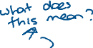

How many professionals today participate in Continuing Professional Development. Placing value on CPD did not necessarily translate into participating in it. (Andrew Rothwell, 2006). CPD is essential for all professionals today, to stay up to date with latest trends and new skills, so they can not only remain competent but for professional body evidence and, for promotions or new positions. (Bailey, 2011, 2016). This research includes guiding students to become professionals by engaging actively in CPD. Professional bodies are rapidly changing in knowledge, skills, and practice due to the competence expectations required in specific areas and departments. RGU wants to provide students a tool and process for CPD that they could take with them to the workplace. (Bailey, 2011).



Organizational learning, classroom learning, teamwork learning, seminars, self-study, collaboration learning, networking colleagues, attending conferences, certification training and, small group discussions are all forms of learning activities required to consolidate a student and will improve their practice prospectively. All these forms of learning are recorded as part of their curriculum.

This CPD app is a software with the main aim of allowing RGU students to document their CPD as a reflective practice by uploading evidence of their learning type (Trigger) to prove their attendance, Input the hours of learning, record their learning, submit a report of reflections and how the student handled situations or challenges at work if experienced, upload an attachment/documents, upload photos and images of the experience, input the timestamp of when the learning occurred and create a summary or report of their experience. We shall discuss more in detail in this report.

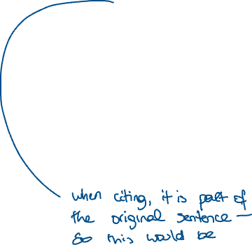

## 1.1 CHAPTER SUMMARY

Chapter 1 gives a background review of the reflective postcard system and CPD concept developed by Professor Fulford and Dr. Moira for students on various management and business courses to help RGU students develop reflective skills. Also, we covered the aim and objectives as a motivation for this project. We described reflective CPD and why this application reinforces the existing system in RGU today.

Chapter 2 provides a critical analysis of the problem we are trying to solve using a software-aided tool. Also, we will compare and analyse four models for reflections and how they contribute to the art (skill) of critical reflection and thinking (Bailey, 2011). We will also describe CPD in general, evaluate all the approaches used past till present and, justify the gaps in the research. Digital tools were discussed as alternative tools for recording students experience and also making notes of their reflections. These digital tools were considered but were not matching the specification for this project. Many CPD applications are currently being used but knowing the difference in what we are building is discussed in detail.

In Chapter 3, We then go ahead to provide a solution design that encapsulates the scope of the application, the user interaction design as it increases student’s level of interactivity, the database design, the reason why we are choosing the technologies (web stack) and system architecture after considering critically other alternatives. The methodology is also discussed as the process and pattern to which the solution is carried out. We selected Agile methodology which allows the project to be developed, tested, and deployed in phases called sprint due to the nature of the project. We will continue to see more features as we go on as opposed to the waterfall methodology that plans and builds all the features from the beginning.

Chapter 4, covers the major constraints identified with the project from the software development tools for the client-side and server-side to hosting the application in the cloud. We will also highlight the functional and non-functional requirements that explain what is required to build and maintain the system for user-friendly interaction in Chapter 5. This report attempts to cover the software and hardware requirement, ensuring there is no server downtime and latency associated with the App.

In Chapter 6, the legal, ethical, social, and professional (LESP) issues and considerations are discussed.

Finally, a conclusion to the report is presented in the last chapter, with an implementation strategy and purpose clearly stated.

## 1.2 BACKGROUND



The “reflective postcard” is a concept and platform developed by Professor Fulford and Moira in 2014, that enables RGU students to plan, record, and reflect their learning (formal and informal). This learning is categorised into 4 types called triggers:



* Events
* Enactment
* Encounters
* Experiences

**Events** refer to reflection by participation in training sessions like classroom-based learning, professional development events, and personal/private study.

**Enactment** refers to reflection triggered by performing tasks during an enterprise or entrepreneurship project such as setting up a business as a student, also performing market research, upskill, and practice.

**Encounters** refer to reflection triggered by networking and team discussions whether organized, Adhoc meetings, or scheduled professional groups.

**Experiences** refer to reflections that occur during incidents whether positive or negative of any kind. Also, challenges and problems encountered during industry experience or in the field.

The key idea here is reflection. Moira’s presentation on “What the Higher Education Academy says about Reflection” (Dr Bailey, 2013) backs up the concept of the reflective postcard by what reflection means literally. Reflection deepens knowledge. It is one of the most advanced way of taking advantage of your ability to think and use the human brain(Dr Bailey, 2013). I also researched what reflection means and it says “serious thought or consideration” (Oxford Dictionary). So, the idea of the postcard was to tell students the difference between description and reflection. Also, that it takes more effort to develop reflective skills than just describing a learning experience. We discuss more on the postcard in section 1.1.2.



### Reflective CPD in RGU

Research in reflective learning and professional development shows that a number of tools that supports reflection have been developed, with learning logs, diary and journal discussed more often (Moon, 2006) and (Moon, 1999). RGU Business school have supplied the usage of postcards to students and graduate interns on residential training programmes (Fulford, Marcella and Levie 2013), This was inspired by the “Lefthand Column” technique outlined in Senge et al. (1994) in which students drew line down the middle of a page in a book. The left-side of the page used to transcribe the recording of a training session while the right-side used to write what they feel and think.



Professor Fulford and Moira devised the postcard as visual resource to aid the development of reflective fluency. So, RGU students were introduced to the postcard concept by discussing with them using typical holidays postcards and to respond to each of the four triggers outlined above (events, enactment, experiences, and encounters) by recording what happened (descriptive) and then reflecting on it (analytical). A sample is printed for them below in fig 1.0



FIG 1.0 A Two-Sided Postcard ( FULFORD, H. & BAILEY, M., 2014)



**Postcard: the “recording side”**

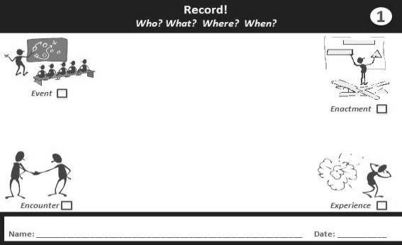

**Postcard: the “reflecting side”**

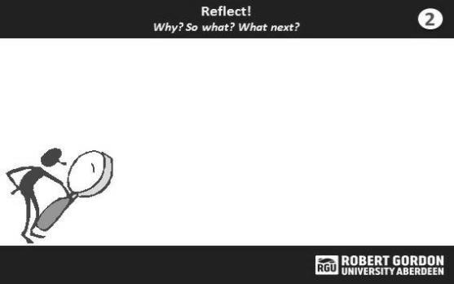

RGU entrepreneurship modules, like BSM539 (Entrepreneurship Contexts) and BSM2530 (Enterprise Creation) make use of these postcards within the curriculum for mentoring students. The modules form an integral part of the students’ experiential learning projects. RGU MSc degree students typically work in small group, and are given copies of the postcards each week by their module coordinator. The students are instructed to return to their tutorial session the following week prepared to give feedback about the progress of their business start-up project with their mentor/tutor.

Part of the feedback session requires they bring their completed postcards, with the assumption that they have recorded their experiences and reflected them on both sides of the postcard during the week. If you take a look at the postcard in fig 1.0. There are questions to be answered by the students during their start-up project. The who? the what? the where? and the when? They are meant to also answer the questions at the reflecting side of the postcard. Through these questions, it becomes much easier to differentiate between recording and reflecting. Consequently, knowledge is passed across to RGU students.

Experience to date has shown that as RGU Masters student continue to take the entrepreneurship module, they become more aware of this distinction between description and reflection, and so reflection starts to become a more natural and habitual activity. (Moon, J. A., 1999) . This leads to why we are developing an App so that this same element will be incorporated into a software having the postcard format as a user interface. We will design and structure this software to fit the same purpose of reflective learning in this project.

### Aims

This project aims to develop a CPD app that incorporates the currently used RGU business school postcard format (fig1.0). RGU business school students are currently using the postcard for CPD, so this application is just the digital type of the postcard but this time in a user-friendly manner. This application is to be used by all professions which ultimately documents and archives the process of the reflective learning that students could take with them to the workplace. This will enable the student to review their learning as they grow in career and life. Also, many professional bodies require students to attach a CPD portfolio as part of the membership and registration process. To effectively communicate and achieve this, students will do two things. One, record their learning which is descriptive learning based on the 4 trigger types mentioned in fig 1.0, and then reflect them which is analytical learning. (Fulford, H. & Bailey, M., 2014)

### Objectives

We are to investigate existing CPD apps in other higher educations and professions to see if the application is already in existence. Also, to investigate the current postcard paper-based design and integrate the idea into the CPD software app.

To investigate the data type, design and structure in tandem with the postcard format and CPD requirements. To also ascertain the potential benefits this software could have in the RGU educational system across all profession and improve on features that implements reflective learning.

Investigate the strength and weaknesses of CPD app.

Develop, Design, implement, test and document a software solution that can register students in RGU, record their learning, upload files and images of their learning environment, document their CPD and generate a CPD portfolio. This is to be used during students professional practice and career according to Professor Fulford and Bailey’s three stages of tried and tested reflective learning development. (Fulford, H. & Bailey, M., 2014)

Investigate the Integrated Development Environment (IDE) that best suits the CPD application.

# LITERATURE REVIEW

## MODELS FOR REFLECTION

## DIGITAL TOOLS FOR REFLECTIVE PRACTICE

Using technology tools like an app to support teaching, Mentoring and learning make things move fast. Any institution involve in teaching would come to terms with the concept of reflective practice. It is key to professions integrating Continuing Professional Development (CPD).

The Higher Education Authority (now part of AdvanceHE) explored how professional reflection

Is thinking about what you are doing or learning rather than fussing over what is been learnt. (Warwick, 2007). Their primary intention was to make obvious that between notions of reflection and the attributes practiced by those in the educational sector.

Moira and Fulford who is proposing this idea of using a digital tool to extend the already used postcard concept for RGU students, believes there is a connection between thinking criticallyand reflecting on what has been taught, and also it is a must skill for undergraduate and post graduate student who wants to keep up with the trends of the profession they seek to participatein. (Fulford, H. & Bailey, M., 2014)



Meanwhile, reflection can easily be limited especially with students finding it tasking to carry bunch of postcards every time they want to record and reflect their learning either informal or formal. Also, the postcard is limited in space to convey their thoughts and reflections.

Using digital tools for reflection can also enhance more general [digital capabilities](https://www.jisc.ac.uk/building-digital-capability), which are increasingly valued in the workplace. (University of Sussex , 2018). This forms part of the reasons why digital tools that can make it easier can bring benefits for learning and professional development.

From research, the fact that technology is much popular and plays a vital role in this era than it did for previous generations has made today’s generation to demand and desire the need for digital tools and literacy. “From the millennial to Gen-Z, these are the generations that are coming into the classroom today and they share unique characteristics that define their generations.  These generations expect to be engaged in their learning and they do not do well being passive learners.  Hence, technology has to be embraced in today’s education and teachers have to apply technology as part of the students learning.” (Harwati, 2018).

First let us look at alternative digital equivalents in the next section that can help students record and reflect their learning and achieve the concept of paper-based postcard used by RGU students.

### Alternative Digital Documents, Note-taking apps for Recording and Reflecting

Note-taking apps such as OneNote, Evernote, Google Keep, Googledocs offer possibilities to students in writing down their reflections. Meeting, lecture notes, reminders and assigning task can be carried out. With these apps you can add images or photos as evidence of CPD learning and publish to the web. They can also synchronize across all your devices whether mobile or web. This can be useful as student’s virtual notebook.

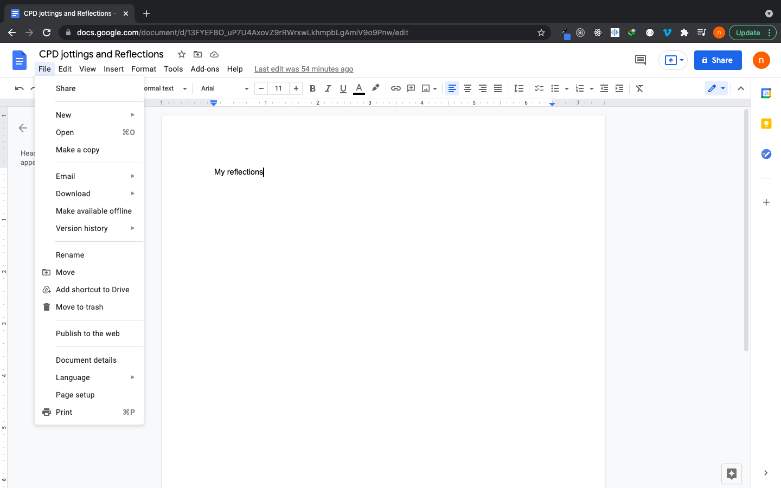

Fig 2.0

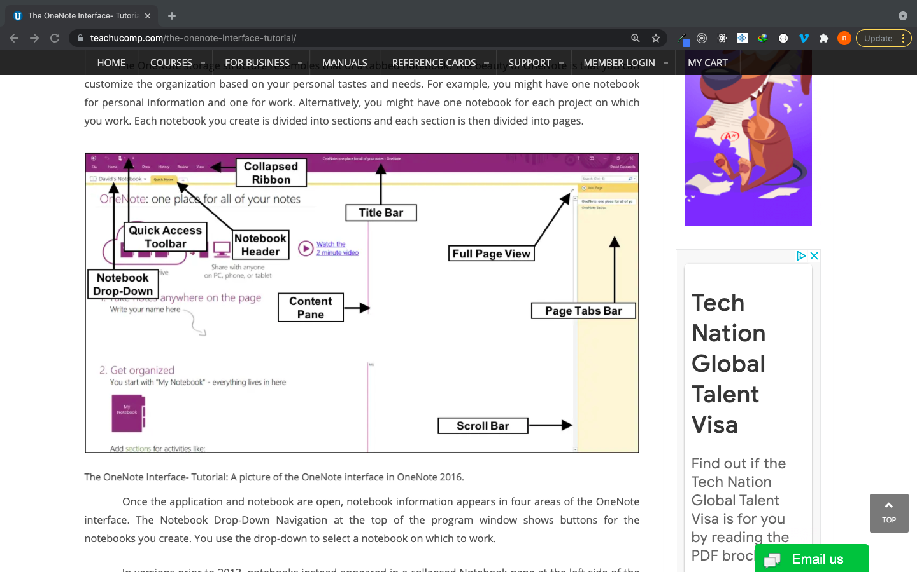. Fig 2.1

Fig 2.2

Microsoft OneNote combines well with Microsoft 365 (see fig 2.1), for students to store their notebooks in OneDrive

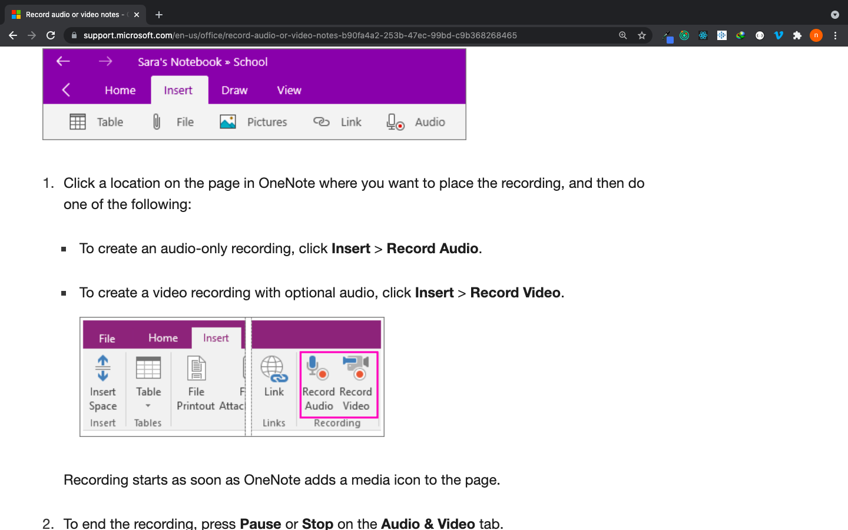

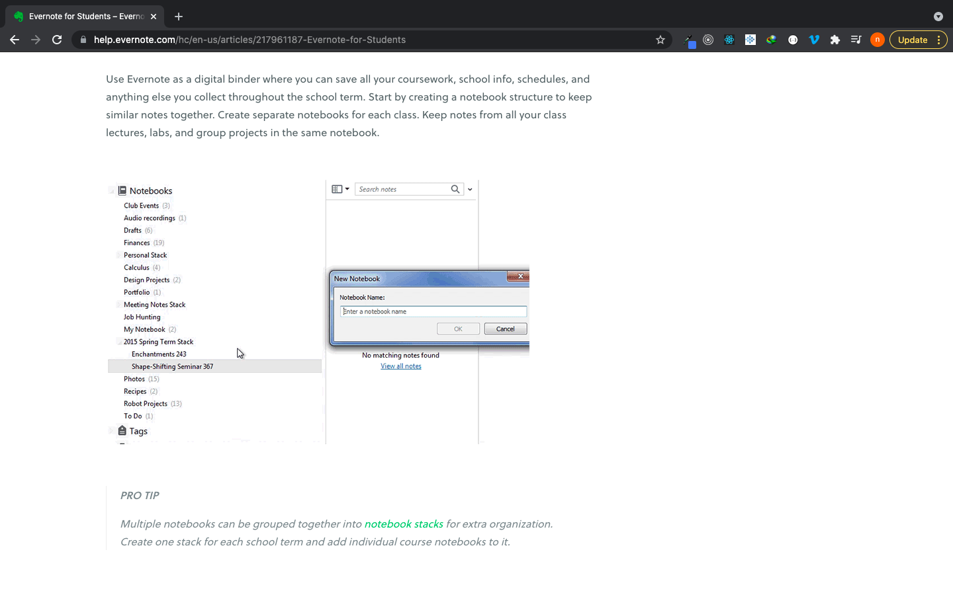

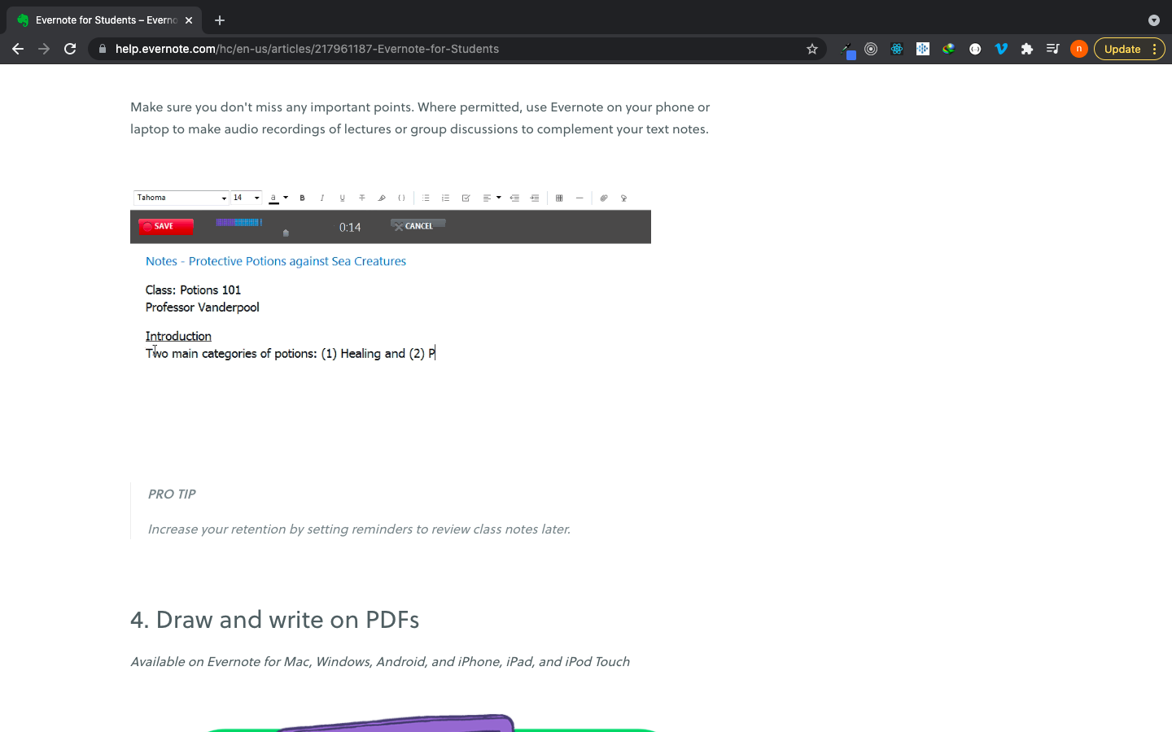

|  |  |  |  |
| --- | --- | --- | --- |
|  | **OneNote** | **Evernote** | **Google Docs** |
| **User Devices** | Windows, MacBook, iOS, Android and web | Windows, MacBook, iOS, Android and web | Windows, MacBook, iOS, Android and web |  |
| **Content type and features that can be used** | Text, images, web content, emails, tables, Audio recording and video recordings. | Text, images, web content, Audio recording and checklist | Text, web content, No audio recordings, arts and drawing, photos and list |
| **Sharing notes with other digital tools** | yes | yes | yes |

Table 2.0. Comparison as at November 2018

OneNote outperforms Evernote and GoogleDocs through the video capturing feature. Also, OneNote has tools for dictation but Evernote lacks it. However, Evernote has a good user experience and collaboration functionality than GoogleDocs and OneNote but they both do the same. The most difference between Evernote and OneNote is that the full potential of Evernote comes with the paid version, while you can access all features in the advanced version of One Note when it is free. (Pierke, 2016)

### Strength of the note-taking app.

* Digital notebook is used instead of Microsoft word inorder to create one or more files where students can write their reflections, add image files and hyperlinks.
* They can be use on smartphones, PC, laptops and tablets.
* RGU students are each entitled to sign in to used Microsoft Office and store file up to 1TB with office 365.

### Weakness of the note-taking app.

* The aim of the CPD application is not to follow inbuilt tools available on the note-taking apps
* Rather, we are building features that enhances students reflective learning ranging from the formal, through the informal, to the incidental in three stages of design.(Fulford, H. & Bailey, M., 2014)
* The note-taking app does not have structure for mentoring like in Fig 1.0. An interface for long-term reflections will need a free-text journaling tool so students can aggregate their reflective jottings over the life of a project like a summary or reflection statement.
* The note-taking app does not have a database to help students plan their CPD activities like reflective journals database for the students based on weekly, monthly and yearly plans.
* There will be a need for a calendar feature mapping to each students learning period.
* Note-taking apps does not have the postcard reflection system, cv repository, facility for recording contacts, audiovisual guide and a profession skills questionnaire (see fig 2.5 below)

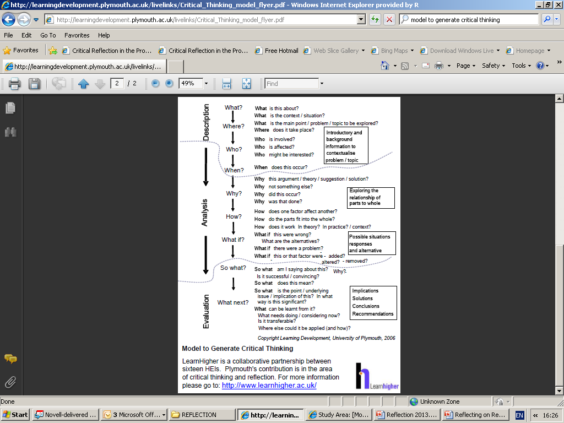

(Dr Moira, 2013)



## RESEARCH OF REFLECTIVE LEARNING SYSTEM AND CPD APPS

An exploratory project was reported in which seven primary teachers in England shared their experiences of mentoring students through small data visualized on postcards. Two of the

reasons why they used data during the data sharing discussion between the student and the teachers were; reflection on practice and reviewing professional lives.(Burnett, Merchant and Guest, 2020). From the report, they proposed the project worked. However, still temporary.

Burnett’s report of sharing on postcards to students was focused primarily on the teacher’s experience of how literacy education would be beneficial to teachers more than the students. They obtained feedback on the students learning experience and how they performed during their projects. (Burnett, 2020). David and Eytan discussed a medicine rotation by medical student using postcard to reflect upon the way medicine is practice and taught just after recording the professionalism and ethics during medical visits. (David, Eytan, Kathy, 2010). However, the postcard approach Fulford and Bailey proposed focuses on short-term and long-term reflections carried out by RGU students which covers all professions including Human resources, Project management professionals, Procurement and supply chain, Health and safety, General management and all professions governed by a professional body which is the gap that this project is to fill. (Fulford, H. & Bailey, M., 2014). Let us look at professions already participating in CPD and the applications used to evidence CPD in the next section.



### Professions Participating in CPD and Activities

### Comparison of CPD App in the other Professions and what is to be developed in RGU.

### Evaluation.

### 

# PROBLEM ANALYSIS AND SOLUTION DESIGN

## CONSTRAINTS

This is a list of the major constraints identified with the project.

|  |  |
| --- | --- |
| **CONSTRAINT** | **ISSUE/SOLUTION** |
| Server Hosting | CPD is designed to meet user(students) needs, yet to be effective and operational, the client-side and server-side script has to be deployed and hosted on a Server (remote cloud). For this project, the serving Host will be initially Heroku which is preferred due to it is flexible and easy to use for this project. then later we will consider AWS, the tools used for Hosting are Git installations and Heroku CLI. Heroku will manage this application with Git, the popular version control system. The application is first deployed or pushed to the Git repository, then the Heroku command Line interface tracks the Git repository. Heroku provides Pipelines, which makes the CPD easy to maintain in separate staging and production environments. |
| GitHub | GitHub repository will be employed. GitHub is a hosting platform for version control and collaboration. A private repository will be created for this project on GitHub with a default branch called Master. Subsequently, other branches will be created based on the different features. For instance, working on the Signup page, the branch name will be called feature_signup. The project supervisor will be made a collaborator. GitHub master branch is the base branch that will merge all feature branches through a pull request, then the source code can be deployed on a cloud server (Heroku) from the master branch, and changes can be tracked for both GitHub and Heroku. |
| Client-Side (REACT) | Users of this application (CPD) must be able to interact with an interface. They must be able to see all the pages designed in Fig 1.1. HTML for the structure of the webpage (text and content), CSS for styling the webpage (putting aesthetics to the page) will be embedded in the REACT.  The front-end will have an interface that students can interact with. |
| Sever-Side (Node and MongoDB) | This application requires a server to receive the request, and also should respond to the request. It understands the language of the browser and can respond to the request made by a clientside (web interface) over HTTP (Hypertext Transfer Protocol). The server also has a controller function that can communicate with the database and render the data to the front-end. This application will make use of the MongoDB database for storing, querying, retrievals made by several users (students that are registered. |
| Features  • Login system | The system in place for users to log in will take series of steps.  There will be a form that takes in username and password. This credential will be validated from the front-end and also the back-end |
| • Roles and Permission | Two users exist in the CPD app. Logged-in users and general users. Logged-in users can access a CPD portfolio and, a general user cannot. |
| • File Upload | The logged-in user will be permitted to upload resources as part of his CPD representing the materials of his learning. The file upload input will be displayed after he has logged in using a login credential (username and password), and the database will store a reference to this material. |

## SCOPE AND PROCESS OF PROJECT

This is a process breakdown of the application in terms of the user interaction flow:

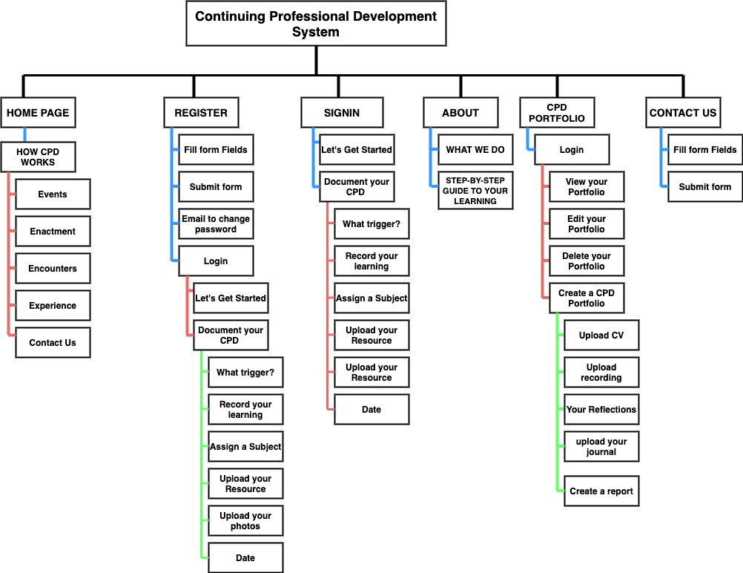

Figure 3.0 User-interaction flow

## METHODOLOGY

In this project, we will be using the Agile Methodology which makes use of the SCRUM framework. SCRUM makes it possible for the project to be broken down into items based on priority (hierarchy of functional features starting from what is most important). These items are called Product Backlog Items (PBI’s or PBL). So, we will have to choose the items (features) to build and deliver as an MVP (Most Viable product) in a sprint (first cycle). Each sprint will have its items to be shipped and deployed called Sprint Backlog (SBL). The SBL is a subset of the BPL based on what can be developed in a sprint.

## TECHNOLOGY AND SYSTEM ARCHITECTURE

In this project, we will employ the Monolithic architecture pattern. This will host a single code base with multiple modules. Modules are files with separate functions that implement certain technical and business features. The whole system in each sprint must be ready before it can be deployed.



Figure 1.2 Monolithic Architecture

U

SER

I

NTERFACE

BUSINESS

LOGIC

DATA

LAYER

DATAB

ASE

In this project, the technology we will employ includes the web stack to be used for the development of the application. MERN stack will be used which makes JavaScript the programming language. The front end includes ReactJs, Back-end is NodeJS and the database is NoSQL which is MongoDB. My choice of this web stack stems out from the fact that NodeJS has a cross-platform run-time environment that makes mobile, web, and desktop able to consume the same endpoint (data) through REST API (Representational State Transfer).

ReactJs is also most suitable for the client-side due to its inbuilt style of modularity, supports single-page applications, makes page routing easy, and flexibly handles state(data). The database chosen is MongoDB, a NoSQL database system with its ability to handle large unstructured data in a flexible way. Queries are faster and have great performance.

## DATABASE DESIGN

# PROJECT REQUIREMENTS AND SPECIFICATION

## FUNCTIONAL REQUIREMENTS

This section details how the system should behave. In terms of priority, we will use the MOSCOW Method. “M” stands for must, “S” for Should, “C” for could, “W” for Won’t.

|  |  |  |  |
| --- | --- | --- | --- |
| **Item** | **Component** | **Method**  **(MOSCOW)** | **Description** |
| User  Management | Register | S | A user/student can register by entering his name, email, and password. The user waits for approval by the application’s backend. |
| Login | M | A user will enter his email and password to access the admin dashboard. |
| Logout | M | A user can log out through the navigation bar and he won’t be able to access the CPD portfolio except he logs back into the system. |
| Role | Logged-in User | M | This user has access to the CPD portfolio with Admin rights and can create a CPD portfolio, view his portfolio, report his reflections, and more. |
| General User | M | This user can only visit the home page, see how the CPD works. He can also visit the about page and view step by step process of learning. He can also contact us through the contact us form for inquiry. |
| Authentication | Login | M | The system will check the username and password of the user exist in the database as approved by the system. If not, he is redirected to the homepage to register. |
| Authorization | User role check with session or cookies | C | The system check for the user role after logging if the user is a general user or logged-in user through his session. |
| User  Interaction | Search | C | A logged-in user can search for a CPD based on the date he created one. From the CPD search bar, the user will input a keyword and the database will dynamically recall the last date of the document by filtering the search. |
| Resource upload | M | Resources include e-books, images, and files for students to upload while documenting their learning. It is a feature that can read in an image file, e-book and others. |
| Post | M | Logged-in users can access the features of publishing a post and upload an image. The feature of deleting a post and delete comments made by general users and approve comments is going to be nice to have in the future. |
| Profile | C | A logged-in user shall be able to create a profile by filling a form in the CPD Portfolio area after log-in. |
|  | Hyperlinks | M | Links will be created on every page for easy navigation. |
| Navigation bar | M | The Homepage, register page, Login page, about us page, CPD portfolio page, and contact us page will have icons on the navigation bar that routes to its direct page |
| Database | CRUD | M | The database shall be able to perform a create, read/write, update and delete the user and a portfolio |

## NON-FUNCTIONAL REQUIREMENTS

These are quality attributes the product should have to give the user a good experience.

|  |  |  |
| --- | --- | --- |
| **DOCUMENT NAME** |  | **DESCRIPTION** |
| Software Requirements | • | This is a web-based application for a start, so an internet connection must be established. |
| Hardware Requirements | • | CPD is intended to work on any computer with a minimum capacity of 4GB of hard drive, Memory of 128MB and above, operation system of WIN XP/VISTA/MAC/LINUX |
| Security | • | Password shall never be viewable at the point of input. |
|  | • | There must password encryption for users in the database during storage. |
|  | • | Users will in the future be forced to change their password the next time they log in and there will be a password expiration time. |
|  | • | HTTPS encryption must be used to protect user credentials over the web when the begins to scale. |
|  | • | The system will approve admin rights to users that have logged in. |
| Performance | • | There should be no limits in the number of users that can be added or created in the database. |
|  | • | The programming language should be up to date in a version that improves performance. |
|  | • | The version of Node should give massive performance improvements and thereby, server response time optimized. |
|  | • | The server’s location must be in proximity to the client, thereby reducing network latency. |
| Reliability | • | The application must ensure a great user experience across all pages. It automatically sorts the fresh content to the user during search. |
|  | • | Links to automatically and dynamically loads page and resource from the database and renders it to the user on his request page. |
|  | • | There is no data loss due to the database type and data type are accurately chosen for all input. |
|  | • | The URL is friendly and file uploads are received seamlessly by the system. |
| Scalability | • | When the app starts to receive more requests per second than the server limit, horizontal scaling is recommended due to its nature of purchasing CPU, memory space, and Hard disk, servers, database per scaling. With this type of scaling, we will be able to keep track of what is been used. |
|  | • | In the long run, an MVC pattern of design for the code will help scale the application due to its modularity. Different developers can work on different areas when it scales. |
| Technology Architecture | • | The client-server model and architecture are built by using Front-end stacks for hosting the page, backend for the server and database to deliver the data, which are NODE and Express, then the database is MongoDB. |
| Ease of Use | • | Users with no technical background would visit how the page works in the home page in order to manage the website, create a CPD, edit and manage their learning process and content online. |
| Availability | • | The application shall be available for use 24/7 |
|  | • | The system shall achieve more than 80% uptime. |
|  | • | The cloud service must keep track of changes with a system alert, also concerning the upgrade of configurations/ library stacks and new deployments. |
| Testing | • | The input for username must be characters of length not greater than 30 |
|  | • | The email for signup must be an input type of email for HTML validation |
|  | • | The password from the input to be stored in the database must be added to a randomly generated special character by the server and hashed using hashing algorithms. |
|  | • | There must be cross-platform testing on several browsers. |

# LESP

# SUMMARY AND CONCLUSION