GKE Multi-Cluster on GCP
Project Output and Test Evidence
Narendra Reddy K
GCP Take-Home Assessment
September 2026
Repository: github.com/NNARENDR/gcp-gke-multicluster-assessment

1. Overview
This document collects the output and screenshots from my test runs. Each section matches one part of the assessment. The code, setup steps and design decisions are in the README of the GitHub repository.
What I built:
- One GCP project (gke-assessment) with a custom VPC and two private GKE clusters: gke-primary in us-central1 and gke-secondary in us-east1.
- Two stateless web apps (App A: hello-app, App B: whereami), each running 3 pods in both clusters.
- Multi-cluster Ingress: one global IP (130.211.22.144) that sends users to the closest healthy cluster and fails over automatically.
- Security: Cloud Armor WAF and rate limiting, Workload Identity per app, and Secret Manager with least-privilege access.
- Observability: load balancer and GKE logs exported to BigQuery, and a Grafana Cloud dashboard with error rate, pod restarts, latency and CPU/memory.
- All infrastructure is Terraform with remote state in a GCS bucket.

Assessment checklist
Requirement | Where to see it | Result
1 project, 2 GKE clusters in 2 regions (Terraform) | Section 2 | Done
2 stateless apps on multiple pods | Section 3 | Done, 3 pods each per cluster
Global load balancing (Multi-cluster Ingress) | Sections 2 and 3 | Done, single global IP
Failover between regions | Section 4 | Tested for App A and App B
Cloud Armor | Section 5.1 | 200 normal, 403 XSS and SQLi
Workload Identity | Section 5.2 | Pod runs as app-a-sa, no keys
Secret Manager | Section 5.3 | app-b allowed, app-a denied
Logs to BigQuery + queries | Section 6.1 | Done
Grafana: error rate, pod restarts, latency, CPU/memory | Section 6.2 | Done, 5 panels
Troubleshooting write-up | Section 7 | Done

Architecture
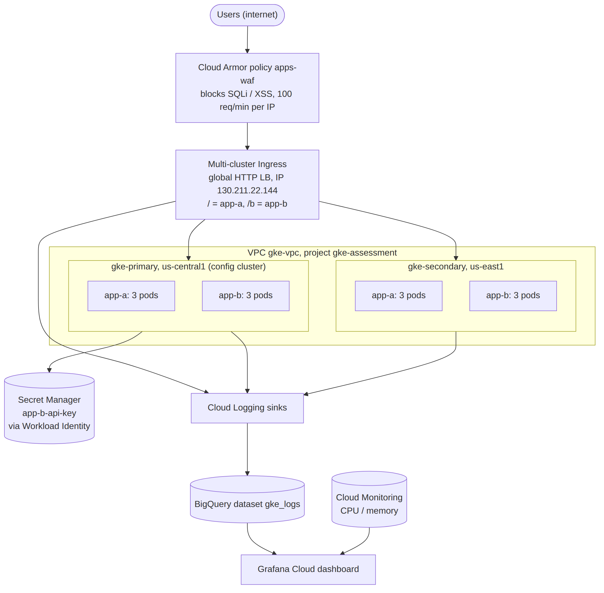
Figure 1: Architecture: Cloud Armor and Multi-cluster Ingress in front of two GKE clusters, logs to BigQuery, Grafana on top.

2. Infrastructure (Terraform)
terraform apply finished and printed the outputs: the VPC and subnets, the service account for each app, the CI/CD and node service accounts, and the Artifact Registry path.
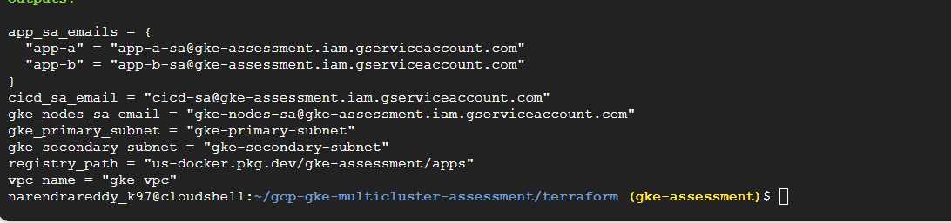
Figure 2: Terraform outputs after apply.
Multi-cluster Ingress built the whole global load balancer by itself: backend services and health checks for both apps, one NEG per app in each cluster (us-central1-a and us-east1-b), the URL map, target proxy and the VIP 130.211.22.144.
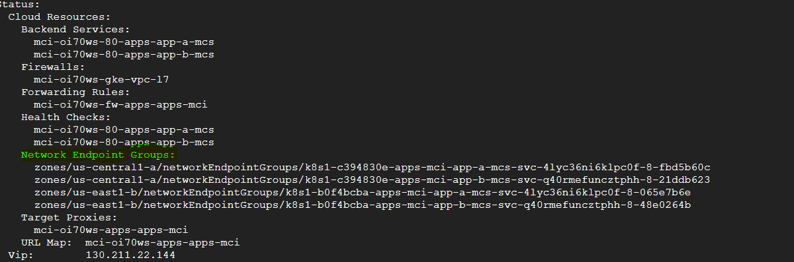
Figure 3: kubectl describe mci apps-mci: cloud resources created for both clusters.

3. Apps Running Behind the Global IP

3.1 App A spread across pods (primary cluster)
I called App A in a loop. The hostname changes between the three pods, so the load balancer is using all of them. The pod list below the output shows the same three pods Running.
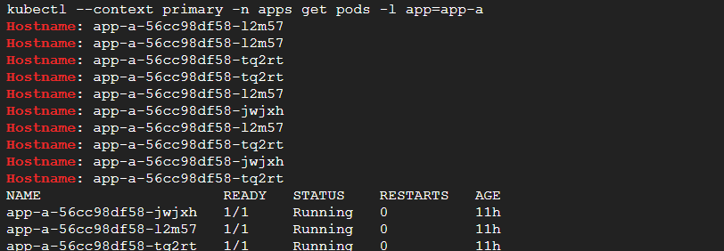
Figure 4: App A responses rotate across 3 pods in gke-primary.
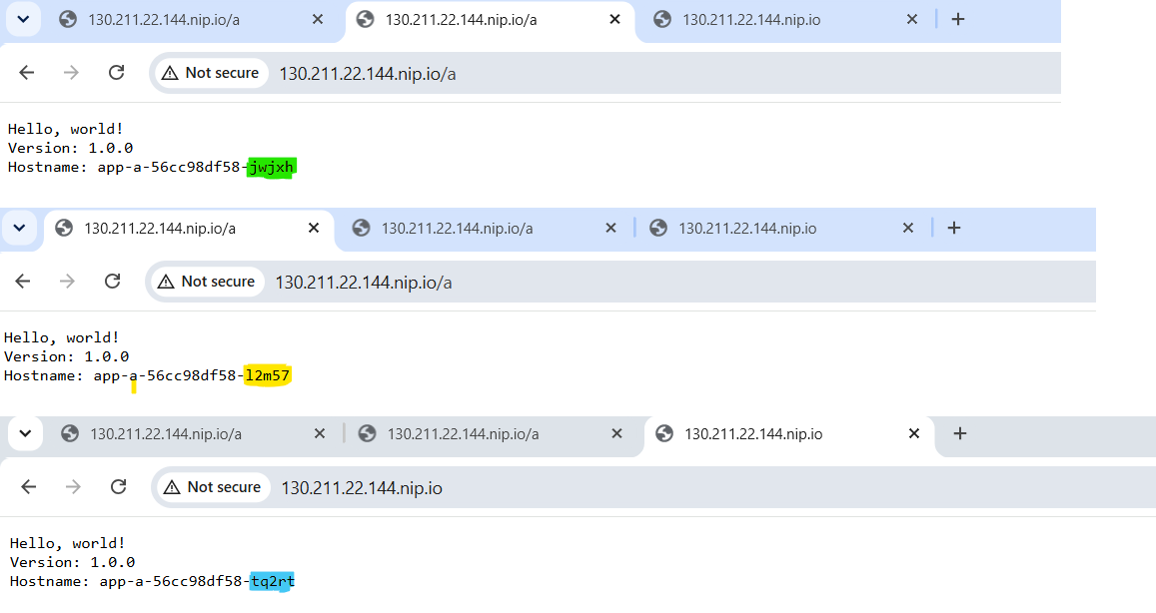
Figure 5: App A in the browser: three tabs, three different pods (jwjxh, l2m57, tq2rt).

3.2 App B and proximity routing
App B returns JSON with the cluster, zone and pod name. From my location every request goes to gke-primary in us-central1-a, because Multi-cluster Ingress sends users to the nearest healthy cluster. The JSON also shows gce_service_account = app-b-sa, so the pod is running with its own identity.
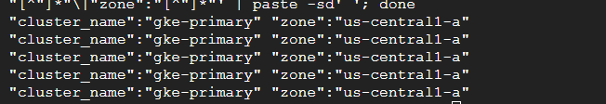
Figure 6: curl loop on /b: all answers from gke-primary, us-central1-a.
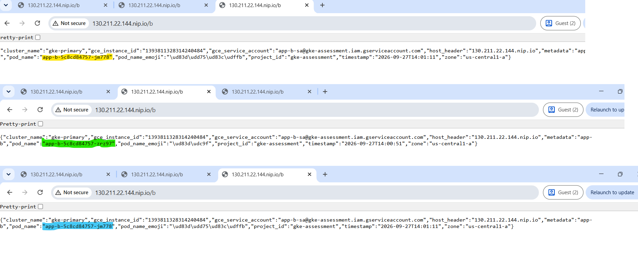
Figure 7: App B in the browser: different pods, same cluster (gke-primary).

4. Failover Tests

4.1 App A failover
I removed App A from the primary cluster. kubectl shows no App A pods in primary and 3 Running in secondary. The same URL kept working and was now answered by the secondary pods (2zwfv, jks28, vcwz6).
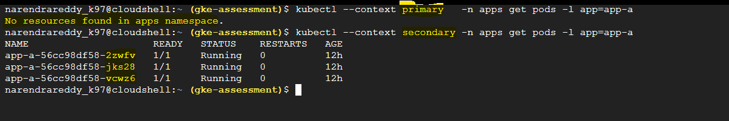
Figure 8: App A: 0 pods in gke-primary, 3 pods Running in gke-secondary.
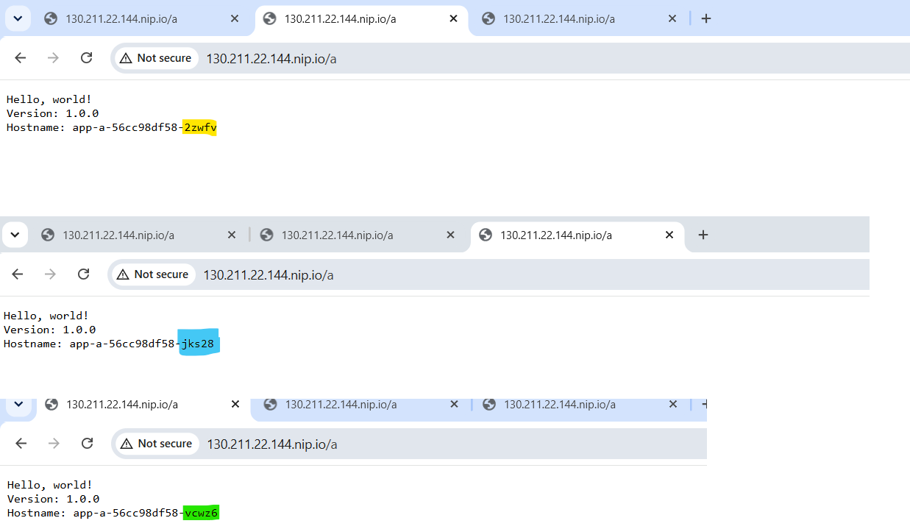
Figure 9: Same URL, now served by the pods in gke-secondary.

4.2 App B failover with timestamps
I ran a curl every 5 seconds and scaled App B to 0 replicas in the primary cluster. At 14:10:55 the answer still came from gke-primary. From 14:11:00 every answer came from gke-secondary in us-east1-b. I did not change DNS or anything else. The load balancer moved the traffic because the primary backend failed its health checks.
kubectl --context primary -n apps scale deployment app-b --replicas=0
for i in $(seq 1 20); do echo -n "$(date +%T) "; curl -s http://$MCI_IP/b \
| grep -o '"cluster_name":"[^"]*"\|"zone":"[^"]*"' | paste -sd' '; sleep 5; done
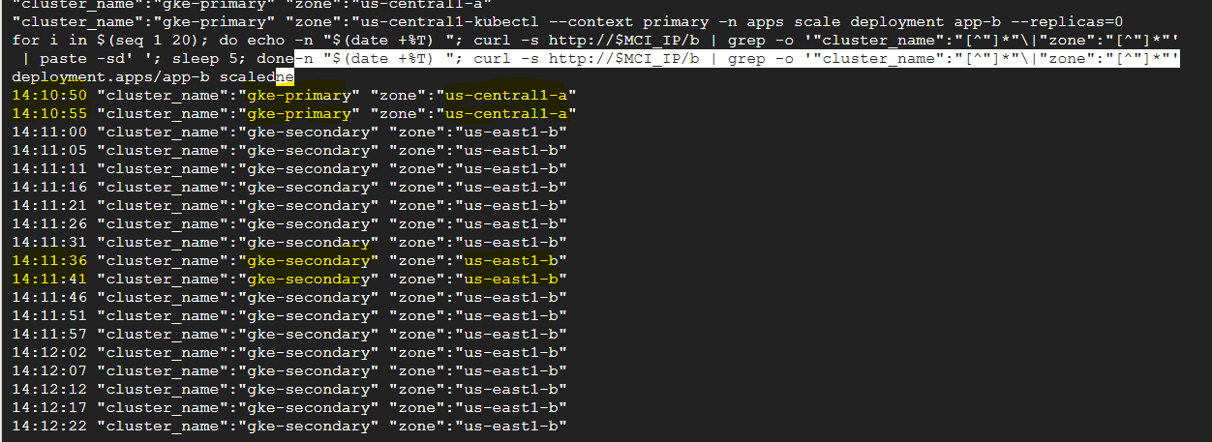
Figure 10: App B switches from gke-primary to gke-secondary within about 5 seconds.
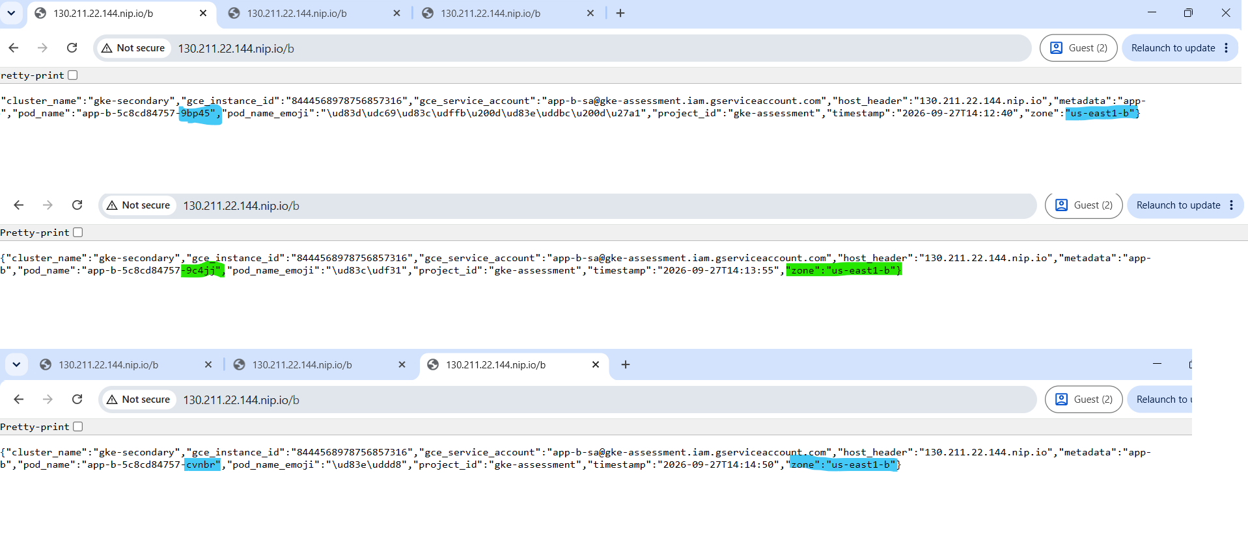
Figure 11: App B in the browser after failover: cluster gke-secondary, zone us-east1-b.
After the test I scaled App B back to 3 replicas in the primary cluster.

5. Security

5.1 Cloud Armor
The policy apps-waf is attached to both backend services through BackendConfig. A normal request returns 200. An XSS attempt and a SQL injection attempt are blocked with 403 at the edge, before they reach the cluster. The policy also has a rate limit of 100 requests per minute per IP (429).
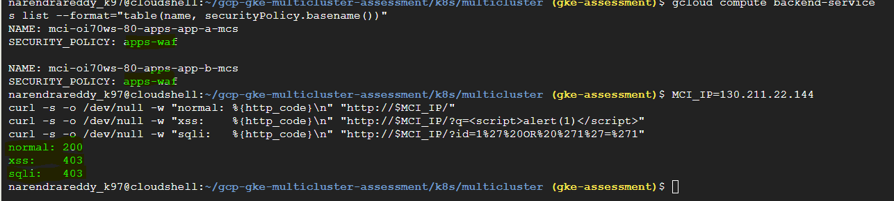
Figure 12: Both backend services use apps-waf. normal = 200, xss = 403, sqli = 403.

5.2 Workload Identity
I started a test pod with the Kubernetes service account app-a-ksa and asked the metadata server which identity it has. The answer is app-a-sa@gke-assessment.iam.gserviceaccount.com. The pod gets a Google identity from its Kubernetes service account, with no key file.
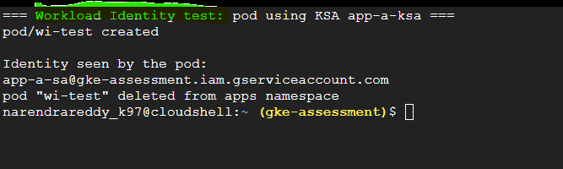
Figure 13: Pod using app-a-ksa is seen by Google as app-a-sa.

5.3 Secret Manager (least privilege)
The secret app-b-api-key can only be read by app-b-sa. I tested it with two pods: one as app-b-ksa (should be allowed) and one as app-a-ksa (should be denied). The value was added with gcloud, not Terraform, so it is not stored in the Terraform state.
- Pod as app-b-ksa: secret value returned (allowed)
- Pod as app-a-ksa: 403 PERMISSION_DENIED (denied)
[ Add screenshot here: successful Secret Manager test, app-b allowed and app-a 403 ]
My first attempts at this test failed with 401 and empty output. The cause and fix are in Section 7, item 6.

6. Observability

6.1 Logs in BigQuery
Two log sinks send data to the BigQuery dataset gke_logs: load balancer request logs (table requests) and GKE container, pod and event logs (tables stdout, stderr, events and others). A count by status code shows the normal traffic (200), Cloud Armor blocks (403) and the failover window (502). All queries are in docs/bigquery-queries.md in the repo.
SELECT httpRequest.status AS status, COUNT(*) AS n
FROM `gke-assessment.gke_logs.requests`
GROUP BY status ORDER BY status;
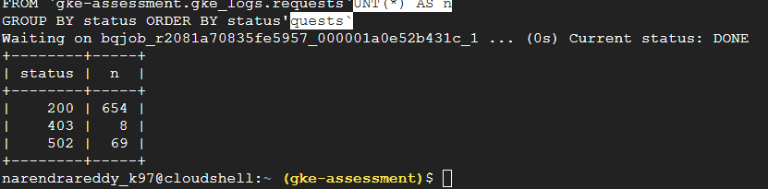
Figure 14: BigQuery: 200 = 654, 403 = 8, 502 = 69.

6.2 Grafana dashboard
Dashboard "GKE Multi-cluster Observability" in Grafana Cloud. It has two data sources: Google BigQuery (error rate, pod restarts, latency) and Google Cloud Monitoring (CPU and memory). Grafana uses a read-only service account. The time range is my test window, 27 Sep 2026, 17:45 to 19:15 (Central).
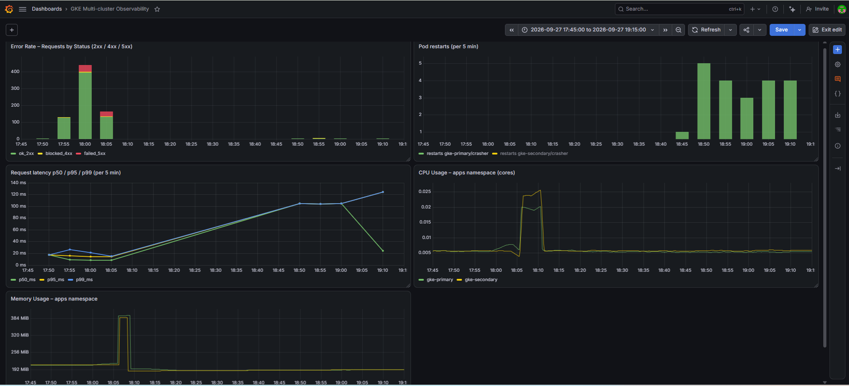
Figure 15: Full dashboard with all five panels.

Panel 1: Error Rate – Requests by Status
Requests per 5 minutes, split into 2xx (green), 4xx (yellow, mostly Cloud Armor blocks) and 5xx (red). Error rate is the red part divided by the whole bar. The red at 18:00 and 18:05 is the failover test. After that there are no errors.
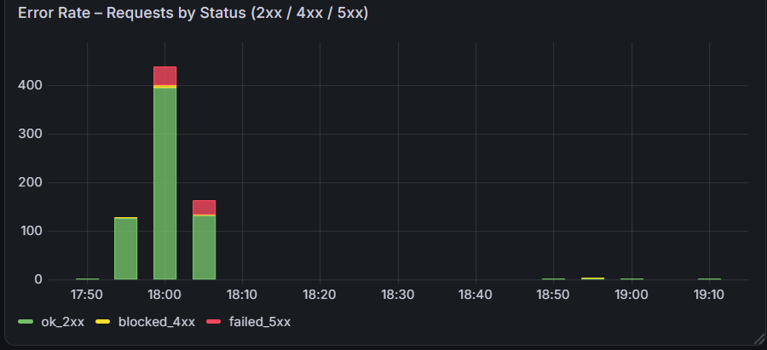
Figure 16: Error rate: short 5xx spike during failover, then back to zero.

Panel 2: Pod Restarts
CrashLoopBackOff events per 5 minutes, by pod. To test this panel I ran a pod that exits on purpose (crasher in the chaos-test namespace). Kubernetes kept trying to restart it, about 3 to 5 times every 5 minutes. I deleted it after the test.
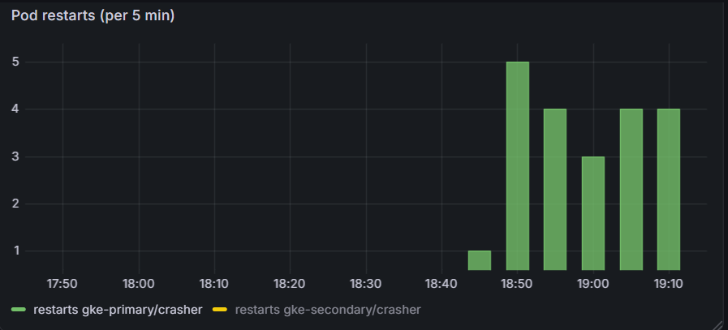
Figure 17: Pod restarts: the crasher test pod in gke-primary.

Panel 3: Request Latency p50 / p95 / p99
Latency of successful requests. During my tests p99 stayed under 30 ms. The later points (about 100 to 125 ms) are a few outside requests from the internet. Load balancer latency includes the network time to the client, so clients far away show higher numbers.
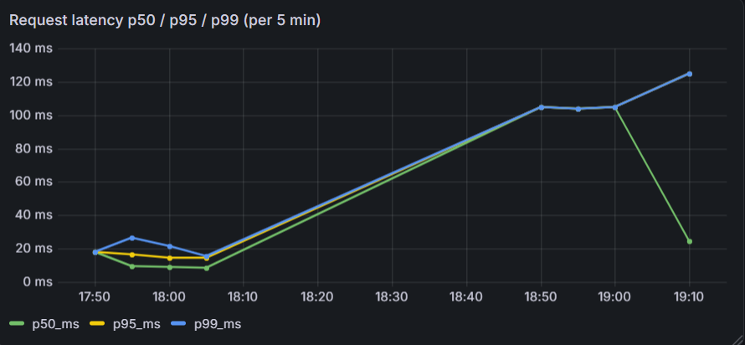
Figure 18: Latency p50 / p95 / p99 in milliseconds.

Panel 4: CPU and Memory
CPU cores and non-evictable memory used by the apps namespace in each cluster (from Cloud Monitoring). At baseline it is about 0.005 cores and 200 MiB per cluster. The spike around 18:06 to 18:10 is from pods being recreated after the failover test. Both lines go back to baseline, so there is no memory leak.
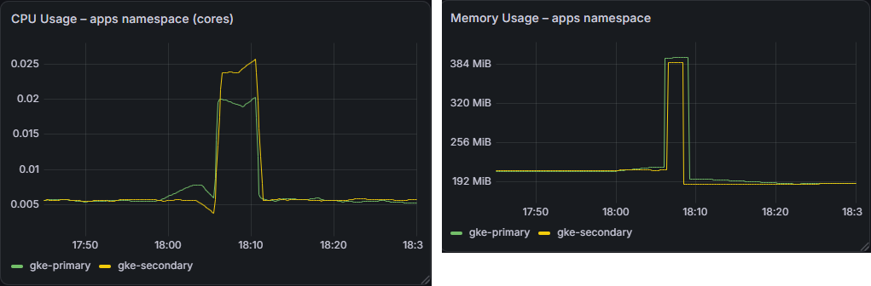
Figure 19: CPU (left) and memory (right) per cluster.

7. Troubleshooting
These are the real problems I hit and how I fixed them. The full write-up with commands is in docs/troubleshooting.md in the repo.
# | Problem | Cause | Fix
1 | terraform not found in Cloud Shell | Not preinstalled | Installed from HashiCorp apt repo, copied to ~/bin
2 | GitHub rejected push (117 MB file) | .terraform/ provider binary was committed | Fixed .gitignore, removed .terraform from git
3 | IPv6 "cannot assign requested address" | Cloud Shell VM network issue | Restarted Cloud Shell; -refresh=false when repeated
4 | Cloud Build failed (logs bucket access) | Default compute SA used by Cloud Build | Ran as cicd-sa + logWriter + CLOUD_LOGGING_ONLY
5 | Log sink IAM binding failed | Logging service agent not created yet | gcloud beta services identity create
6 | Secret test: 401, then empty output | Newline in token; WI token not ready | tr -d "\n" on token, sleep 5
7 | kubectl "couldn't attach" warning | Pod finished before attach | Harmless, output still shown
8 | Grafana: wrong source, hard-to-read graph | Default Prometheus source; % per minute | BigQuery source; stacked counts per 5 min
9 | tfvars in git, SA key exposed | Committed before .gitignore rule | Untracked tfvars; deleted and rotated key

Issue 2: GitHub rejected the push
remote: error: File terraform/.terraform/providers/.../terraform-provider-google_v6.50.0_x5
is 116.88 MB; this exceeds GitHub's file size limit of 100.00 MB
! [remote rejected] main -> main (pre-receive hook declined)
Fix: added .terraform/, *.tfstate, *.tfvars and key files to .gitignore, then git reset --soft origin/main and git rm -r --cached terraform/.terraform before committing again.

Issue 3: Cloud Shell IPv6 error
Error: Error when reading or editing ComputeNetwork "projects/gke-assessment/global/networks/gke-vpc":
Get "https://compute.googleapis.com/...": dial tcp [2607:f8b0:4001:c06::5f]:443:
connect: cannot assign requested address
Cause: the Cloud Shell VM tried the Google API over IPv6 and had no working IPv6 route. Not a Terraform or GCP problem. Fix: restarted Cloud Shell and re-ran plan (no changes). When it kept coming back, terraform apply -refresh=false.

Issue 4 (main): Cloud Build and the default service account
docker push from Cloud Shell to Artifact Registry was refused, so I moved the image copy into Cloud Build. The build then failed because, with no service account given, Cloud Build used the Compute Engine default service account, which had no access to the Cloud Build logs bucket.
- Ran the build as my own cicd-sa with --service-account.
- Added roles/logging.logWriter to cicd-sa in Terraform.
- Set options: logging: CLOUD_LOGGING_ONLY in the build config.
Lesson: always choose the automation service account yourself, with only the roles it needs.

Issue 6: Secret Manager test returned 401
Both test pods got 401 CREDENTIALS_MISSING even though a token existed (length 622). The token had a trailing newline, which broke the Authorization header.
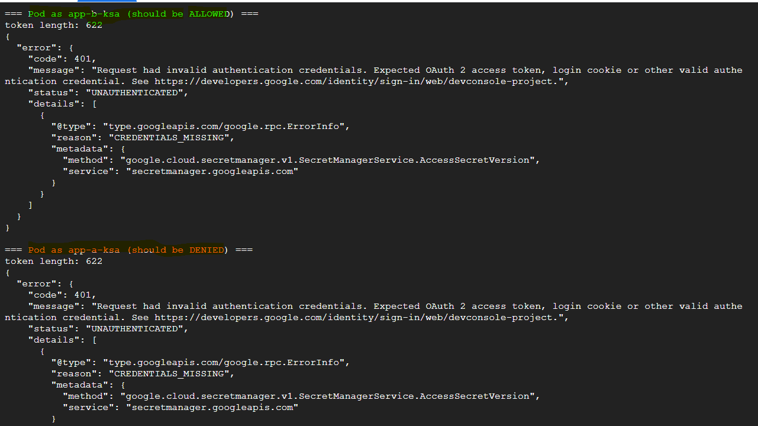
Figure 20: First run: 401 CREDENTIALS_MISSING for both pods.
In some runs the pods printed nothing (curl exit 43). The pod called the metadata server before its Workload Identity token was ready.
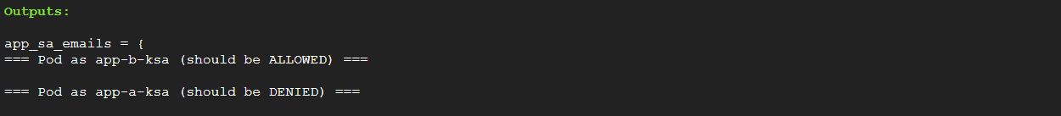
Figure 21: Empty output: no token yet when the pod started.
Fix: tr -d "\n" on the token and sleep 5 before the call. After that, app-b was allowed and app-a got 403.

Issue 7: kubectl attach warning
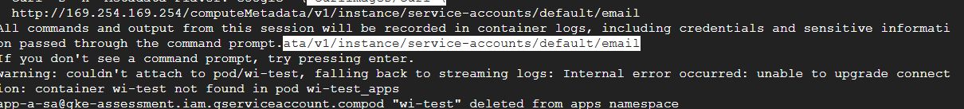
Figure 22: Warning is harmless: the identity app-a-sa is still printed.

Issue 8: First error-rate panel was hard to read
My first version showed error rate as a percentage per minute. With low traffic, one failed request out of two shows as 50%, and bot 4xx made the lines jump between 0 and 100%. I changed it to stacked request counts per 5 minutes by status class (Figure 16).
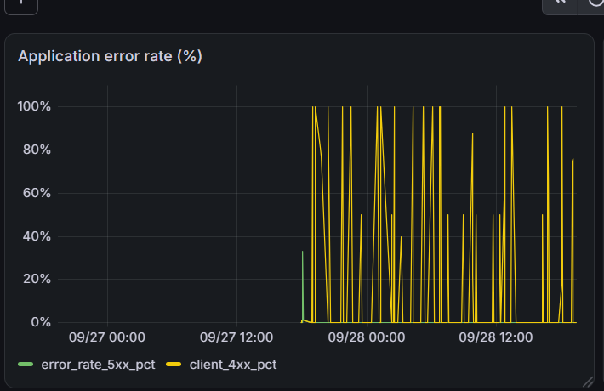
Figure 23: Before: error rate % per minute, noisy and hard to read.

8. Cleanup and Cost
Running cost was about $8 to $10 per day, mostly the nodes of the two clusters, the load balancer and Cloud NAT. The test namespace chaos-test was deleted after the pod restart test, and old service account keys were removed.
To remove everything:
kubectl --context primary -n apps delete mci apps-mci
cd terraform && terraform destroy

