Task 1.3

Helping classmates report

# Public posts and Comments in Microsoft Team’s study group

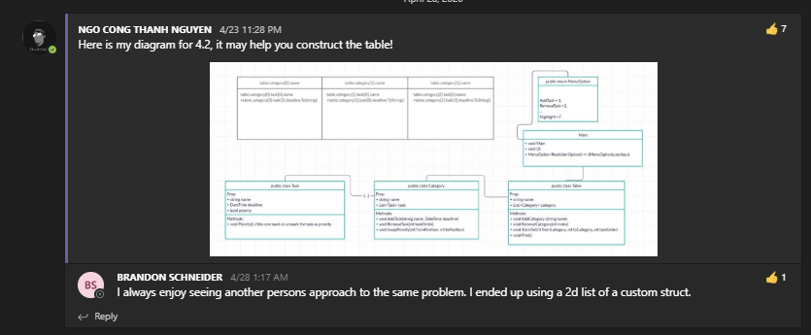

Demonstrate an approach to design table for task 4.2

[NGO CONG THANH NGUYEN: Here is my diagram for 4.2, it may help you construct the tabl…](https://teams.microsoft.com/l/message/19:b66a733a2a6b495d930f7eda71cbec03@thread.tacv2/1587648525558?tenantId=d02378ec-1688-46d5-8540-1c28b5f470f6&groupId=3e01526d-41e6-437e-8897-8cbca64d1cda&parentMessageId=1587648525558&teamName=SIT232%20Object%20Oriented%20Development%202020%20T1&channelName=Online%20Peer-to-Peer%20Study%20Group&createdTime=1587648525558)

posted in SIT232 Object Oriented Development 2020 T1 / Online Peer-to-Peer Study Group at Apr 23, 2020 11:28 PM



Demonstrate the outcome of task 3.2

Link to post:

[NGO CONG THANH NGUYEN: MEHUL NATARAJAN](https://teams.microsoft.com/l/message/19:b66a733a2a6b495d930f7eda71cbec03@thread.tacv2/1586351447216?tenantId=d02378ec-1688-46d5-8540-1c28b5f470f6&groupId=3e01526d-41e6-437e-8897-8cbca64d1cda&parentMessageId=1586351447216&teamName=SIT232%20Object%20Oriented%20Development%202020%20T1&channelName=Online%20Peer-to-Peer%20Study%20Group&createdTime=1586351447216)

posted in SIT232 Object Oriented Development 2020 T1 / Online Peer-to-Peer Study Group at Apr 8, 2020 11:10 PM

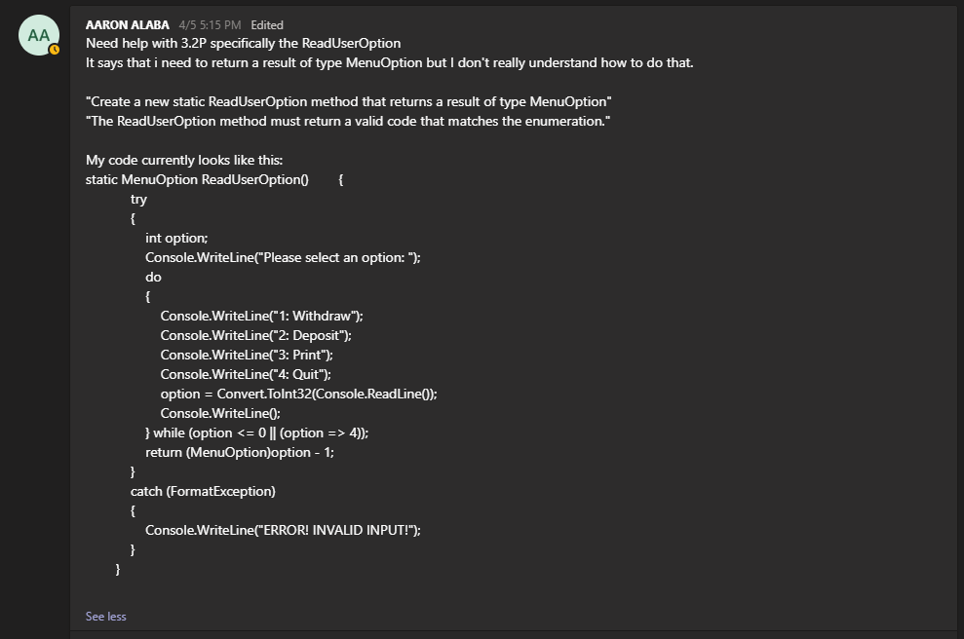

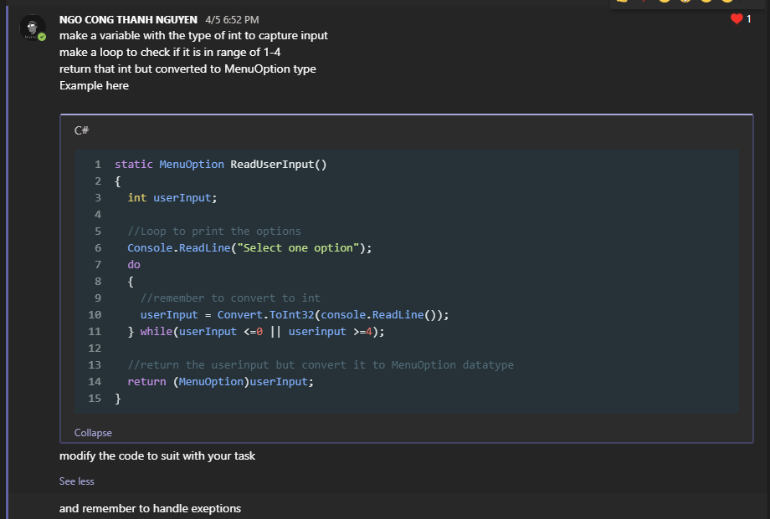

[AARON ALABA: Need help with 3.2P specifically the ReadUserOption It says t…](https://teams.microsoft.com/l/message/19:b66a733a2a6b495d930f7eda71cbec03@thread.tacv2/1586070959941?tenantId=d02378ec-1688-46d5-8540-1c28b5f470f6&groupId=3e01526d-41e6-437e-8897-8cbca64d1cda&parentMessageId=1586070959941&teamName=SIT232%20Object%20Oriented%20Development%202020%20T1&channelName=Online%20Peer-to-Peer%20Study%20Group&createdTime=1586070959941)

posted in SIT232 Object Oriented Development 2020 T1 / Online Peer-to-Peer Study Group at Apr 5, 2020 5:15 PM

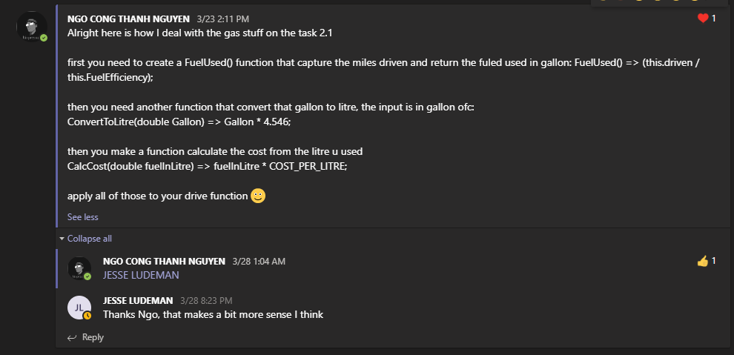

Demonstrate a solution for gas calculation function of task2.1

[NGO CONG THANH NGUYEN: Alright here is how I deal with the gas stuff on the task 2.1 …](https://teams.microsoft.com/l/message/19:b66a733a2a6b495d930f7eda71cbec03@thread.tacv2/1584933103153?tenantId=d02378ec-1688-46d5-8540-1c28b5f470f6&groupId=3e01526d-41e6-437e-8897-8cbca64d1cda&parentMessageId=1584933103153&teamName=SIT232%20Object%20Oriented%20Development%202020%20T1&channelName=Online%20Peer-to-Peer%20Study%20Group&createdTime=1584933103153)

posted in SIT232 Object Oriented Development 2020 T1 / Online Peer-to-Peer Study Group at Mar 23, 2020 2:11 PM

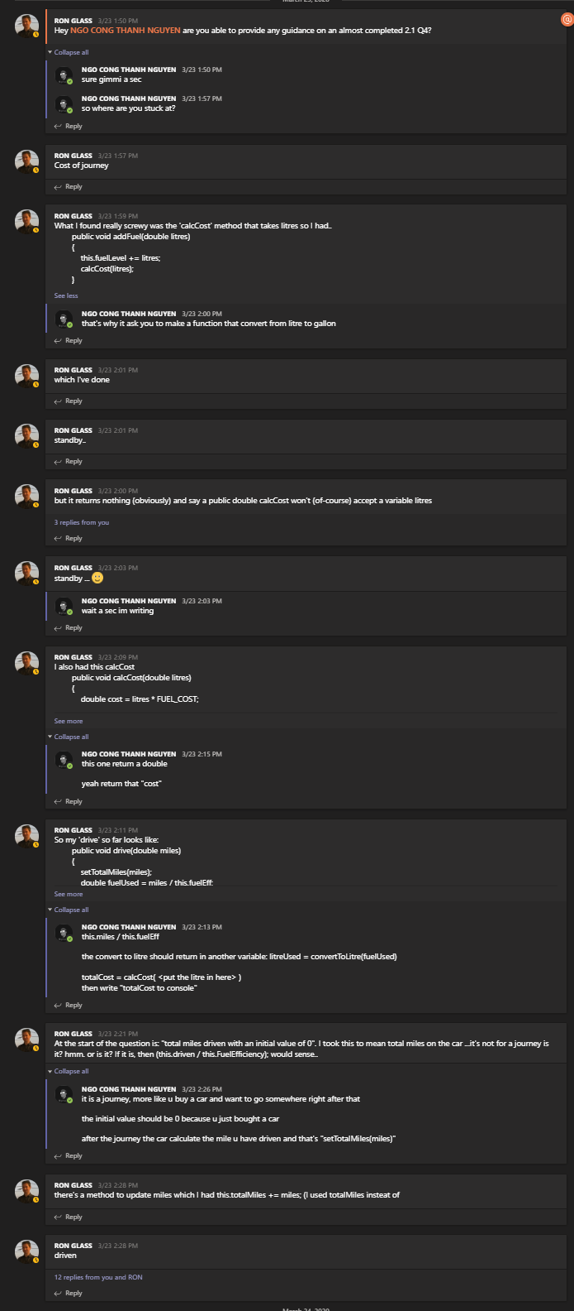

[RON GLASS: Hey NGO CONG THANH NGUYEN are you able to provide any guidance on an almos…](https://teams.microsoft.com/l/message/19:b66a733a2a6b495d930f7eda71cbec03@thread.tacv2/1584931830713?tenantId=d02378ec-1688-46d5-8540-1c28b5f470f6&groupId=3e01526d-41e6-437e-8897-8cbca64d1cda&parentMessageId=1584931830713&teamName=SIT232%20Object%20Oriented%20Development%202020%20T1&channelName=Online%20Peer-to-Peer%20Study%20Group&createdTime=1584931830713)

posted in SIT232 Object Oriented Development 2020 T1 / Online Peer-to-Peer Study Group at Mar 23, 2020 1:50 PM

# Private Message

## Minh Anh Phan

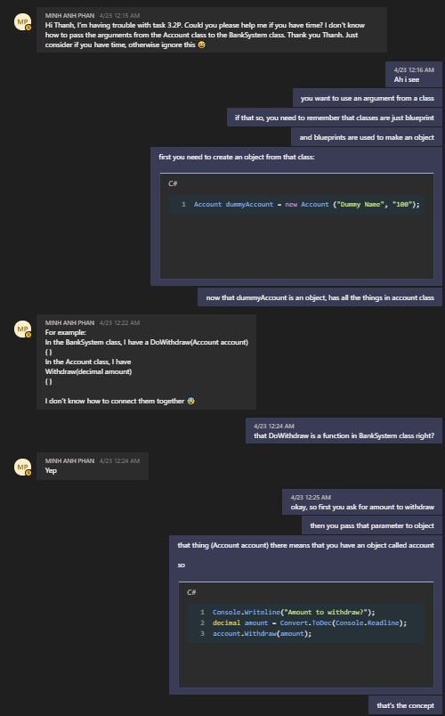

He got stuck in passing arguments between classes.

## Nathan William John

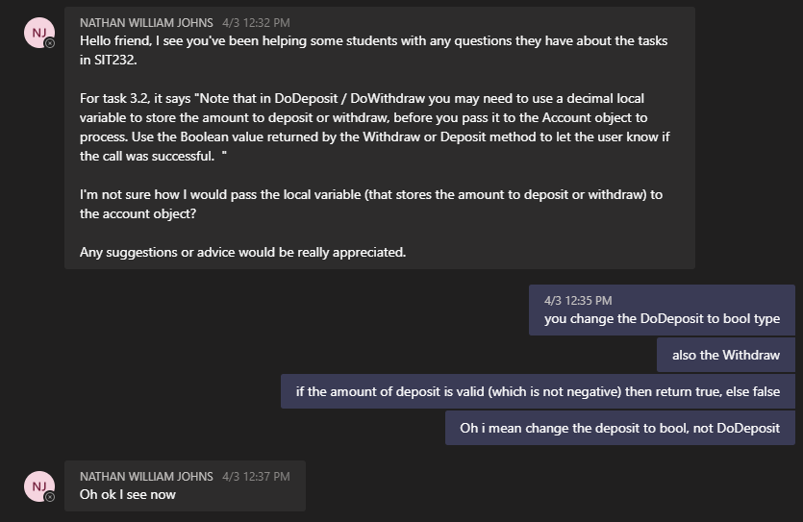

## Sumith Inchiparambil

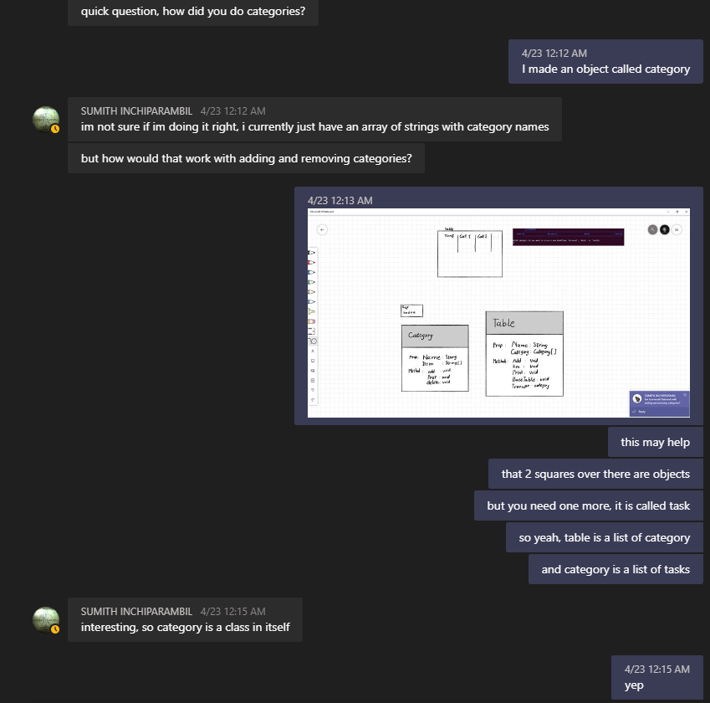

Discussion about constructing table

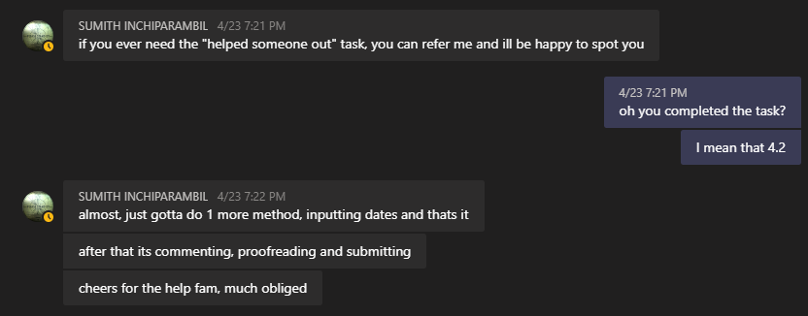

## Others

I got some Vietnamese friends having this unit as well. However, we were discussing tasks in out language, so that I won’t capture our discussions for evidences for this task.

Before the epidemic, me and some students have made a slack workspace to help each other as well, the link can be found in the discussion forum of the unit. We mainly discuss about problems and our approach to solve them.