Island Assembly Roadmap

Generate random models for a mainland and select one that satisfies N\* ✔

Assume mainland is selected community ✔

* Islands are built using species in mainland so they are subsets of mainland matrices with different Ns. Set max N (N\*) and build islands towards that N until they are stable. Graph the islands’ paths to stability. (continually sampling mainland and adding those subsets to island matrix)
  + (keep immigration time stable for now but eventually allow for variance, so don’t hard code time)

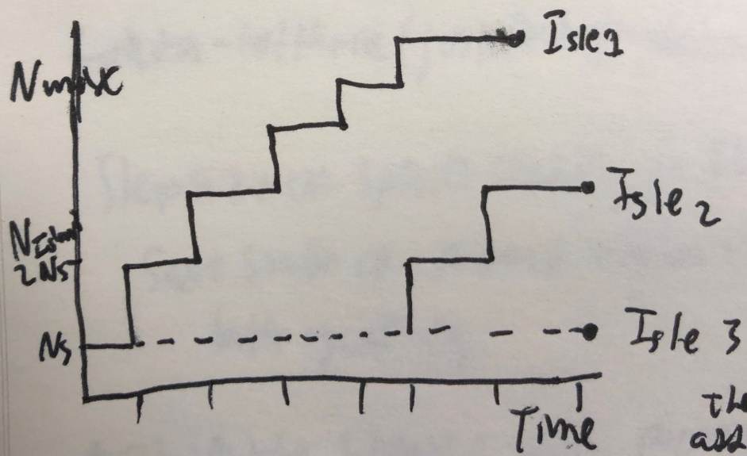

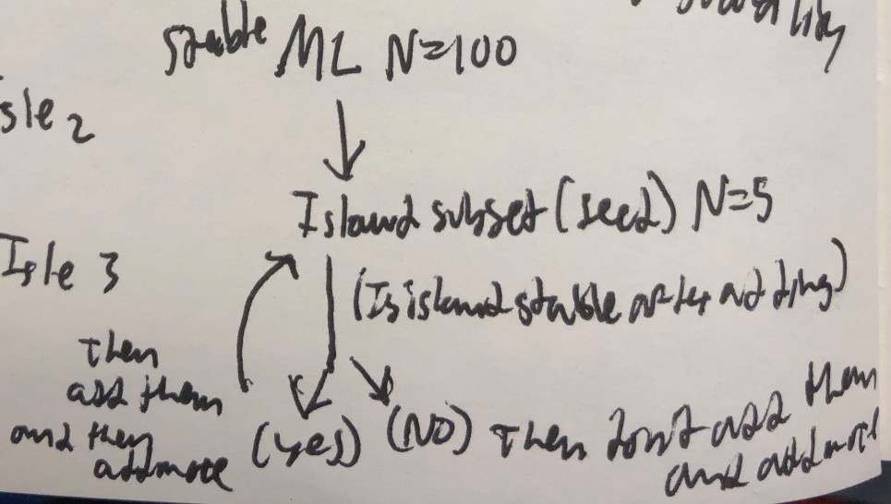

* Generate some path (subset of species) from the mainland and integrate that path over time.
  + Transfer surviving species to new matrix with final abundances from integration. Then add new species to the new matrix with some initial abundance and repeat the process. Vary the time of integration throughout the process.
  + Repeat this for multiple paths.

Goal: Step graph of island through time from initial N (rn it’s 5) to Nmax (N\*)