Freight Rate Prediction — Assessment Report
Machine Learning Engineer Assessment · Spotter

1. Train/Test Validation Approach
The labeled data (data/train_test.csv, 48,000 rows spanning 2025-01-01 through 2025-10-31) was split chronologically rather than randomly. The final validation set the model must ultimately score (data/validation.csv) covers 2025-11-01 through 2025-12-31 — entirely in the future relative to every labeled row. A random split would let same-day market conditions leak between the train and test folds and overstate accuracy on this real forecasting task.
Split used for model selection:
- Sort all labeled rows by date.
- Train on the first 85% of dates (Jan 1 – Sep 15, 2025, 40,706 rows).
- Hold out the last 15% of dates (Sep 15 – Oct 31, 2025, 7,294 rows) purely for evaluation.
- Early stopping on the holdout set picks the boosting round count; that same round count (scaled up ~15% for the larger data volume) is reused when the final model is refit on 100% of the labeled rows for scoring validation.csv.
This mirrors the actual deployment gap (train on the past, predict the future) and avoids optimistic bias from random-split leakage.

Holdout results
Metric | Value
MAE | $119.41
RMSE | $602.64
MAPE | 5.43%
% of predictions within 10% of actual | 97.0%
% of predictions within 20% of actual | 98.5%

RMSE is notably larger than MAE, which points to a small number of large-error outliers rather than broad inaccuracy — see Section 3.

2. Data Exploration & Quality Issues

Key findings
- posted_rate is driven overwhelmingly by distance (correlation 0.91); quote_signal and market_index add smaller, complementary signal (distance × quote_signal correlates at 0.90).
- market_index behaves like a shared daily market factor: within any given date, its standard deviation across loads is only ~0.025, while the daily mean drifts smoothly from ~0.75 to ~1.45 over the year.
- quote_signal is comparatively noisy per shipment (within-lane std ~0.24 even on the exact same route) — it does not reduce to a clean date-level or lane-level constant.
- Rate-per-mile ranges from ~$0.33/mi to ~$14.1/mi; the extreme end is a small cluster (~0.7% of rows) of short-haul, high-$/mile loads (mostly Reefer/Flatbed) — plausible expedited/spot-market premiums rather than data errors, but a hard segment for any model trained mainly on typical lanes.

Data-quality issues identified and how they were addressed
- Sign-flipped weight: 292 rows (0.6%) had negative weight values whose magnitude matched the normal weight distribution — corrected with abs().
- Missing weight: 300 rows (0.6%) — imputed with the training-set median weight.
- Missing market_index: 374 rows in train_test.csv (0.8%), 249 in validation.csv (2.1%) — imputed using the same-date market average computed from all rows that do have a value (justified by the low within-date variance noted above), falling back to a fitted day-of-year trend for any date with zero observed values.
- december_chart_inputs.csv omits market_index and quote_signal entirely for the fixed Lexington→Fort Wayne route. market_index was recovered exactly using the combined train+validation daily average, which has full coverage through Dec 31. quote_signal has no reliable date-level pattern, so it was filled with the historical median quote_signal observed on this exact lane for Dry Van loads (n=27, median 2.002) — a documented approximation, not an exact recovery.
- No duplicate load_id or duplicate full rows were found in either file.

3. Model & Feature Importance
Model: LightGBM gradient-boosted trees, trained on log1p(posted_rate), with early stopping on the time-based holdout.
Features: distance, weight, market_index, quote_signal, distance × quote_signal, equipment, pickup, delivery, month, day-of-week, day-of-year, is_weekend.
Feature importance (gain), most to least important: distance (dominant), distance × quote_signal, delivery city, quote_signal, pickup city, equipment, day-of-year, market_index, weight, month, day-of-week, is_weekend. distance alone accounts for the large majority of predictive gain, consistent with its 0.91 raw correlation with posted_rate; quote_signal contributes mainly through its interaction with distance.
Largest holdout errors cluster on the same high-$/mile outlier segment identified in Section 2 (short-haul premium loads) — e.g. several $10k+ absolute errors on loads with rate-per-mile above $12, versus a typical error of ~$50–150 on the other 97% of loads. This is a known limitation: these loads appear to be driven by information not present in the given feature set (e.g. urgency/spot-market conditions), rather than a fixable modeling error.

4. December 2025 Predicted Rate — Fixed Lane
Fixed inputs held constant across all 31 rows: Lexington → Fort Wayne, 360 miles, Dry Van, 32,000 lb. Only the date changes. Chart generated by the provided score.py from data/december_chart_inputs_filled.csv:
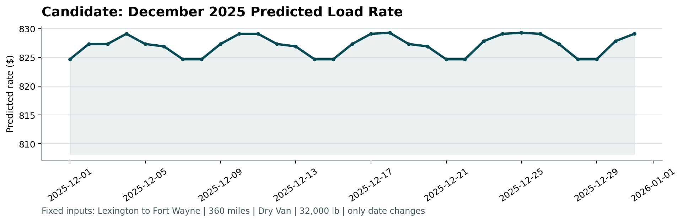
The weekly ripple (visible ~7-day cycle) comes from the day-of-week feature interacting with the fitted market_index seasonal level for December; the model was not given any December-specific quote_signal, so this reflects the lane's typical historical rate level (~$825–$829) modulated by the recovered daily market index, not date-specific spot-market swings.

5. Repository & Reproduction
Full source, data, and run instructions are in the submitted GitHub repository. Summary:
- src/features.py — shared cleaning + feature engineering
- src/train.py — time-based holdout training, prints metrics, saves model artifacts
- src/predict.py — refits on all labeled data, writes validation_predictions.csv and the filled December input file
- src/score.py — provided scorer; validates both output files and renders the chart above
See the repository README for exact setup and run commands.

