[18:24:06] App started. Add processes or load a CSV file.
[18:25:16] Line 2 skipped (invalid values): P1,0,8
[18:25:16] Line 3 skipped (invalid values): P2,1,4
[18:25:16] Line 4 skipped (invalid values): P3,2,9
[18:25:16] Line 5 skipped (invalid values): P4,3,5
[18:25:16] Line 6 skipped (invalid values): P5,4,2
[18:25:16] Line 7 skipped (invalid values): P6,5,6
[18:25:16] Line 8 skipped (invalid values): P7,6,3
[18:25:16] Line 9 skipped (invalid values): P8,7,7
[18:25:16] Line 10 skipped (invalid values): P9,8,1
[18:25:16] Line 11 skipped (invalid values): P10,9,4
[18:25:16] Line 12 skipped (invalid values): P11,10,6
[18:25:16] Line 13 skipped (invalid values): P12,12,3
[18:25:16] Line 14 skipped (invalid values): P13,13,8
[18:25:16] Line 15 skipped (invalid values): P14,15,2
[18:25:16] Line 16 skipped (invalid values): P15,16,5
[18:25:16] Line 17 skipped (invalid values): P16,17,4
[18:25:16] Line 18 skipped (invalid values): P17,18,7
[18:25:16] Line 19 skipped (invalid values): P18,20,3
[18:25:16] Line 20 skipped (invalid values): P19,21,6
[18:25:16] Line 21 skipped (invalid values): P20,23,2
[18:25:16] Loaded 0 processes from: C:/Users/admin/Downloads/input_output/fcfs_input.csv
[18:25:28] ═══════════ STRESS TEST STARTED ═══════════
[18:25:29] FCFS | n=100 | Time=9 µs | AvgWT=%.2f | AvgTAT=%.2f
[18:25:29] SJF | n=100 | Time=137 µs | AvgWT=%.2f | AvgTAT=%.2f
[18:25:29] FCFS | n=500 | Time=48 µs | AvgWT=%.2f | AvgTAT=%.2f
[18:25:29] SJF | n=500 | Time=3300 µs | AvgWT=%.2f | AvgTAT=%.2f
[18:25:29] FCFS | n=1000 | Time=174 µs | AvgWT=%.2f | AvgTAT=%.2f
[18:25:29] SJF | n=1000 | Time=16257 µs | AvgWT=%.2f | AvgTAT=%.2f
[18:25:29] FCFS | n=5000 | Time=668 µs | AvgWT=%.2f | AvgTAT=%.2f
[18:25:29] SJF | n=5000 | Time=334230 µs | AvgWT=%.2f | AvgTAT=%.2f
[18:25:29] FCFS | n=10000 | Time=1169 µs | AvgWT=%.2f | AvgTAT=%.2f
[18:25:31] SJF | n=10000 | Time=1317164 µs | AvgWT=%.2f | AvgTAT=%.2f
[18:25:31] ═══════════ STRESS TEST DONE ═══════════
[18:25:32] Stress test exported: output/StressTest_20260412_182531.csv
[18:25:33] ═══════════ STRESS TEST STARTED ═══════════
[18:25:33] FCFS | n=100 | Time=18 µs | AvgWT=%.2f | AvgTAT=%.2f
[18:25:33] SJF | n=100 | Time=260 µs | AvgWT=%.2f | AvgTAT=%.2f
[18:25:33] FCFS | n=500 | Time=84 µs | AvgWT=%.2f | AvgTAT=%.2f
[18:25:33] SJF | n=500 | Time=5959 µs | AvgWT=%.2f | AvgTAT=%.2f
[18:25:33] FCFS | n=1000 | Time=218 µs | AvgWT=%.2f | AvgTAT=%.2f
[18:25:33] SJF | n=1000 | Time=16667 µs | AvgWT=%.2f | AvgTAT=%.2f
[18:25:33] FCFS | n=5000 | Time=557 µs | AvgWT=%.2f | AvgTAT=%.2f
[18:25:33] SJF | n=5000 | Time=323715 µs | AvgWT=%.2f | AvgTAT=%.2f
[18:25:33] FCFS | n=10000 | Time=1118 µs | AvgWT=%.2f | AvgTAT=%.2f
[18:25:35] SJF | n=10000 | Time=1371087 µs | AvgWT=%.2f | AvgTAT=%.2f
[18:25:35] ═══════════ STRESS TEST DONE ═══════════
[18:25:36] Stress test exported: output/StressTest_20260412_182535.csv
[18:25:36] ═══════════ STRESS TEST STARTED ═══════════
[18:25:36] FCFS | n=100 | Time=9 µs | AvgWT=%.2f | AvgTAT=%.2f
[18:25:36] SJF | n=100 | Time=148 µs | AvgWT=%.2f | AvgTAT=%.2f
[18:25:36] FCFS | n=500 | Time=50 µs | AvgWT=%.2f | AvgTAT=%.2f
[18:25:36] SJF | n=500 | Time=3460 µs | AvgWT=%.2f | AvgTAT=%.2f
[18:25:36] FCFS | n=1000 | Time=105 µs | AvgWT=%.2f | AvgTAT=%.2f
[18:25:36] SJF | n=1000 | Time=13432 µs | AvgWT=%.2f | AvgTAT=%.2f
[18:25:36] FCFS | n=5000 | Time=588 µs | AvgWT=%.2f | AvgTAT=%.2f
[18:25:37] SJF | n=5000 | Time=331949 µs | AvgWT=%.2f | AvgTAT=%.2f
[18:25:37] FCFS | n=10000 | Time=1183 µs | AvgWT=%.2f | AvgTAT=%.2f
[18:25:38] SJF | n=10000 | Time=1354992 µs | AvgWT=%.2f | AvgTAT=%.2f
[18:25:38] ═══════════ STRESS TEST DONE ═══════════
[18:25:40] Stress test exported: output/StressTest_20260412_182538.csv
[18:25:50] Line 2 skipped (invalid values): P1,0,8
[18:25:50] Line 3 skipped (invalid values): P2,1,4
[18:25:50] Line 4 skipped (invalid values): P3,2,9
[18:25:50] Line 5 skipped (invalid values): P4,3,5
[18:25:50] Line 6 skipped (invalid values): P5,4,2
[18:25:50] Line 7 skipped (invalid values): P6,5,6
[18:25:50] Line 8 skipped (invalid values): P7,6,3
[18:25:50] Line 9 skipped (invalid values): P8,7,7
[18:25:50] Line 10 skipped (invalid values): P9,8,1
[18:25:50] Line 11 skipped (invalid values): P10,9,4
[18:25:50] Line 12 skipped (invalid values): P11,10,6
[18:25:50] Line 13 skipped (invalid values): P12,12,3
[18:25:50] Line 14 skipped (invalid values): P13,13,8
[18:25:50] Line 15 skipped (invalid values): P14,15,2
[18:25:50] Line 16 skipped (invalid values): P15,16,5
[18:25:50] Line 17 skipped (invalid values): P16,17,4
[18:25:50] Line 18 skipped (invalid values): P17,18,7
[18:25:50] Line 19 skipped (invalid values): P18,20,3
[18:25:50] Line 20 skipped (invalid values): P19,21,6
[18:25:50] Line 21 skipped (invalid values): P20,23,2
[18:25:50] Loaded 0 processes from: C:/Users/admin/Downloads/input_output/fcfs_input.csv
[18:28:38] Loaded 20 processes from: C:/Users/admin/Downloads/FCFS INPUT.csv
[18:30:02] ▶ FCFS | Avg WT=%.2f | Avg TAT=%.2f | Time=6200 ns
[18:30:02] ▶ SJF | Avg WT=%.2f | Avg TAT=%.2f | Time=26700 ns
[18:34:50] Line 5 skipped (invalid values): 4,0,9
[18:34:50] Loaded 149 processes from: C:/Users/admin/OneDrive/Tài liệu/test_data_150.csv
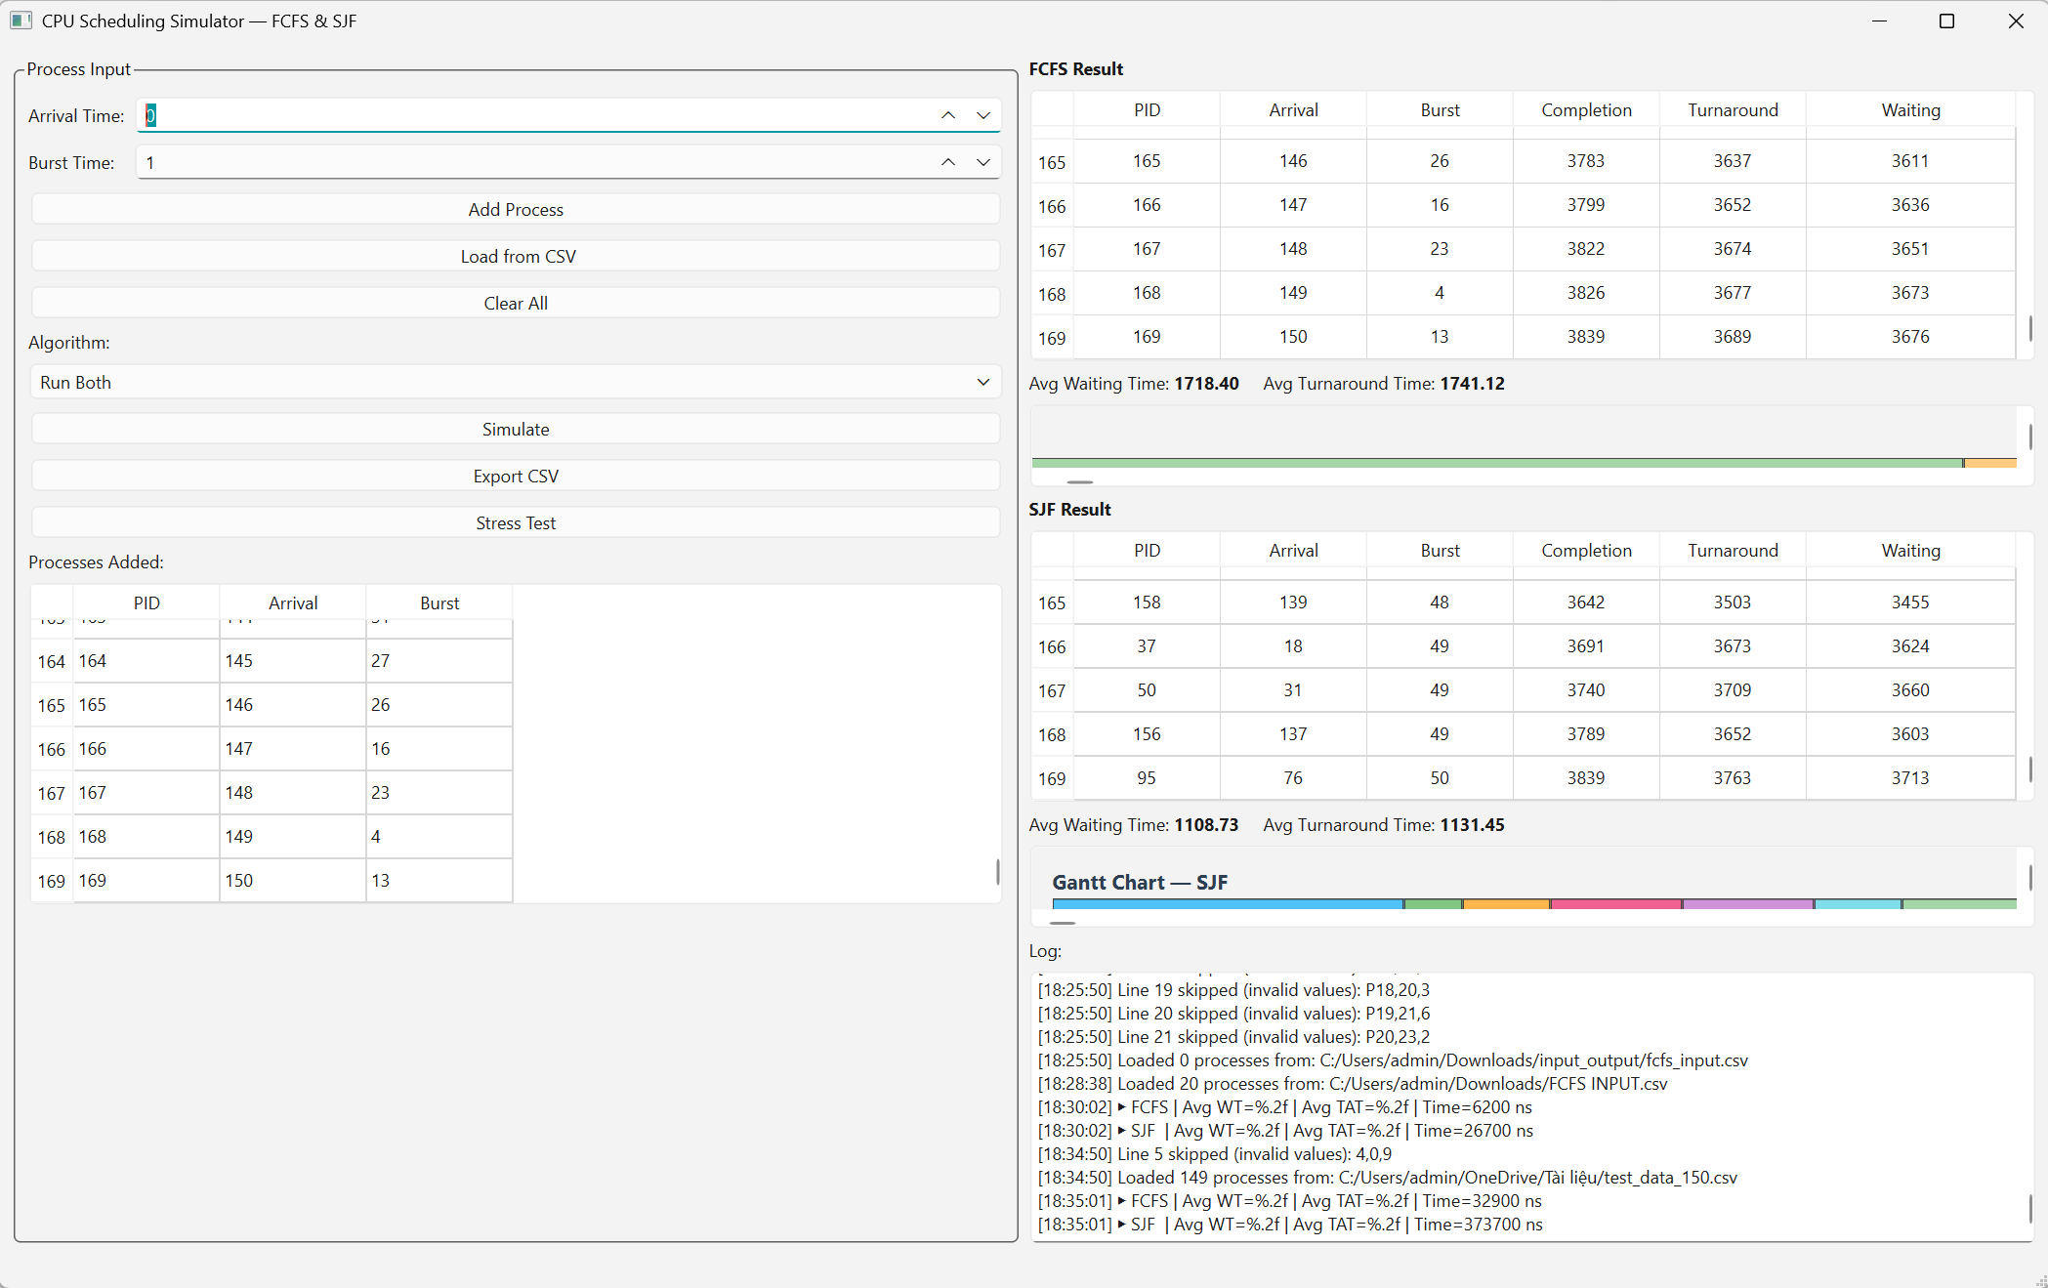
[18:35:01] ▶ FCFS | Avg WT=%.2f | Avg TAT=%.2f | Time=32900 ns
[18:35:01] ▶ SJF | Avg WT=%.2f | Avg TAT=%.2f | Time=373700 ns
[18:36:38] Line 117 skipped (invalid values): 116,0,5
[18:36:38] Line 169 skipped (invalid values): 168,0,11
[18:36:38] Line 198 skipped (invalid values): 197,0,1
[18:36:38] Line 233 skipped (invalid values): 232,0,11
[18:36:38] Loaded 246 processes from: C:/Users/admin/OneDrive/Tài liệu/test_data_150.csv
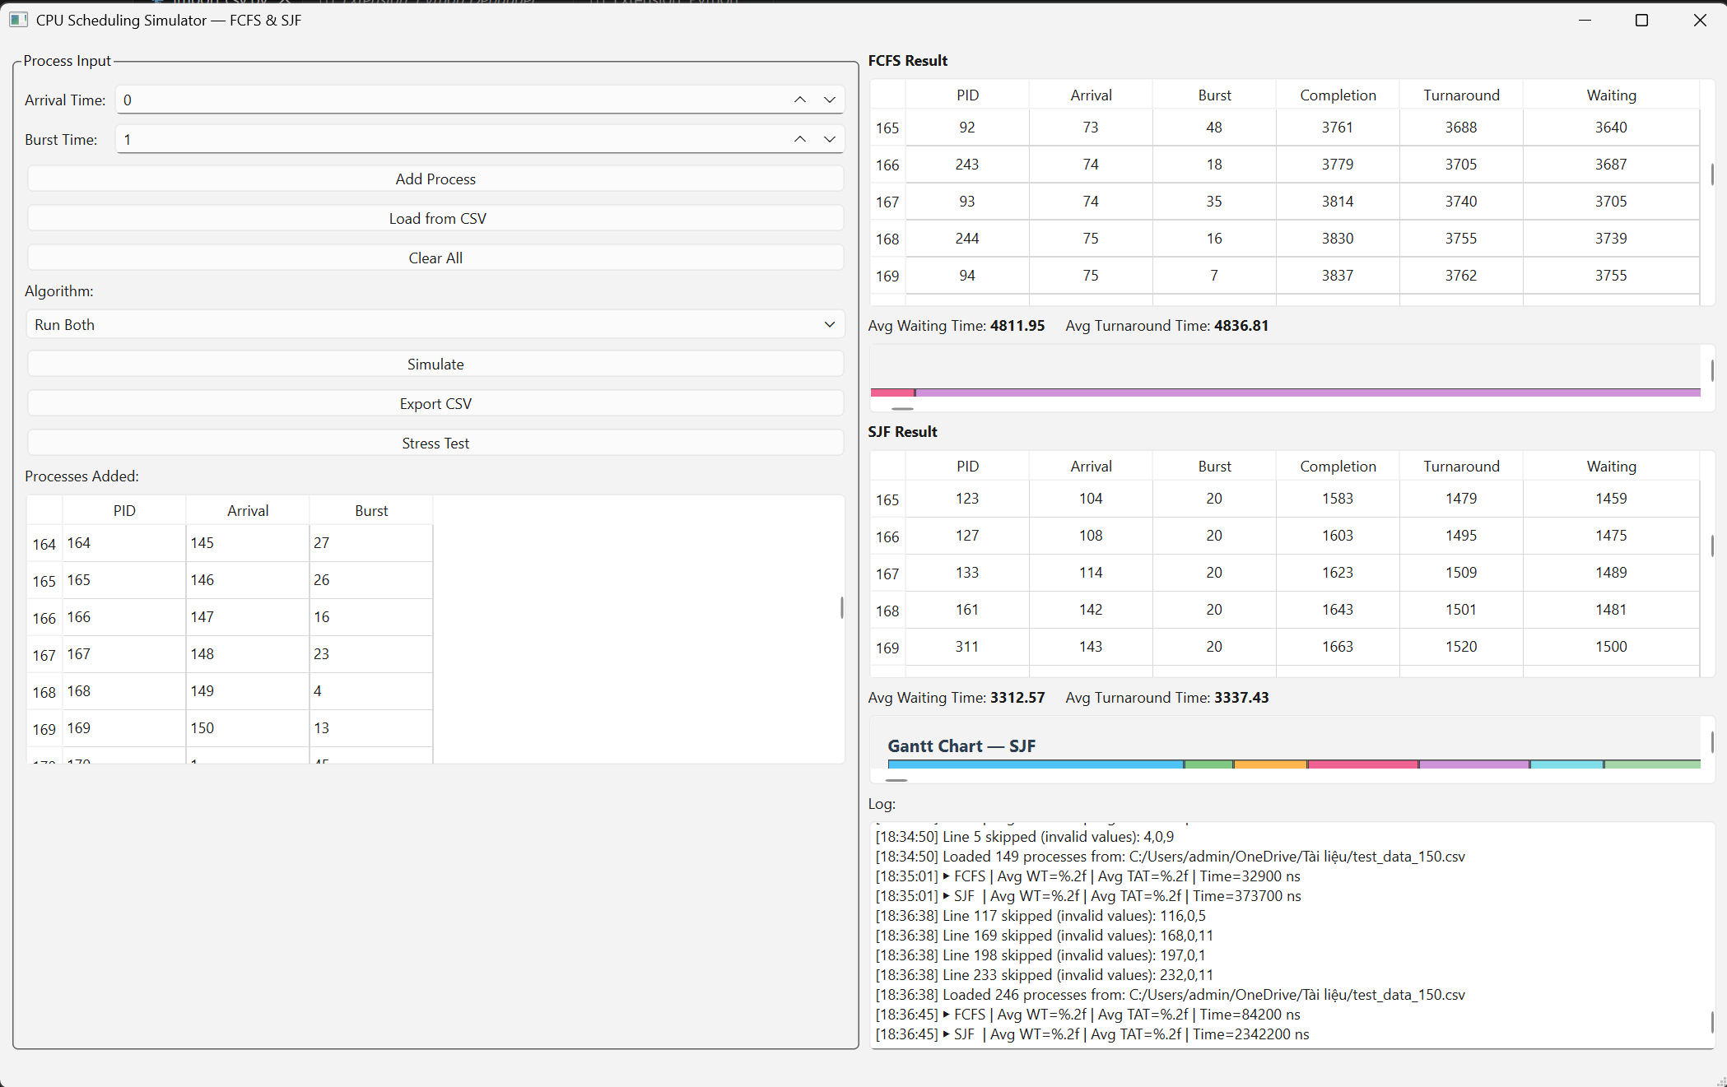
[18:36:45] ▶ FCFS | Avg WT=%.2f | Avg TAT=%.2f | Time=84200 ns
[18:36:45] ▶ SJF | Avg WT=%.2f | Avg TAT=%.2f | Time=2342200 ns
[18:37:47] Line 20 skipped (invalid values): 19,0,12
[18:37:47] Line 74 skipped (invalid values): 73,0,14
[18:37:47] Line 83 skipped (invalid values): 82,0,12
[18:37:47] Line 137 skipped (invalid values): 136,0,4
[18:37:47] Line 159 skipped (invalid values): 158,0,12
[18:37:47] Line 165 skipped (invalid values): 164,0,17
[18:37:47] Line 169 skipped (invalid values): 168,0,4
[18:37:47] Line 175 skipped (invalid values): 174,0,9
[18:37:47] Line 198 skipped (invalid values): 197,0,4
[18:37:47] Line 277 skipped (invalid values): 276,0,2
[18:37:47] Line 281 skipped (invalid values): 280,0,7
[18:37:47] Line 333 skipped (invalid values): 332,0,5
[18:37:47] Loaded 338 processes from: C:/Users/admin/OneDrive/Tài liệu/test_data_150.csv
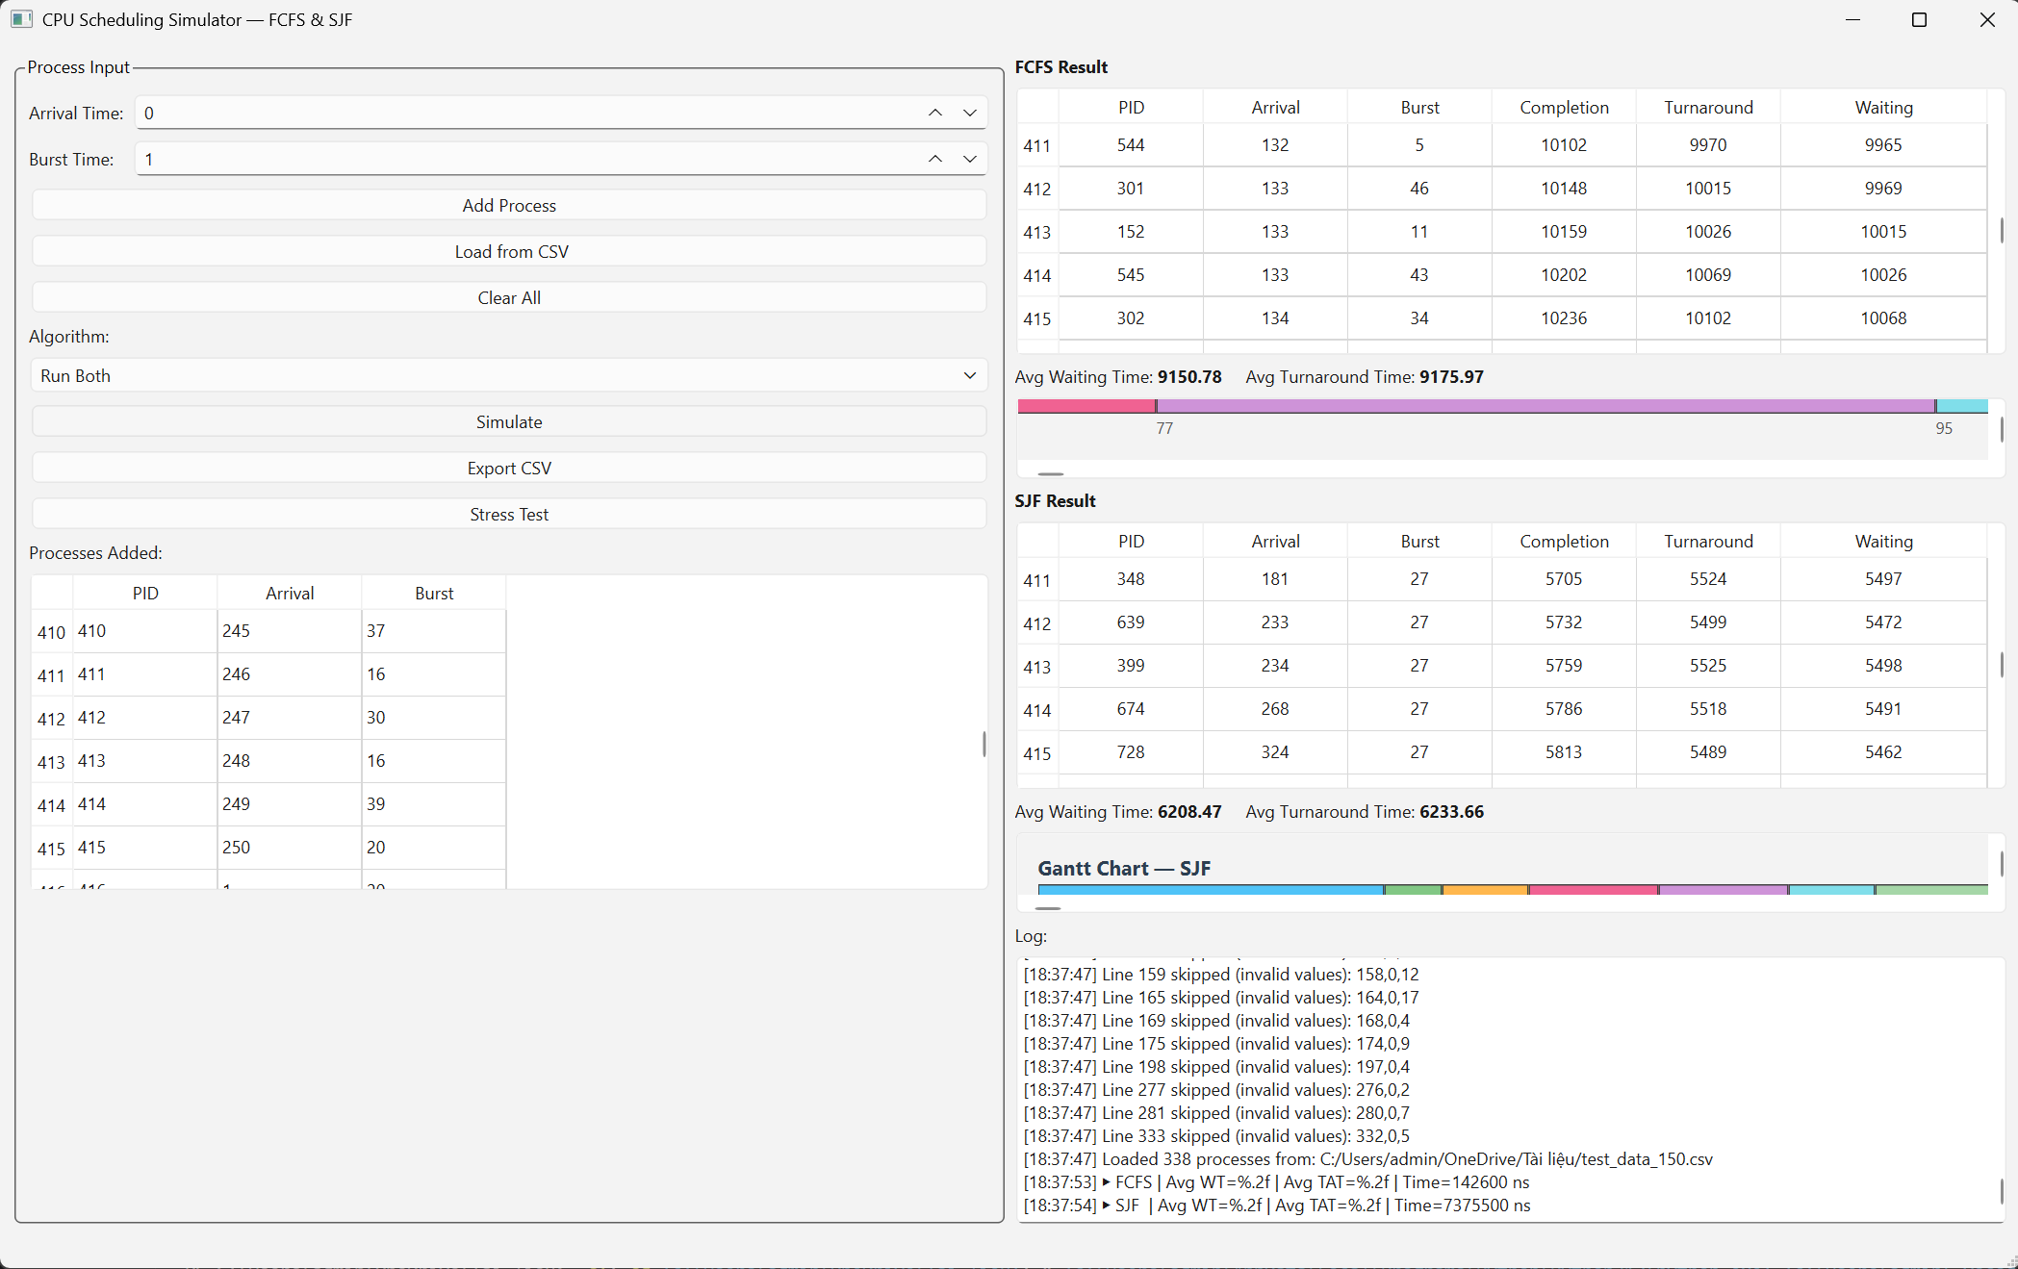
[18:37:53] ▶ FCFS | Avg WT=%.2f | Avg TAT=%.2f | Time=142600 ns
[18:37:54] ▶ SJF | Avg WT=%.2f | Avg TAT=%.2f | Time=7375500 ns
[18:38:32] Line 14 skipped (invalid values): 13,0,6
[18:38:32] Line 33 skipped (invalid values): 32,0,4
[18:38:32] Line 71 skipped (invalid values): 70,0,6
[18:38:32] Line 99 skipped (invalid values): 98,0,14
[18:38:32] Line 111 skipped (invalid values): 110,0,2
[18:38:32] Line 222 skipped (invalid values): 221,0,5
[18:38:32] Line 243 skipped (invalid values): 242,0,16
[18:38:32] Line 274 skipped (invalid values): 273,0,12
[18:38:32] Line 277 skipped (invalid values): 276,0,5
[18:38:32] Line 336 skipped (invalid values): 335,0,4
[18:38:32] Line 342 skipped (invalid values): 341,0,20
[18:38:32] Line 379 skipped (invalid values): 378,0,5
[18:38:32] Loaded 438 processes from: C:/Users/admin/OneDrive/Tài liệu/test_data_150.csv
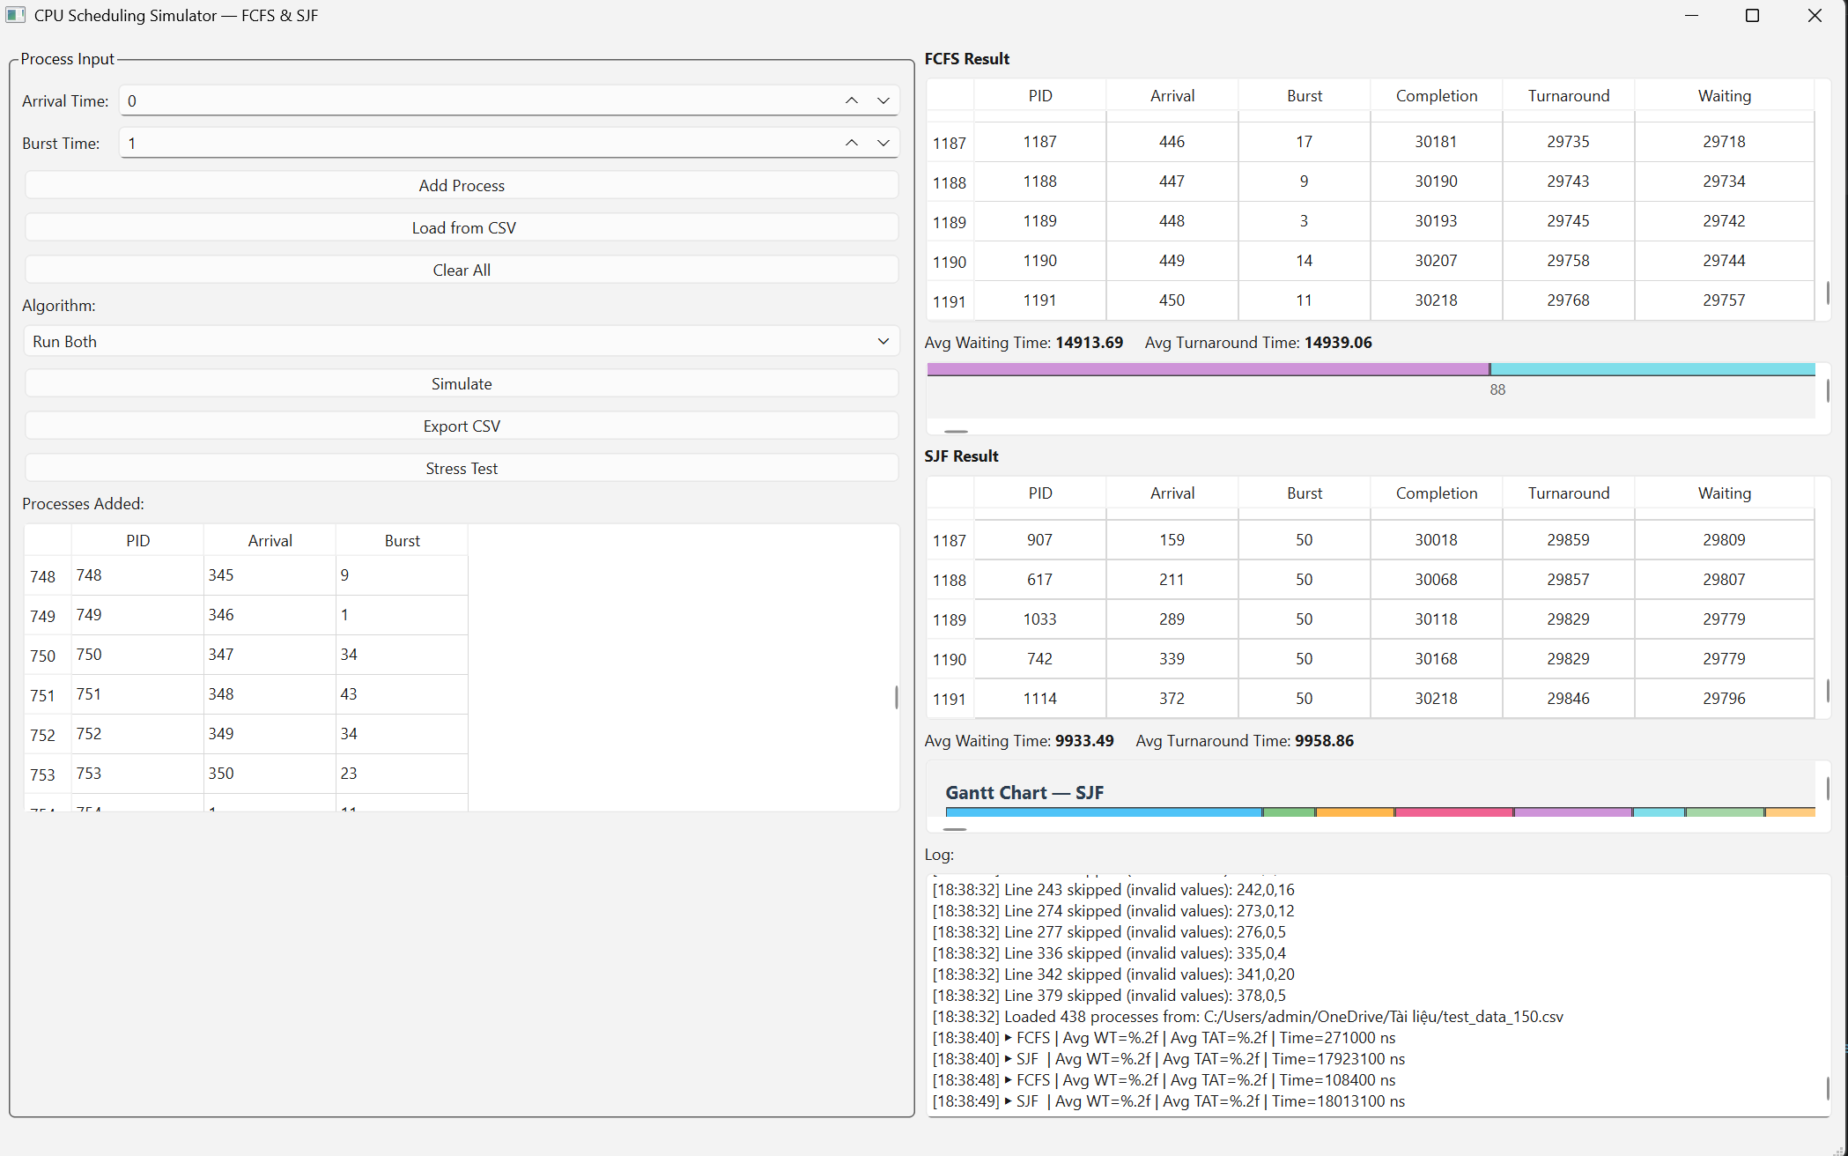
[18:38:40] ▶ FCFS | Avg WT=%.2f | Avg TAT=%.2f | Time=271000 ns
[18:38:40] ▶ SJF | Avg WT=%.2f | Avg TAT=%.2f | Time=17923100 ns
[18:38:48] ▶ FCFS | Avg WT=%.2f | Avg TAT=%.2f | Time=108400 ns
[18:38:49] ▶ SJF | Avg WT=%.2f | Avg TAT=%.2f | Time=18013100 ns
[18:39:42] Line 77 skipped (invalid values): 76,0,17
[18:39:42] Line 118 skipped (invalid values): 117,0,11
[18:39:42] Line 122 skipped (invalid values): 121,0,8
[18:39:42] Line 198 skipped (invalid values): 197,0,18
[18:39:42] Line 260 skipped (invalid values): 259,0,9
[18:39:42] Line 271 skipped (invalid values): 270,0,19
[18:39:42] Line 318 skipped (invalid values): 317,0,7
[18:39:42] Line 344 skipped (invalid values): 343,0,19
[18:39:42] Line 365 skipped (invalid values): 364,0,4
[18:39:42] Line 500 skipped (invalid values): 499,0,10
[18:39:42] Loaded 540 processes from: C:/Users/admin/OneDrive/Tài liệu/test_data_150.csv
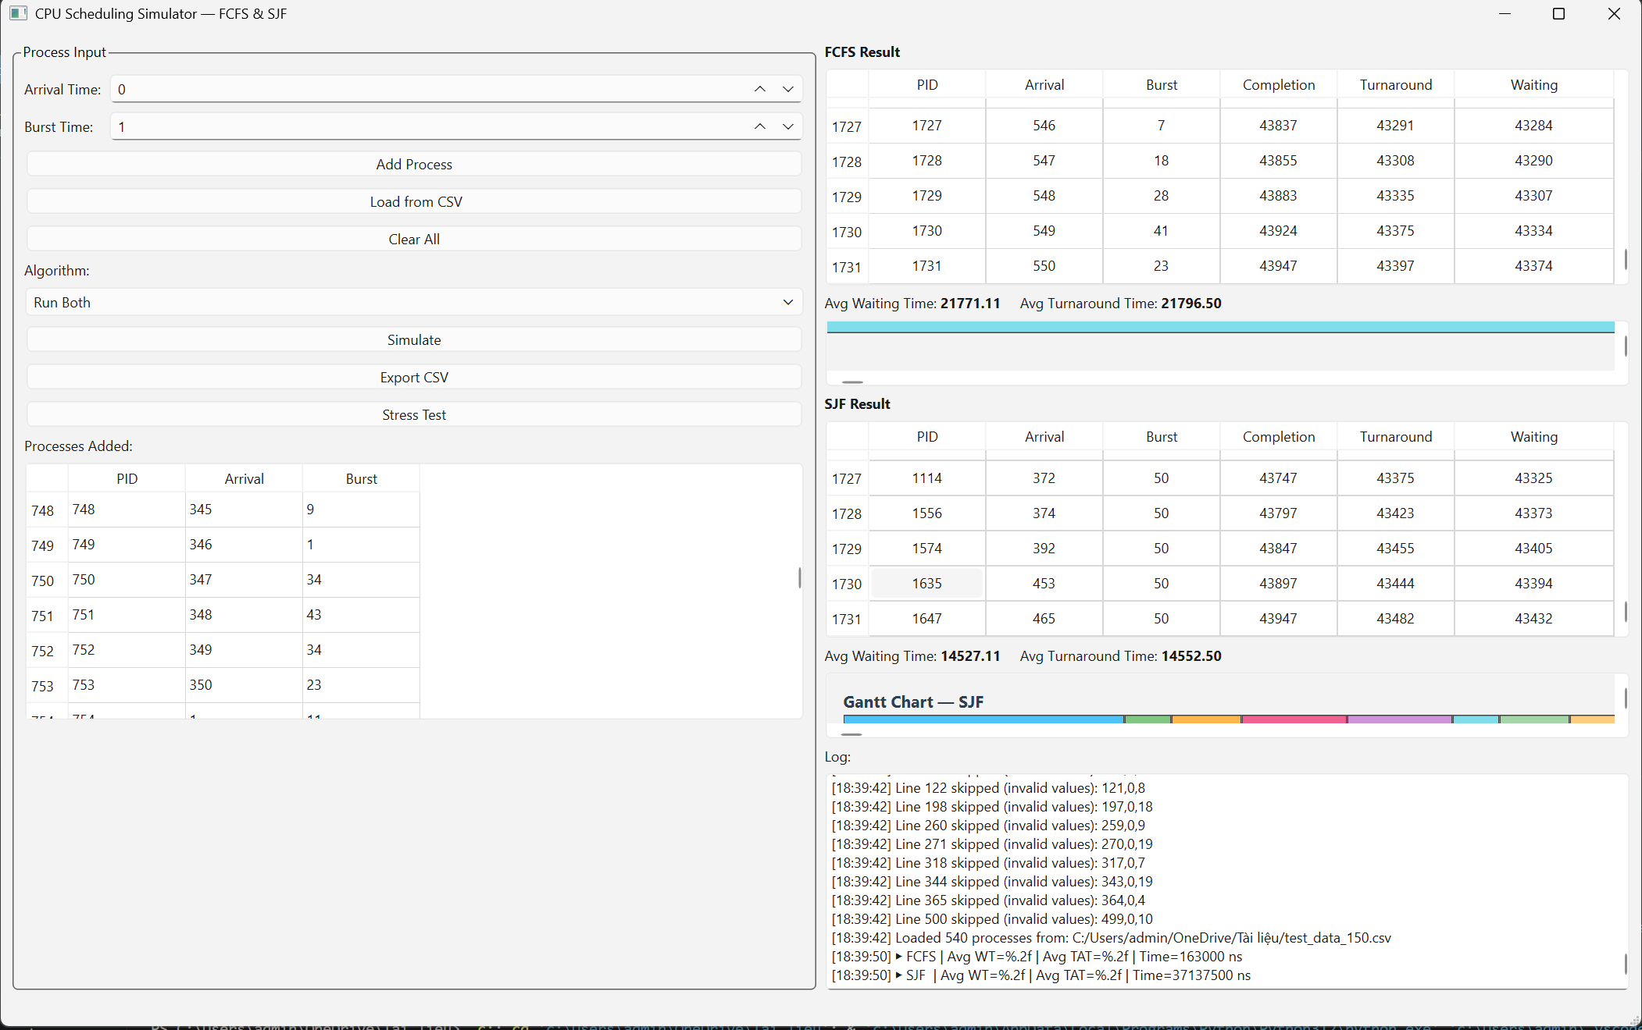
[18:39:50] ▶ FCFS | Avg WT=%.2f | Avg TAT=%.2f | Time=163000 ns
[18:39:50] ▶ SJF | Avg WT=%.2f | Avg TAT=%.2f | Time=37137500 ns
[18:40:33] Line 20 skipped (invalid values): 19,0,17
[18:40:33] Line 32 skipped (invalid values): 31,0,1
[18:40:33] Line 70 skipped (invalid values): 69,0,10
[18:40:33] Line 125 skipped (invalid values): 124,0,3
[18:40:33] Line 156 skipped (invalid values): 155,0,8
[18:40:33] Line 175 skipped (invalid values): 174,0,4
[18:40:33] Line 215 skipped (invalid values): 214,0,8
[18:40:33] Line 366 skipped (invalid values): 365,0,11
[18:40:33] Line 433 skipped (invalid values): 432,0,11
[18:40:33] Line 506 skipped (invalid values): 505,0,17
[18:40:33] Line 512 skipped (invalid values): 511,0,16
[18:40:33] Line 528 skipped (invalid values): 527,0,13
[18:40:33] Line 550 skipped (invalid values): 549,0,3
[18:40:33] Line 618 skipped (invalid values): 617,0,5
[18:40:33] Line 650 skipped (invalid values): 649,0,4
[18:40:33] Line 659 skipped (invalid values): 658,0,17
[18:40:33] Line 697 skipped (invalid values): 696,0,17
[18:40:33] Line 767 skipped (invalid values): 766,0,9
[18:40:33] Line 833 skipped (invalid values): 832,0,9
[18:40:33] Line 835 skipped (invalid values): 834,0,9
[18:40:33] Line 874 skipped (invalid values): 873,0,2
[18:40:33] Line 935 skipped (invalid values): 934,0,14
[18:40:33] Loaded 1028 processes from: C:/Users/admin/OneDrive/Tài liệu/test_data_150.csv
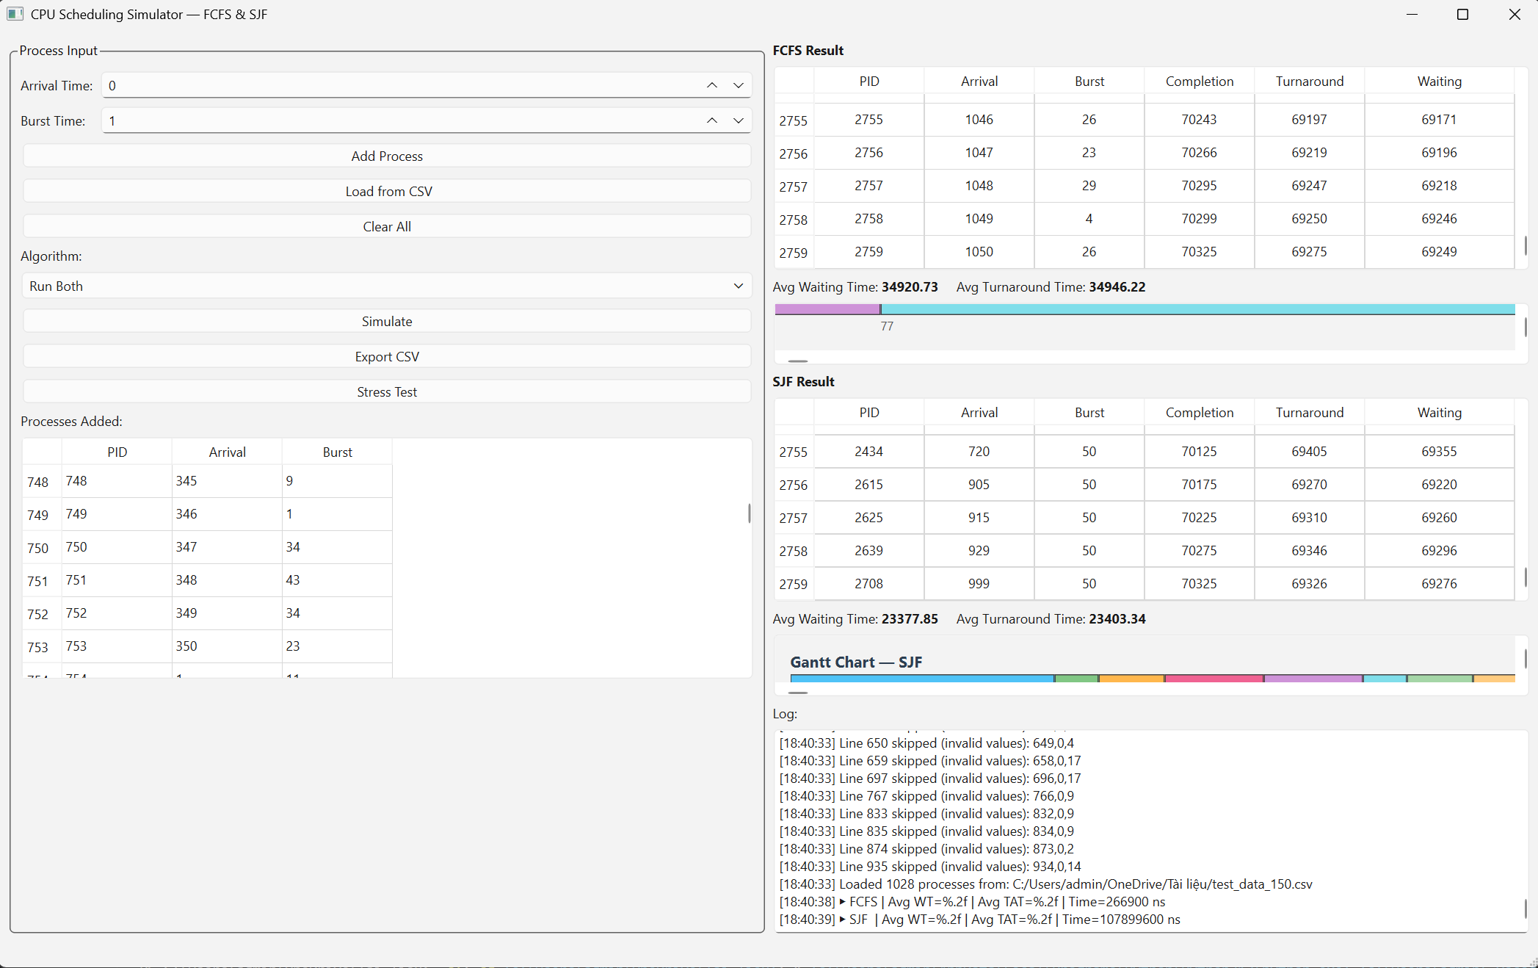
[18:40:38] ▶ FCFS | Avg WT=%.2f | Avg TAT=%.2f | Time=266900 ns
[18:40:39] ▶ SJF | Avg WT=%.2f | Avg TAT=%.2f | Time=107899600 ns
[18:41:15] ▶ FCFS | Avg WT=%.2f | Avg TAT=%.2f | Time=253700 ns
[18:41:15] ▶ SJF | Avg WT=%.2f | Avg TAT=%.2f | Time=95721000 ns
[18:41:36] Line 71 skipped (invalid values): 70,0,14
[18:41:36] Line 127 skipped (invalid values): 126,0,3
[18:41:36] Line 194 skipped (invalid values): 193,0,14
[18:41:36] Line 218 skipped (invalid values): 217,0,11
[18:41:36] Line 243 skipped (invalid values): 242,0,16
[18:41:36] Line 345 skipped (invalid values): 344,0,9
[18:41:36] Line 393 skipped (invalid values): 392,0,8
[18:41:36] Line 433 skipped (invalid values): 432,0,16
[18:41:36] Line 435 skipped (invalid values): 434,0,1
[18:41:36] Line 453 skipped (invalid values): 452,0,15
[18:41:36] Line 483 skipped (invalid values): 482,0,2
[18:41:36] Line 507 skipped (invalid values): 506,0,15
[18:41:36] Line 527 skipped (invalid values): 526,0,20
[18:41:36] Line 559 skipped (invalid values): 558,0,20
[18:41:36] Line 733 skipped (invalid values): 732,0,5
[18:41:36] Line 857 skipped (invalid values): 856,0,3
[18:41:36] Line 941 skipped (invalid values): 940,0,13
[18:41:36] Line 949 skipped (invalid values): 948,0,16
[18:41:36] Line 971 skipped (invalid values): 970,0,11
[18:41:36] Line 1033 skipped (invalid values): 1032,0,19
[18:41:36] Line 1084 skipped (invalid values): 1083,0,11
[18:41:36] Line 1142 skipped (invalid values): 1141,0,13
[18:41:36] Line 1146 skipped (invalid values): 1145,0,2
[18:41:36] Line 1180 skipped (invalid values): 1179,0,1
[18:41:36] Line 1218 skipped (invalid values): 1217,0,3
[18:41:36] Line 1251 skipped (invalid values): 1250,0,18
[18:41:36] Line 1327 skipped (invalid values): 1326,0,13
[18:41:36] Line 1349 skipped (invalid values): 1348,0,4
[18:41:36] Line 1366 skipped (invalid values): 1365,0,8
[18:41:36] Line 1398 skipped (invalid values): 1397,0,11
[18:41:36] Line 1518 skipped (invalid values): 1517,0,4
[18:41:36] Line 1530 skipped (invalid values): 1529,0,9
[18:41:36] Line 1572 skipped (invalid values): 1571,0,19
[18:41:36] Line 1581 skipped (invalid values): 1580,0,15
[18:41:36] Line 1587 skipped (invalid values): 1586,0,19
[18:41:36] Line 1607 skipped (invalid values): 1606,0,10
[18:41:36] Line 1620 skipped (invalid values): 1619,0,11
[18:41:36] Line 1657 skipped (invalid values): 1656,0,2
[18:41:36] Line 1665 skipped (invalid values): 1664,0,1
[18:41:36] Line 1892 skipped (invalid values): 1891,0,11
[18:41:36] Line 1925 skipped (invalid values): 1924,0,5
[18:41:36] Line 2038 skipped (invalid values): 2037,0,20
[18:41:36] Loaded 2008 processes from: C:/Users/admin/OneDrive/Tài liệu/test_data_150.csv
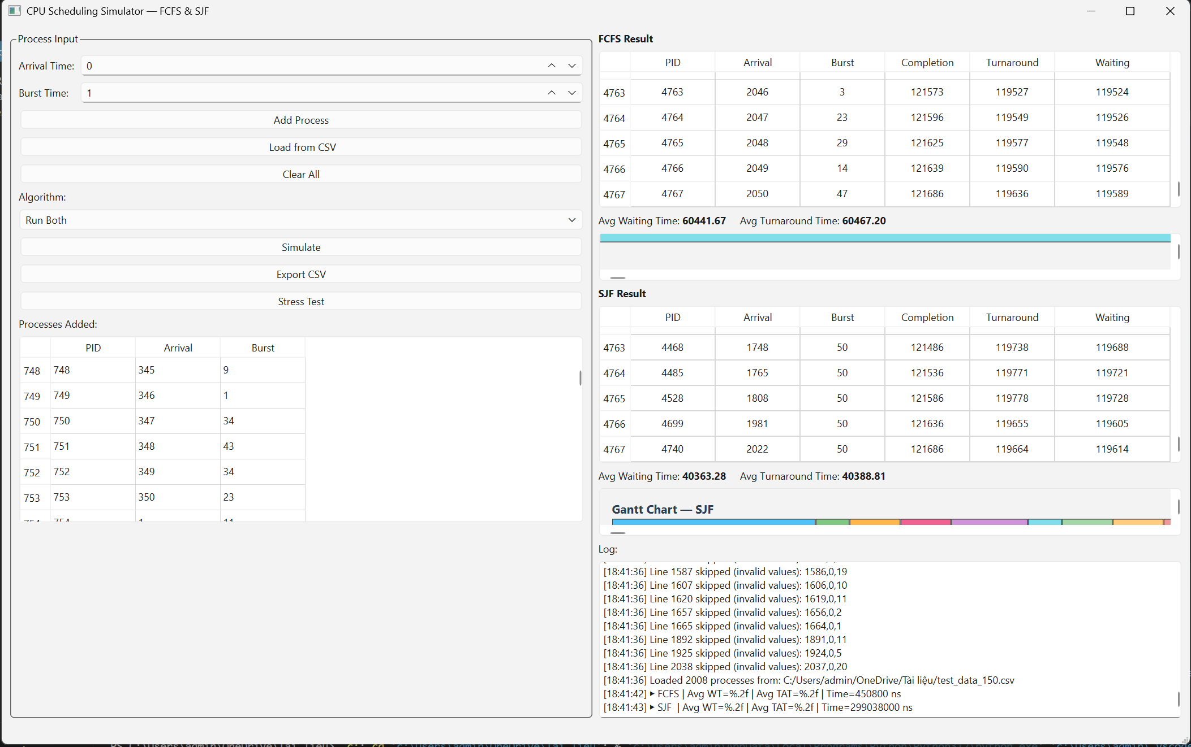
[18:41:42] ▶ FCFS | Avg WT=%.2f | Avg TAT=%.2f | Time=450800 ns
[18:41:43] ▶ SJF | Avg WT=%.2f | Avg TAT=%.2f | Time=299038000 ns
[18:42:20] Line 28 skipped (invalid values): 27,0,5
[18:42:20] Line 95 skipped (invalid values): 94,0,12
[18:42:20] Line 96 skipped (invalid values): 95,0,2
[18:42:20] Line 169 skipped (invalid values): 168,0,12
[18:42:20] Line 199 skipped (invalid values): 198,0,6
[18:42:20] Line 393 skipped (invalid values): 392,0,2
[18:42:20] Line 431 skipped (invalid values): 430,0,16
[18:42:20] Line 474 skipped (invalid values): 473,0,9
[18:42:20] Line 519 skipped (invalid values): 518,0,6
[18:42:20] Line 541 skipped (invalid values): 540,0,19
[18:42:20] Line 567 skipped (invalid values): 566,0,10
[18:42:20] Line 587 skipped (invalid values): 586,0,13
[18:42:20] Line 606 skipped (invalid values): 605,0,15
[18:42:20] Line 619 skipped (invalid values): 618,0,1
[18:42:20] Line 626 skipped (invalid values): 625,0,6
[18:42:20] Line 788 skipped (invalid values): 787,0,8
[18:42:20] Line 1023 skipped (invalid values): 1022,0,20
[18:42:20] Line 1065 skipped (invalid values): 1064,0,18
[18:42:20] Line 1151 skipped (invalid values): 1150,0,18
[18:42:20] Line 1171 skipped (invalid values): 1170,0,16
[18:42:20] Line 1175 skipped (invalid values): 1174,0,3
[18:42:20] Line 1307 skipped (invalid values): 1306,0,10
[18:42:20] Line 1310 skipped (invalid values): 1309,0,19
[18:42:20] Line 1446 skipped (invalid values): 1445,0,8
[18:42:20] Line 1455 skipped (invalid values): 1454,0,8
[18:42:20] Line 1490 skipped (invalid values): 1489,0,19
[18:42:20] Line 1566 skipped (invalid values): 1565,0,3
[18:42:20] Line 1635 skipped (invalid values): 1634,0,14
[18:42:20] Line 1764 skipped (invalid values): 1763,0,6
[18:42:20] Line 1800 skipped (invalid values): 1799,0,7
[18:42:20] Line 1831 skipped (invalid values): 1830,0,16
[18:42:20] Line 1945 skipped (invalid values): 1944,0,4
[18:42:20] Line 1972 skipped (invalid values): 1971,0,3
[18:42:20] Line 1983 skipped (invalid values): 1982,0,15
[18:42:20] Line 2035 skipped (invalid values): 2034,0,9
[18:42:20] Line 2042 skipped (invalid values): 2041,0,5
[18:42:20] Line 2066 skipped (invalid values): 2065,0,4
[18:42:21] Line 2217 skipped (invalid values): 2216,0,2
[18:42:21] Line 2286 skipped (invalid values): 2285,0,12
[18:42:21] Line 2336 skipped (invalid values): 2335,0,18
[18:42:21] Line 2582 skipped (invalid values): 2581,0,20
[18:42:21] Line 2704 skipped (invalid values): 2703,0,2
[18:42:21] Line 2709 skipped (invalid values): 2708,0,13
[18:42:21] Line 2910 skipped (invalid values): 2909,0,2
[18:42:21] Line 2983 skipped (invalid values): 2982,0,3
[18:42:21] Line 3011 skipped (invalid values): 3010,0,18
[18:42:21] Line 3135 skipped (invalid values): 3134,0,6
[18:42:21] Line 3138 skipped (invalid values): 3137,0,19
[18:42:21] Line 3227 skipped (invalid values): 3226,0,5
[18:42:21] Line 3230 skipped (invalid values): 3229,0,19
[18:42:21] Line 3407 skipped (invalid values): 3406,0,14
[18:42:21] Line 3514 skipped (invalid values): 3513,0,6
[18:42:21] Line 3538 skipped (invalid values): 3537,0,10
[18:42:21] Line 3630 skipped (invalid values): 3629,0,9
[18:42:21] Line 3790 skipped (invalid values): 3789,0,18
[18:42:21] Line 3834 skipped (invalid values): 3833,0,20
[18:42:21] Line 3975 skipped (invalid values): 3974,0,18
[18:42:21] Line 4026 skipped (invalid values): 4025,0,2
[18:42:21] Line 4105 skipped (invalid values): 4104,0,6
[18:42:21] Line 4184 skipped (invalid values): 4183,0,19
[18:42:21] Line 4223 skipped (invalid values): 4222,0,7
[18:42:21] Line 4276 skipped (invalid values): 4275,0,17
[18:42:21] Line 4317 skipped (invalid values): 4316,0,17
[18:42:21] Line 4345 skipped (invalid values): 4344,0,14
[18:42:21] Line 4366 skipped (invalid values): 4365,0,13
[18:42:21] Line 4371 skipped (invalid values): 4370,0,18
[18:42:21] Line 4397 skipped (invalid values): 4396,0,8
[18:42:21] Line 4465 skipped (invalid values): 4464,0,6
[18:42:21] Line 4510 skipped (invalid values): 4509,0,13
[18:42:21] Line 4688 skipped (invalid values): 4687,0,19
[18:42:21] Line 4739 skipped (invalid values): 4738,0,10
[18:42:21] Line 4789 skipped (invalid values): 4788,0,1
[18:42:21] Line 4815 skipped (invalid values): 4814,0,6
[18:42:21] Line 4927 skipped (invalid values): 4926,0,14
[18:42:21] Line 5027 skipped (invalid values): 5026,0,12
[18:42:21] Loaded 4975 processes from: C:/Users/admin/OneDrive/Tài liệu/test_data_150.csv
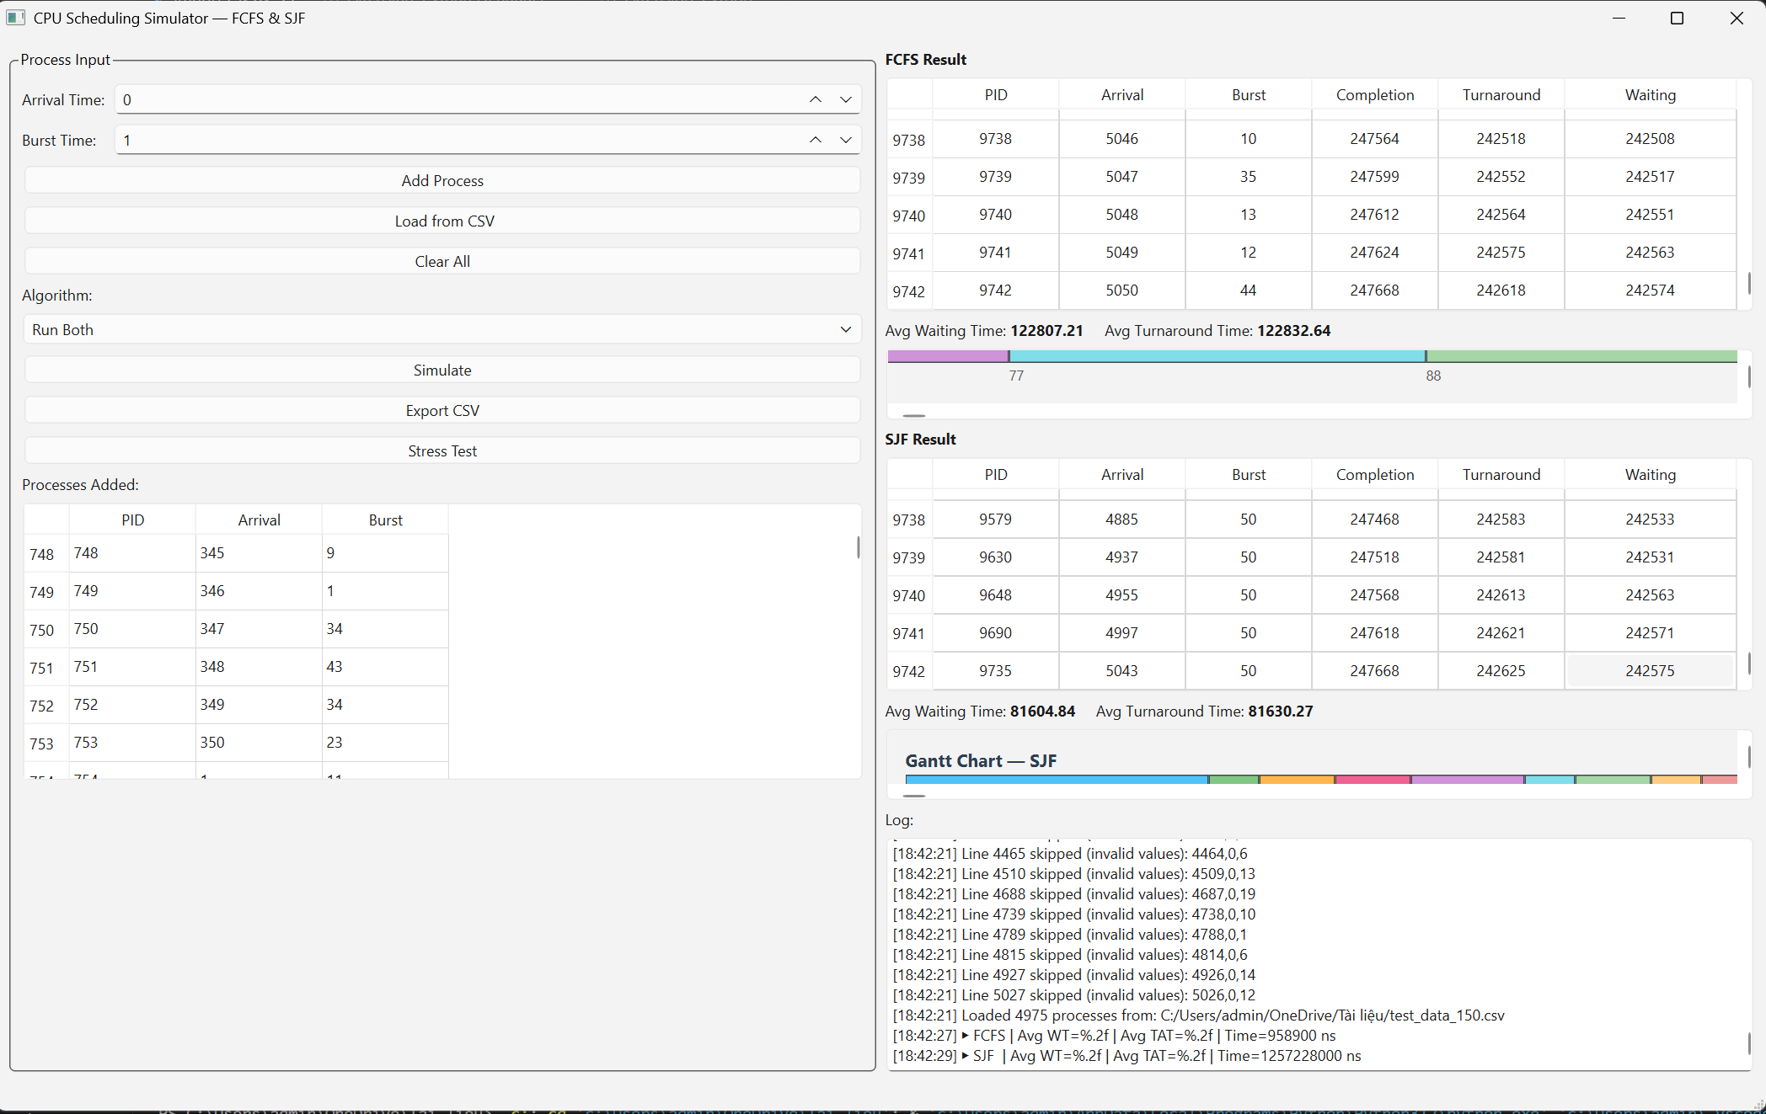
[18:42:27] ▶ FCFS | Avg WT=%.2f | Avg TAT=%.2f | Time=958900 ns
[18:42:29] ▶ SJF | Avg WT=%.2f | Avg TAT=%.2f | Time=1257228000 ns
[18:43:09] Line 115 skipped (invalid values): 114,0,6
[18:43:09] Line 171 skipped (invalid values): 170,0,6
[18:43:09] Line 194 skipped (invalid values): 193,0,15
[18:43:09] Line 198 skipped (invalid values): 197,0,19
[18:43:09] Line 208 skipped (invalid values): 207,0,15
[18:43:09] Line 225 skipped (invalid values): 224,0,1
[18:43:09] Line 440 skipped (invalid values): 439,0,2
[18:43:09] Line 464 skipped (invalid values): 463,0,18
[18:43:09] Line 521 skipped (invalid values): 520,0,8
[18:43:09] Line 620 skipped (invalid values): 619,0,19
[18:43:09] Line 651 skipped (invalid values): 650,0,9
[18:43:09] Line 727 skipped (invalid values): 726,0,2
[18:43:09] Line 732 skipped (invalid values): 731,0,9
[18:43:09] Line 827 skipped (invalid values): 826,0,8
[18:43:09] Line 885 skipped (invalid values): 884,0,19
[18:43:09] Line 964 skipped (invalid values): 963,0,13
[18:43:09] Line 979 skipped (invalid values): 978,0,7
[18:43:09] Line 1046 skipped (invalid values): 1045,0,6
[18:43:09] Line 1100 skipped (invalid values): 1099,0,13
[18:43:09] Line 1145 skipped (invalid values): 1144,0,5
[18:43:09] Line 1316 skipped (invalid values): 1315,0,9
[18:43:09] Line 1323 skipped (invalid values): 1322,0,2
[18:43:09] Line 1334 skipped (invalid values): 1333,0,2
[18:43:09] Line 1343 skipped (invalid values): 1342,0,11
[18:43:09] Line 1413 skipped (invalid values): 1412,0,13
[18:43:09] Line 1484 skipped (invalid values): 1483,0,4
[18:43:09] Line 1496 skipped (invalid values): 1495,0,2
[18:43:09] Line 1590 skipped (invalid values): 1589,0,7
[18:43:09] Line 1603 skipped (invalid values): 1602,0,12
[18:43:09] Line 1747 skipped (invalid values): 1746,0,5
[18:43:09] Line 1756 skipped (invalid values): 1755,0,15
[18:43:09] Line 1816 skipped (invalid values): 1815,0,19
[18:43:09] Line 1824 skipped (invalid values): 1823,0,2
[18:43:09] Line 1852 skipped (invalid values): 1851,0,11
[18:43:09] Line 1923 skipped (invalid values): 1922,0,14
[18:43:09] Line 1931 skipped (invalid values): 1930,0,6
[18:43:09] Line 1933 skipped (invalid values): 1932,0,10
[18:43:09] Line 1953 skipped (invalid values): 1952,0,10
[18:43:09] Line 1981 skipped (invalid values): 1980,0,15
[18:43:09] Line 2016 skipped (invalid values): 2015,0,20
[18:43:09] Line 2026 skipped (invalid values): 2025,0,6
[18:43:09] Line 2039 skipped (invalid values): 2038,0,17
[18:43:09] Line 2103 skipped (invalid values): 2102,0,8
[18:43:09] Line 2191 skipped (invalid values): 2190,0,2
[18:43:09] Line 2231 skipped (invalid values): 2230,0,18
[18:43:09] Line 2249 skipped (invalid values): 2248,0,3
[18:43:09] Line 2253 skipped (invalid values): 2252,0,15
[18:43:09] Line 2381 skipped (invalid values): 2380,0,6
[18:43:09] Line 2508 skipped (invalid values): 2507,0,10
[18:43:09] Line 2694 skipped (invalid values): 2693,0,19
[18:43:09] Line 2808 skipped (invalid values): 2807,0,15
[18:43:09] Line 2840 skipped (invalid values): 2839,0,17
[18:43:09] Line 2842 skipped (invalid values): 2841,0,20
[18:43:09] Line 2877 skipped (invalid values): 2876,0,19
[18:43:09] Line 2892 skipped (invalid values): 2891,0,19
[18:43:09] Line 2924 skipped (invalid values): 2923,0,8
[18:43:09] Line 3036 skipped (invalid values): 3035,0,14
[18:43:09] Line 3045 skipped (invalid values): 3044,0,4
[18:43:09] Line 3104 skipped (invalid values): 3103,0,5
[18:43:09] Line 3173 skipped (invalid values): 3172,0,7
[18:43:09] Line 3175 skipped (invalid values): 3174,0,10
[18:43:09] Line 3225 skipped (invalid values): 3224,0,10
[18:43:09] Line 3265 skipped (invalid values): 3264,0,6
[18:43:09] Line 3314 skipped (invalid values): 3313,0,9
[18:43:09] Line 3485 skipped (invalid values): 3484,0,12
[18:43:09] Line 3598 skipped (invalid values): 3597,0,17
[18:43:09] Line 3622 skipped (invalid values): 3621,0,7
[18:43:09] Line 3624 skipped (invalid values): 3623,0,3
[18:43:09] Line 3758 skipped (invalid values): 3757,0,6
[18:43:09] Line 3799 skipped (invalid values): 3798,0,17
[18:43:09] Line 3822 skipped (invalid values): 3821,0,20
[18:43:09] Line 3861 skipped (invalid values): 3860,0,10
[18:43:09] Line 3870 skipped (invalid values): 3869,0,12
[18:43:09] Line 3910 skipped (invalid values): 3909,0,19
[18:43:09] Line 3932 skipped (invalid values): 3931,0,1
[18:43:09] Line 3943 skipped (invalid values): 3942,0,19
[18:43:09] Line 3978 skipped (invalid values): 3977,0,12
[18:43:09] Line 4095 skipped (invalid values): 4094,0,6
[18:43:09] Line 4222 skipped (invalid values): 4221,0,14
[18:43:09] Line 4290 skipped (invalid values): 4289,0,16
[18:43:09] Line 4389 skipped (invalid values): 4388,0,6
[18:43:09] Line 4422 skipped (invalid values): 4421,0,20
[18:43:09] Line 4474 skipped (invalid values): 4473,0,6
[18:43:09] Line 4555 skipped (invalid values): 4554,0,11
[18:43:09] Line 4617 skipped (invalid values): 4616,0,4
[18:43:09] Line 4621 skipped (invalid values): 4620,0,7
[18:43:09] Line 4622 skipped (invalid values): 4621,0,6
[18:43:09] Line 4628 skipped (invalid values): 4627,0,13
[18:43:09] Line 4836 skipped (invalid values): 4835,0,18
[18:43:09] Line 4861 skipped (invalid values): 4860,0,11
[18:43:09] Line 4935 skipped (invalid values): 4934,0,11
[18:43:09] Line 4999 skipped (invalid values): 4998,0,17
[18:43:09] Line 5060 skipped (invalid values): 5059,0,20
[18:43:09] Line 5081 skipped (invalid values): 5080,0,11
[18:43:09] Line 5127 skipped (invalid values): 5126,0,14
[18:43:09] Line 5135 skipped (invalid values): 5134,0,12
[18:43:09] Line 5151 skipped (invalid values): 5150,0,9
[18:43:09] Line 5165 skipped (invalid values): 5164,0,11
[18:43:09] Line 5282 skipped (invalid values): 5281,0,3
[18:43:09] Line 5291 skipped (invalid values): 5290,0,5
[18:43:09] Line 5313 skipped (invalid values): 5312,0,2
[18:43:09] Line 5327 skipped (invalid values): 5326,0,9
[18:43:09] Line 5424 skipped (invalid values): 5423,0,11
[18:43:09] Line 5522 skipped (invalid values): 5521,0,7
[18:43:09] Line 5533 skipped (invalid values): 5532,0,20
[18:43:09] Line 5564 skipped (invalid values): 5563,0,12
[18:43:09] Line 5717 skipped (invalid values): 5716,0,9
[18:43:09] Line 5753 skipped (invalid values): 5752,0,4
[18:43:09] Line 5786 skipped (invalid values): 5785,0,10
[18:43:09] Line 5817 skipped (invalid values): 5816,0,4
[18:43:09] Line 5842 skipped (invalid values): 5841,0,4
[18:43:09] Line 5866 skipped (invalid values): 5865,0,3
[18:43:09] Line 5885 skipped (invalid values): 5884,0,6
[18:43:09] Line 5890 skipped (invalid values): 5889,0,13
[18:43:09] Line 6002 skipped (invalid values): 6001,0,11
[18:43:09] Line 6011 skipped (invalid values): 6010,0,15
[18:43:09] Line 6032 skipped (invalid values): 6031,0,8
[18:43:09] Line 6044 skipped (invalid values): 6043,0,6
[18:43:09] Line 6079 skipped (invalid values): 6078,0,13
[18:43:09] Line 6109 skipped (invalid values): 6108,0,20
[18:43:09] Line 6114 skipped (invalid values): 6113,0,9
[18:43:09] Line 6162 skipped (invalid values): 6161,0,15
[18:43:09] Line 6186 skipped (invalid values): 6185,0,3
[18:43:09] Line 6206 skipped (invalid values): 6205,0,7
[18:43:09] Line 6242 skipped (invalid values): 6241,0,16
[18:43:09] Line 6259 skipped (invalid values): 6258,0,8
[18:43:09] Line 6386 skipped (invalid values): 6385,0,13
[18:43:09] Line 6461 skipped (invalid values): 6460,0,5
[18:43:09] Line 6469 skipped (invalid values): 6468,0,5
[18:43:09] Line 6498 skipped (invalid values): 6497,0,12
[18:43:09] Line 6510 skipped (invalid values): 6509,0,20
[18:43:09] Line 6595 skipped (invalid values): 6594,0,10
[18:43:09] Line 6644 skipped (invalid values): 6643,0,10
[18:43:09] Line 6662 skipped (invalid values): 6661,0,15
[18:43:09] Line 6799 skipped (invalid values): 6798,0,3
[18:43:09] Line 6807 skipped (invalid values): 6806,0,14
[18:43:09] Line 6833 skipped (invalid values): 6832,0,16
[18:43:09] Line 6840 skipped (invalid values): 6839,0,1
[18:43:09] Line 6884 skipped (invalid values): 6883,0,20
[18:43:09] Line 6885 skipped (invalid values): 6884,0,15
[18:43:09] Line 6936 skipped (invalid values): 6935,0,11
[18:43:09] Line 6955 skipped (invalid values): 6954,0,19
[18:43:09] Line 7015 skipped (invalid values): 7014,0,14
[18:43:09] Line 7017 skipped (invalid values): 7016,0,1
[18:43:09] Line 7075 skipped (invalid values): 7074,0,13
[18:43:09] Line 7115 skipped (invalid values): 7114,0,6
[18:43:09] Line 7208 skipped (invalid values): 7207,0,11
[18:43:09] Line 7268 skipped (invalid values): 7267,0,8
[18:43:09] Line 7313 skipped (invalid values): 7312,0,9
[18:43:09] Line 7368 skipped (invalid values): 7367,0,18
[18:43:09] Line 7486 skipped (invalid values): 7485,0,16
[18:43:09] Line 7490 skipped (invalid values): 7489,0,6
[18:43:09] Line 7545 skipped (invalid values): 7544,0,3
[18:43:09] Line 7668 skipped (invalid values): 7667,0,20
[18:43:09] Line 7689 skipped (invalid values): 7688,0,15
[18:43:09] Line 7706 skipped (invalid values): 7705,0,18
[18:43:09] Line 7732 skipped (invalid values): 7731,0,2
[18:43:09] Line 7747 skipped (invalid values): 7746,0,11
[18:43:09] Line 7874 skipped (invalid values): 7873,0,10
[18:43:09] Line 7882 skipped (invalid values): 7881,0,3
[18:43:09] Line 7917 skipped (invalid values): 7916,0,18
[18:43:09] Line 7919 skipped (invalid values): 7918,0,4
[18:43:09] Line 7950 skipped (invalid values): 7949,0,3
[18:43:09] Line 7982 skipped (invalid values): 7981,0,17
[18:43:09] Line 8000 skipped (invalid values): 7999,0,13
[18:43:09] Line 8038 skipped (invalid values): 8037,0,15
[18:43:09] Line 8065 skipped (invalid values): 8064,0,3
[18:43:09] Line 8204 skipped (invalid values): 8203,0,1
[18:43:09] Line 8217 skipped (invalid values): 8216,0,5
[18:43:09] Line 8255 skipped (invalid values): 8254,0,10
[18:43:09] Line 8386 skipped (invalid values): 8385,0,15
[18:43:09] Line 8429 skipped (invalid values): 8428,0,18
[18:43:09] Line 8527 skipped (invalid values): 8526,0,9
[18:43:09] Line 8594 skipped (invalid values): 8593,0,8
[18:43:09] Line 8792 skipped (invalid values): 8791,0,9
[18:43:09] Line 8916 skipped (invalid values): 8915,0,13
[18:43:09] Line 9003 skipped (invalid values): 9002,0,14
[18:43:09] Line 9024 skipped (invalid values): 9023,0,17
[18:43:09] Line 9069 skipped (invalid values): 9068,0,16
[18:43:09] Line 9100 skipped (invalid values): 9099,0,3
[18:43:09] Line 9153 skipped (invalid values): 9152,0,11
[18:43:09] Line 9158 skipped (invalid values): 9157,0,13
[18:43:09] Line 9165 skipped (invalid values): 9164,0,9
[18:43:09] Line 9166 skipped (invalid values): 9165,0,9
[18:43:09] Line 9203 skipped (invalid values): 9202,0,1
[18:43:09] Line 9241 skipped (invalid values): 9240,0,8
[18:43:09] Line 9260 skipped (invalid values): 9259,0,14
[18:43:09] Line 9291 skipped (invalid values): 9290,0,2
[18:43:09] Line 9295 skipped (invalid values): 9294,0,16
[18:43:09] Line 9365 skipped (invalid values): 9364,0,3
[18:43:09] Line 9484 skipped (invalid values): 9483,0,15
[18:43:09] Line 9493 skipped (invalid values): 9492,0,11
[18:43:09] Line 9571 skipped (invalid values): 9570,0,6
[18:43:09] Line 9647 skipped (invalid values): 9646,0,12
[18:43:09] Line 9724 skipped (invalid values): 9723,0,19
[18:43:09] Line 9780 skipped (invalid values): 9779,0,18
[18:43:09] Line 9785 skipped (invalid values): 9784,0,18
[18:43:09] Line 9807 skipped (invalid values): 9806,0,16
[18:43:09] Line 9845 skipped (invalid values): 9844,0,4
[18:43:09] Line 9945 skipped (invalid values): 9944,0,11
[18:43:09] Line 9982 skipped (invalid values): 9981,0,14
[18:43:09] Line 9992 skipped (invalid values): 9991,0,9
[18:43:09] Line 10022 skipped (invalid values): 10021,0,1
[18:43:09] Loaded 9847 processes from: C:/Users/admin/OneDrive/Tài liệu/test_data_150.csv
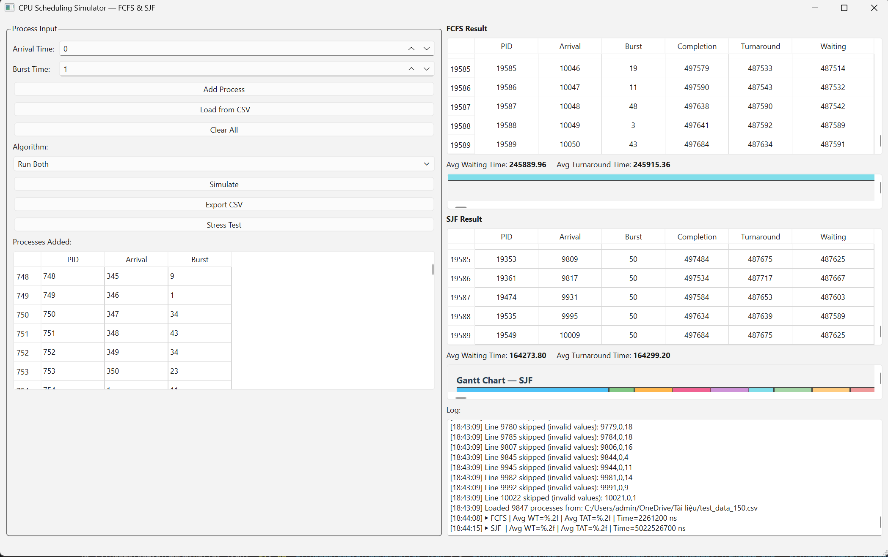
[18:44:08] ▶ FCFS | Avg WT=%.2f | Avg TAT=%.2f | Time=2261200 ns
[18:44:15] ▶ SJF | Avg WT=%.2f | Avg TAT=%.2f | Time=5022526700 ns

