Laboratory Work #2
Normalization & DDL

Normalization

Task 1
The Booking_receipt table violates the First Normal Form (1NF).
A relation is in 1NF if every value it stores is single-valued and atomic. The seat_numbers column stores a comma-separated list of values (e.g. "12A, 12B"), which means the values are not atomic — this directly violates the 1NF constraint.

Task 2

1NF
To bring the relation to 1NF, we remove the repeating group of values in seat_numbers by splitting the list of seats into separate rows. After the split, one row corresponds to one passenger within one booking, so the primary key becomes composite: (booking_id, passenger_passport_number).
Booking_receipt_1NF
booking_id (PK)
passenger_passport_number (PK)
passenger_full_name
flight_number
departure_airport_name
departure_city
arrival_airport_name
arrival_city
airline_name
seat_number
ticket_price

2NF
A relation is in 2NF if it satisfies 1NF and every non-key attribute is fully (not partially) dependent on the whole composite primary key. Attributes that depend on only part of the key are moved into separate tables.
Passengers
passenger_passport_number (PK)
passenger_full_name

Flights_2NF
flight_number (PK)
departure_airport_name
departure_city
arrival_airport_name
arrival_city
airline_name

Bookings
booking_id (PK)
flight_number (FK)
ticket_price

Tickets
booking_id (PK, FK)
passenger_passport_number (PK, FK)
seat_number

3NF
A relation is in 3NF if it satisfies all 2NF conditions and every transitive dependency of non-key attributes on the key has been removed. Cities depend on airports (not directly on the flight), so we move them into a separate table.
Airports
airport_name (PK)
city

Flights_3NF
flight_number (PK)
departure_airport_name (FK)
arrival_airport_name (FK)
airline_name

The Passengers, Bookings and Tickets tables remain the same as in 2NF.

Task 3
Functional dependencies used to justify each normalization step in Task 2:
- booking_id, passenger_passport_number → seat_number
- booking_id → flight_number, ticket_price
- passenger_passport_number → passenger_full_name
- flight_number → departure_airport_name, departure_city, arrival_airport_name, arrival_city, airline_name
- departure_airport_name → departure_city (transitive dependency)
- arrival_airport_name → arrival_city (transitive dependency)

Task 4
Current Primary Key: flight_id
Functional Dependencies:
flight_id → sch_departure_time, sch_arrival_time, departing_airport_id, arriving_airport_id, departing_gate, arriving_gate, airline_id, act_departure_time, act_arrival_time, created_at, updated_at
3NF Check: Yes, the Flights table is in 3NF.
A relation in 3NF must have no transitive dependencies of non-key attributes on the key column. Since airport and airline data has been moved into separate tables (Airport, Airline) and is represented here only by foreign keys (departing_airport_id, arriving_airport_id, airline_id), there are no transitive dependencies within the Flights table.

Task 5

SQL Implementation

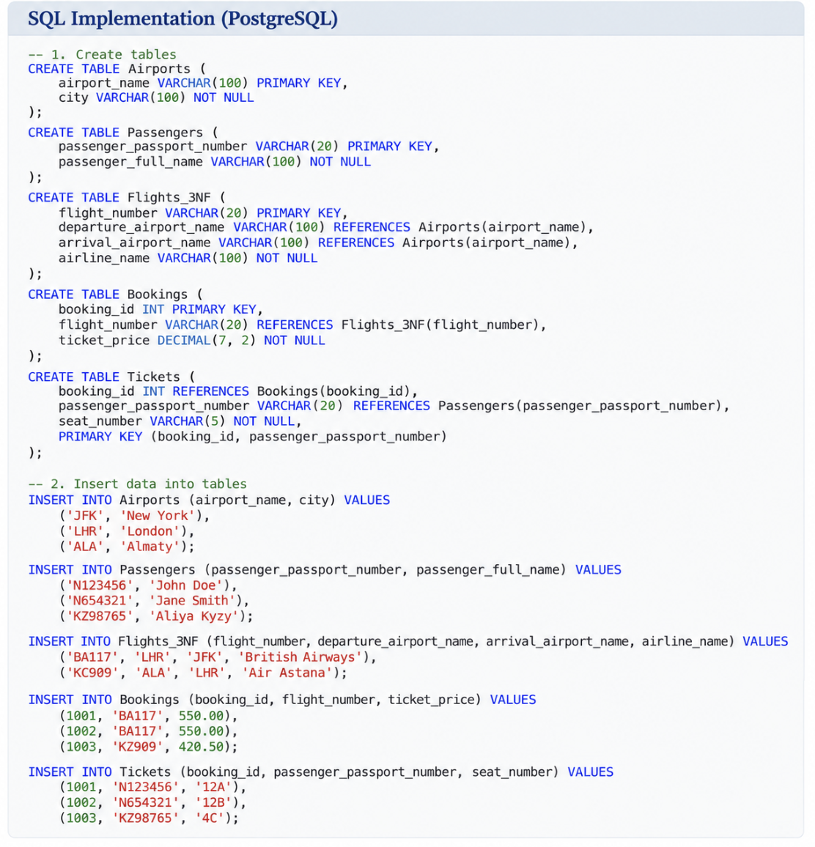

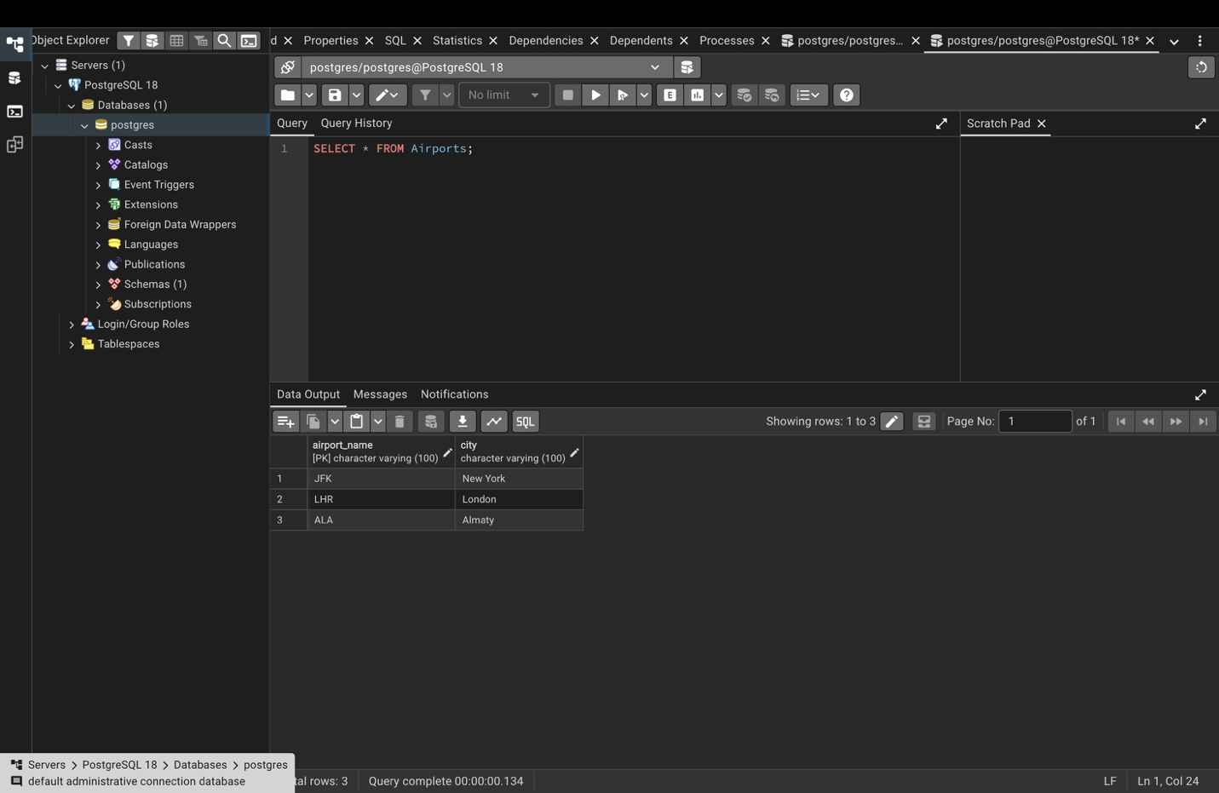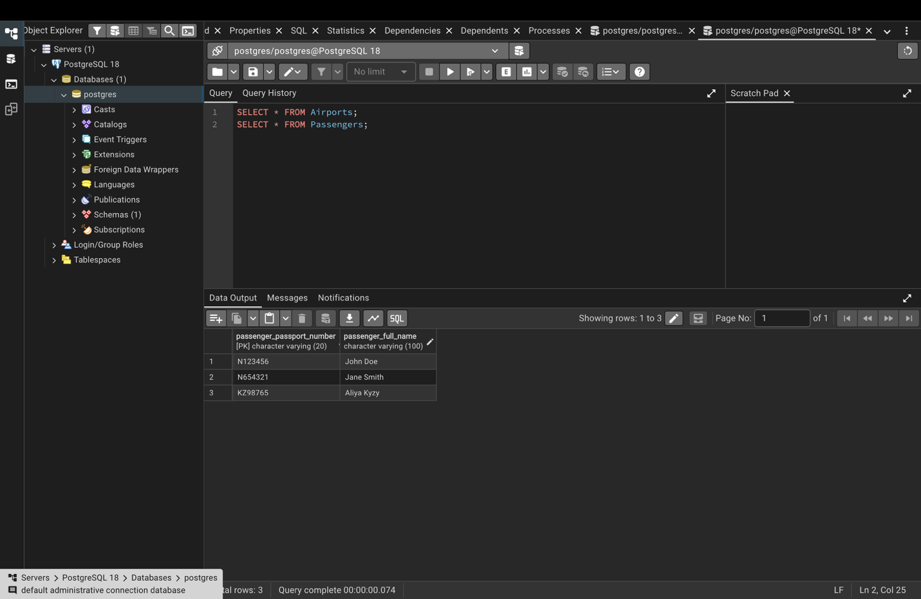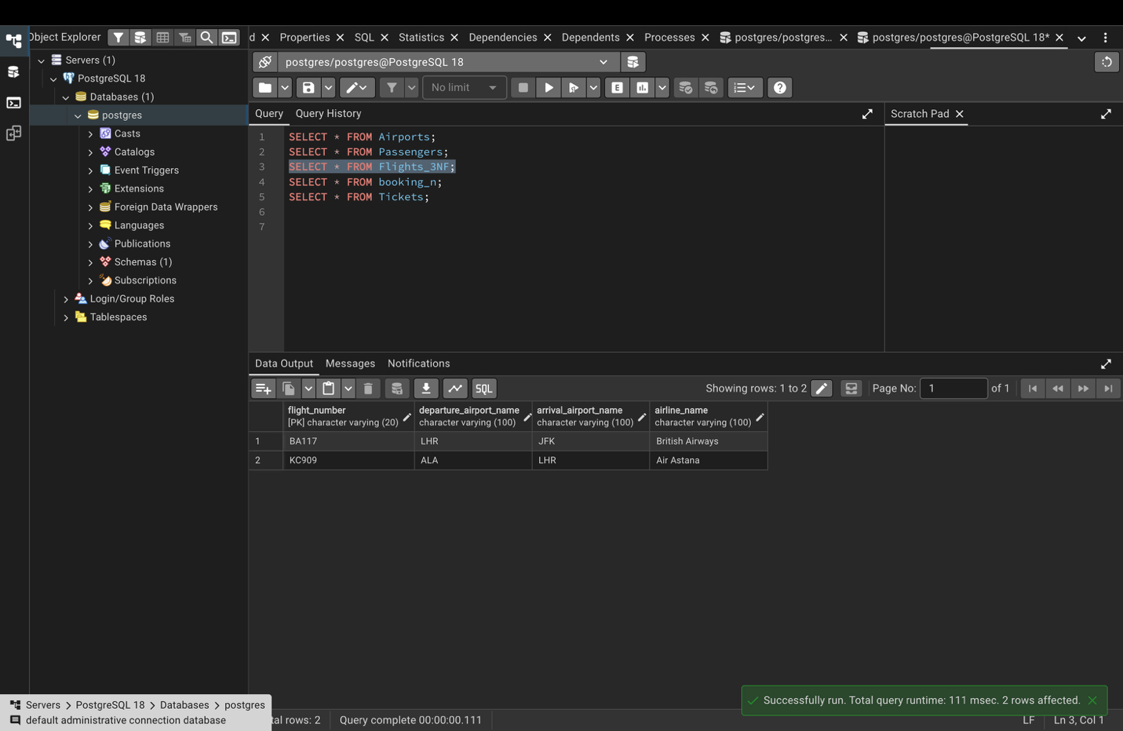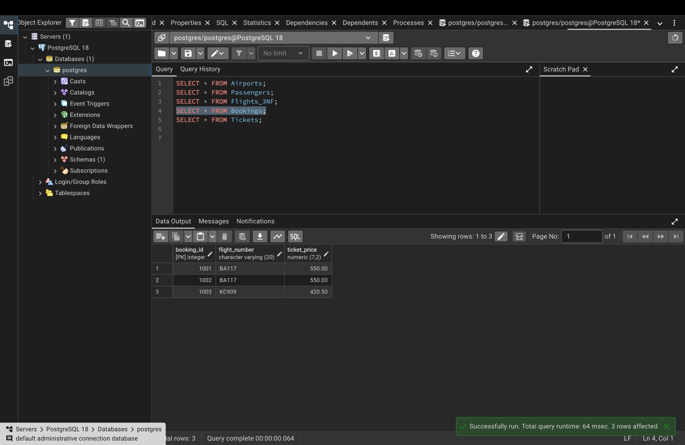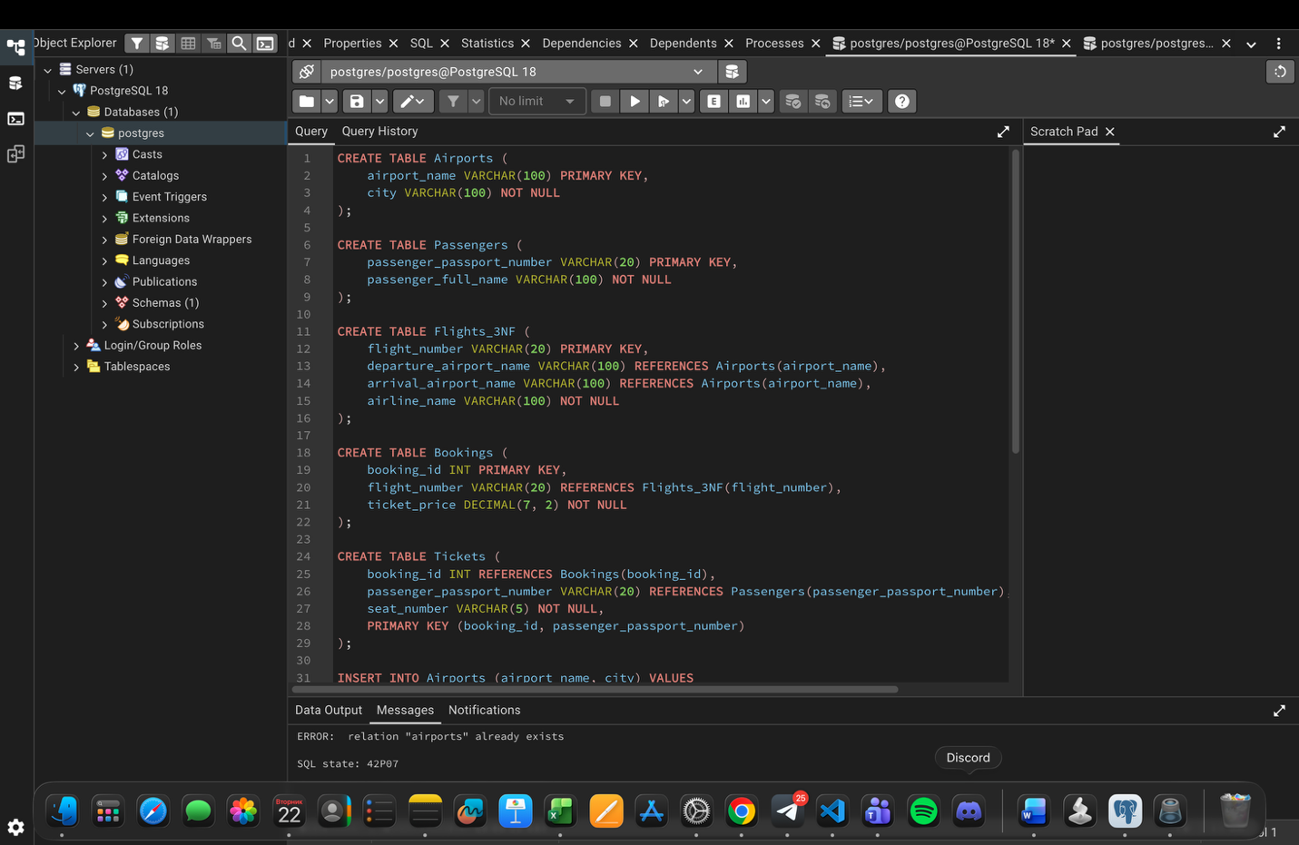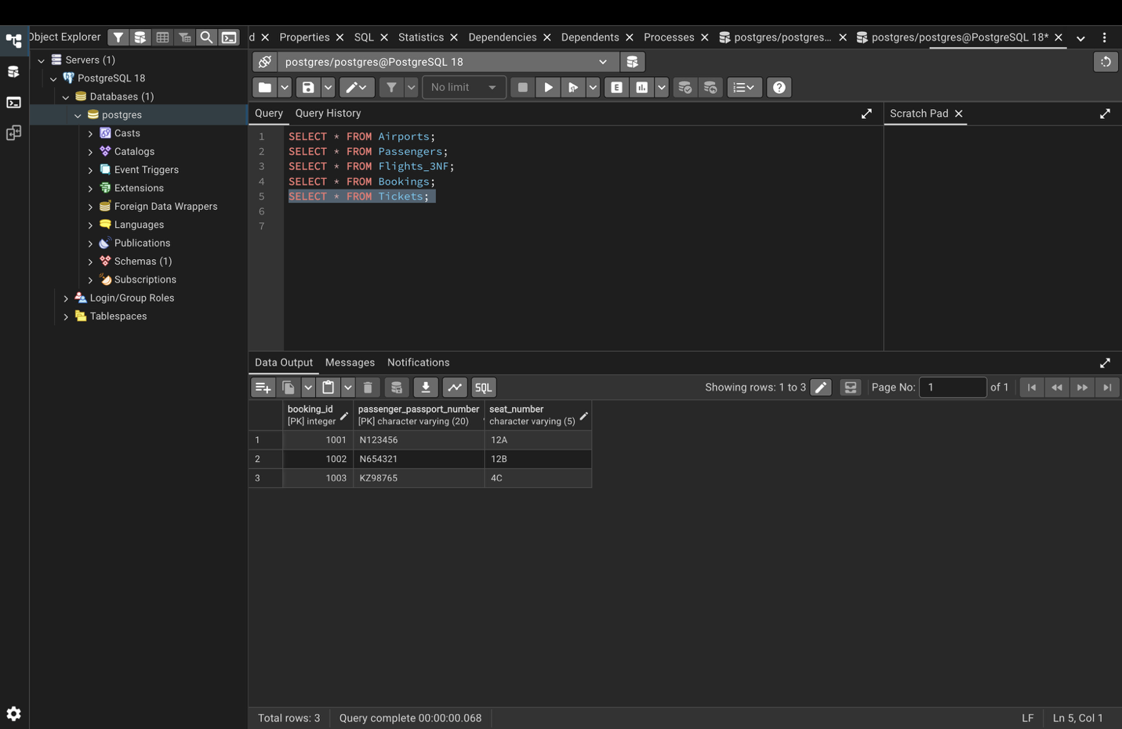

DDL

2. SQL Implementation and DDL

2.1 Task 5 — Database implementation
The normalized design was implemented in PostgreSQL. The DDL stage creates the required tables and then adds keys, constraints and relationships. The following ten tables are part of the implementation:
- Airline_info (renamed to Airline)
- Airport
- Baggage_check
- Baggage
- Boarding_pass
- Booking_flight
- Booking
- Flights
- Passengers
- Security_check

2.2 CREATE TABLE statements
The database tables were created with CREATE TABLE statements. The initial creation included the required attributes and data types; later ALTER TABLE statements were used to add constraints and apply the requested changes.
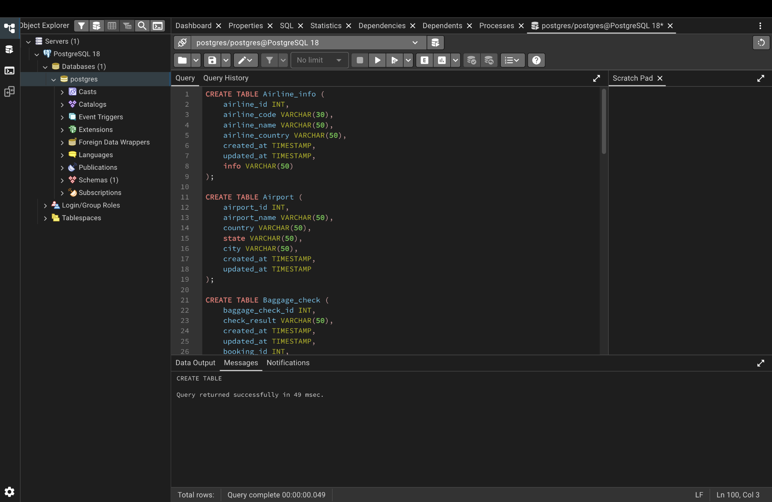
Figure 1. CREATE TABLE statements executed successfully in pgAdmin.

2.3 Primary keys
Primary keys were added to uniquely identify records in each table:
ALTER TABLE Airline
ADD PRIMARY KEY (airline_id);

ALTER TABLE Airport
ADD PRIMARY KEY (airport_id);

ALTER TABLE Baggage_check
ADD PRIMARY KEY (baggage_check_id);

ALTER TABLE Baggage
ADD PRIMARY KEY (baggage_id);

ALTER TABLE Boarding_pass
ADD PRIMARY KEY (boarding_pass_id);

ALTER TABLE Booking_flight
ADD PRIMARY KEY (booking_flight_id);

ALTER TABLE Booking
ADD PRIMARY KEY (booking_id);

ALTER TABLE Flights
ADD PRIMARY KEY (flight_id);

ALTER TABLE Passengers
ADD PRIMARY KEY (passenger_id);

ALTER TABLE Security_check
ADD PRIMARY KEY (security_check_id);

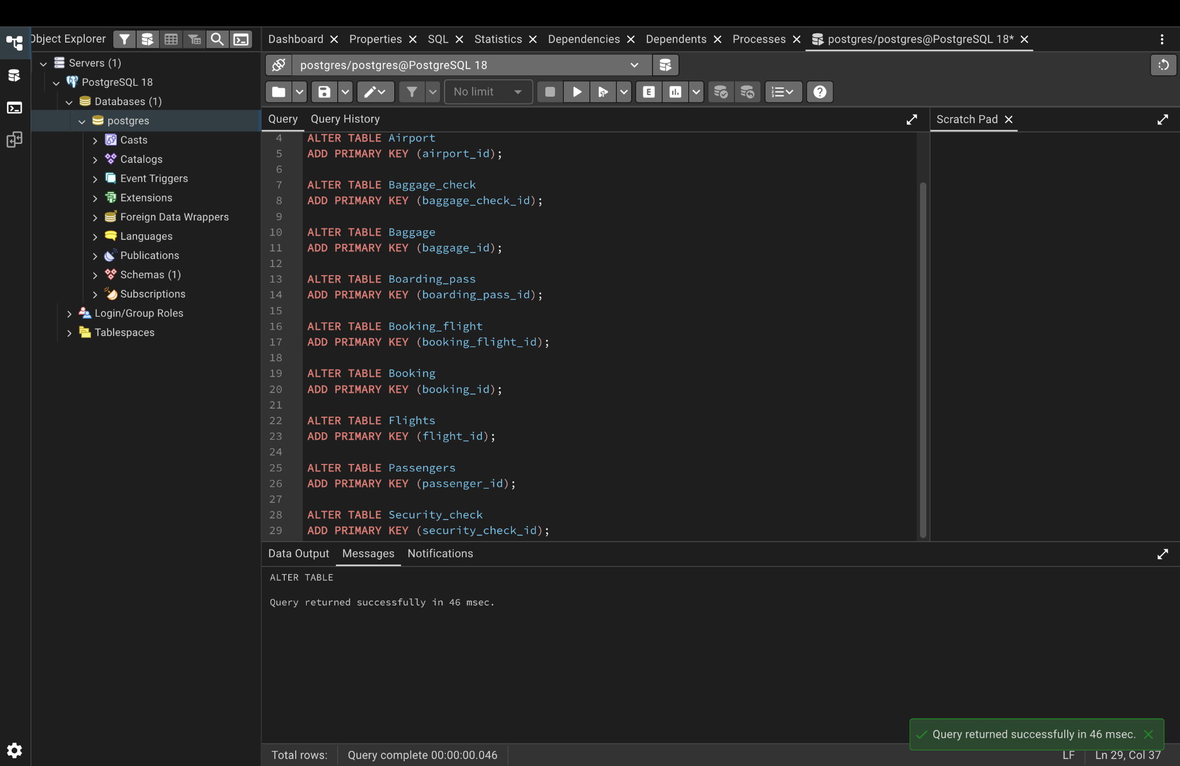
Figure 2. Primary-key definitions executed successfully.

2.4 NOT NULL constraints
NOT NULL constraints were applied to the required attributes. This prevents required fields from containing NULL values.
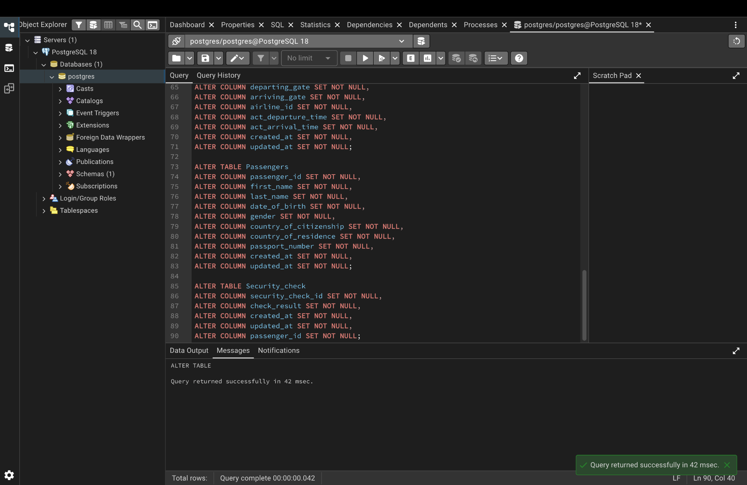
Figure 3. NOT NULL constraints applied to the database attributes.

2.5 ALTER TABLE operations

Rename Airline_info to Airline
ALTER TABLE Airline_info
RENAME TO Airline;

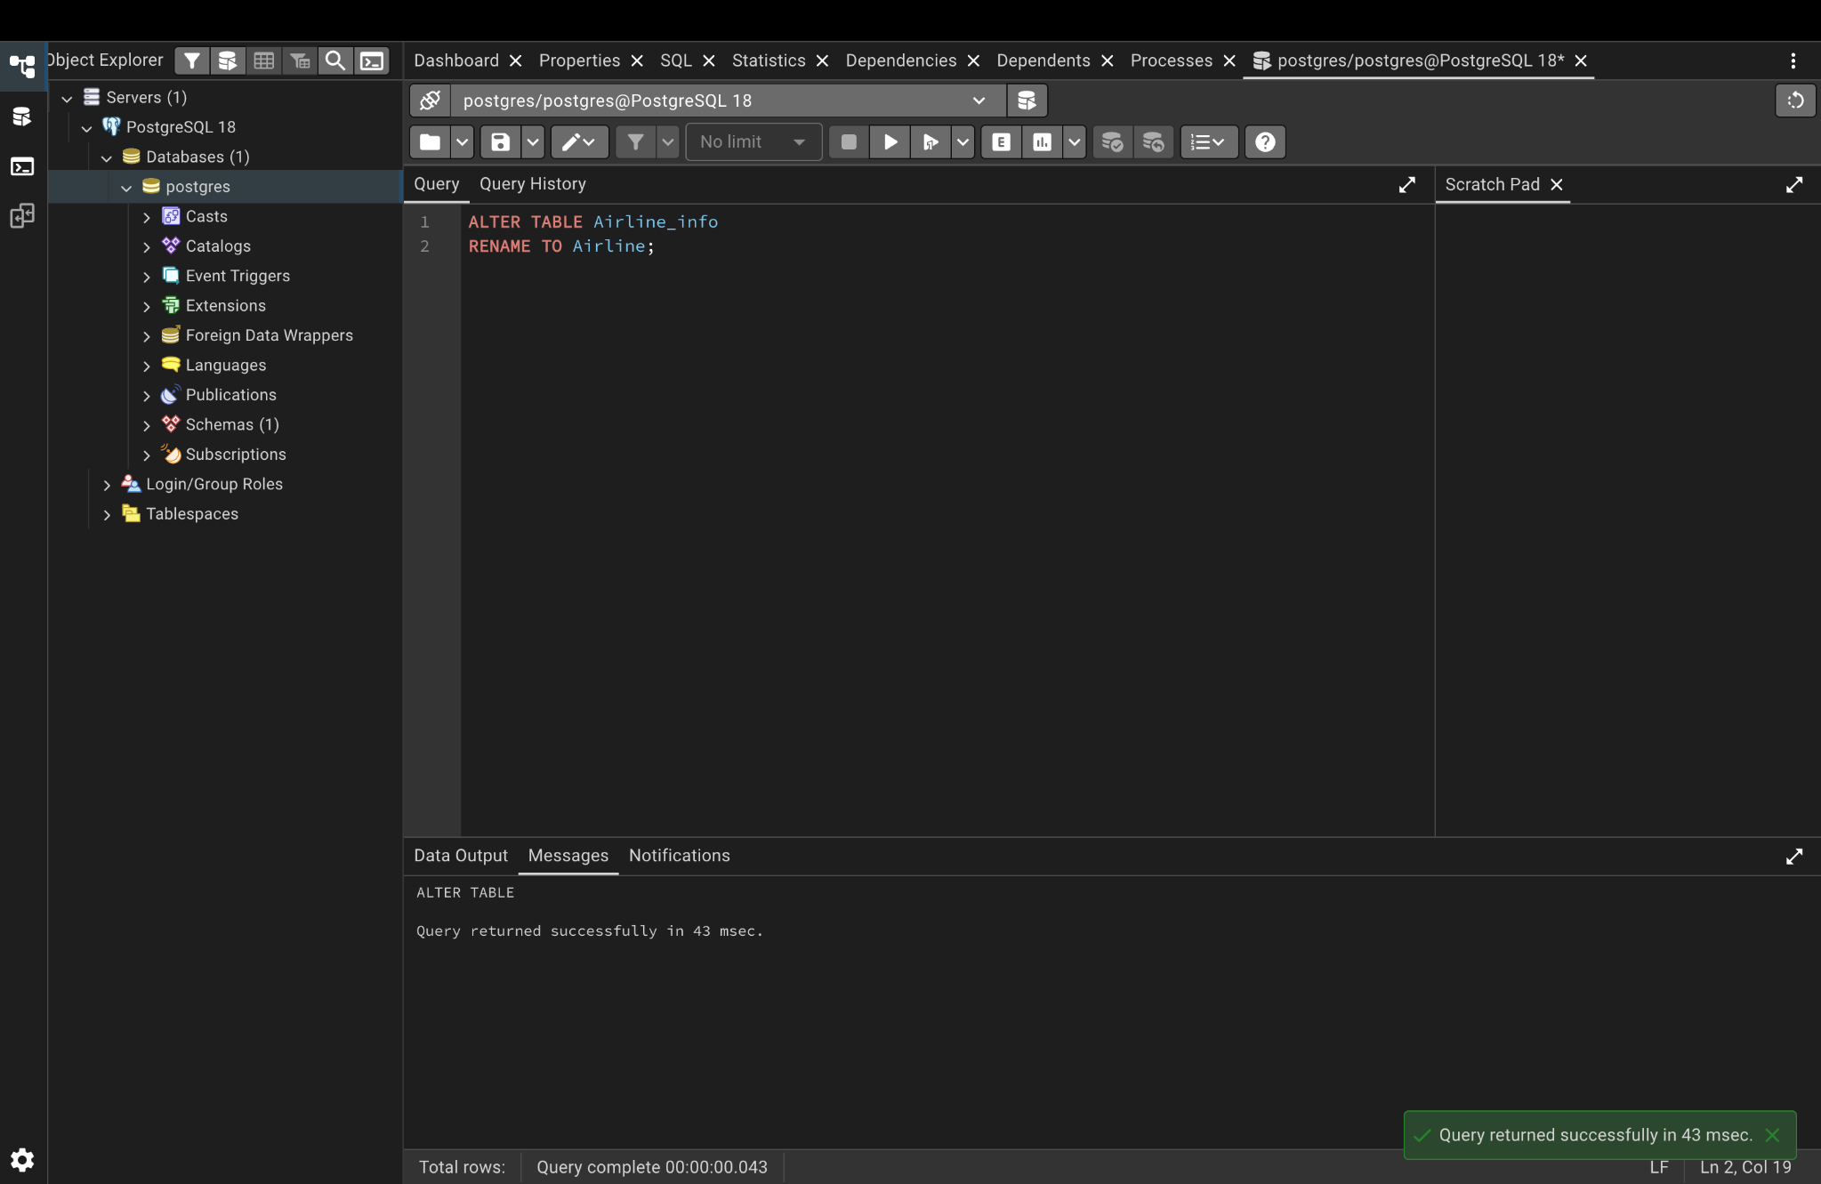
Figure 4. The Airline_info table was renamed to Airline.

Rename price to ticket_price
ALTER TABLE Booking
RENAME COLUMN price TO ticket_price;

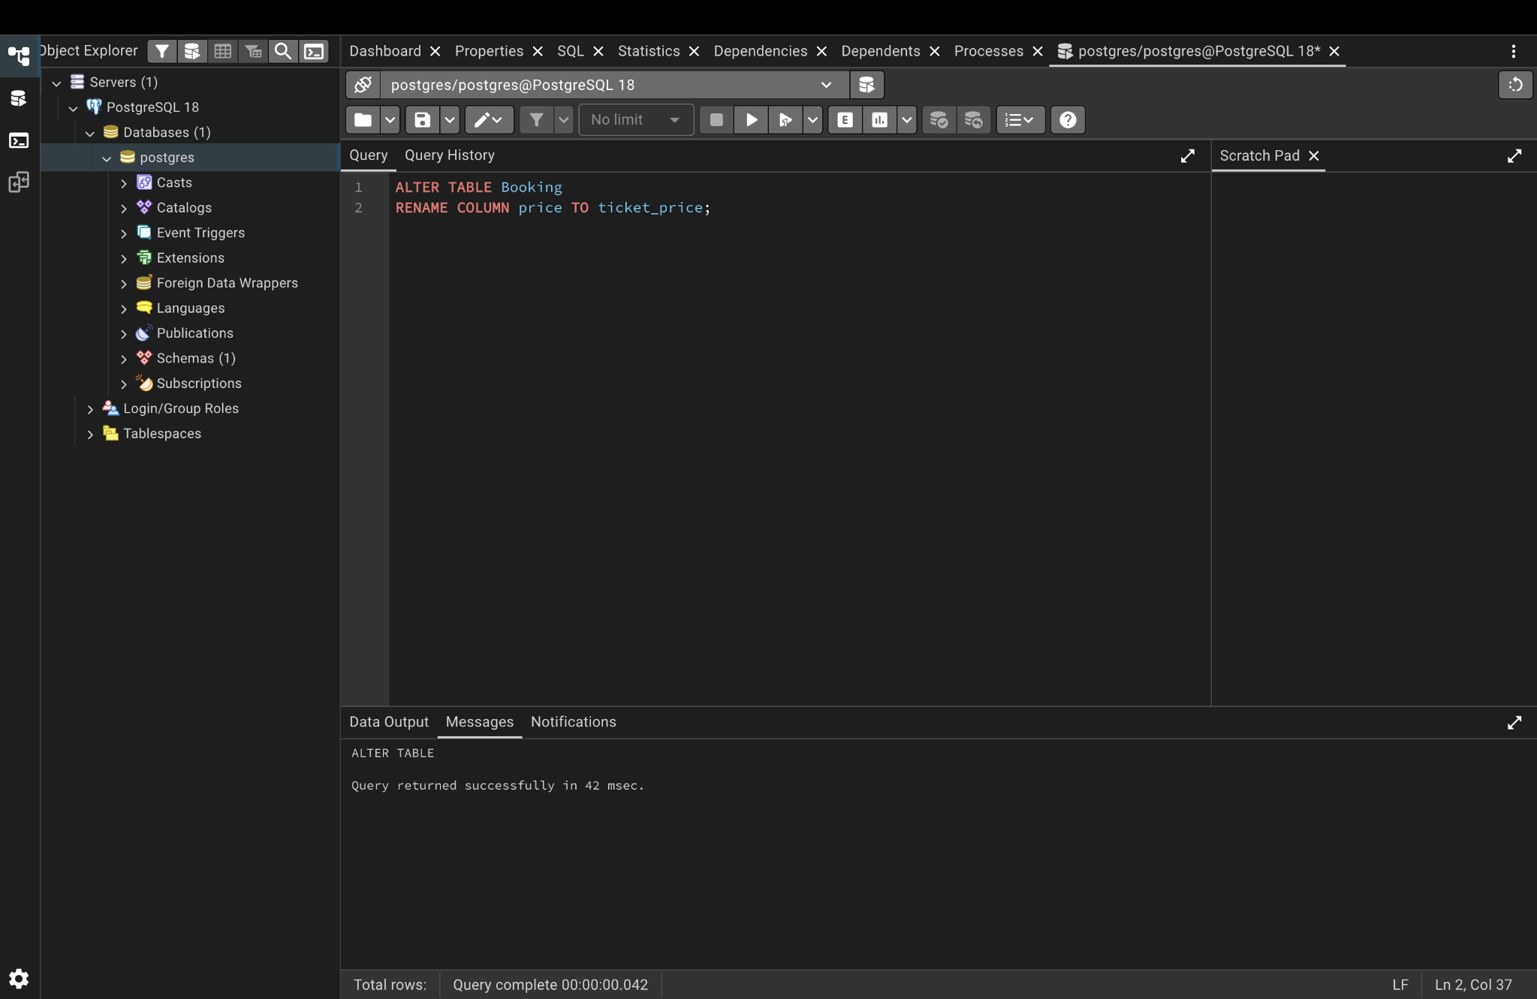
Figure 5. The price column was renamed to ticket_price.

Change departing_gate from VARCHAR(50) to TEXT
ALTER TABLE Flights
ALTER COLUMN departing_gate TYPE TEXT;

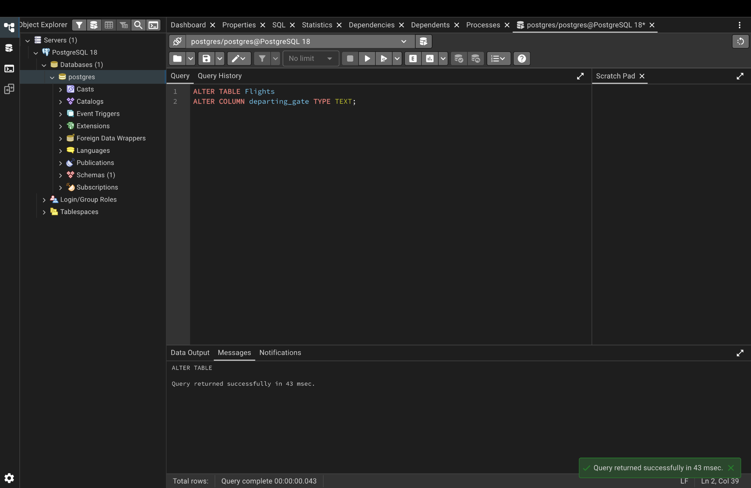
Figure 6. The departing_gate data type was changed to TEXT.

Drop the info column from Airline
ALTER TABLE Airline
DROP COLUMN info;

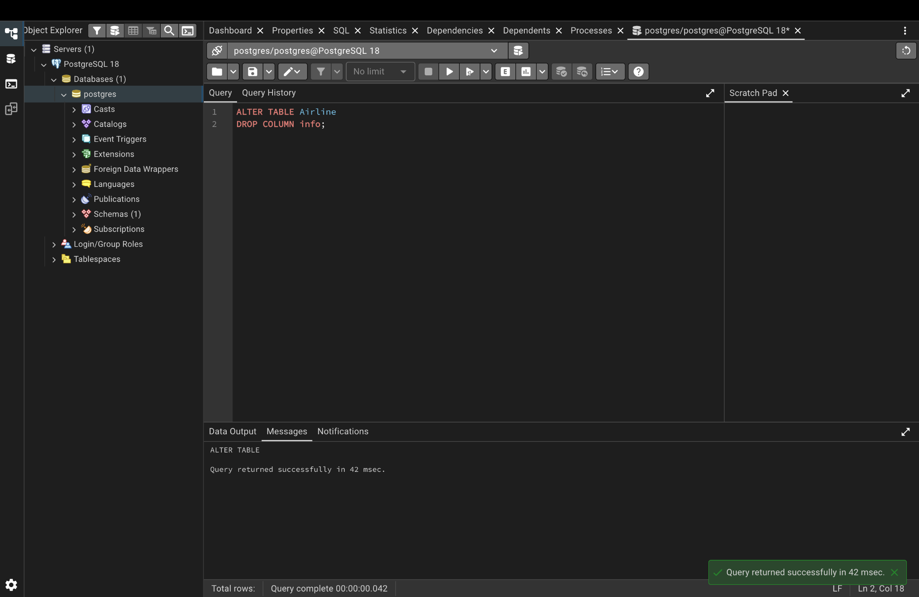
Figure 7. The unnecessary info column was removed from Airline.

2.6 Foreign-key relationships
The following foreign-key constraints establish the relationships between the tables:
ALTER TABLE Booking_flight
ADD CONSTRAINT fk_booking_flight_booking
FOREIGN KEY (booking_id)
REFERENCES Booking(booking_id);

ALTER TABLE Booking_flight
ADD CONSTRAINT fk_booking_flight_flight
FOREIGN KEY (flight_id)
REFERENCES Flights(flight_id);

ALTER TABLE Flights
ADD CONSTRAINT fk_flights_departing_airport
FOREIGN KEY (departing_airport_id)
REFERENCES Airport(airport_id);

ALTER TABLE Flights
ADD CONSTRAINT fk_flights_arriving_airport
FOREIGN KEY (arriving_airport_id)
REFERENCES Airport(airport_id);

ALTER TABLE Flights
ADD CONSTRAINT fk_flights_airline
FOREIGN KEY (airline_id)
REFERENCES Airline(airline_id);

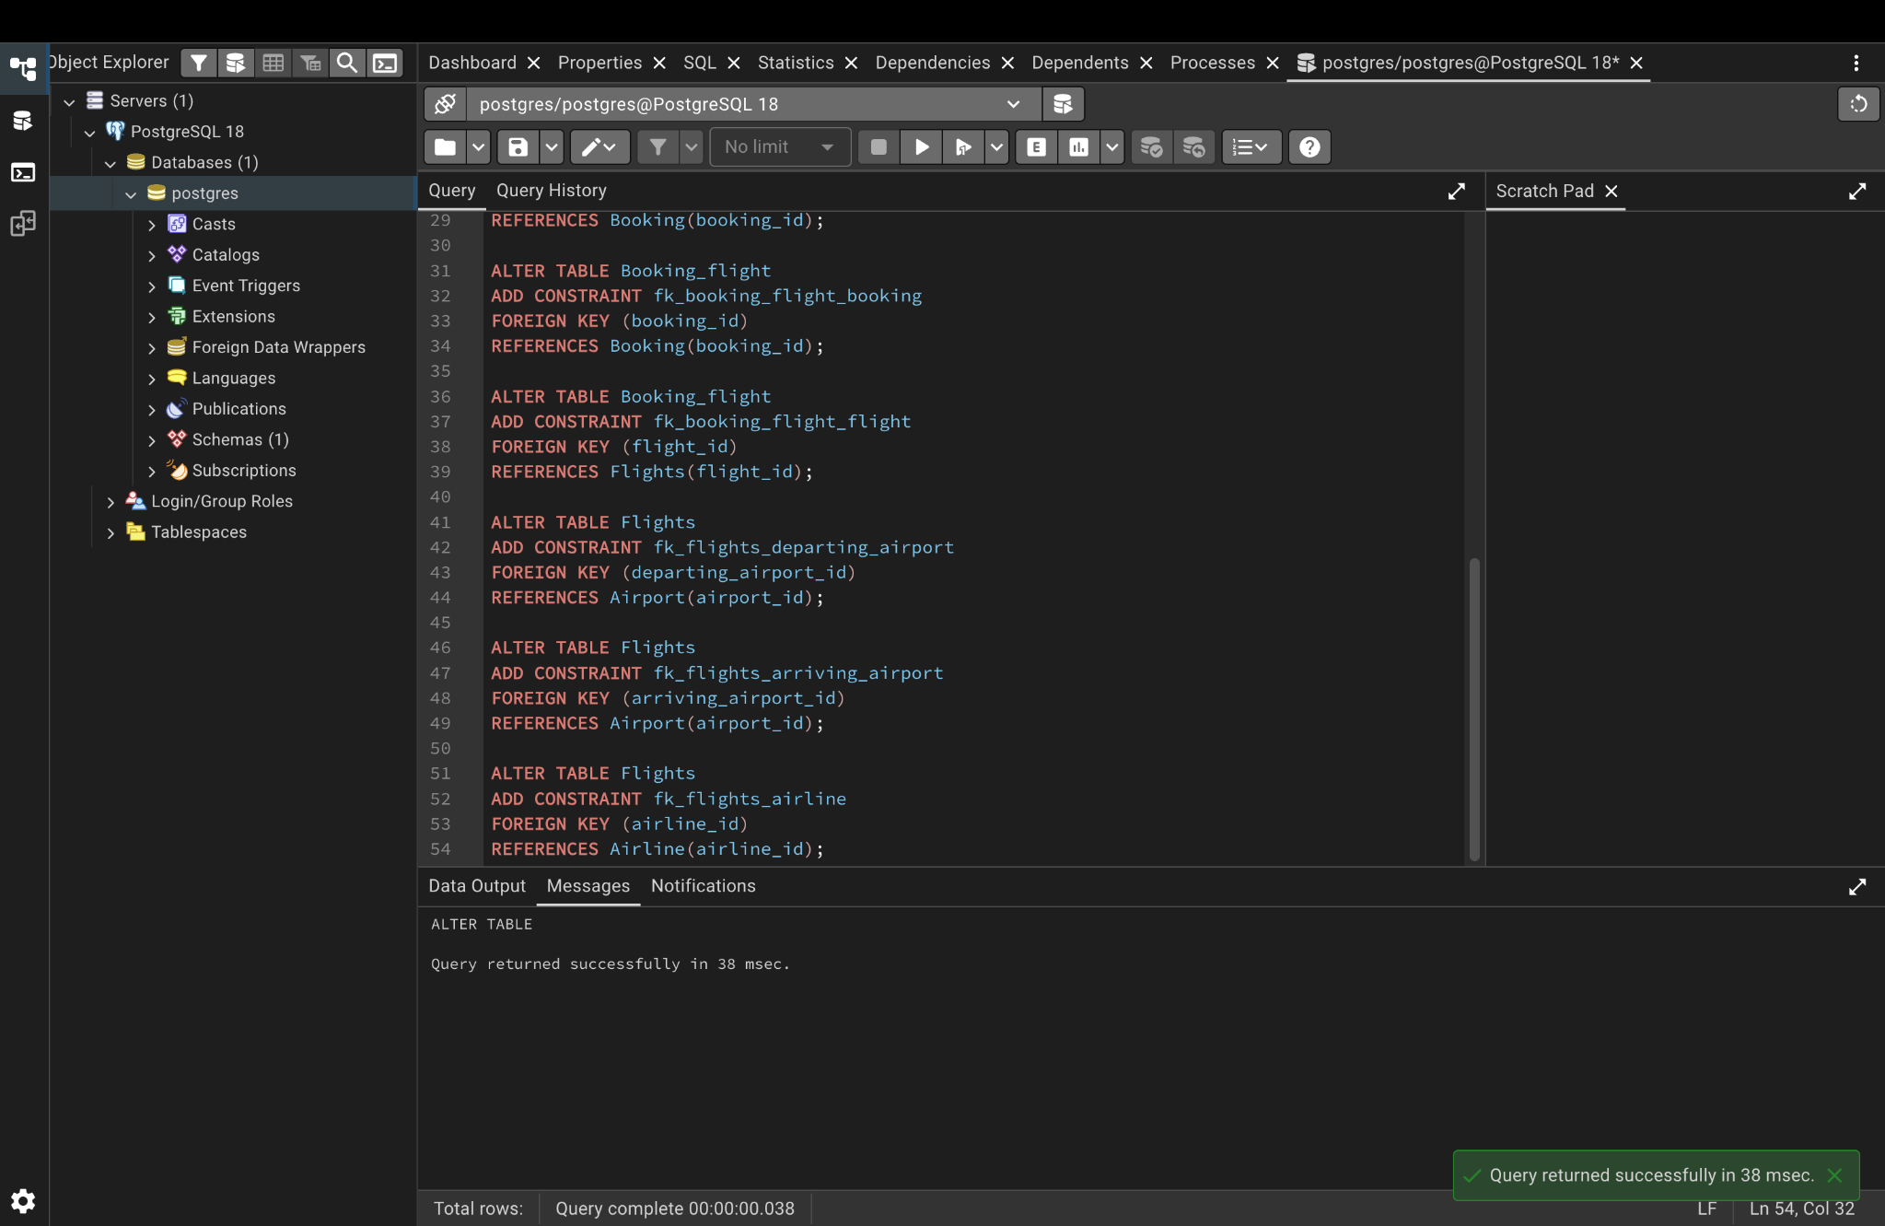
Figure 8. Foreign-key constraints were created successfully.

2.7 Verification query and result
After creating the relationships, the database metadata was queried through information_schema to verify which columns reference other tables.
SELECT
tc.table_name,
kcu.column_name,
ccu.table_name AS referenced_table,
ccu.column_name AS referenced_column
FROM information_schema.table_constraints AS tc
JOIN information_schema.key_column_usage AS kcu
ON tc.constraint_name = kcu.constraint_name
AND tc.table_schema = kcu.table_schema
JOIN information_schema.constraint_column_usage AS ccu
ON ccu.constraint_name = tc.constraint_name
AND ccu.table_schema = tc.table_schema
WHERE tc.constraint_type = 'FOREIGN KEY'
AND tc.table_schema = 'public'
ORDER BY tc.table_name;

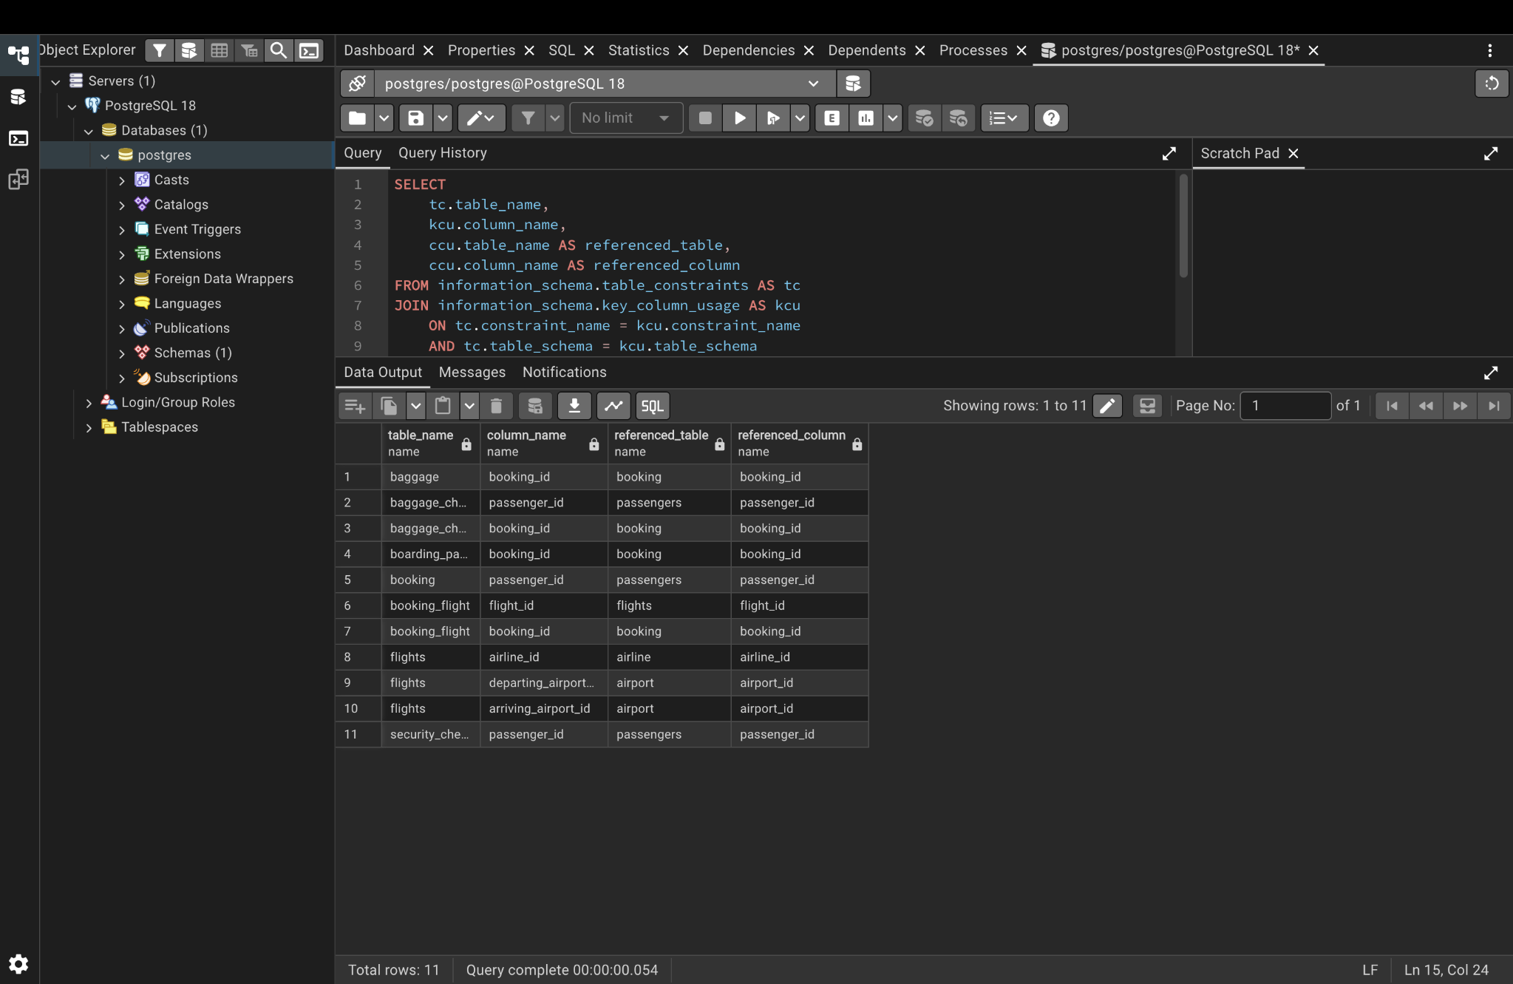
Figure 9. Verification query showing 11 foreign-key relationships.
The verification result contains 11 foreign-key relationships. It confirms references from Baggage, Baggage_check, Boarding_pass, Booking, Booking_flight, Flights and Security_check to their related tables.

3. Conclusion
In this laboratory work, the database design was normalized from 1NF through 3NF by removing repeating groups, partial dependencies and transitive dependencies. Functional dependencies were used to explain why attributes were separated into Passengers, Flights, Bookings, Tickets and Airports.
The resulting design was then implemented in PostgreSQL using DDL. The required tables were created, primary keys and NOT NULL constraints were added, and several ALTER TABLE operations were performed to rename objects, change a data type and remove an unnecessary column. Foreign keys were then created to connect the tables.
Finally, the information_schema query confirmed the foreign-key relationships in the database. Therefore, the laboratory demonstrates both the theoretical normalization process and its practical implementation in PostgreSQL.

