Corporate credit risk assessment
Portfolio model review | Independent work sample
Audience: technical reviewers and credit analysts. All borrowers and financial observations are synthetic.

Assessment
The logistic model ranks defaults more effectively than the benchmark tree in the held-out cohort: ROC-AUC is 0.745 versus 0.711. Its mean predicted default probability is 21.9%, compared with an observed 12-month default rate of 22.8%. The transparent logistic specification remains the demonstration model for scenario analysis.
The exercise demonstrates a reproducible analytical workflow using synthetic data. The generator uses a logistic relationship, which favors the fitted logistic model. The results cannot establish production model validity or the credit quality of any real institution or borrower.

Population and validation design
Cohort | Snapshot years | Borrowers | Default rate
Training | 2017 to 2019 | 2,400 | 20.4%
Validation | 2021 | 800 | 20.9%
Held-out test | 2023 to 2024 | 1,598 | 22.8%
Maturity embargo | 2020 and 2022 | 1,600 | Excluded

Each borrower appears once. The target records default during the next 12 months, with test outcomes matured by the end of 2025. Maturity embargoes exclude 2020 and 2022 snapshots so training and validation outcomes finish before the next evaluation period. The workflow joins financial, repayment and macroeconomic records using explicit keys and records reconciliation exceptions.

Held out model comparison
Measure | Logistic | Decision tree
ROC-AUC | 0.745 | 0.711
Average precision | 0.454 | 0.385
Brier score | 0.1539 | 0.1594
Classification threshold | 0.250 | 0.210

Sources: data/processed/model_data.csv; outputs/model_metrics.csv; outputs/test_predictions.csv. Lower Brier scores indicate less squared probability error.

Statistical validation
The logistic specification uses debt-to-assets leverage, debt-service coverage, borrowing interest rate, GDP growth and a prior 30-day delinquency indicator. Maximum-likelihood estimation fits the training sample only. HC1 standard errors describe the fitted synthetic sample. They do not establish causal effects or account for all dependence from shared macroeconomic conditions.

Coefficient diagnostics
Predictor | Coefficient | HC1 SE | p value
Intercept | -2.316 | 0.413 | <0.001
Leverage | 2.800 | 0.344 | <0.001
Debt-service coverage | -0.517 | 0.072 | <0.001
Borrowing rate | 0.167 | 0.088 | 0.058
GDP growth | -0.072 | 0.053 | 0.174
Prior 30-day delinquency | 1.496 | 0.192 | <0.001

Source: outputs/coefficients.csv. Rates enter in percentage points. Leverage is debt/assets; DSCR is EBITDA/debt service. Coefficients operate on log-odds.

Probability calibration
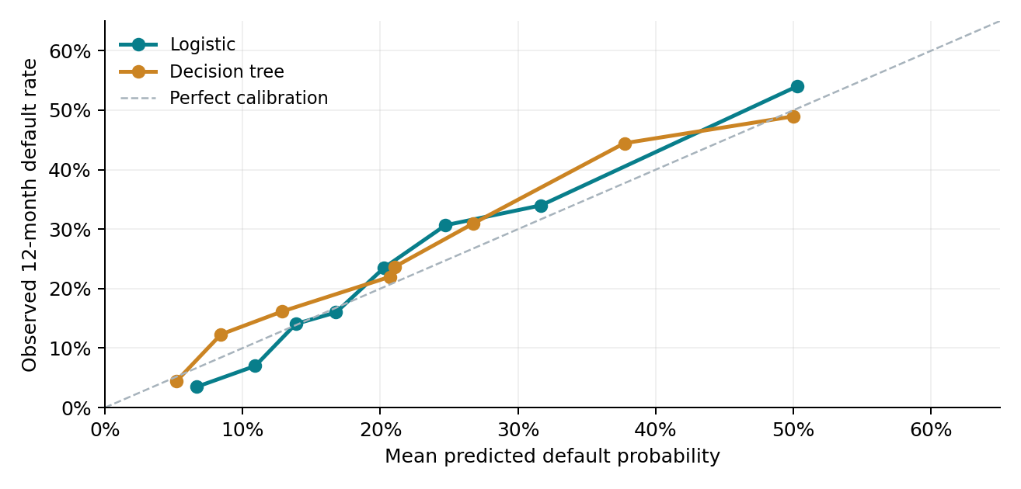
The overall prediction gap is -0.94 percentage points. Logistic probability groups contain 199 to 200 borrowers. The highest group averages 50.3% predicted default versus 54.0% observed. Maximum training VIF is 1.42; the borrowing-rate and GDP coefficients have HC1 p values above 0.05.
Sources: outputs/calibration_bins.csv; outputs/coefficients.csv; outputs/metrics.json. Thresholds and tree settings use validation data only. HC1 inference assumes independent borrower observations.

Conditional stress review
The scenarios rescore the same held-out borrowers with frozen logistic coefficients. They change observable features directly and quantify conditional model sensitivity. They do not forecast macroeconomic transmission or simulate accounting cash flows.
Driver | Base | Adverse | Severe
Leverage | Unchanged | +0.05 | +0.10
Debt-service coverage | Unchanged | Multiply by 0.85 | Multiply by 0.70
Borrowing rate | Unchanged | +1 pp | +2 pp
GDP growth | Unchanged | −2 pp | −4 pp

Illustrative analyst assumptions. Leverage is bounded to [0,1]. Prior delinquency is unchanged. pp denotes percentage points.
Scenario | Mean PD | Loss proxy  CNY million | Change vs base
Base | 21.9% | 9,782.1 | —
Adverse | 32.0% | 13,969.1 | +42.8%
Severe | 44.2% | 18,811.2 | +92.3%

Under the adverse inputs, the expected-loss proxy increases from CNY 9,782.1 million to CNY 13,969.1 million. The severe inputs produce CNY 18,811.2 million. These comparisons hold debt balances and the 45% loss-given-default assumption constant.
The proxy sums borrower debt multiplied by modeled 12-month default probability and assumed loss given default. Debt substitutes for exposure at default. The calculation excludes undrawn commitments, collateral recoveries, discounting, staging and lifetime losses. It is not an IFRS 9 or regulatory capital calculation.

Review implications
GDP growth lies outside the training range for 800 of 1,598 base-case borrowers and every borrower under the adverse and severe scenarios. These predictions therefore involve extrapolation. Before operational use, real data would require independent outcome verification, segment validation, recalibration and a separately justified exposure and recovery model.

Reproduction and scope
Run python -m src.pipeline from the repository root to rebuild the analytical outputs. Run python reports/build_memo.py to regenerate this memo. The Excel file exposes scoring formulas and scenario controls. The repository documents execution status for optional R and SAS implementations.
Sources: outputs/scenario_summary.csv; outputs/scenario_support.csv; outputs/coefficients.csv. All figures refer to the fixed held-out cohort. Rounding may affect displayed sums.

