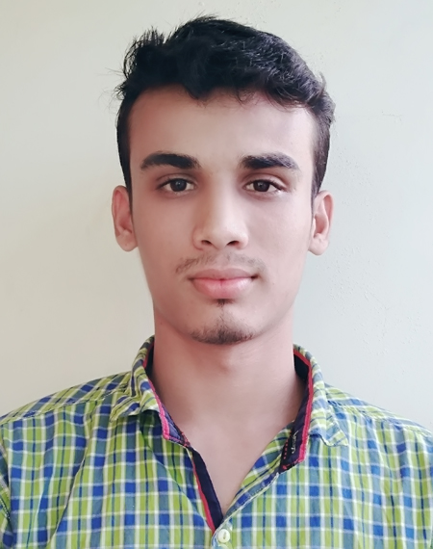
RESUME

OF
Abdul Alim

Contact Number: 01839-365353
www.mralim.com
Email: abdulalimrakib53@gmail.com

CAREER OBJECTIVES
I want to work in an environment where there is opportunity of self-assessment that frequently faces various challenges and serves. The community with individual skills in a disciplined way.

EDUCATIONAL QUALIFICATION

Diploma engineering
 Institute | : | Feni Polytechnic Institute
Technology | : | Power Technology
Session | : | 2012-13
Result | : | 3.19(Out of scale 4.00)
Board | : | Technical Education Board Dhaka

Secondary School Certificate (SSC)
 Institution | : | Mridhar Hat High School
 Group | : | Science
Year of Passing | : | 2012
Result | : | 3.94 (Out of scale 5.00)
Board | : | Comilla

COMPUTER SKILLS

- I'm experts in HTML, CSS, Sass.
- I'm also intermediate level experts in JavaScript & React.js. This time I'm working with React.js.
- Also have an excellent typing speed in English.

STRENGTH

1. Communicative, friendly, positive thinking attitude& willing to serve dedicatedly.
2. Readiness to work with a stress worthy environment.
3. Handle high pressure situation and deadlines.
4. Sharp sense of social responsibility.

EXPERIENCS

Company Name | : | YoungOne
Designation | : | Sub-assistant Engineer
Division | : | Technical Division
Join Date | : | 06-03-2017
End Date | : | Continue.

LANGUAGE AND COMMUNICATION SKILLS

Fluent English and Bangla Speaking and Written Skills.

PERSONAL DETAILS

Name | : | Abdul Alim
Father’s Name | : | Abul Kashem
Mother’s Name | : | Bibi Kulsum
Permanent Address | : | Village : Anispur, P/O : Mridhar Hat  P/S : Noakhali Sadar, District : Noakhali
Date of Birth | : | 31 Dec 1995
Martial Status | : | Single
Sex | : | Male
Religion | : | Muslim
Nationality | : | Bangladesh
Home District | : | Noakhali

declaration of authenticity

I declare here by that all information I have presented so far are true to my knowledge. If required and where applicable, this document can be supported by authentic certificates\papers.

Note: In This Resume My current experience isn’t Programming Related. All of my Programming skills are self-learning From w3school, YouTube, stack overflow etc. I have 3years of self-learning experience in Front-end web development.

Signature:
Date:

