Environmental and LTL Indicators MAB and Shelf-wide

Table of Contents

Trend lines are shown when slope is significantly different from 0 at the p < 0.05 level. An orange line signifies an overall positive trend, and purple signifies a negative trend. Note that in the final report we will only test for trend when N >= 30. However, I have relaxed that requirement for the purposes of this document so that trends are highlighted when N >= 20. **This means that some trends shown here will not be present in the final document**. Dashed lines represent mean values of time series unless the indicator is an anomaly, in which case the dashed line is equal to 0. Shaded regions indicate the past ten years. If there are no new data for 2018, the shaded region will still cover this time period.

## Mid-Atlantic Bight

### Ocean Temperature

#### SST

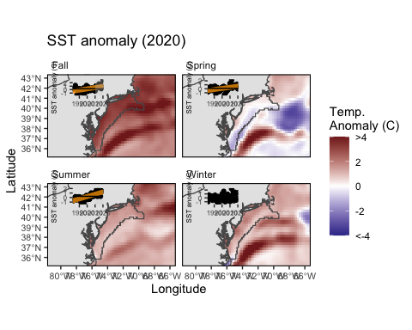

MAB seasonal sea surface temperature time series overlaid onto 2020 seasonal spatial anomalies.

#### Bottom temperature

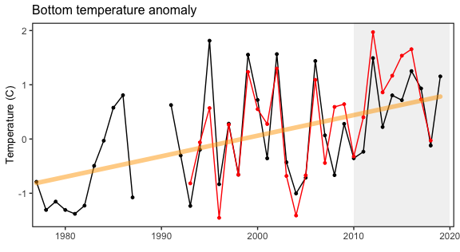

Annual bottom temperature in the Mid-Atlantic Bight. (black = Paula’s, red = GLORYS)

### Chlorophyll and Primary Productivity

#### Primary production

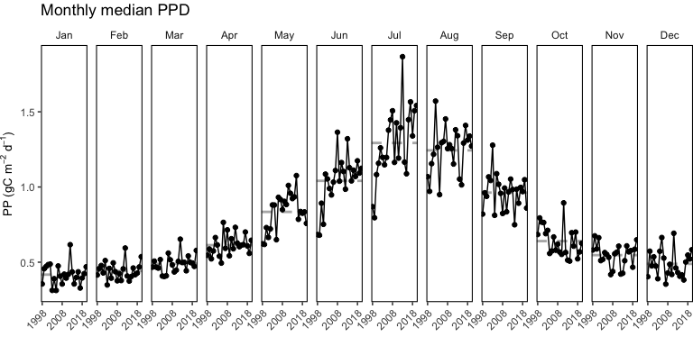

Monthly primary production trends show the annual cycle (i.e. the peak during the summer months) and the changes over time for each month.

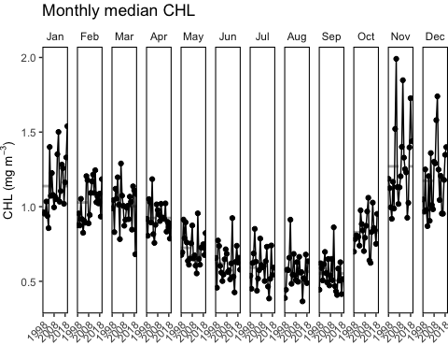

#### Sesonal chlorophyll *a* & primary production

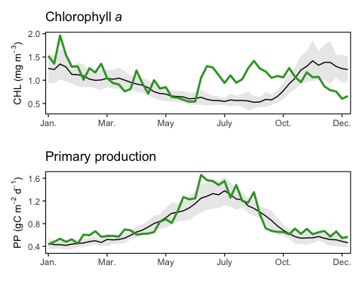

Weekly chlorophyll concentrations and primary productivity in the Mid-Atlantic are shown for by the colored line for 2020. The long-term mean is shown in black and shading indicates +/- 1 sample SD.

#### Phytoplankton Size Class

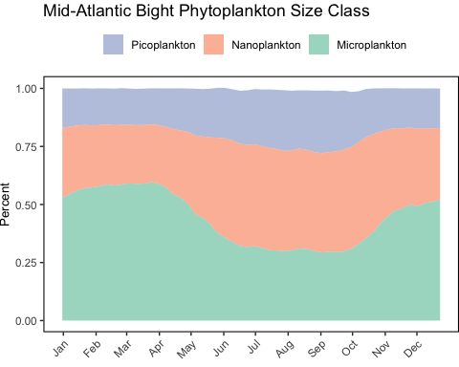

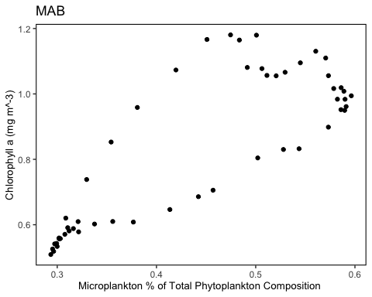

### Chesapeake Bay Water Quality Attainment

NO NEW DATA

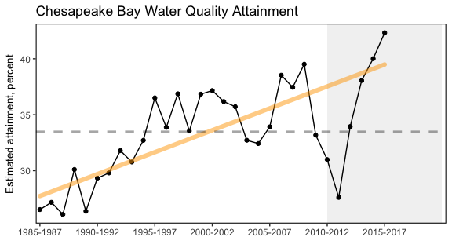

Water quality attainment in Chesapeake Bay following rolling three year assessment periods.

### Chesapeake Bay

NO NEW DATA, only summary

Headline: Warmer-than-average winter water temps in Chesapeake Bay likely help blue crabs, hurt striped bass numbers.

[Details here](https://docs.google.com/document/u/1/d/12Aq9nxrdrtZKESoZ8KtW152i0amf_O54/edit?usp=drive_web&ouid=111390006230717850267&rtpof=true).

### Zooplankton

#### Euphausiids + Cnidarians

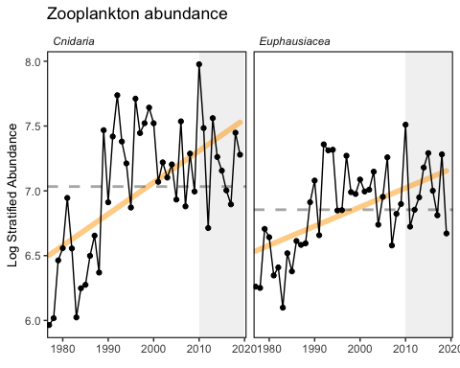

Stratified abundance of cnidarians and euphausiids in Mid-Atlantic Bight.

#### Abundance anomaly

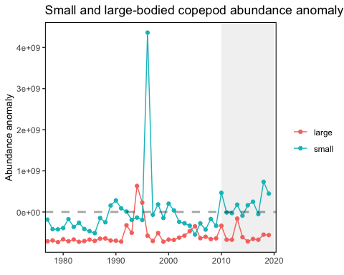

Large (red) and small-bodied (blue) copepod abundance in the Mid-Atlantic Bight.

#### Zooplankton Diversity

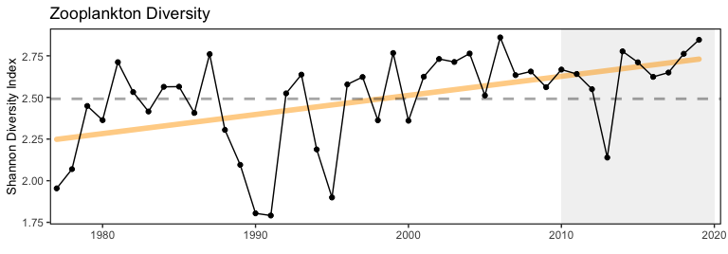

Zooplankton diversity in the Mid-Atlantic Bight.

#### Calanus Stage

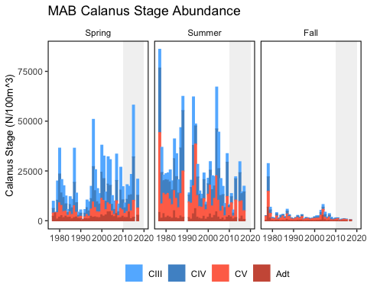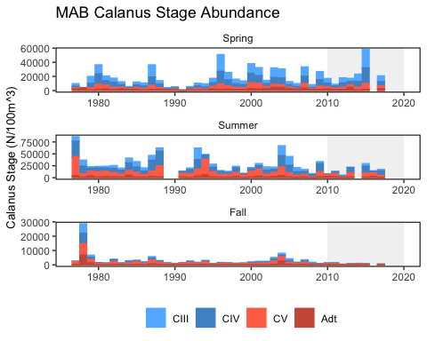

### Cold Pool Index

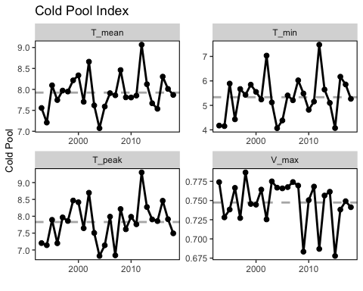

Cold pool index.

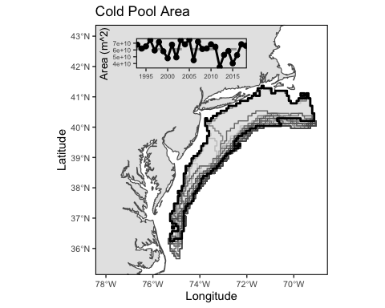

Map of cold pool area- final year (2018) in bold. Time series of cold pool spatial extent FROM 1993-2018.

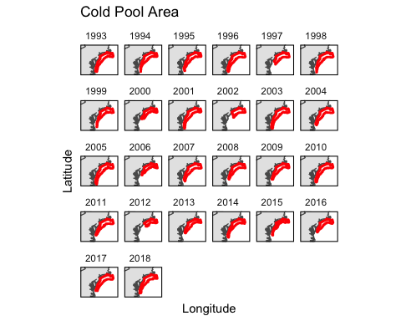

Map of cold pool area.

### Marine Heat Wave

[notes here](https://docs.google.com/document/u/1/d/1ik6aAXY85DEgLmz4BaBwxtdEPq6e9xXo/edit?usp=drive_web&ouid=111390006230717850267&rtpof=true)

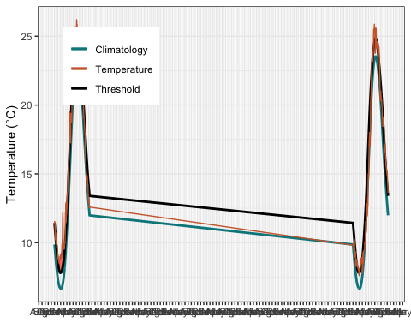

Marine heatwave events (red) in the Mid-Atlantic occuring in 2020.

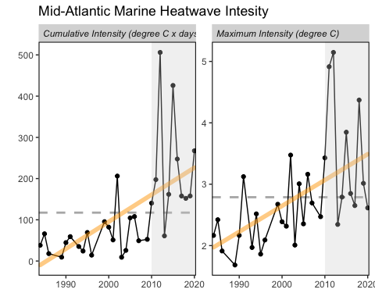

Marine heatwave cumulative intesity (left) and maximum intensity (right) in the Mid-Atlantic Bight.

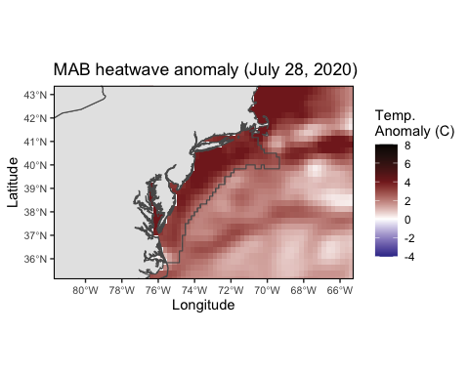

Maximum intensity heatwave anomaly in the Mid-Atlantic Bight occuring on July 28, 2020.

### Habitat Vulnerability

[Habitat Table found here](https://noaa-edab.github.io/ecodata/Hab_table)

### Ocean Acidication

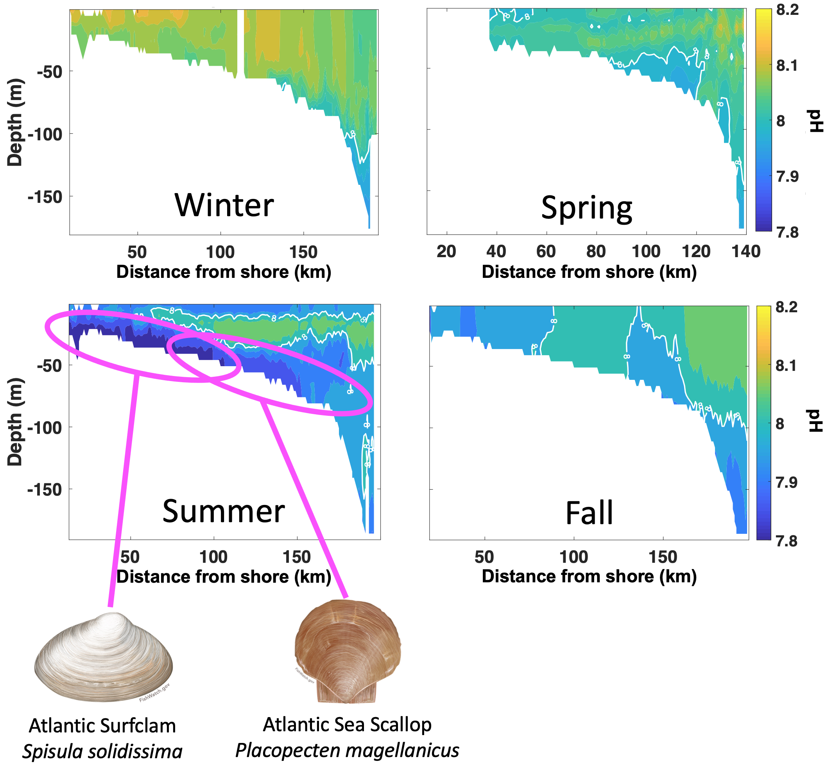

Seasonal glider-based pH observations on the Mid-Atlantic Bight shelf (New Jersey cross-shelf transect) in relation to Atlantic surfclam and Atlantic sea scallop habitats (modified from Wright-Fairbanks et al. 2020).

## Shelfwide Indicators

### Seasonal SST anomaly

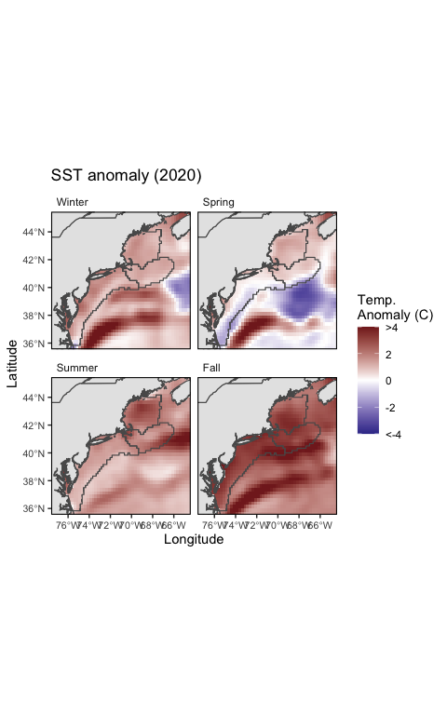

Seasonal sea surface temperature anomalies for 2020 over the Northeast US Shelf.

### Long-term SST

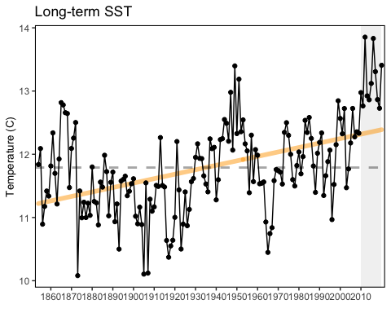

Average annual sea surface temperature (SST) over the Northeast US Shelf.

### GSI

[Notes](https://docs.google.com/document/d/1SgZ9m4pal3ygKnUSYr4UwgOoMJeaKzpO/edit)

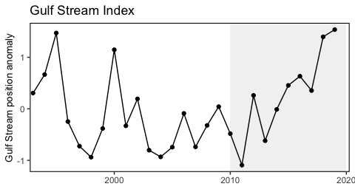

Index representing the north wall of the Gulf Stream. Positive values represent a more northerly Gulf Stream position.

### Warm Core Rings

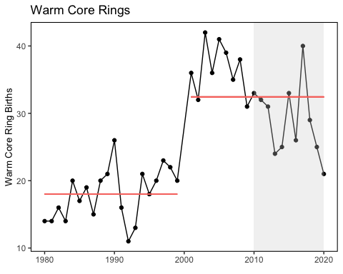

Warm core ring formation on the Northeast US Shelf.