Environmental and LTL Indicators GB and GOM

Table of Contents

Trend lines are shown when slope is significantly different from 0 at the p < 0.05 level. An orange line signifies an overall positive trend, and purple signifies a negative trend. Note that in the final report we will only test for trend when N >= 30. However, I have relaxed that requirement for the purposes of this document so that trends are highlighted when N >= 20. **This means that some trends shown here will not be present in the final document**. Dashed lines represent mean values of time series unless the indicator is an anomaly, in which case the dashed line is equal to 0. Shaded regions indicate the past ten years. If there are no new data for 2018, the shaded region will still cover this time period.

## Gulf of Maine & Georges Bank

### Ocean Temperature

#### SST

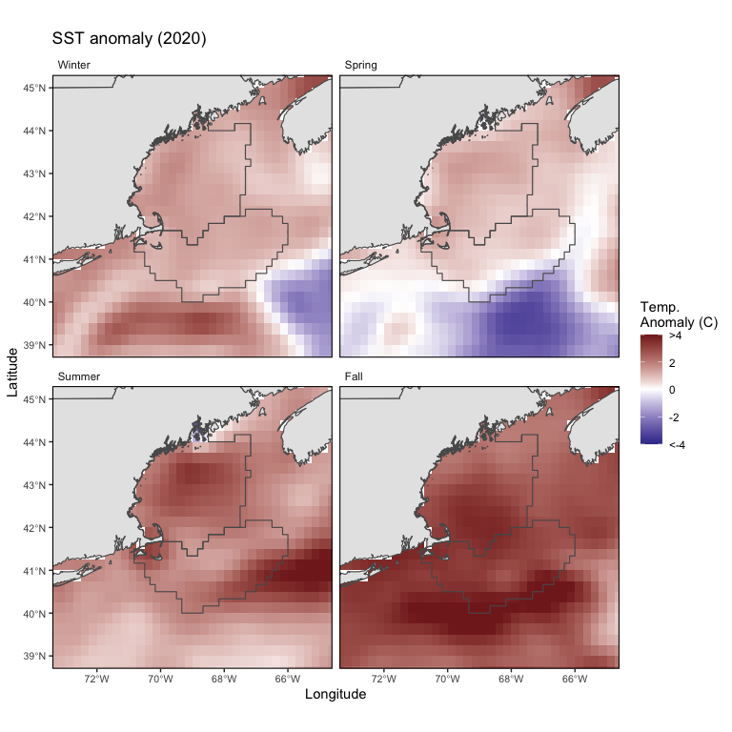

GB and GOM 2020 seasonal sea surface temperature spatial anomalies.

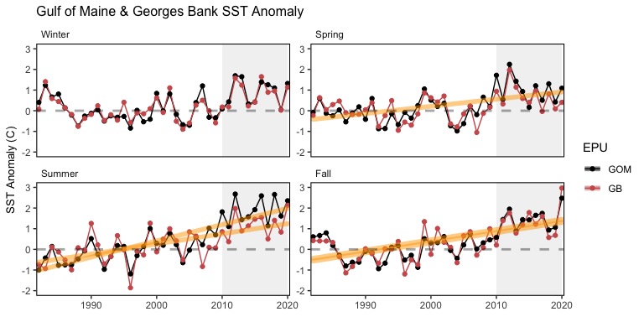

GB and GOM seasonal sea surface temperature anomaly time series.

#### Bottom temperature

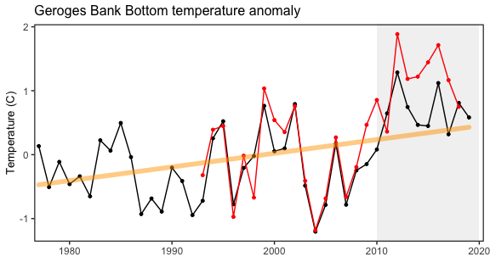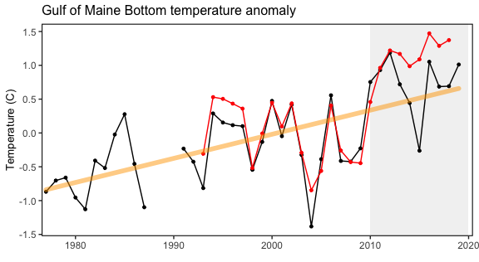

#### GOM Slopewater Proportions

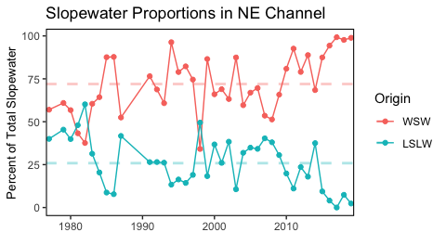

Proportion of warm slope water (WSW) and Labrador slope water (LSLW) entering the Gulf of Maine through the Northeast Channel.

### Chlorophyll and Primary Productivity

#### Primary production

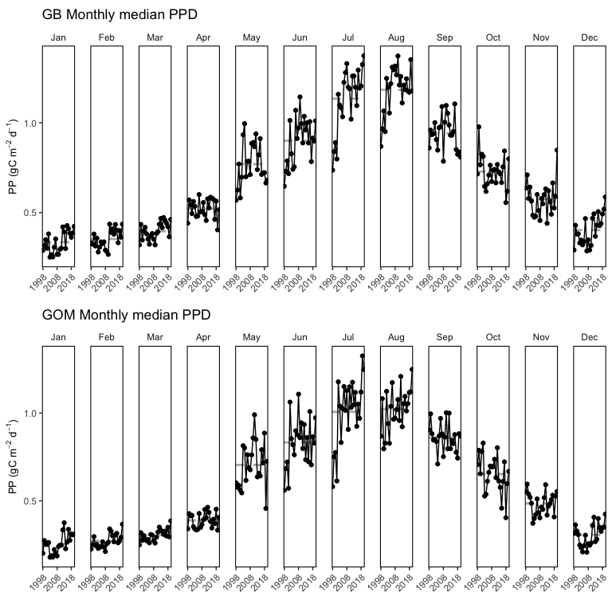

Monthly primary production trends show the annual cycle (i.e. the peak during the summer months) and the changes over time for each month.

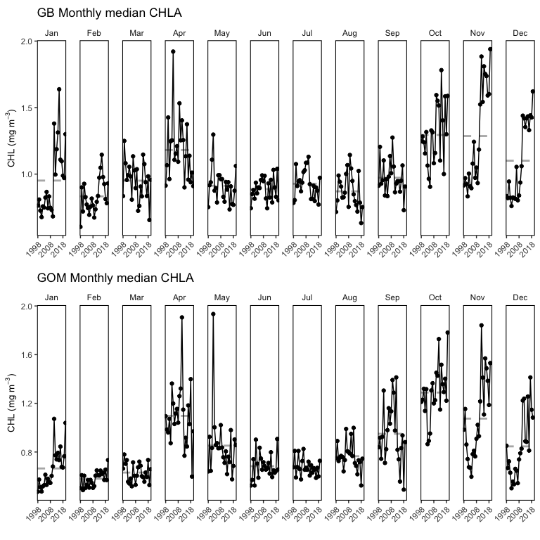

Monthly chlorophyll trends show the annual cycle (i.e. the peak during the summer months) and the changes over time for each month.

#### Seasonal chlorophyll *a* & primary production

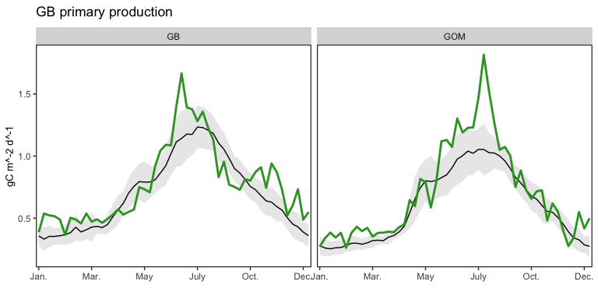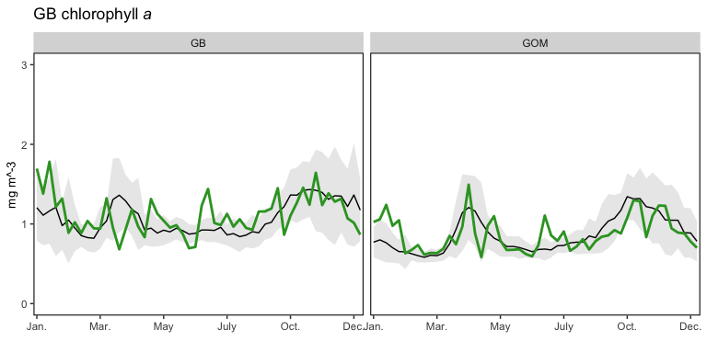

#### Phytoplankton Size Class

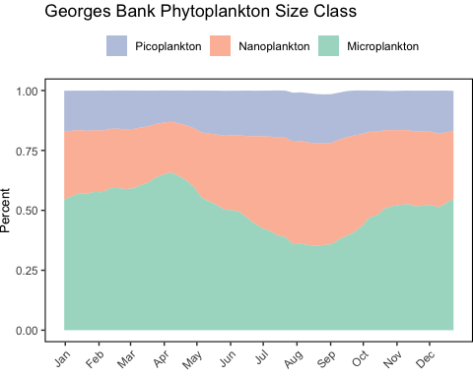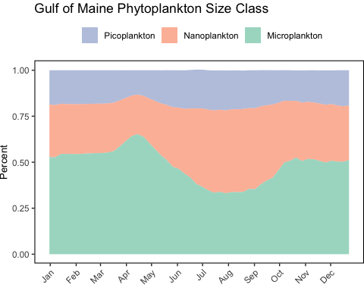

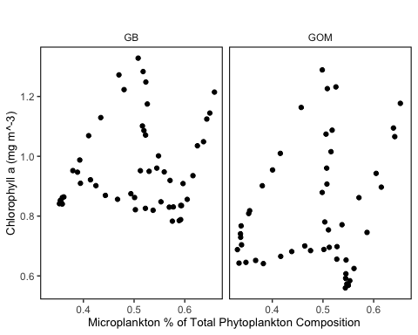

### Zooplankton

#### Euphausiids + Cnidarians

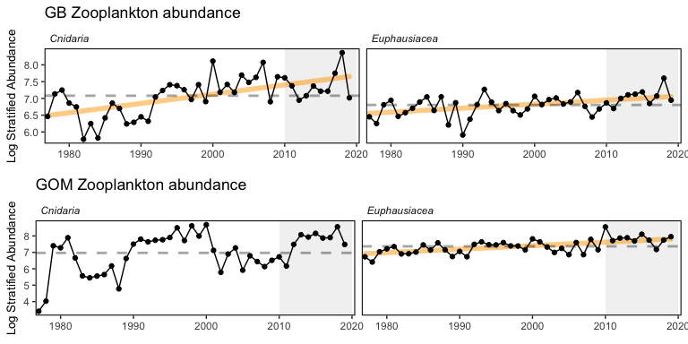

Stratified abundance of cnidarians and euphausiids in Mid-Atlantic Bight.

#### Abundance anomaly

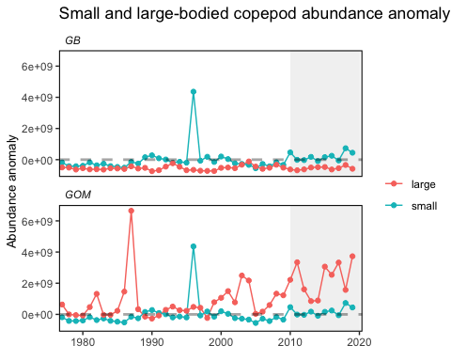

Large (red) and small-bodied (blue) copepod zooplankton abundance in New England.

#### Calanus Stage

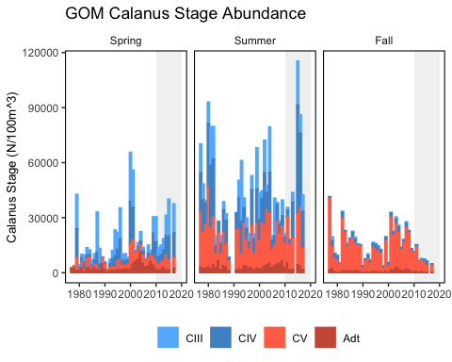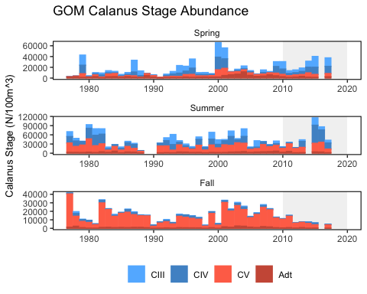

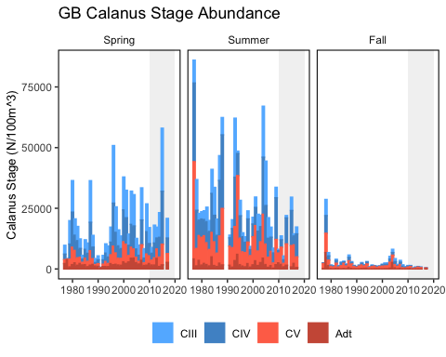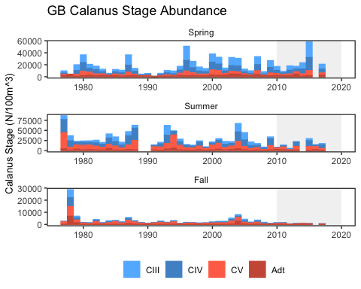

#### Zooplankton Diversity

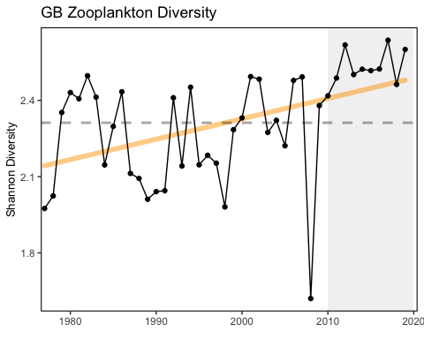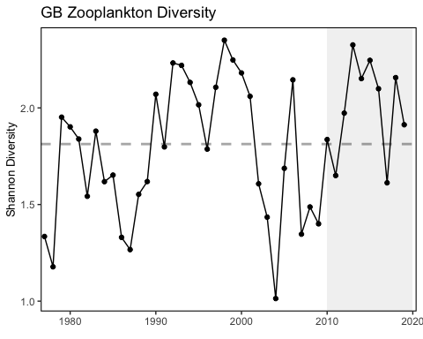

### Marine Heat Wave

[notes here](https://docs.google.com/document/u/1/d/1ik6aAXY85DEgLmz4BaBwxtdEPq6e9xXo/edit?usp=drive_web&ouid=111390006230717850267&rtpof=true)

#### Monthly time series

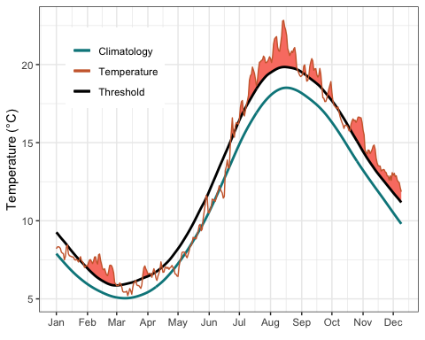

Georges Bank

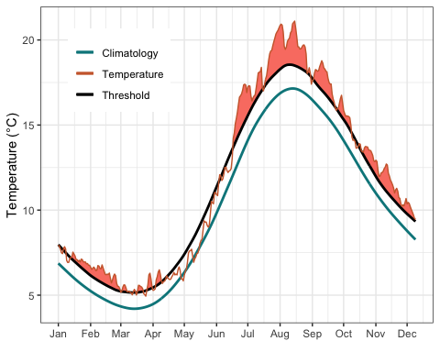

Gulf of Maine

#### Yearly timeseries

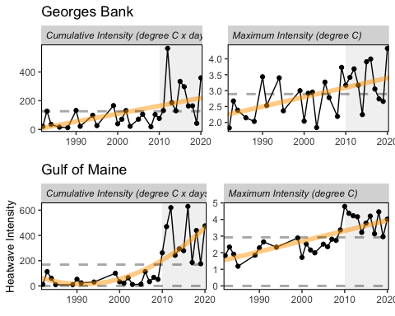

Marine heatwave cumulative intesity (left) and maximum intensity (right) in the Georges Bank and Gulf of Maine .

#### Maps

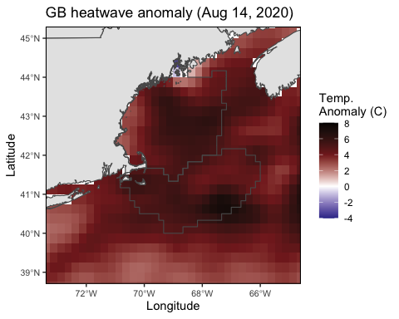

Maximum intensity heatwave anomaly in Georges Bank occuring on August 14, 2020.

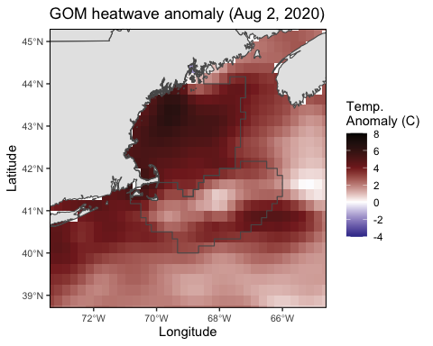

Maximum intensity heatwave anomaly in Gulf of Maine occuring on August 2, 2020.

### Habitat Vulnerability

[Table to be described in SOE](https://noaa-edab.github.io/ecodata/Hab_table).