Human Dimensions MAB and Shelf-wide

Table of Contents

Mid-Atlantic 2

Commercial 2

Recreational fisheries 13

Primary Production Required 17

Wind Energy Revenue 18

Shelfwide Indicators 19

Wind Development Speed 19

Trend lines are shown when slope is significantly different from 0 at the p < 0.05 level. An orange line signifies an overall positive trend, and purple signifies a negative trend. To minimize bias introduced by small sample size, no trend is fit when N < 30. Dashed lines represent mean values of time series unless the indicator is an anomaly, in which case the dashed line is equal to 0. Shaded regions indicate the past ten years. If there are no new data for 2018, the shaded region will still cover this time period.

## Mid-Atlantic

### Commercial

#### Commercial landings

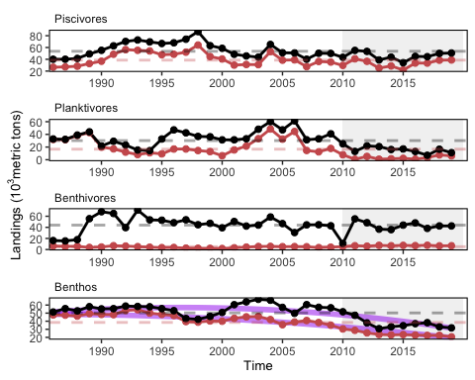

MAFMC managed species landings (red) and total commercial landings (black) by feeding guild.

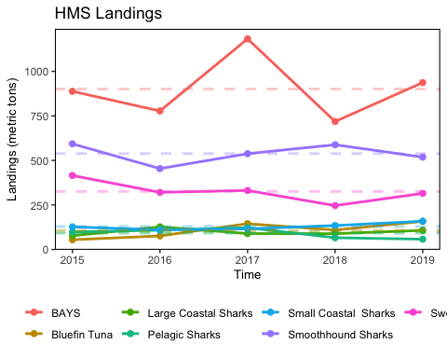

HMS groups include “Bluefin Tuna”, “BAYS”, “Swordfish”, “Large Coastal Sharks”, “Small Coastal Sharks”, “Pelagic Sharks”, “Smoothhound Sharks”. “BAYS” includes bigeye, albacore, yellowfin and skipjack tunas. “Large Coastal Sharks” includes blacktip, bull, great hammerhead, scalloped hammerhead, smooth hammerhead, lemon, nurse, sandbar, silky, spinner, and tiger sharks. “Small Coastal Sharks” includes Atlantic sharpnose, blacknose, bonnethead, finetooth sharks. “Pelagic Sharks” includes blue, porbeagle, shortfin mako, and thresher sharks. “Smoothhound Sharks” includes smooth dogfish shark.

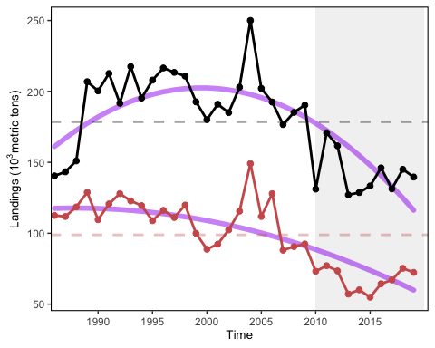

Total commercial seafood landings (black) shown with Mid-Atlantic managed seafood landings (red).

#### Commercial revenue

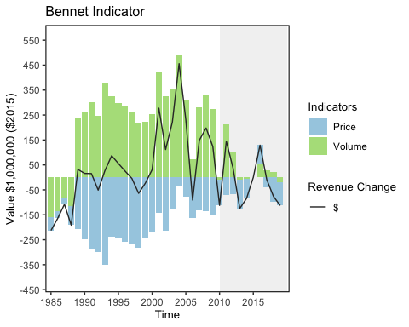

Revenue change from the 2015 values in dollars (black), Price (PI), and Volume Indicators (VI) for commercial landings in the Mid-Atlantic Bight.

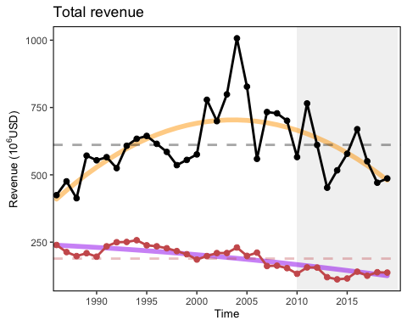

Total revenue for the region (black) and revenue from MAFMC managed species (red).

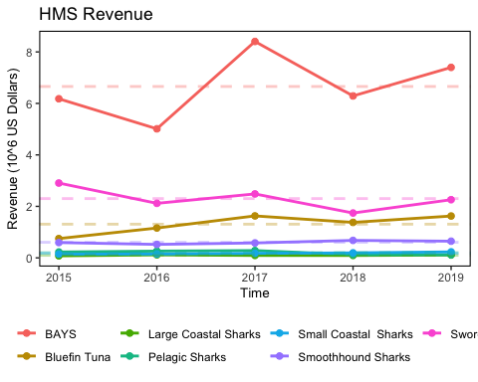

HMS revenue.

#### Commercial diversity

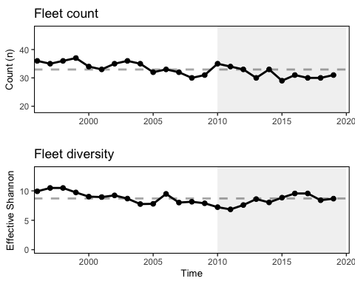

Fleet diversity and fleet count in the Mid-Atlantic.

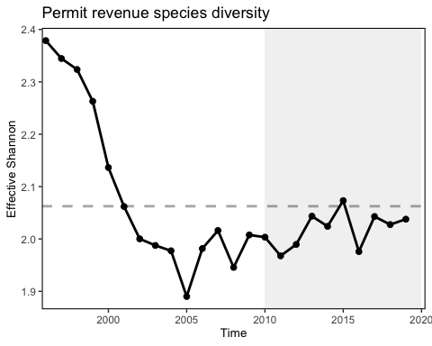

Species revenue diversity in the Mid-Atlantic.

#### Stock status

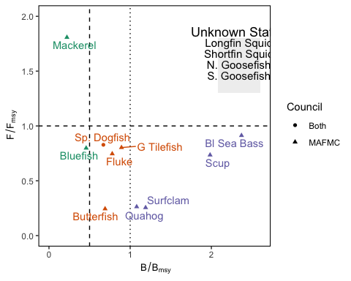

Summary of single species status for MAMFC and jointly managed stocks, Goosefish and Dogfish jointly managed.

#### Oyster aquaculture

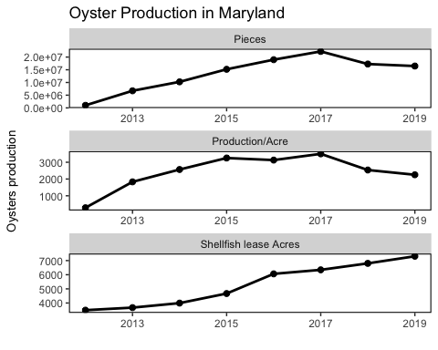

Oyster aquaculture production in terms pieces, lease area and production by acre.

#### Engagement and reliance

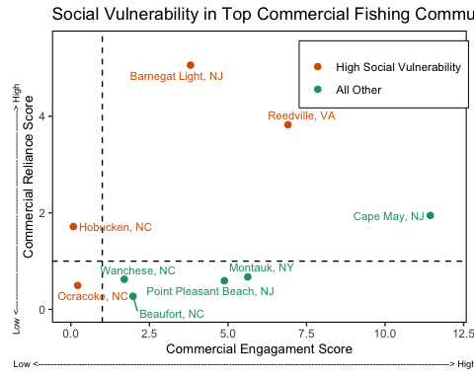

Commercial engagement and reliance for the top top commercial fishing communities in the Mid-Atlantic.

### Recreational fisheries

#### Recreational landings

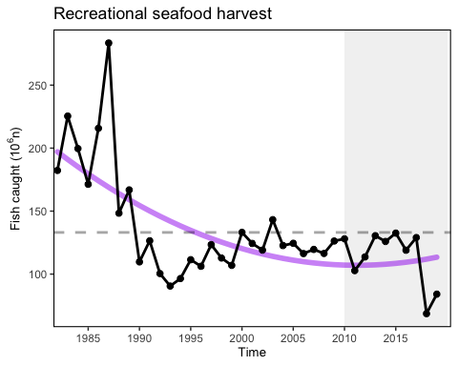

Total recreational landings in the Mid-Atlantic region.

#### Recreational diversity

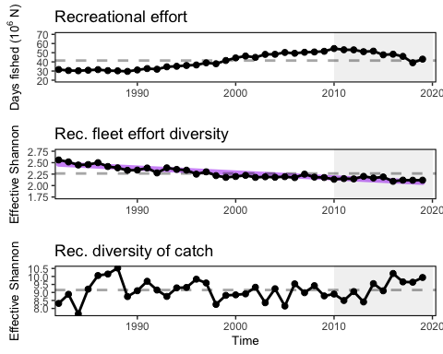

Recreational effort, recreational effort diversity, number of recreational anglers, and diversity of recreational catch in the Mid-Atlantic.

#### Recreational Engagement and Reliance

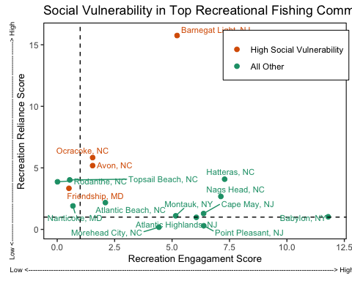

Commercial engagement and reliance for the top top recreational fishing communities in the Mid-atlantic.

#### Recreational Shark Landings

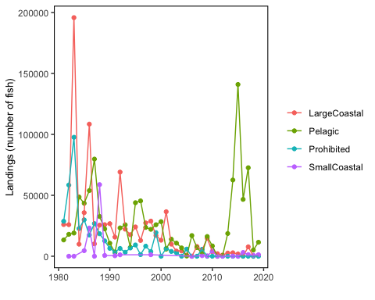

Recreational shark landings from mrip.

Recent pelagic landings coming primarily from Common Thresher and Shortfin Mako.

### Primary Production Required

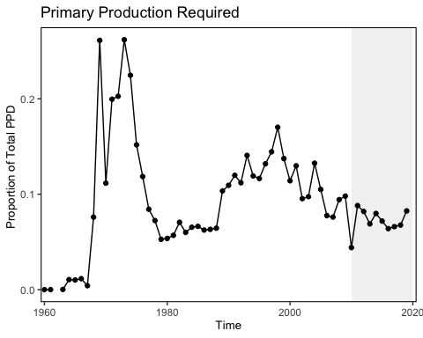

Primary production required to support the commercial landings. Included are the top species accounting for 80% of the landings in each year.

### Wind Energy Revenue

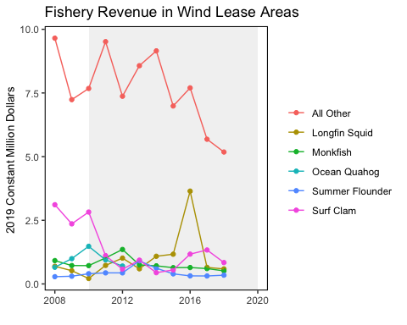

Wind energy revenue in the Mid-Atlantic

## Shelfwide Indicators

### Wind Development Speed

