Human Dimensions GB and GOM

Table of Contents

Trend lines are shown when slope is significantly different from 0 at the p < 0.05 level. An orange line signifies an overall positive trend, and purple signifies a negative trend. To minimize bias introduced by small sample size, no trend is fit when N < 30. Dashed lines represent mean values of time series unless the indicator is an anomaly, in which case the dashed line is equal to 0. Shaded regions indicate the past ten years. If there are no new data for 2018, the shaded region will still cover this time period.

## New England

### Commercial fisheries

#### Commercial landings

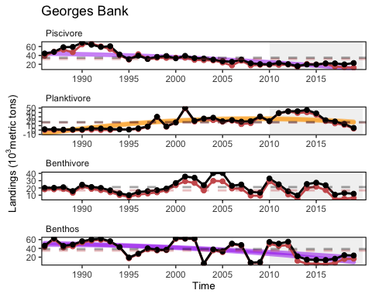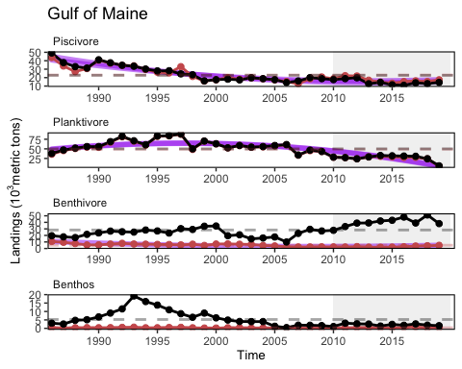

## $x  
## list()  
## - attr(*, "class")= chr [1:2] "element_blank" "element"  
##   
## attr(,"class")  
## [1] "labels"

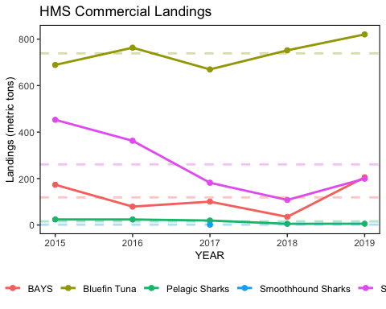

HMS groups include “Bluefin Tuna”, “BAYS”, “Swordfish”, “Large Coastal Sharks”, “Small Coastal Sharks”, “Pelagic Sharks”, “Smoothhound Sharks”. “BAYS” includes bigeye, albacore, yellowfin and skipjack tunas. “Large Coastal Sharks” includes blacktip, bull, great hammerhead, scalloped hammerhead, smooth hammerhead, lemon, nurse, sandbar, silky, spinner, and tiger sharks. “Small Coastal Sharks” includes Atlantic sharpnose, blacknose, bonnethead, finetooth sharks. “Pelagic Sharks” includes blue, porbeagle, shortfin mako, and thresher sharks. “Smoothhound Sharks” includes smooth dogfish shark.

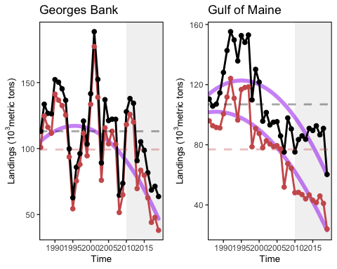

Total commercial seafood landings (black) shown with NEFMC managed seafood landings (red) in Gulf of Maine (left) and Georges Bank (right).

#### Commercial revenue

## $colour  
## $title  
## list()  
## attr(,"class")  
## [1] "waiver"  
##   
## $title.position  
## NULL  
##   
## $title.theme  
## NULL  
##   
## $title.hjust  
## NULL  
##   
## $title.vjust  
## NULL  
##   
## $label  
## [1] TRUE  
##   
## $label.position  
## NULL  
##   
## $label.theme  
## NULL  
##   
## $label.hjust  
## NULL  
##   
## $label.vjust  
## NULL  
##   
## $keywidth  
## NULL  
##   
## $keyheight  
## NULL  
##   
## $direction  
## NULL  
##   
## $override.aes  
## named list()  
##   
## $nrow  
## NULL  
##   
## $ncol  
## NULL  
##   
## $byrow  
## [1] FALSE  
##   
## $reverse  
## [1] FALSE  
##   
## $order  
## [1] 1  
##   
## $available_aes  
## [1] "any"  
##   
## $name  
## [1] "legend"  
##   
## attr(,"class")  
## [1] "guide" "legend"  
##   
## $fill  
## $title  
## list()  
## attr(,"class")  
## [1] "waiver"  
##   
## $title.position  
## NULL  
##   
## $title.theme  
## NULL  
##   
## $title.hjust  
## NULL  
##   
## $title.vjust  
## NULL  
##   
## $label  
## [1] TRUE  
##   
## $label.position  
## NULL  
##   
## $label.theme  
## NULL  
##   
## $label.hjust  
## NULL  
##   
## $label.vjust  
## NULL  
##   
## $keywidth  
## NULL  
##   
## $keyheight  
## NULL  
##   
## $direction  
## NULL  
##   
## $override.aes  
## named list()  
##   
## $nrow  
## NULL  
##   
## $ncol  
## NULL  
##   
## $byrow  
## [1] FALSE  
##   
## $reverse  
## [1] FALSE  
##   
## $order  
## [1] 0  
##   
## $available_aes  
## [1] "any"  
##   
## $name  
## [1] "legend"  
##   
## attr(,"class")  
## [1] "guide" "legend"  
##   
## attr(,"class")  
## [1] "guides"

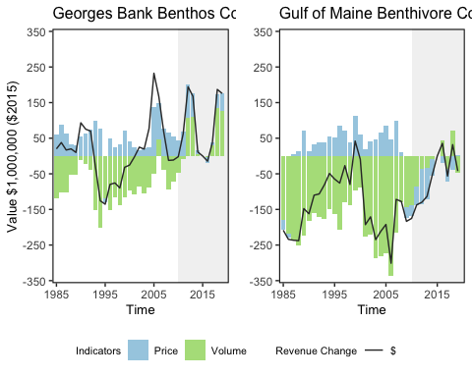

Revenue change from the long-term mean in 2015 dollars (black), Price (PI), and Volume Indicators (VI) for commercial landings in Georges Bank (left) and Gulf of Maine (right).

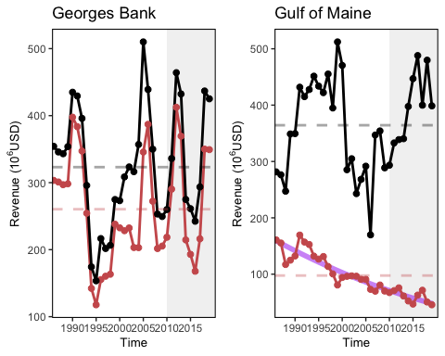

Total commercial revenue (black) and revenue from NEFMC managed species (red) in Georges Bank (left) and Gulf of Maine (right).

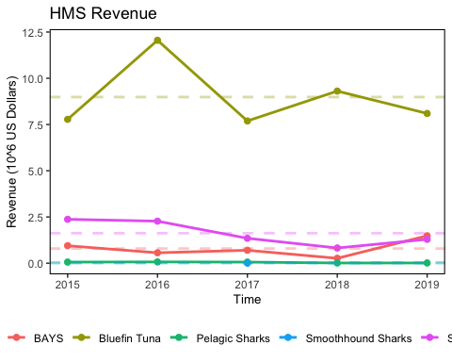

HMS revenue.

#### Commercial diversity

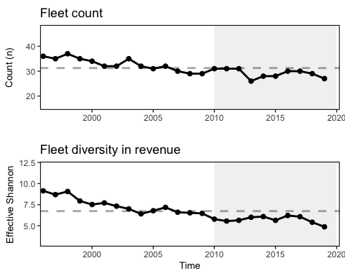

Fleet diversity and fleet count in New England.

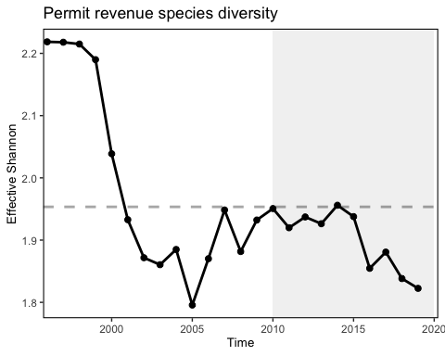

Species revenue diversity in New England.

#### Stock status

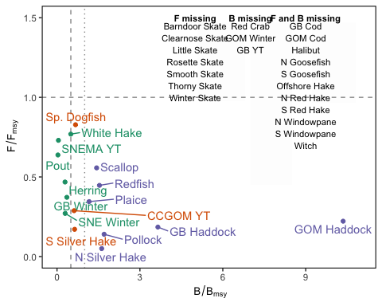

Summary of single species status for NEFMC and jointly managed stocks.

#### Engagement and reliance

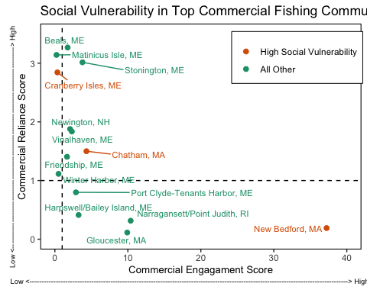

Commercial engagement and reliance for the top top commercial fishing communities in New England.

#### Oyster aquaculture

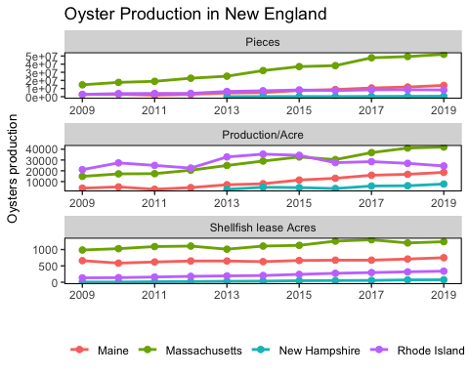

Oyster aquaculture production in terms pieces, lease area and production by acre.

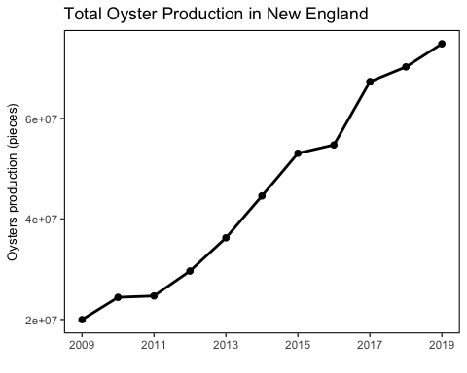

Oyster aquaculture production in pieces for four New England states (Maine, Massachusettes, New Hampshire and Rhode Island).

### Recreational fisheries

#### Recreational landings

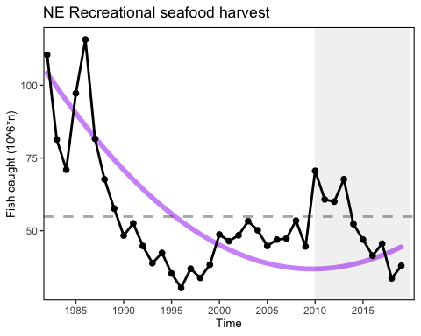

Total recreational landings in New England.

#### Recreational diversity

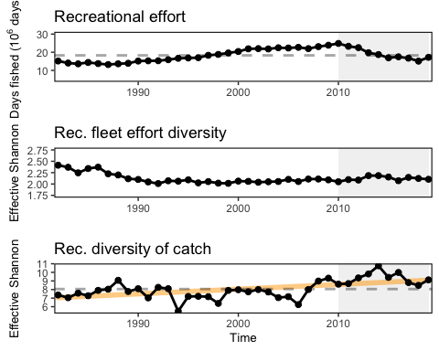 #### Recreational Engagement and Social Vulnerability

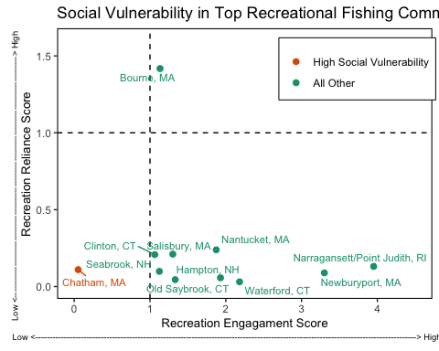

Commercial engagement and reliance for the top top recreational fishing communities in New England.

#### Recreational Shark Landings

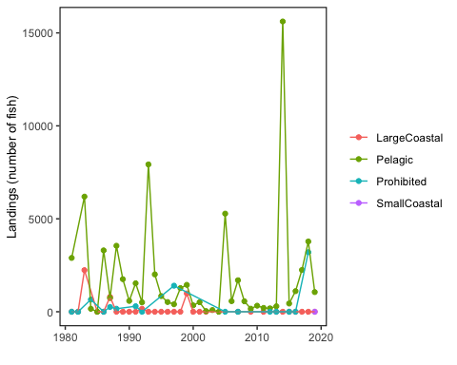

Recreational shark Landings from mrip.

### Primary Production Required

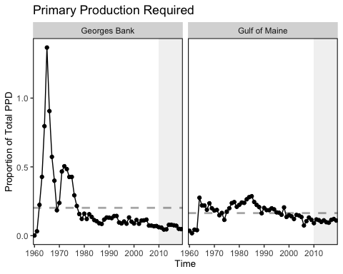

Primary production required to support the commercial landings. Included are the top species accounting for 80% of the landings in each year.

### Wind Energy Revenue

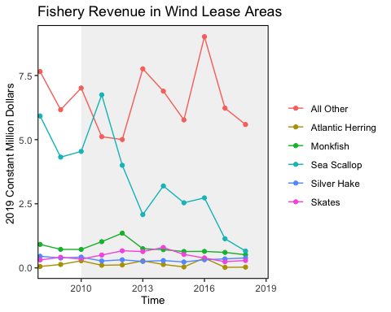

Fisheries revenue from wind lease areas in New England.