Macrofauna MAB and Shelf-wide

Table of Contents

Trend lines are shown when slope is significantly different from 0 at the p < 0.05 level. An orange line signifies an overall positive trend, and purple signifies a negative trend. To minimize bias introduced by small sample size, no trend is fit when N < 30. Dashed lines represent mean values of time series unless the indicator is an anomaly, in which case the dashed line is equal to 0. Shaded regions indicate the past ten years. If there are no new data for 2018, the shaded region will still cover this time period.

## Mid-Atlantic Bight

### Surveys

NO NEW DATA - NO SURVEY IN 2020

#### NEFSC BTS & NEAMAP

NO NEW DATA - NO SURVEY IN 2020

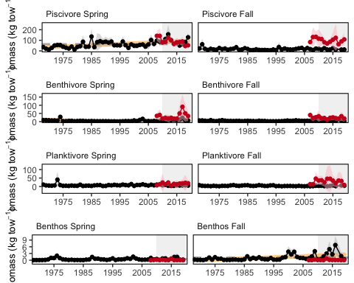

Spring (left) and fall (right) surveyed biomass in the Mid-Atlantic Bight. Data from the NEFSC Bottom Trawl Survey are shown in black, with NEAMAP shown in red.

#### Proportion managed species in NEFSC BTS

NO NEW DATA - NO SURVEY IN 2020

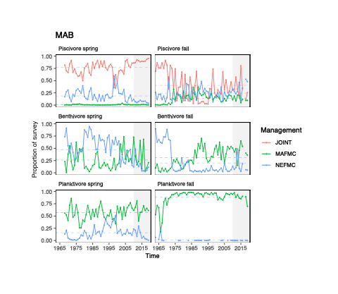

#### MAFMC Planktivores in NE

NO NEW DATA - NO SURVEY IN 2020

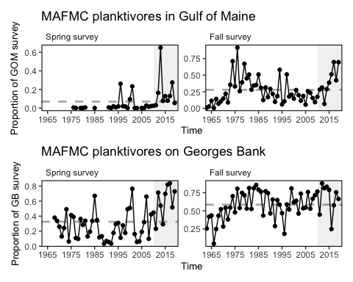

### Productivity anomaly

NO NEW DATA - NO SURVEY IN 2020

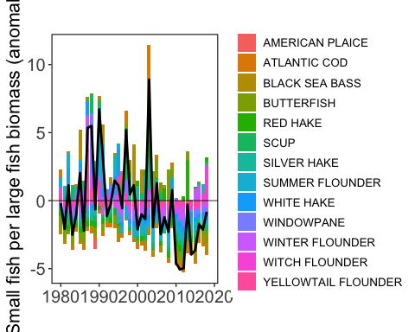

Small fish per large fish biomass anomaly in the Mid-Atlantic Bight.

### Condition factor

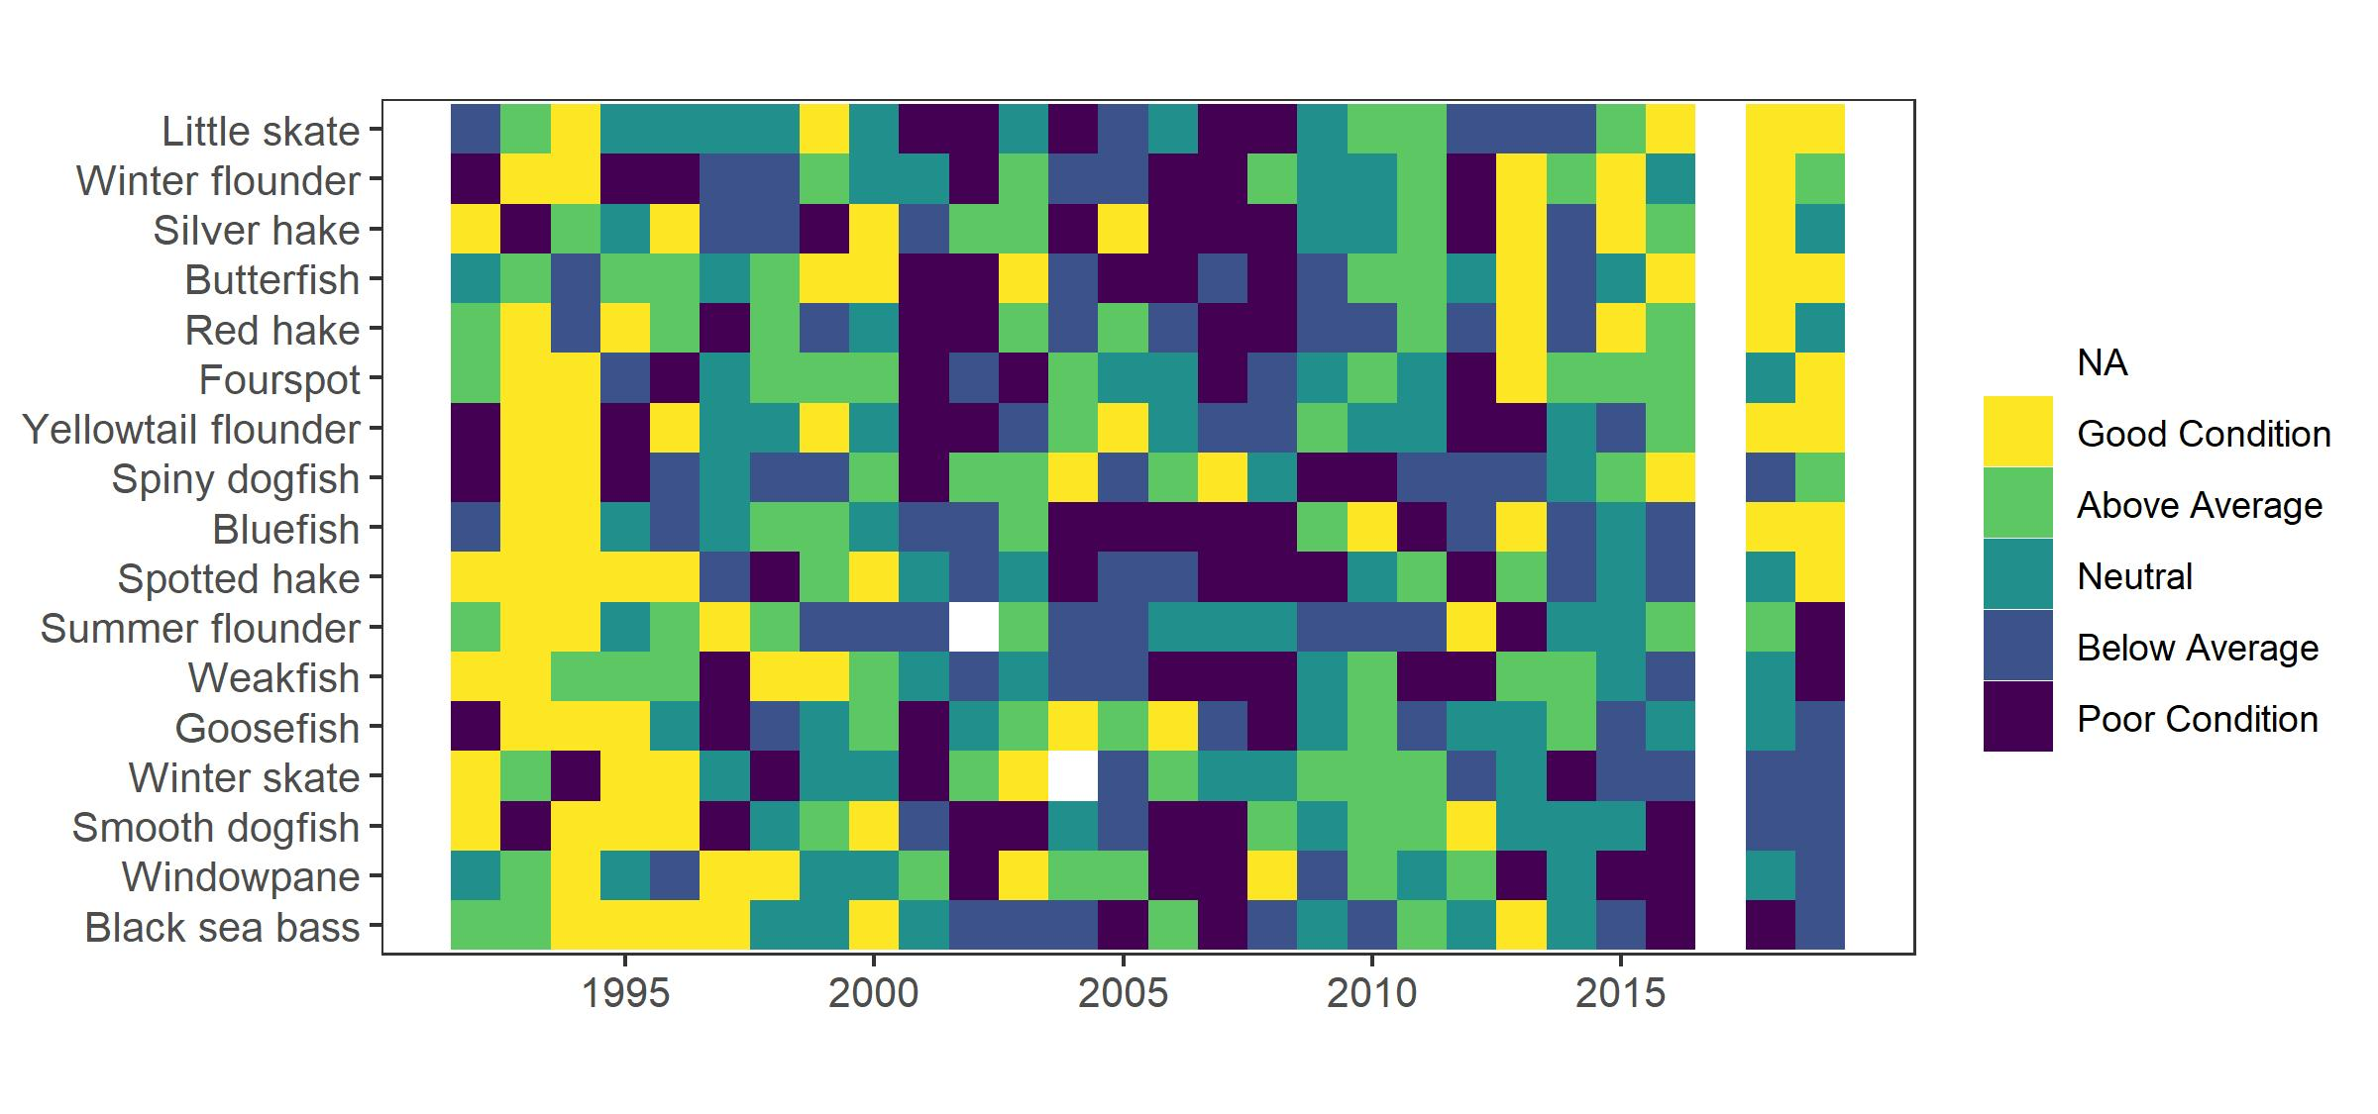

Condition factor for species sampled in MAB.

### Stomach Fullness

NO NEW DATA - NO SURVEY IN 2020

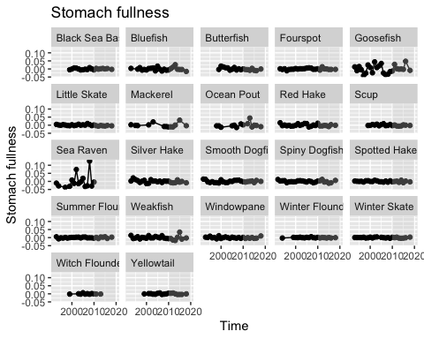

Stomach fullness anomaly in the Mid-Atlantic Bight.

### Larval diversity

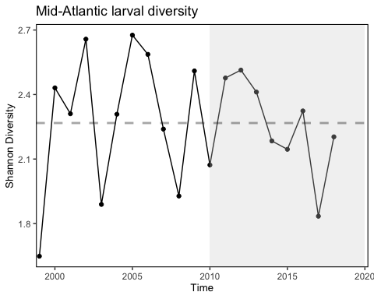

### Virginia Common Tern Abundance

NO NEW DATA

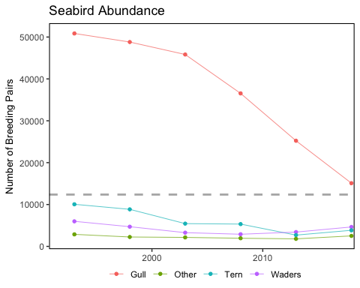

Estimated number of breeding pairs in Virginia barrier island/lagoon system.

### Forage Anomaly

[Taxa include](https://docs.google.com/spreadsheets/d/108snlOTy1wzMGmxbYp1qJuKgqYfYM8MD/edit#gid=966266704)

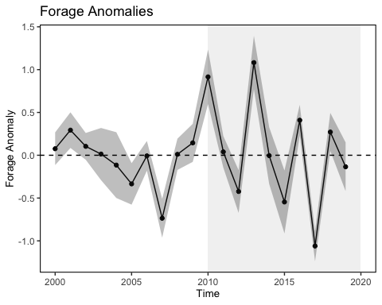

### Observed Shark Numbers

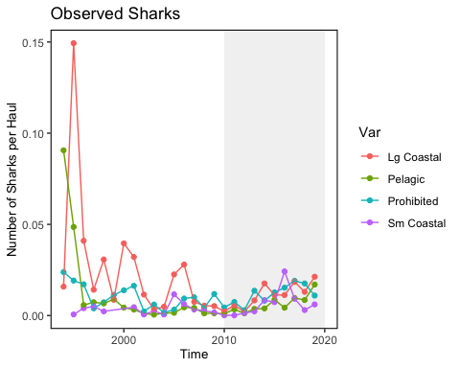

## Shelfwide Indicators

### Protected species

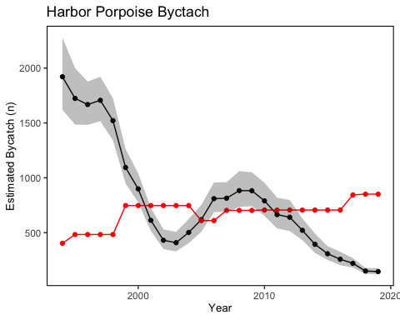

Estimated Harbor porpoise bycatch (black) and the potential biological removal (red).

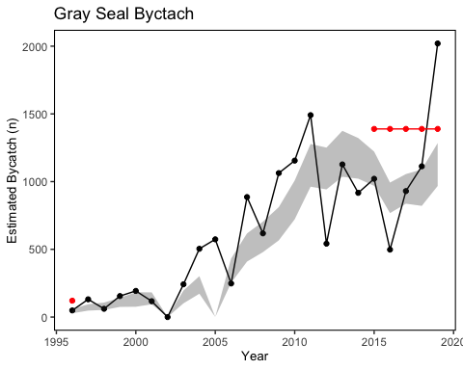

Estimated gray seal bycatch (black) and the potential biological removal (red).

[Starter text from Chris](https://docs.google.com/document/d/0B1lP7X3GP_hQSWRHV1NGWkFlc0VUNVNPcGJRalVUTEpUSjVz/edit?dls=true)

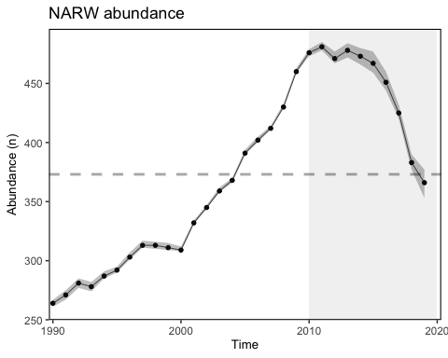

Estimated North Atlanic right whale abundance on the Northeast Shelf.

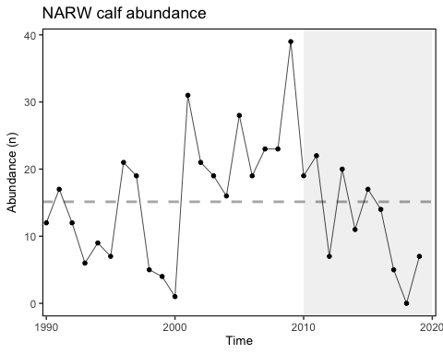

Number of North Atlantic right whale calf births, 1990 - 2019.

### Aggregate species distribution

NO NEW DATA

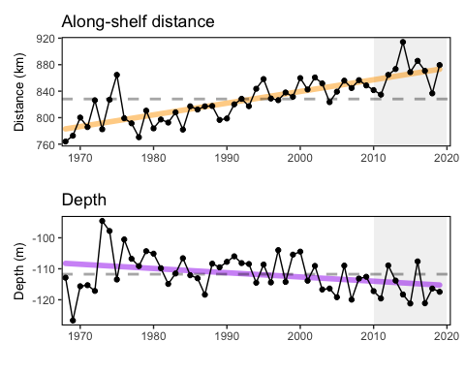

Aggregate species distribution metrics for species in the Northeast Large Marine Ecosystem.

### Forage fish energy content

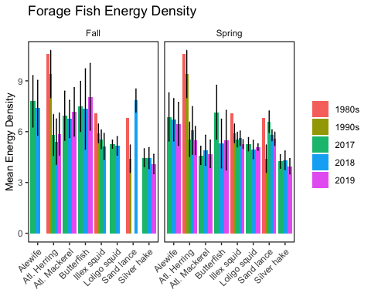

### Condition project

[text here](https://docs.google.com/document/d/1uHMmMTnZG2LAmPi5SSO30k5_5NzfzdKj/edit) 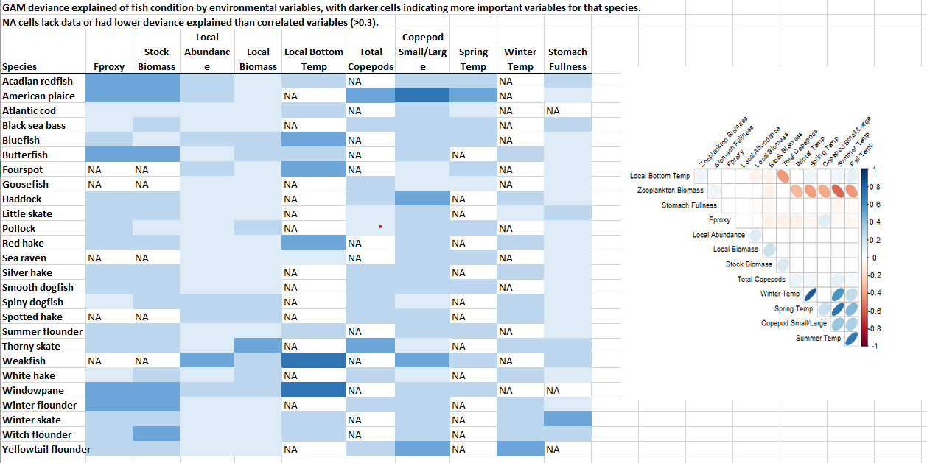

### HMS CPUE

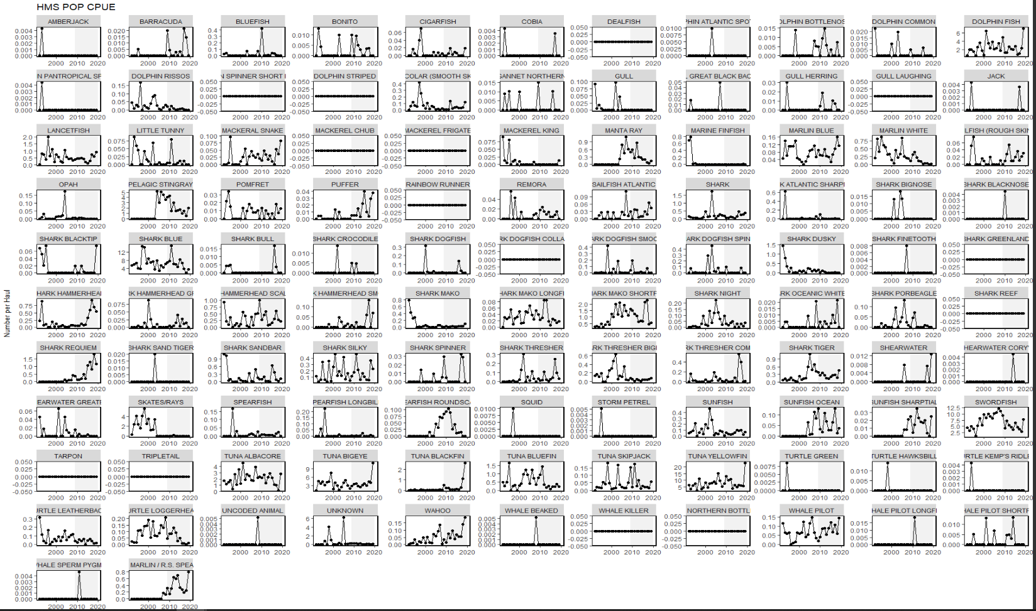

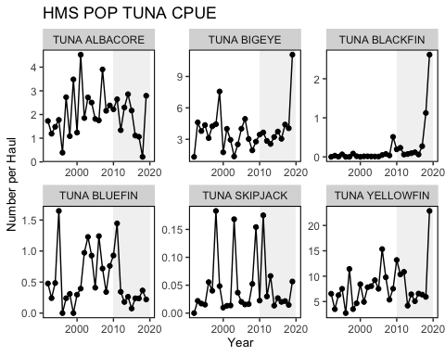

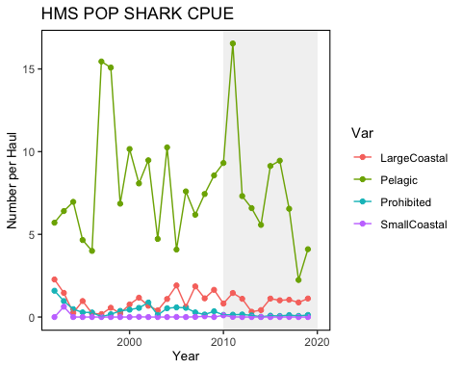

Species groupings based on list from Debbie Duarte - missing Boonethead, Atlantic Angel shark, Sixgill shark, sevengill shark, nurse shark, white shark, basking shark, lemon shark.