Macrofauna GB and GOM

Table of Contents

Trend lines are shown when slope is significantly different from 0 at the p < 0.05 level. An orange line signifies an overall positive trend, and purple signifies a negative trend. To minimize bias introduced by small sample size, no trend is fit when N < 30. Dashed lines represent mean values of time series unless the indicator is an anomaly, in which case the dashed line is equal to 0. Shaded regions indicate the past ten years. If there are no new data for 2018, the shaded region will still cover this time period.

## New England

### Surveys

ONLY ME/NH NEW DATA

#### NEFSC BTS

NO NEW DATA - NO SURVEY IN 2020

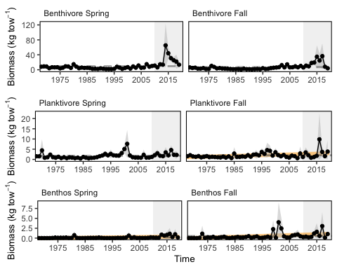

Spring (left) and fall (right) NEFSC surveyed biomass in Georges Bank.

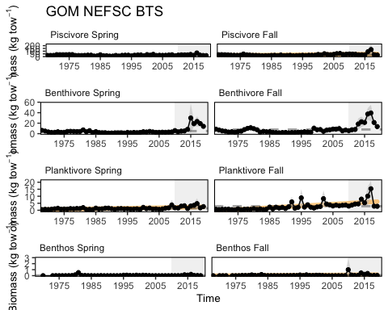

Spring (left) and fall (right) NEFSC surveyed biomass in the Gulf of Maine.

#### NEFMC Benthivores in MAB

NO NEW DATA - NO SURVEY IN 2020

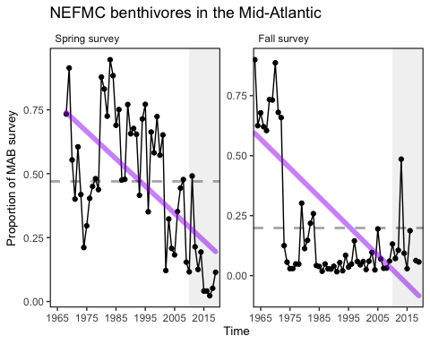

#### MA inshore survey

NO NEW DATA - NO SURVEY IN 2020

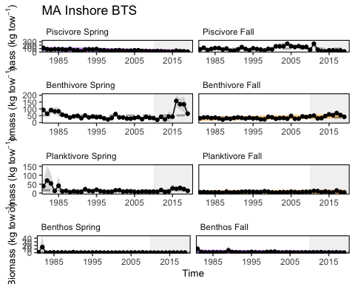

Spring (left) and fall (right) surveyed biomass from the Massachusetts state inshore bottom trawl survey.

#### ME/NH inshore survey

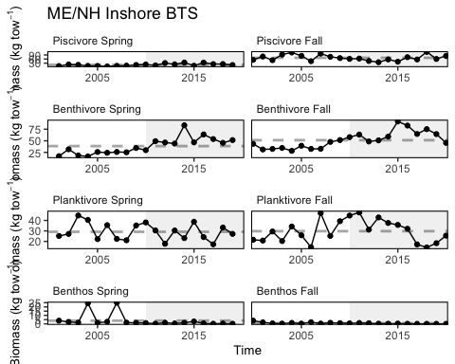

Spring (left) and fall (right) surveyed biomass from the ME/NH state inshore bottom trawl survey.

#### Proportion managed species in NEFSC BTS

NO NEW DATA - NO SURVEY IN 2020

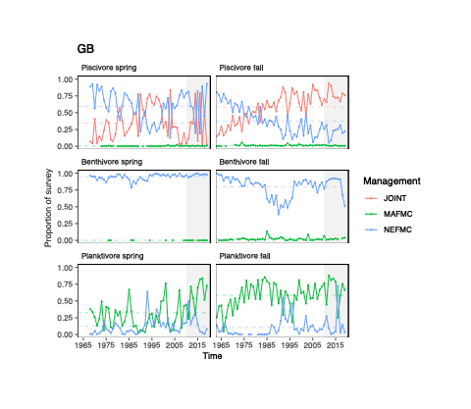

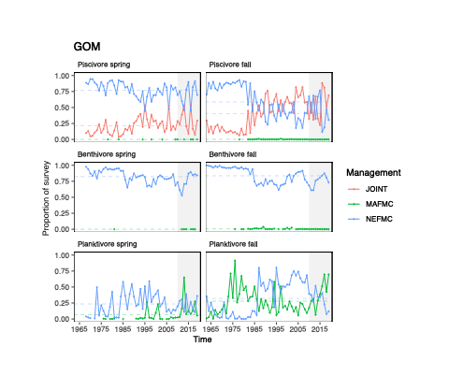

### Productivity anomaly

NO NEW DATA - NO SURVEY IN 2020

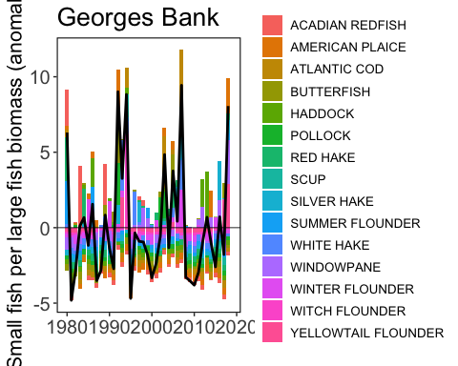

Small fish per large fish biomass anomaly in Georges Bank.

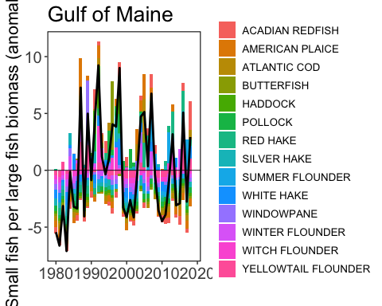

Small fish per large fish biomass anomaly in the Gulf of Maine.

### Condition factor

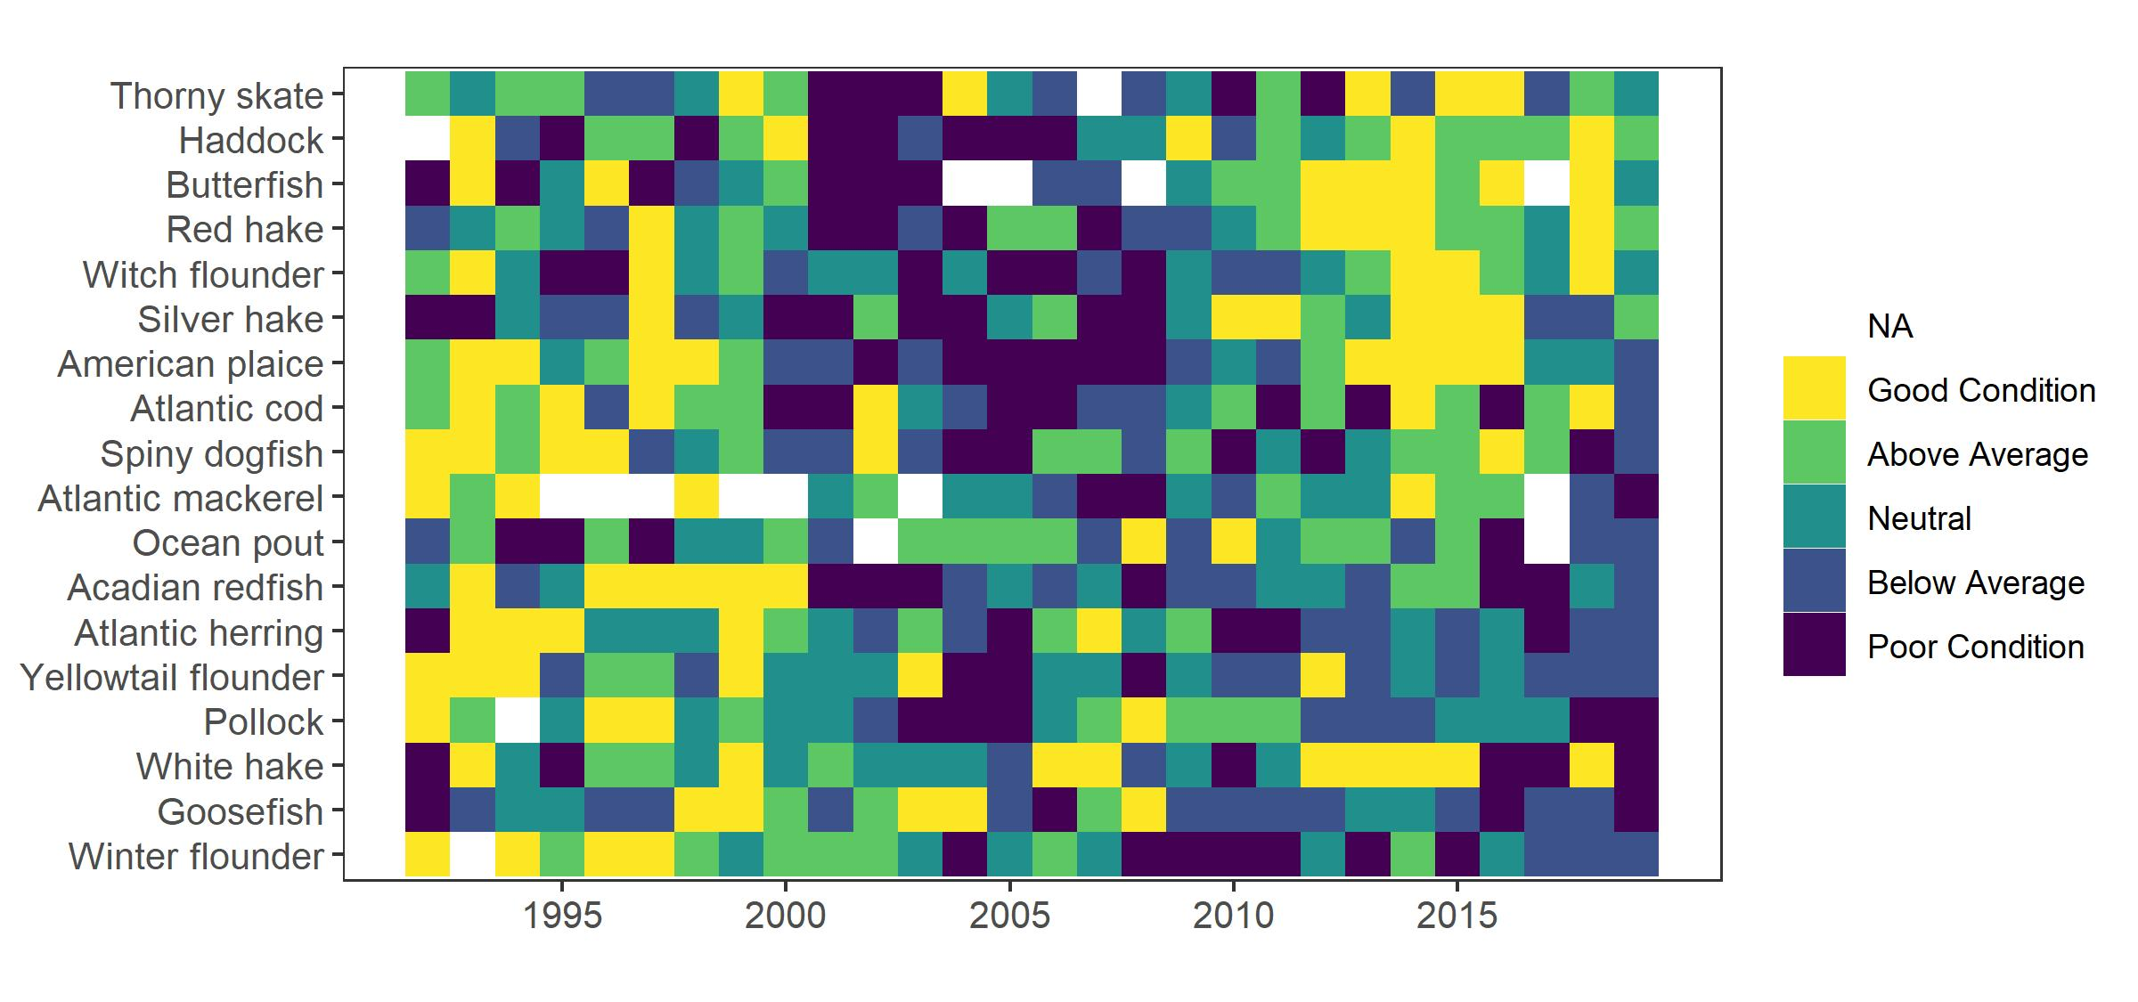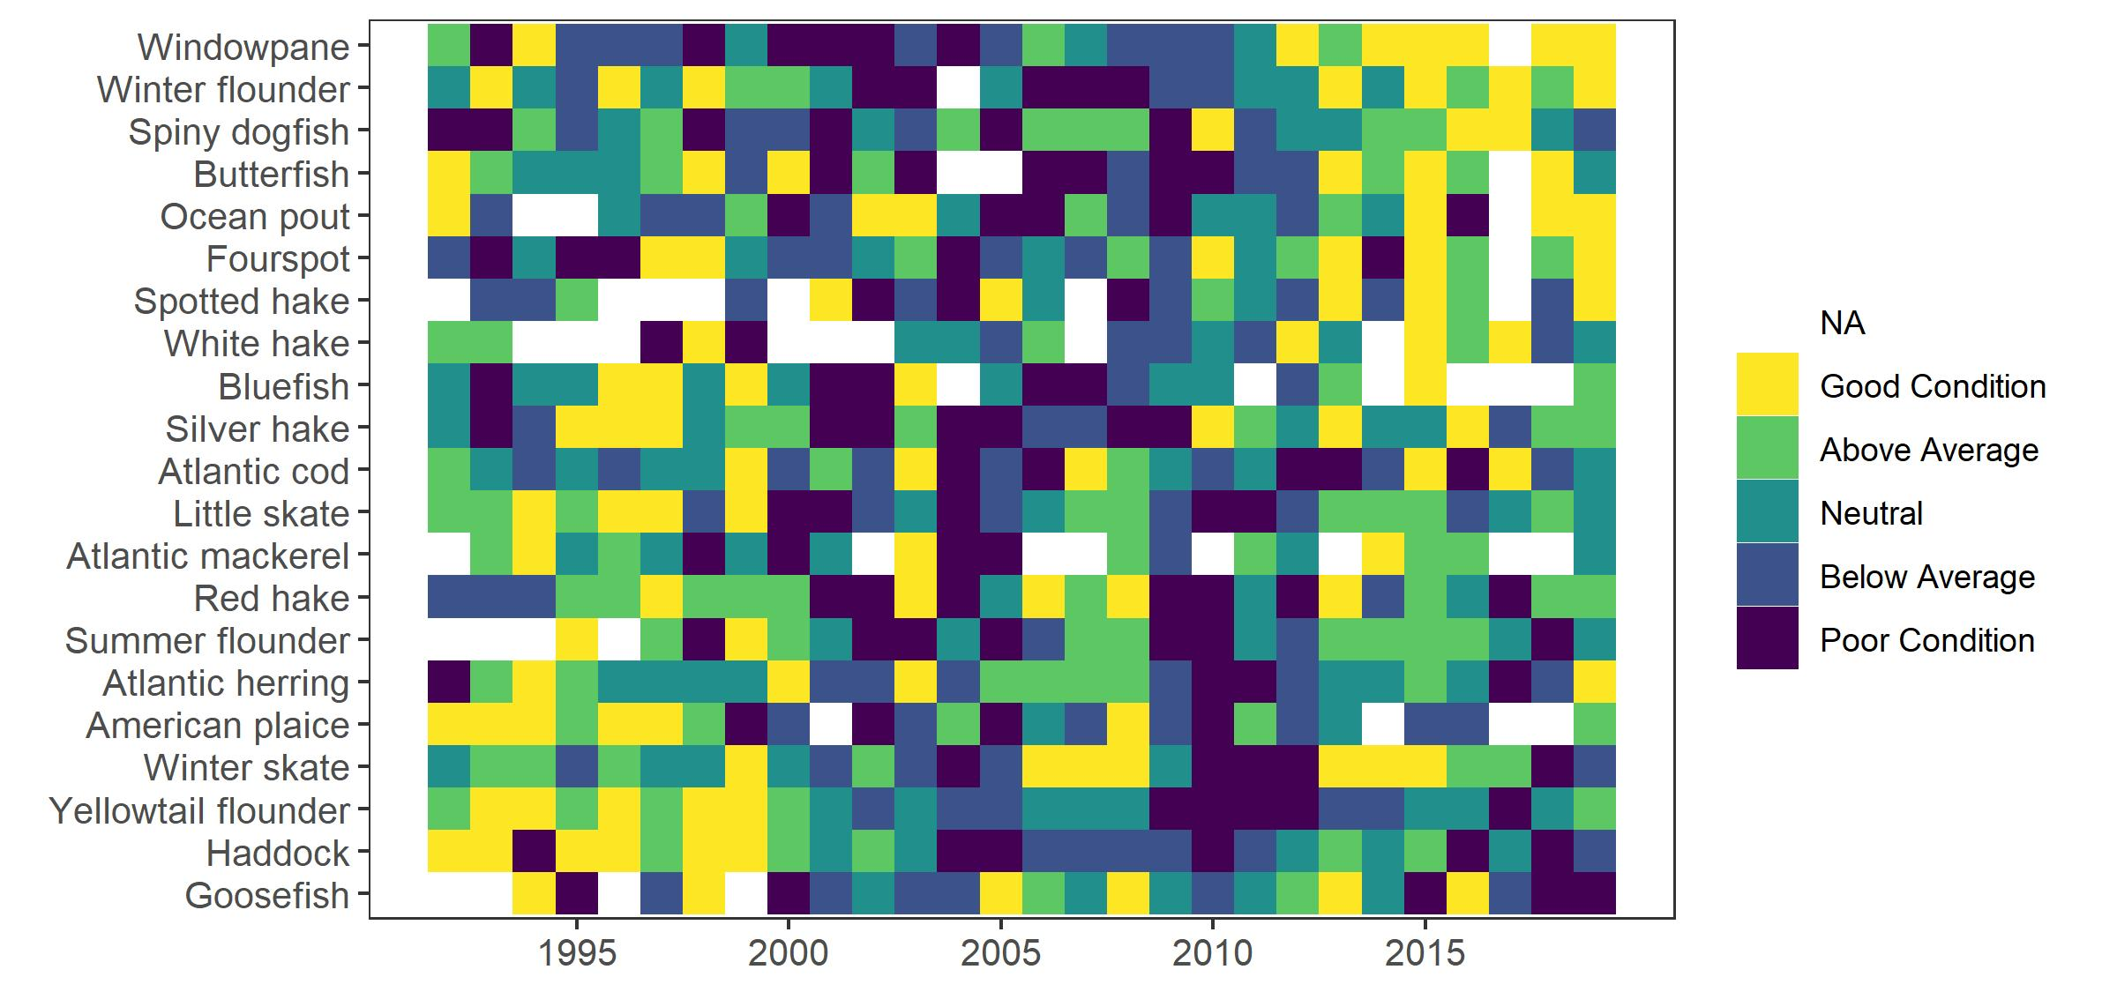

### Stomach Fullness

NO NEW DATA - NO SURVEY IN 2020

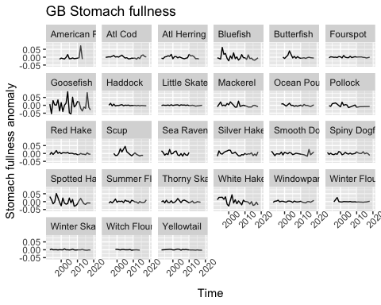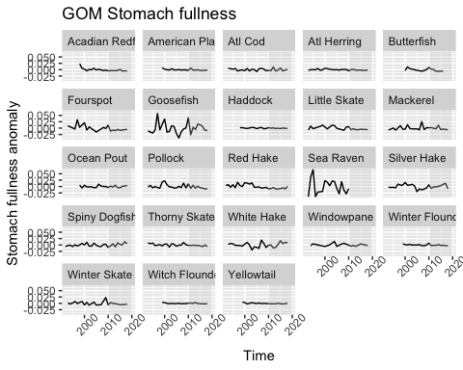

### Larval diversity

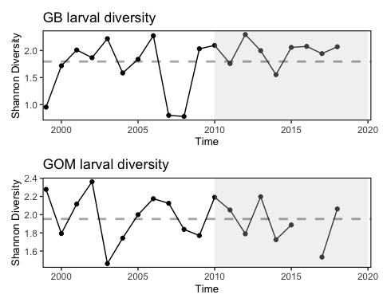

### GOM Common Tern

2020 was a challenging year for terns raising chicks - although diet composition was pretty similar to the long term average the quantity of food readily available was apparently less than normal, particularly around the time of chick hatching (confounded a little by cold, wet weather) and when chicks would normally be close to fledging (mid-late July). Our anecdotal observations of feeding rates were low at both those times.

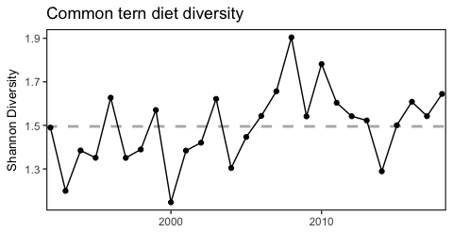

Shannon diversity of common tern diets observed at nesting sites in Gulf of Maine. Diversity of common tern diets has been predominantly above the long-term mean since 2006.

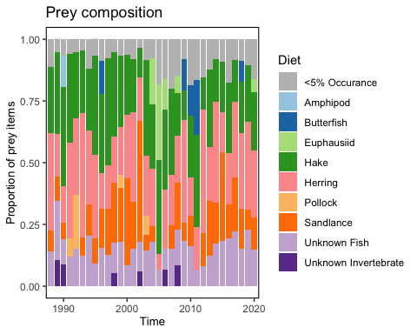

Prey frequencies in the diets of common tern observed at seven different islands in Gulf of Maine.

#### Common tern sampling sites

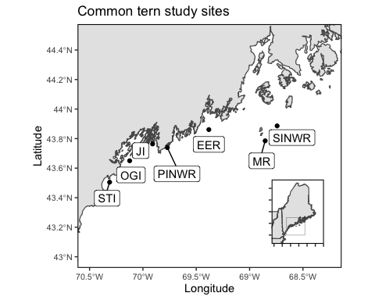

Locations of the seven sampled common tern nesting sites in Gulf of Maine (EER = Eastern Egg Rock, JI = Jenny Island, MR = Matinicus Rock, OGI = Outer Green Island, PINWR = Pond Island National Wildlife Refuge, SINWR = Seal Island National Wildlife Refuge, STI = Stratton Island).

#### Common tern productivity

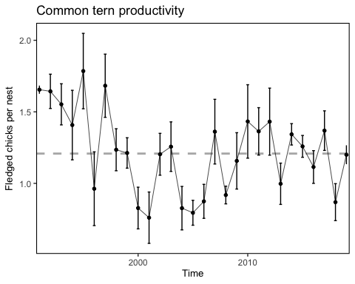

Mean common tern productivity at nesting sites in Gulf of Maine. Error bars show +/- 1 SE of the mean.

### Forage Anomaly

[Taxa include](https://docs.google.com/spreadsheets/d/108snlOTy1wzMGmxbYp1qJuKgqYfYM8MD/edit#gid=966266704)

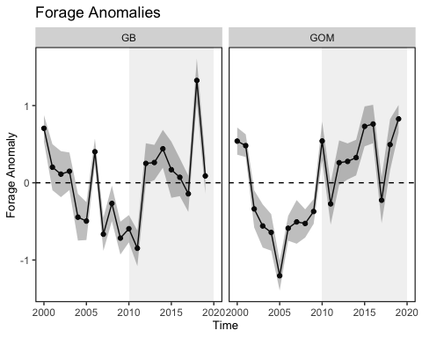

### Observed Shark Numbers

