Preliminary ESP regressions

Abigail Tyrell

23 Mar 2021

# Black sea bass

Stock region: Mid

EPU: MAB, All, all, NE

# 1 Introduction

These are preliminary regressions that compare Mid Black sea bass catch, abundance, recruitment, and F to various indicators in the MAB, All, all, NE Environmental Protection Units (EPUs) taken from the ecodata package. The indicators are lagged by 1 years.

# 2 Regression analysis

All regressions are simple linear correlations assessed at the p < 0.5 level. Please note, due to the large number of indicators tested, a certain amount of statistically significant results are expected even if there are no underlying mechanistic connections. These correlations do not necessarily imply causation.

## 2.1 Trends with time

#### Figures

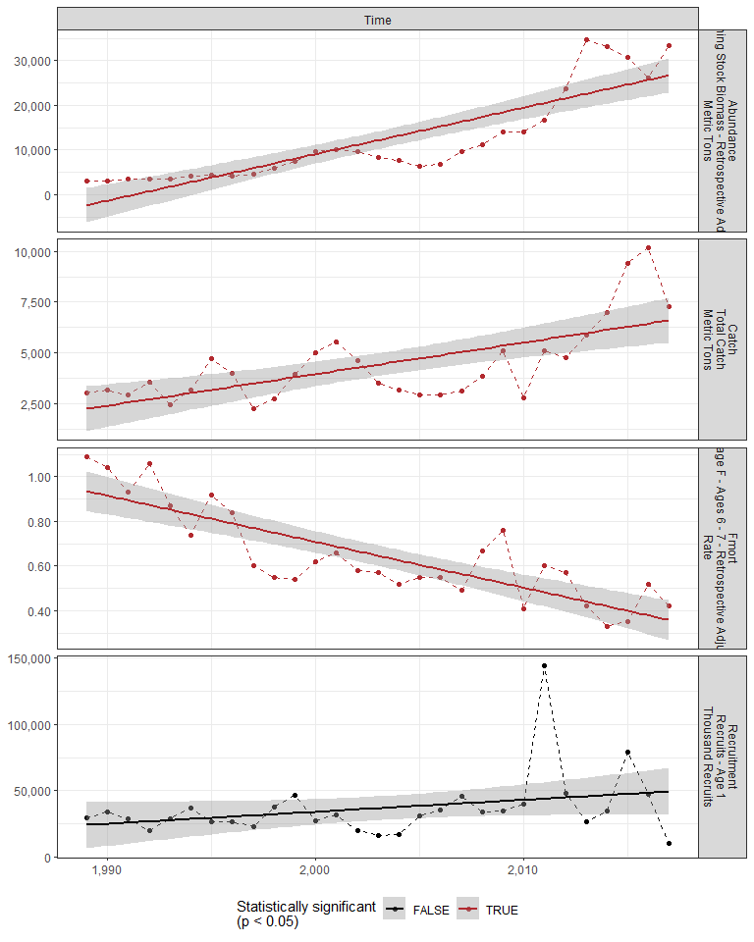

#### Regression statistics

Table 2.1: Catch vs Time

|  |  |  |  |  |
| --- | --- | --- | --- | --- |
|  | Estimate | Std. Error | t value | Pr(>|t|) |
| (Intercept) | -307118.84 | 66180.85 | -4.64 | 0 |
| Val | 155.53 | 33.04 | 4.71 | 0 |

|  |  |
| --- | --- |
| Name | Value |
| F-statistic | 22.16 |
| df | 1, 27 |
| R2 | 0.45 |
| R2-adj | 0.43 |

Table 2.1: Fmort vs Time

|  |  |  |  |  |
| --- | --- | --- | --- | --- |
|  | Estimate | Std. Error | t value | Pr(>|t|) |
| (Intercept) | 41.95 | 5.33 | 7.87 | 0 |
| Val | -0.02 | 0.00 | -7.75 | 0 |

|  |  |
| --- | --- |
| Name | Value |
| F-statistic | 60.1 |
| df | 1, 27 |
| R2 | 0.69 |
| R2-adj | 0.68 |

Table 2.1: Abundance vs Time

|  |  |  |  |  |
| --- | --- | --- | --- | --- |
|  | Estimate | Std. Error | t value | Pr(>|t|) |
| (Intercept) | -2070955 | 231857.79 | -8.93 | 0 |
| Val | 1040 | 115.75 | 8.98 | 0 |

|  |  |
| --- | --- |
| Name | Value |
| F-statistic | 80.72 |
| df | 1, 27 |
| R2 | 0.75 |
| R2-adj | 0.74 |

## 2.2 Physical indicators

### 2.2.1 Cold pool index

#### Figures

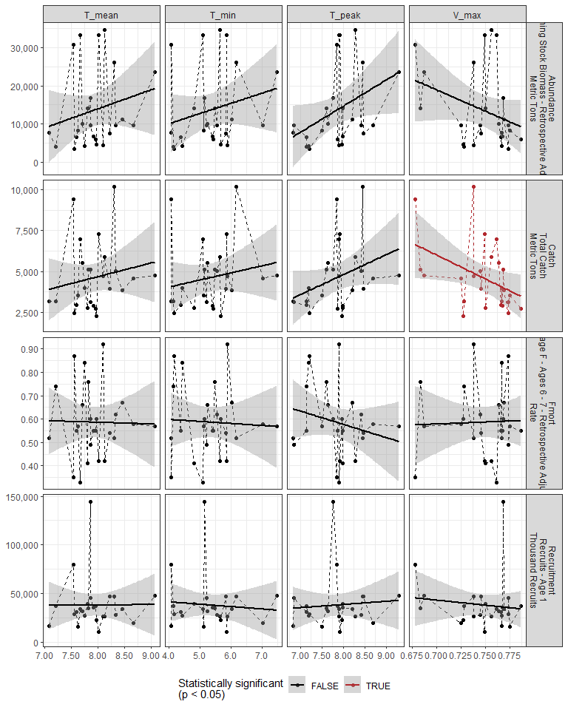

#### Regression statistics

Table 2.2: Catch vs V_max

|  |  |  |  |  |
| --- | --- | --- | --- | --- |
|  | Estimate | Std. Error | t value | Pr(>|t|) |
| (Intercept) | 26413.32 | 9926.97 | 2.66 | 0.01 |
| Val | -29157.48 | 13268.12 | -2.20 | 0.04 |

|  |  |
| --- | --- |
| Name | Value |
| F-statistic | 4.83 |
| df | 1, 23 |
| R2 | 0.17 |
| R2-adj | 0.14 |

### 2.2.2 Warm core rings

#### Figures

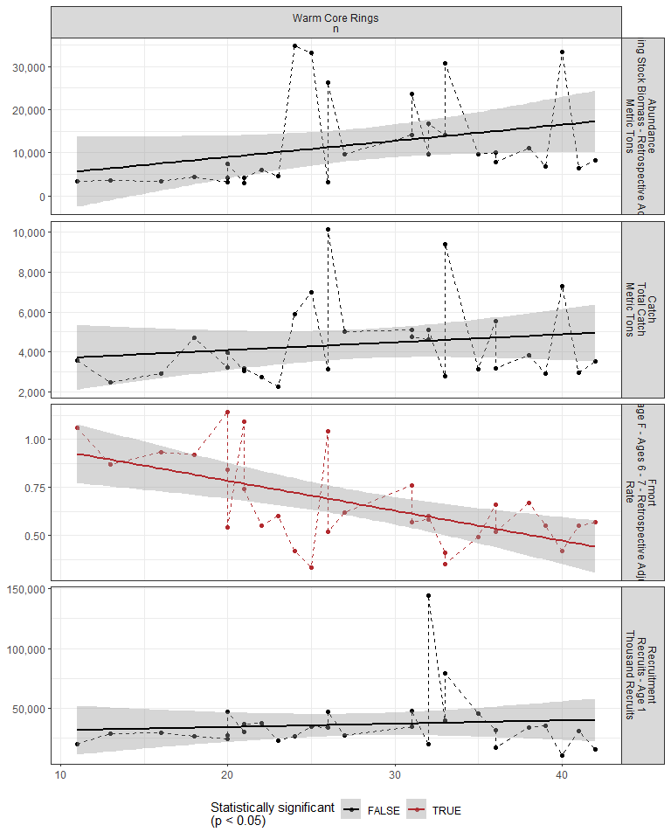

#### Regression statistics

Table 2.3: Fmort vs Warm Core Rings n

|  |  |  |  |  |
| --- | --- | --- | --- | --- |
|  | Estimate | Std. Error | t value | Pr(>|t|) |
| (Intercept) | 1.10 | 0.12 | 9.45 | 0 |
| Val | -0.02 | 0.00 | -3.90 | 0 |

|  |  |
| --- | --- |
| Name | Value |
| F-statistic | 15.19 |
| df | 1, 28 |
| R2 | 0.35 |
| R2-adj | 0.33 |

### 2.2.3 Marine heatwave index

#### Figures

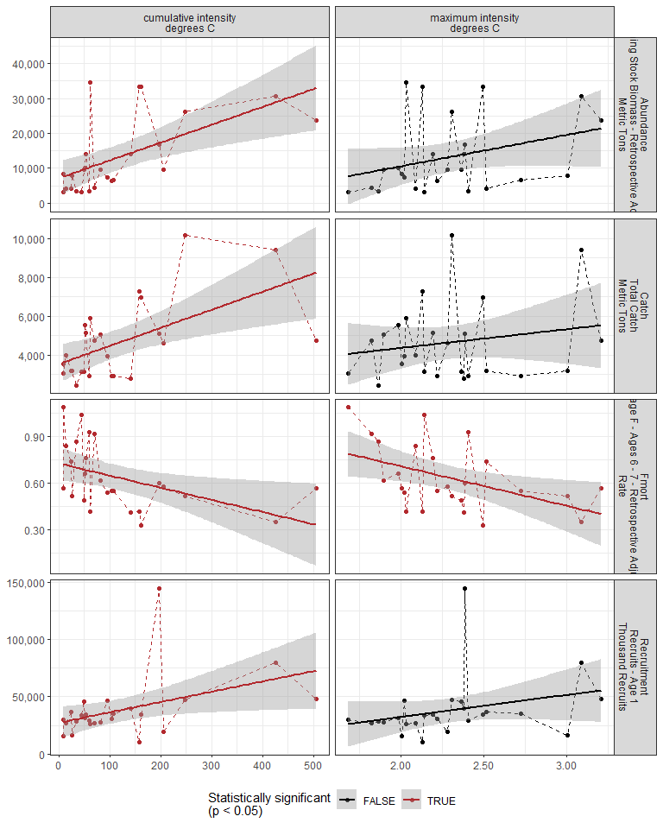

#### Regression statistics

Table 2.4: Catch vs cumulative intensity degrees C

|  |  |  |  |  |
| --- | --- | --- | --- | --- |
|  | Estimate | Std. Error | t value | Pr(>|t|) |
| (Intercept) | 3531.16 | 476.48 | 7.41 | 0 |
| Val | 9.30 | 2.82 | 3.30 | 0 |

|  |  |
| --- | --- |
| Name | Value |
| F-statistic | 10.89 |
| df | 1, 23 |
| R2 | 0.32 |
| R2-adj | 0.29 |

Table 2.4: Fmort vs cumulative intensity degrees C

|  |  |  |  |  |
| --- | --- | --- | --- | --- |
|  | Estimate | Std. Error | t value | Pr(>|t|) |
| (Intercept) | 0.73 | 0.05 | 13.69 | 0.00 |
| Val | 0.00 | 0.00 | -2.49 | 0.02 |

|  |  |
| --- | --- |
| Name | Value |
| F-statistic | 6.19 |
| df | 1, 23 |
| R2 | 0.21 |
| R2-adj | 0.18 |

Table 2.4: Fmort vs maximum intensity degrees C

|  |  |  |  |  |
| --- | --- | --- | --- | --- |
|  | Estimate | Std. Error | t value | Pr(>|t|) |
| (Intercept) | 1.22 | 0.23 | 5.29 | 0.00 |
| Val | -0.26 | 0.10 | -2.57 | 0.02 |

|  |  |
| --- | --- |
| Name | Value |
| F-statistic | 6.6 |
| df | 1, 23 |
| R2 | 0.22 |
| R2-adj | 0.19 |

Table 2.4: Recruitment vs cumulative intensity degrees C

|  |  |  |  |  |
| --- | --- | --- | --- | --- |
|  | Estimate | Std. Error | t value | Pr(>|t|) |
| (Intercept) | 27233.93 | 6711.26 | 4.06 | 0.00 |
| Val | 90.00 | 39.71 | 2.27 | 0.03 |

|  |  |
| --- | --- |
| Name | Value |
| F-statistic | 5.14 |
| df | 1, 23 |
| R2 | 0.18 |
| R2-adj | 0.15 |

Table 2.4: Abundance vs cumulative intensity degrees C

|  |  |  |  |  |
| --- | --- | --- | --- | --- |
|  | Estimate | Std. Error | t value | Pr(>|t|) |
| (Intercept) | 7099.18 | 2439.91 | 2.91 | 0.01 |
| Val | 51.19 | 14.44 | 3.55 | 0.00 |

|  |  |
| --- | --- |
| Name | Value |
| F-statistic | 12.58 |
| df | 1, 23 |
| R2 | 0.35 |
| R2-adj | 0.33 |

### 2.2.4 GLORYS bottom temperature

#### Figures

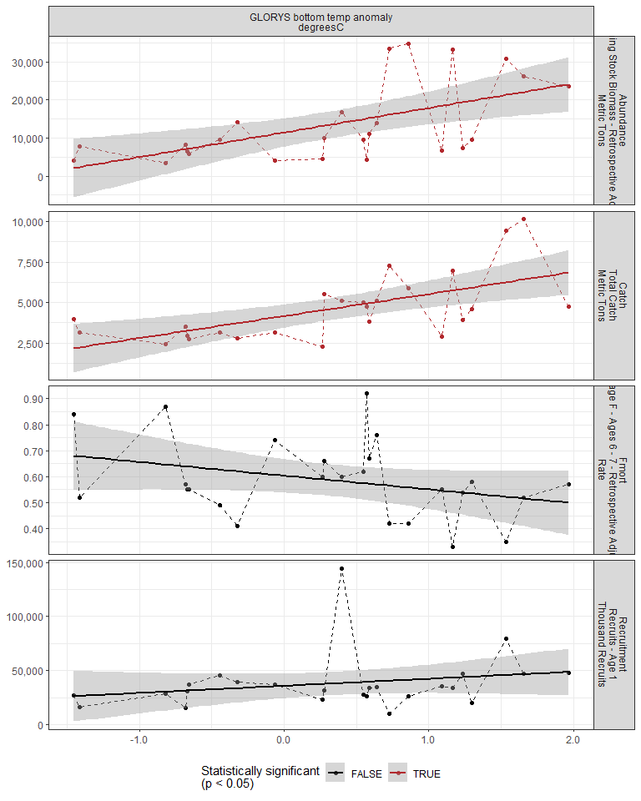

#### Regression statistics

Table 2.5: Catch vs GLORYS bottom temp anomaly degreesC

|  |  |  |  |  |
| --- | --- | --- | --- | --- |
|  | Estimate | Std. Error | t value | Pr(>|t|) |
| (Intercept) | 4161.68 | 348.97 | 11.93 | 0 |
| Val | 1359.11 | 355.03 | 3.83 | 0 |

|  |  |
| --- | --- |
| Name | Value |
| F-statistic | 14.65 |
| df | 1, 23 |
| R2 | 0.39 |
| R2-adj | 0.36 |

Table 2.5: Abundance vs GLORYS bottom temp anomaly degreesC

|  |  |  |  |  |
| --- | --- | --- | --- | --- |
|  | Estimate | Std. Error | t value | Pr(>|t|) |
| (Intercept) | 11455.96 | 1815.64 | 6.31 | 0 |
| Val | 6429.92 | 1847.18 | 3.48 | 0 |

|  |  |
| --- | --- |
| Name | Value |
| F-statistic | 12.12 |
| df | 1, 23 |
| R2 | 0.35 |
| R2-adj | 0.32 |

### 2.2.5 Long-term sea surface temperature

#### Figures

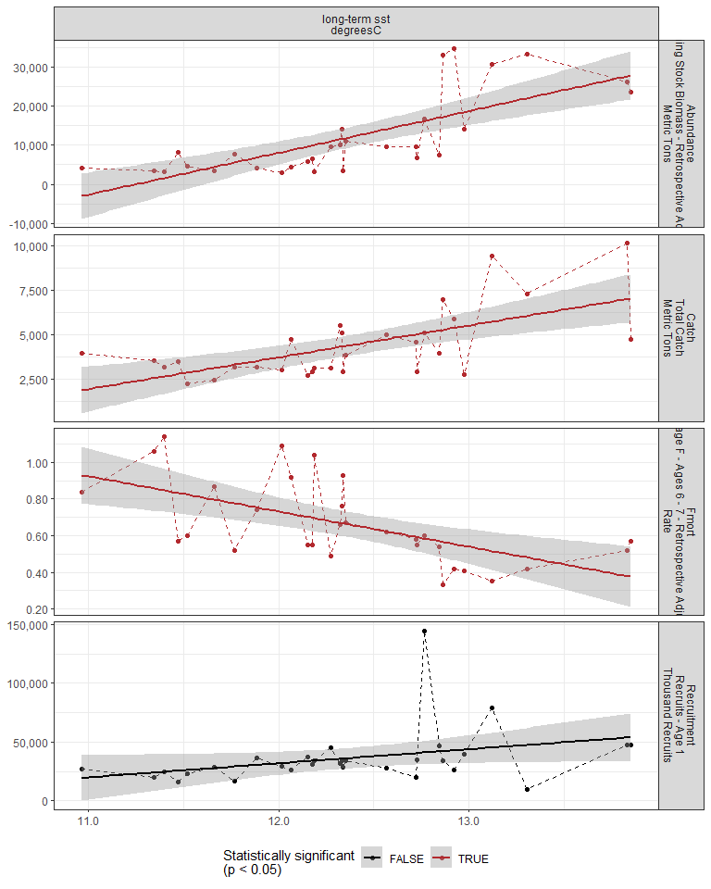

#### Regression statistics

Table 2.6: Catch vs long-term sst degreesC

|  |  |  |  |  |
| --- | --- | --- | --- | --- |
|  | Estimate | Std. Error | t value | Pr(>|t|) |
| (Intercept) | -17672.95 | 4983.39 | -3.55 | 0 |
| Val | 1784.02 | 402.62 | 4.43 | 0 |

|  |  |
| --- | --- |
| Name | Value |
| F-statistic | 19.63 |
| df | 1, 28 |
| R2 | 0.41 |
| R2-adj | 0.39 |

Table 2.6: Fmort vs long-term sst degreesC

|  |  |  |  |  |
| --- | --- | --- | --- | --- |
|  | Estimate | Std. Error | t value | Pr(>|t|) |
| (Intercept) | 3.04 | 0.61 | 5.02 | 0 |
| Val | -0.19 | 0.05 | -3.93 | 0 |

|  |  |
| --- | --- |
| Name | Value |
| F-statistic | 15.47 |
| df | 1, 28 |
| R2 | 0.36 |
| R2-adj | 0.33 |

Table 2.6: Abundance vs long-term sst degreesC

|  |  |  |  |  |
| --- | --- | --- | --- | --- |
|  | Estimate | Std. Error | t value | Pr(>|t|) |
| (Intercept) | -120713.25 | 22838.28 | -5.29 | 0 |
| Val | 10728.69 | 1845.17 | 5.81 | 0 |

|  |  |
| --- | --- |
| Name | Value |
| F-statistic | 33.81 |
| df | 1, 28 |
| R2 | 0.55 |
| R2-adj | 0.53 |

### 2.2.6 Sea surface temperature anomaly

#### Figures

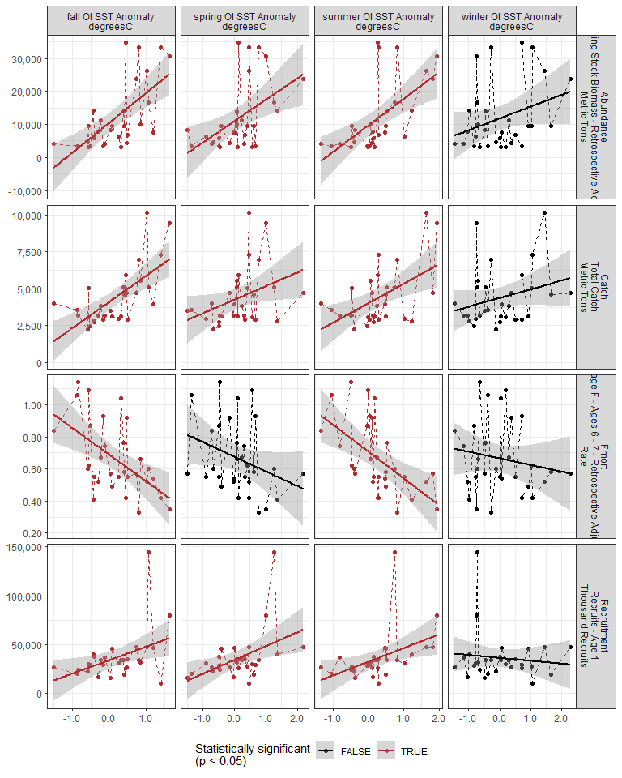

#### Regression statistics

Table 2.7: Catch vs fall OI SST Anomaly degreesC

|  |  |  |  |  |
| --- | --- | --- | --- | --- |
|  | Estimate | Std. Error | t value | Pr(>|t|) |
| (Intercept) | 4102.56 | 272.43 | 15.06 | 0 |
| Val | 1768.91 | 363.06 | 4.87 | 0 |

|  |  |
| --- | --- |
| Name | Value |
| F-statistic | 23.74 |
| df | 1, 28 |
| R2 | 0.46 |
| R2-adj | 0.44 |

Table 2.7: Catch vs spring OI SST Anomaly degreesC

|  |  |  |  |  |
| --- | --- | --- | --- | --- |
|  | Estimate | Std. Error | t value | Pr(>|t|) |
| (Intercept) | 4254.40 | 340.77 | 12.48 | 0.00 |
| Val | 921.04 | 431.08 | 2.14 | 0.04 |

|  |  |
| --- | --- |
| Name | Value |
| F-statistic | 4.57 |
| df | 1, 28 |
| R2 | 0.14 |
| R2-adj | 0.11 |

Table 2.7: Catch vs summer OI SST Anomaly degreesC

|  |  |  |  |  |
| --- | --- | --- | --- | --- |
|  | Estimate | Std. Error | t value | Pr(>|t|) |
| (Intercept) | 4024.02 | 327.25 | 12.30 | 0 |
| Val | 1335.11 | 411.21 | 3.25 | 0 |

|  |  |
| --- | --- |
| Name | Value |
| F-statistic | 10.54 |
| df | 1, 28 |
| R2 | 0.27 |
| R2-adj | 0.25 |

Table 2.7: Fmort vs fall OI SST Anomaly degreesC

|  |  |  |  |  |
| --- | --- | --- | --- | --- |
|  | Estimate | Std. Error | t value | Pr(>|t|) |
| (Intercept) | 0.69 | 0.04 | 19.17 | 0 |
| Val | -0.17 | 0.05 | -3.46 | 0 |

|  |  |
| --- | --- |
| Name | Value |
| F-statistic | 11.99 |
| df | 1, 28 |
| R2 | 0.3 |
| R2-adj | 0.27 |

Table 2.7: Fmort vs summer OI SST Anomaly degreesC

|  |  |  |  |  |
| --- | --- | --- | --- | --- |
|  | Estimate | Std. Error | t value | Pr(>|t|) |
| (Intercept) | 0.71 | 0.04 | 19.30 | 0 |
| Val | -0.17 | 0.05 | -3.65 | 0 |

|  |  |
| --- | --- |
| Name | Value |
| F-statistic | 13.31 |
| df | 1, 28 |
| R2 | 0.32 |
| R2-adj | 0.3 |

Table 2.7: Recruitment vs fall OI SST Anomaly degreesC

|  |  |  |  |  |
| --- | --- | --- | --- | --- |
|  | Estimate | Std. Error | t value | Pr(>|t|) |
| (Intercept) | 34016.90 | 4163.72 | 8.17 | 0.00 |
| Val | 13750.39 | 5548.74 | 2.48 | 0.02 |

|  |  |
| --- | --- |
| Name | Value |
| F-statistic | 6.14 |
| df | 1, 28 |
| R2 | 0.18 |
| R2-adj | 0.15 |

Table 2.7: Recruitment vs spring OI SST Anomaly degreesC

|  |  |  |  |  |
| --- | --- | --- | --- | --- |
|  | Estimate | Std. Error | t value | Pr(>|t|) |
| (Intercept) | 34286.32 | 4041.73 | 8.48 | 0.00 |
| Val | 14170.01 | 5112.84 | 2.77 | 0.01 |

|  |  |
| --- | --- |
| Name | Value |
| F-statistic | 7.68 |
| df | 1, 28 |
| R2 | 0.22 |
| R2-adj | 0.19 |

Table 2.7: Recruitment vs summer OI SST Anomaly degreesC

|  |  |  |  |  |
| --- | --- | --- | --- | --- |
|  | Estimate | Std. Error | t value | Pr(>|t|) |
| (Intercept) | 32436.50 | 4270.62 | 7.60 | 0.00 |
| Val | 14077.54 | 5366.41 | 2.62 | 0.01 |

|  |  |
| --- | --- |
| Name | Value |
| F-statistic | 6.88 |
| df | 1, 28 |
| R2 | 0.2 |
| R2-adj | 0.17 |

Table 2.7: Abundance vs fall OI SST Anomaly degreesC

|  |  |  |  |  |
| --- | --- | --- | --- | --- |
|  | Estimate | Std. Error | t value | Pr(>|t|) |
| (Intercept) | 10486.21 | 1447.99 | 7.24 | 0 |
| Val | 9033.07 | 1929.65 | 4.68 | 0 |

|  |  |
| --- | --- |
| Name | Value |
| F-statistic | 21.91 |
| df | 1, 28 |
| R2 | 0.44 |
| R2-adj | 0.42 |

Table 2.7: Abundance vs spring OI SST Anomaly degreesC

|  |  |  |  |  |
| --- | --- | --- | --- | --- |
|  | Estimate | Std. Error | t value | Pr(>|t|) |
| (Intercept) | 11031.30 | 1656.73 | 6.66 | 0 |
| Val | 6475.66 | 2095.78 | 3.09 | 0 |

|  |  |
| --- | --- |
| Name | Value |
| F-statistic | 9.55 |
| df | 1, 28 |
| R2 | 0.25 |
| R2-adj | 0.23 |

Table 2.7: Abundance vs summer OI SST Anomaly degreesC

|  |  |  |  |  |
| --- | --- | --- | --- | --- |
|  | Estimate | Std. Error | t value | Pr(>|t|) |
| (Intercept) | 9749.72 | 1591.95 | 6.12 | 0 |
| Val | 8097.17 | 2000.43 | 4.05 | 0 |

|  |  |
| --- | --- |
| Name | Value |
| F-statistic | 16.38 |
| df | 1, 28 |
| R2 | 0.37 |
| R2-adj | 0.35 |

### 2.2.7 Stratification

#### Figures

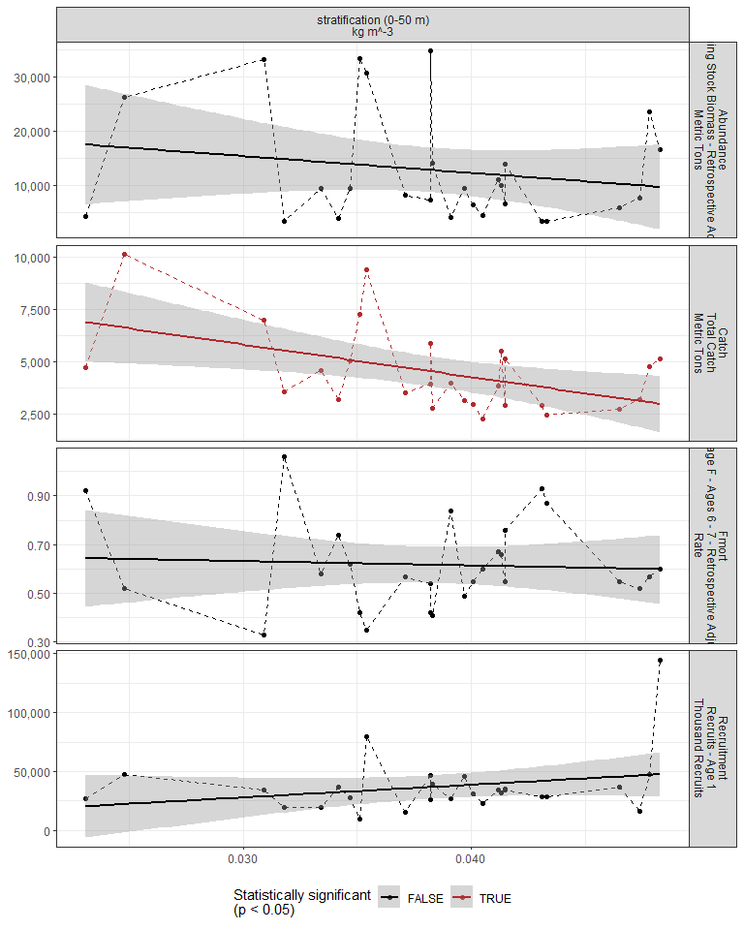

#### Regression statistics

Table 2.8: Catch vs stratification (0-50 m) kg m^-3

|  |  |  |  |  |
| --- | --- | --- | --- | --- |
|  | Estimate | Std. Error | t value | Pr(>|t|) |
| (Intercept) | 10497.99 | 2181.53 | 4.81 | 0.00 |
| Val | -155908.94 | 56111.74 | -2.78 | 0.01 |

|  |  |
| --- | --- |
| Name | Value |
| F-statistic | 7.72 |
| df | 1, 25 |
| R2 | 0.24 |
| R2-adj | 0.21 |

### 2.2.8 Winter wind speed

#### Figures

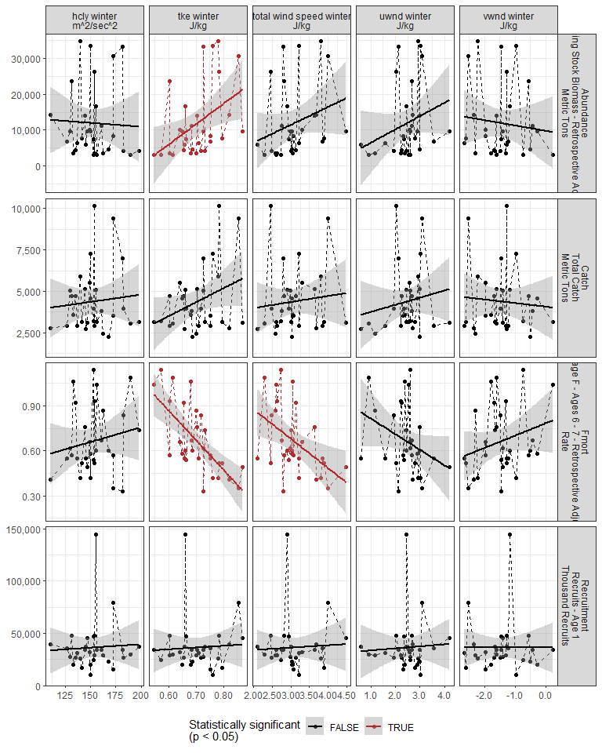

#### Regression statistics

Table 2.9: Fmort vs tke winter J/kg

|  |  |  |  |  |
| --- | --- | --- | --- | --- |
|  | Estimate | Std. Error | t value | Pr(>|t|) |
| (Intercept) | 2.06 | 0.28 | 7.41 | 0 |
| Val | -1.98 | 0.39 | -5.05 | 0 |

|  |  |
| --- | --- |
| Name | Value |
| F-statistic | 25.46 |
| df | 1, 28 |
| R2 | 0.48 |
| R2-adj | 0.46 |

Table 2.9: Fmort vs total wind speed winter J/kg

|  |  |  |  |  |
| --- | --- | --- | --- | --- |
|  | Estimate | Std. Error | t value | Pr(>|t|) |
| (Intercept) | 1.27 | 0.21 | 5.93 | 0.00 |
| Val | -0.20 | 0.07 | -2.87 | 0.01 |

|  |  |
| --- | --- |
| Name | Value |
| F-statistic | 8.23 |
| df | 1, 28 |
| R2 | 0.23 |
| R2-adj | 0.2 |

Table 2.9: Abundance vs tke winter J/kg

|  |  |  |  |  |
| --- | --- | --- | --- | --- |
|  | Estimate | Std. Error | t value | Pr(>|t|) |
| (Intercept) | -28194.90 | 15487.66 | -1.82 | 0.08 |
| Val | 56959.11 | 21884.15 | 2.60 | 0.01 |

|  |  |
| --- | --- |
| Name | Value |
| F-statistic | 6.77 |
| df | 1, 28 |
| R2 | 0.19 |
| R2-adj | 0.17 |

### 2.2.9 Spring wind speed

#### Figures

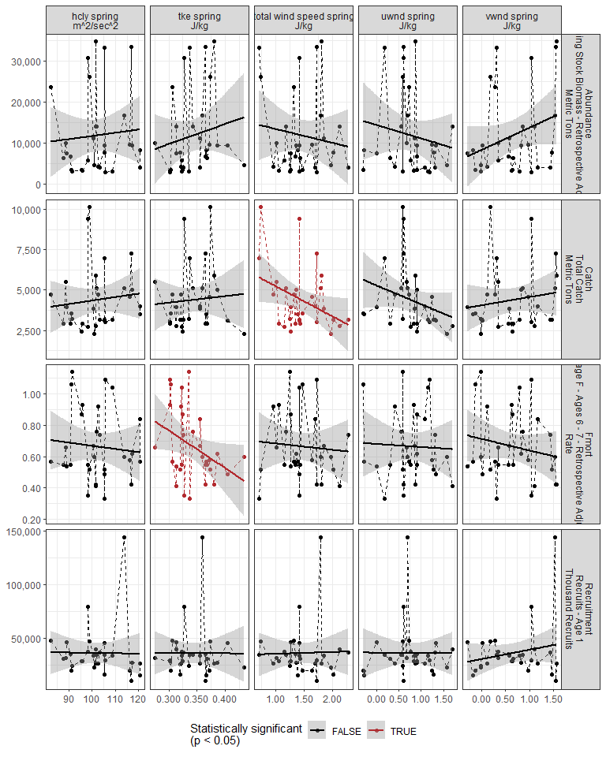

#### Regression statistics

Table 2.10: Catch vs total wind speed spring J/kg

|  |  |  |  |  |
| --- | --- | --- | --- | --- |
|  | Estimate | Std. Error | t value | Pr(>|t|) |
| (Intercept) | 7094.50 | 1329.36 | 5.34 | 0.00 |
| Val | -1863.44 | 880.92 | -2.12 | 0.04 |

|  |  |
| --- | --- |
| Name | Value |
| F-statistic | 4.47 |
| df | 1, 28 |
| R2 | 0.14 |
| R2-adj | 0.11 |

Table 2.10: Fmort vs tke spring J/kg

|  |  |  |  |  |
| --- | --- | --- | --- | --- |
|  | Estimate | Std. Error | t value | Pr(>|t|) |
| (Intercept) | 1.48 | 0.39 | 3.78 | 0.00 |
| Val | -2.39 | 1.14 | -2.10 | 0.04 |

|  |  |
| --- | --- |
| Name | Value |
| F-statistic | 4.41 |
| df | 1, 28 |
| R2 | 0.14 |
| R2-adj | 0.11 |

### 2.2.10 Summer wind speed

#### Figures

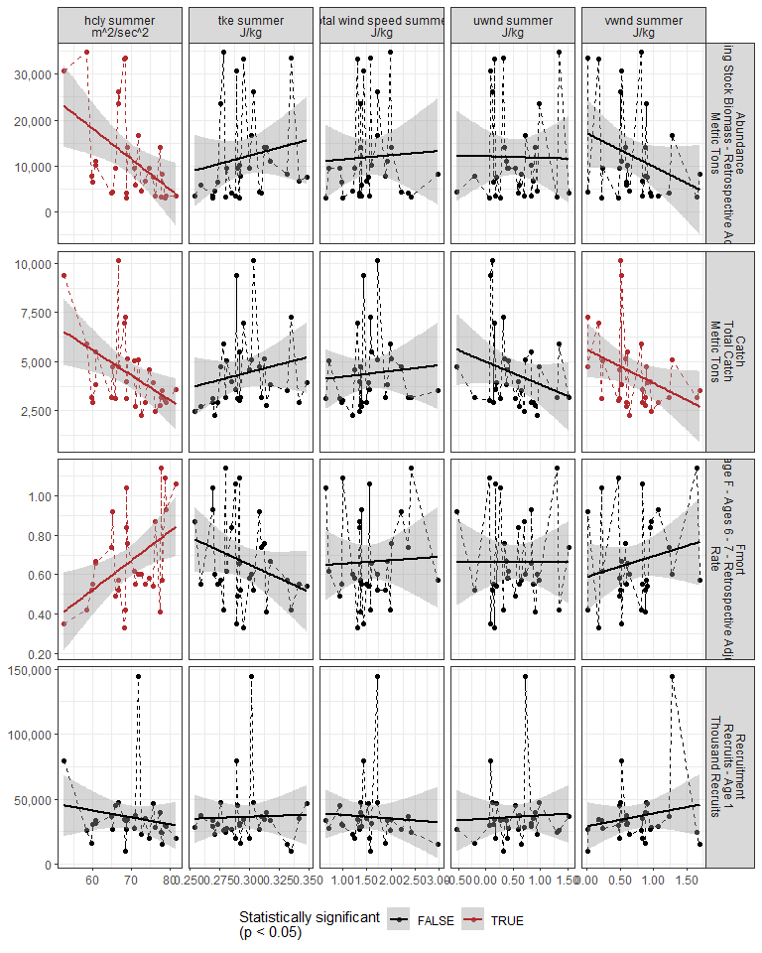

#### Regression statistics

Table 2.11: Catch vs hcly summer m2/sec2

|  |  |  |  |  |
| --- | --- | --- | --- | --- |
|  | Estimate | Std. Error | t value | Pr(>|t|) |
| (Intercept) | 13201.22 | 3175.90 | 4.16 | 0.00 |
| Val | -127.08 | 45.49 | -2.79 | 0.01 |

|  |  |
| --- | --- |
| Name | Value |
| F-statistic | 7.8 |
| df | 1, 28 |
| R2 | 0.22 |
| R2-adj | 0.19 |

Table 2.11: Catch vs vwnd summer J/kg

|  |  |  |  |  |
| --- | --- | --- | --- | --- |
|  | Estimate | Std. Error | t value | Pr(>|t|) |
| (Intercept) | 5599.38 | 686.23 | 8.16 | 0.00 |
| Val | -1703.64 | 830.36 | -2.05 | 0.05 |

|  |  |
| --- | --- |
| Name | Value |
| F-statistic | 4.21 |
| df | 1, 28 |
| R2 | 0.13 |
| R2-adj | 0.1 |

Table 2.11: Fmort vs hcly summer m2/sec2

|  |  |  |  |  |
| --- | --- | --- | --- | --- |
|  | Estimate | Std. Error | t value | Pr(>|t|) |
| (Intercept) | -0.37 | 0.37 | -1.00 | 0.32 |
| Val | 0.01 | 0.01 | 2.82 | 0.01 |

|  |  |
| --- | --- |
| Name | Value |
| F-statistic | 7.97 |
| df | 1, 28 |
| R2 | 0.22 |
| R2-adj | 0.19 |

Table 2.11: Abundance vs hcly summer m2/sec2

|  |  |  |  |  |
| --- | --- | --- | --- | --- |
|  | Estimate | Std. Error | t value | Pr(>|t|) |
| (Intercept) | 57832.49 | 16591.63 | 3.49 | 0.00 |
| Val | -661.64 | 237.63 | -2.78 | 0.01 |

|  |  |
| --- | --- |
| Name | Value |
| F-statistic | 7.75 |
| df | 1, 28 |
| R2 | 0.22 |
| R2-adj | 0.19 |

### 2.2.11 Fall wind speed

#### Figures

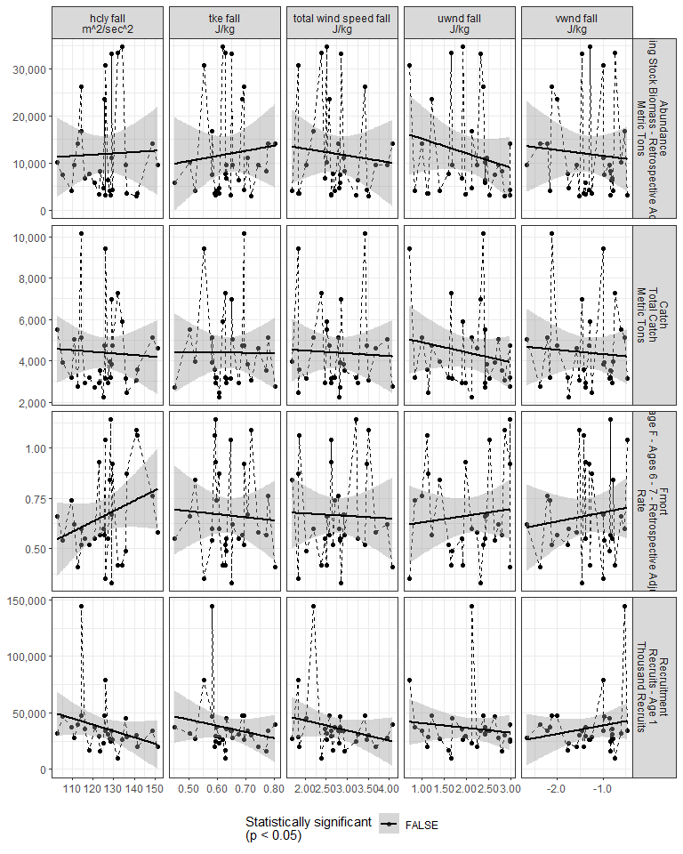

#### Regression statistics

[1] “No statistically significant data”

### 2.2.12 Gulf Stream Index

#### Figures

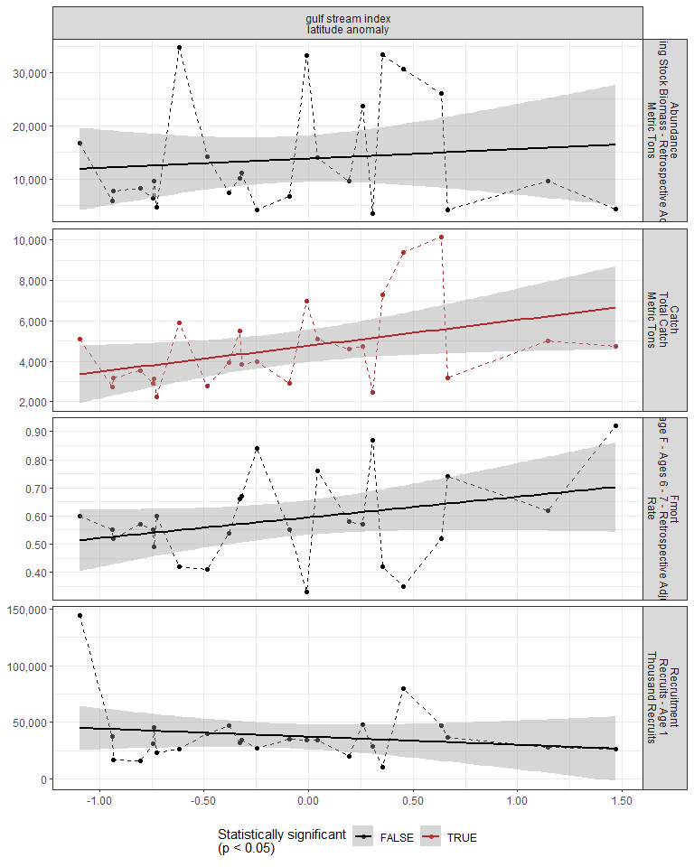

#### Regression statistics

Table 2.12: Catch vs gulf stream index latitude anomaly

|  |  |  |  |  |
| --- | --- | --- | --- | --- |
|  | Estimate | Std. Error | t value | Pr(>|t|) |
| (Intercept) | 4764.51 | 387.91 | 12.28 | 0.00 |
| Val | 1279.11 | 581.57 | 2.20 | 0.04 |

|  |  |
| --- | --- |
| Name | Value |
| F-statistic | 4.84 |
| df | 1, 23 |
| R2 | 0.17 |
| R2-adj | 0.14 |

### 2.2.13 North Atlantic Oscillation

#### Figures

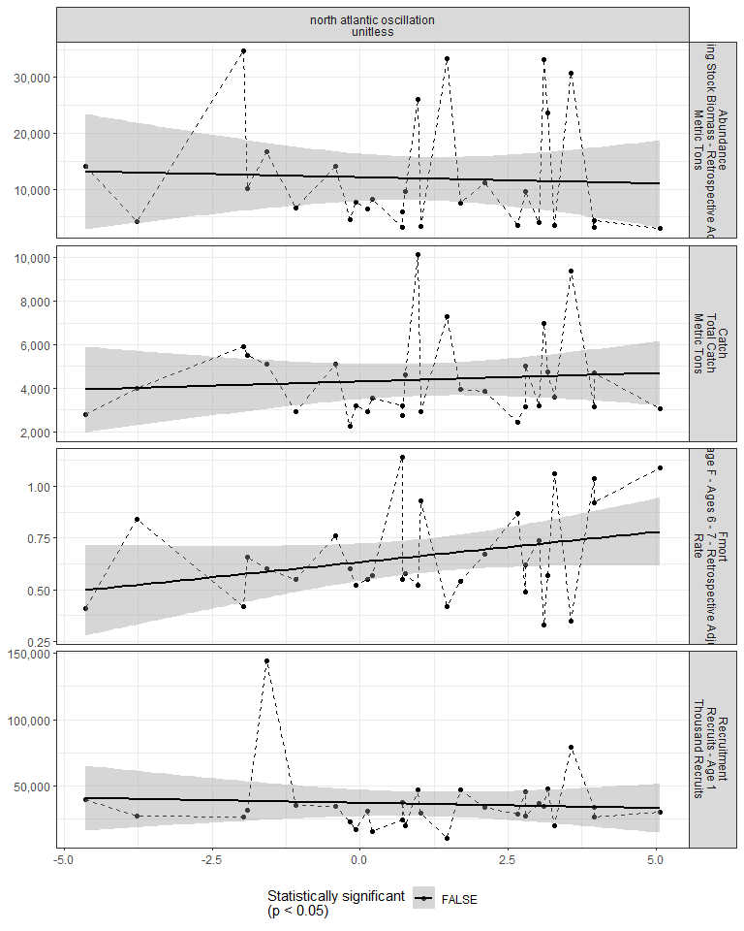

#### Regression statistics

[1] “No statistically significant data”

### 2.2.14 Chlorophyll

#### Figures

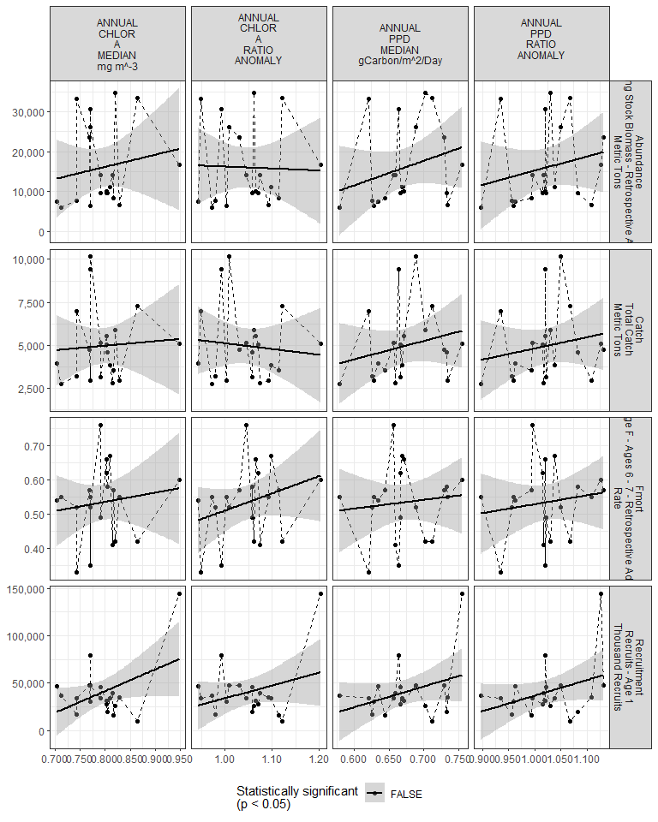

#### Regression statistics

[1] “No statistically significant data”

## 2.3 Trophic indicators

### 2.3.1 Spring zooplankton abundance by species

#### Figures

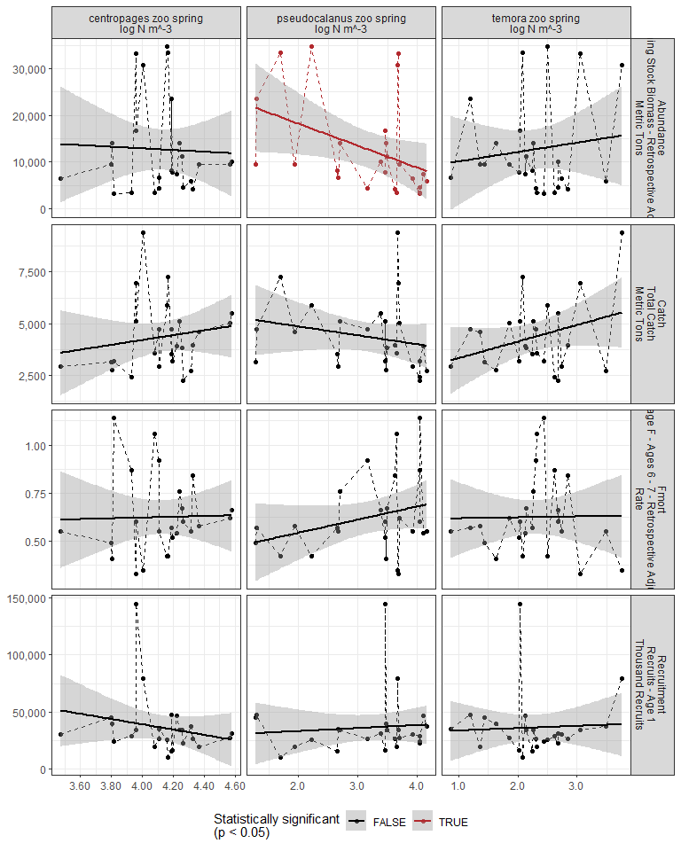

#### Regression statistics

Table 2.13: Abundance vs pseudocalanus zoo spring log N m^-3

|  |  |  |  |  |
| --- | --- | --- | --- | --- |
|  | Estimate | Std. Error | t value | Pr(>|t|) |
| (Intercept) | 27685.83 | 7254.53 | 3.82 | 0.00 |
| Val | -4728.25 | 2201.65 | -2.15 | 0.04 |

|  |  |
| --- | --- |
| Name | Value |
| F-statistic | 4.61 |
| df | 1, 23 |
| R2 | 0.17 |
| R2-adj | 0.13 |

### 2.3.2 Fall zooplankton abundance by species

#### Figures

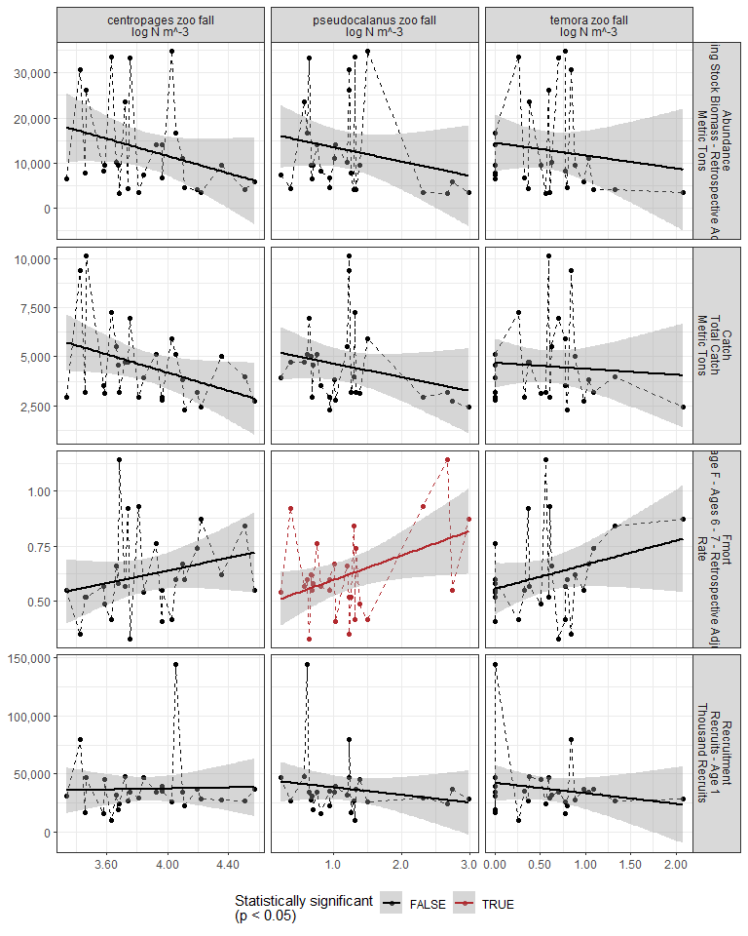

#### Regression statistics

Table 2.14: Fmort vs pseudocalanus zoo fall log N m^-3

|  |  |  |  |  |
| --- | --- | --- | --- | --- |
|  | Estimate | Std. Error | t value | Pr(>|t|) |
| (Intercept) | 0.49 | 0.07 | 7.10 | 0.00 |
| Val | 0.11 | 0.05 | 2.27 | 0.03 |

|  |  |
| --- | --- |
| Name | Value |
| F-statistic | 5.13 |
| df | 1, 25 |
| R2 | 0.17 |
| R2-adj | 0.14 |

### 2.3.3 Zooplankton abundance by group

#### Figures

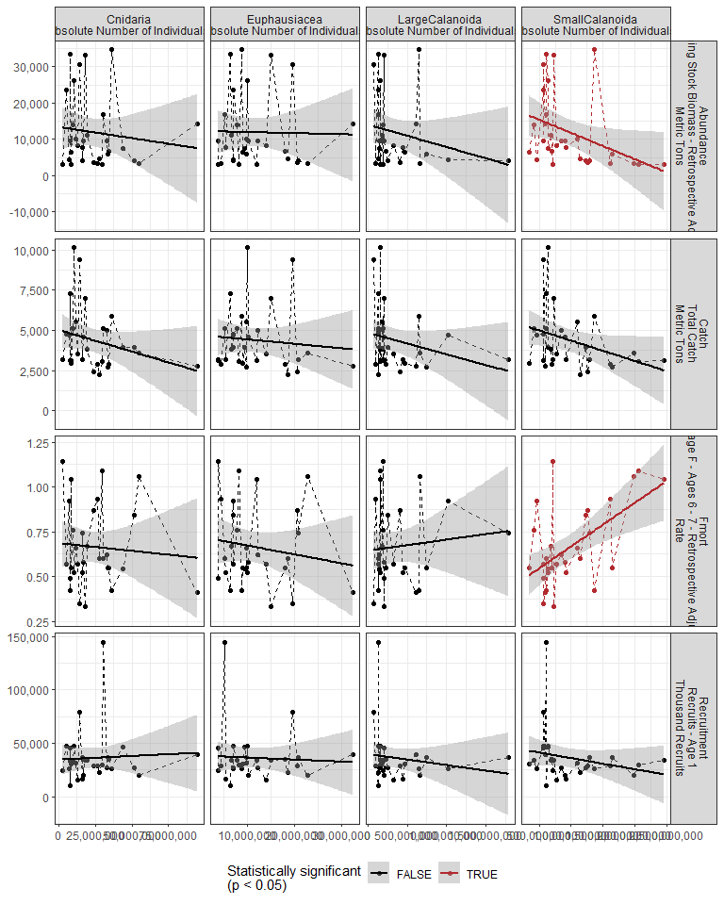

#### Regression statistics

Table 2.15: Fmort vs SmallCalanoida Absolute Number of Individuals

|  |  |  |  |  |
| --- | --- | --- | --- | --- |
|  | Estimate | Std. Error | t value | Pr(>|t|) |
| (Intercept) | 0.42 | 0.07 | 5.77 | 0 |
| Val | 0.00 | 0.00 | 3.68 | 0 |

|  |  |
| --- | --- |
| Name | Value |
| F-statistic | 13.51 |
| df | 1, 28 |
| R2 | 0.33 |
| R2-adj | 0.3 |

Table 2.15: Abundance vs SmallCalanoida Absolute Number of Individuals

|  |  |  |  |  |
| --- | --- | --- | --- | --- |
|  | Estimate | Std. Error | t value | Pr(>|t|) |
| (Intercept) | 18989.93 | 3735.35 | 5.08 | 0.00 |
| Val | 0.00 | 0.00 | -2.16 | 0.04 |

|  |  |
| --- | --- |
| Name | Value |
| F-statistic | 4.65 |
| df | 1, 28 |
| R2 | 0.14 |
| R2-adj | 0.11 |

### 2.3.4 Abundance of Calanus CV and adults

#### Figures

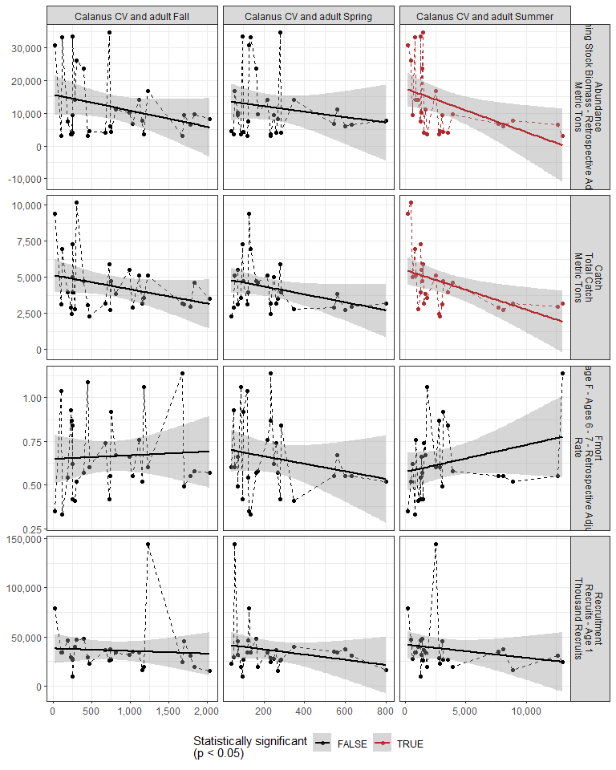

#### Regression statistics

Table 2.16: Catch vs Calanus CV and adult Summer

|  |  |  |  |  |
| --- | --- | --- | --- | --- |
|  | Estimate | Std. Error | t value | Pr(>|t|) |
| (Intercept) | 5487.59 | 490.63 | 11.18 | 0.00 |
| Val | -0.27 | 0.10 | -2.74 | 0.01 |

|  |  |
| --- | --- |
| Name | Value |
| F-statistic | 7.49 |
| df | 1, 24 |
| R2 | 0.24 |
| R2-adj | 0.21 |

Table 2.16: Abundance vs Calanus CV and adult Summer

|  |  |  |  |  |
| --- | --- | --- | --- | --- |
|  | Estimate | Std. Error | t value | Pr(>|t|) |
| (Intercept) | 17493.05 | 2569.88 | 6.81 | 0.00 |
| Val | -1.33 | 0.53 | -2.53 | 0.02 |

|  |  |
| --- | --- |
| Name | Value |
| F-statistic | 6.39 |
| df | 1, 24 |
| R2 | 0.21 |
| R2-adj | 0.18 |

### 2.3.5 Zooplankton abundance anomaly

#### Figures

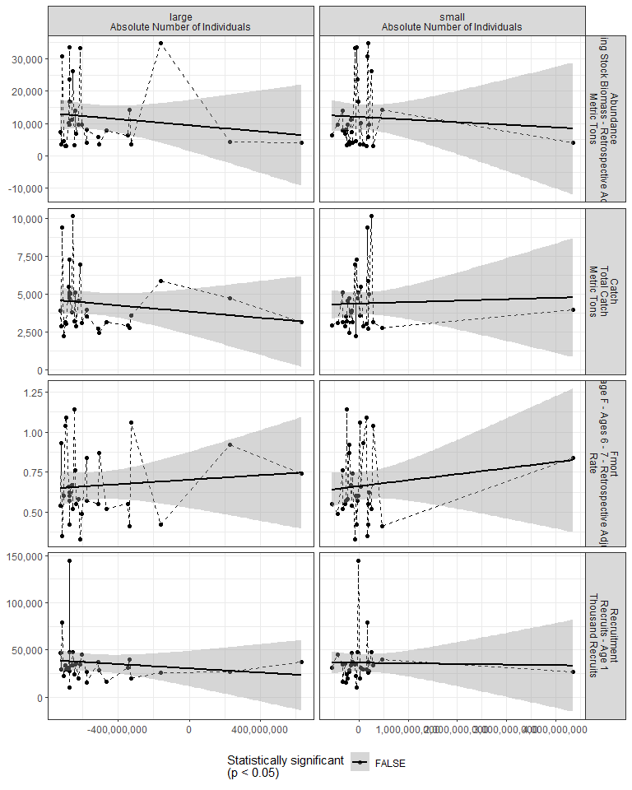

#### Regression statistics

[1] “No statistically significant data”

### 2.3.6 Zooplankton diversity index

#### Figures

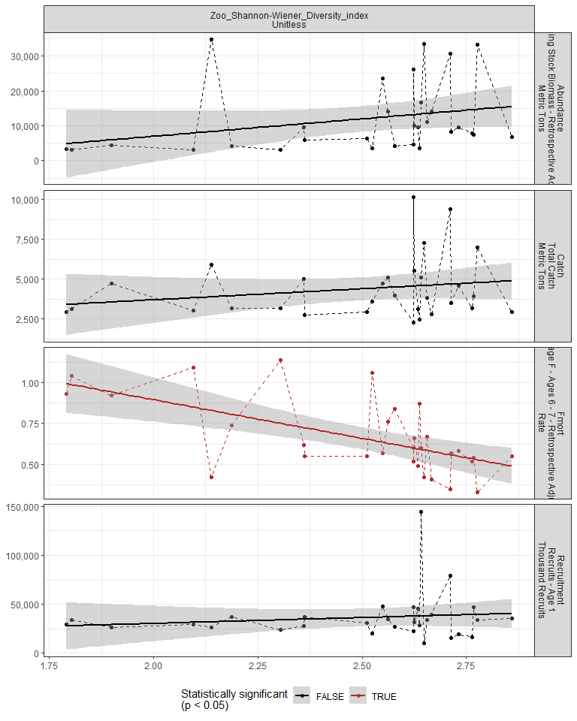

#### Regression statistics

Table 2.17: Fmort vs Zoo_Shannon-Wiener_Diversity_index Unitless

|  |  |  |  |  |
| --- | --- | --- | --- | --- |
|  | Estimate | Std. Error | t value | Pr(>|t|) |
| (Intercept) | 1.84 | 0.29 | 6.36 | 0 |
| Val | -0.47 | 0.12 | -4.10 | 0 |

|  |  |
| --- | --- |
| Name | Value |
| F-statistic | 16.78 |
| df | 1, 28 |
| R2 | 0.37 |
| R2-adj | 0.35 |

### 2.3.7 Small/large copepod anomaly

#### Figures

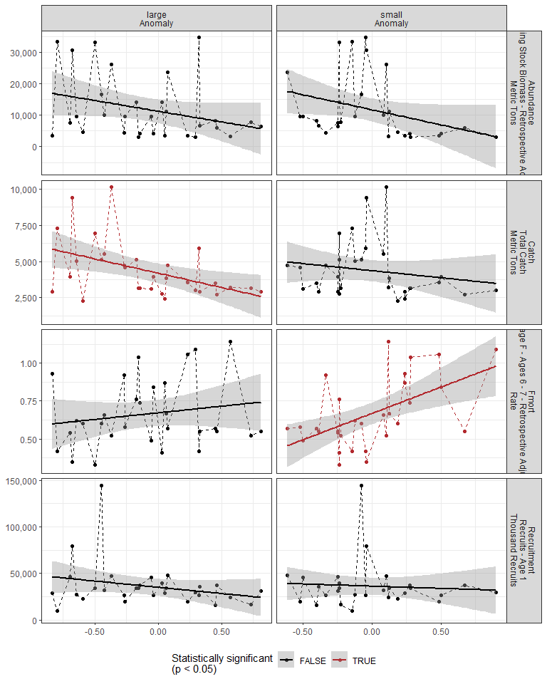

#### Regression statistics

Table 2.18: Catch vs large Anomaly

|  |  |  |  |  |
| --- | --- | --- | --- | --- |
|  | Estimate | Std. Error | t value | Pr(>|t|) |
| (Intercept) | 4198.72 | 327.22 | 12.83 | 0.00 |
| Val | -1975.31 | 712.08 | -2.77 | 0.01 |

|  |  |
| --- | --- |
| Name | Value |
| F-statistic | 7.7 |
| df | 1, 28 |
| R2 | 0.22 |
| R2-adj | 0.19 |

Table 2.18: Fmort vs small Anomaly

|  |  |  |  |  |
| --- | --- | --- | --- | --- |
|  | Estimate | Std. Error | t value | Pr(>|t|) |
| (Intercept) | 0.67 | 0.04 | 19.08 | 0 |
| Val | 0.35 | 0.10 | 3.53 | 0 |

|  |  |
| --- | --- |
| Name | Value |
| F-statistic | 12.45 |
| df | 1, 28 |
| R2 | 0.31 |
| R2-adj | 0.28 |

### 2.3.8 Ichthyoplankton diversity

#### Figures

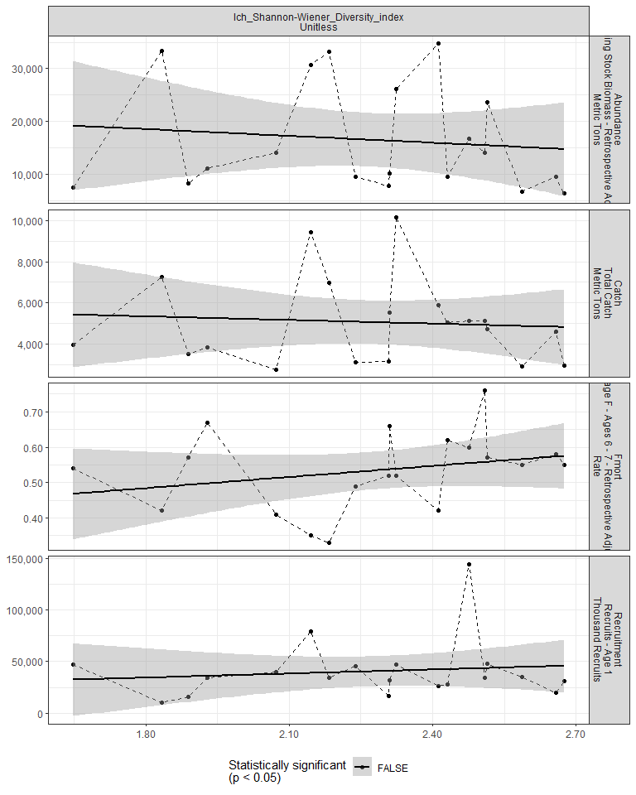

#### Regression statistics

[1] “No statistically significant data”

### 2.3.9 Forage fish abundance

#### Figures

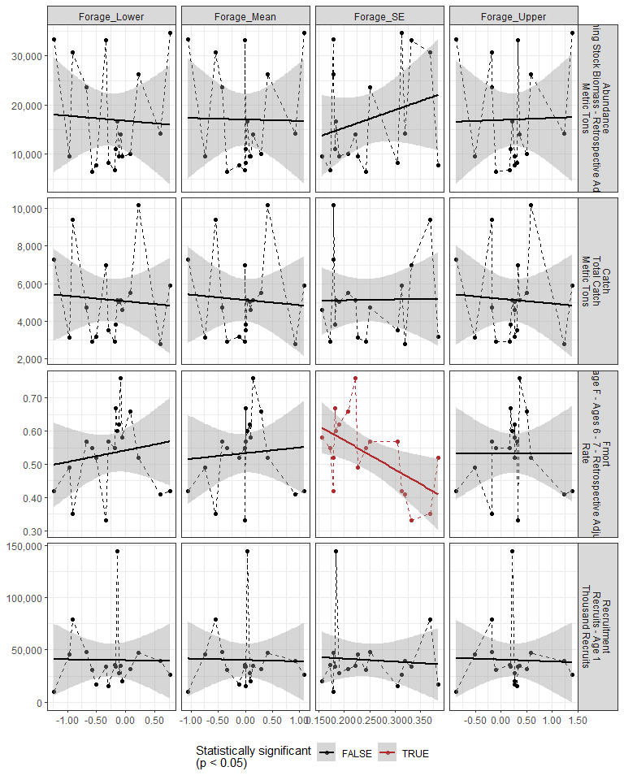

#### Regression statistics

Table 2.19: Fmort vs Forage_SE

|  |  |  |  |  |
| --- | --- | --- | --- | --- |
|  | Estimate | Std. Error | t value | Pr(>|t|) |
| (Intercept) | 0.75 | 0.08 | 9.06 | 0.00 |
| Val | -0.89 | 0.32 | -2.73 | 0.01 |

|  |  |
| --- | --- |
| Name | Value |
| F-statistic | 7.47 |
| df | 1, 16 |
| R2 | 0.32 |
| R2-adj | 0.28 |

### 2.3.10 Species distribution

#### Figures

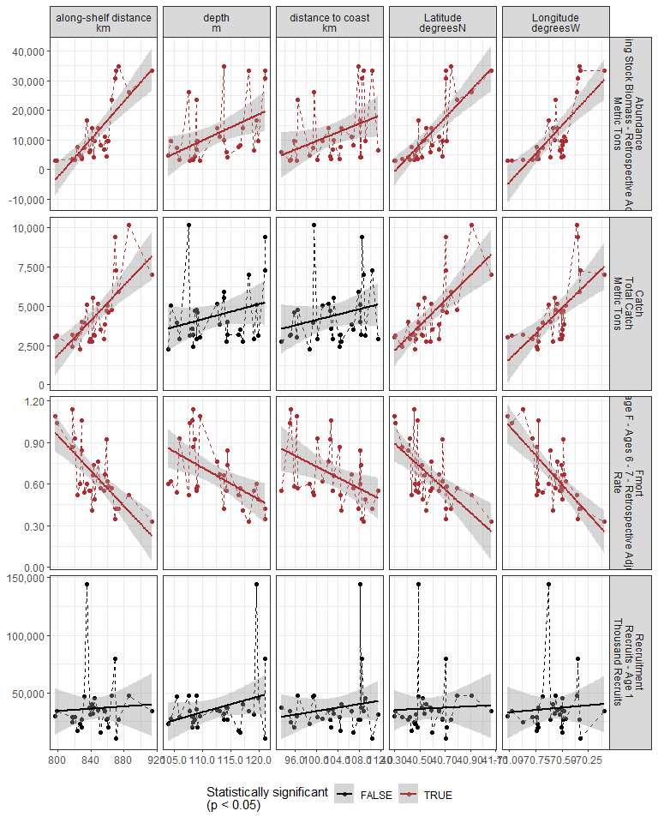

#### Regression statistics

Table 2.20: Catch vs along-shelf distance km

|  |  |  |  |  |
| --- | --- | --- | --- | --- |
|  | Estimate | Std. Error | t value | Pr(>|t|) |
| (Intercept) | -42302.73 | 8777.68 | -4.82 | 0 |
| Val | 55.25 | 10.39 | 5.32 | 0 |

|  |  |
| --- | --- |
| Name | Value |
| F-statistic | 28.3 |
| df | 1, 28 |
| R2 | 0.5 |
| R2-adj | 0.48 |

Table 2.20: Catch vs Latitude degreesN

|  |  |  |  |  |
| --- | --- | --- | --- | --- |
|  | Estimate | Std. Error | t value | Pr(>|t|) |
| (Intercept) | -319031.69 | 61804.05 | -5.16 | 0 |
| Val | 7970.74 | 1523.23 | 5.23 | 0 |

|  |  |
| --- | --- |
| Name | Value |
| F-statistic | 27.38 |
| df | 1, 28 |
| R2 | 0.49 |
| R2-adj | 0.48 |

Table 2.20: Catch vs Longitude degreesW

|  |  |  |  |  |
| --- | --- | --- | --- | --- |
|  | Estimate | Std. Error | t value | Pr(>|t|) |
| (Intercept) | 466397.08 | 98581.22 | 4.73 | 0 |
| Val | 6546.14 | 1396.74 | 4.69 | 0 |

|  |  |
| --- | --- |
| Name | Value |
| F-statistic | 21.97 |
| df | 1, 28 |
| R2 | 0.44 |
| R2-adj | 0.42 |

Table 2.20: Fmort vs along-shelf distance km

|  |  |  |  |  |
| --- | --- | --- | --- | --- |
|  | Estimate | Std. Error | t value | Pr(>|t|) |
| (Intercept) | 6.03 | 1.03 | 5.86 | 0 |
| Val | -0.01 | 0.00 | -5.22 | 0 |

|  |  |
| --- | --- |
| Name | Value |
| F-statistic | 27.24 |
| df | 1, 28 |
| R2 | 0.49 |
| R2-adj | 0.48 |

Table 2.20: Fmort vs Latitude degreesN

|  |  |  |  |  |
| --- | --- | --- | --- | --- |
|  | Estimate | Std. Error | t value | Pr(>|t|) |
| (Intercept) | 34.22 | 7.84 | 4.36 | 0 |
| Val | -0.83 | 0.19 | -4.28 | 0 |

|  |  |
| --- | --- |
| Name | Value |
| F-statistic | 18.31 |
| df | 1, 28 |
| R2 | 0.4 |
| R2-adj | 0.37 |

Table 2.20: Fmort vs Longitude degreesW

|  |  |  |  |  |
| --- | --- | --- | --- | --- |
|  | Estimate | Std. Error | t value | Pr(>|t|) |
| (Intercept) | -59.23 | 10.26 | -5.77 | 0 |
| Val | -0.85 | 0.15 | -5.84 | 0 |

|  |  |
| --- | --- |
| Name | Value |
| F-statistic | 34.06 |
| df | 1, 28 |
| R2 | 0.55 |
| R2-adj | 0.53 |

Table 2.20: Fmort vs depth m

|  |  |  |  |  |
| --- | --- | --- | --- | --- |
|  | Estimate | Std. Error | t value | Pr(>|t|) |
| (Intercept) | 3.25 | 0.78 | 4.17 | 0 |
| Val | -0.02 | 0.01 | -3.33 | 0 |

|  |  |
| --- | --- |
| Name | Value |
| F-statistic | 11.07 |
| df | 1, 28 |
| R2 | 0.28 |
| R2-adj | 0.26 |

Table 2.20: Fmort vs distance to coast km

|  |  |  |  |  |
| --- | --- | --- | --- | --- |
|  | Estimate | Std. Error | t value | Pr(>|t|) |
| (Intercept) | 2.69 | 0.76 | 3.56 | 0.00 |
| Val | -0.02 | 0.01 | -2.69 | 0.01 |

|  |  |
| --- | --- |
| Name | Value |
| F-statistic | 7.21 |
| df | 1, 28 |
| R2 | 0.2 |
| R2-adj | 0.18 |

Table 2.20: Abundance vs along-shelf distance km

|  |  |  |  |  |
| --- | --- | --- | --- | --- |
|  | Estimate | Std. Error | t value | Pr(>|t|) |
| (Intercept) | -256928.6 | 40489.81 | -6.35 | 0 |
| Val | 318.2 | 47.91 | 6.64 | 0 |

|  |  |
| --- | --- |
| Name | Value |
| F-statistic | 44.11 |
| df | 1, 28 |
| R2 | 0.61 |
| R2-adj | 0.6 |

Table 2.20: Abundance vs Latitude degreesN

|  |  |  |  |  |
| --- | --- | --- | --- | --- |
|  | Estimate | Std. Error | t value | Pr(>|t|) |
| (Intercept) | -1823618.58 | 292531.51 | -6.23 | 0 |
| Val | 45237.98 | 7209.74 | 6.27 | 0 |

|  |  |
| --- | --- |
| Name | Value |
| F-statistic | 39.37 |
| df | 1, 28 |
| R2 | 0.58 |
| R2-adj | 0.57 |

Table 2.20: Abundance vs Longitude degreesW

|  |  |  |  |  |
| --- | --- | --- | --- | --- |
|  | Estimate | Std. Error | t value | Pr(>|t|) |
| (Intercept) | 2727010.57 | 457526.1 | 5.96 | 0 |
| Val | 38469.23 | 6482.4 | 5.93 | 0 |

|  |  |
| --- | --- |
| Name | Value |
| F-statistic | 35.22 |
| df | 1, 28 |
| R2 | 0.56 |
| R2-adj | 0.54 |

Table 2.20: Abundance vs depth m

|  |  |  |  |  |
| --- | --- | --- | --- | --- |
|  | Estimate | Std. Error | t value | Pr(>|t|) |
| (Intercept) | -88012.35 | 36859.04 | -2.39 | 0.02 |
| Val | 888.82 | 327.65 | 2.71 | 0.01 |

|  |  |
| --- | --- |
| Name | Value |
| F-statistic | 7.36 |
| df | 1, 28 |
| R2 | 0.21 |
| R2-adj | 0.18 |

Table 2.20: Abundance vs distance to coast km

|  |  |  |  |  |
| --- | --- | --- | --- | --- |
|  | Estimate | Std. Error | t value | Pr(>|t|) |
| (Intercept) | -63089.82 | 35460.10 | -1.78 | 0.09 |
| Val | 727.37 | 343.65 | 2.12 | 0.04 |

|  |  |
| --- | --- |
| Name | Value |
| F-statistic | 4.48 |
| df | 1, 28 |
| R2 | 0.14 |
| R2-adj | 0.11 |

## 2.4 Larvae and YOY indicators

### 2.4.1 Recruitment

#### Figures

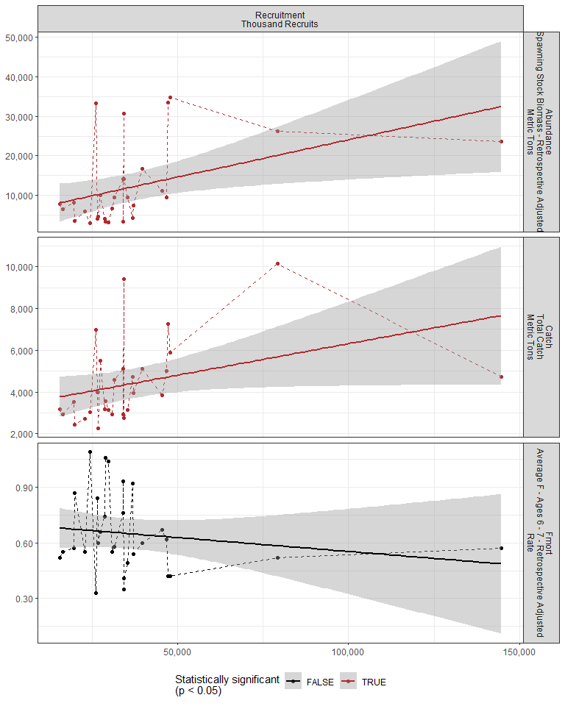

#### Regression statistics

Table 2.21: Catch vs Recruitment Thousand Recruits

|  |  |  |  |  |
| --- | --- | --- | --- | --- |
|  | Estimate | Std. Error | t value | Pr(>|t|) |
| (Intercept) | 3298.04 | 642.76 | 5.13 | 0.00 |
| Val | 0.03 | 0.01 | 2.06 | 0.05 |

|  |  |
| --- | --- |
| Name | Value |
| F-statistic | 4.26 |
| df | 1, 27 |
| R2 | 0.14 |
| R2-adj | 0.1 |

Table 2.21: Abundance vs Recruitment Thousand Recruits

|  |  |  |  |  |
| --- | --- | --- | --- | --- |
|  | Estimate | Std. Error | t value | Pr(>|t|) |
| (Intercept) | 5196.06 | 3212.70 | 1.62 | 0.12 |
| Val | 0.19 | 0.07 | 2.58 | 0.02 |

|  |  |
| --- | --- |
| Name | Value |
| F-statistic | 6.65 |
| df | 1, 27 |
| R2 | 0.2 |
| R2-adj | 0.17 |

### 2.4.2 Larval growth

## 2.5 Juvenile indicators

### 2.5.1 Length-age curves

### 2.5.2 Condition

### 2.5.3 CPUE

## 2.6 Adult indicators

### 2.6.1 Abundance

#### Figures

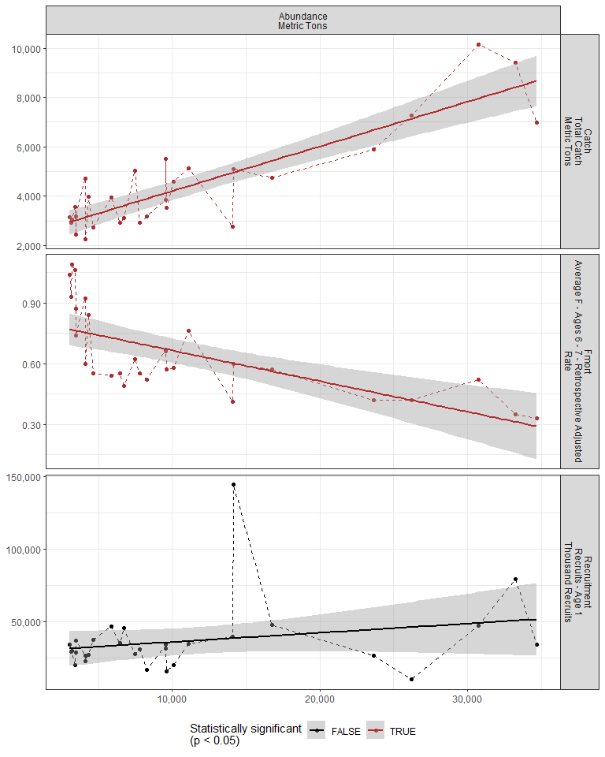

#### Regression statistics

Table 2.22: Catch vs Abundance Metric Tons

|  |  |  |  |  |
| --- | --- | --- | --- | --- |
|  | Estimate | Std. Error | t value | Pr(>|t|) |
| (Intercept) | 2402.56 | 285.15 | 8.43 | 0 |
| Val | 0.18 | 0.02 | 9.21 | 0 |

|  |  |
| --- | --- |
| Name | Value |
| F-statistic | 84.85 |
| df | 1, 27 |
| R2 | 0.76 |
| R2-adj | 0.75 |

Table 2.22: Fmort vs Abundance Metric Tons

|  |  |  |  |  |
| --- | --- | --- | --- | --- |
|  | Estimate | Std. Error | t value | Pr(>|t|) |
| (Intercept) | 0.82 | 0.05 | 17.90 | 0 |
| Val | 0.00 | 0.00 | -4.83 | 0 |

|  |  |
| --- | --- |
| Name | Value |
| F-statistic | 23.29 |
| df | 1, 27 |
| R2 | 0.46 |
| R2-adj | 0.44 |

### 2.6.2 Mean age of spawning stock

### 2.6.3 Age distribution

### 2.6.4 Length-age curves

### 2.6.5 Condition

#### Figures

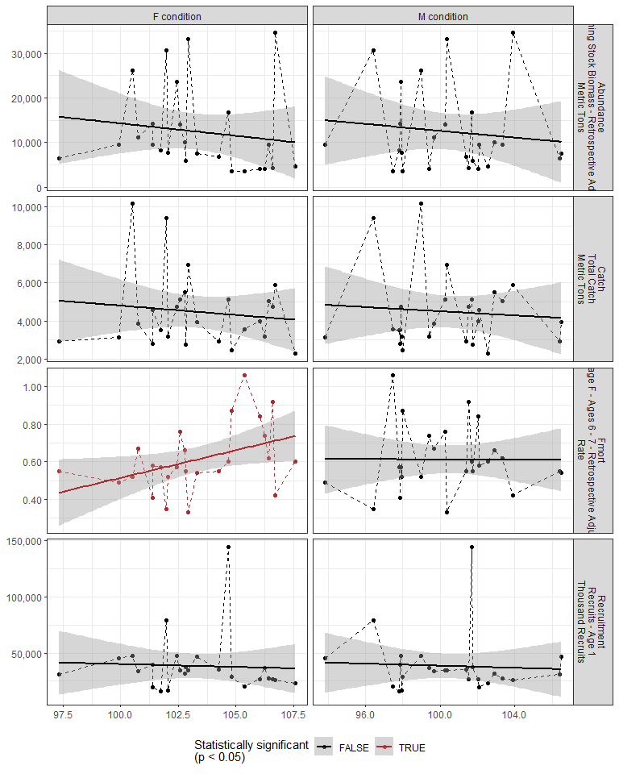

#### Regression statistics

Table 2.23: Fmort vs F condition

|  |  |  |  |  |
| --- | --- | --- | --- | --- |
|  | Estimate | Std. Error | t value | Pr(>|t|) |
| (Intercept) | -2.43 | 1.36 | -1.79 | 0.09 |
| Val | 0.03 | 0.01 | 2.24 | 0.04 |

|  |  |
| --- | --- |
| Name | Value |
| F-statistic | 5.01 |
| df | 1, 23 |
| R2 | 0.18 |
| R2-adj | 0.14 |

### 2.6.6 Stomach fullness

#### Figures

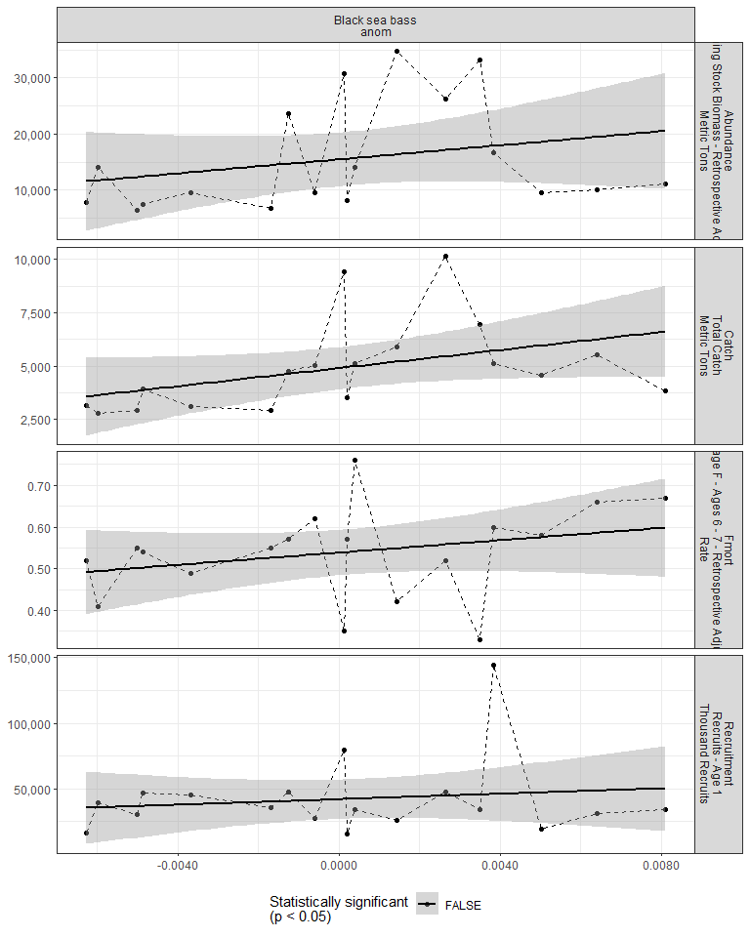

#### Regression statistics

[1] “No statistically significant data”

### 2.6.7 Center of gravity and area occupied

## 2.7 Socioeconomic indicators

### 2.7.1 CPUE by catch strategy

### 2.7.2 Recreational CPUE

#### Figures

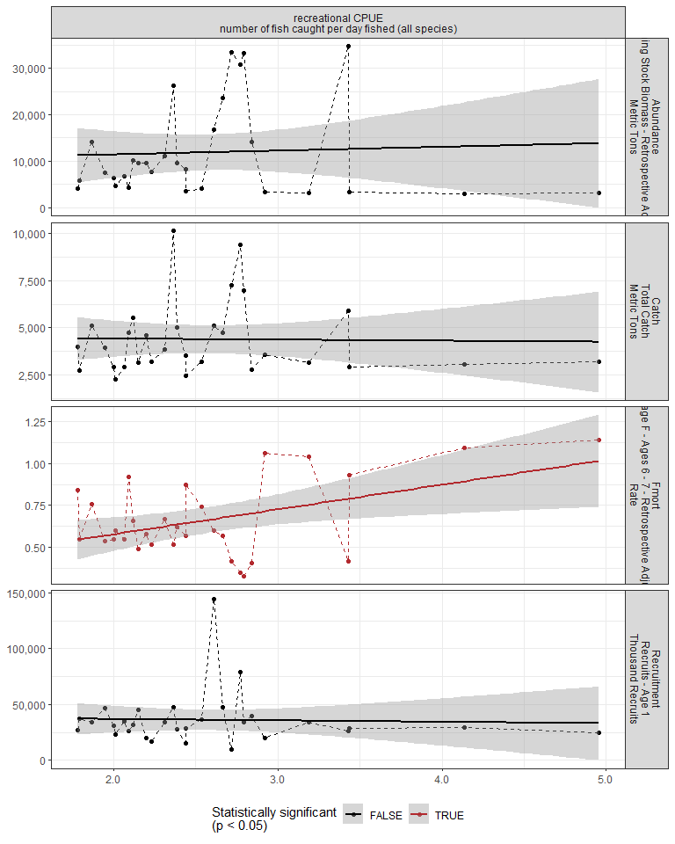

#### Regression statistics

Table 2.24: Fmort vs recreational CPUE number of fish caught per day fished (all species)

|  |  |  |  |  |
| --- | --- | --- | --- | --- |
|  | Estimate | Std. Error | t value | Pr(>|t|) |
| (Intercept) | 0.29 | 0.14 | 1.98 | 0.06 |
| Val | 0.15 | 0.05 | 2.72 | 0.01 |

|  |  |
| --- | --- |
| Name | Value |
| F-statistic | 7.4 |
| df | 1, 28 |
| R2 | 0.21 |
| R2-adj | 0.18 |

# 3 Summary of statistically significant indicators

## 3.1 Abundance

|  |  |  |  |  |
| --- | --- | --- | --- | --- |
| Indicator | Number of data points | Slope | P-value | R2_adj |
| Time | 29 | 1000 | 1.3e-09 | 0.74 |
| cumulative intensity |  |  |  |  |
| degrees C | 25 | 51 | 0.0017 | 0.33 |
| GLORYS bottom temp anomaly |  |  |  |  |
| degreesC | 25 | 6400 | 0.002 | 0.32 |
| long-term sst |  |  |  |  |
| degreesC | 30 | 11000 | 3e-06 | 0.53 |
| fall OI SST Anomaly |  |  |  |  |
| degreesC | 30 | 9000 | 6.6e-05 | 0.42 |
| spring OI SST Anomaly |  |  |  |  |
| degreesC | 30 | 6500 | 0.0045 | 0.23 |
| summer OI SST Anomaly |  |  |  |  |
| degreesC | 30 | 8100 | 0.00037 | 0.35 |
| tke winter |  |  |  |  |
| J/kg | 30 | 57000 | 0.015 | 0.17 |
| hcly summer |  |  |  |  |
| m2/sec2 | 30 | -660 | 0.0095 | 0.19 |
| pseudocalanus zoo spring |  |  |  |  |
| log N m^-3 | 25 | -4700 | 0.043 | 0.13 |
| SmallCalanoida |  |  |  |  |
| Absolute Number of Individuals | 30 | -7.3e-06 | 0.04 | 0.11 |
| Calanus CV and adult Summer | 26 | -1.3 | 0.018 | 0.18 |
| along-shelf distance |  |  |  |  |
| km | 30 | 320 | 3.3e-07 | 0.6 |
| Latitude |  |  |  |  |
| degreesN | 30 | 45000 | 8.8e-07 | 0.57 |
| Longitude |  |  |  |  |
| degreesW | 30 | 38000 | 2.2e-06 | 0.54 |
| depth |  |  |  |  |
| m | 30 | 890 | 0.011 | 0.18 |
| distance to coast |  |  |  |  |
| km | 30 | 730 | 0.043 | 0.11 |
| Recruitment |  |  |  |  |
| Thousand Recruits | 29 | 0.19 | 0.016 | 0.17 |

## 3.2 Recruitment

|  |  |  |  |  |
| --- | --- | --- | --- | --- |
| Indicator | Number of data points | Slope | P-value | R2_adj |
| cumulative intensity |  |  |  |  |
| degrees C | 25 | 90 | 0.033 | 0.15 |
| fall OI SST Anomaly |  |  |  |  |
| degreesC | 30 | 14000 | 0.02 | 0.15 |
| spring OI SST Anomaly |  |  |  |  |
| degreesC | 30 | 14000 | 0.0098 | 0.19 |
| summer OI SST Anomaly |  |  |  |  |
| degreesC | 30 | 14000 | 0.014 | 0.17 |

## 3.3 Catch

|  |  |  |  |  |
| --- | --- | --- | --- | --- |
| Indicator | Number of data points | Slope | P-value | R2_adj |
| Time | 29 | 160 | 6.7e-05 | 0.43 |
| V_max | 25 | -29000 | 0.038 | 0.14 |
| cumulative intensity |  |  |  |  |
| degrees C | 25 | 9.3 | 0.0031 | 0.29 |
| GLORYS bottom temp anomaly |  |  |  |  |
| degreesC | 25 | 1400 | 0.00086 | 0.36 |
| long-term sst |  |  |  |  |
| degreesC | 30 | 1800 | 0.00013 | 0.39 |
| fall OI SST Anomaly |  |  |  |  |
| degreesC | 30 | 1800 | 3.9e-05 | 0.44 |
| spring OI SST Anomaly |  |  |  |  |
| degreesC | 30 | 920 | 0.042 | 0.11 |
| summer OI SST Anomaly |  |  |  |  |
| degreesC | 30 | 1300 | 0.003 | 0.25 |
| stratification (0-50 m) |  |  |  |  |
| kg m^-3 | 27 | -160000 | 0.01 | 0.21 |
| total wind speed spring |  |  |  |  |
| J/kg | 30 | -1900 | 0.043 | 0.11 |
| hcly summer |  |  |  |  |
| m2/sec2 | 30 | -130 | 0.0093 | 0.19 |
| vwnd summer |  |  |  |  |
| J/kg | 30 | -1700 | 0.05 | 0.1 |
| gulf stream index |  |  |  |  |
| latitude anomaly | 25 | 1300 | 0.038 | 0.14 |
| Calanus CV and adult Summer | 26 | -0.27 | 0.012 | 0.21 |
| large |  |  |  |  |
| Anomaly | 30 | -2000 | 0.0097 | 0.19 |
| along-shelf distance |  |  |  |  |
| km | 30 | 55 | 1.2e-05 | 0.48 |
| Latitude |  |  |  |  |
| degreesN | 30 | 8000 | 1.5e-05 | 0.48 |
| Longitude |  |  |  |  |
| degreesW | 30 | 6500 | 6.5e-05 | 0.42 |
| Recruitment |  |  |  |  |
| Thousand Recruits | 29 | 0.03 | 0.049 | 0.1 |
| Abundance |  |  |  |  |
| Metric Tons | 29 | 0.18 | 8e-10 | 0.75 |

## 3.4 Fmort

|  |  |  |  |  |
| --- | --- | --- | --- | --- |
| Indicator | Number of data points | Slope | P-value | R2_adj |
| Time | 29 | -0.021 | 2.5e-08 | 0.68 |
| Warm Core Rings |  |  |  |  |
| n | 30 | -0.016 | 0.00055 | 0.33 |
| cumulative intensity |  |  |  |  |
| degrees C | 25 | -0.00078 | 0.021 | 0.18 |
| maximum intensity |  |  |  |  |
| degrees C | 25 | -0.26 | 0.017 | 0.19 |
| long-term sst |  |  |  |  |
| degreesC | 30 | -0.19 | 5e-04 | 0.33 |
| fall OI SST Anomaly |  |  |  |  |
| degreesC | 30 | -0.17 | 0.0017 | 0.27 |
| summer OI SST Anomaly |  |  |  |  |
| degreesC | 30 | -0.17 | 0.0011 | 0.3 |
| tke winter |  |  |  |  |
| J/kg | 30 | -2 | 2.4e-05 | 0.46 |
| total wind speed winter |  |  |  |  |
| J/kg | 30 | -0.2 | 0.0078 | 0.2 |
| tke spring |  |  |  |  |
| J/kg | 30 | -2.4 | 0.045 | 0.11 |
| hcly summer |  |  |  |  |
| m2/sec2 | 30 | 0.015 | 0.0087 | 0.19 |
| pseudocalanus zoo fall |  |  |  |  |
| log N m^-3 | 27 | 0.11 | 0.032 | 0.14 |
| SmallCalanoida |  |  |  |  |
| Absolute Number of Individuals | 30 | 2.4e-10 | 0.001 | 0.3 |
| Zoo_Shannon-Wiener_Diversity_index |  |  |  |  |
| Unitless | 30 | -0.47 | 0.00032 | 0.35 |
| small |  |  |  |  |
| Anomaly | 30 | 0.35 | 0.0015 | 0.28 |
| Forage_SE | 18 | -0.89 | 0.015 | 0.28 |
| along-shelf distance |  |  |  |  |
| km | 30 | -0.0063 | 1.5e-05 | 0.48 |
| Latitude |  |  |  |  |
| degreesN | 30 | -0.83 | 2e-04 | 0.37 |
| Longitude |  |  |  |  |
| degreesW | 30 | -0.85 | 2.8e-06 | 0.53 |
| depth |  |  |  |  |
| m | 30 | -0.023 | 0.0025 | 0.26 |
| distance to coast |  |  |  |  |
| km | 30 | -0.02 | 0.012 | 0.18 |
| Abundance |  |  |  |  |
| Metric Tons | 29 | -1.5e-05 | 4.9e-05 | 0.44 |
| F condition | 25 | 0.029 | 0.035 | 0.14 |
| recreational CPUE |  |  |  |  |
| number of fish caught per day fished (all species) | 30 | 0.15 | 0.011 | 0.18 |