Black sea bass indicator analysis

Abigail Tyrell

26 Apr 2021

## Recruitment

### Winter SST anomaly

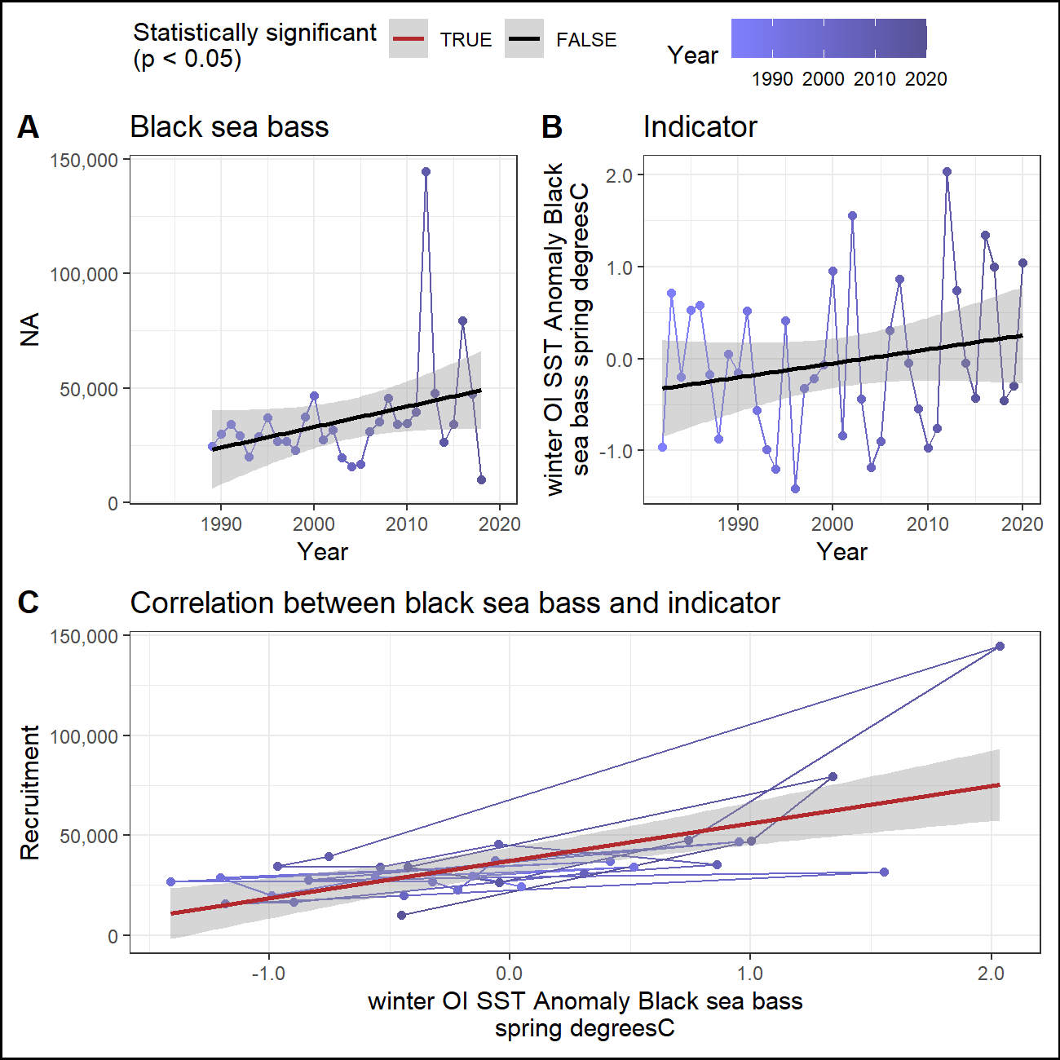

### Fall SST anomaly (prior year)

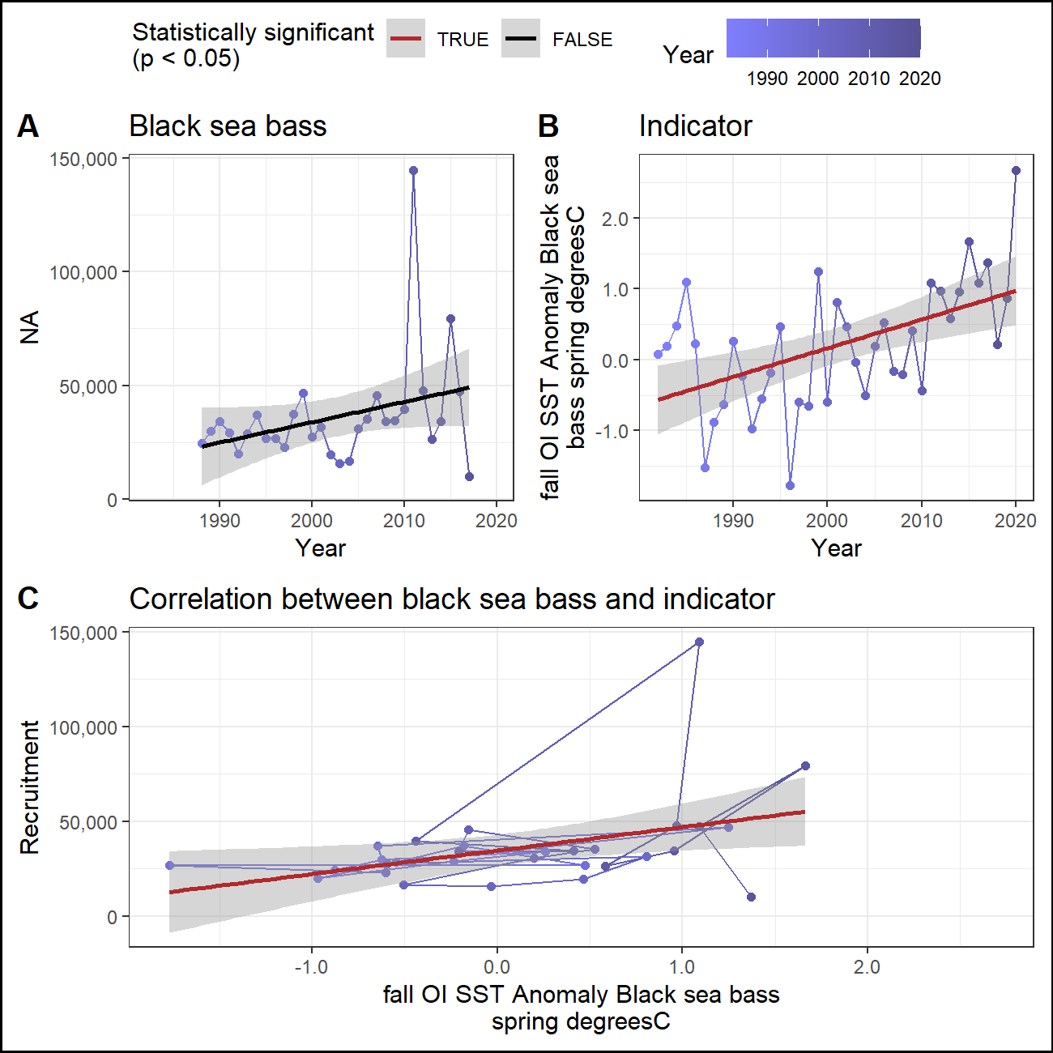

### Winter primary production

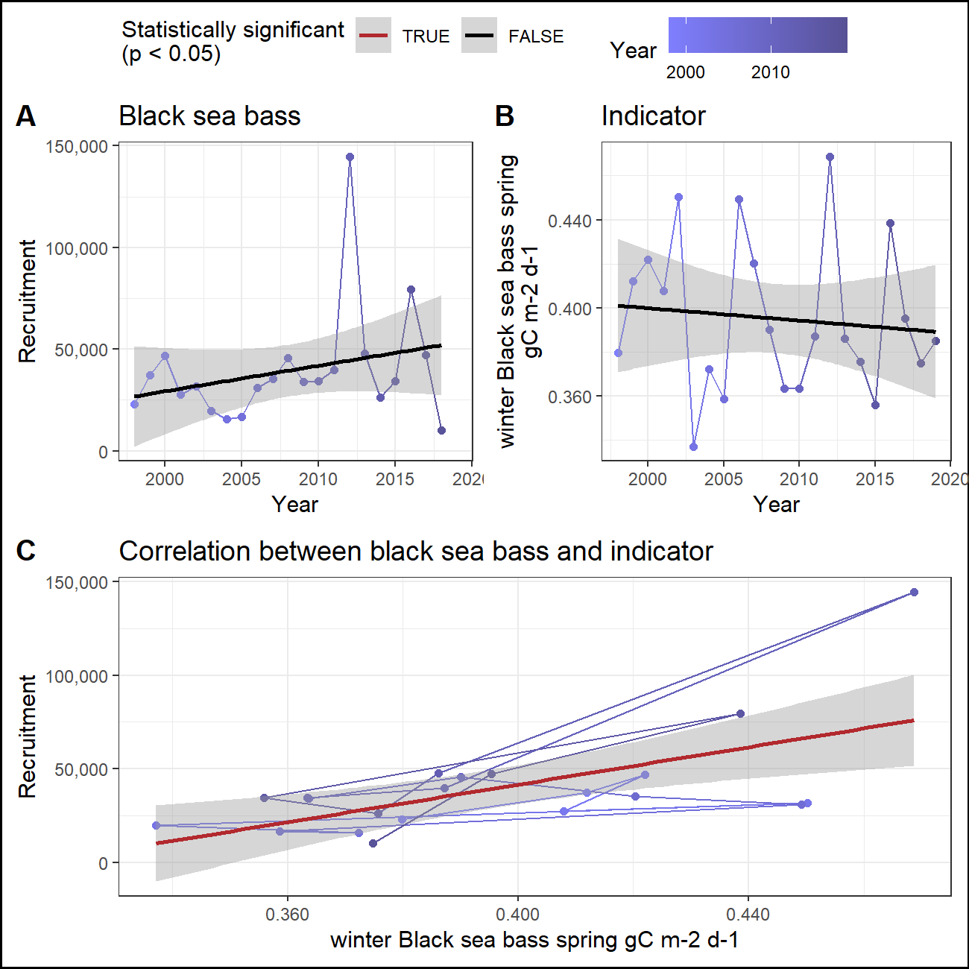

### Fall primary production (prior year)

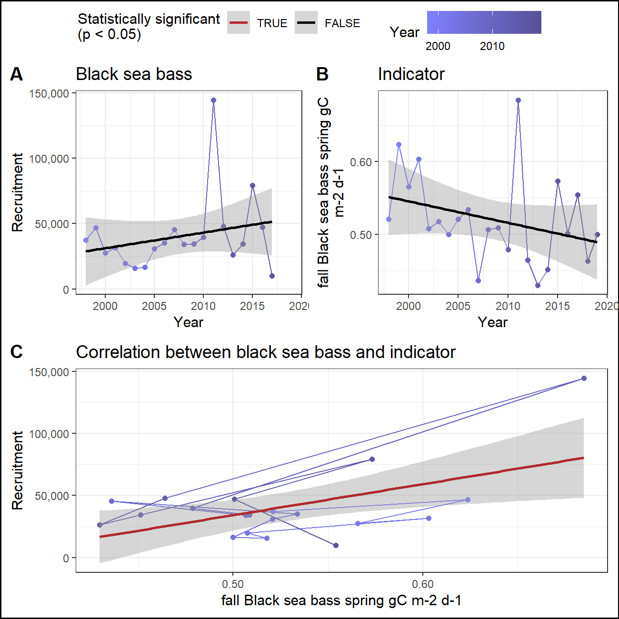

### Cold pool index (prior year)

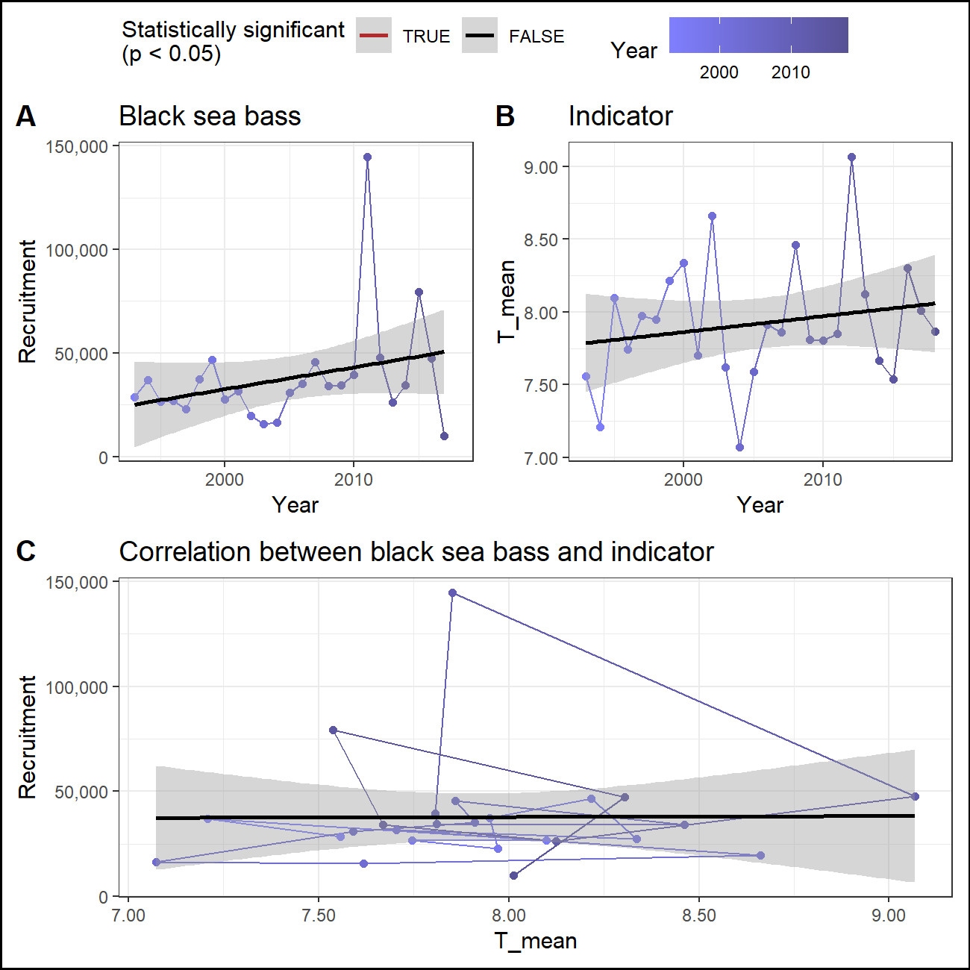

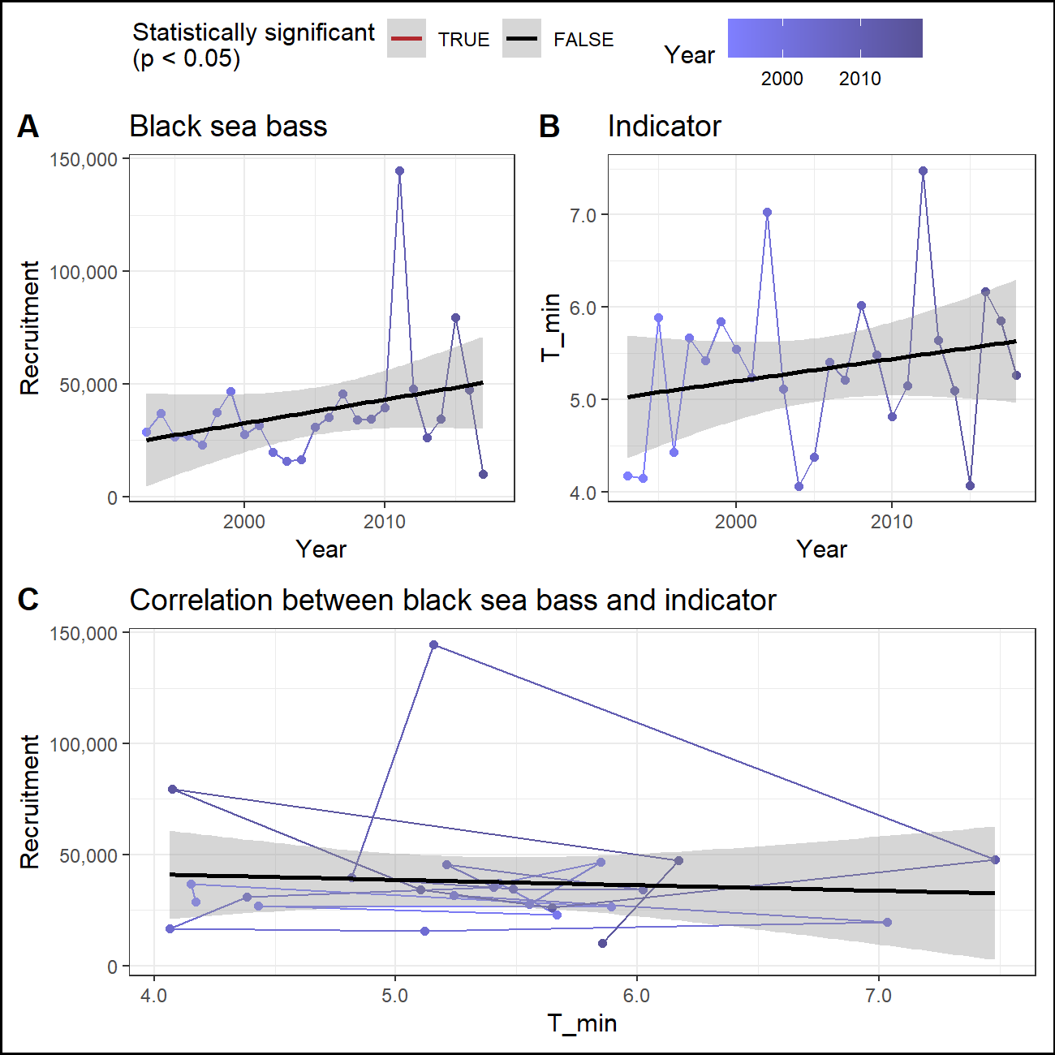

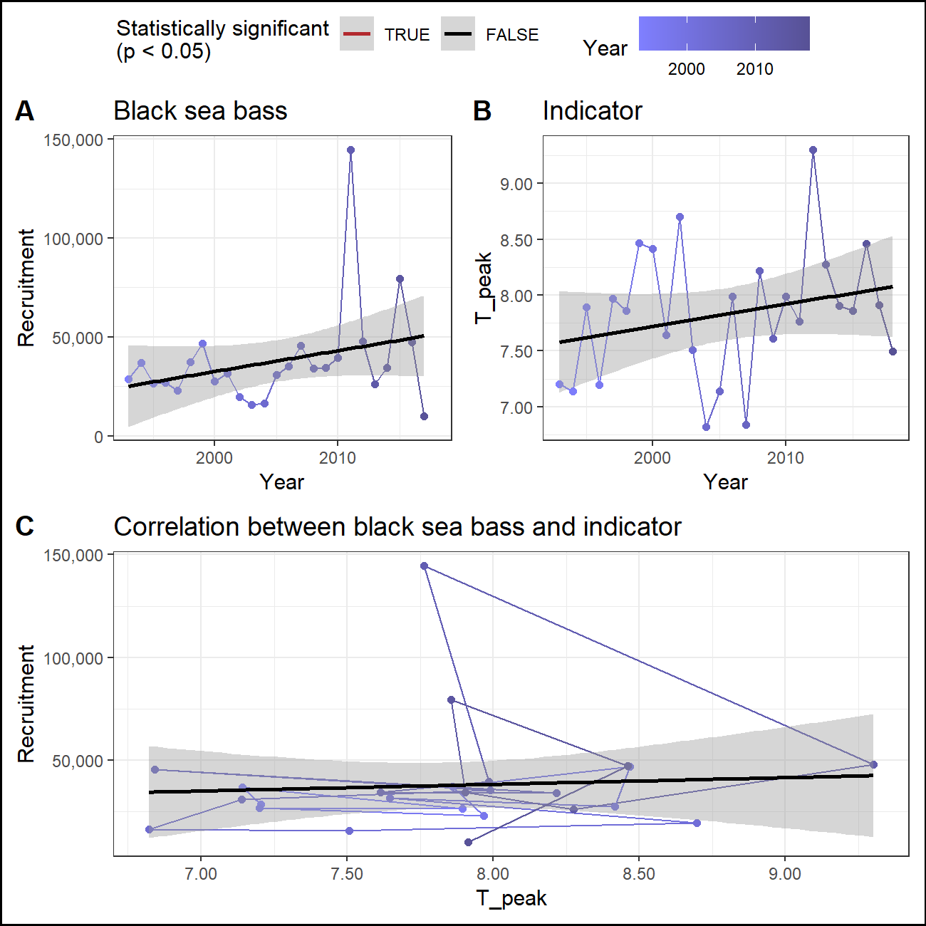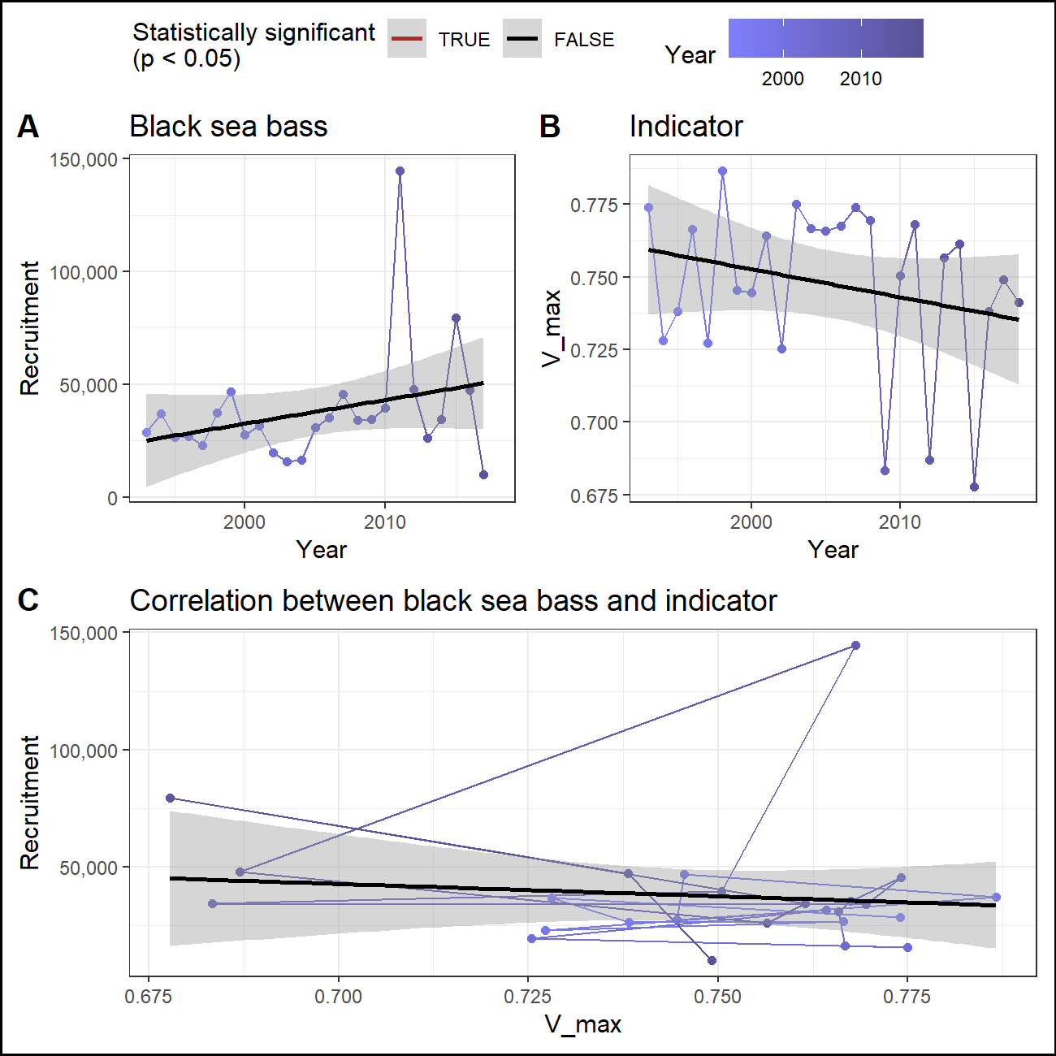

### Predator abundance

## Ecosystem

### Sea surface temperature

#### Recruitment

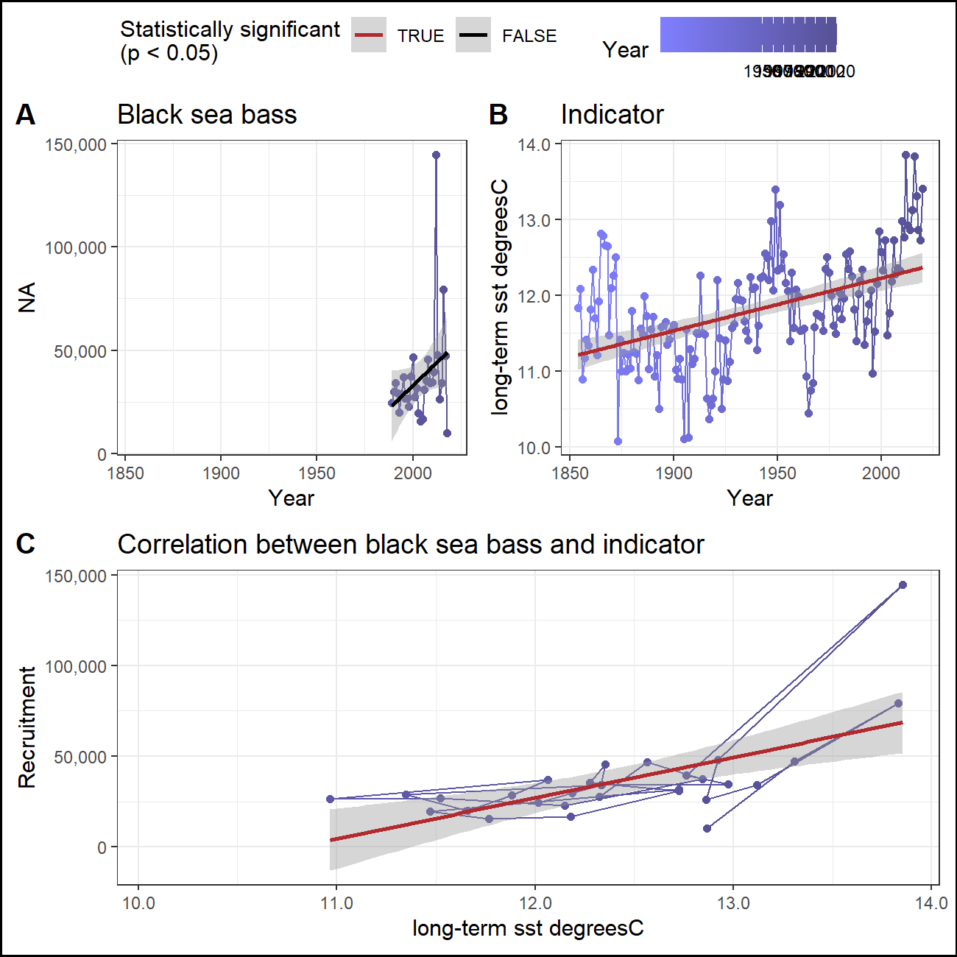

#### Abundance

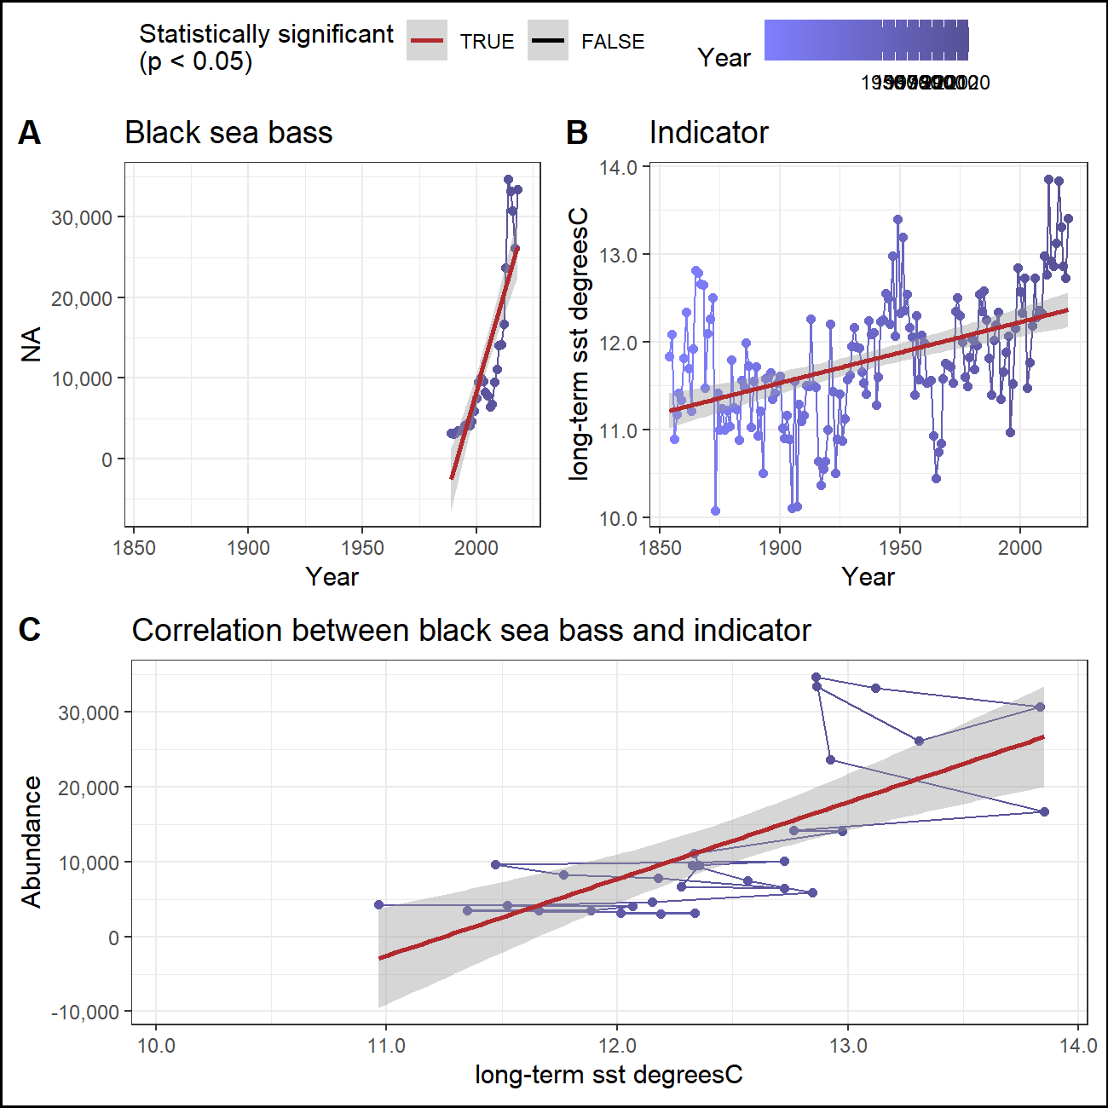

### Marine heatwaves

#### Recruitment

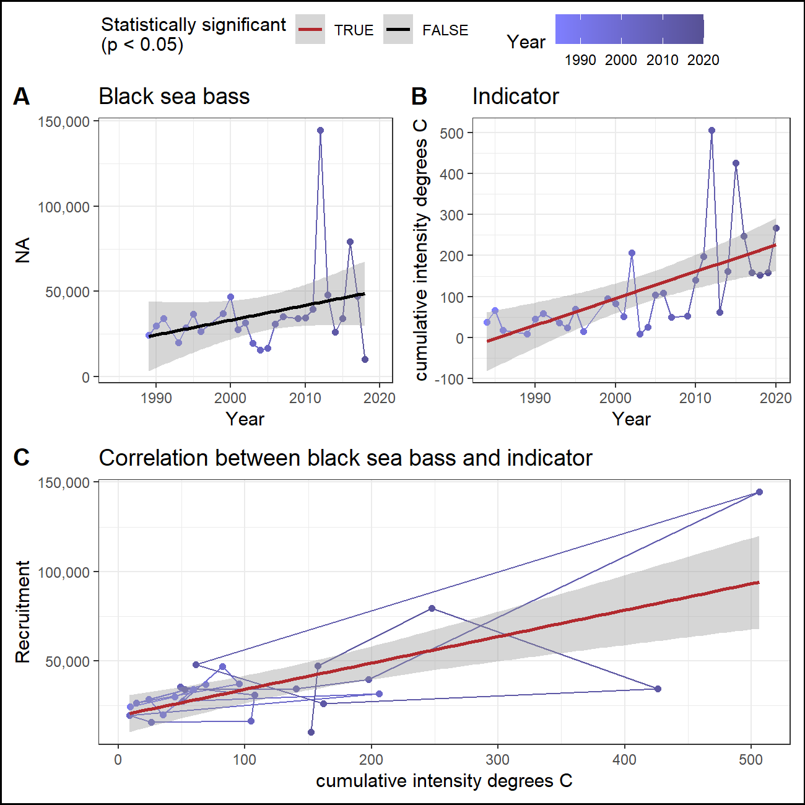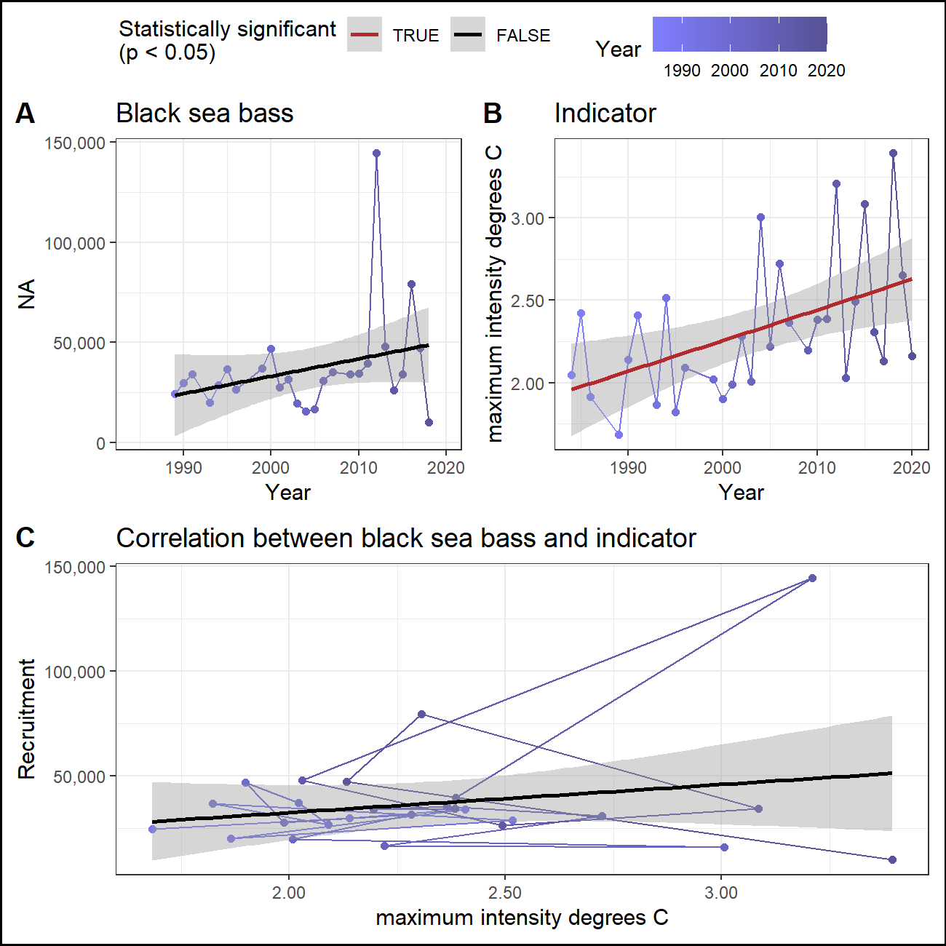

#### Abundance

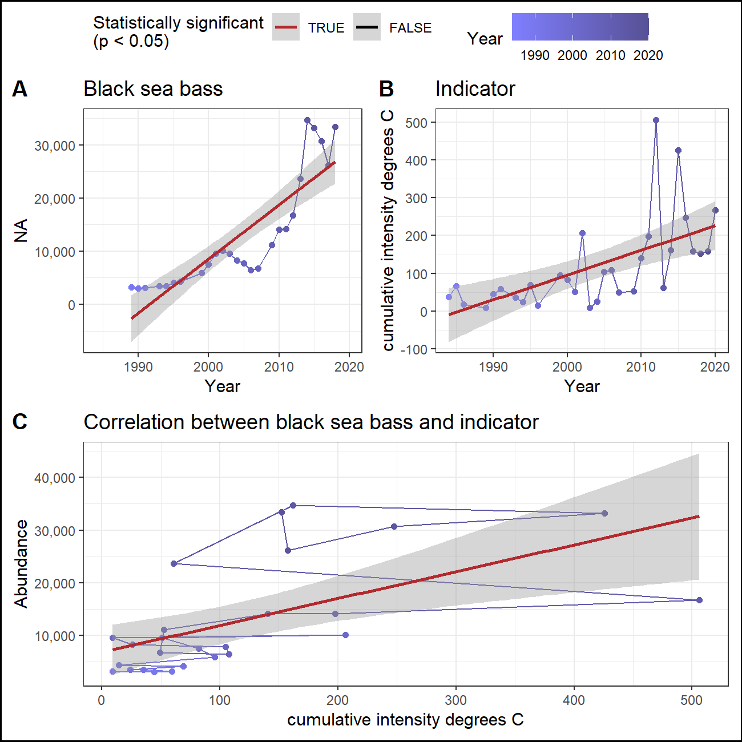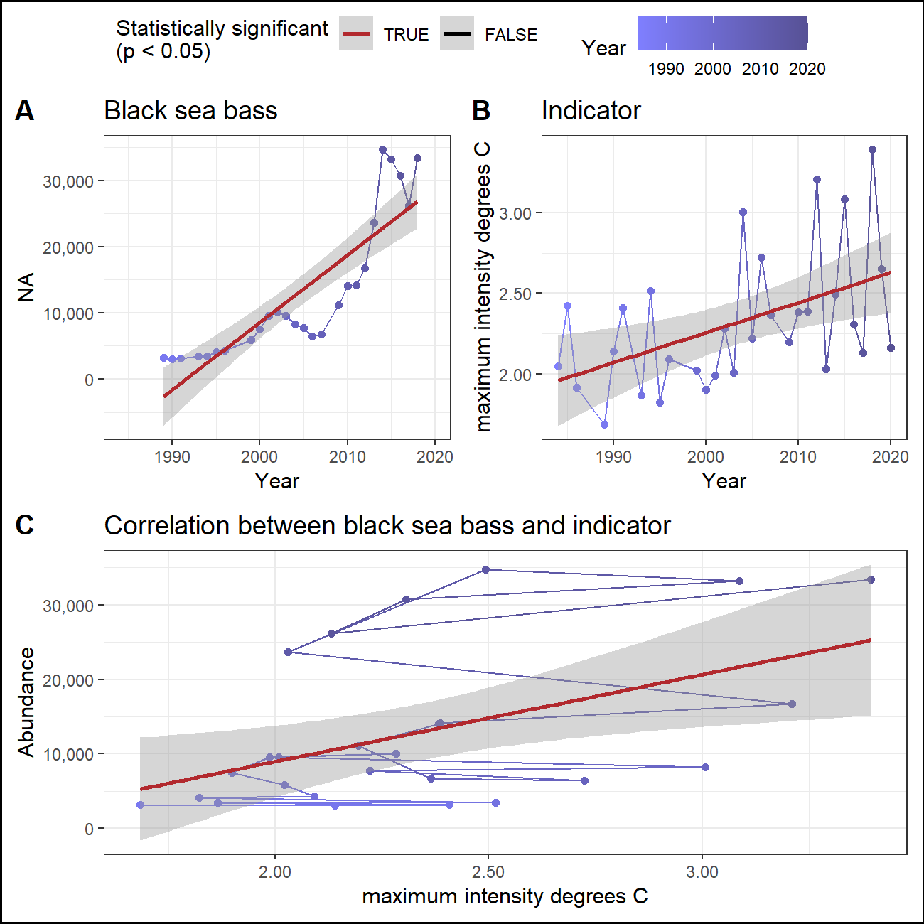

## Management

### Total catch

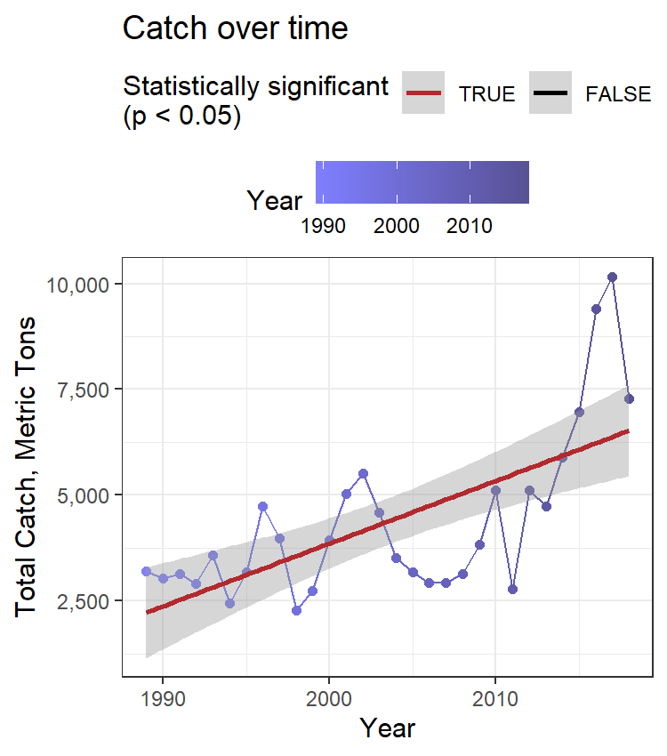

### CPUE

### Catch vs TAC

### Stock range

#### Northern range

Northernmost survey observation in each year.

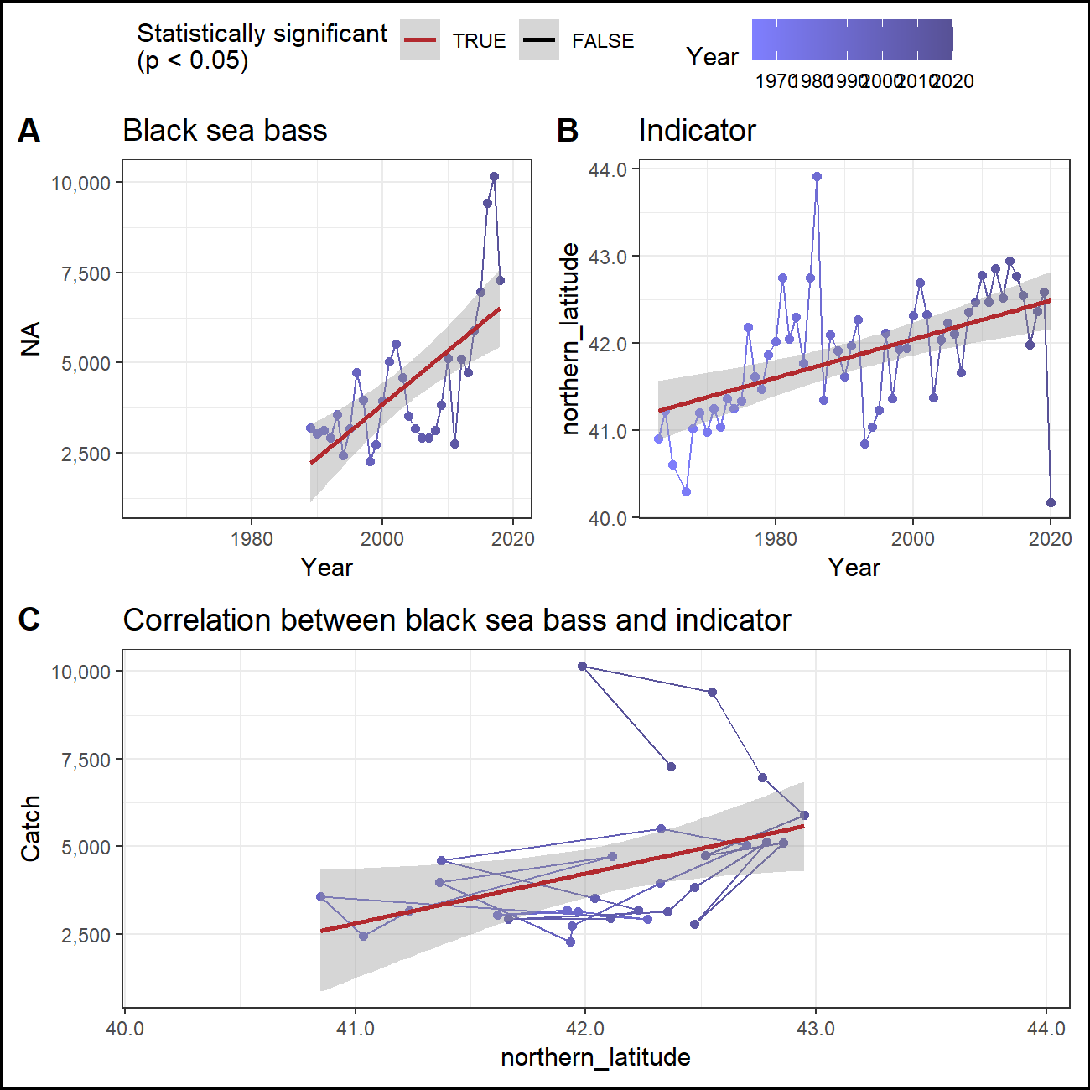

#### Southern range

Southernmost survey observation in each year.

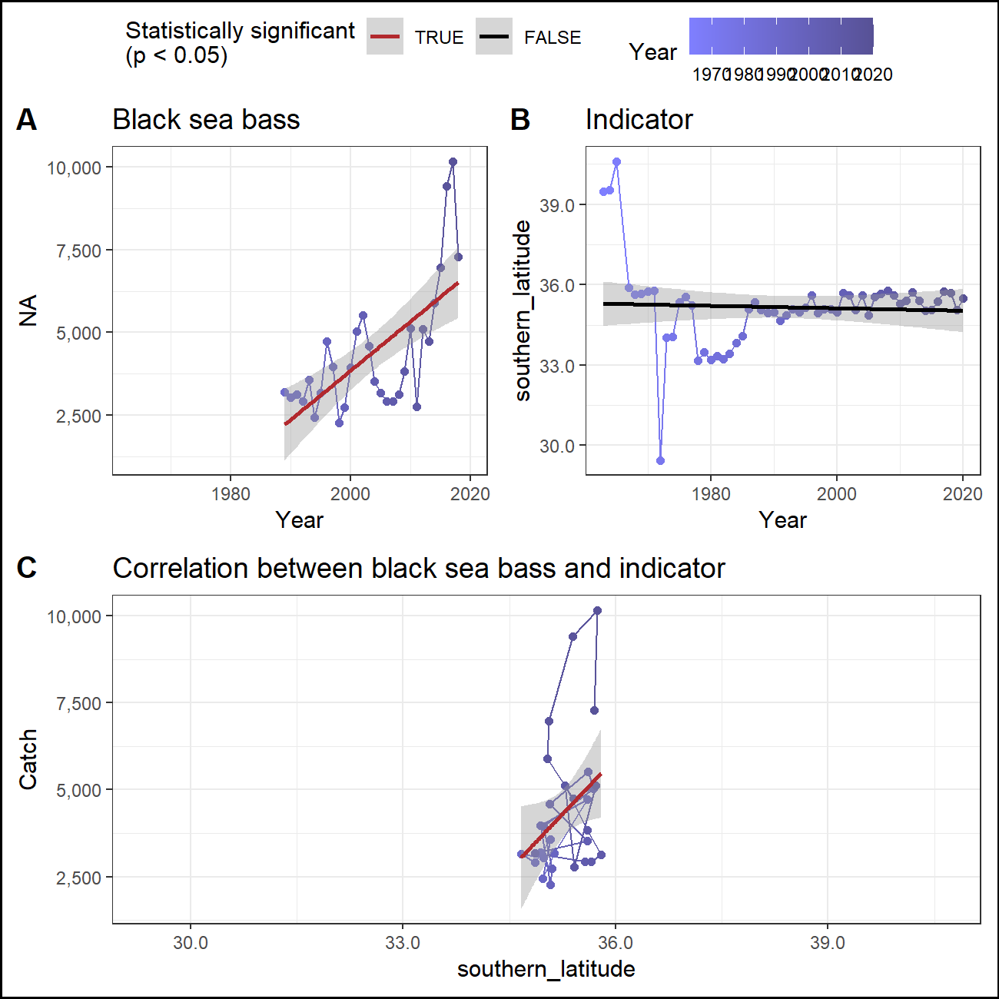

### Center of mass

## Report card

|  |  |  |  |  |  |  |  |  |  |  |  |
| --- | --- | --- | --- | --- | --- | --- | --- | --- | --- | --- | --- |
| Time | SST_winter | SST_fall | PP_winter | PP_fall | T_mean | T_min | T_peak | V_max | SST_annual | cumulative intensity degrees C | maximum intensity degrees C |
| 2016 | 1.34, high | 1.09, neutral | 0.44, high | 0.5, neutral | 8.3, neutral | 6.17, neutral | 8.46, high | 0.74, neutral | 13.83, high | 124.89, high | 124.89, high |
| 2017 | 1, high | 1.37, high | 0.4, neutral | 0.55, neutral | 8.01, neutral | 5.86, neutral | 7.91, neutral | 0.75, neutral | 13.31, high | 79.92, neutral | 79.92, neutral |
| 2018 | -0.45, neutral | 0.21, neutral | 0.37, neutral | 0.46, neutral | 7.87, neutral | 5.27, neutral | 7.49, neutral | 0.74, neutral | 12.87, high | 77.71, neutral | 77.71, neutral |
| 2019 | -0.3, neutral | 0.87, neutral | 0.39, neutral | 0.5, neutral | NA | NA | NA | NA | 12.73, high | 80.26, neutral | 80.26, neutral |
| 2020 | 1.04, high | 2.68, high | NA | NA | NA | NA | NA | NA | 13.41, high | 134.81, high | 134.81, high |
| 5-year mean | 0.53 ± 0.83 | 1.24 ± 0.91 | 0.4 ± 0.03 | 0.5 ± 0.04 | 8.06 ± 0.22 | 5.76 ± 0.46 | 7.96 ± 0.48 | 0.74 ± 0.01 | 13.23 ± 0.44 | 99.52 ± 27.93 | 99.52 ± 27.93 |
| long-term mean | -0.04 ± 0.83 | 0.21 ± 0.89 | 0.4 ± 0.03 | 0.52 ± 0.06 | 7.92 ± 0.43 | 5.33 ± 0.85 | 7.83 ± 0.58 | 0.75 ± 0.03 | 11.79 ± 0.72 | 59.83 ± 58.78 | 59.83 ± 58.78 |