Black sea bass indicator analysis

Abigail Tyrell

27 Apr 2021

## Recruitment

### Winter SST anomaly

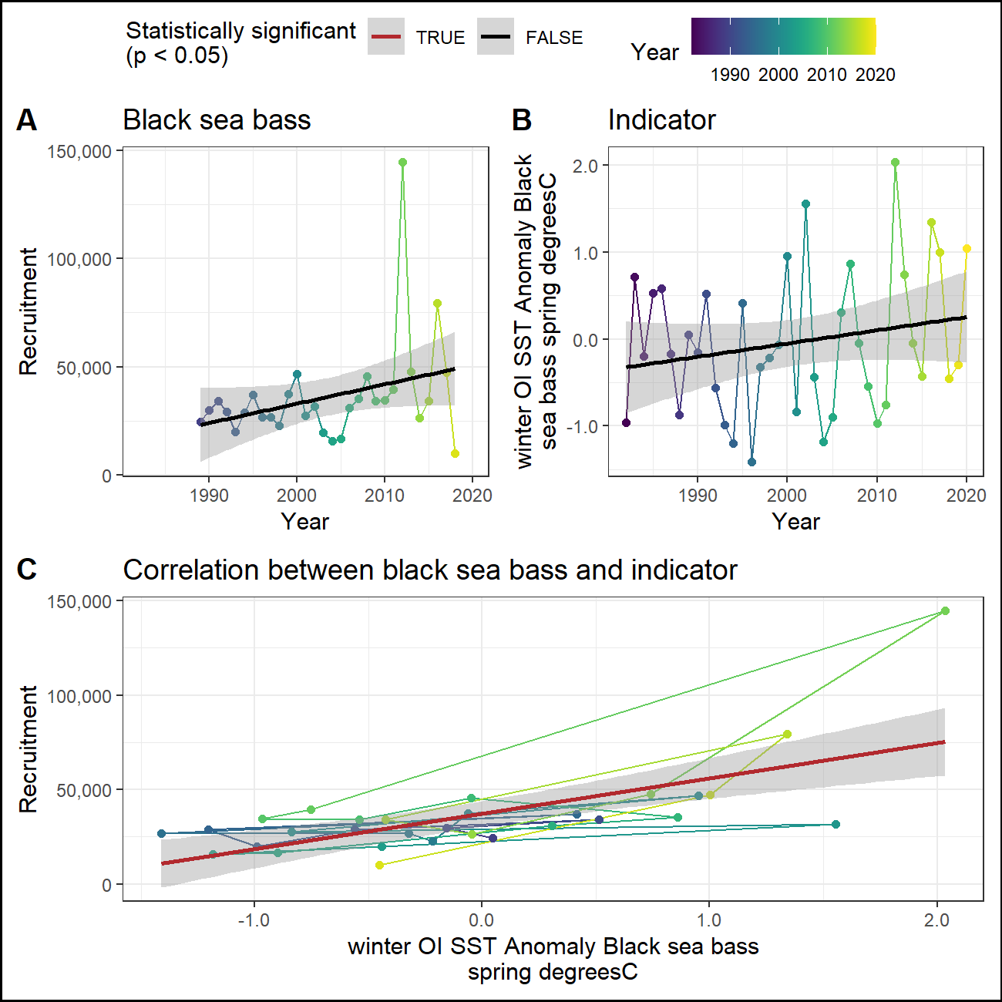

### Fall SST anomaly (prior year)

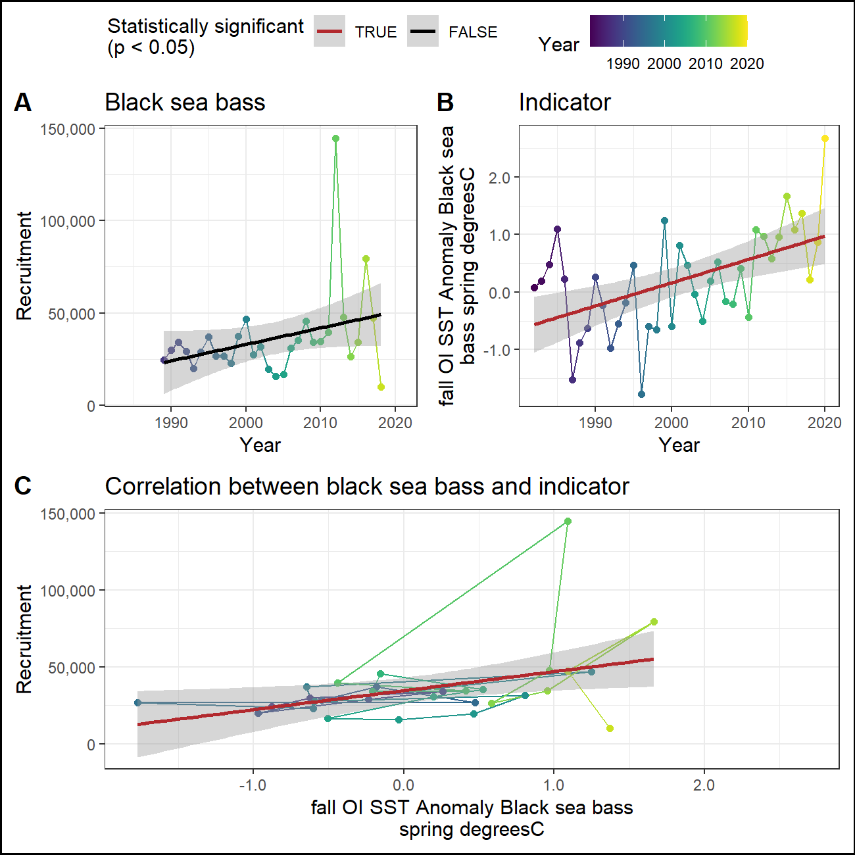

### Winter primary production

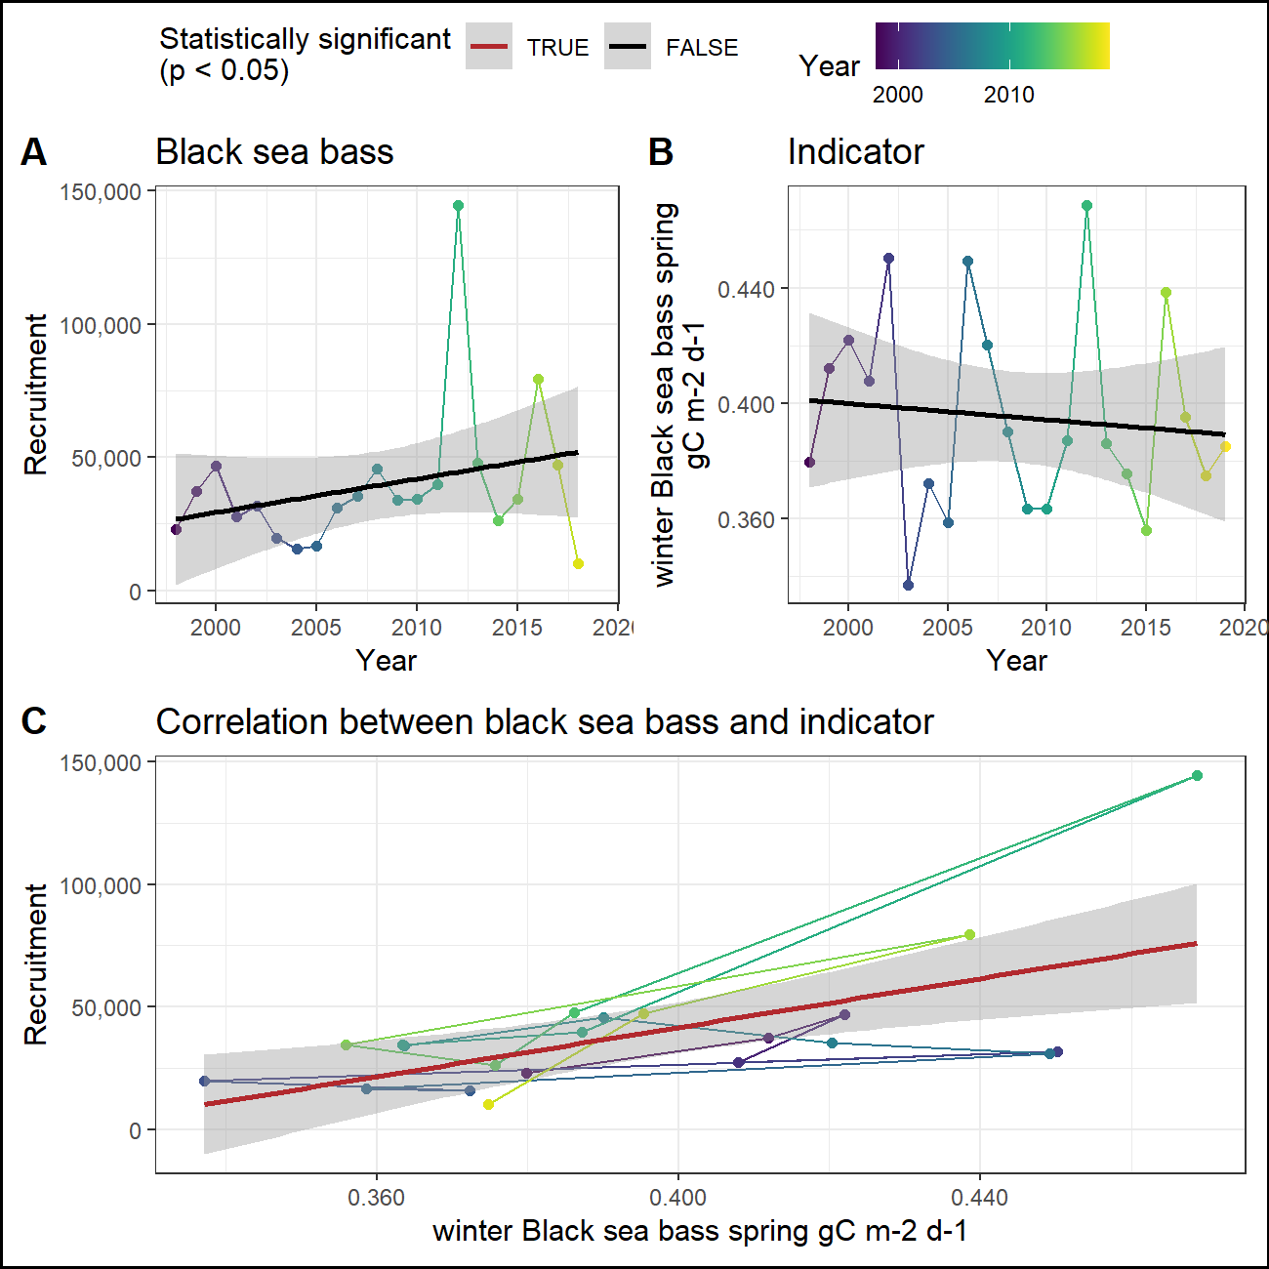

### Fall primary production (prior year)

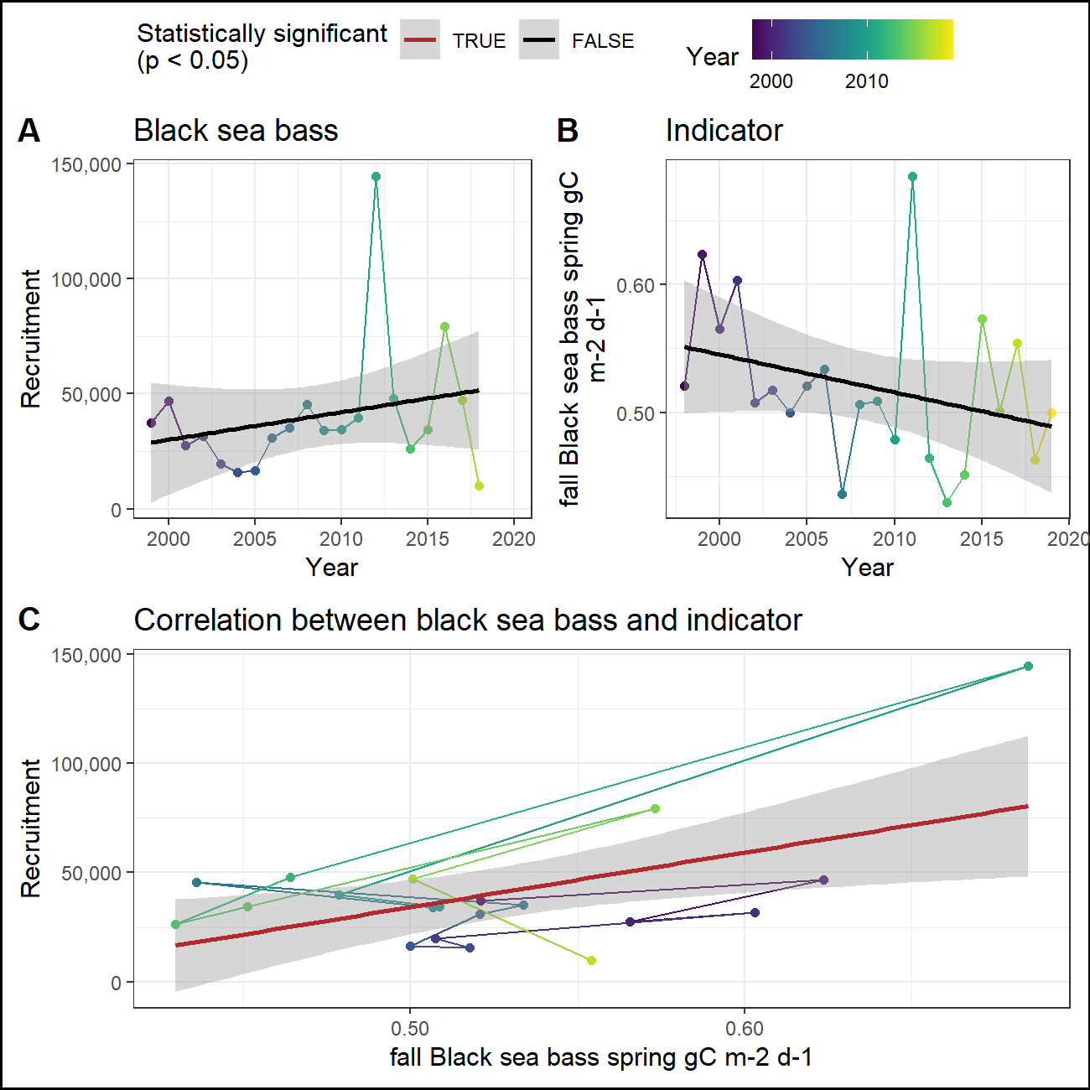

### Cold pool index (prior year)

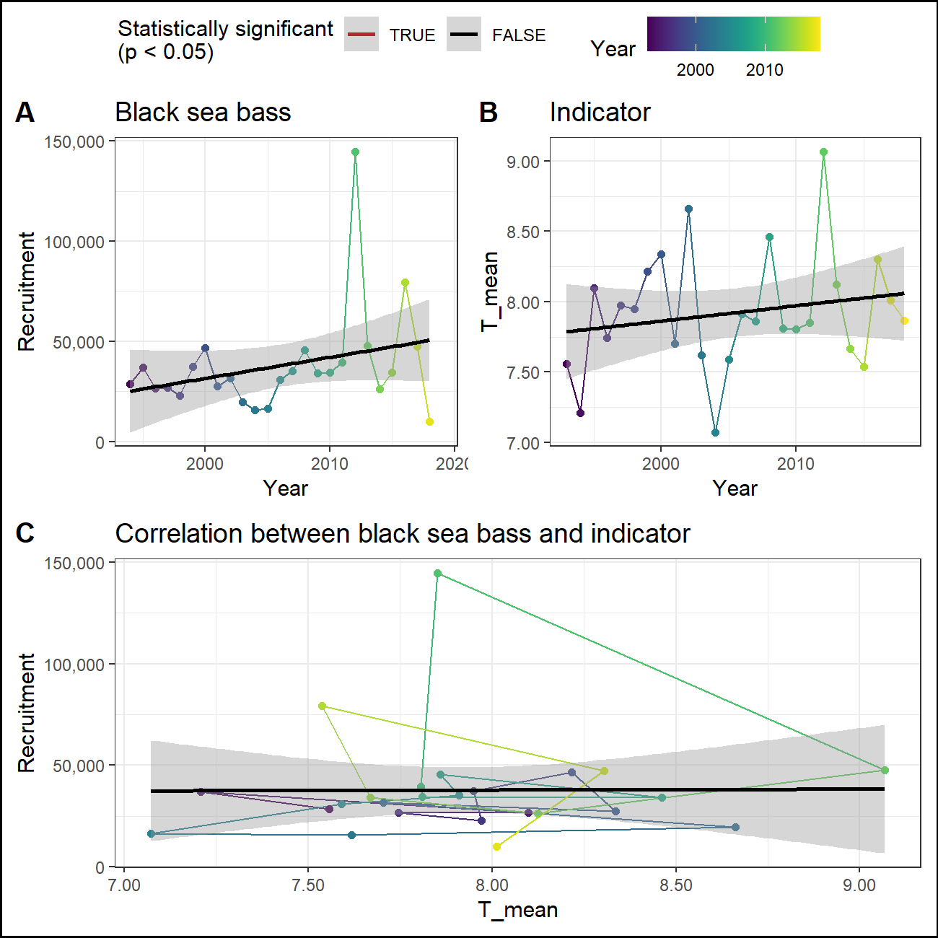

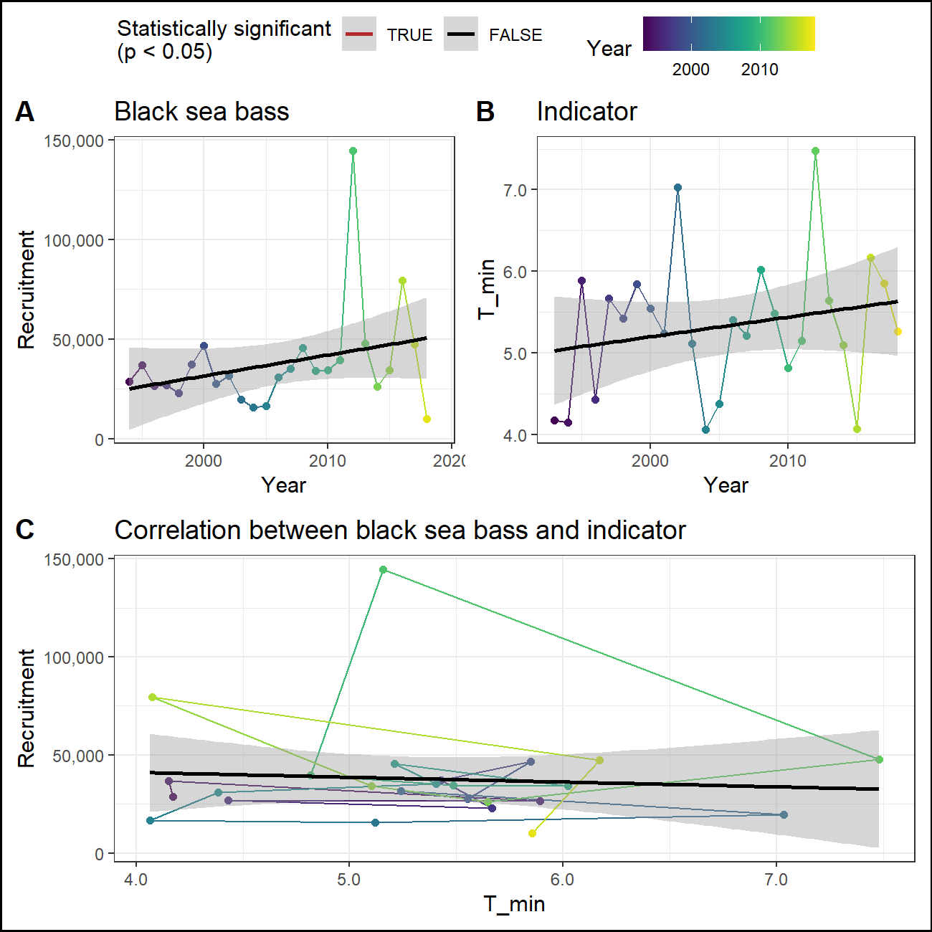

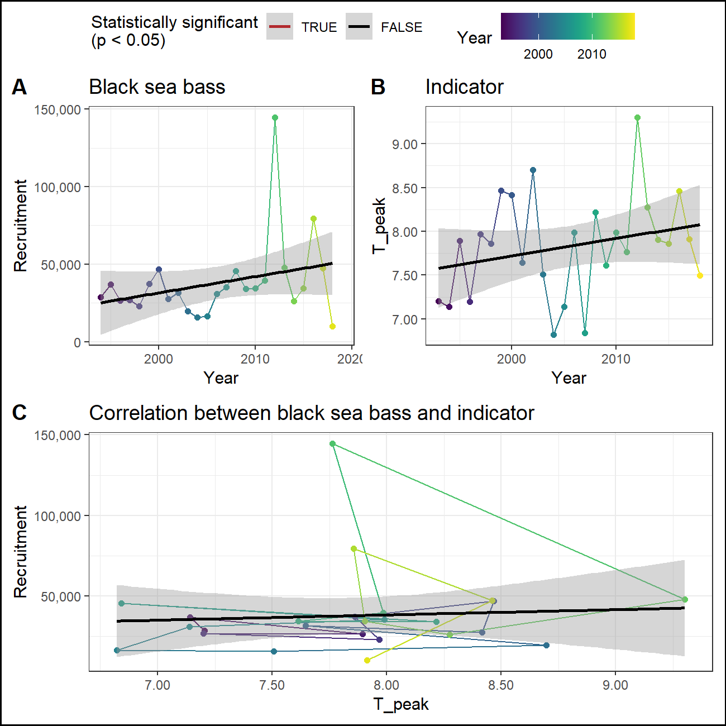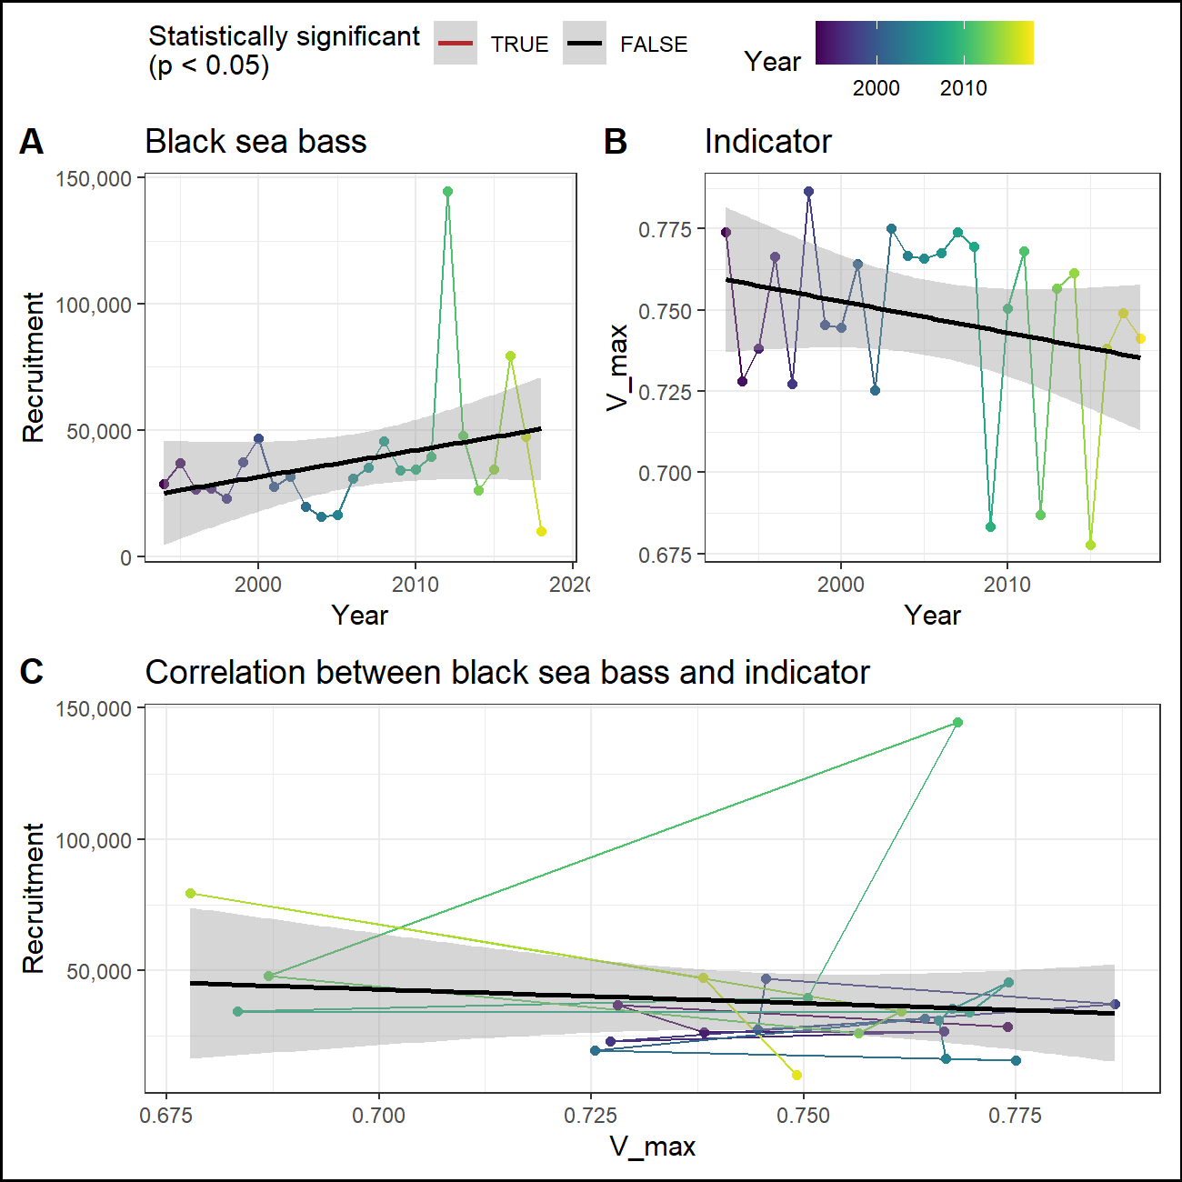

### Predator abundance

## Ecosystem

### Sea surface temperature

#### Recruitment

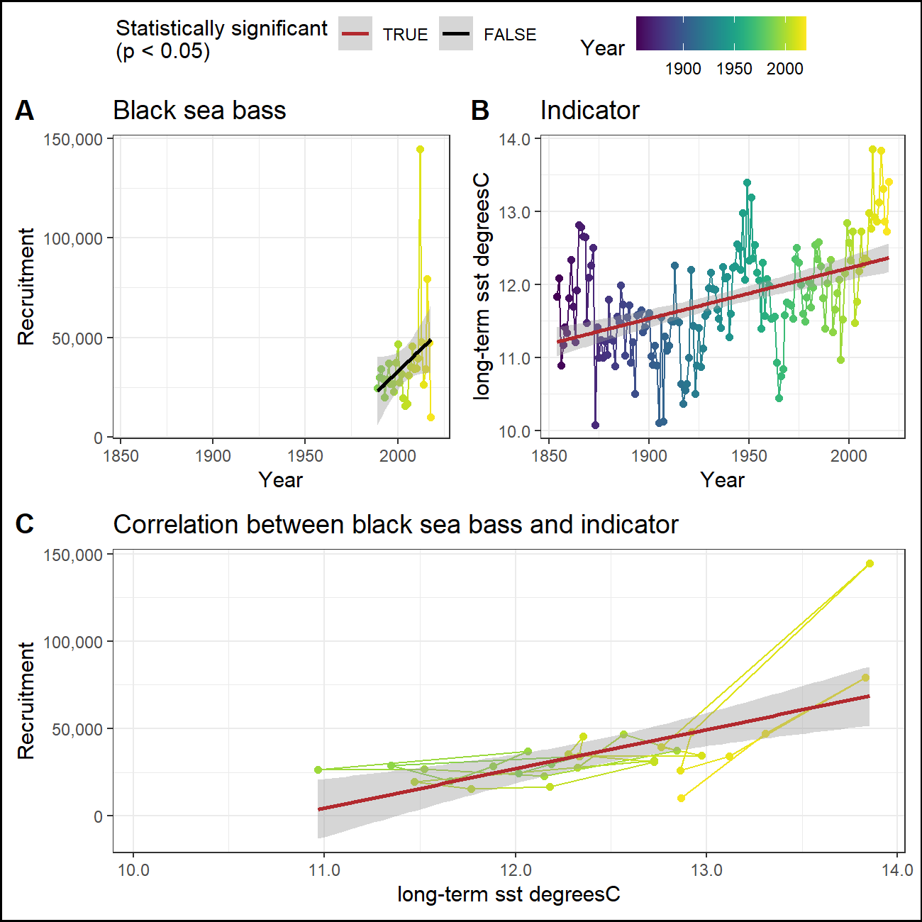

#### Abundance

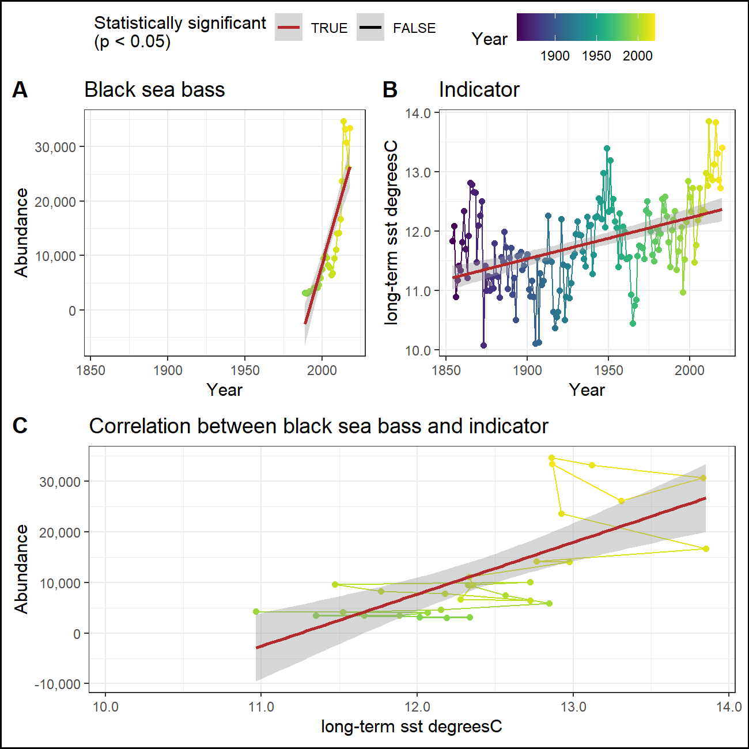

### Marine heatwaves

#### Recruitment

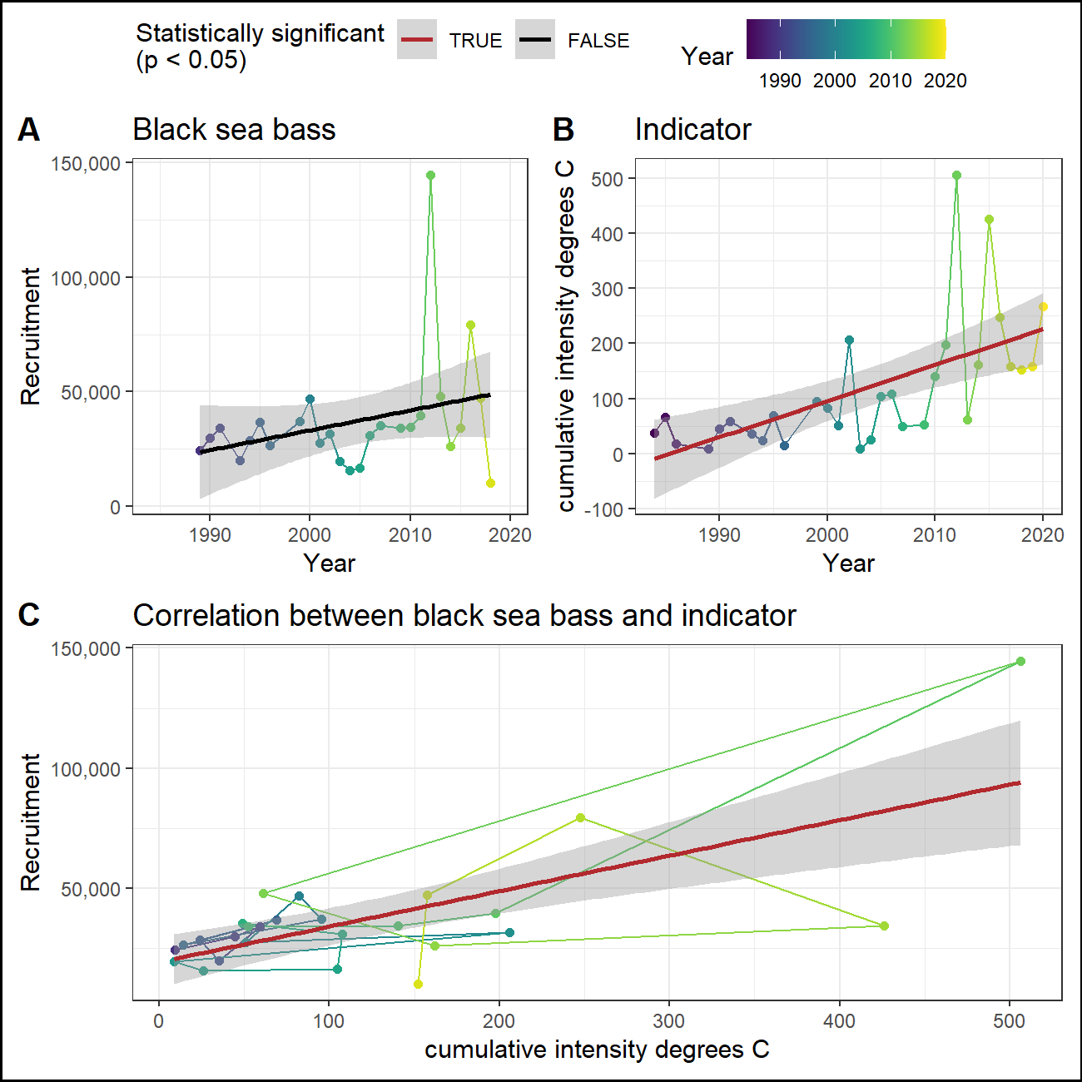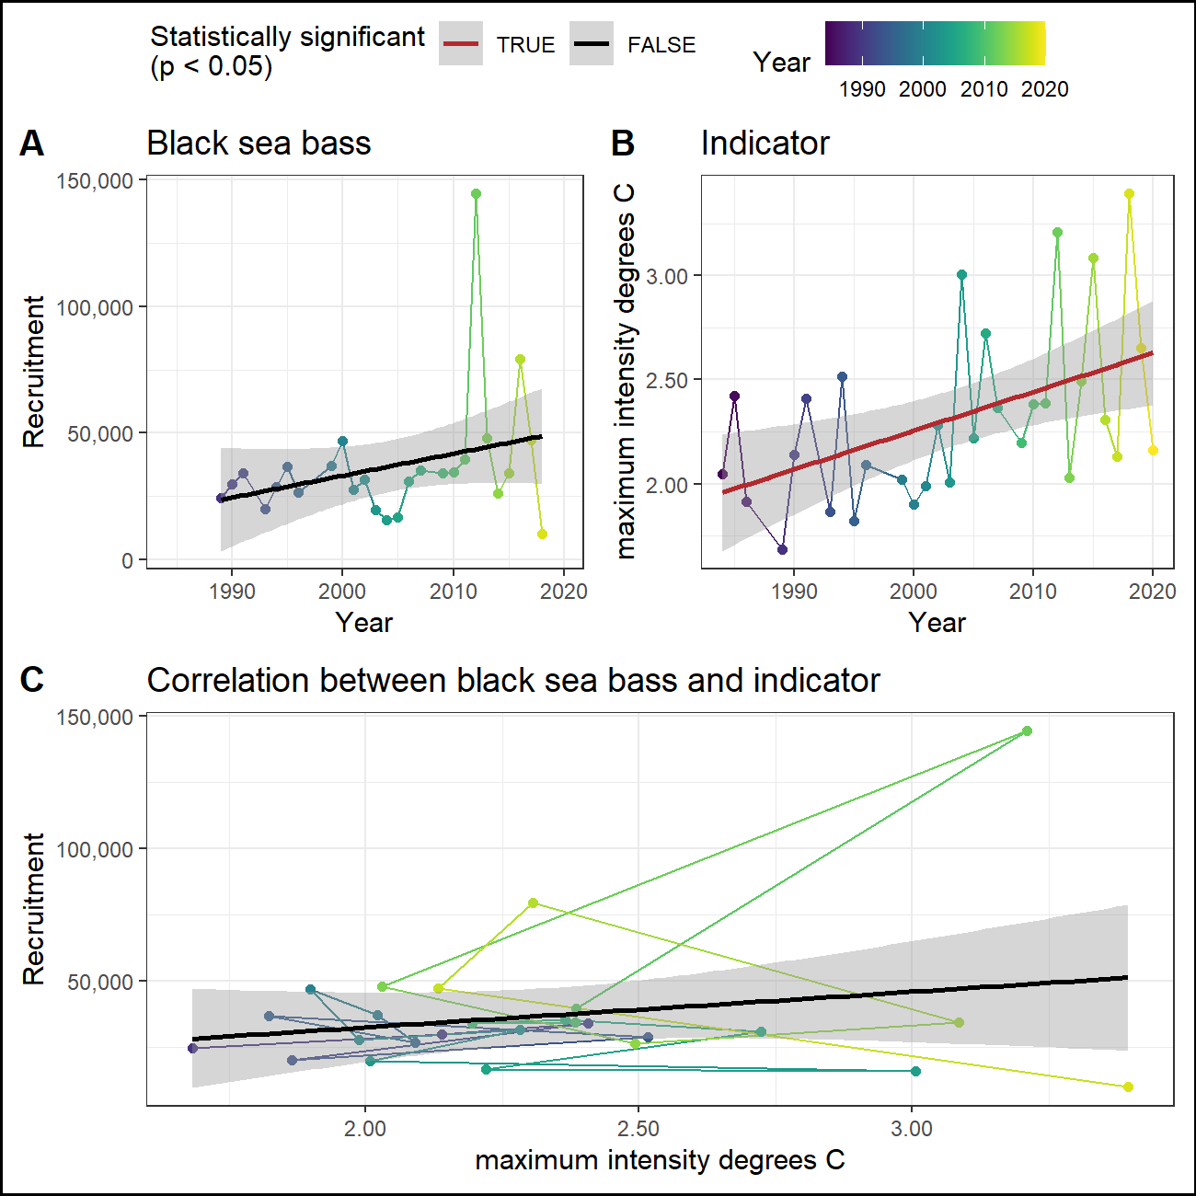

#### Abundance

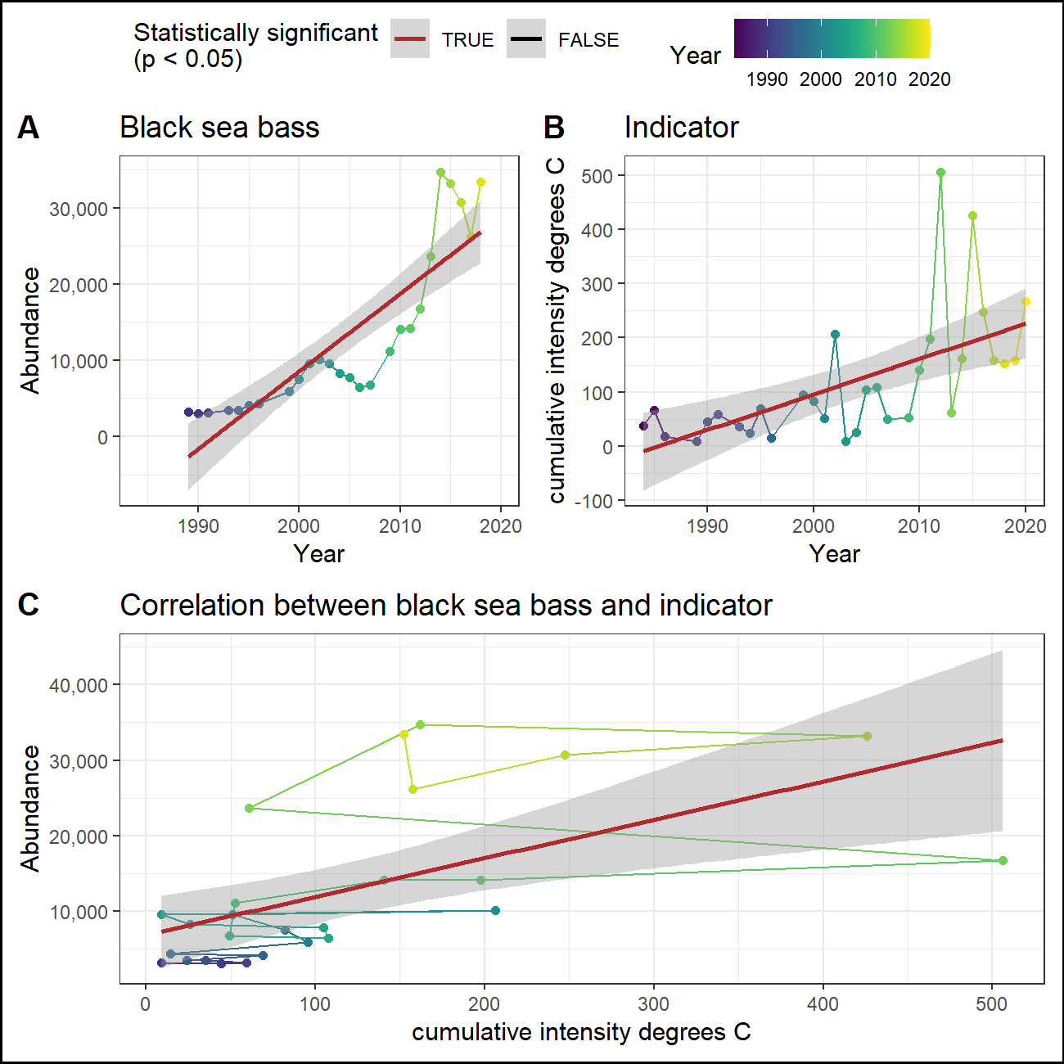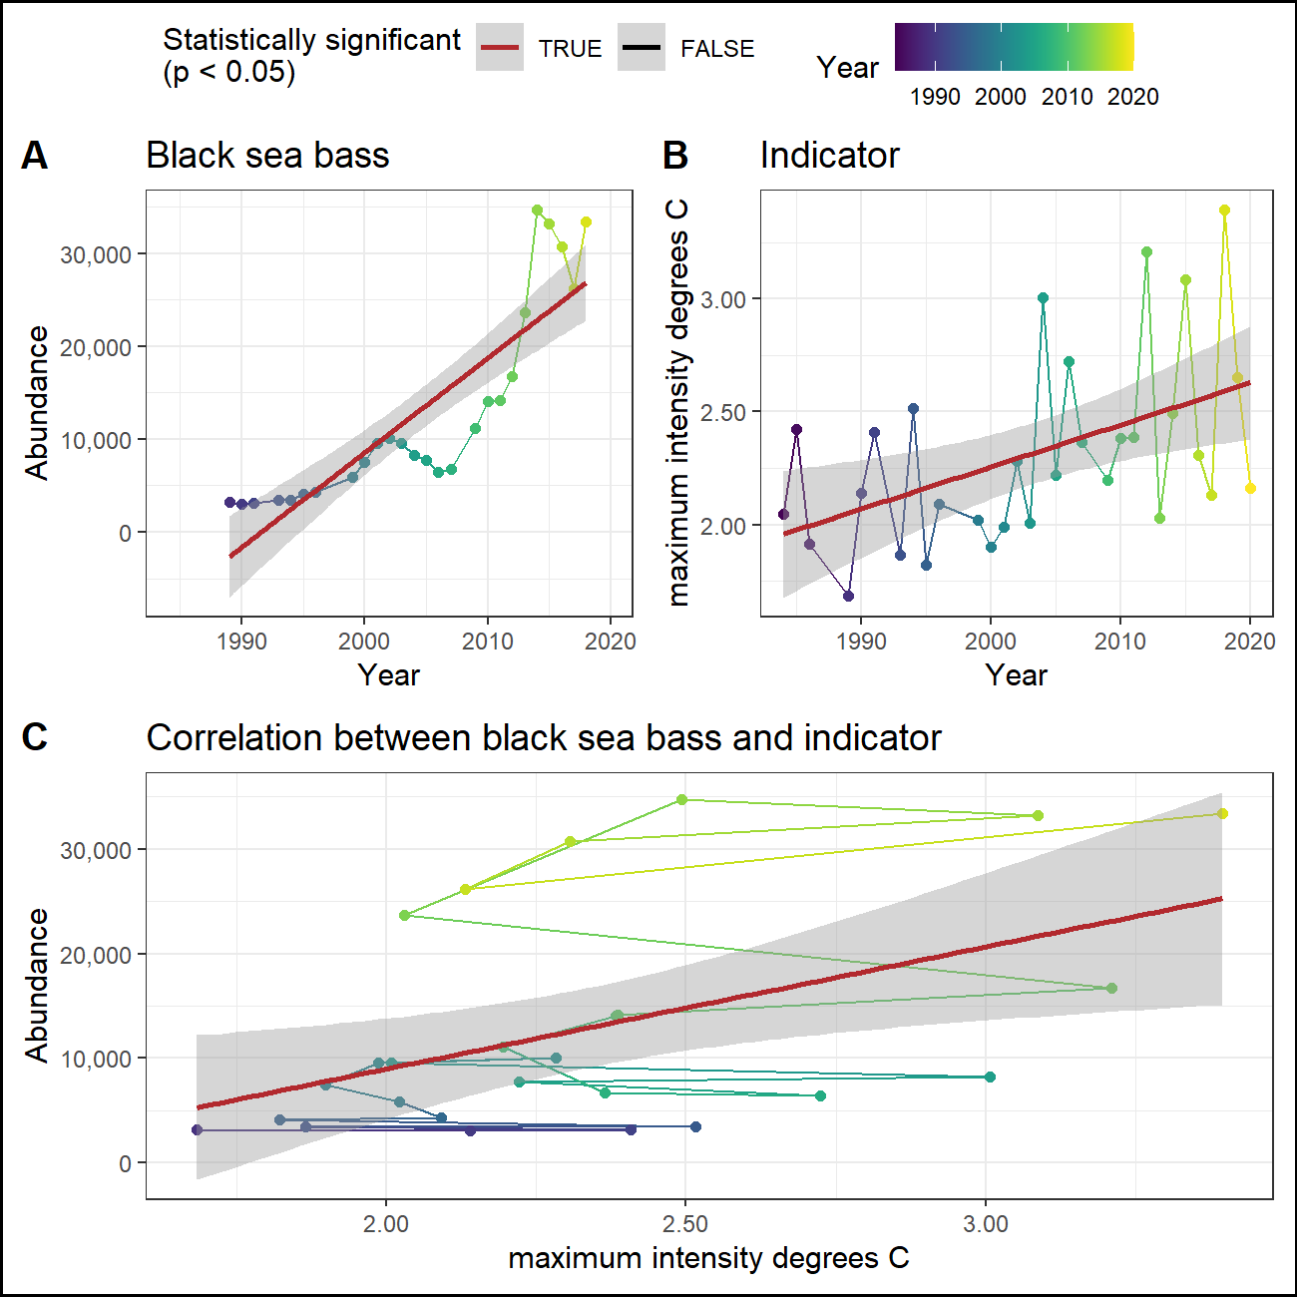

## Management

### Total catch

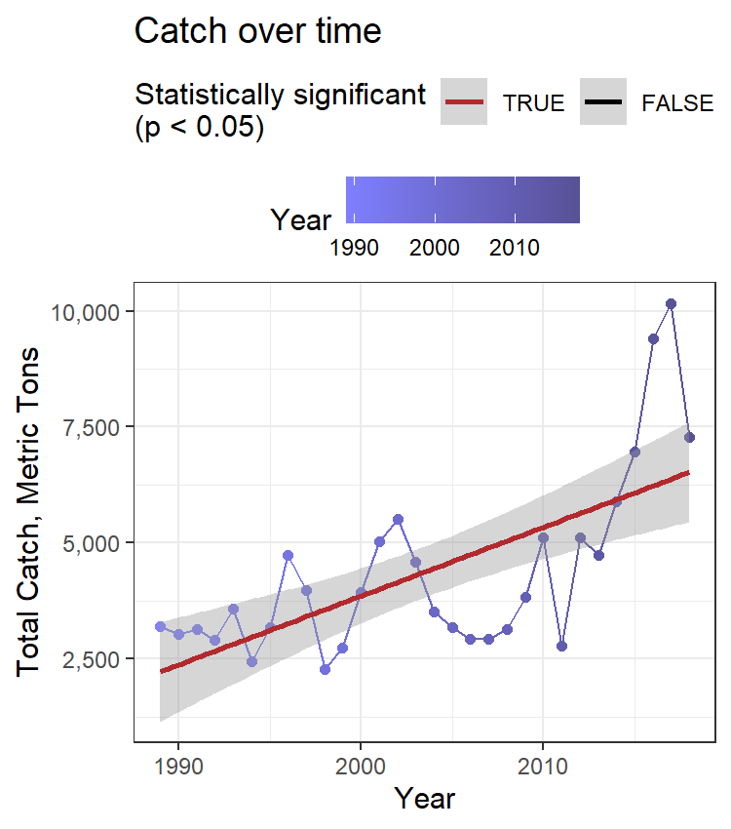

### CPUE

### Catch vs TAC

### Stock range

#### Northern range

Northernmost survey observation in each year.

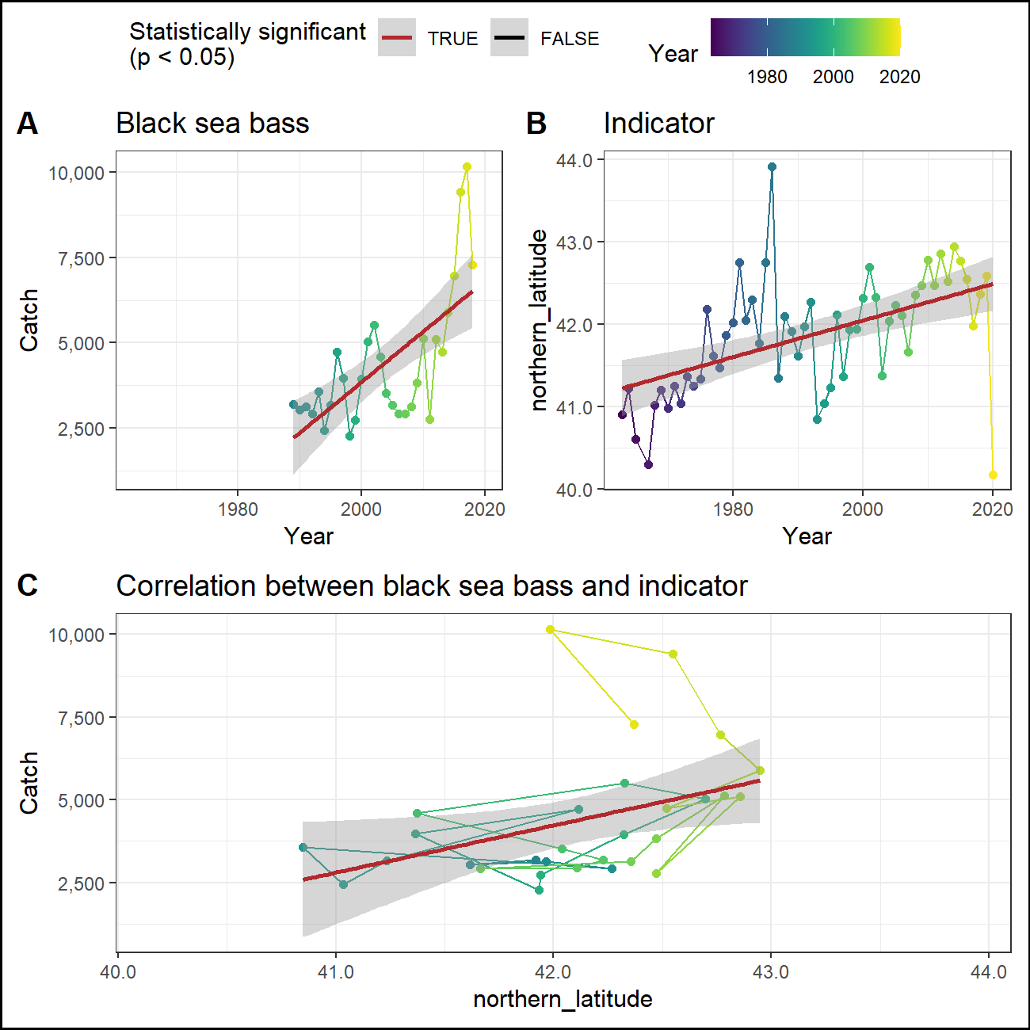

#### Southern range

Southernmost survey observation in each year.

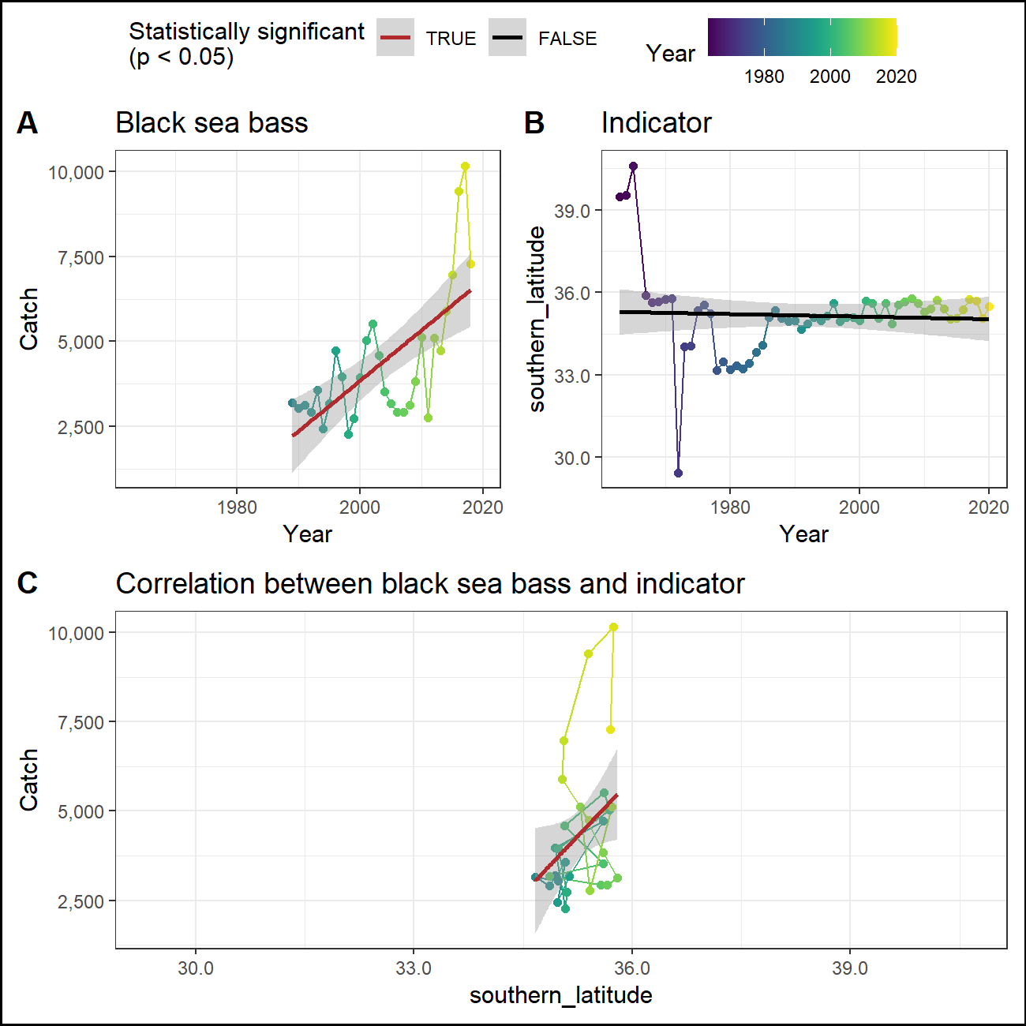

### Center of mass

## Report card

|  |  |  |  |  |  |  |  |  |  |  |  |  |  |  |  |  |
| --- | --- | --- | --- | --- | --- | --- | --- | --- | --- | --- | --- | --- | --- | --- | --- | --- |
| Time | winter OI SST Anomaly Black sea bass spring degreesC | fall OI SST Anomaly Black sea bass spring degreesC | winter Black sea bass spring gC m-2 d-1 | fall Black sea bass spring gC m-2 d-1 | T_mean | T_min | T_peak | V_max | long-term sst degreesC.x | long-term sst degreesC.y | cumulative intensity degrees C.x | maximum intensity degrees C.x | cumulative intensity degrees C.y | maximum intensity degrees C.y | northern_latitude | southern_latitude |
| 2016 | 1.34, high | 1.09, neutral | 0.44, high | 0.5, neutral | 5.92, high | 5.92, high | 5.92, high | 5.92, high | 13.83, high | 13.83, high | 124.89, high | 124.89, high | 124.89, high | 124.89, high | 42.55, neutral | 35.39, neutral |
| 2017 | 1, high | 1.37, high | 0.4, neutral | 0.55, neutral | 5.63, neutral | 5.63, neutral | 5.63, neutral | 5.63, neutral | 13.31, high | 13.31, high | 79.92, neutral | 79.92, neutral | 79.92, neutral | 79.92, neutral | 41.99, neutral | 35.74, neutral |
| 2018 | -0.45, neutral | 0.21, neutral | 0.37, neutral | 0.46, neutral | 5.34, neutral | 5.34, neutral | 5.34, neutral | 5.34, neutral | 12.87, high | 12.87, high | 77.71, neutral | 77.71, neutral | 77.71, neutral | 77.71, neutral | 42.37, neutral | 35.7, neutral |
| 2019 | -0.3, neutral | 0.87, neutral | 0.39, neutral | 0.5, neutral | NA | NA | NA | NA | 12.73, high | 12.73, high | 80.26, neutral | 80.26, neutral | 80.26, neutral | 80.26, neutral | 42.59, neutral | 35.05, neutral |
| 2020 | 1.04, high | 2.68, high | NA | NA | NA | NA | NA | NA | 13.41, high | 13.41, high | 134.81, high | 134.81, high | 134.81, high | 134.81, high | 40.17, low | 35.5, neutral |
| recent mean | 0.53 Â± 0.83 | 1.24 Â± 0.91 | 0.4 Â± 0.03 | 0.5 Â± 0.04 | 5.63 Â± 0.29 | 5.63 Â± 0.29 | 5.63 Â± 0.29 | 5.63 Â± 0.29 | 13.23 Â± 0.44 | 13.23 Â± 0.44 | 99.52 Â± 27.93 | 99.52 Â± 27.93 | 99.52 Â± 27.93 | 99.52 Â± 27.93 | 41.93 Â± 1.01 | 35.48 Â± 0.28 |
| long-term mean | -0.04 Â± 0.83 | 0.21 Â± 0.89 | 0.4 Â± 0.03 | 0.52 Â± 0.06 | 5.46 Â± 0.44 | 5.46 Â± 0.44 | 5.46 Â± 0.44 | 5.46 Â± 0.44 | 11.79 Â± 0.72 | 11.79 Â± 0.72 | 59.83 Â± 58.78 | 59.83 Â± 58.78 | 59.83 Â± 58.78 | 59.83 Â± 58.78 | 41.87 Â± 0.73 | 35.16 Â± 1.53 |