Black sea bass indicator analysis

Abigail Tyrell

21 Apr 2021

## Recruitment

### Winter SST anomaly

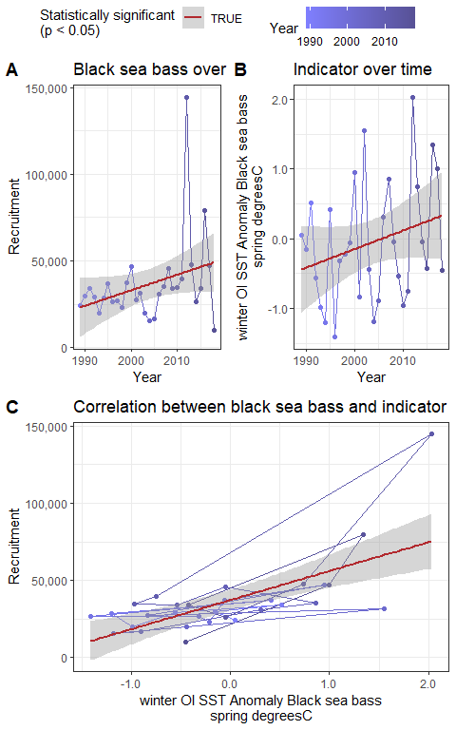

### Fall SST anomaly (prior year)

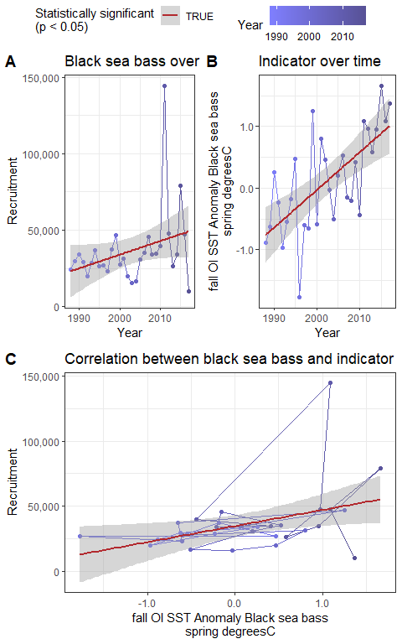

### Winter primary production

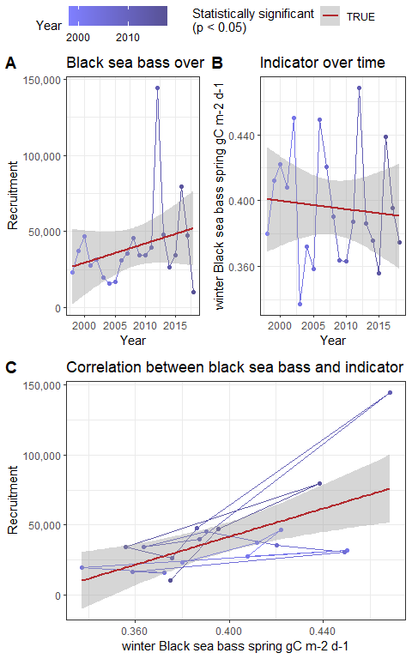

### Fall primary production (prior year)

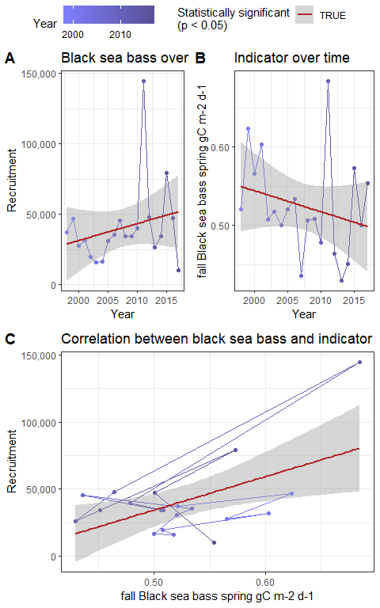

### Cold pool index (prior year)

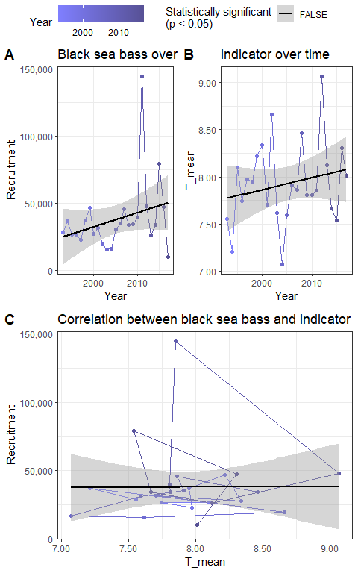

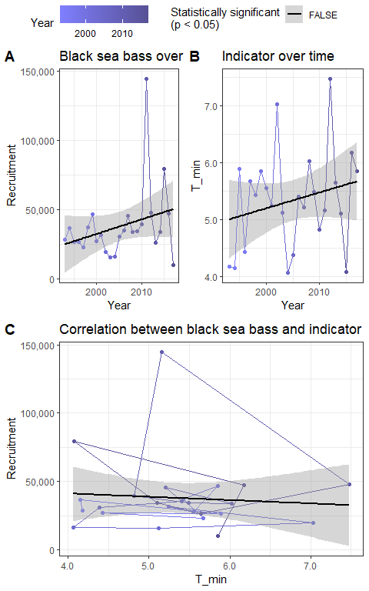

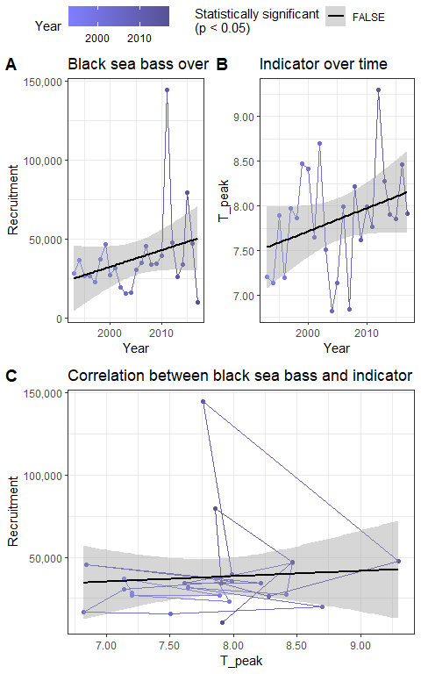

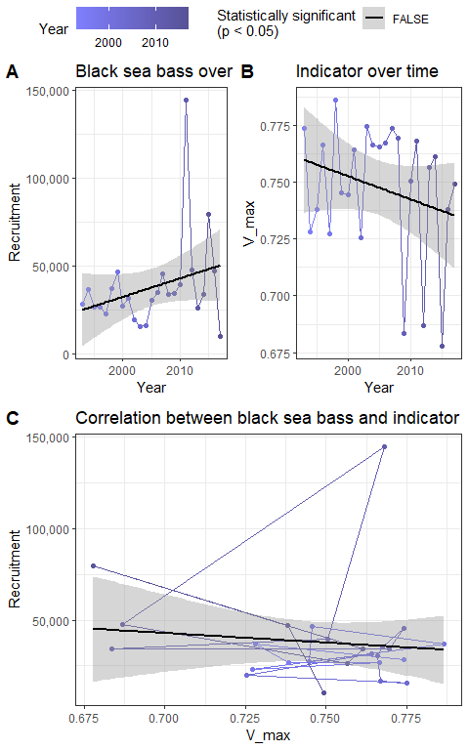

### Predator abundance

## Ecosystem

### Sea surface temperature

### Marine heatwaves

## Management

### Northern and southern bounds

### Center of gravity

### Total catch

### CPUE

### Catch vs TAC