indicator analysis

Abigail Tyrell

15 Jul 2021

## Indicator data

### Black_sea_bass_Mid_MAB_0_lag_FALSE_rr_heatwave-stock.RDS

[1] “Recruitment_cumulative_intensity_Black_sea_bass_spring_degrees_C_(annual_mean).png” 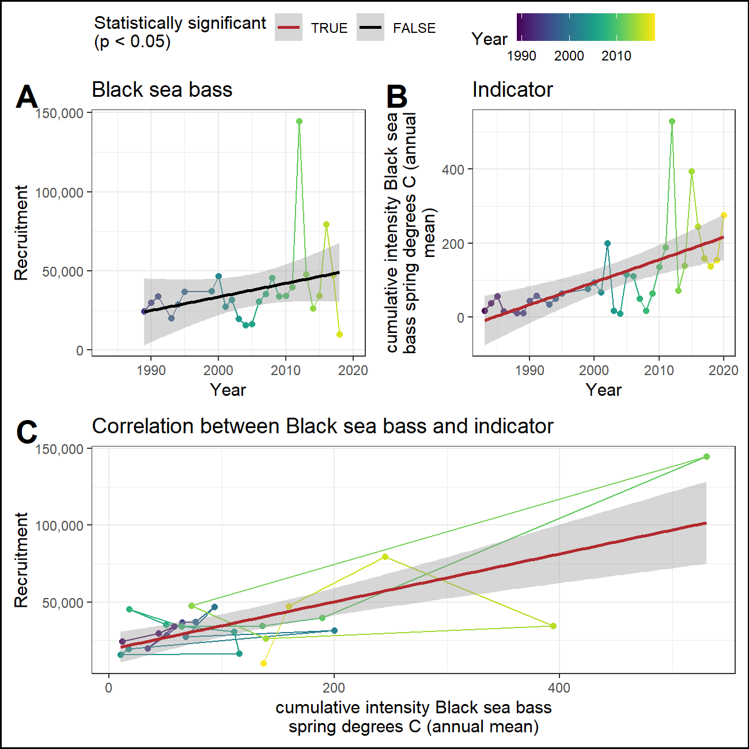

### Black_sea_bass_Mid_MAB_0_lag_FALSE_rr_heatwave-stock.RDS

[1] “Recruitment_maximum_intensity_Black_sea_bass_spring_degrees_C_(annual_mean).png” 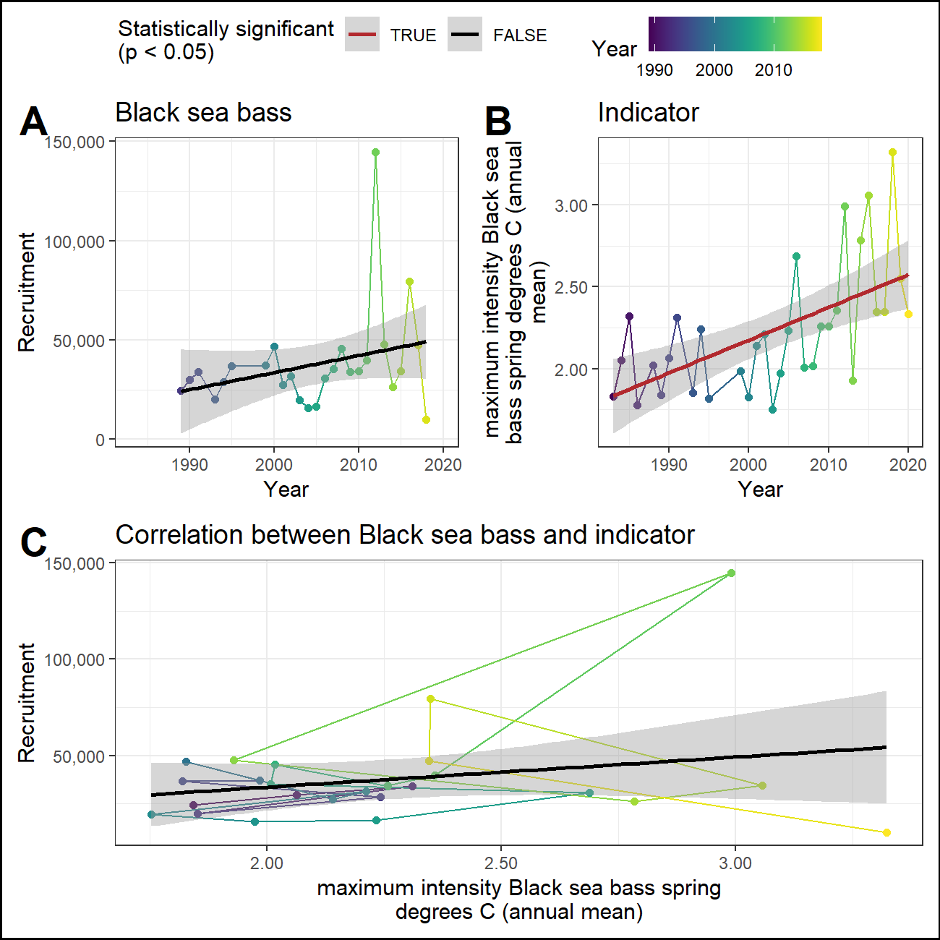

### Black_sea_bass_Mid_MAB_0_lag_FALSE_rr_northern-bound.RDS

[1] “Catch_northern_latitude.png” 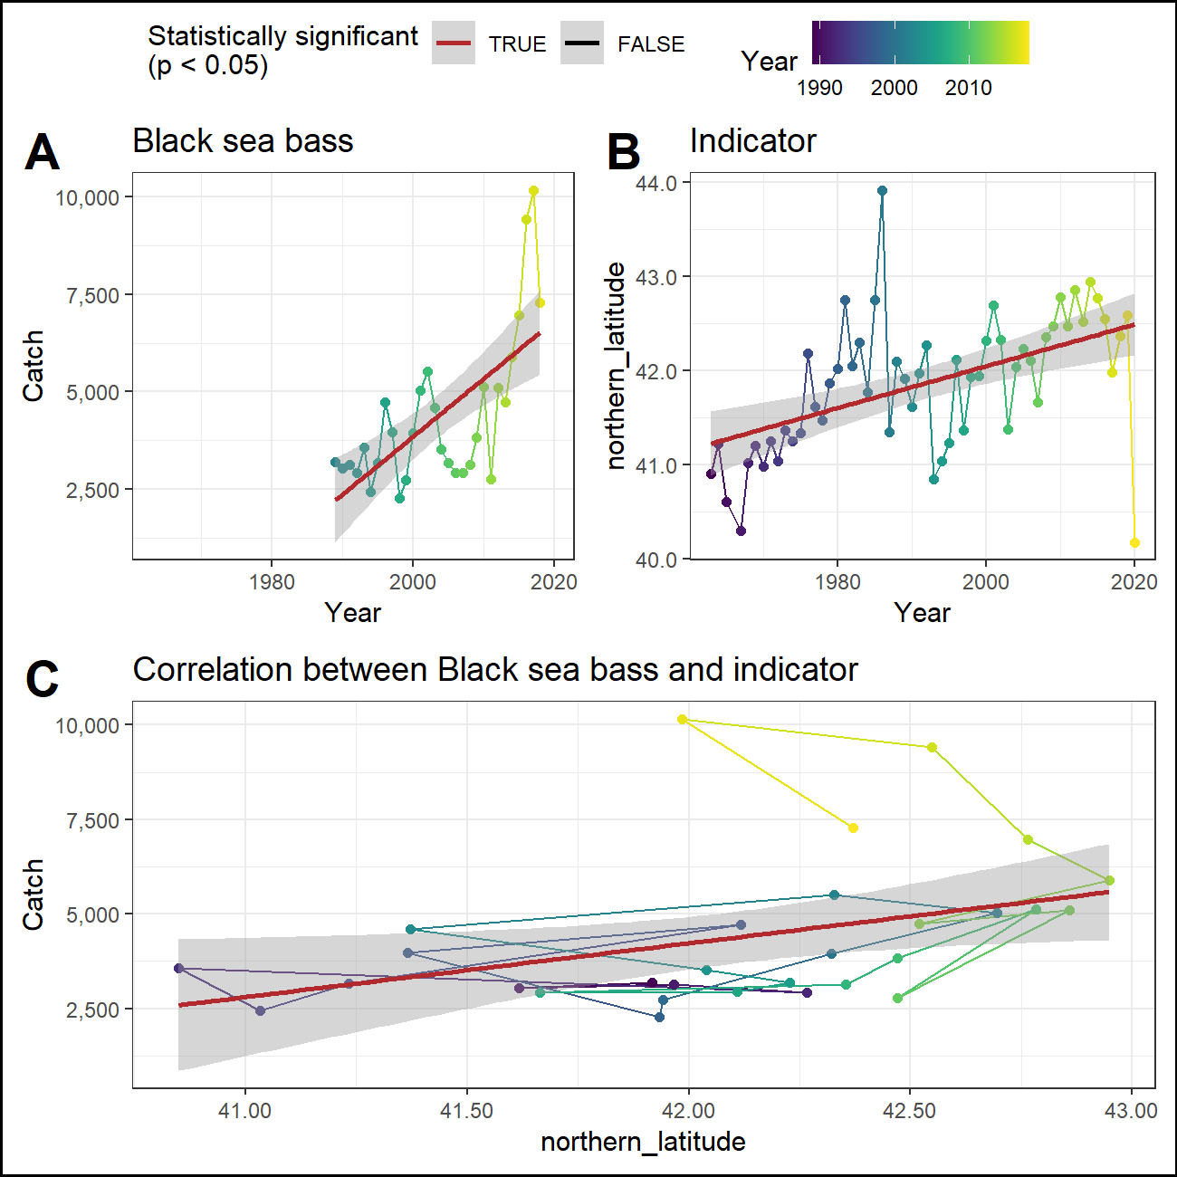

### Black_sea_bass_Mid_MAB_0_lag_FALSE_rr_pp-stock.RDS

[1] “Recruitment_winter_Black_sea_bass_spring_gC_m-2_d-1.png” 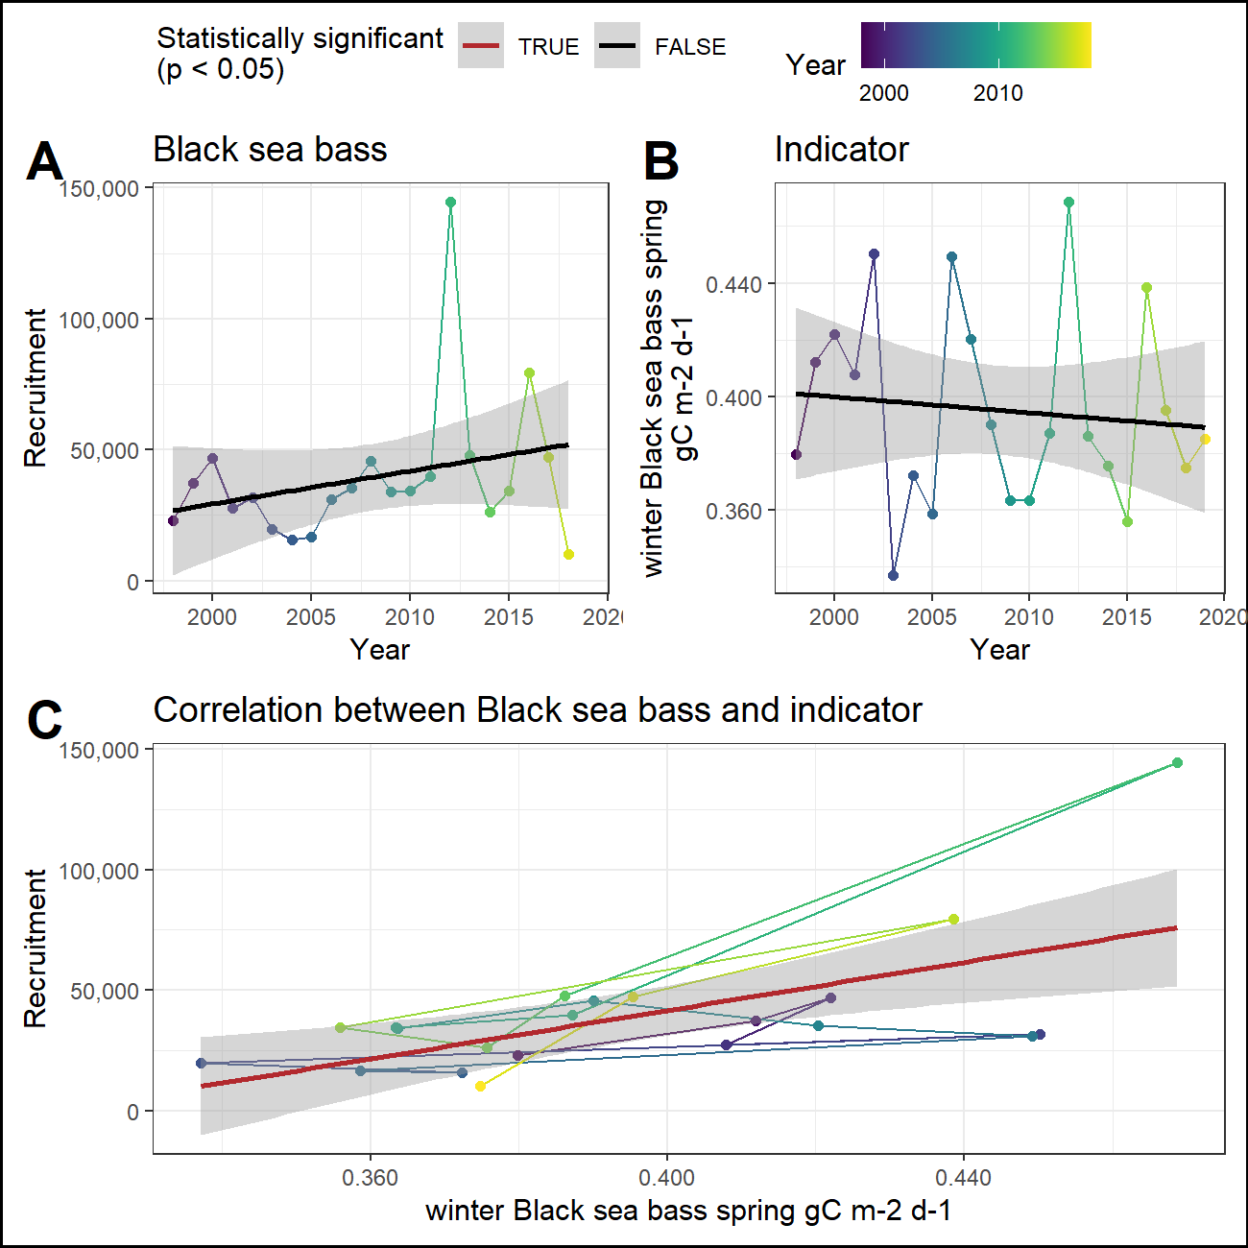

### Black_sea_bass_Mid_MAB_0_lag_FALSE_rr_southern-bound.RDS

[1] “Catch_southern_latitude.png” 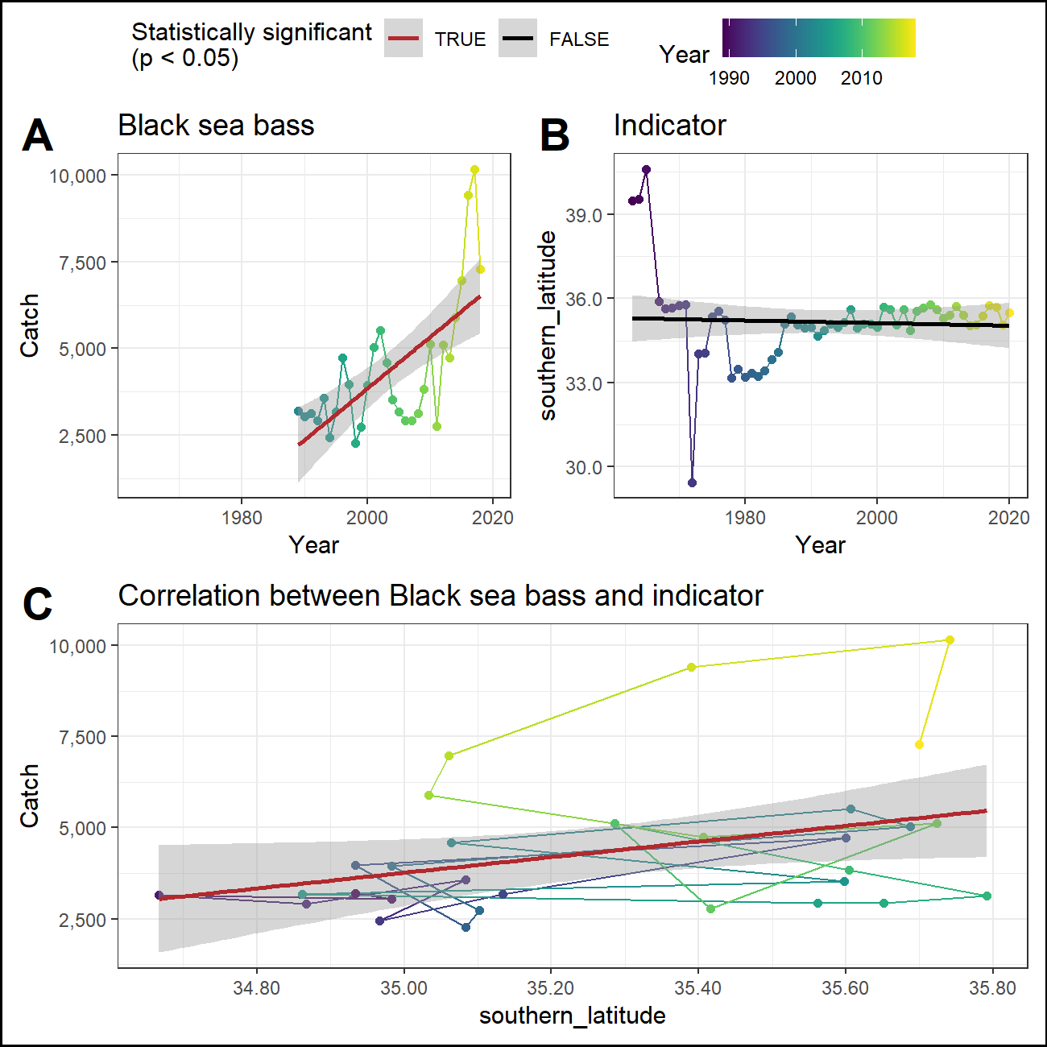

### Black_sea_bass_Mid_MAB_0_lag_FALSE_rr_sst-anom-stock.RDS

[1] “Recruitment_winter_OI_SST_Anomaly_Black_sea_bass_spring_degreesC.png” 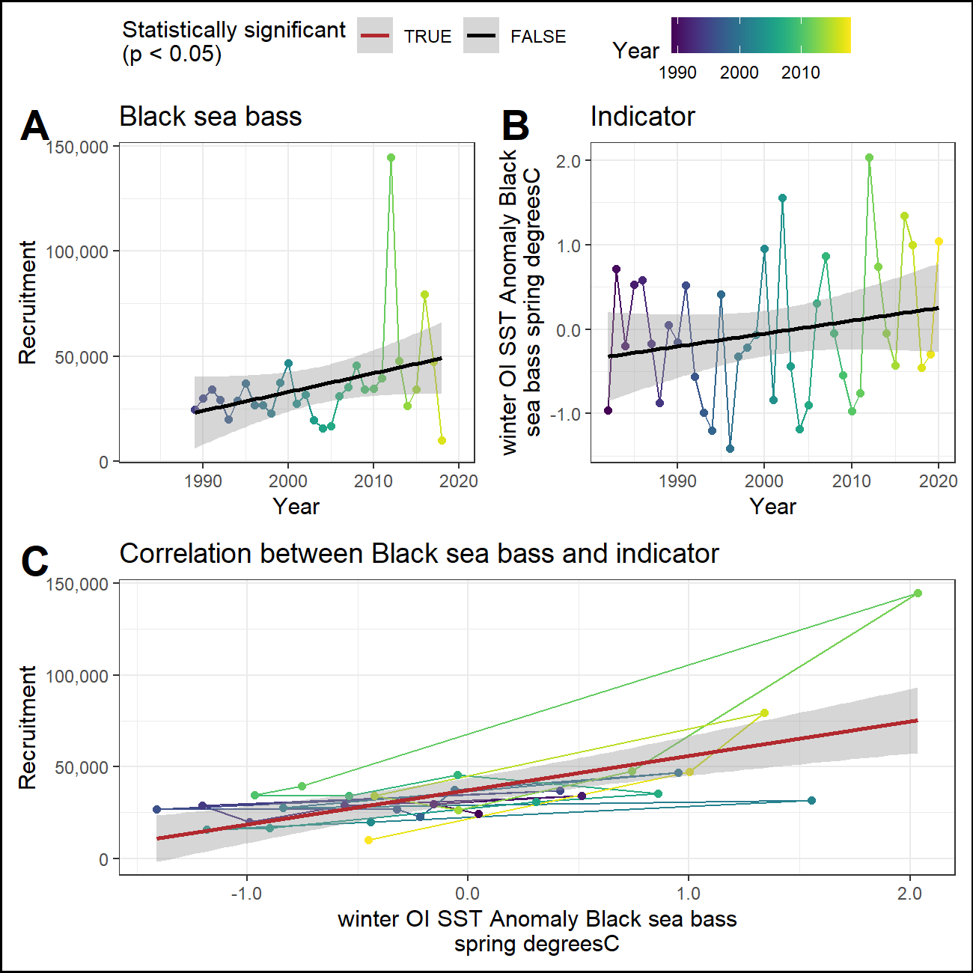

### Black_sea_bass_Mid_MAB_0_lag_FALSE_rr_sst.RDS

[1] “Recruitment_long-term_sst_degreesC.png” 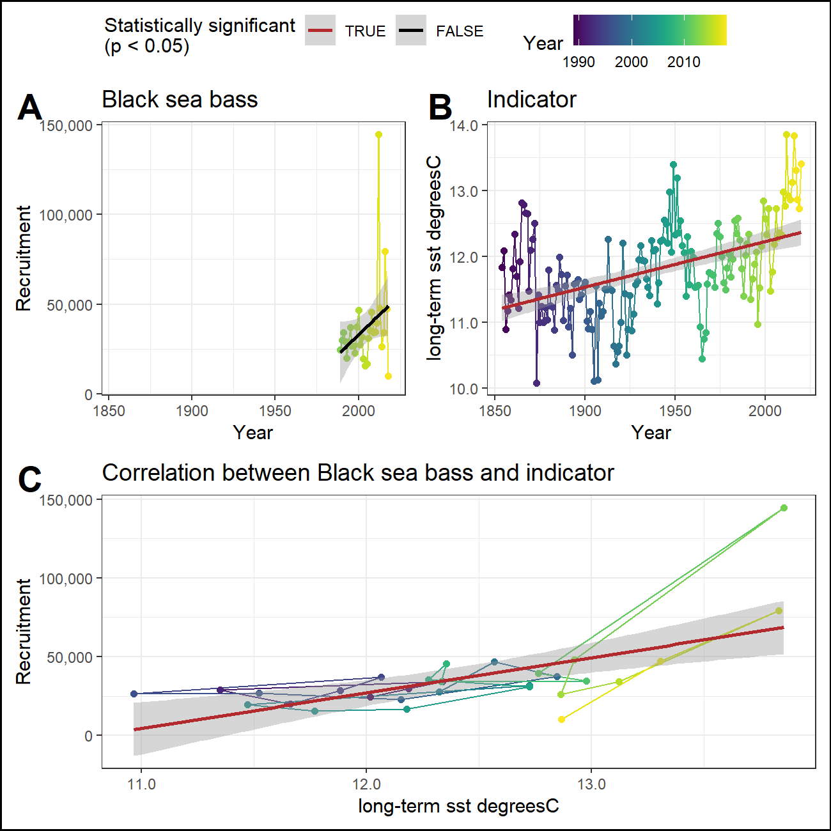

### Black_sea_bass_Mid_MAB_1_lag_FALSE_rr_pp-stock.RDS

[1] “Recruitment_fall_Black_sea_bass_spring_gC_m-2_d-1.png” 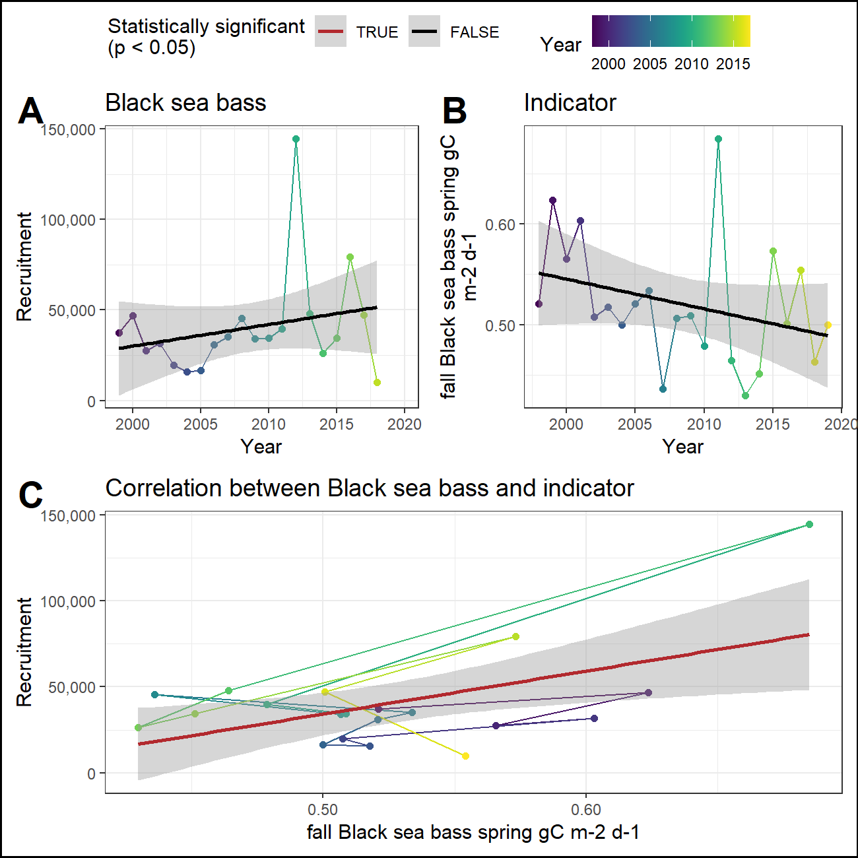

### Black_sea_bass_Mid_MAB_1_lag_FALSE_rr_sst-anom-stock.RDS

[1] “Recruitment_fall_OI_SST_Anomaly_Black_sea_bass_spring_degreesC.png” 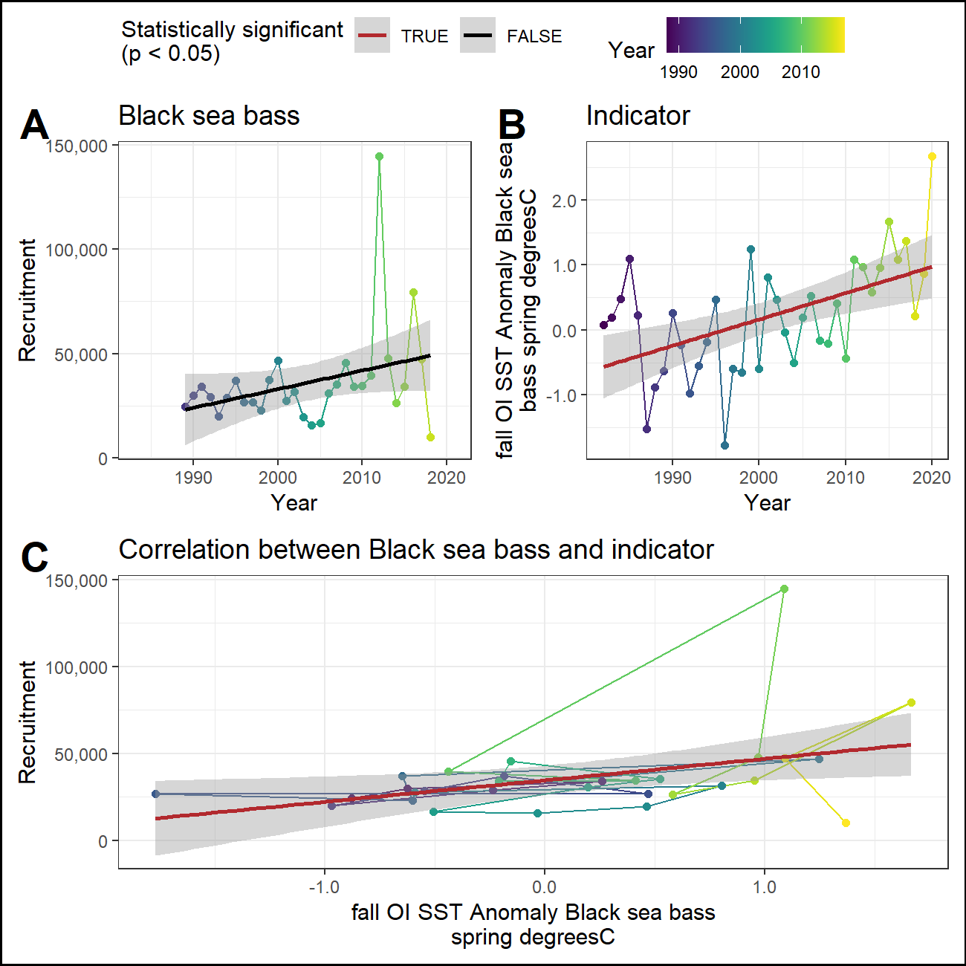

## Report cards

### Indicator report card

| Indicator | Trend with time | Trend with recruitment | Trend with catch |
| --- | --- | --- | --- |
| cumulative intensity Black sea bass spring degrees C (annual mean) | Yes, positive | Yes, positive | Not tested |
| maximum intensity Black sea bass spring degrees C (annual mean) | Yes, positive | No | Not tested |
| northern_latitude | Yes, positive | Not tested | Yes, positive |
| winter Black sea bass spring gC m-2 d-1 | No | Yes, positive | Not tested |
| southern_latitude | No | Not tested | Yes, positive |
| winter OI SST Anomaly Black sea bass spring degreesC | No | Yes, positive | Not tested |
| long-term sst degreesC | Yes, positive | Yes, positive | Not tested |
| fall Black sea bass spring gC m-2 d-1 | No | Yes, positive | Not tested |
| fall OI SST Anomaly Black sea bass spring degreesC | Yes, positive | Yes, positive | Not tested |

### Time series report card

| Time | cumulative intensity Black sea bass spring degrees C (annual mean) | northern latitude | winter Black sea bass spring gC m-2 d-1 | southern latitude | winter OI SST Anomaly Black sea bass spring degreesC | long-term sst degreesC | fall Black sea bass spring gC m-2 d-1 | fall OI SST Anomaly Black sea bass spring degreesC |
| --- | --- | --- | --- | --- | --- | --- | --- | --- |
| 2016 | 244.81 | 42.55 | 0.44 | 35.39 | 1.34 | 13.83 | 0.5 | 1.09 |
| 2017 | 159.65 | 41.99 | 0.4 | 35.74 | 1 | 13.31 | 0.55 | 1.37 |
| 2018 | 136.83 | 42.37 | 0.37 | 35.7 | -0.45 | 12.87 | 0.46 | 0.21 |
| 2019 | 154.56 | 42.59 | 0.39 | 35.05 | -0.3 | 12.73 | 0.5 | 0.87 |
| 2020 | 276.19 | 40.18 |  | 35.5 | 1.04 | 13.41 |  | 2.68 |
| recent mean | 194.41 ± 61.93 | 41.93 ± 1.01 | 0.4 ± 0.03 | 35.48 ± 0.28 | 0.53 ± 0.83 | 13.23 ± 0.44 | 0.5 ± 0.04 | 1.24 ± 0.91 |
| long-term mean | 110.85 ± 115.21 | 41.87 ± 0.73 | 0.4 ± 0.03 | 35.16 ± 1.53 | -0.04 ± 0.83 | 11.79 ± 0.72 | 0.52 ± 0.06 | 0.21 ± 0.89 |
|  |  |  |  |  |  |  |  |  |

## Appendix

### R session information

## R version 4.0.3 (2020-10-10)  
## Platform: x86_64-w64-mingw32/x64 (64-bit)  
## Running under: Windows 10 x64 (build 19042)  
##   
## Matrix products: default  
##   
## locale:  
## [1] LC_COLLATE=English_United States.1252 LC_CTYPE=English_United States.1252 LC_MONETARY=English_United States.1252 LC_NUMERIC=C   
## [5] LC_TIME=English_United States.1252   
##   
## attached base packages:  
## [1] stats graphics grDevices utils datasets methods base   
##   
## other attached packages:  
## [1] NEespShiny_0.1.1 shiny_1.6.0   
##   
## loaded via a namespace (and not attached):  
## [1] ggnewscale_0.4.5 colorspace_2.0-0 ggsignif_0.6.1 ellipsis_0.3.1 rio_0.5.26 rprojroot_2.0.2 flextable_0.6.4 base64enc_0.1-3 fs_1.5.0   
## [10] rstudioapi_0.13 ggpubr_0.4.0 farver_2.1.0 remotes_2.2.0 DT_0.17 fansi_0.4.1 xml2_1.3.2 splines_4.0.3 cachem_1.0.4   
## [19] knitr_1.31.6 pkgload_1.2.0 jsonlite_1.7.2 broom_0.7.5 compiler_4.0.3 backports_1.2.1 assertthat_0.2.1 Matrix_1.2-18 fastmap_1.1.0   
## [28] cli_2.3.1 later_1.1.0.1 htmltools_0.5.1.1 prettyunits_1.1.1 tools_4.0.3 gtable_0.3.0 glue_1.4.2 dplyr_1.0.5 Rcpp_1.0.6   
## [37] carData_3.0-4 cellranger_1.1.0 jquerylib_0.1.3 vctrs_0.3.6 nlme_3.1-149 crosstalk_1.1.1 xfun_0.19 stringr_1.4.0 ps_1.5.0   
## [46] openxlsx_4.2.3 testthat_3.0.2 NEesp_0.1.1 mime_0.10 lifecycle_1.0.0 devtools_2.3.2 rstatix_0.7.0 scales_1.1.1 hms_1.0.0   
## [55] promises_1.2.0.1 yaml_2.2.1 curl_4.3 memoise_2.0.0 gridExtra_2.3 ggplot2_3.3.3 gdtools_0.2.3 sass_0.3.1 stringi_1.5.3   
## [64] highr_0.8 desc_1.3.0 pkgbuild_1.2.0 zip_2.1.1 systemfonts_1.0.1 rlang_0.4.10 pkgconfig_2.0.3 evaluate_0.14 lattice_0.20-41   
## [73] purrr_0.3.4 htmlwidgets_1.5.3 labeling_0.4.2 cowplot_1.1.1 processx_3.4.5 tidyselect_1.1.0 magrittr_2.0.1 R6_2.5.0 generics_0.1.0   
## [82] DBI_1.1.1 pillar_1.5.1 haven_2.3.1 foreign_0.8-80 withr_2.4.1 mgcv_1.8-33 abind_1.4-5 tibble_3.0.4 crayon_1.4.1   
## [91] car_3.0-10 uuid_0.1-4 utf8_1.1.4 officer_0.3.17 rmarkdown_2.7 viridis_0.5.1 usethis_2.0.1 grid_4.0.3 readxl_1.3.1   
## [100] data.table_1.14.0 callr_3.5.1 forcats_0.5.1 digest_0.6.27 xtable_1.8-4 tidyr_1.1.3 httpuv_1.5.5 munsell_0.5.0 viridisLite_0.3.0  
## [109] bslib_0.2.4 sessioninfo_1.1.1

### NEesp information

## Package: NEesp  
## Title: Generate Preliminary ESP Reports for the Northeast  
## Version: 0.1.1  
## Description: Generates preliminary Ecosystem and Socioeconomic Profiles for Northeast and Mid-Atlantic USA fishery stocks.  
## License: file LICENSE  
## Authors@R: c(person("Abigail", "Tyrell", email = "abigail.tyrell@noaa.gov", role = c("aut", "cre"), comment = c(ORCID = "0000-0002-6656-8470")),  
## person("Ricky", "Tabandera", email = "ricky.tabandera@noaa.gov", role = "aut"))  
## Maintainer: Abigail Tyrell <abigail.tyrell@noaa.gov>  
## URL: https://noaa-edab.github.io/NEesp/  
## BugReports: https://github.com/NOAA-EDAB/NEesp/issues  
## Imports: assessmentdata, bookdown, DT, ecodata, FSA, ggpubr, ggrepel, ggridges, ggthemes, here, nmfspalette, papeR, priceR, rgeos, rnaturalearth,  
## rnaturalearthhires, tidyquant, viridis  
## Remotes: ropensci/rnaturalearthhires, nmfs-general-modeling-tools/nmfspalette, NOAA-EDAB/ecodata, NOAA-EDAB/assessmentdata  
## Encoding: UTF-8  
## LazyData: true  
## Roxygen: list(markdown = TRUE)  
## RoxygenNote: 7.1.1  
## Depends: R (>= 3.5.0)  
## Suggests: testthat (>= 3.0.0)  
## Config/testthat/edition: 3  
## RemoteType: github  
## RemoteHost: api.github.com  
## RemoteRepo: NEesp  
## RemoteUsername: NOAA-EDAB  
## RemoteRef: dev  
## RemoteSha: 998e0ef5df14bb9a870c579e74ca7cd9742e313c  
## GithubRepo: NEesp  
## GithubUsername: NOAA-EDAB  
## GithubRef: dev  
## GithubSHA1: 998e0ef5df14bb9a870c579e74ca7cd9742e313c  
## NeedsCompilation: no  
## Packaged: 2021-07-15 20:41:25 UTC; abigail.tyrell  
## Author: Abigail Tyrell [aut, cre] (<https://orcid.org/0000-0002-6656-8470>), Ricky Tabandera [aut]  
## Built: R 4.0.3; ; 2021-07-15 20:41:32 UTC; windows  
##   
## -- File: C:/Users/abigail.tyrell/Documents/R/win-library/4.0/NEesp/Meta/package.rds

### NEespShiny information

## Package: NEespShiny  
## Title: Shiny App to Generate Preliminary ESP Reports for the Northeast  
## Version: 0.1.1  
## Description: Generates preliminary Ecosystem and Socioeconomic Profiles for Northeast and Mid-Atlantic USA fishery stocks in a Shiny app.  
## License: file LICENSE  
## Authors@R: person("Abigail", "Tyrell", email = "abigail.tyrell@noaa.gov", role = c("aut", "cre"), comment = c(ORCID = "0000-0002-6656-8470"))  
## Depends: shiny  
## Imports: NEesp  
## Remotes: NOAA-EDAB/NEesp  
## Encoding: UTF-8  
## LazyData: false  
## Roxygen: list(markdown = TRUE)  
## RoxygenNote: 7.1.1  
## Suggests: rmarkdown, knitr  
## VignetteBuilder: knitr  
##   
## -- File: C:/Users/abigail.tyrell/Documents/NEespShiny/DESCRIPTION