Generalized Additive Model Analysis of Composition Likelihood Accuracy
Method specific simplex surfaces diagnostics and comparison of five estimators
Analysis of results code E and associated GAM diagnostic plots

Purpose and principal conclusion
This memorandum evaluates how the estimation accuracy of methods i through v changes over the compositional simplex and across the simulation design. The global generalized additive model uses 500,000 observations and explains 62.1% of deviance. It shows decisive effects of metric, method, G, sigma, mean sample size, theta_true, design block, and theta_CV, together with a significant metric-by-method interaction. Group size G and noise level sigma are the dominant experimental drivers. Method ii is consistently least accurate. Methods iii and v form the leading group, with iii favored for adjusted RMSE and v favored slightly for adjusted L1 and Linf at the model reference configuration.
The two-dimensional p1-p2 surfaces reveal genuine method-specific morphology. Methods iv and v have nearly parallel smooth surfaces, method iii has a similar broad pattern with stronger decline toward high p1, method ii follows a comparatively simple diagonal gradient, and method i exhibits the most localized structure. The basis dimension k = 30 is adequate for every fitted smooth according to gam.check. This does not validate the Gaussian error model: both diagnostic panels show right-skewed residuals, strong heteroscedasticity, and influential upper-tail observations. Inferential p values should therefore be interpreted as descriptive evidence from a very large simulation sample and supplemented by robust or distributionally appropriate sensitivity fits.
The targeted v-versus-iii model requires special care. Its response is log1p of the absolute method difference, not a signed log-ratio. It identifies where v and iii disagree most, but it cannot determine which method is superior in those regions. Disagreement is smallest across much of the central simplex and grows toward the high-p1 and high-p2 boundary, most strongly for L1, then Linf, and least for RMSE.

Executive findings
- The global GAM has adjusted R-squared 0.621 and 62.1% deviance explained; the v-versus-iii absolute-difference GAM has adjusted R-squared 0.390 and 39.1% deviance explained.
- G is the largest experimental term by F statistic (90,046.7), closely followed by sigma (81,932.4). Mean_nsamp, theta_true, design block, and theta_CV follow in that order.
- Metric, method, and metric-by-method are all highly significant. The leading adjusted method depends modestly on the error definition, while method ii remains last.
- All global smooths have k-index 0.98 with p values 0.14 to 0.23 and effective degrees of freedom well below k-prime = 29. The chosen k is sufficient.
- The difference-model k-indices are 1.04 with p values 0.83 to 0.87. L1 uses 26.2 of 29 available degrees of freedom, so a larger-k sensitivity fit is prudent even though the formal diagnostic is satisfactory.
- Residual diagnostics are materially imperfect for both models. The global fit is especially affected by upper-tail nonnormality and fitted-value-dependent variance.

Analytical specification and scale
Component | Global GAM | Difference GAM
Rows analyzed | 500,000 | 144,342
Response | log1p(accuracy) | log1p(abs(v minus iii difference))
Smooths | Separate p1-p2 surface by method | Separate p1-p2 surface by metric
Basis | Thin plate regression spline k = 30 | Thin plate regression spline k = 30
Other terms | metric by method plus design factors | metric plus design factors
Fitting | Gaussian identity with fREML | Gaussian identity with fREML
Sampling | Maximum 500,000; seed 543 | Maximum 300,000; available 144,342

The global response is log(1 + error), not log(error). A coefficient b therefore multiplies 1 + error by exp(b); 100[exp(b) - 1] is an exact percentage change in 1 + error, not generally an exact percentage change in error. For small errors this distinction can be important. The difference response is even more restrictive: taking the absolute value removes direction before fitting, so no exponentiated coefficient from that model can establish whether v or iii has lower error.

1 Global GAM Results
The global model converged at full rank, 167 of 167, with negligible score gradients. Its large sample yields high power, so practical magnitude and surface structure are more informative than p values alone. The ANOVA table ranks the main experimental drivers clearly, while the method coefficients and interactions show that comparative performance varies by error metric.

Hierarchy of experimental influence
Rank | Term | df | F statistic | Interpretation
1 | G | 1 | 90,046.7 | Dominant information-size effect
2 | sigma | 1 | 81,932.4 | Dominant degradation from noise
3 | mean_nsamp | 1 | 14,182.6 | Large improvement with sampling effort
4 | theta_true | 1 | 3,784.2 | Moderate signal-level effect
5 | design_block | 2 | 2,784.3 | Distributional context matters
6 | theta_CV | 1 | 169.4 | Detectable but comparatively weak

Note. F statistics provide a useful within-model influence ranking but are not variance components or partial eta-squared values. Design block has two numerator degrees of freedom, so direct comparisons should remain descriptive.
The estimated signs are coherent with the simulation design. Increasing G lowers log1p error (b = -0.03969), while increasing sigma raises it (b = 0.03783). On the 1 + error scale these correspond to approximately -3.89% and +3.86% per modeled unit. Mean_nsamp is beneficial (-1.56%), theta_true is beneficial (-0.81%), and theta_CV is mildly adverse (+0.17%). These percentages apply to the coding and unit changes used in the fitted model; they should not be read as full-range contrasts unless the predictors were scaled to that range.
Relative to the omitted design block, Negative binomial and Poisson blocks have coefficients -0.01653 and -0.01766, or approximately 1.64% and 1.75% lower 1 + error. The output does not identify the omitted block in its printed coefficient table, so those effects are reference contrasts rather than a complete ranking of all sampling distributions.

Metric and method effects
Metric is the largest parametric term, F = 60,361.6, because RMSE, L1, and Linf quantify different aspects and scales of compositional error. Method is also decisive, F = 477.1, and the metric-by-method interaction is highly significant, F = 168.4. A single method ranking averaged over all metrics would therefore conceal meaningful changes in the size of the method effects.

Metric | Adjusted ordering at reference configuration | Key contrast on 1 plus error scale
L1 | v < iii < iv < i < ii | v is 1.13% below i; ii is 2.92% above i
Linf | v approximately iii < iv < i < ii | v is 0.70% below i; iii is 0.67% below i
RMSE | iii < v < iv < i < ii | iii is 0.42% below i; ii is 0.94% above i

Note. These orderings combine the method main effects with the relevant metric-by-method interactions. They apply at the model reference configuration and the centered smooth effects, not uniformly over the simplex.
Method ii is the only method with an unambiguous adverse position: its adjusted effect is positive for every metric. Methods iii and v are the leading pair. Method v has the lowest adjusted L1 and Linf, while iii has the lowest adjusted RMSE. Their differences from method i are small in percentage terms but precisely estimated. Method iv is intermediate, and its main L1 contrast with i is not significant (p = 0.179), although the Linf interaction is significant (p = 0.027).

Method specific smooth significance
Method | edf of 29 | F | p value | Interpretation
i | 12.87 | 7.919 | < 2e-16 | Strong and locally complex surface
ii | 5.22 | 2.399 | 0.0168 | Simpler but detectable surface
iii | 10.61 | 9.207 | < 2e-16 | Strongest smooth test statistic
iv | 8.43 | 4.509 | 5.95e-06 | Moderate nonlinear surface
v | 6.38 | 1.778 | 0.0625 | Weak evidence after other terms

The nonsignificant v smooth does not imply that method v has constant accuracy over the simplex. It means that its centered method-specific p1-p2 deviation is not clearly different from zero after the parametric terms and smoothing penalty. The full prediction surface still changes because all model components contribute. The separate color scales in the gratia panels also prevent direct comparison of color intensity among methods; numerical contours in the prediction panels are more appropriate for cross-method comparison.

2 Surface Morphology Across the Simplex
The method-specific surfaces show where composition geometry changes adjusted error. The plotted domain is triangular because p1 and p2 are compositional coordinates and the remaining mass constrains their joint support. Interior predictions are supported by denser observations; boundary and corner interpretations deserve more caution because thin-plate smooths have less local information there.
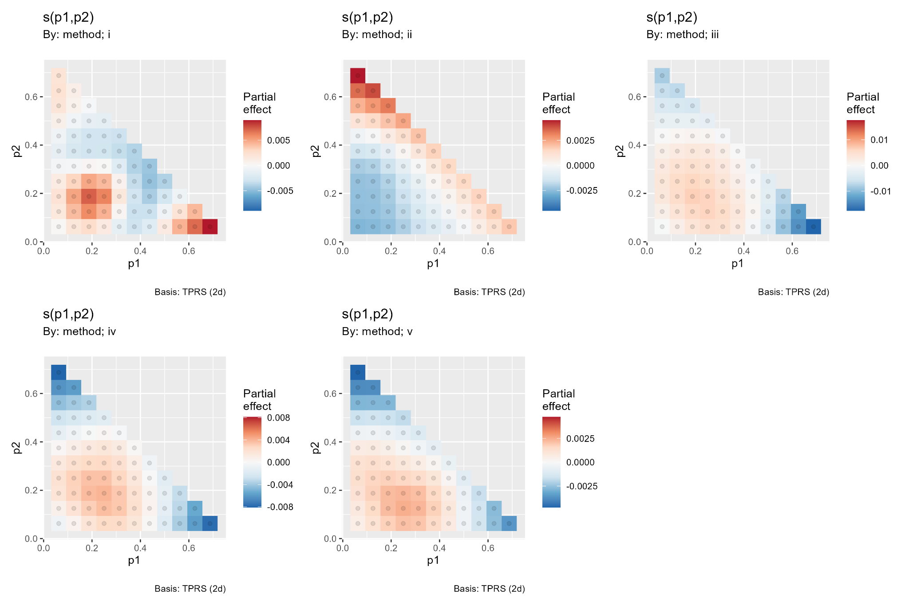
Figure 1. Centered p1-p2 partial effects by method from gratia. Warm colors raise the fitted log1p error relative to the centered method surface and cool colors lower it. Each panel has its own color scale, so morphology is comparable but color magnitude is not.

Morphological interpretation
- Method i has the most localized surface: a positive region occurs near p1 about 0.2 and p2 about 0.2, with negative regions through much of the middle-upper simplex and a positive turn near the high-p1 lower boundary.
- Method ii has the simplest broad gradient. Its fitted effect is relatively low over much of the lower-left interior and increases toward high p2 and the upper-left boundary.
- Method iii shows a broad central positive region and a strong negative gradient toward high p1, especially when p2 is small. Its partial-effect range is visually the largest, consistent with edf 10.61 and the largest smooth F statistic.
- Methods iv and v have closely matched shapes: modest positive effects in the lower-central interior and negative effects toward high p1 and upper-left boundary regions. This similarity supports their classification as morphologically stable estimators over most of the simplex.
- The strongest method separation is expected near simplex boundaries, where the direction and curvature of the method-specific surfaces differ most.
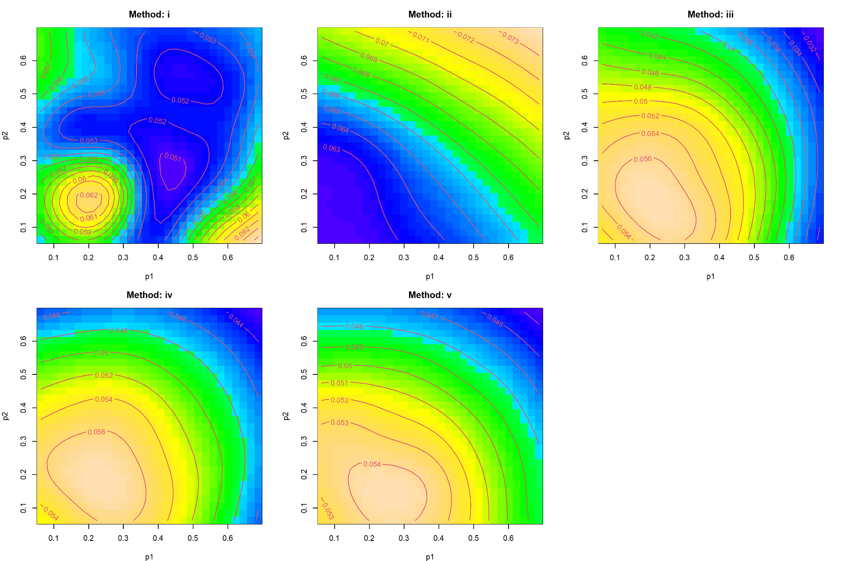
Figure 2. Full fitted method-specific surfaces over p1 and p2. Contour labels are fitted log1p accuracy values under the plotting reference conditions; lower contours indicate better accuracy. These plots incorporate parametric and smooth components and are therefore preferable to partial-effect panels for comparing predicted levels.
The prediction panels reinforce the adjusted hierarchy. Method ii occupies the highest error range, approximately 0.063 to 0.073 in the plotted configuration. Method i is lower but contains a pronounced local peak near p1 = 0.2 and p2 = 0.2. Methods iii, iv, and v generally occupy lower ranges and decline toward high p1. Methods iv and v are almost parallel across the simplex, while iii reaches especially low fitted values near the high-p1 upper boundary. These surfaces show conditional performance, not marginal averages over the full factorial design.

3 Basis Dimension and Global Model Diagnostics
The basis-dimension diagnostic is satisfactory. Every method smooth has k-prime = 29, k-index = 0.98, and a simulation p value between 0.14 and 0.23. The largest effective dimension is 12.87, less than half the available maximum. There is no evidence that k = 30 truncates the fitted global surfaces, and increasing k is unlikely to alter their broad morphology materially.
Smooth | k prime | edf | k index | p value | Assessment
method i | 29 | 12.87 | 0.98 | 0.21 | Adequate
method ii | 29 | 5.22 | 0.98 | 0.22 | Adequate
method iii | 29 | 10.61 | 0.98 | 0.23 | Adequate
method iv | 29 | 8.42 | 0.98 | 0.21 | Adequate
method v | 29 | 6.38 | 0.98 | 0.14 | Adequate

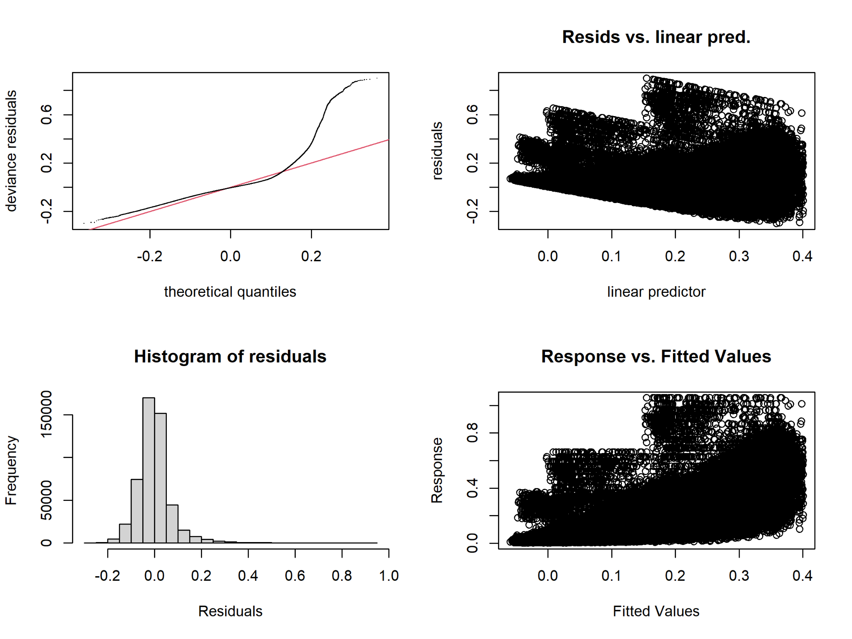
Figure 3. Global GAM diagnostic panel. The Q-Q plot and histogram show a pronounced right tail; residual-versus-predictor and response-versus-fitted panels show structured bands and increasing dispersion. These features concern the Gaussian variance model, not the adequacy of k.

Residual adequacy
The global residuals depart materially from Gaussian homoscedasticity. The Q-Q curve follows the reference line in the central range but bends sharply upward in the upper tail. The histogram is right-skewed with residuals extending toward 1.0. Residual variance changes with the linear predictor, and the banded response-versus-fitted structure indicates unmodeled factorial discreteness, metric-specific variance, or both. With 500,000 observations, coefficient estimates may remain stable, but conventional Gaussian standard errors and smooth-test p values can be anti-conservative under such misspecification.
A stronger inferential analysis should compare the current fit with a location-scale GAM, metric-specific variance model, or robust likelihood. A Gamma response is not directly suitable if zero errors occur; a Tweedie model, scaled-t family, or two-part model can accommodate a point mass near zero and a continuous right tail. Cluster-robust or simulation-block bootstrap uncertainty would further protect against dependence among observations generated from the same scenario or simplex.

4 Targeted Comparison of Methods v and iii
The targeted model explains the magnitude of disagreement between v and iii. It does not retain the sign of v minus iii because the response is log1p(abs(diff)). Consequently, positive fitted values indicate greater absolute separation, not poorer performance by either named method. This distinction is fundamental: the model is suitable for robustness mapping but not for a local superiority map.

Parametric results
Term | Estimate | t statistic | p value | Effect on disagreement magnitude
sigma | 0.004793 | 217.80 | < 2e-16 | Largest increase
theta_true | -0.000741 | -33.68 | < 2e-16 | Moderate decrease
G | -0.000227 | -10.32 | < 2e-16 | Small decrease
mean_nsamp | 0.000184 | 8.37 | < 2e-16 | Small increase
theta_CV | 0.000132 | 6.00 | 1.98e-09 | Very small increase
Negative binomial block | -0.001724 | -39.17 | < 2e-16 | Lower than reference block
Poisson block | -0.001838 | -41.75 | < 2e-16 | Lower than reference block

Sigma is overwhelmingly the dominant linear driver of v-iii separation. The positive coefficient means that the absolute gap grows as noise increases. Higher theta_true and G reduce the gap, while mean sample size and theta_CV increase it slightly. These coefficients act on log(1 + absolute difference); because the differences are small, percentage changes in 1 + difference can look numerically modest even when the relative change in the raw gap is meaningful.
Relative to L1, the metric coefficients for Linf and RMSE are -0.00846 and -0.01200. At the centered surface and reference design, disagreement is therefore largest for L1, smaller for Linf, and smallest for RMSE. The metric-specific surfaces confirm that this ordering is not spatially uniform but is a useful overall characterization.

Metric specific smooths
Metric | edf of 29 | F | p value | Interpretation
L1 | 26.23 | 207.59 | < 2e-16 | Strongest and most detailed surface
Linf | 23.41 | 70.32 | < 2e-16 | Strong complex surface
RMSE | 18.58 | 12.78 | < 2e-16 | Smaller but clear surface

All three surfaces are highly significant. L1 uses 26.2 of the 29 available degrees of freedom, and Linf uses 23.4. The k-index does not diagnose under-dimensioning, but the proximity of L1 edf to k-prime justifies a sensitivity refit at k = 40 or 50. Stability should be judged by comparing fitted surfaces and uncertainty, not by seeking a different p value.
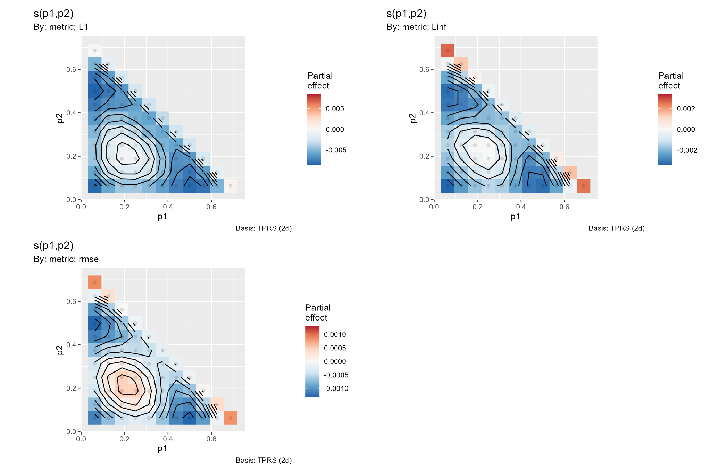
Figure 4. Centered p1-p2 partial effects for the absolute v-iii difference by metric. The surfaces share a central region of relatively small disagreement and stronger boundary behavior. Panel-specific color scales should not be used to compare absolute magnitude among metrics.

5 Spatial Pattern of v and iii Disagreement
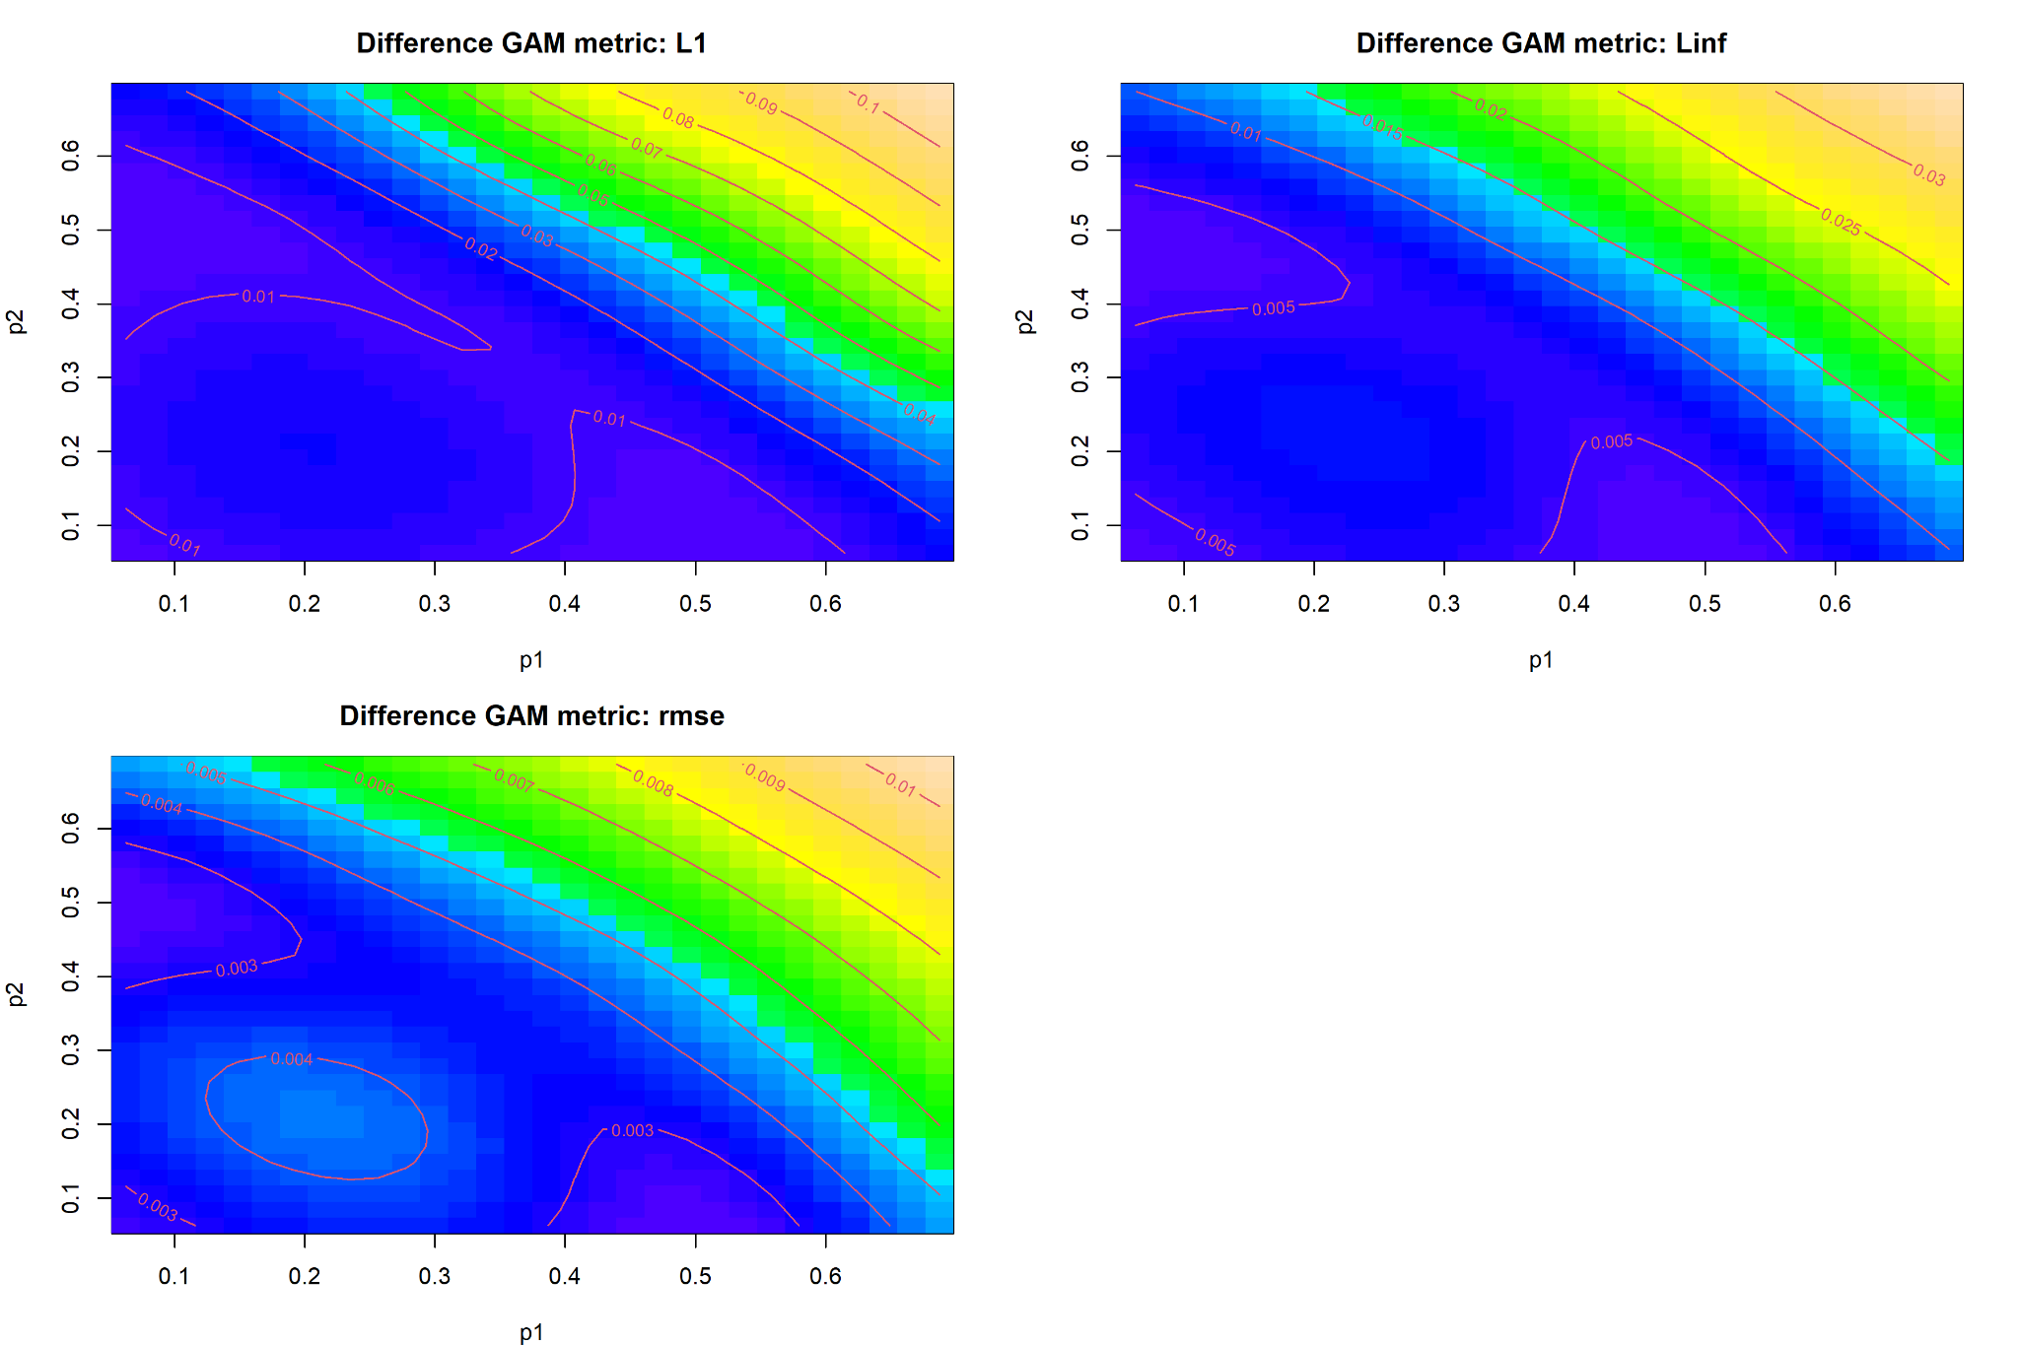
Figure 5. Full fitted surfaces for log1p absolute v-iii differences by metric. Contours show the magnitude of separation. They do not show its sign and therefore cannot identify the locally superior method.
The three metrics share a clear topography. The absolute v-iii gap is comparatively small through the lower-left and central simplex, then rises along a diagonal toward simultaneously large p1 and p2. This boundary escalation is strongest for L1, where contours rise from roughly 0.01 in the interior to 0.08-0.10 near the upper-right edge. Linf rises from about 0.005 to 0.025-0.03, and RMSE rises from approximately 0.003-0.004 to 0.009-0.010. Thus, the two leading methods agree most closely for balanced or moderate compositions and diverge most for compositions concentrated in the first two coordinates.
The surface also contains localized departures from the diagonal gradient. L1 has a shallow low-separation basin near p1 = 0.2 and p2 = 0.2. RMSE shows a small interior feature in the same region. These structures are statistically supported but modest in magnitude. Near the extreme edges, uncertainty should be displayed explicitly because data are sparse and the smooth is extrapolating across fewer nearby compositions.
A signed follow-up model should replace abs(diff) with a direct contrast such as log(error_v + epsilon) minus log(error_iii + epsilon). Contours at zero and simultaneous confidence bands would then identify whether the methods cross and where any superiority is supported. Without that refit, the present surfaces should be described only as maps of disagreement.

Difference model diagnostics
Smooth | k prime | edf | k index | p value | Assessment
L1 | 29 | 26.2 | 1.04 | 0.85 | Pass; larger-k sensitivity advisable
Linf | 29 | 23.4 | 1.04 | 0.83 | Pass
RMSE | 29 | 18.6 | 1.04 | 0.87 | Pass

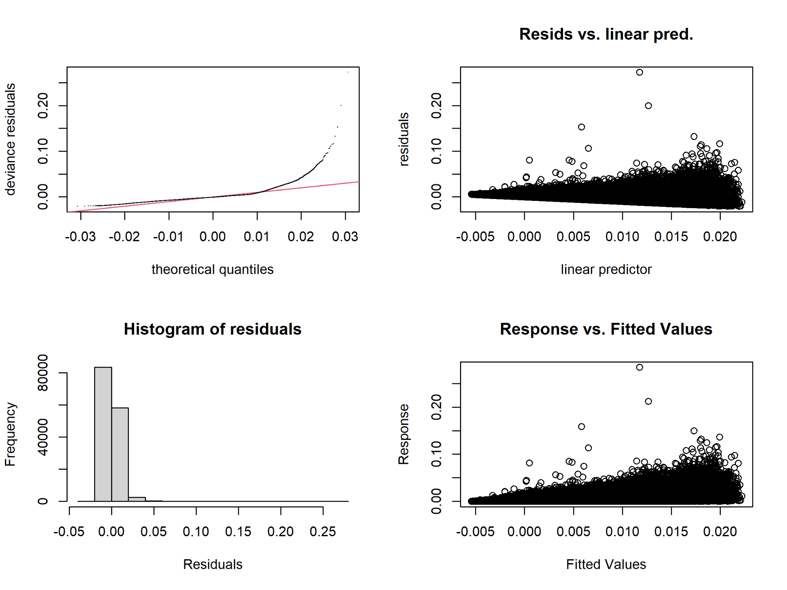
Figure 6. Diagnostic panel for the absolute v-iii difference GAM. Residuals remain right-skewed and heteroscedastic, with several influential positive observations. The deviations are smaller in absolute scale than in the global model but remain inferentially relevant.
The difference-model Q-Q plot has a marked positive-tail departure, and the residual-versus-linear-predictor panel forms a wedge. Several extreme observations reach residuals near 0.25. The Gaussian identity fit can also generate slightly negative predictions for a nonnegative response. These findings favor a nonnegative likelihood or robust sensitivity model, while retaining the current GAM as a descriptive surface estimator.

6 Integrated Interpretation and Recommendations
The Code E analysis adds a spatial robustness dimension to the earlier factorial comparisons. The broad hierarchy is stable: ii is least accurate; iii and v are the leading methods; iv is competitive but intermediate; and i has stronger local irregularity. The global adjusted ranking is metric-dependent, with iii best for RMSE and v marginally best for L1 and Linf at the reference configuration. Differences between iii and v are small compared with the large effect of G and sigma, so experimental conditions matter more than choosing between the two leading estimators in many parts of the design space.
The simplex surfaces refine this conclusion. Methods iii, iv, and v share a broad low-error region and generally improve toward high p1. Methods iv and v are especially similar in morphology. Method i has localized peaks and valleys, implying greater sensitivity to composition geometry. Method ii combines the highest adjusted error with a relatively simple diagonal surface; its inferiority is broad rather than confined to a narrow niche.
Methods v and iii are most interchangeable across the central simplex and least interchangeable near high-p1 and high-p2 boundaries. L1 exhibits the largest disagreement, followed by Linf and RMSE. However, because the targeted model discards the sign, these regions cannot be labeled as v-favorable or iii-favorable. A signed contrast GAM is required for that decision.

Recommended methodological actions
- Retain k = 30 for the global GAM. Refit the difference GAM with k = 40 or 50 as a sensitivity check for the L1 surface because its edf is 26.2 of 29.
- Fit a signed v-minus-iii log-error contrast and plot zero contours with simultaneous confidence intervals to locate supported crossovers.
- Address heteroscedasticity using a location-scale GAM, robust scaled-t family, Tweedie or two-part model, or scenario-level bootstrap. Compare surfaces rather than p values alone.
- Use a common color scale and prediction grid for publication figures. Add uncertainty masks or standard-error contours and visibly mark regions with sparse simplex support.
- Report response-scale predictions using exp(fitted) minus 1, while noting that back-transforming expected log1p error does not equal the expected raw error without bias correction.
- Validate the method hierarchy with out-of-sample or held-out simulation scenarios, stratified by sigma, G, metric, and boundary proximity.

Final statistical conclusion
Code E provides strong evidence that composition geometry and the simulation design jointly influence estimator accuracy. G and sigma dominate the factorial effects, while the p1-p2 surface changes by method and metric. Method ii is not recommended when estimation accuracy is the primary criterion. Methods iii and v are the preferred estimators: iii has the lowest adjusted RMSE, whereas v has slightly lower adjusted L1 and Linf under the model reference configuration. Method v and iii are effectively close over much of the simplex, but their separation grows near high-p1 and high-p2 boundaries. Because residual misspecification is visible and the targeted comparison is unsigned, the most defensible recommendation is to retain both iii and v as leading candidates until a signed, heteroscedasticity-robust contrast analysis confirms local dominance.

Source material
results-code-E.txt and six associated Code E plots covering the global and v-versus-iii gam.check diagnostics, gratia smooths, method surfaces, and metric-specific difference surfaces.

