Factorial assessment of composition estimation strategies:
Simulation evidence for linear Dirichlet-multinomial estimators

Jon K. T. Brodziak¹, Matthew Supernaw², Kelli F. Johnson³
¹ Pacific Islands Fisheries Science Center, NOAA Fisheries, Honolulu, HI, USA
² Office of Science and Technology, NOAA Fisheries, St. Petersburg, FL, USA
³ Office of Science and Technology, NOAA Fisheries, Seattle, WA, USA

Abstract
Compositional data describing the age or size structure of fish populations are central inputs to integrated stock assessment models. However, these data are often overdispersed and correlated relative to multinomial sampling assumptions. We compare the following five estimators for estimating proportions at age or size from composition data: (i) an unconstrained Dirichlet-multinomial concentration-vector estimator, (ii) a saturated Dirichlet-multinomial estimator with an estimated total concentration, (iii) a linear Dirichlet-multinomial estimator with fixed scaling parameter, (iv) a multinomial estimator, and (v) a linear Dirichlet-multinomial estimator with an estimated scaling parameter. We apply a mesh-based simulation design over the simplex of feasible proportions to evaluate relative estimator accuracy under a factorial experiment with 5 factors. The simulated composition data were generated from a Dirichlet-multinomial operating model. The experiment varied the number of sampled groups, the mean sample size by group, the between-group composition variability, the true concentration, and the concentration heterogeneity. Estimation accuracy was measured by root mean square error, total absolute error, and maximum error. These accuracy performance measures were analyzed on log-transformed error scales using factorial MANOVA/ANOVA, mixed-effects models, pairwise Hotelling contrasts, generalized additive models over the simplex, and rank-based summaries. We repeated the experiment using simulated composition data constrained to fall within the observed survey data from the 2026 Pacific hake stock assessment. In addition, we conducted a sensitivity analysis experiment with a multinomial operating model and a reduced factorial design. The results were indicated that methods (v) and (iii) form the leading tier, method (iv) is a strong secondary estimator, method (i) is an intermediate baseline, and method (ii) is the least reliable. Method (v) has the strongest support by log-error magnitude and estimated marginal means, while method (iii) is nearly tied and provides strong rank robustness. The results of the sensitivity analysis produced the same rankings. Overall, the practical conclusion is that linear Dirichlet-multinomial estimators provide the best-supported general-purpose platform, with the choice between fixed and estimated scaling parameter depending on prior information, numerical stability, and implementation goals.
Keywords: Dirichlet-multinomial, composition data, effective sample size, overdispersion, stock assessment, likelihood weighting, simulation experiment, log-error analysis

1. Introduction
Age- and size-composition data provide essential information on recruitment, growth, mortality, and selectivity in integrated stock assessment models. The standard multinomial likelihood treats observed counts as independent draws with fixed probabilities for each category, but composition samples collected from fisheries and surveys often show extra-multinomial variation because fish are sampled in clusters, group-level compositions differ, and sampling protocols induce correlations among categories.
The Dirichlet-multinomial distribution is a practical extension of the multinomial likelihood because it allows the category probabilities to vary among sampling units. This extra variation is governed by concentration parameters, and different parameterizations of those concentration parameters can have different numerical and statistical behavior even when they describe closely related likelihood families.
The goal of this study is to identify which estimation methods provide accurate and stable recovery of the underlying three-proportion composition vector. The problem is that estimator performance depends on both the likelihood parameterization and the simulation environment, especially sample size, overdispersion, and between-group variation. The solution is to compare estimators using a factorial simulation design over the simplex and to summarize results with complementary statistical analyses of log-transformed accuracy metrics. We compare the following five estimators: (i) an unconstrained Dirichlet-multinomial concentration-vector estimator, (ii) a saturated Dirichlet-multinomial estimator with group-specific total concentration, (iii) a linear Dirichlet-multinomial estimator with fixed theta, (iv) a multinomial estimator, and (v) a linear Dirichlet-multinomial estimator with theta estimated.

2. Model framework outline
The model framework explains how the Factorial Assessment of Composition Estimation Strategies (FACES) study compared five estimators of a three-component composition vector under controlled numerical experiments. This section proceeds from the common probability model and notation, through the factorial design and simulation operating model, to estimator fitting, accuracy measurement, experiment-level summaries, and the complementary multivariate analyses. This makes the distinction between data generation, estimation, and performance evaluation explicit.
The primary inferential objective was to determine whether the five estimation strategies differed in accuracy and whether their relative performance changed with the simulation environment. The analysis therefore addressed two linked questions: (1) which methods had the smallest estimation errors on average, and (2) which design factors explained variation in absolute and relative performance. Evidence was intentionally combined across error magnitude, ranks, repeated-measures comparisons, multivariate tests, mixed models, and smooth response surfaces because no single statistic fully characterizes estimator performance.

Test-case structure
The paper should introduce the four test cases before describing the common simulation machinery. Each test case should be named, its operating model identified as Dirichlet-multinomial or multinomial, and its simplex domain identified as the full simplex or an application-specific restricted domain. The common algorithms described below can then be referenced rather than repeated for every case.
The four test cases consisted of the following configurations:
- A Dirichlet-multinomial operating model evaluated over the full interior simplex, implemented in the analytical script faces.R with 3 composition categories and default category proportion bounds $0≤p_{k}≤1$.
- A Dirichlet-multinomial operating model experiment restricted to the region of the simplex represented by 2026 Pacific hake survey compositions, with 3 composition categories.
- A multinomial-operating-model sensitivity experiment with 3 composition categories implemented in an extension of the analytical script faces.R.
- A fourth test case that extends test case 1 to be evaluated with 6 composition categories and default category proportion bounds $0≤p_{k}≤1$.
Each test case needs to have a specific goal and be assigned a definitive name and design that provides the exact hake bounds and multinomial-operating-model script.

Composition data and probability models
The common model framework defines the observed composition data before describing the five estimators. Let $g=1,…,G$ index sampled groups and $k=1,…,K$ index composition categories. For group $g$, let
$$x_{g}={\left(x_{g1},…,x_{gK}\right)}^{T}, N_{g}=\sum_{k=1}^{K}{x_{gk}},$$
and let $p={\left(p_{1},…,p_{K}\right)}^{T}$ denote the target composition, where $p_{k}>0$ and k​pk=1. The simulations used $K=3$, so $p_{3}=1-p_{1}-p_{2}$ and the feasible compositions can be represented on a two-dimensional simplex.
For a Dirichlet-multinomial observation with total concentration $a_{0g}$ and mean composition $p$,
$$Pr\left(X_{g}=x_{g}∣N_{g},p,a_{0g}\right)=\frac{N_{g}!}{\prod_{k=1}^{K}{x_{gk}}!}\frac{Γ\left(a_{0g}\right)}{Γ\left(N_{g}+a_{0g}\right)}\prod_{k=1}^{K}{\frac{Γ\left(x_{gk}+a_{0g}p_{k}\right)}{Γ\left(a_{0g}p_{k}\right)}}.$$
Equivalently, a latent group composition is drawn as $ϕ_{g}∼Dirichlet\left(a_{0g}p\right)$, followed by $X_{g}∣ϕ_{g}∼Multinomial\left(N_{g},ϕ_{g}\right)$. Smaller $a_{0g}$ produces greater extra-multinomial variation, whereas the distribution approaches a multinomial as $a_{0g}$ becomes large.
The multinomial comparison model is
$$Pr\left(X_{g}=x_{g}∣N_{g},p\right)=\frac{N_{g}!}{\prod_{k=1}^{K}{x_{gk}}!}\prod_{k=1}^{K}{p_{k}^{x_{gk}}}.$$
The optimization code omitted the multinomial coefficient from the log likelihood because it is constant with respect to the estimated parameters. Positivity and the unit-sum constraint were imposed through a baseline-category softmax transformation. For $z∈R^{K-1}$, the code formed $v=\left(z_{1},…,z_{K-1},0\right)$ and used
$$p_{k}\left(z\right)=\frac{exp\left(v_{k}\right)}{\sum_{j=1}^{K}{exp}\left(v_{j}\right)}.$$

Factorial experimental design and computational workflow
The factorial design varied five three-level factors within each sample-size-distribution block. The factors and retained levels were:
Factor | Levels | Role in the experiment
Mean group sample size, $μ_{N}$ (mean_nsamp) | 25, 50, 100 | Controlled the expected information per sampled group.
Between-group log-composition SD, $σ$ | 0.25, 0.50, 1.00 | Controlled departure of group compositions from the target composition.
Baseline concentration weight, $θ_{true}$ | 0.5, 1.0, 2.0 | Controlled Dirichlet concentration relative to $N_{g}$.
Concentration coefficient of variation, $CV_{θ}$ | 0, 0.2, 0.6 | Controlled heterogeneity in concentration weights among groups.
Number of sampled groups, $G$ | 2, 4, 8 | Controlled the amount of group-level replication.
Within a sample-size block, the full crossing contained $3^{5}=243$ factorial combinations. The retained design used three sample-size distributions—Poisson, lognormal, and negative binomial—so the intended three-block design contains $3×243=729$ experiments per test case. The design held the lognormal log-scale SD at $τ=1$ and the negative-binomial size parameter at $r=25$.
The source files contain a run-count discrepancy that must be resolved in the paper. build_design_matrix.R constructs four blocks by additionally including a log-uniform block, giving $4×243=972$ candidate experiments. In contrast, write_input_files.R explicitly removes the log-uniform block, renumbers the remaining rows, and writes 729 input files. The summarize_faces_lst_files.R analyzes the log files from the 729 experiments.

Sample-size distributions
Group sample sizes were generated independently for each simulated dataset and group. All draws were constrained to be at least one.
For the Poisson block,
$$N_{g}=max\{1,Y_{g}\}, Y_{g}∼Poisson\left(μ_{N}\right).$$
For the lognormal block, a continuous draw was generated with log-scale SD $τ=1$ and mean $μ_{N}$, then rounded to the nearest integer:
$$Y_{g}∼Lognormal​\left(logμ_{N}-\frac{τ^{2}}{2},τ^{2}\right), N_{g}=max\{1,round\left(Y_{g}\right)\}.$$
For the negative-binomial block, the R mean-size parameterization was used:
$$N_{g}=max\{1,Y_{g}\}, Y_{g}∼NegBin\left(μ_{N},r\right), Var\left(Y_{g}\right)=μ_{N}+\frac{μ_{N}^{2}}{r},$$
with $r=25$. These distributions changed the allocation and variability of information among groups even when their target means were identical. The number of groups was controlled separately by $G$; the sample-size distribution controlled the values of $N_{g}$, not the number of groups.

Design construction, input generation, and batch execution
The computational workflow can be described in three reproducible stages.
First, build_design_matrix.R generated the Cartesian product of the five factor levels within each distribution block. Factor level codes $\left(-1,0,1\right)$ were retained in the design metadata, and $G$ cycled fastest in the row ordering. Fixed settings were $K=3$, simplex increment parameter $h=0.10$, five simulation replicates per simplex point (nsims = 5), and overdispersion multiplier od_mult = 1. The default full-simplex bounds were $p_{min}=\left(0,0,0\right)$ and $p_{max}=\left(1,1,1\right)$.
Second, write_input_files.R removed the deprecated log-uniform block, assigned a unique positive integer seed to each retained experiment, and wrote one key = value input file per design row. The input manifest recorded the experiment identifier, block, distribution code, $G$, random seed, and distribution-specific parameters. Unique seeds separated Monte Carlo draws among factorial experiments while permitting reproducible regeneration when the seed-generator seed was specified.
Third, run_experiments.R processed the input files sequentially. For experiment $e$, it copied faces_exe.inp to the generic faces.inp, evaluated faces.R in a new environment, restored the original input file, and archived all outputs in directory exe. The principal log was renamed faces_exe.lst; data tables, estimated-marginal-mean summaries, simplex samples, and graphics were renamed with the same experiment stem. This organization preserved a one-to-one mapping among the factorial design row, input parameters, random seed, and outputs.

Operating model and simulated-data generation
The operating model generated replicated composition datasets at a regular set of points in the interior of the simplex. The following steps were used to generate and analyze simulated data in this specific computational order.

Step 1: Construct the simplex mesh
The simplex algorithm set $M=⌈1/h⌉$ and enumerated all nonnegative integer vectors $q=\left(q_{1},…,q_{K}\right)$ satisfying k​qk=M. Each integer composition was transformed to
$$p_{k}=\frac{q_{k}+1}{M+K}, k=1,…,K.$$
The addition of one kept every component strictly positive. With $K=3$ and $h=0.10$, $M=10$ and the mesh contained $\left({M+K-1 \atop K-1}\right)=\left({12 \atop 2}\right)=66$ interior simplex points. Optional lower and upper component bounds were applied after mesh construction. Each point was repeated nsims = 5 times, producing $66×5=330$ simulated datasets for a full-simplex factorial experiment before any bound-based filtering.

Step 2: Draw group sample sizes
For every simplex point and replicate, the operating model independently generated $G$ sample sizes from the experiment’s Poisson, lognormal, or negative-binomial block. The resulting vector was $N=\left(N_{1},…,N_{G}\right)$. Realized means, SDs, and selected quantiles were written to the experiment log as a diagnostic check on the sample-size generator.

Step 3: Generate group-specific concentration weights
The group-specific concentration weight was lognormally distributed with specified arithmetic mean $θ_{true}$ and coefficient of variation $CV_{θ}$. The code used
$$σ_{θ}=\sqrt{log\left(1+CV_{θ}^{2}\right)}, θ_{g}=θ_{true}exp​\left(ε_{θg}-\frac{σ_{θ}^{2}}{2}\right), ε_{θg}∼N\left(0,σ_{θ}^{2}\right).$$
Thus $E\left(θ_{g}\right)=θ_{true}$. Total concentration was linked linearly to sample size:
$$a_{0g}=\left(θ_{g} c_{OD}\right)N_{g},$$
where the overdispersion multiplier was $c_{OD}=1$ in the default factorial design.

Step 4: Introduce between-group composition variability
The target simplex point $p^{true}$ was perturbed independently for each group on the log scale. For category $k$,
$$z_{gk}=logp_{k}^{true}+ε_{gk}, ε_{gk}\overset{iid}{∼}N\left(0,σ^{2}\right),$$
and the group composition was obtained by renormalization,
$$p_{gk}=\frac{exp\left(z_{gk}\right)}{\sum_{j=1}^{K}{exp}\left(z_{gj}\right)}.$$
The factor $σ$ therefore controlled heterogeneity in mean composition among sampled groups. This source of variation is distinct from the Dirichlet-multinomial observation layer and from heterogeneity in $θ_{g}$.

Step 5: Generate Dirichlet-multinomial observations
For the Dirichlet-multinomial operating model, category concentrations were $α_{gk}=a_{0g}p_{gk}$. The latent composition and observed counts were generated as
$$ϕ_{g}∼Dirichlet\left(α_{g}\right), X_{g}∣ϕ_{g}∼Multinomial\left(N_{g},ϕ_{g}\right).$$
The code implemented the Dirichlet draw using independent gamma variables with common rate one followed by normalization. This operating model incorporated both group-level shifts in expected composition and extra-multinomial sampling variation.

Step 6: Generate multinomial observations for sensitivity cases
For a multinomial operating model, the natural corresponding observation step is
$$X_{g}∼Multinomial\left(N_{g},p_{g}\right),$$
without the latent Dirichlet draw. This formulation retains group-level perturbations when $σ>0$ but removes Dirichlet-multinomial overdispersion conditional on $p_{g}$. The supplied faces.R implements only the Dirichlet-multinomial generator, so the final paper should verify this equation and the reduced factor levels against the production multinomial test-case script.

Composition estimation strategies
All five methods estimated a single target composition from the $G$ observed group count vectors. Let
$$l_{DM}\left(x_{g};p,a_{0g}\right)=logΓ\left(a_{0g}\right)-logΓ\left(N_{g}+a_{0g}\right)+\sum_{k=1}^{K}{\left[logΓ\left(x_{gk}+a_{0g}p_{k}\right)-logΓ\left(a_{0g}p_{k}\right)\right]}$$
denote the parameter-dependent part of the group Dirichlet-multinomial log likelihood.

Method (i): unconstrained Dirichlet-multinomial concentration vector
Method (i) estimated one positive concentration parameter $α_{k}$ for each category, shared across groups. With $α_{k}=exp\left(t_{k}\right)$ and α0=k​αk, it maximized
$$l_{i}\left(α\right)=\sum_{g=1}^{G}{\left\{logΓ\left(α_{0}\right)-logΓ\left(N_{g}+α_{0}\right)+\sum_{k=1}^{K}{\left[logΓ\left(x_{gk}+α_{k}\right)-logΓ\left(α_{k}\right)\right]}\right\}}.$$
The estimated composition was ${\hat{p}}_{ik}={\hat{α}}_{k}/{\hat{α}}_{0}$. This method used $K$ free log-concentration parameters and did not explicitly link total concentration to group sample size.

Method (ii): saturated Dirichlet-multinomial
Method (ii) estimated a common composition and a separate total concentration for every group. It used $p=softmax\left(z\right)$ and $a_{0g}=exp\left(t_{g}\right)$ and maximized
$$l_{ii}\left(p,a_{01},…,a_{0G}\right)=\sum_{g=1}^{G}{l_{DM}}\left(x_{g};p,a_{0g}\right).$$
The model therefore contained $\left(K-1\right)+G$ free parameters. Its flexibility allowed concentration to differ among groups without imposing the linear $N_{g}$ relationship, but it also increased parameter dimension as $G$ increased.

Method (iii): linear Dirichlet-multinomial with fixed scaling
Method (iii) fixed the scaling parameter at the operating-model value $θ_{true}$ and constrained total concentration to
$$a_{0g}=θ_{true}N_{g}.$$
It estimated only the $\left(K-1\right)$ composition logits by maximizing
$$l_{iii}\left(p\right)=\sum_{g=1}^{G}{l_{DM}}\left(x_{g};p,θ_{true}N_{g}\right).$$
This estimator represents the case in which the linear concentration weight is known from design information or external calibration.

Method (iv): multinomial estimator
Method (iv) pooled the counts under the multinomial likelihood. Its maximum-likelihood estimate was
$${\hat{p}}_{iv,k}=\frac{\sum_{g=1}^{G}{x_{gk}}}{\sum_{g=1}^{G}{N_{g}}}.$$
This method provided a simple benchmark that ignored extra-multinomial variation and group-specific concentration.

Method (v): linear Dirichlet-multinomial with estimated scaling
Method (v) retained the linear relationship $a_{0g}=θN_{g}$ but estimated one common positive scaling parameter, $θ=exp\left(t\right)$. It maximized
$$l_{v}\left(p,θ\right)=\sum_{g=1}^{G}{l_{DM}}\left(x_{g};p,θN_{g}\right).$$
The estimator contained $K$ free parameters: $\left(K-1\right)$ composition logits and one log-scaling parameter. It preserved the sample-size link while learning the overall concentration weight from the data.

Numerical optimization
Methods (i), (ii), (iii), and (v) were fitted by BFGS optimization with analytic gradients, a maximum of 500 iterations, and relative tolerance ${10}^{-10}$. Starting compositions were obtained from pooled counts after replacing zero pooled categories by one. Method (i) initialized total concentration at one; group log concentrations for method (ii) and log $θ$ for method (v) were initialized at zero. Failed optimizations for methods (ii), (iii), and (v) were returned as missing estimates, whereas method (iv) was available in closed form. The paper should state how failed fits were counted or excluded in aggregate analyses.

Estimation-accuracy measures
The accuracy measures compared each fitted composition ${\hat{p}}_{m}$ with the target simplex point $p^{true}$. For method $m$,
$${RMSE}_{m}=\sqrt{\frac{1}{K}\sum_{k=1}^{K}{{\left({\hat{p}}_{mk}-p_{k}^{true}\right)}^{2}}},$$
$$L_{1,m}=\sum_{k=1}^{K}{\left|{\hat{p}}_{mk}-p_{k}^{true}\right|},$$
and
$$L_{∞,m}=\max_{1≤k≤K}\left|{\hat{p}}_{mk}-p_{k}^{true}\right|.$$
RMSE emphasized squared component deviations, $L_{1}$ measured total absolute discrepancy, and $L_{∞}$ measured the largest component error. The three measures were retained because methods can differ in their control of average, aggregate, and worst-component error. Mean values over the five replicates at each simplex point were also used for ternary accuracy surfaces.

Univariate comparisons within each factorial experiment
The single-experiment script compared methods separately for RMSE, $L_{1}$, and $L_{∞}$ using the raw accuracy values. The simulated dataset identifier—simplex point crossed with replicate—served as the repeated-measures block because every method was applied to the same generated counts.

Friedman test and Kendall’s concordance
For each metric, the Friedman rank-sum test evaluated
$$H_{0}:\text{the five methods have the same within-dataset rank distribution}$$
against the alternative that at least one method differed. The reported statistic was Friedman’s $χ_{F}^{2}$ with $K_{m}-1=4$ degrees of freedom, where $K_{m}=5$ was the number of methods. Kendall’s coefficient of concordance was calculated as
$$W=\frac{χ_{F}^{2}}{n\left(K_{m}-1\right)},$$
where $n$ was the number of simulated datasets in the experiment. $W$ summarized the strength of systematic method differences on a scale from zero to one.

Paired Wilcoxon comparisons and relative-error summaries
All ten method pairs were compared with paired Wilcoxon signed-rank tests. For methods $a$ and $b$, the null hypothesis was that the paired difference had zero location shift. The omnibus pairwise $p$-values were adjusted by Holm’s method within each metric. Separate paired Wilcoxon calls produced confidence intervals for the location shift with exact = FALSE; these intervals were not multiplicity-adjusted in the script.
The magnitude of each pairwise difference was also summarized as a percentage change,
$$Δ_{b:a}=100 \frac{D_{b}-D_{a}}{D_{a}},$$
where $D_{m}$ denoted the selected distance for method $m$. The script reported the median, interquartile range, and 25th and 75th percentiles of $Δ_{b:a}$ across paired datasets.

Random-intercept linear mixed models
For each raw distance metric, the script fitted
$$D_{dm}=μ+τ_{m}+b_{d}+ε_{dm}, b_{d}∼N\left(0,σ_{b}^{2}\right),$$
where $d$ indexed simulated datasets and $m$ indexed methods. The null hypothesis was $H_{0}:τ_{1}=⋯=τ_{5}=0$, meaning no adjusted method effect. lmerTest supplied an ANOVA test with Satterthwaite denominator degrees of freedom. Estimated marginal means, 95% confidence intervals, and Holm-adjusted pairwise comparisons summarized the direction and magnitude of method differences. Singular-fit warnings were recorded because a negligible dataset-level variance component would weaken the justification for the random intercept.

Across-experiment summaries and distance correlations
The experiment-log summarizer linked each exe/faces_exe.lst file to its experiment number and sample-size distribution. It extracted the estimated marginal mean for each method and metric, selected the method with the minimum marginal mean as the experiment-level winner, and tabulated winner frequencies by sample-size distribution for RMSE, $L_{1}$, and $L_{∞}$.

Correlations within method across experiments
For every method, Spearman rank correlations were calculated across factorial experiments for each metric pair: RMSE versus $L_{1}$, RMSE versus $L_{∞}$, and $L_{1}$ versus $L_{∞}$. For metric pair $\left(r,s\right)$ and method $m$, the test evaluated
$$H_{0}:ρ_{S,m}^{\left(r,s\right)}=0 \text{versus} H_{A}:ρ_{S,m}^{\left(r,s\right)}≠0.$$
The output included the number of complete experiment pairs, Spearman’s ${\hat{ρ}}_{S}$, the R cor.test $S$ statistic, and the two-sided asymptotic $p$-value (exact = FALSE). Raw significance at $α=0.05$ and Holm-adjusted significance across the 15 within-method tests were reported.

Correlations of method-averaged metrics across experiments
To evaluate agreement among distance measures without conditioning on method, the script first averaged each metric across the five methods within each experiment,
$${\overline{D}}_{e,r}=\frac{1}{5}\sum_{m=1}^{5}{D_{e,m,r}}.$$
Only experiments with finite values for all five methods contributed to the average. Spearman correlations were then calculated across experiments for the same three metric pairs. The null hypothesis was zero rank association between the two method-averaged metrics. These three rows were appended after the 15 method-specific rows in distance_correlations.csv, with Holm adjustment applied across the three method-averaged tests.

Multivariate and factorial statistical analyses
The across-experiment analyses used long- and wide-format accuracy tables derived from the archived experiment outputs. Nonnegative distances were transformed where stated to reduce right skew and stabilize variance. The scripts used either $log\left(1+D\right)$ or $log\left(D+{10}^{-6}\right)$; these transformations should not be described as interchangeable because they have different interpretations near zero.

Code A: factorial MANOVA, component ANOVAs, and marginal means
Code A tested whether method and the simulation factors affected the joint distribution of transformed RMSE and $L_{1}$. It analyzed a reproducible, partition-balanced sample of at most 500,000 complete rows. Define the design-factor set as
$$F=\{block,G,θ_{true},CV_{θ},σ,μ_{N},p_{1},p_{2}\}.$$
The multivariate model was written compactly as
log1+RMSE,log1+L1∼method+f∈F​f+f∈F​method:f.
For each main effect or method interaction, the MANOVA null hypothesis was that the corresponding coefficient matrix was zero for both responses. Pillai’s trace was the primary multivariate evaluation statistic, accompanied by its approximate $F$ statistic, numerator and denominator degrees of freedom, and $p$-value. Response-specific ANOVA tables decomposed significant multivariate effects for transformed RMSE and $L_{1}$.
Because $L_{∞}$ was modeled separately, Code A fitted the same factorial formula to $log\left(1+L_{∞}\right)$ with ordinary least squares and reported the coefficient summary and ANOVA $F$ tests. Separate linear models for all three metrics supplied estimated marginal means for method at a representative condition: categorical factors at their modal fitted levels and $p_{1},p_{2}$ at their sample means. Pairwise method contrasts used Holm adjustment. The main inferential role of Code A was to test global method effects, design-factor effects, and method-by-factor interactions while retaining metric-specific interpretation.

Code B: weighted mixed-effects model with simplex random effects
Code B accounted for repeated measurements associated with simplex location. Individual observations were first reduced to means of $log\left(1+D\right)$ within simplex-by-experiment-by-method-by-metric cells, with the number of original observations retained as a prior weight. A reproducible sample of complete simplex groups was used if the reduced table exceeded 20,000 simplex identifiers.
Using the design-factor set $F$ defined above, the model was
log1+D∼method*metric+f∈F​method*f+1∣simplex_id.
The fixed-effect null hypothesis for each Type III term was that all coefficients associated with that adjusted term were zero. Sum-to-zero contrasts supported Type III interpretation, and Satterthwaite-adjusted $F$ statistics, denominator degrees of freedom, and $p$-values were reported. The random-intercept variance quantified residual heterogeneity among simplex locations after adjustment for $p_{1}$ and $p_{2}$. Estimated marginal means compared methods within each metric and after equal averaging over metrics at a documented representative design condition; pairwise tests used Holm adjustment. Convergence messages and the singular-fit diagnostic were retained as model-quality checks.

Code C: pairwise one-sample Hotelling tests on log-error contrasts
Code C tested every pair of methods using the joint vector of metric-specific log-error differences. Within each experiment-design-simplex cell, the code formed
$$y_{a:b}=\left(\begin{matrix}log\left({RMSE}_{a}+ϵ\right)-log\left({RMSE}_{b}+ϵ\right) \\ log\left(L_{1,a}+ϵ\right)-log\left(L_{1,b}+ϵ\right) \\ log\left(L_{∞,a}+ϵ\right)-log\left(L_{∞,b}+ϵ\right)\end{matrix}\right), ϵ={10}^{-6}.$$
For each of the ten method pairs, the hypothesis was
$$H_{0}:E\left(y_{a:b}\right)=0 \text{versus} H_{A}:E\left(y_{a:b}\right)≠0.$$
The test statistic was Hotelling’s
$$T^{2}=n {\overline{y}}^{T}S^{-1}\overline{y},$$
with $p=3$ responses and equivalent
$$F=\frac{n-p}{p\left(n-1\right)}T^{2}∼F_{p,n-p}$$
under the null hypothesis. The script also reported the equivalent one-sample Pillai quantity $V=T^{2}/\left(T^{2}+n-1\right)$ and the $p$-value. Mean log differences were exponentiated to error ratios, $exp\left({\overline{y}}_{r}\right)$, and percent changes, $100\left[exp\left({\overline{y}}_{r}\right)-1\right]$. Negative log differences indicated lower error for the target method. Code C did not adjust the ten global pairwise $p$-values for multiplicity; the manuscript should either state that they were treated as planned contrasts or apply and report a familywise adjustment.

Code D: factorial MANOVA of raw pairwise error differences
Code D asked which design conditions changed the relative advantage of one method over another. For each method pair and metric, it calculated the raw difference $D_{a}-D_{b}$, with the second method in the enumerated pair treated as the target. The full response vector was
$$δ_{a:b}={\left(ΔRMSE,ΔL_{1},ΔL_{∞}\right)}^{T},$$
and the factorial model included additive predictors
$$δ_{a:b}∼block+G+θ_{true}+CV_{θ}+σ+μ_{N}+p_{1}+p_{2}.$$
For each predictor, the null hypothesis was that its adjusted multivariate effect on the pairwise difference vector was zero. Pillai’s trace, approximate $F$, numerator and denominator degrees of freedom, and $p$-value evaluated the joint hypothesis; component ANOVA $F$ tests showed which distance metrics contributed to the effect.
Before the MANOVA summary, the script examined the numerical rank of the residual response matrix. If RMSE, $L_{1}$, and $L_{∞}$ were exactly linearly dependent, it retained a deterministic maximal subset of at least two independent responses for the joint test while still fitting all three responses for the univariate ANOVAs. At most 500,000 rows per pair were retained using reproducible partition-wise sampling. Code D did not apply a multiplicity correction across method pairs or factorial terms, so the final paper should specify whether these tests were confirmatory or exploratory.

Code E: generalized additive models over the simplex
Code E evaluated nonlinear variation in accuracy over simplex location. Let $F_{0}=\{block,G,θ_{true},CV_{θ},σ,μ_{N}\}$. The global model was fitted with mgcv::bam:
log1+D∼metric*method+smp1,p2;k=30+f∈F0​f.
where $s_{m}$ was a method-specific bivariate smooth and $k=30$ was the basis dimension. The model used fast restricted maximum likelihood (fREML) and discrete fitting. The parametric tests evaluated zero adjusted coefficients for the corresponding main effects and interactions. For each smooth, the approximate null hypothesis was that the adjusted surface contribution was zero over the sampled simplex; the summary reported effective degrees of freedom, reference degrees of freedom, approximate $F$, and $p$-value. gam.check, residual diagnostics, and the basis-dimension check were used to evaluate adequacy, while contour and gratia plots displayed the conditional surfaces.
A second GAM focused on the magnitude of the difference between methods (v) and (iii). After averaging duplicate method cells, it defined $Δ=D_{v}-D_{iii}$ and fitted
log1+Δ∼metric+smetricp1,p2;k=30+f∈F0​f.
This model tested where the two leading methods differed in magnitude, not which method was better, because the absolute value removed the sign of $Δ$. The metric-specific smooth tests and surfaces therefore quantify spatial variation in separation between methods (v) and (iii).

Integrating multiple lines of evidence
The final Methods subsection should explain that estimator evaluation was based on concordance among complementary forms of evidence. Magnitude-based metrics answered how large the estimation errors were; Friedman and rank summaries answered how consistently methods ordered within common datasets; mixed models accounted for repeated simplex effects; pairwise Hotelling tests assessed the three-dimensional error contrast jointly; factorial MANOVAs identified conditions that altered absolute or relative performance; and GAMs revealed nonlinear spatial structure over the simplex. Spearman correlations determined whether RMSE, $L_{1}$, and $L_{∞}$ carried similar ordinal information or contributed distinct perspectives.
No method should be declared universally superior from a single global ranking. The sample-size distribution changed the pattern of $N_{g}$ and therefore the allocation of information among groups, while $G$ controlled the number of replicated groups. The five factorial predictors determined baseline information, between-group composition noise, concentration, concentration heterogeneity, and replication. Method-by-factor interactions and the pairwise-difference MANOVAs tested whether a method’s advantage depended on those conditions. Relative importance should therefore be summarized from the size and consistency of Pillai traces, $F$ statistics, estimated contrasts or error ratios, interaction patterns, and GAM effects—not from $p$-values alone.
The rationale for combining evidence is strongest when it distinguishes general performance from application-specific performance. Agreement across the four test cases and across all three distance metrics supports a robust strategy. Conversely, changes in ranking by sample-size block, $σ$, $G$, or operating model indicate that the observation-noise mechanism matters for an individual application. The paper should report both the overall evidence hierarchy and the conditional results needed to match an estimator to the anticipated sampling and observation process.

Reproducibility details and manuscript completion checks
The Methods should identify the R packages used for optimization, parallel simulation, mixed models, estimated marginal means, data reduction, MANOVA, and GAM analysis. It should report the production R version, package versions, computing platform, random-seed policy, number of retained experiments and simulated datasets, exclusion rules for failed optimizations, maximum-row sampling safeguards, and the archived filenames associated with each test case.
Before converting this outline into final manuscript prose, the following issues require reconciliation:
- Define and name the fourth test case and state whether the four cases form a full operating-model-by-simplex-domain crossing.
- Resolve whether the analyzed factorial design contained 972 experiments (four blocks) or 729 experiments (three retained blocks) per test case. The current builder, writer, and summarizer do not agree.
- Supply the numerical lower and upper simplex bounds used for the Pacific hake case and describe how those bounds were derived from the 2026 survey data.
- Verify the multinomial operating-model equation, retained factorial levels, and replication settings against the production sensitivity script.
- State how optimization failures and incomplete metric vectors were handled in every aggregate analysis.
- Decide whether Code C and Code D global tests will receive multiplicity adjustment or will be explicitly labeled planned or exploratory analyses.
- Report the realized sample sizes used by Codes A-E after memory-safe sampling and identify which analyses used all rows versus reproducible subsets.

Incorporate 2.1 and 2.2 into the Methods Outline

2.1 Composition data and the Dirichlet-multinomial likelihood
Let x_g = (x_g1, ..., x_gK) denote the observed count vector for sampling group g, with total sample size N_g = sum_k x_gk. The true composition vector is p = (p1, ..., pK), where p_k > 0 and sum_k p_k = 1. The simulations focus on K = 3 so the entire composition space can be evaluated over the two-dimensional simplex, with p3 = 1 - p1 - p2.
Under the multinomial model, x_g is distributed as Multinomial(N_g, p). Under the Dirichlet-multinomial model, a latent group-specific probability vector phi_g is drawn from a Dirichlet distribution and x_g is then drawn from a multinomial distribution conditional on phi_g. The total Dirichlet concentration a0_g controls the amount of overdispersion: smaller concentration values imply more variable group-level compositions, while large values approach the multinomial model.
The practical modeling question is how a0_g should be represented. The estimators compared here differ in whether they estimate a free concentration vector, estimate group-specific total concentrations, impose a linear relationship between concentration and sample size, or ignore extra-multinomial variation.

2.2 Estimation methods compared

Methods iii and v are the principal linear Dirichlet-multinomial forms. Both enforce the same structural idea, groups with larger observed sample sizes receive larger total concentration and therefore higher effective information. Method iii is appropriate when theta is fixed by design or external calibration, while method v is appropriate when theta should be estimated within the likelihood.

3. Methods

3.1 Factorial experimental design
The simulation design was constructed to vary the factors most likely to affect estimation accuracy. The design treats the sample-size distribution as a design block and crosses five three-level experimental factors within each block. This structure separates the effect of the sample-size generator from the effects of sample-size level, composition heterogeneity, concentration level, concentration heterogeneity, and the number of sampled groups.
The five experimental factors are mean_nsamp, sigma, theta_true, theta_CV, and G. Distribution-specific spread parameters are held fixed within the retained common-factor design so that G can serve as the common fifth factor across sample-size distribution blocks. This choice makes the factorial comparisons more interpretable because the same five factors are tested across all retained blocks.

3.2 Data generation
For each true composition on the proportion simplex and each simulated dataset, group sample sizes N_g were generated according to the sample-size distribution block. The data generator then formed group-level concentration values using a linear concentration structure, a0_g = (theta_g * od_mult) N_g, where theta_g represents the group-specific concentration weight and od_mult is a fixed multiplier. Group-specific composition variation was introduced by perturbing log(p_true) with normally distributed deviations having standard deviation sigma and then renormalizing to the simplex.
Conditional on the generated group-level composition and concentration, observed counts were sampled from the Dirichlet-multinomial mechanism. This design deliberately favors the linear Dirichlet-multinomial family as the data-generating structure, but the factorial design evaluates when the relative advantage is large, small, or practically negligible across sample-size regimes, overdispersion levels, and simplex locations.

3.3 Accuracy metrics
Estimator accuracy was assessed by comparing the fitted composition vector with the true composition vector. The following three metrics were used: root mean square error (RMSE), the L1 norm, and the Linf norm. RMSE measures average squared component error giving more weight to errors that are larger, the L1 norm measures total absolute component error between sets of data, and the Linf norm measures the largest absolute component error between sets of data. Using all three metrics checks whether conclusions depend on average error, aggregate absolute error, or worst-component error.

3.4 Statistical analyses
All scalar accuracy metrics were analyzed on log-transformed scales. The transformation log1p(x) = log(1 + x) was used for nonnegative accuracy values because it keeps zero values valid, reduces right skew, and stabilizes variance. For pairwise method contrasts, differences on the log scale are interpreted as log-ratios of errors, so a negative contrast for method A minus method B indicates lower relative error for method A.
The statistical analysis used complementary models rather than relying on a single test. A factorial MANOVA/ANOVA summarized how method and design factors affected transformed RMSE, L1, and Linf. A mixed-effects model analyzed log1p(accuracy) with fixed effects for method, metric, design block, G, theta_true, theta_CV, sigma, mean_nsamp, p1, and p2, and random intercepts for experiment, simplex point, and dataset. Pairwise Hotelling or MANOVA contrasts tested method differences using log-ratios of errors (citation). A factorial pairwise contrast analysis identified which design factors altered relative method performance.
The global GAM provided a complementary surface analysis over the two-dimensional simplex. The model included metric-by-method effects, design factors, and method-specific smooth terms s(p1, p2). The resulting gratia plot shows partial effects on the fitted log1p error scale. Positive red regions indicate simplex locations where the fitted error is higher than expected after adjustment, whereas negative blue regions indicate lower fitted error after adjustment. Finally, the rank analysis assigned rank 1 to the method with the lowest error within each dataset and metric and summarized the probability that each method was best.

4. Results

4.1 Integrated ranking of methods
The integrated statistical evidence supports the ranking v approximately tied with iii, followed by iv, i, and ii. Method v is the best point-estimate method by log-error magnitude and mixed-model estimated marginal means. Method iii is nearly tied with method v and is the most defensible co-leader because the estimated advantage of v over iii is small. Method iv is consistently competitive but is usually slightly worse than iii and v. Method i is a reasonable baseline, while method ii is the least reliable default because it has poor average performance despite occasional individual wins.

4.2 Experiment 437 as an RMSE example
Experiment 437 illustrates the typical RMSE pattern in which the linear Dirichlet-multinomial methods are in the leading group and method ii is clearly less accurate. In this example, method ii has the largest estimated marginal mean RMSE, at about 0.093, while methods iii, iv, and v are clustered near 0.073-0.074. Method v is numerically lowest, and its RMSE is roughly 22% lower than method ii in this example. The practical point is that the strongest methods are close to one another, whereas the separation between the leading group and method ii is large enough to matter.
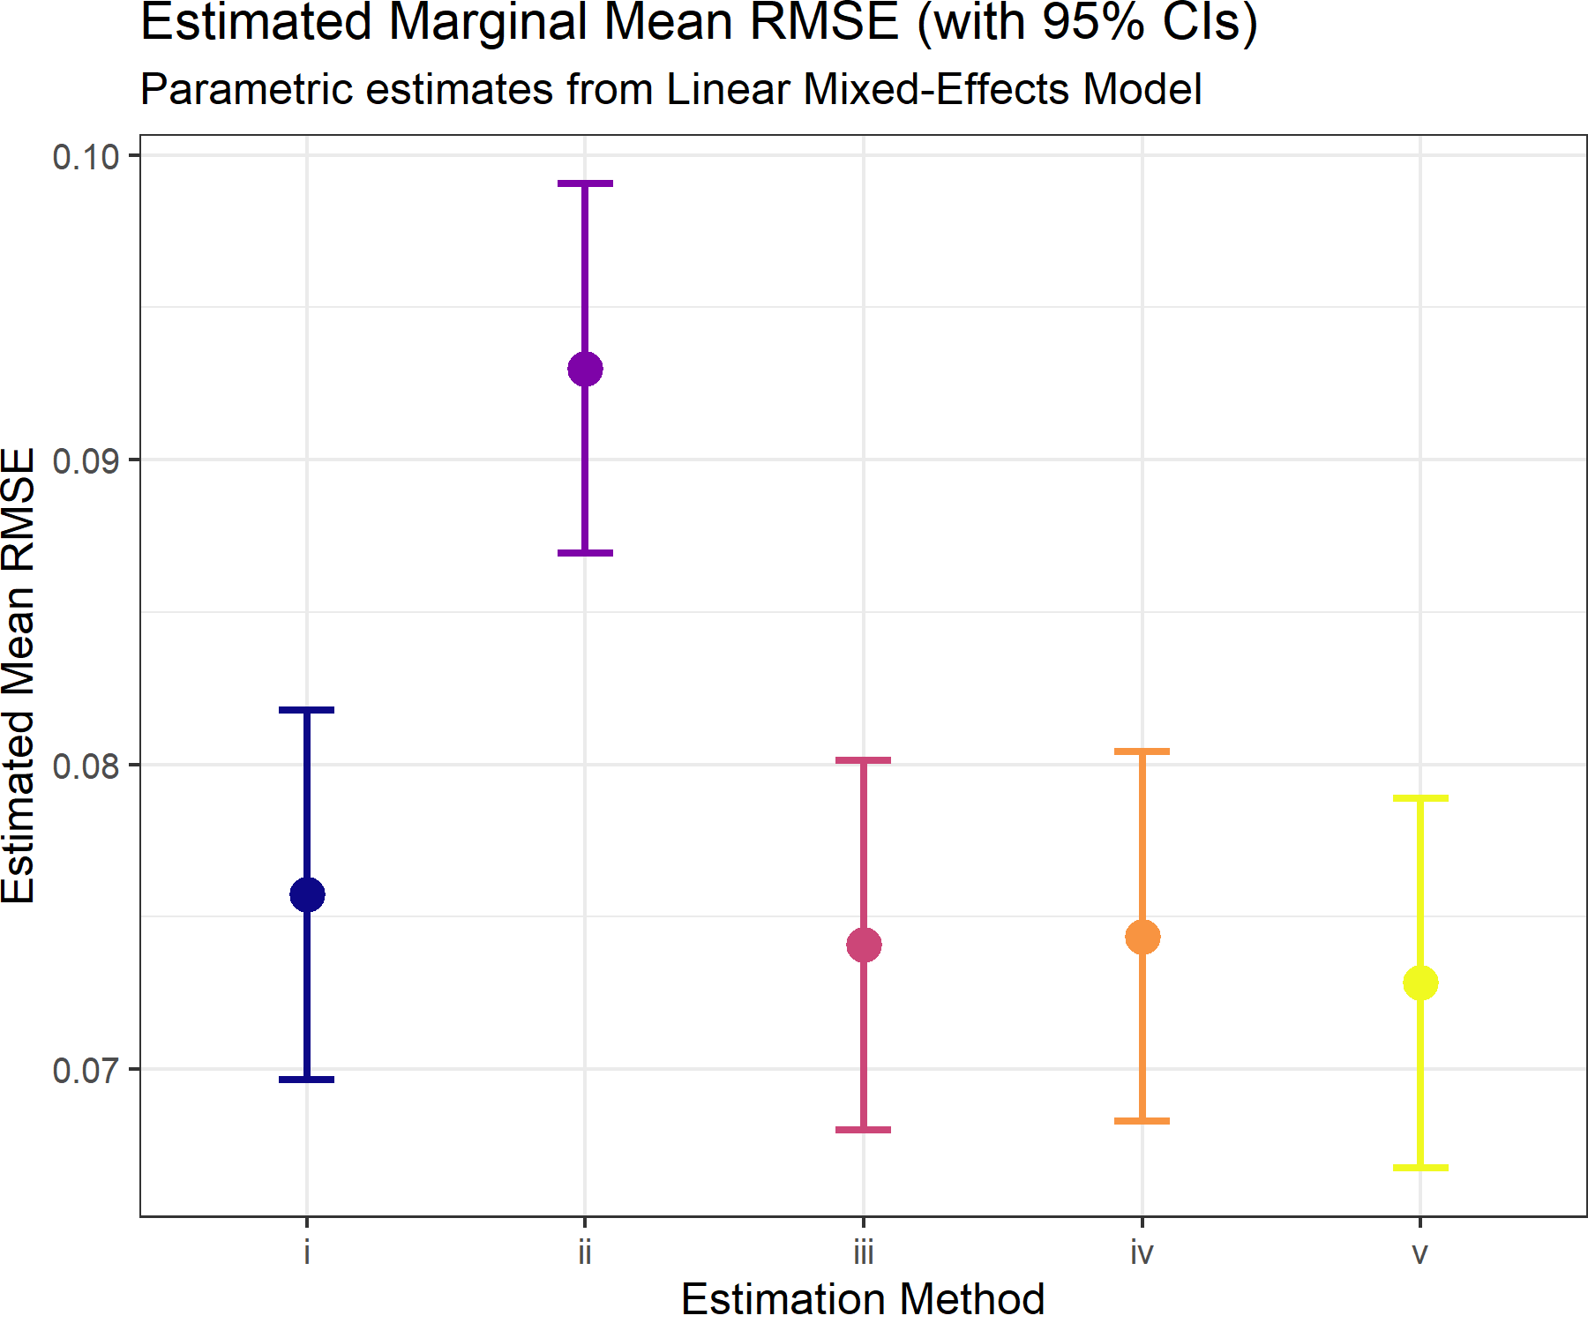
Figure 1. Estimated marginal mean RMSE for experiment 437, with 95% confidence intervals. The figure provides an experiment-level example of the leading performance of methods iii, iv, and v relative to method ii, with method v numerically lowest.

4.3 Experiment 185 as an L1 example
Experiment 185 shows that the relative accuracy pattern can be more pronounced under the L1 norm. In this example, method i has the largest estimated marginal mean L1 error, near 0.27, method ii is lower but still clearly above the leading methods, near 0.14, and methods iii, iv, and v are clustered near 0.09. Relative to method ii, the leading methods reduce L1 error by about one-third or more; relative to method i, the reduction is about two-thirds. This example reinforces the integrated result that methods iii, iv, and v are practically stronger than the weaker methods, even when the identity of the worst method varies by experiment.
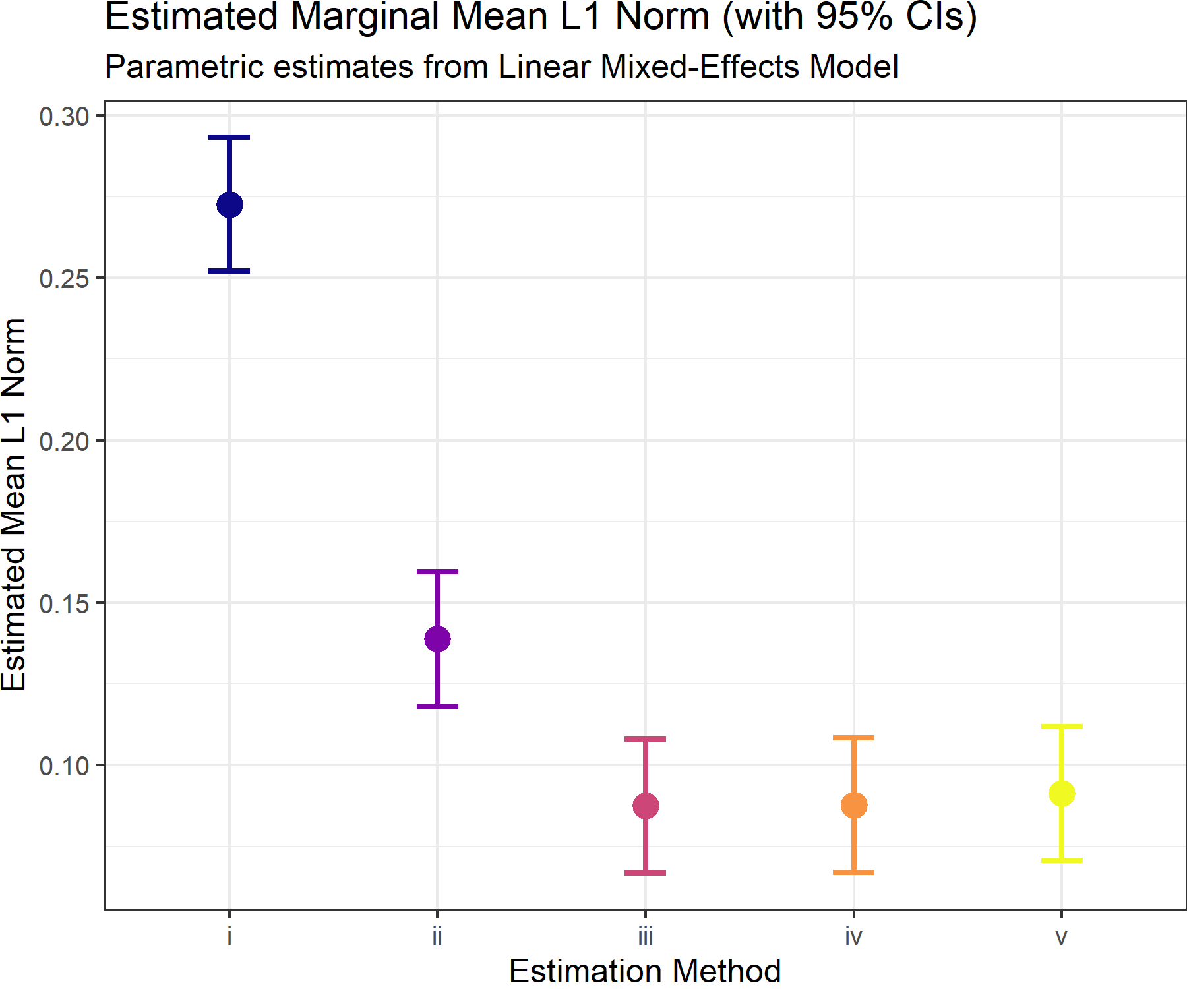
Figure 2. Estimated marginal mean L1 norm for experiment 185, with 95% confidence intervals. The figure shows a strong separation between the leading methods iii, iv, and v and the weaker methods in this experiment.

4.4 Simplex-dependent relative accuracy from the GAM
The GAM smooths show that composition location affects fitted error even after accounting for method, metric, design block, and other design factors. Across methods, fitted error tends to be higher in the interior of the simplex, where the three proportions are more balanced, and lower near edges or vertices, where one component dominates. This is a geometry effect: balanced compositions leave more room for estimation error to be distributed among components, while dominance cases constrain error in different ways.
The method-specific panels show differences in the strength of this geometry effect. Method ii has the flattest fitted surface and appears least sensitive to simplex location, but that does not imply better total accuracy. Methods iv and v show the strongest interior positive effects, while methods i and iii are intermediate. The plot should therefore be interpreted as a map of where adjusted error is higher or lower, not as the primary method ranking.
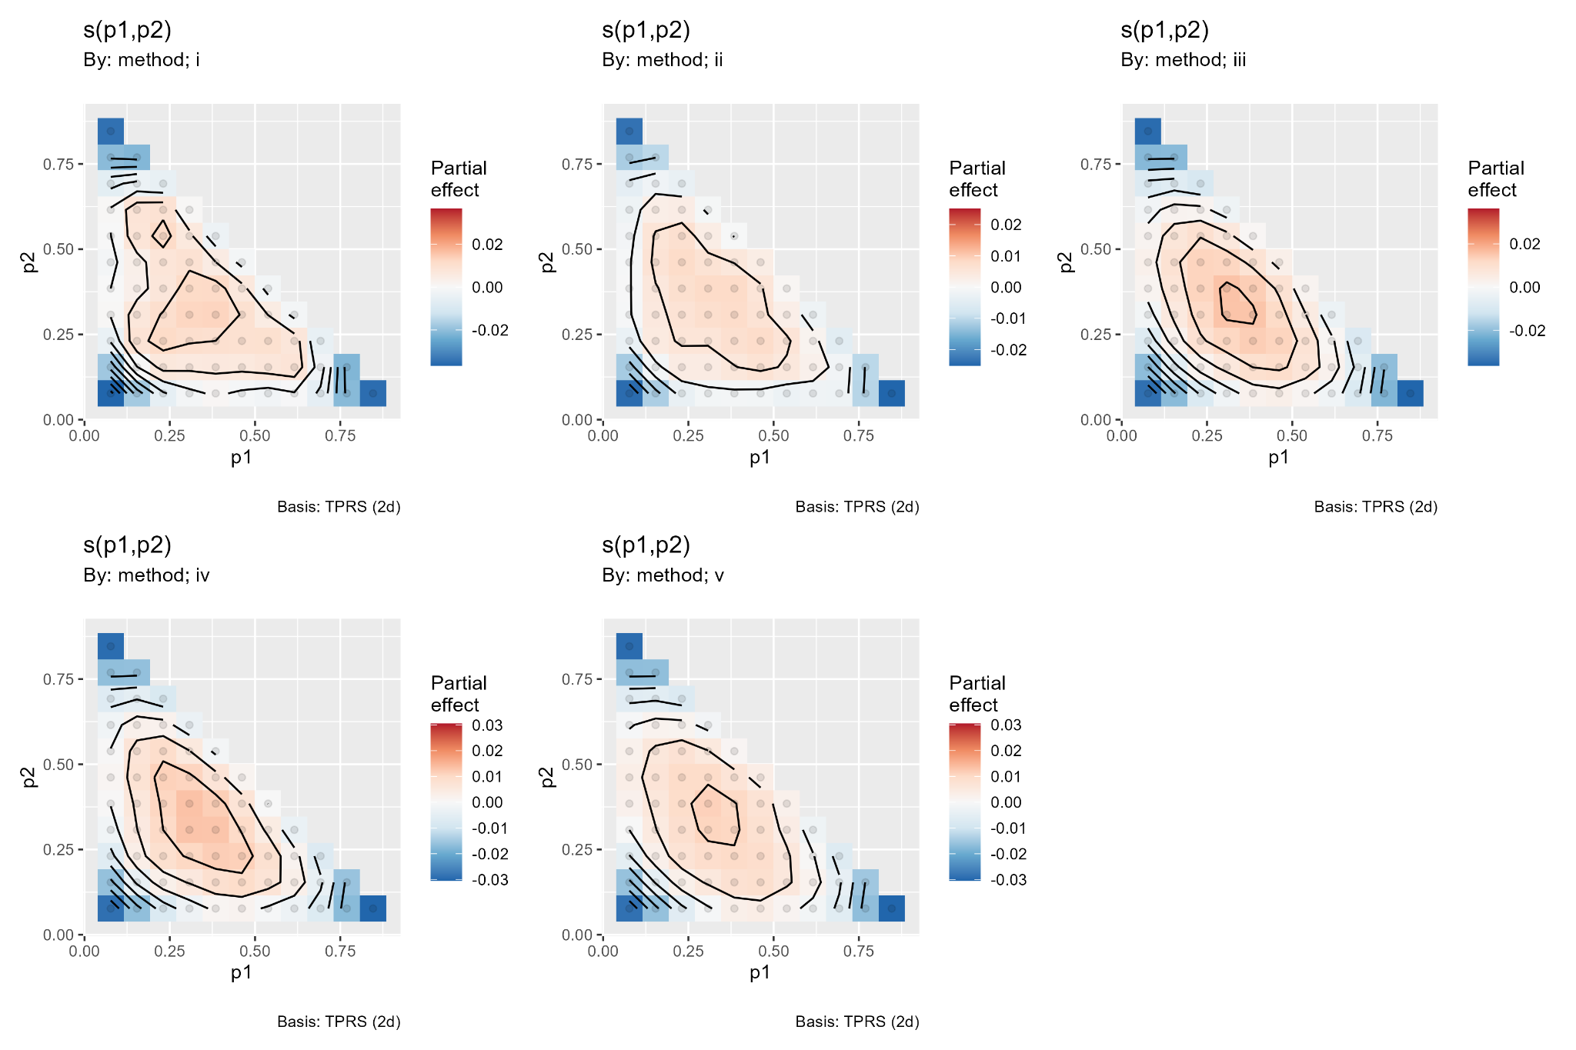
Figure 3. Method-specific GAM smooths over the two-dimensional simplex. Positive red regions show higher fitted log1p error after adjustment for design factors; negative blue regions show lower fitted error. The main pattern is higher adjusted error in the simplex interior and lower adjusted error near boundaries.

4.5 Probability that each method is best
The rank-probability analysis provides the most direct ordinal summary of how often each method is best within a dataset and metric. Rank 1 was assigned to the lowest error within each comparison set. The figure shows that method ii can have a high probability of being rank 1 in individual comparisons, but this result must be interpreted with the magnitude-based analyses. A method can win often and still be a poor default if its losses are large or if its mean rank and average error are unfavorable.
The practical bottom line is therefore not that a single rank-probability panel should determine the default method. Instead, the rank analysis is most useful as a robustness check on the magnitude-based conclusion. The integrated conclusion remains that methods v and iii form the best-supported leading tier, method iv is a strong secondary option, method i is intermediate, and method ii is too volatile to recommend as the default.
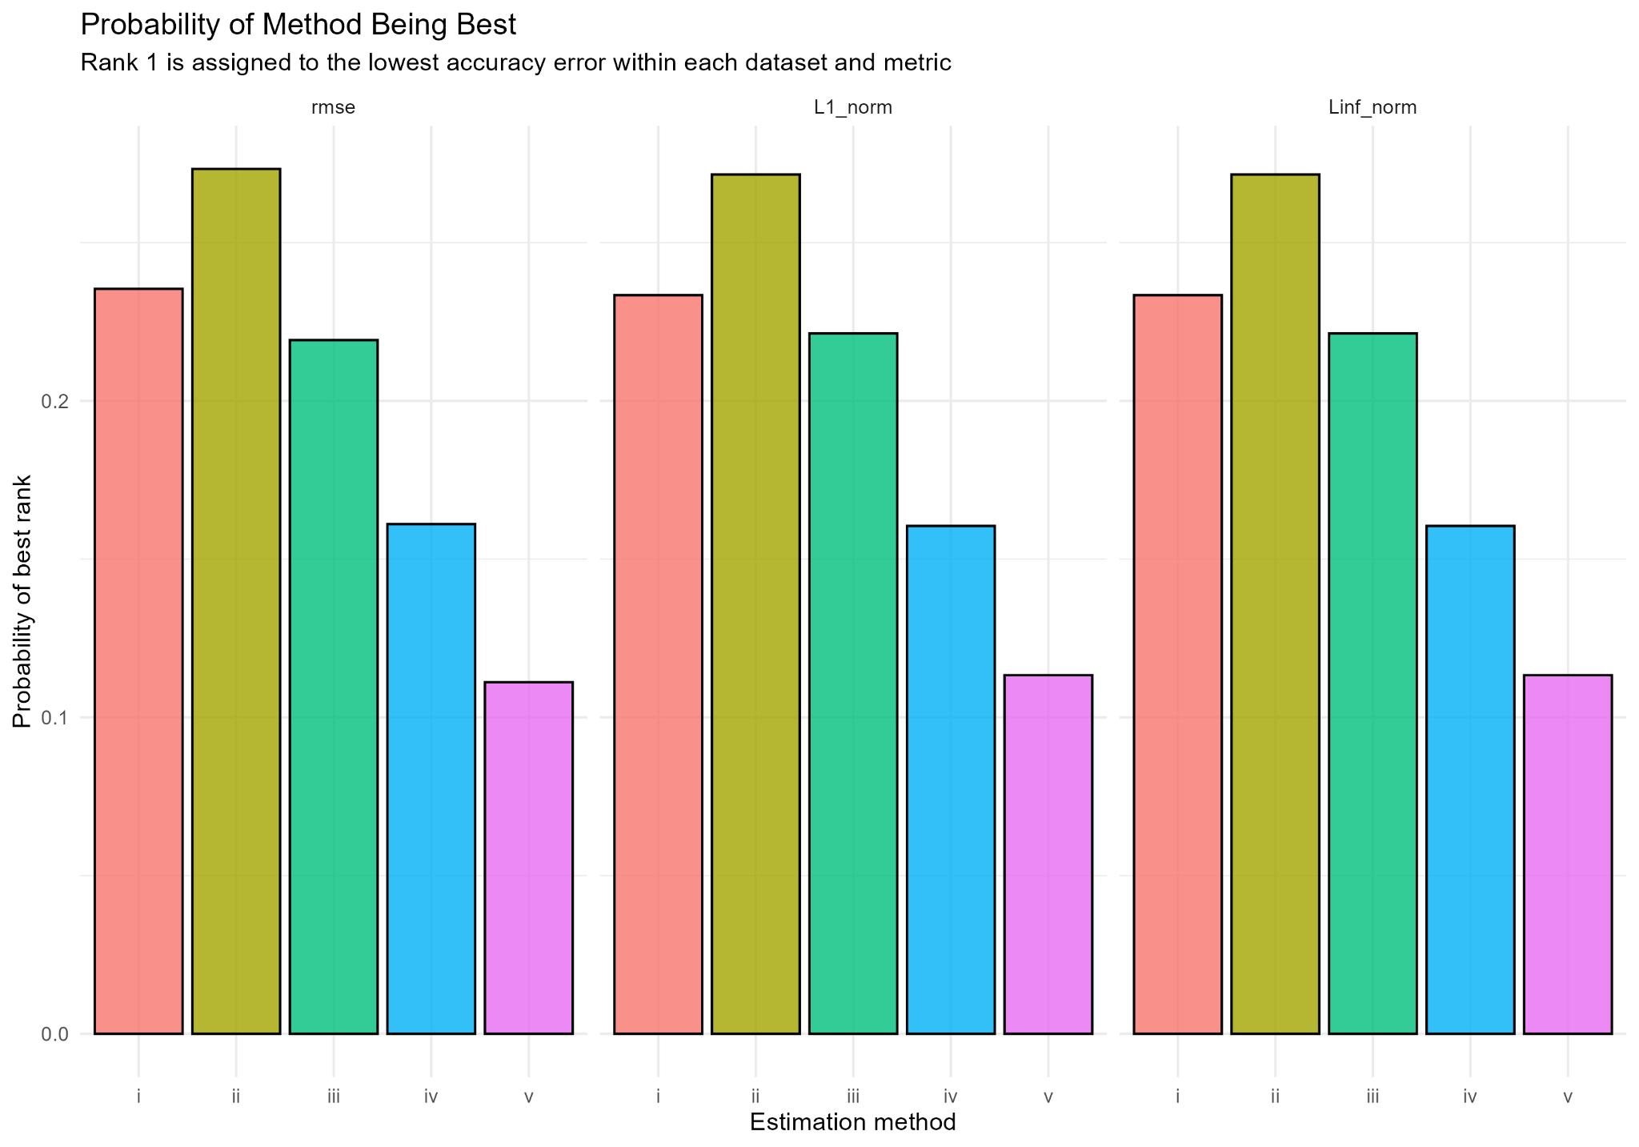
Figure 4. Probability that each method is rank 1, by accuracy metric. The figure summarizes how often each method is best within a dataset and metric, but it should be read together with the log-error and mixed-model analyses because rank 1 probability does not measure the size of wins or losses.

5. Discussion

5.1 Practical importance of the method ranking
The main practical result is that the two linear Dirichlet-multinomial estimators are the safest general-purpose choices. Method v is the best-supported point-estimate method because it has the lowest fitted error in the log-error and estimated-marginal-mean analyses. Method iii is nearly tied with method v, and the estimated difference between the two is small enough that practical considerations should matter. If theta can be fixed from prior calibration or design information, method iii is a simple and defensible choice. If theta should be learned from the data, method v is the more flexible default.
Method iv is a credible secondary estimator but should be interpreted cautiously. Its performance is often close to methods iii and v, which means a multinomial estimator can remain useful in some regimes. However, method iv does not model Dirichlet-multinomial overdispersion and should be expected to degrade when sigma, theta_CV, or other sources of extra-multinomial variation are important.
Method ii should not be selected as the default solely because it sometimes has a high probability of being best in rank-probability summaries. The integrated results indicate a volatile winner-or-loser behavior: method ii can win individual comparisons, but it also has poor mean error behavior and weak average ranking. For practical stock assessment work, dependable average accuracy and stable behavior are more important than occasional rank 1 outcomes.

5.2 Why the experimental factors matter
Sigma is the dominant experimental driver because it directly controls how much the group-level compositions depart from a common target. As sigma increases, the information being pooled across groups becomes less coherent, and the relative advantages of methods that model or approximate extra-multinomial variation become more important.
Design block, G, and mean sample size provide the next layer of practical interpretation. The sample-size generator controls the distribution of information across groups, G controls replication, and mean sample size controls the baseline precision of each group. Together these factors define the effective information content of the simulation. Theta_true and theta_CV matter less on average, but they remain useful sensitivity factors because they test whether the assumed concentration structure is aligned with the data-generating process.

5.3 Implications for stock assessment modeling
The simulation results support a linear Dirichlet-multinomial likelihood as a practical default for age- and size-composition data. The linear form gives analysts a transparent link between observed sample size, total concentration, and effective information. This link is useful in integrated assessments because composition weights are often tuned, down-weighted, or diagnosed through effective sample-size concepts.
The results also suggest that model diagnostics should focus on the environments where method choice matters most. High sigma conditions, uneven sample-size blocks, and low effective information are the settings where estimator differences are most likely to affect scientific conclusions. In these settings, method v or method iii should be preferred over the saturated Dirichlet-multinomial and multinomial alternatives unless independent diagnostics indicate otherwise.

5.4 Limitations and future work
The simulation study focuses on the three-component simplex because K = 3 permits direct visualization of the entire composition space. Real age- and length-composition data usually have more categories, plus groups, missing cells, and time-varying selectivity. The qualitative advantage of linear Dirichlet-multinomial estimators should therefore be evaluated in higher-dimensional composition settings and in full integrated assessment models.
Future work should also evaluate misspecified data-generating mechanisms. The present simulation uses a linear concentration structure for data generation, so the leading performance of methods iii and v is expected. The more demanding question is how much of this advantage persists when the true concentration structure is nonlinear, fleet-specific, time-varying, or influenced by unmodeled clustering.

6. Conclusions
Goal. The goal was to compare five methods for estimating a three-component composition vector under Dirichlet-multinomial and multinomial likelihood assumptions.
Problem. Estimator accuracy depends on both the likelihood parameterization and the simulation environment. The strongest design driver is between-group composition variability, followed by sample-size distribution, the number of sampled groups, method, and mean sample size.
Solution. The integrated analyses support methods v and iii as the leading estimators. Method v is preferred when the objective is lowest log-error magnitude and theta should be estimated. Method iii is nearly tied and is preferred when theta can be fixed from external information or when a simpler estimator is desired. Method iv is a useful secondary method, method i is an intermediate baseline, and method ii is not recommended as the default because its occasional wins are offset by weak average performance.

7. References
Fisch, N., Camp, E., Shertzer, K., & Ahrens, R. (2021). Assessing likelihoods for fitting composition data within stock assessments, with emphasis on different degrees of process and observation error. Fisheries Research, 243, 106069. https://doi.org/10.1016/j.fishres.2021.106069
Thorson, J. T., Johnson, K. F., Methot, R. D., & Taylor, I. G. (2017). Model-based estimates of effective sample size in stock assessment models using the Dirichlet-multinomial distribution. Fisheries Research, 192, 84-93. https://doi.org/10.1016/j.fishres.2016.06.005

Table 1. Glossary of terms used to describe composition data by sampling group.
Variable | Description
$$A$$ | Number of categories of age or size bins indexed by a = 1, 2, …, A
$$x$$ | True population count vector with elements $x_{a}$
$$x_{obs}$$ | Observed count vector with elements $x_{obs,a}$
$$x_{pred}$$ | Predicted count vector with elements $x_{pred,a}$
$$p$$ | True population proportion vector with elements $p_{a}$
$$p_{obs}$$ | Observed proportion vector with elements $p_{obs,a}$
$$p_{pred}$$ | Predicted proportion vector with elements $p_{pred,a}$
$$n_{obs}$$ | Observed composition sample size
$$α$$ | Concentration parameter vector of a Dirichlet-multinomial distribution
$$α_{0}$$ | Sum of concentration parameters of a Dirichlet-multinomial distribution
$$θ$$ | Scaling parameter of a linear Dirichlet-multinomial distribution
$$β$$ | Weight parameter of a saturated Dirichlet-multinomial distribution
$$n_{eff}$$ | Effective sample size of a observed proportion vector

Table 2. Five estimation methods compared in the simulation study.
Method | Estimator | Parameterization | Practical interpretation | Likelihood
i | Unconstrained Dirichlet-multinomial | Estimates a shared concentration vector alpha directly. | Flexible baseline but can be less efficient because concentration is estimated without an explicit sample-size link. | $$L_{DMU}\left(α|x_{obs}\right)=\frac{Γ\left(n_{obs}+1\right)}{\prod_{a=1}^{A}{Γ\left(x_{obs,a}+1\right)}}\frac{Γ\left(α_{0}\right)}{Γ\left(n_{obs}+α_{0}\right)}\prod_{a=1}^{A}{\frac{Γ\left(x_{obs,a}+α_{a}\right)}{Γ\left(α_{a}\right)}}$$
ii | Saturated Dirichlet-multinomial | Uses a shared composition p with group-specific total concentration a0_g. | Flexible over groups, but the added concentration parameters can increase variability and reduce reliability. | $$L_{DMS}\left(p_{pred},β|x_{obs}\right)=\frac{Γ\left(n_{obs}+1\right)}{\prod_{a=1}^{A}{Γ\left(n_{obs}p_{obs,a}+1\right)}}\frac{Γ\left(β\right)}{Γ\left(n_{obs}+β\right)}\prod_{a=1}^{A}{\frac{Γ\left(n_{obs}p_{obs,a}+β⋅p_{pred,a}\right)}{Γ\left(β⋅p_{pred,a}\right)}}$$
iii | Linear Dirichlet-multinomial with fixed theta | Constrains a0_g = theta_true N_g. | Uses the known or externally specified overdispersion weight and directly links concentration to sample size. | $$L_{DML}\left(p_{pred}|x_{obs},θ\right)=\frac{Γ\left(n_{obs}+1\right)}{\prod_{a=1}^{A}{Γ\left(n_{obs}p_{obs,a}+1\right)}}\frac{Γ\left(n_{obs}θ\right)}{Γ\left(n_{obs}+n_{obs}θ\right)}\prod_{a=1}^{A}{\frac{Γ\left(n_{obs}p_{obs,a}+n_{obs}θ∙p_{pred,a}\right)}{Γ\left(n_{obs}θ∙p_{pred,a}\right)}}$$
iv | Multinomial | Pools information under the multinomial likelihood. | Simple and often competitive, but ignores Dirichlet-multinomial overdispersion and group-level correlation. | $$L_{MN}\left(p_{pred}|x_{obs}\right)=\frac{Γ\left(n_{obs}+1\right)}{\prod_{a=1}^{A}{Γ\left(x_{obs,a}+1\right)}}\prod_{a=1}^{A}{{\left(p_{pred,a}\right)}^{n_{obs}⋅p_{obs,a}}}$$
v | Linear Dirichlet-multinomial with freely estimated theta | Constrains a0_g = theta N_g and estimates theta. | Retains the sample-size link while allowing the overall overdispersion level to be learned from the data. | $$L_{DML}\left(p_{pred},θ|x_{obs}\right)=\frac{Γ\left(n_{obs}+1\right)}{\prod_{a=1}^{A}{Γ\left(n_{obs}p_{obs,a}+1\right)}}\frac{Γ\left(n_{obs}θ\right)}{Γ\left(n_{obs}+n_{obs}θ\right)}\prod_{a=1}^{A}{\frac{Γ\left(n_{obs}p_{obs,a}+n_{obs}θ∙p_{pred,a}\right)}{Γ\left(n_{obs}θ∙p_{pred,a}\right)}}$$

Table 3. Five experimental factors and their rationale.
Factor | Definition | Rationale for inclusion
mean_nsamp | Mean sample size within a group. | Controls the baseline amount of information. Larger values generally increase effective concentration and reduce error.
sigma | Between-group perturbation of the true composition on the log scale. | Dominant driver of estimation error. Larger values make group compositions less coherent and increase the difficulty of pooling information.
theta_true | Baseline Dirichlet-multinomial concentration weight. | Controls overdispersion relative to the sample size. It is central for the fixed-theta linear method and informative for the estimated-theta method.
theta_CV | Group-to-group coefficient of variation in theta. | Introduces heterogeneity in concentration. It tests robustness when a single common theta is an approximation.
G | Number of sampled groups. | Controls replication across groups. More groups can improve accuracy but also expose estimators to more between-group composition variability when sigma is positive.

Table 4. Statistical evidence supporting the primary method ranking.
Statistical evidence | Main result | Implication for primary ranking
Pairwise log-ratio Hotelling/MANOVA contrasts | Method ii had about 19.8% higher error than method i; methods iii, iv, and v reduced error by roughly 19-20% relative to method ii. Method v was only about 0.14-0.20% better than method iii and about 1.1% better than method iv. | Strong separation of method ii from the leading methods; v and iii are practically tied.
Mixed-effects estimated marginal means | Method v had the lowest fitted log-error magnitude, method iii was second, and method iv was third; method ii was the weakest and method i was intermediate. | Supports v as the best point-estimate method, with iii close enough to be a co-leader.
Metric-specific summaries | RMSE, L1, and Linf gave the same broad ordering: iii and v strongest, iv close, i intermediate, and ii weak. L1 gave the clearest separation among the top methods and favored v. | Ranking is not an artifact of a single accuracy metric.
Factor hierarchy | Sigma was the dominant driver of error, followed by design block, G, method, and mean sample size. Theta_true was smaller, theta_CV was very small, and p1 and p2 were weak as main effects. | Method performance depends most on the simulation environment, especially between-group composition variability.
GAM simplex surfaces | All methods showed higher fitted error in the simplex interior and lower fitted error near edges or vertices after adjustment for design factors. | Simplex location affects accuracy, but the smooth terms do not by themselves rank methods.
Rank probability analysis | Method ii often achieved rank 1 in individual dataset-metric combinations, but the integrated analyses show that these wins are offset by poor average error and high variability. | Rank 1 frequency is useful, but it should not override log-error magnitude and mean-rank evidence.

