Comparing Dirichlet-Multinomial Parameterizations
for Composition Data
Simulation evidence for linear Dirichlet-multinomial estimators

Jon K. T. Brodziak¹, Matthew Supernaw², Kelli F. Johnson³
¹ Pacific Islands Fisheries Science Center, NOAA Fisheries, Honolulu, HI, USA
² Office of Science and Technology, NOAA Fisheries, St. Petersburg, FL, USA
³ Office of Science and Technology, NOAA Fisheries, Seattle, WA, USA

Abstract
Compositional data describing the age or size structure of fish populations are central inputs to integrated stock assessment models. However, these data are often overdispersed and correlated relative to multinomial sampling assumptions. We compare the following five estimators for estimating proportions at age or size from composition data: (i) an unconstrained Dirichlet-multinomial concentration-vector estimator, (ii) a saturated Dirichlet-multinomial estimator with an estimated total concentration, (iii) a linear Dirichlet-multinomial estimator with fixed scaling parameter, (iv) a multinomial estimator, and (v) a linear Dirichlet-multinomial estimator with an estimated scaling parameter. We apply a mesh-based simulation design over the simplex of feasible proportion to evaluate relative estimator accuracy under a factorial experiment with 5 factors. The simulated composition data were generated from a Dirichlet-multinomial operating model. The experiment varied the number of sampled groups, the mean sample size by group, the between-group composition variability, the true concentration, and the concentration heterogeneity. Estimation accuracy, or performance, was measured by root mean square error, total absolute error, and maximum error. These accuracy performance measures were analyzed on log-transformed error scales using factorial MANOVA/ANOVA, mixed-effects models, pairwise Hotelling contrasts, generalized additive models over the simplex, and rank-based summaries. We repeated the experiment using simulated composition data constrained to fall within the observed survey data from the 2026 Pacific hake stock assessment. In addition, we conducted a sensitivity analysis experiment with a multinomial operating model and a reduced factorial design. The results were indicated that methods (v) and (iii) form the leading tier, method (iv) is a strong secondary estimator, method (i) is an intermediate baseline, and method (ii) is the least reliable. Method (v) has the strongest support by log-error magnitude and estimated marginal means, while method (iii) is nearly tied and provides strong rank robustness. The results of the sensitivity analysis produced the same rankings. Overall, the practical conclusion is that linear Dirichlet-multinomial estimators provide the best-supported general-purpose platform, with the choice between fixed and estimated scaling parameter depending on prior information, numerical stability, and implementation goals.
Keywords: Dirichlet-multinomial, composition data, effective sample size, overdispersion, stock assessment, likelihood weighting, simulation experiment, log-error analysis

1. Introduction
Age- and size-composition data provide essential information on recruitment, growth, mortality, and selectivity in integrated stock assessment models. The standard multinomial likelihood treats observed counts as independent draws with fixed probabilities for each category, but composition samples collected from fisheries and surveys often show extra-multinomial variation because fish are sampled in clusters, group-level compositions differ, and sampling protocols induce correlations among categories.
The Dirichlet-multinomial distribution is a practical extension of the multinomial likelihood because it allows the category probabilities to vary among sampling units. This extra variation is governed by concentration parameters, and different parameterizations of those concentration parameters can have different numerical and statistical behavior even when they describe closely related likelihood families.
The goal of this study is to identify which estimation methods provide accurate and stable recovery of the underlying three-proportion composition vector. The problem is that estimator performance depends on both the likelihood parameterization and the simulation environment, especially sample size, overdispersion, and between-group variation. The solution is to compare estimators using a factorial simulation design over the simplex and to summarize results with complementary statistical analyses of log-transformed accuracy metrics. We compare the following five estimators: (i) an unconstrained Dirichlet-multinomial concentration-vector estimator, (ii) a saturated Dirichlet-multinomial estimator with group-specific total concentration, (iii) a linear Dirichlet-multinomial estimator with fixed theta, (iv) a multinomial estimator, and (v) a linear Dirichlet-multinomial estimator with theta estimated.

2. Model framework

Summary of methods here.

2.1 Composition data and the Dirichlet-multinomial likelihood
Let x_g = (x_g1, ..., x_gK) denote the observed count vector for sampling group g, with total sample size N_g = sum_k x_gk. The true composition vector is p = (p1, ..., pK), where p_k > 0 and sum_k p_k = 1. The simulations focus on K = 3 so the entire composition space can be evaluated over the two-dimensional simplex, with p3 = 1 - p1 - p2.
Under the multinomial model, x_g is distributed as Multinomial(N_g, p). Under the Dirichlet-multinomial model, a latent group-specific probability vector phi_g is drawn from a Dirichlet distribution and x_g is then drawn from a multinomial distribution conditional on phi_g. The total Dirichlet concentration a0_g controls the amount of overdispersion: smaller concentration values imply more variable group-level compositions, while large values approach the multinomial model.
The practical modeling question is how a0_g should be represented. The estimators compared here differ in whether they estimate a free concentration vector, estimate group-specific total concentrations, impose a linear relationship between concentration and sample size, or ignore extra-multinomial variation.

2.2 Estimation methods compared

Methods iii and v are the principal linear Dirichlet-multinomial forms. Both enforce the same structural idea, groups with larger observed sample sizes receive larger total concentration and therefore higher effective information. Method iii is appropriate when theta is fixed by design or external calibration, while method v is appropriate when theta should be estimated within the likelihood.

3. Methods

3.1 Factorial experimental design
The simulation design was constructed to vary the factors most likely to affect estimation accuracy. The design treats the sample-size distribution as a design block and crosses five three-level experimental factors within each block. This structure separates the effect of the sample-size generator from the effects of sample-size level, composition heterogeneity, concentration level, concentration heterogeneity, and the number of sampled groups.
The five experimental factors are mean_nsamp, sigma, theta_true, theta_CV, and G. Distribution-specific spread parameters are held fixed within the retained common-factor design so that G can serve as the common fifth factor across sample-size distribution blocks. This choice makes the factorial comparisons more interpretable because the same five factors are tested across all retained blocks.

3.2 Data generation
For each true composition on the proportion simplex and each simulated dataset, group sample sizes N_g were generated according to the sample-size distribution block. The data generator then formed group-level concentration values using a linear concentration structure, a0_g = (theta_g * od_mult) N_g, where theta_g represents the group-specific concentration weight and od_mult is a fixed multiplier. Group-specific composition variation was introduced by perturbing log(p_true) with normally distributed deviations having standard deviation sigma and then renormalizing to the simplex.
Conditional on the generated group-level composition and concentration, observed counts were sampled from the Dirichlet-multinomial mechanism. This design deliberately favors the linear Dirichlet-multinomial family as the data-generating structure, but the factorial design evaluates when the relative advantage is large, small, or practically negligible across sample-size regimes, overdispersion levels, and simplex locations.

3.3 Accuracy metrics
Estimator accuracy was assessed by comparing the fitted composition vector with the true composition vector. The following three metrics were used: root mean square error (RMSE), the L1 norm, and the Linf norm. RMSE measures average squared component error giving more weight to errors that are larger, the L1 norm measures total absolute component error between sets of data, and the Linf norm measures the largest absolute component error between sets of data. Using all three metrics checks whether conclusions depend on average error, aggregate absolute error, or worst-component error.

3.4 Statistical analyses
All scalar accuracy metrics were analyzed on log-transformed scales. The transformation log1p(x) = log(1 + x) was used for nonnegative accuracy values because it keeps zero values valid, reduces right skew, and stabilizes variance. For pairwise method contrasts, differences on the log scale are interpreted as log-ratios of errors, so a negative contrast for method A minus method B indicates lower relative error for method A.
The statistical analysis used complementary models rather than relying on a single test. A factorial MANOVA/ANOVA summarized how method and design factors affected transformed RMSE, L1, and Linf. A mixed-effects model analyzed log1p(accuracy) with fixed effects for method, metric, design block, G, theta_true, theta_CV, sigma, mean_nsamp, p1, and p2, and random intercepts for experiment, simplex point, and dataset. Pairwise Hotelling or MANOVA contrasts tested method differences using log-ratios of errors (citation). A factorial pairwise contrast analysis identified which design factors altered relative method performance.
The global GAM provided a complementary surface analysis over the two-dimensional simplex. The model included metric-by-method effects, design factors, and method-specific smooth terms s(p1, p2). The resulting gratia plot shows partial effects on the fitted log1p error scale. Positive red regions indicate simplex locations where the fitted error is higher than expected after adjustment, whereas negative blue regions indicate lower fitted error after adjustment. Finally, the rank analysis assigned rank 1 to the method with the lowest error within each dataset and metric and summarized the probability that each method was best.

4. Results

4.1 Integrated ranking of methods
The integrated statistical evidence supports the ranking v approximately tied with iii, followed by iv, i, and ii. Method v is the best point-estimate method by log-error magnitude and mixed-model estimated marginal means. Method iii is nearly tied with method v and is the most defensible co-leader because the estimated advantage of v over iii is small. Method iv is consistently competitive but is usually slightly worse than iii and v. Method i is a reasonable baseline, while method ii is the least reliable default because it has poor average performance despite occasional individual wins.

4.2 Experiment 437 as an RMSE example
Experiment 437 illustrates the typical RMSE pattern in which the linear Dirichlet-multinomial methods are in the leading group and method ii is clearly less accurate. In this example, method ii has the largest estimated marginal mean RMSE, at about 0.093, while methods iii, iv, and v are clustered near 0.073-0.074. Method v is numerically lowest, and its RMSE is roughly 22% lower than method ii in this example. The practical point is that the strongest methods are close to one another, whereas the separation between the leading group and method ii is large enough to matter.
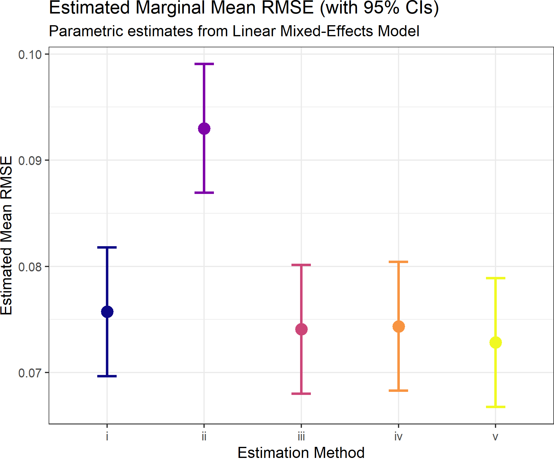
Figure 1. Estimated marginal mean RMSE for experiment 437, with 95% confidence intervals. The figure provides an experiment-level example of the leading performance of methods iii, iv, and v relative to method ii, with method v numerically lowest.

4.3 Experiment 185 as an L1 example
Experiment 185 shows that the relative accuracy pattern can be more pronounced under the L1 norm. In this example, method i has the largest estimated marginal mean L1 error, near 0.27, method ii is lower but still clearly above the leading methods, near 0.14, and methods iii, iv, and v are clustered near 0.09. Relative to method ii, the leading methods reduce L1 error by about one-third or more; relative to method i, the reduction is about two-thirds. This example reinforces the integrated result that methods iii, iv, and v are practically stronger than the weaker methods, even when the identity of the worst method varies by experiment.
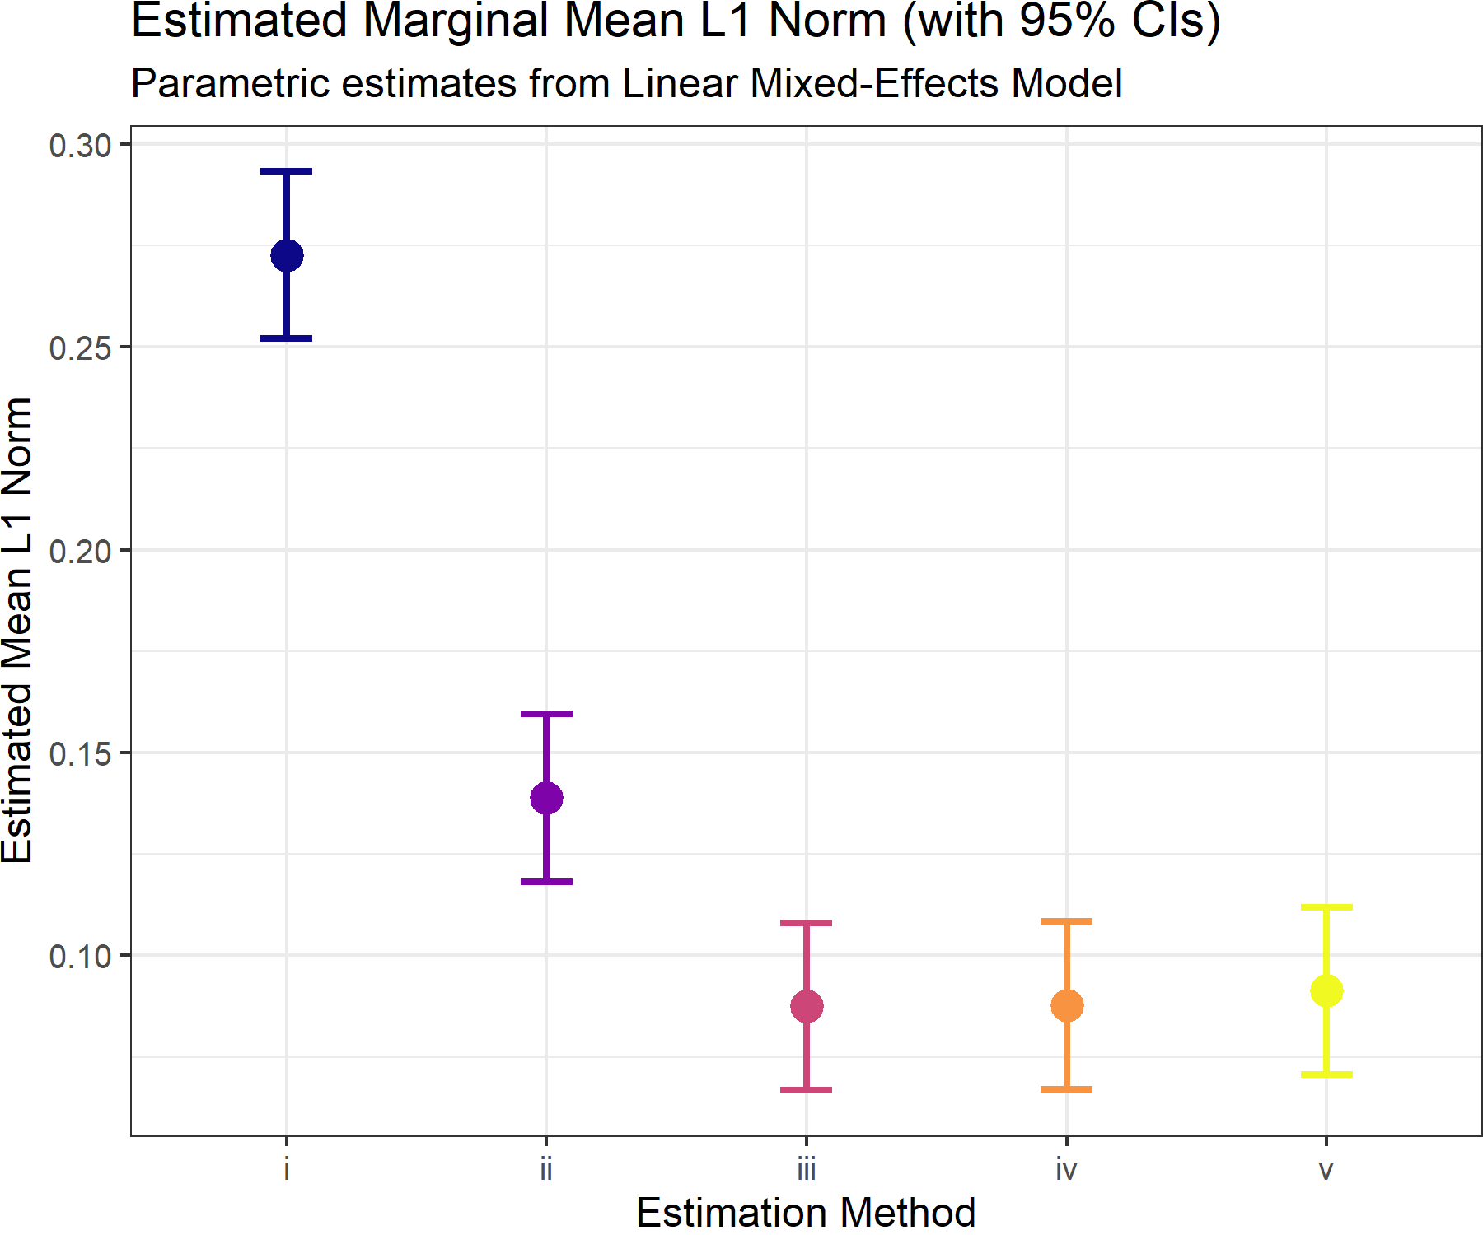
Figure 2. Estimated marginal mean L1 norm for experiment 185, with 95% confidence intervals. The figure shows a strong separation between the leading methods iii, iv, and v and the weaker methods in this experiment.

4.4 Simplex-dependent relative accuracy from the GAM
The GAM smooths show that composition location affects fitted error even after accounting for method, metric, design block, and other design factors. Across methods, fitted error tends to be higher in the interior of the simplex, where the three proportions are more balanced, and lower near edges or vertices, where one component dominates. This is a geometry effect: balanced compositions leave more room for estimation error to be distributed among components, while dominance cases constrain error in different ways.
The method-specific panels show differences in the strength of this geometry effect. Method ii has the flattest fitted surface and appears least sensitive to simplex location, but that does not imply better total accuracy. Methods iv and v show the strongest interior positive effects, while methods i and iii are intermediate. The plot should therefore be interpreted as a map of where adjusted error is higher or lower, not as the primary method ranking.
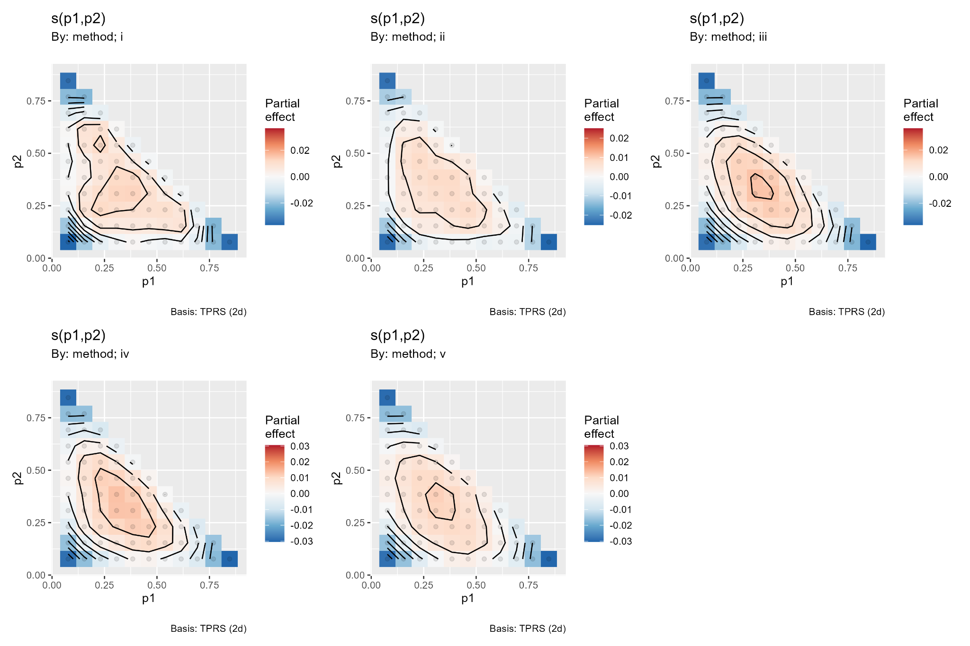
Figure 3. Method-specific GAM smooths over the two-dimensional simplex. Positive red regions show higher fitted log1p error after adjustment for design factors; negative blue regions show lower fitted error. The main pattern is higher adjusted error in the simplex interior and lower adjusted error near boundaries.

4.5 Probability that each method is best
The rank-probability analysis provides the most direct ordinal summary of how often each method is best within a dataset and metric. Rank 1 was assigned to the lowest error within each comparison set. The figure shows that method ii can have a high probability of being rank 1 in individual comparisons, but this result must be interpreted with the magnitude-based analyses. A method can win often and still be a poor default if its losses are large or if its mean rank and average error are unfavorable.
The practical bottom line is therefore not that a single rank-probability panel should determine the default method. Instead, the rank analysis is most useful as a robustness check on the magnitude-based conclusion. The integrated conclusion remains that methods v and iii form the best-supported leading tier, method iv is a strong secondary option, method i is intermediate, and method ii is too volatile to recommend as the default.
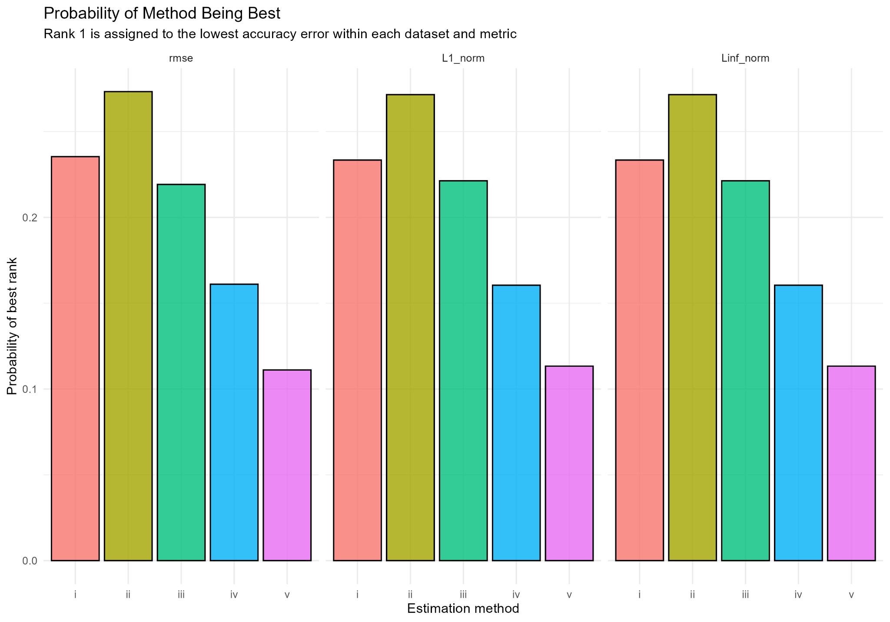
Figure 4. Probability that each method is rank 1, by accuracy metric. The figure summarizes how often each method is best within a dataset and metric, but it should be read together with the log-error and mixed-model analyses because rank 1 probability does not measure the size of wins or losses.

5. Discussion

5.1 Practical importance of the method ranking
The main practical result is that the two linear Dirichlet-multinomial estimators are the safest general-purpose choices. Method v is the best-supported point-estimate method because it has the lowest fitted error in the log-error and estimated-marginal-mean analyses. Method iii is nearly tied with method v, and the estimated difference between the two is small enough that practical considerations should matter. If theta can be fixed from prior calibration or design information, method iii is a simple and defensible choice. If theta should be learned from the data, method v is the more flexible default.
Method iv is a credible secondary estimator but should be interpreted cautiously. Its performance is often close to methods iii and v, which means a multinomial estimator can remain useful in some regimes. However, method iv does not model Dirichlet-multinomial overdispersion and should be expected to degrade when sigma, theta_CV, or other sources of extra-multinomial variation are important.
Method ii should not be selected as the default solely because it sometimes has a high probability of being best in rank-probability summaries. The integrated results indicate a volatile winner-or-loser behavior: method ii can win individual comparisons, but it also has poor mean error behavior and weak average ranking. For practical stock assessment work, dependable average accuracy and stable behavior are more important than occasional rank 1 outcomes.

5.2 Why the experimental factors matter
Sigma is the dominant experimental driver because it directly controls how much the group-level compositions depart from a common target. As sigma increases, the information being pooled across groups becomes less coherent, and the relative advantages of methods that model or approximate extra-multinomial variation become more important.
Design block, G, and mean sample size provide the next layer of practical interpretation. The sample-size generator controls the distribution of information across groups, G controls replication, and mean sample size controls the baseline precision of each group. Together these factors define the effective information content of the simulation. Theta_true and theta_CV matter less on average, but they remain useful sensitivity factors because they test whether the assumed concentration structure is aligned with the data-generating process.

5.3 Implications for stock assessment modeling
The simulation results support a linear Dirichlet-multinomial likelihood as a practical default for age- and size-composition data. The linear form gives analysts a transparent link between observed sample size, total concentration, and effective information. This link is useful in integrated assessments because composition weights are often tuned, down-weighted, or diagnosed through effective sample-size concepts.
The results also suggest that model diagnostics should focus on the environments where method choice matters most. High sigma conditions, uneven sample-size blocks, and low effective information are the settings where estimator differences are most likely to affect scientific conclusions. In these settings, method v or method iii should be preferred over the saturated Dirichlet-multinomial and multinomial alternatives unless independent diagnostics indicate otherwise.

5.4 Limitations and future work
The simulation study focuses on the three-component simplex because K = 3 permits direct visualization of the entire composition space. Real age- and length-composition data usually have more categories, plus groups, missing cells, and time-varying selectivity. The qualitative advantage of linear Dirichlet-multinomial estimators should therefore be evaluated in higher-dimensional composition settings and in full integrated assessment models.
Future work should also evaluate misspecified data-generating mechanisms. The present simulation uses a linear concentration structure for data generation, so the leading performance of methods iii and v is expected. The more demanding question is how much of this advantage persists when the true concentration structure is nonlinear, fleet-specific, time-varying, or influenced by unmodeled clustering.

6. Conclusions
Goal. The goal was to compare five methods for estimating a three-component composition vector under Dirichlet-multinomial and multinomial likelihood assumptions.
Problem. Estimator accuracy depends on both the likelihood parameterization and the simulation environment. The strongest design driver is between-group composition variability, followed by sample-size distribution, the number of sampled groups, method, and mean sample size.
Solution. The integrated analyses support methods v and iii as the leading estimators. Method v is preferred when the objective is lowest log-error magnitude and theta should be estimated. Method iii is nearly tied and is preferred when theta can be fixed from external information or when a simpler estimator is desired. Method iv is a useful secondary method, method i is an intermediate baseline, and method ii is not recommended as the default because its occasional wins are offset by weak average performance.

7. References
Fisch, N., Camp, E., Shertzer, K., & Ahrens, R. (2021). Assessing likelihoods for fitting composition data within stock assessments, with emphasis on different degrees of process and observation error. Fisheries Research, 243, 106069. https://doi.org/10.1016/j.fishres.2021.106069
Thorson, J. T., Johnson, K. F., Methot, R. D., & Taylor, I. G. (2017). Model-based estimates of effective sample size in stock assessment models using the Dirichlet-multinomial distribution. Fisheries Research, 192, 84-93. https://doi.org/10.1016/j.fishres.2016.06.005

Table 1. Glossary of terms used to describe composition data by sampling group.
Variable | Description
$$A$$ | Number of categories of age or size bins indexed by a = 1, 2, …, A
$$x$$ | True population count vector with elements $x_{a}$
$$x_{obs}$$ | Observed count vector with elements $x_{obs,a}$
$$x_{pred}$$ | Predicted count vector with elements $x_{pred,a}$
$$p$$ | True population proportion vector with elements $p_{a}$
$$p_{obs}$$ | Observed proportion vector with elements $p_{obs,a}$
$$p_{pred}$$ | Predicted proportion vector with elements $p_{pred,a}$
$$n_{obs}$$ | Observed composition sample size
$$α$$ | Concentration parameter vector of a Dirichlet-multinomial distribution
$$α_{0}$$ | Sum of concentration parameters of a Dirichlet-multinomial distribution
$$θ$$ | Scaling parameter of a linear Dirichlet-multinomial distribution
$$β$$ | Weight parameter of a saturated Dirichlet-multinomial distribution
$$n_{eff}$$ | Effective sample size of a observed proportion vector

Table 2. Five estimation methods compared in the simulation study.
Method | Estimator | Parameterization | Practical interpretation
i | Unconstrained Dirichlet-multinomial | Estimates a shared concentration vector alpha directly. | Flexible baseline but can be less efficient because concentration is estimated without an explicit sample-size link.
ii | Saturated Dirichlet-multinomial | Uses a shared composition p with group-specific total concentration a0_g. | Flexible over groups, but the added concentration parameters can increase variability and reduce reliability.
iii | Linear Dirichlet-multinomial with fixed theta | Constrains a0_g = theta_true N_g. | Uses the known or externally specified overdispersion weight and directly links concentration to sample size.
iv | Multinomial | Pools information under the multinomial likelihood. | Simple and often competitive, but ignores Dirichlet-multinomial overdispersion and group-level correlation.
v | Linear Dirichlet-multinomial with estimated theta | Constrains a0_g = theta N_g and estimates theta. | Retains the sample-size link while allowing the overall overdispersion level to be learned from the data.

Table 3. Five experimental factors and their rationale.
Factor | Definition | Rationale for inclusion
mean_nsamp | Mean sample size within a group. | Controls the baseline amount of information. Larger values generally increase effective concentration and reduce error.
sigma | Between-group perturbation of the true composition on the log scale. | Dominant driver of estimation error. Larger values make group compositions less coherent and increase the difficulty of pooling information.
theta_true | Baseline Dirichlet-multinomial concentration weight. | Controls overdispersion relative to the sample size. It is central for the fixed-theta linear method and informative for the estimated-theta method.
theta_CV | Group-to-group coefficient of variation in theta. | Introduces heterogeneity in concentration. It tests robustness when a single common theta is an approximation.
G | Number of sampled groups. | Controls replication across groups. More groups can improve accuracy but also expose estimators to more between-group composition variability when sigma is positive.

Table 4. Statistical evidence supporting the primary method ranking.
Statistical evidence | Main result | Implication for primary ranking
Pairwise log-ratio Hotelling/MANOVA contrasts | Method ii had about 19.8% higher error than method i; methods iii, iv, and v reduced error by roughly 19-20% relative to method ii. Method v was only about 0.14-0.20% better than method iii and about 1.1% better than method iv. | Strong separation of method ii from the leading methods; v and iii are practically tied.
Mixed-effects estimated marginal means | Method v had the lowest fitted log-error magnitude, method iii was second, and method iv was third; method ii was the weakest and method i was intermediate. | Supports v as the best point-estimate method, with iii close enough to be a co-leader.
Metric-specific summaries | RMSE, L1, and Linf gave the same broad ordering: iii and v strongest, iv close, i intermediate, and ii weak. L1 gave the clearest separation among the top methods and favored v. | Ranking is not an artifact of a single accuracy metric.
Factor hierarchy | Sigma was the dominant driver of error, followed by design block, G, method, and mean sample size. Theta_true was smaller, theta_CV was very small, and p1 and p2 were weak as main effects. | Method performance depends most on the simulation environment, especially between-group composition variability.
GAM simplex surfaces | All methods showed higher fitted error in the simplex interior and lower fitted error near edges or vertices after adjustment for design factors. | Simplex location affects accuracy, but the smooth terms do not by themselves rank methods.
Rank probability analysis | Method ii often achieved rank 1 in individual dataset-metric combinations, but the integrated analyses show that these wins are offset by poor average error and high variability. | Rank 1 frequency is useful, but it should not override log-error magnitude and mean-rank evidence.

