Generalized Additive Model Analysis of Composition Estimation Accuracy
Method specific simplex surfaces, relative efficiency, and model diagnostics
Analysis of results-code-E-run3.txt and associated figures
The global GAM confirms a stable average hierarchy in which methods iii, iv, and v have lower fitted error than method i, while method ii has higher error. Sigma and G dominate the experimental effects, and the method-by-metric interaction shows that method separation is greatest for L1. All five p1-p2 smooths are highly significant, demonstrating that composition geometry changes estimation error, although the surface shapes are similar enough that the main ranking is not reversed globally.
The spline bases are adequate, but the Gaussian error model is not fully adequate. The actual fitted basis was k = 20, not k = 30. Effective degrees of freedom remained between 6.91 and 8.65 out of k' = 19, k-indices were 0.98-1.02, and basis-test p-values were 0.10-0.75. In contrast, the appraisal plots show right-tailed residuals, outliers, and variance increasing with fitted values. Statistical significance is therefore strong, but standard errors and tail inference should be confirmed with a variance model or robust sensitivity analysis.

1 Model Specification and Overall Fit
The analysis reduced 236,925 long-format observations to 47,385 aggregated records and fitted a Gaussian identity-link GAM by fREML. The model was y ~ metric * method + s(p1,p2,by=method,k=20) + design_block + G + theta_true + sigma + mean_nsamp. The five method-specific thin-plate regression splines permit composition geometry to affect each estimator differently, while the parametric terms adjust the overall level of log-transformed error.
The global model explained 69.2 percent of deviance, with adjusted R-squared = 0.691 and residual scale = 0.00934. The optimizer converged with negligible gradients and full model rank 116/116. These numerical diagnostics support stable estimation of the penalized mean structure.
Term | F | p value | Log scale estimate | Approximate interpretation | Influence
Sigma | 35548.33 | <2e-16 | +0.04584 per coded unit | Approximately +4.69 percent error | Dominant
G | 15041.00 | <2e-16 | -0.02982 per coded unit | Approximately -2.94 percent error | Second
Metric | 5152.00 | <2e-16 | L1 +0.10497; Linf +0.02294 | Metric scales differ | Strong
Mean sample size | 346.67 | <2e-16 | -0.00453 per coded unit | Approximately -0.45 percent error | Moderate
Design block | 291.76 | <2e-16 | NB -0.00946; Poisson -0.01076 | About 0.94-1.07 percent below reference | Moderate
Metric by method | 34.76 | <2e-16 | Eight df interaction | Method gaps vary by metric | Important
Method | 7.08 | 1.09e-05 | Four df omnibus effect | Adjusted methods differ | Small but clear
Theta true | 1.51 | 0.219 | +0.00030 per coded unit | Approximately +0.03 percent; NS | Minimal

Table 1. Global GAM parametric effects. Percentage changes use 100[exp(beta)-1]. Numeric-factor effects are per unit of the coding used in the fitted model; they should not be interpreted per raw biological unit unless the coding is verified. NB denotes Negative binomial and NS denotes not significant.

2 Method Effects and Metric Dependence
The omnibus method effect was significant, F = 7.08, p = 1.09e-05, after adjustment for experimental factors and method-specific smooths. At the centered RMSE reference, method ii was estimated 0.00805 log units above method i, whereas methods iii, iv, and v were 0.00749-0.00815 below method i. The individual reference-condition coefficients were only marginal (p = 0.054-0.083), so the omnibus test and fitted contrasts across the full surface are more informative than any single baseline coefficient.
The method-by-metric interaction was highly significant, F = 34.76, p < 2e-16. Relative to method i, the centered L1 increments were +0.01184 for method ii and -0.00749 to -0.00861 for methods iii-v. These terms widen the separation under L1. Linf interaction coefficients were small and nonsignificant (p = 0.114-0.210), indicating that Linf preserves approximately the RMSE ordering and relative spacing. Thus, no method shows a unique worst-case Linf failure; method ii is generally less accurate, while iii-v are generally more accurate across all three metrics.
Smooth | edf | F | Smooth p | k index | Basis p
Method i | 8.649 | 80.03 | <2e-16 | 0.98 | 0.12
Method ii | 7.984 | 45.49 | <2e-16 | 0.98 | 0.15
Method iii | 7.266 | 67.34 | <2e-16 | 0.98 | 0.15
Method iv | 6.908 | 53.88 | <2e-16 | 0.98 | 0.10
Method v | 7.537 | 53.36 | <2e-16 | 0.98 | 0.12

Table 2. Method-specific p1-p2 smooths. The fitted basis was k = 20, giving k' = 19 for every smooth. None of the basis checks indicates that k is too small.

3 Basis Adequacy and Surface Morphology
Every method-specific smooth was highly significant, but each used less than half of its available basis dimension. The k-index of 0.98 is close to one and its p-values are not small. Increasing k from 20 to 30 is therefore unlikely to change the principal fitted structure, although a direct refit remains the definitive sensitivity check. The estimated edf values near 7-9 indicate moderate nonlinearity rather than a highly convoluted surface.
Along the observed composition path, partial effects are positive at lower p1 and higher p2 and become negative as p1 increases and p2 decreases. The full fitted surfaces similarly show larger error toward low-p1 regions and sharply lower error toward high p1. Methods iii-v share nearly parallel topography, while methods i and ii show somewhat different curvature. This common morphology indicates a strong geometry effect that shifts all estimators together, with smaller method-specific deviations layered on that pattern.
The observed p1-p2 combinations occupy a narrow descending band rather than the full rectangular plotting domain, reflecting the compositional constraint. Consequently, the apparent two-dimensional surface is well supported only near that band. Colors and contours far from the observed cells are extrapolations and should not be used to identify optimal regions or rank reversals. A simplex-respecting display or an isometric log-ratio coordinate model would give a more defensible geometric interpretation.

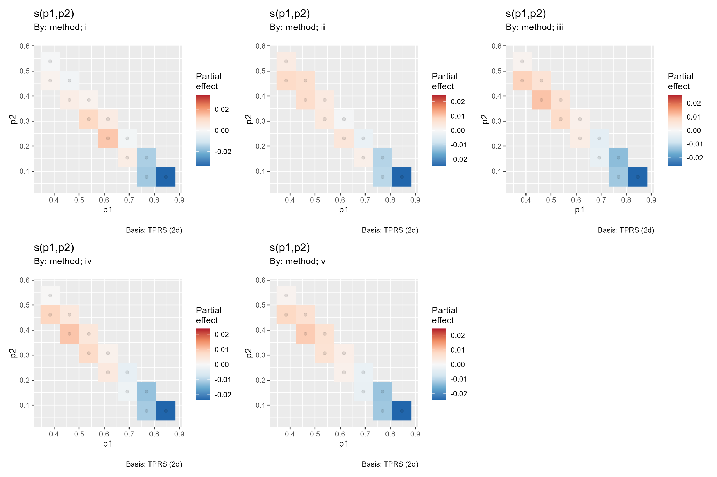
Figure 1. Method-specific partial smooths from gratia. Colored cells show the supported composition path; red indicates positive and blue negative partial effects on fitted log error.
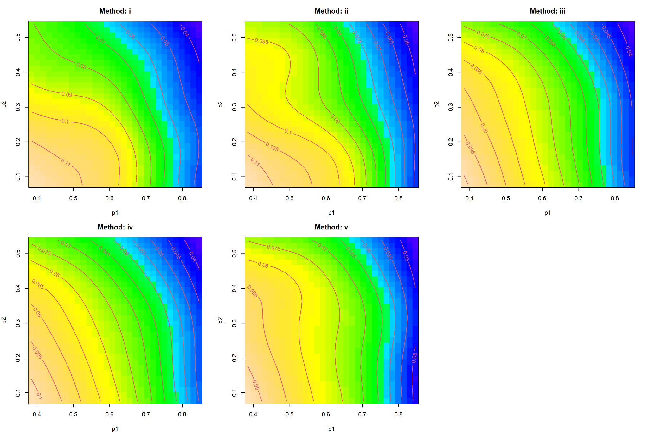
Figure 2. Global fitted method surfaces. The common decline toward high p1 is evident, but rectangular regions away from observed compositions should be treated as extrapolation.

4 Focused Comparison of Methods v and iii
The first v-minus-iii GAM explained 14.4 percent of deviance (adjusted R-squared = 0.142; residual scale = 0.000159). Its L1 surface was clearly nonconstant, edf = 7.00, F = 5.80, p < 2e-16, whereas RMSE and Linf surfaces were not significant (p = 0.611 and 0.191). Sigma increased the v-minus-iii gap by 0.00456 log units per coded unit, theta_true reduced it by 0.00131, and Negative binomial and Poisson blocks reduced it by approximately 0.00082 and 0.00075 relative to the reference. G was marginal and mean sample size was nonsignificant. The L1 contour range is visibly larger than those for RMSE or Linf, confirming that composition geometry matters most for the L1 distinction between these closely matched methods.
The explicitly signed analysis defined y = log[(error_v + 0.004223)/(error_iii + 0.004223)]. Positive values indicate larger error for v. It explained only 2.16 percent of deviance, although design block, G, sigma, mean sample size, and all three low-edf smooths were significant. The prediction grid classified v as lower-error in 62.1 percent of RMSE cells, 60.4 percent of L1 cells, and 60.8 percent of Linf cells. These are unweighted grid proportions, not empirical win probabilities or average error comparisons: a minority of cells can dominate the mean if their positive gaps are larger or more frequently observed.
Term | Signed log ratio test | Interpretation
Metric | F = 0.131, p = 0.877 | No overall signed-ratio difference among metrics
Design block | F = 17.80, p = 1.92e-08 | NB +1.31 percent; Poisson +1.68 percent versus reference
G | F = 82.76, p < 2e-16 | +1.34 percent in v/iii ratio per coded unit
Sigma | F = 12.69, p = 0.000369 | +0.52 percent in v/iii ratio per coded unit
Mean sample size | F = 31.17, p = 2.43e-08 | +0.82 percent in v/iii ratio per coded unit
Theta true | F = 0.130, p = 0.719 | No supported directional effect
p1-p2 smooths | F = 3.23-4.20, p = 0.0036-0.0167 | Small nonlinear directional shifts for all metrics

Table 3. Signed method-v relative to method-iii GAM. Percentage interpretations use exponentiated coefficients and depend on the numeric coding of each factor.
The signed model uses an epsilon equal to 0.004223, which is not negligible relative to fitted errors of roughly 0.04-0.11 in the surface plots. It therefore estimates ratios of epsilon-shifted errors, not exact raw-error ratios. The difference between the main difference-GAM pattern and the signed-grid cell counts is a substantive transformation and weighting sensitivity. For publication, the comparison should report both an empirically weighted average log ratio and factor-level contrasts using a prespecified, scientifically justified epsilon.

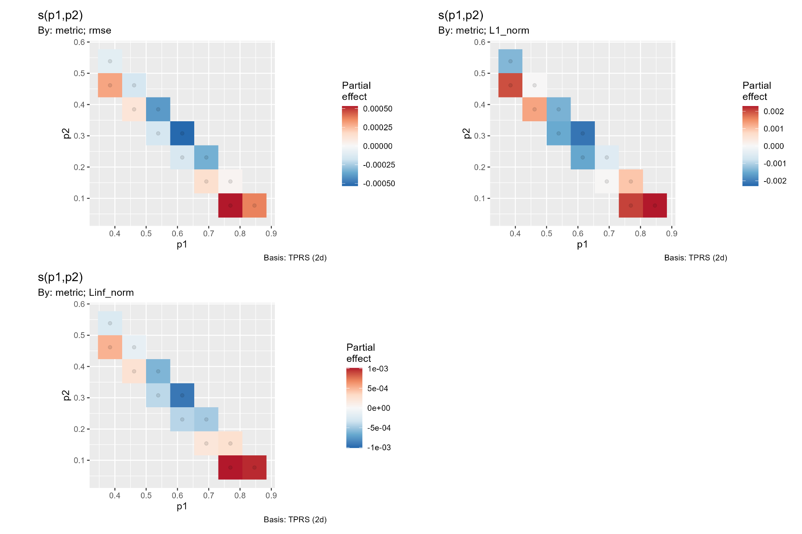
Figure 3. Partial p1-p2 effects for the v-minus-iii difference by metric. The L1 surface has the largest amplitude and strongest nonlinear structure.
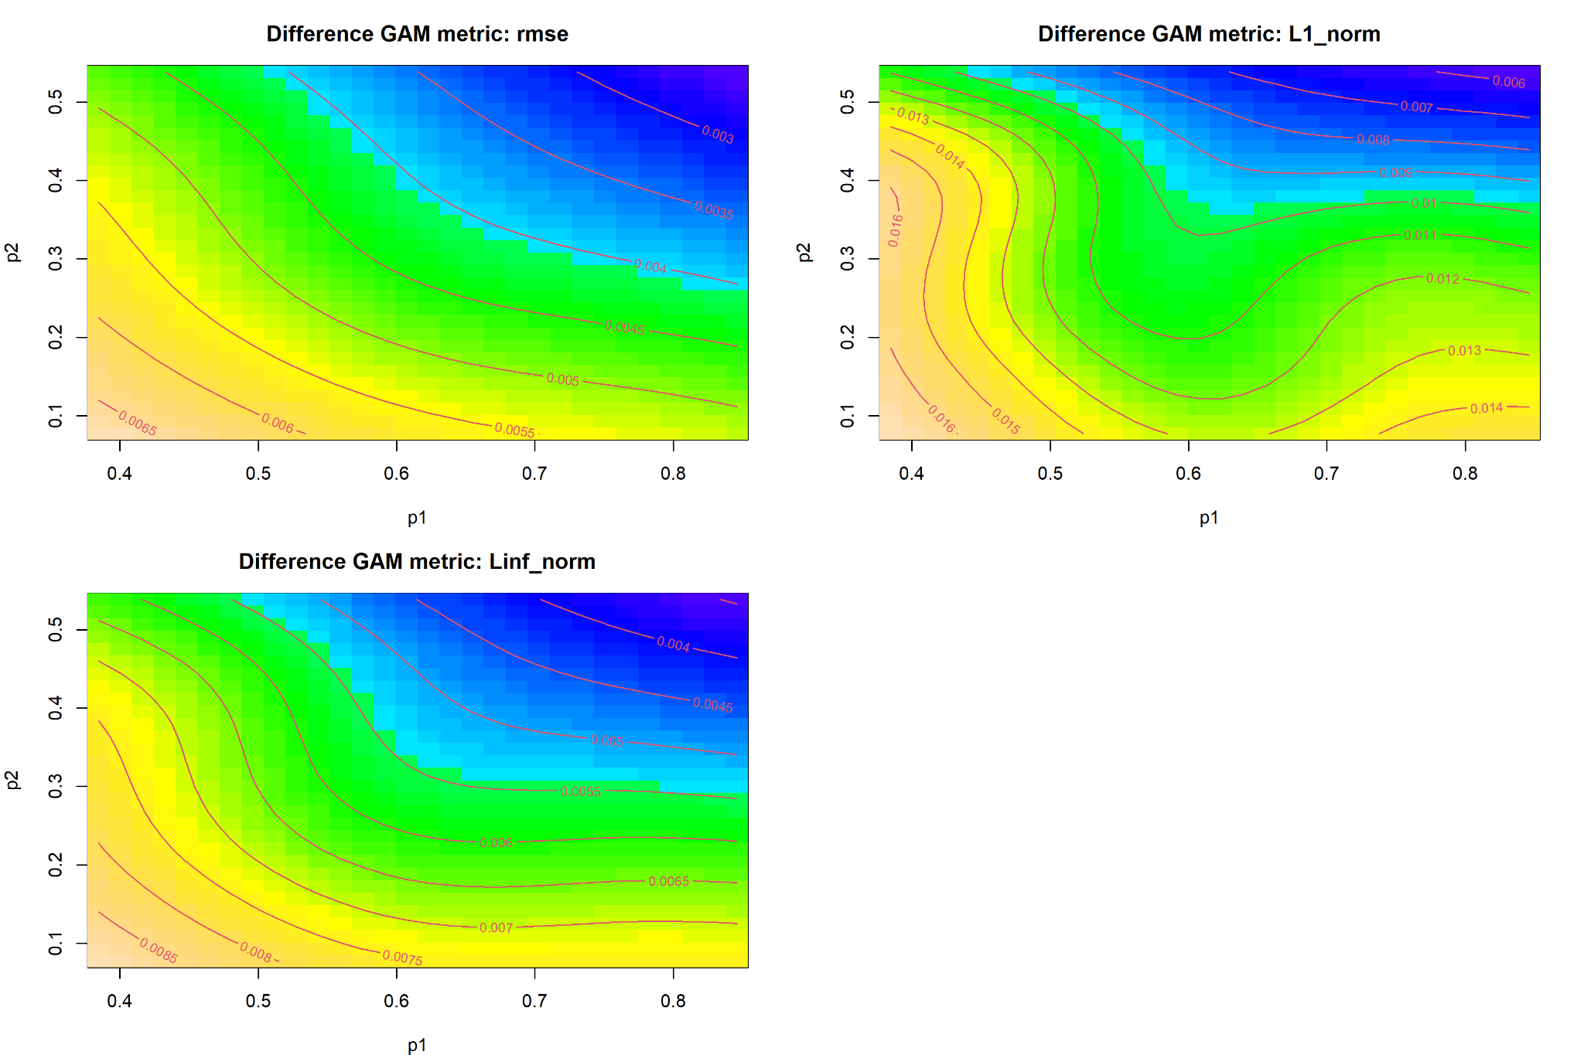
Figure 4. Fitted v-minus-iii difference surfaces. RMSE has the smallest gap, L1 the largest, and Linf an intermediate gap; interpret only within the supported simplex region.

5 Residual Diagnostics and Inferential Reliability
The global appraisal plot shows a pronounced right tail in the QQ plot, a skewed residual histogram, and a funnel in residuals against the linear predictor. Residual dispersion grows substantially with fitted error, and several large positive outliers occur. The observed-versus-fitted panel also shows increasing vertical spread. These patterns violate constant Gaussian variance and weaken literal reliance on model-based standard errors, especially for tail-sensitive statements.
The v-minus-iii appraisal is even more concentrated near zero, with rare but influential positive residuals. This mixture of many near-zero differences and a small number of large departures explains why tiny effects can be highly significant and why the signed model has low explained deviance. The GAM captures systematic mean structure but not the full conditional distribution of errors or pairwise differences.
Recommended sensitivity analyses are: a location-scale GAM or variance function by fitted value, method, and metric; robust or cluster-resampled uncertainty at the simulation-scenario level; quantile GAMs for upper-tail behavior; influence diagnostics with and without extreme simulations; and factor-level simultaneous contrasts on the signed log-ratio scale. Residual plots should also be stratified by metric and method because the pooled appraisal can conceal group-specific variance patterns.
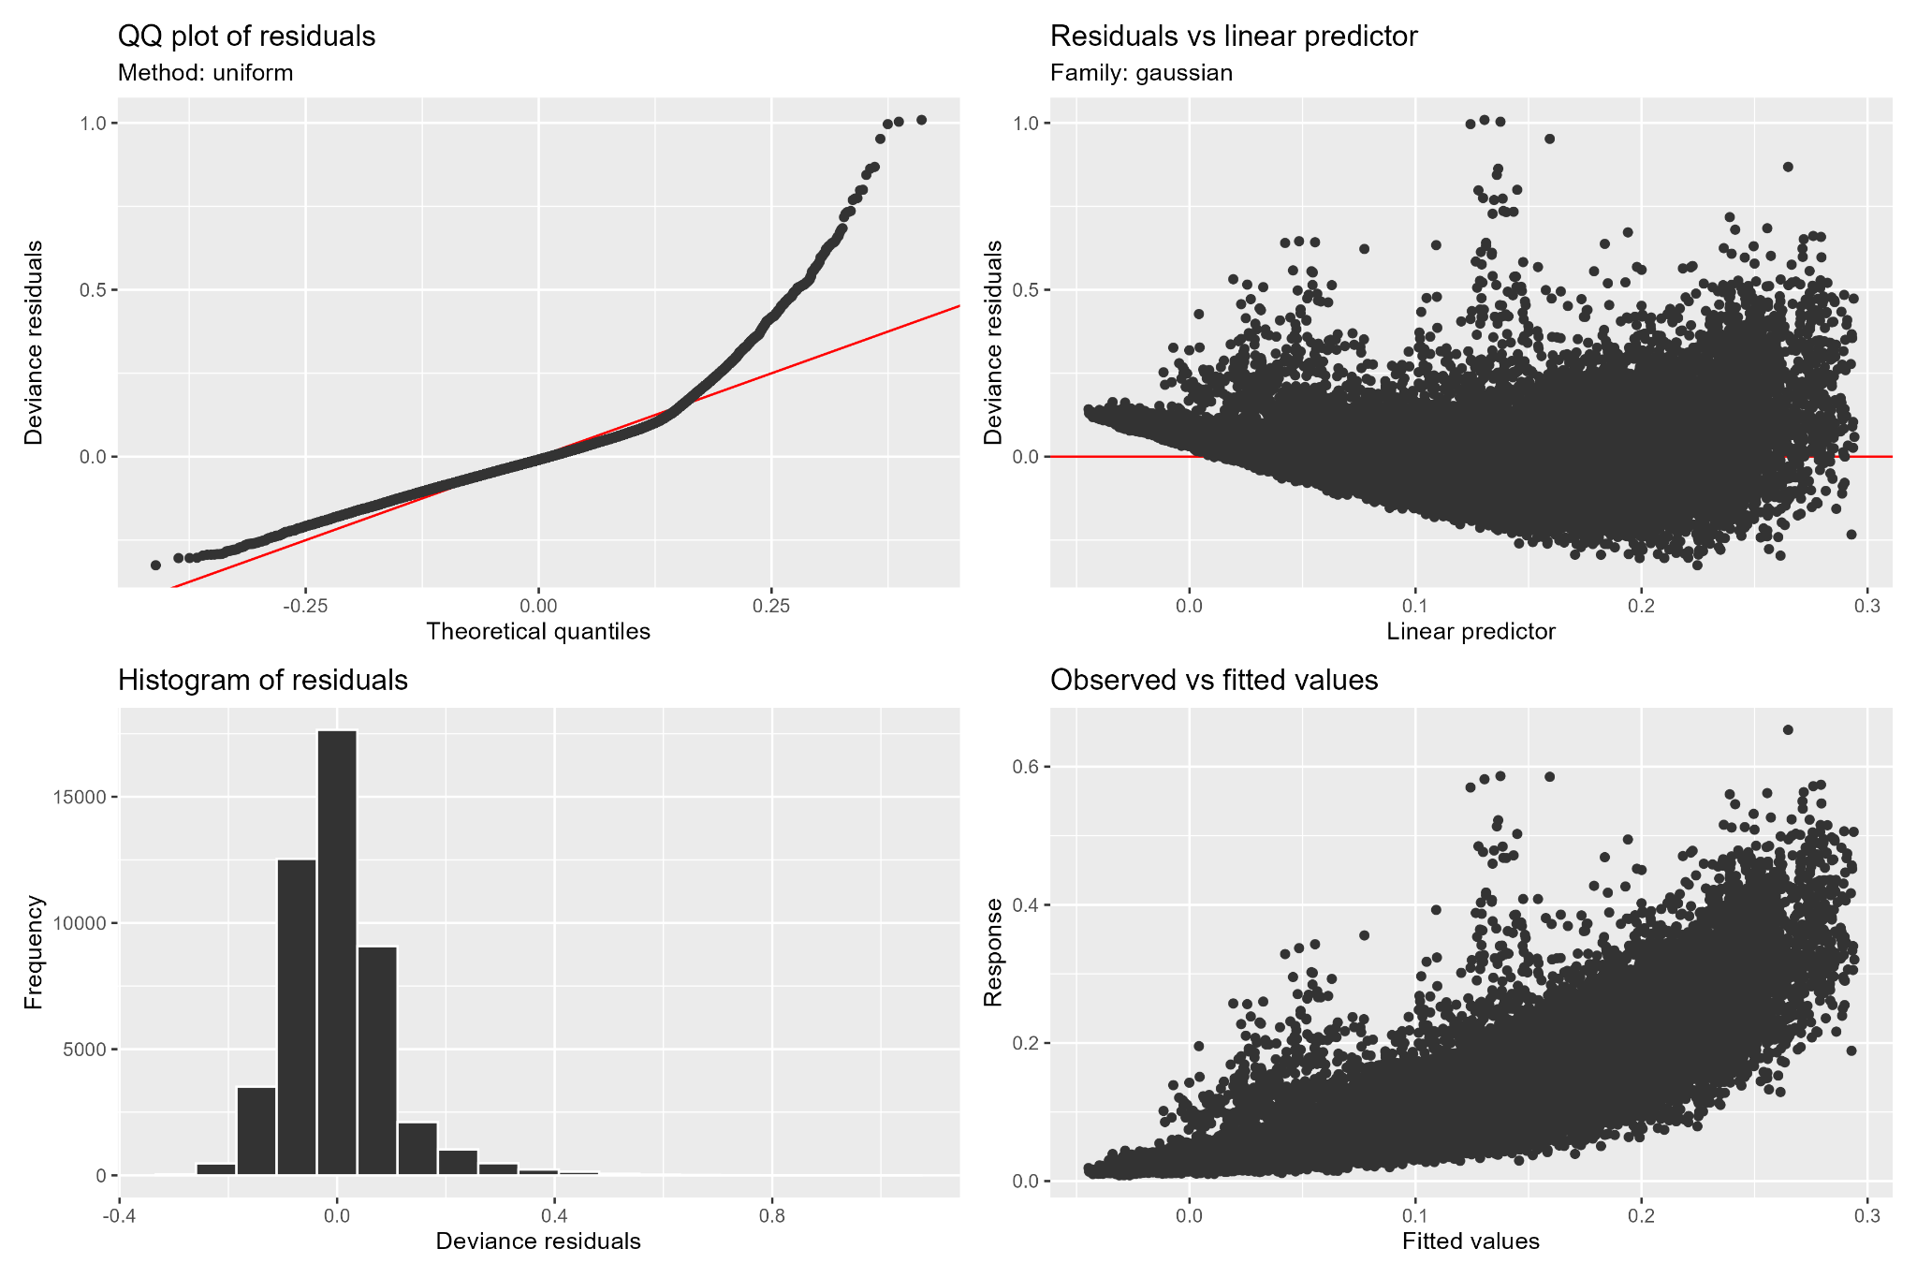
Figure 5. Global GAM appraisal. Curved QQ behavior, a strong variance funnel, and upper-tail observations indicate non-normality and heteroscedasticity.

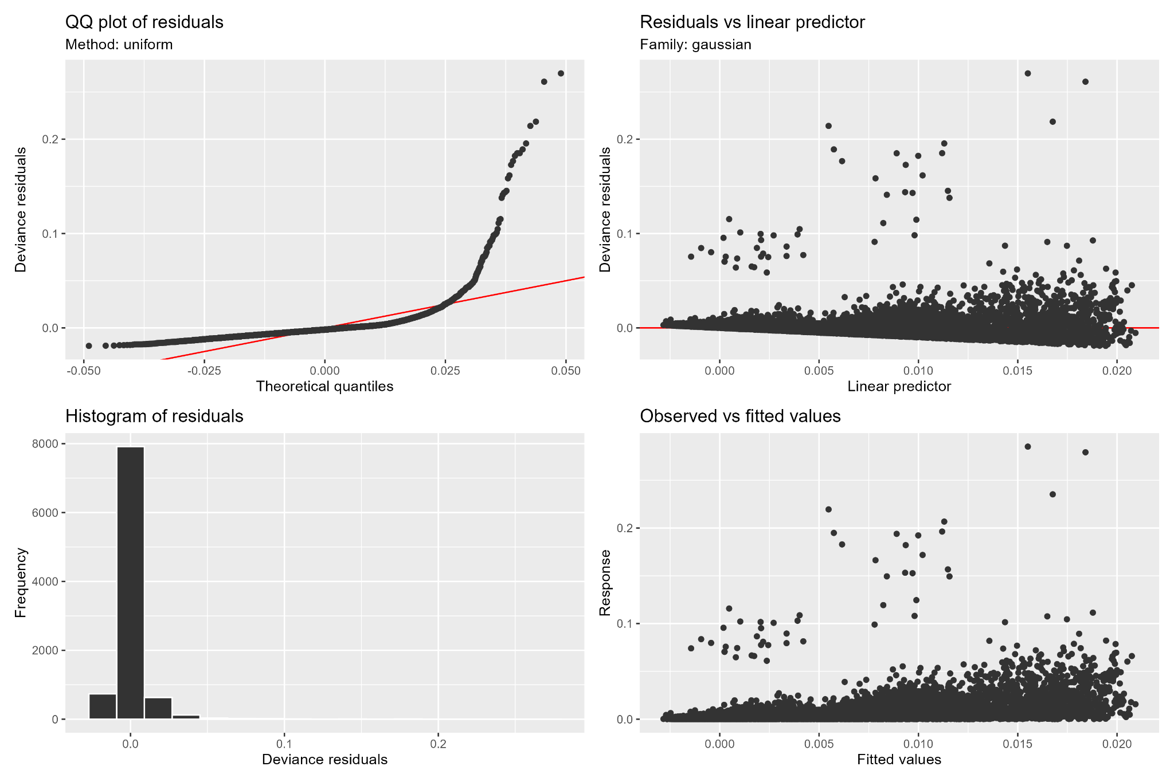
Figure 6. Appraisal for the v-minus-iii difference GAM. Most residuals are near zero, with sparse positive outliers and fitted-dependent dispersion.

6 Integrated Assessment and Recommendation
Code E supports methods iii, iv, and v as the leading estimators. Their global parametric effects are nearly equal, their composition surfaces have similar shapes, and their fitted errors are below method i across the centered comparisons. Method ii remains least favorable, especially for L1, where its adverse method interaction is largest. Method iii has the most negative centered method coefficient and is the best-supported default on average, but the margin over iv and v is small and varies across the simplex.
Sigma is the dominant experimental driver, followed by G. Mean sample size and sampling design block have smaller but highly significant effects, while theta_true has no supported global effect. Composition location is also important: all method-specific p1-p2 smooths are significant. However, the data occupy a narrow compositional path, so evidence concerns variation along that path rather than a fully sampled two-dimensional simplex.
The focused v-versus-iii analysis demonstrates local specialization. Method v is predicted to have lower epsilon-adjusted error in roughly 60-62 percent of unweighted grid cells, yet the average global model slightly favors method iii. This does not constitute a contradiction: cell frequency, gap magnitude, epsilon choice, and off-support predictions affect the summaries. The most defensible conclusion is that iii is the general default, while iv and v are practically competitive and may be preferred in verified regions identified by supported factor-level contrasts.
The spline basis is adequate, so increasing k alone is not the priority. Before peer-reviewed use, inference should address the pronounced heteroscedasticity and right-tail behavior, verify results under robust or scenario-level resampling, and repeat the signed comparison using an explicitly justified epsilon and empirical weighting. Subject to those checks, the Code E evidence reinforces the hierarchy iii approximately iv approximately v, followed by i, with ii least accurate, while identifying sigma, G, and simplex position as the principal sources of performance variation.

