Generalized Additive Model Analysis of Compositional Likelihood Accuracy
  - Method specific simplex surfaces model diagnostics and relative performance
Analysis of results-code-E-K9.txt and associated diagnostic figures using the report format of summary-results-code-A.docx
The Code E K9 analysis shows that method performance depends on both the error metric and the location of the true composition on the p1-p2 simplex. At the reference metric L1, method v has the lowest adjusted log1p error, followed by iii, iv, i, and ii. For Linf, v and iii are nearly tied and both outperform iv, i, and ii. For RMSE, iii has the lowest parametric contrast, followed by v and iv. Method v is the most compositionally stable: its p1-p2 smooth is nonsignificant and comparatively simple, whereas methods i through iv retain significant spatial structure. Sigma, G, and mean sample size dominate the experimental effects after the metric effect.
The basis dimension k = 30 is adequate. Effective degrees of freedom are 6.0-17.3 for the global method surfaces and 2.1-13.2 for the v-versus-iii gap surfaces, all well below k' = 29. K-index values are 0.96 with p values from 0.050 to 0.100; the boundary result for method v does not indicate basis saturation because that smooth uses only 6.03 degrees of freedom and is not significant. Residual plots, however, show pronounced right tails, nonconstant variance, and structured bands. These distributional departures, rather than k, are the principal inferential concern.
Critical scale qualification. The fitted global response is log(1 + error), not log(error). The difference model uses log(1 + |error_v - error_iii|), not a signed log-ratio. It therefore measures the magnitude of separation between v and iii but cannot determine which method has lower error at a given simplex location. Direct statements about relative superiority across p1 and p2 require a signed response such as log[(error_v + epsilon)/(error_iii + epsilon)].

Analysis Design and Model Scope
The analysis sampled 637,997 of 31,899,582 simplex units, a realized rate of 2.000017%, using example_id by mesh_id by sim_id as the sampling unit across 61 disk-backed partitions. The global model used 9,569,955 records: five methods by three metrics for each sampled unit. The method-v versus method-iii model used 1,913,991 paired records. Both models were fitted with Gaussian identity-link bam models using fREML and discrete computation.
Model | Response and formula | Purpose
Global GAM | log1p(accuracy) by metric x method plus method-specific s(p1,p2) and design covariates | Compare methods and characterize composition-dependent accuracy
Difference GAM | log1p(abs(error v - error iii)) by metric plus metric-specific s(p1,p2) and design covariates | Describe where and how strongly v and iii separate, without direction
Design effects | block, G, theta true, theta CV, sigma, mean sample size | Adjust surfaces and quantify experimental sensitivity
Diagnostics | gam.check, vis.gam, gratia draw and appraise | Assess k adequacy, morphology, tails, variance, and fit

1 Global GAM Results
The global GAM explains 69.0% of deviance, with adjusted R-squared 0.690 and residual scale 0.00609. Given 9.57 million observations, p values are dominated by precision; F statistics, coefficient magnitude, surface complexity, and diagnostics are more informative for practical interpretation. Metric is the largest parametric effect (F = 1,832,808), followed by G (1,643,018), sigma (1,063,228), mean sample size (372,283), theta true (78,943), design block (58,171), theta CV (3,474), the metric-by-method interaction (2,717), and method (747).
Effect | df | F statistic | p value | Interpretation
Metric | 2 | 1,832,807.9 | < 2.22e-16 | Largest effect; metrics differ strongly in scale
G | 1 | 1,643,017.8 | < 2.22e-16 | Largest experimental driver
sigma | 1 | 1,063,228.2 | < 2.22e-16 | Second experimental driver
Mean sample size | 1 | 372,283.3 | < 2.22e-16 | Strong information effect
theta true | 1 | 78,942.5 | < 2.22e-16 | Moderate signal-level effect
Design block | 2 | 58,170.7 | < 2.22e-16 | Distribution-family effect
theta CV | 1 | 3,473.8 | < 2.22e-16 | Smallest experimental effect
Metric by method | 8 | 2,716.7 | < 2.22e-16 | Method contrasts depend on metric
Method | 4 | 746.7 | < 2.22e-16 | Average differences after adjustment

2 Comparative Method Performance
Because L1 is the reference metric and method i is the reference method, each metric-specific contrast is the method coefficient plus its interaction adjustment. Exponentiating a contrast gives a ratio of 1 + error, not a raw error ratio. At the centered smooth and reference design condition, the ordering is stable enough to identify v and iii as the leading methods, but the significant interaction prevents a single coefficient from representing all three metrics.
Metric | Method ii vs i | Method iii vs i | Method iv vs i | Method v vs i | Conditional ordering
L1 | +0.01640 (+1.65%) | -0.01451 (-1.44%) | -0.00610 (-0.61%) | -0.01760 (-1.74%) | v, iii, iv, i, ii
Linf | +0.00542 (+0.54%) | -0.01034 (-1.03%) | -0.00781 (-0.78%) | -0.01069 (-1.06%) | v about iii, iv, i, ii
RMSE | +0.00670 (+0.67%) | -0.00332 (-0.33%) | -0.00183 (-0.18%) | -0.00240 (-0.24%) | iii, v, iv, i, ii

Method ii has higher fitted error than i for every metric, although its disadvantage is much smaller for Linf and RMSE than for L1. Methods iii and v are consistently favorable. Method iii has the strongest RMSE contrast, while v has the strongest L1 and Linf contrasts. Method iv provides a smaller improvement over i. These are conditional parametric contrasts; the method-specific smooths can change local differences across the simplex.

3 Experimental Factor Influence
The signs of the linear coefficients indicate that fitted log1p error decreases with G, theta true, and mean sample size; increases with sigma and theta CV; and is lower under Poisson and negative-binomial blocks than under the reference block. The F-statistic hierarchy identifies G and sigma as dominant. Coefficients are interpreted per one unit on the variables as stored in the analysis, so design-range changes should not be extrapolated without confirming coding and linearity.
Factor | Coefficient | Change in 1 plus error per unit | F statistic | Practical reading
G | -0.03962 | -3.88% | 1,643,017.8 | Strongest experimental influence; larger G lowers error
sigma | +0.03186 | +3.24% | 1,063,228.2 | Higher noise increases error
Mean sample size | -0.01885 | -1.87% | 372,283.3 | More sampling lowers error
theta true | -0.00868 | -0.86% | 78,942.5 | Larger signal lowers fitted error
theta CV | +0.00182 | +0.18% | 3,473.8 | Small adverse heterogeneity effect

4 Method Specific Simplex Surfaces
Method | edf | F | p value | Surface interpretation
i | 17.29 | 190.47 | < 2e-16 | Most complex and strongest p1-p2 dependence
ii | 12.51 | 5.39 | < 2e-16 | Weak but detectable nonlinear dependence
iii | 12.16 | 13.43 | < 2e-16 | Moderate nonlinear dependence
iv | 12.35 | 14.21 | < 2e-16 | Moderate nonlinear dependence
v | 6.03 | 1.06 | 0.385 | No supported residual p1-p2 dependence

The fitted surfaces show distinct morphology. Method i has the most irregular topography, with a high-error lobe near low-to-moderate p1 and p2 and troughs through the center-right simplex. Method ii has the highest contour levels overall and a broad low basin at small p1 and p2, with error increasing toward large p2 and the upper-right boundary. Methods iii and iv show broad interior plateaus followed by steep declines toward high p1. Method v has the narrowest contour range and a smooth monotone decline toward large p1, consistent with its nonsignificant smooth and greater compositional robustness.
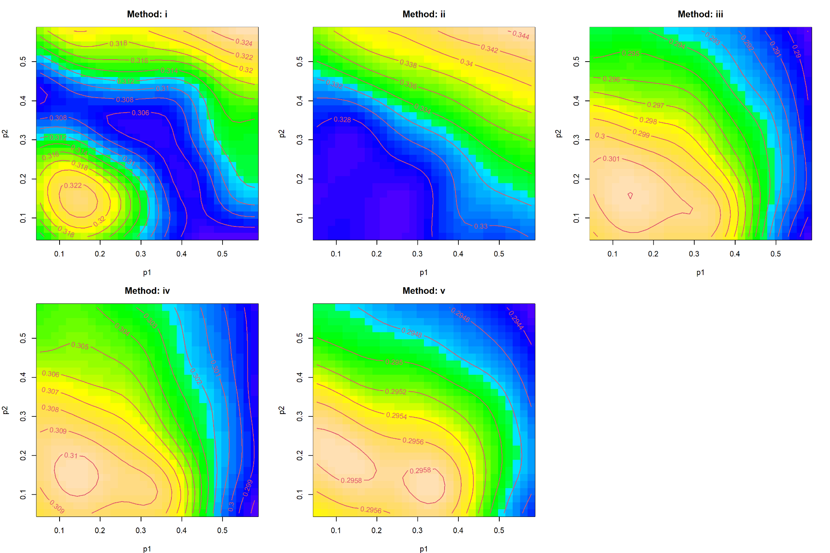
Figure 1 Conditional fitted global GAM surfaces by method. Lower contours indicate lower fitted log1p error; panels should be compared using contour values because their color scales are not guaranteed to be common.
The gratia smooth panels display centered partial effects rather than full fitted values. They support the same conclusion—method i exhibits the greatest local variation and method v the least—but the supplied layout is not publication-ready: simplex panels are compressed, tick labels use excessive decimal precision, and separate legends impede direct comparison. A revised figure should use equal aspect ratios, concise ticks, a common color scale, and explicit masking of the triangular simplex support.

5 Method v Versus Method iii Gap Model
The difference GAM explains 23.7% of deviance with adjusted R-squared 0.237 and residual scale 0.000367. Its response is log1p of the absolute raw error difference. It therefore quantifies separation magnitude only. The baseline L1 gap is larger than the Linf gap by 0.01277 log1p units and larger than the RMSE gap by 0.01903 units. Sigma sharply increases the separation (coefficient 0.00838), whereas G, theta true, and mean sample size reduce it; theta CV increases it slightly.
Metric-specific smooth | edf | F | p value | Conclusion
L1 | 13.18 | 21.23 | < 2e-16 | Strong nonlinear variation in gap magnitude
Linf | 9.62 | 5.48 | < 2e-16 | Moderate nonlinear variation
RMSE | 2.05 | 0.09 | 0.933 | No supported p1-p2 variation

The L1 surface ranges roughly from 0.0225 to 0.0270 on the modeled scale, corresponding to an absolute error gap of about 0.0228-0.0274 after inverse transformation. It contains localized ridges and troughs, especially near the lower simplex boundary. Linf ranges approximately from 0.0105 to 0.0140 and rises toward large p1 or p2. RMSE is nearly planar, about 0.00464-0.00473, matching the nonsignificant smooth test. None of these positive surfaces demonstrates that v is worse than iii; positivity is guaranteed by the absolute-value transformation.
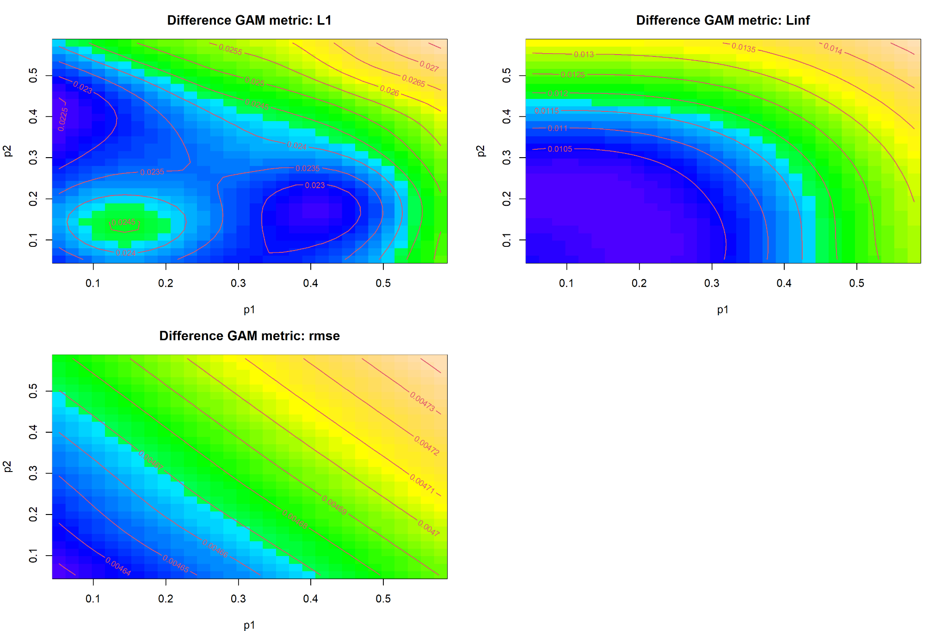
Figure 2 Conditional surfaces for log1p of the absolute v-minus-iii error gap. Contours describe magnitude, not direction.
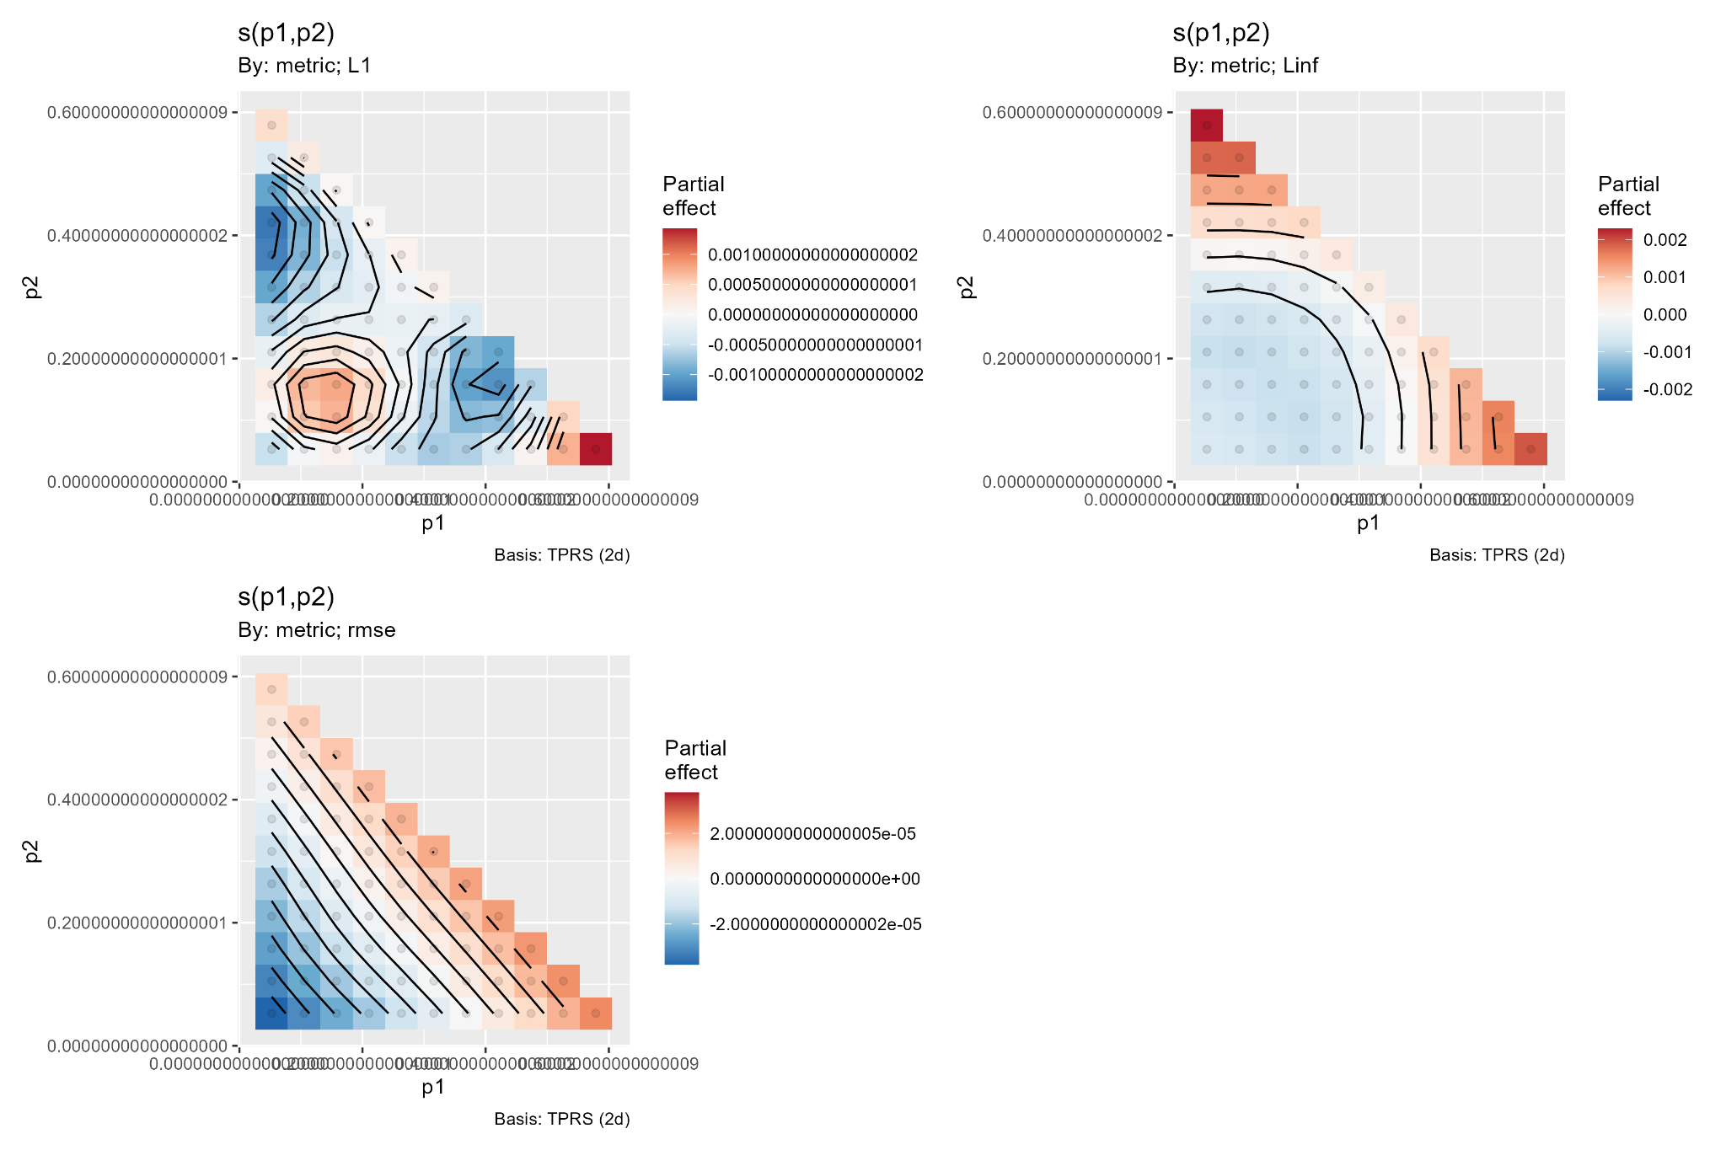
Figure 3 Centered partial effects for the v-versus-iii gap. L1 and Linf vary over the simplex; the RMSE effect is essentially flat.

6 Basis Dimension Adequacy
The k checks do not support increasing k above 30. In the global model, edf values are 17.29, 12.51, 12.16, 12.35, and 6.03 against k' = 29. In the difference model they are 13.18, 9.62, and 2.05. No smooth approaches the available basis rank. All k-index values equal 0.96; global p values are 0.075, 0.060, 0.100, 0.085, and 0.050, while difference-model p values are 0.095, 0.095, and 0.085.
The method-v p value of 0.050 is a boundary flag, not convincing evidence of undersmoothing. A truly inadequate k would usually combine k-index below one, a small p value, and edf close to k'. Here the edf-to-k' ratio is only 0.21 and the smooth itself is nonsignificant. The appropriate conclusion is that k = 30 is adequate, with a routine sensitivity refit at k = 40 or 50 optional for confirmation rather than required for remediation.
Model term | k prime | edf | edf divided by k prime | k index | k test p | Assessment
Global i | 29 | 17.29 | 0.60 | 0.96 | 0.075 | Adequate
Global ii | 29 | 12.51 | 0.43 | 0.96 | 0.060 | Adequate
Global iii | 29 | 12.16 | 0.42 | 0.96 | 0.100 | Adequate
Global iv | 29 | 12.35 | 0.43 | 0.96 | 0.085 | Adequate
Global v | 29 | 6.03 | 0.21 | 0.96 | 0.050 | Adequate; boundary flag only
Gap L1 | 29 | 13.18 | 0.45 | 0.96 | 0.095 | Adequate
Gap Linf | 29 | 9.62 | 0.33 | 0.96 | 0.095 | Adequate
Gap RMSE | 29 | 2.05 | 0.07 | 0.96 | 0.085 | Adequate

7 Residual Diagnostics and Model Reliability
The global diagnostic plots show a pronounced upper-tail departure from the Gaussian reference, a right-skewed residual distribution, and wedge-shaped residual variance that changes with the linear predictor. Response-versus-fitted values form discrete bands associated with metrics and experimental conditions. The model captures the mean structure well enough to explain 69% of deviance, but Gaussian standard errors and p values may be optimistic under this heteroscedastic, clustered structure.
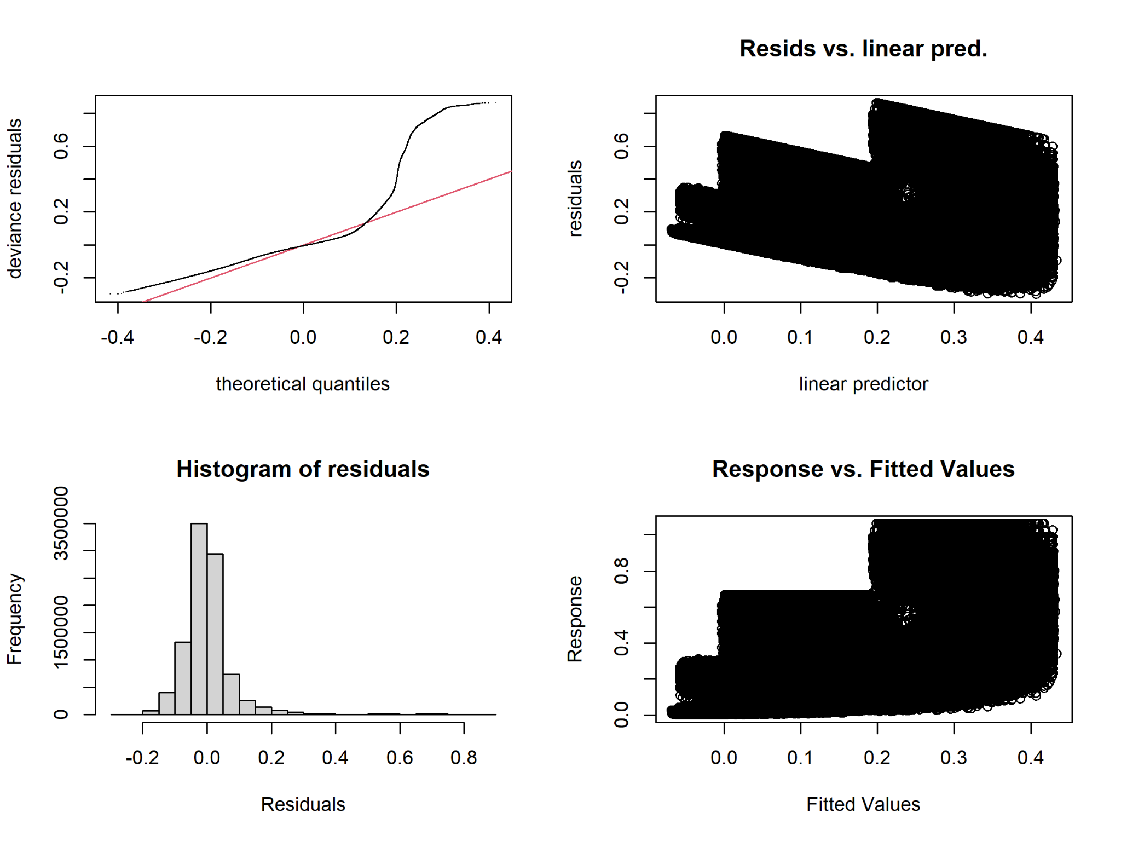
Figure 4 Global GAM diagnostics. The upper-tail departure, banding, and changing residual spread are more important than basis-dimension concerns.
The difference-model diagnostics are more severe because the response is nonnegative and concentrated near zero. The QQ plot has a long upper tail; the histogram is strongly right-skewed; and the residual spread increases with fitted magnitude, with sparse large outliers. These patterns explain the modest 23.7% deviance explained and indicate that a Gaussian model of log1p absolute differences is primarily descriptive.
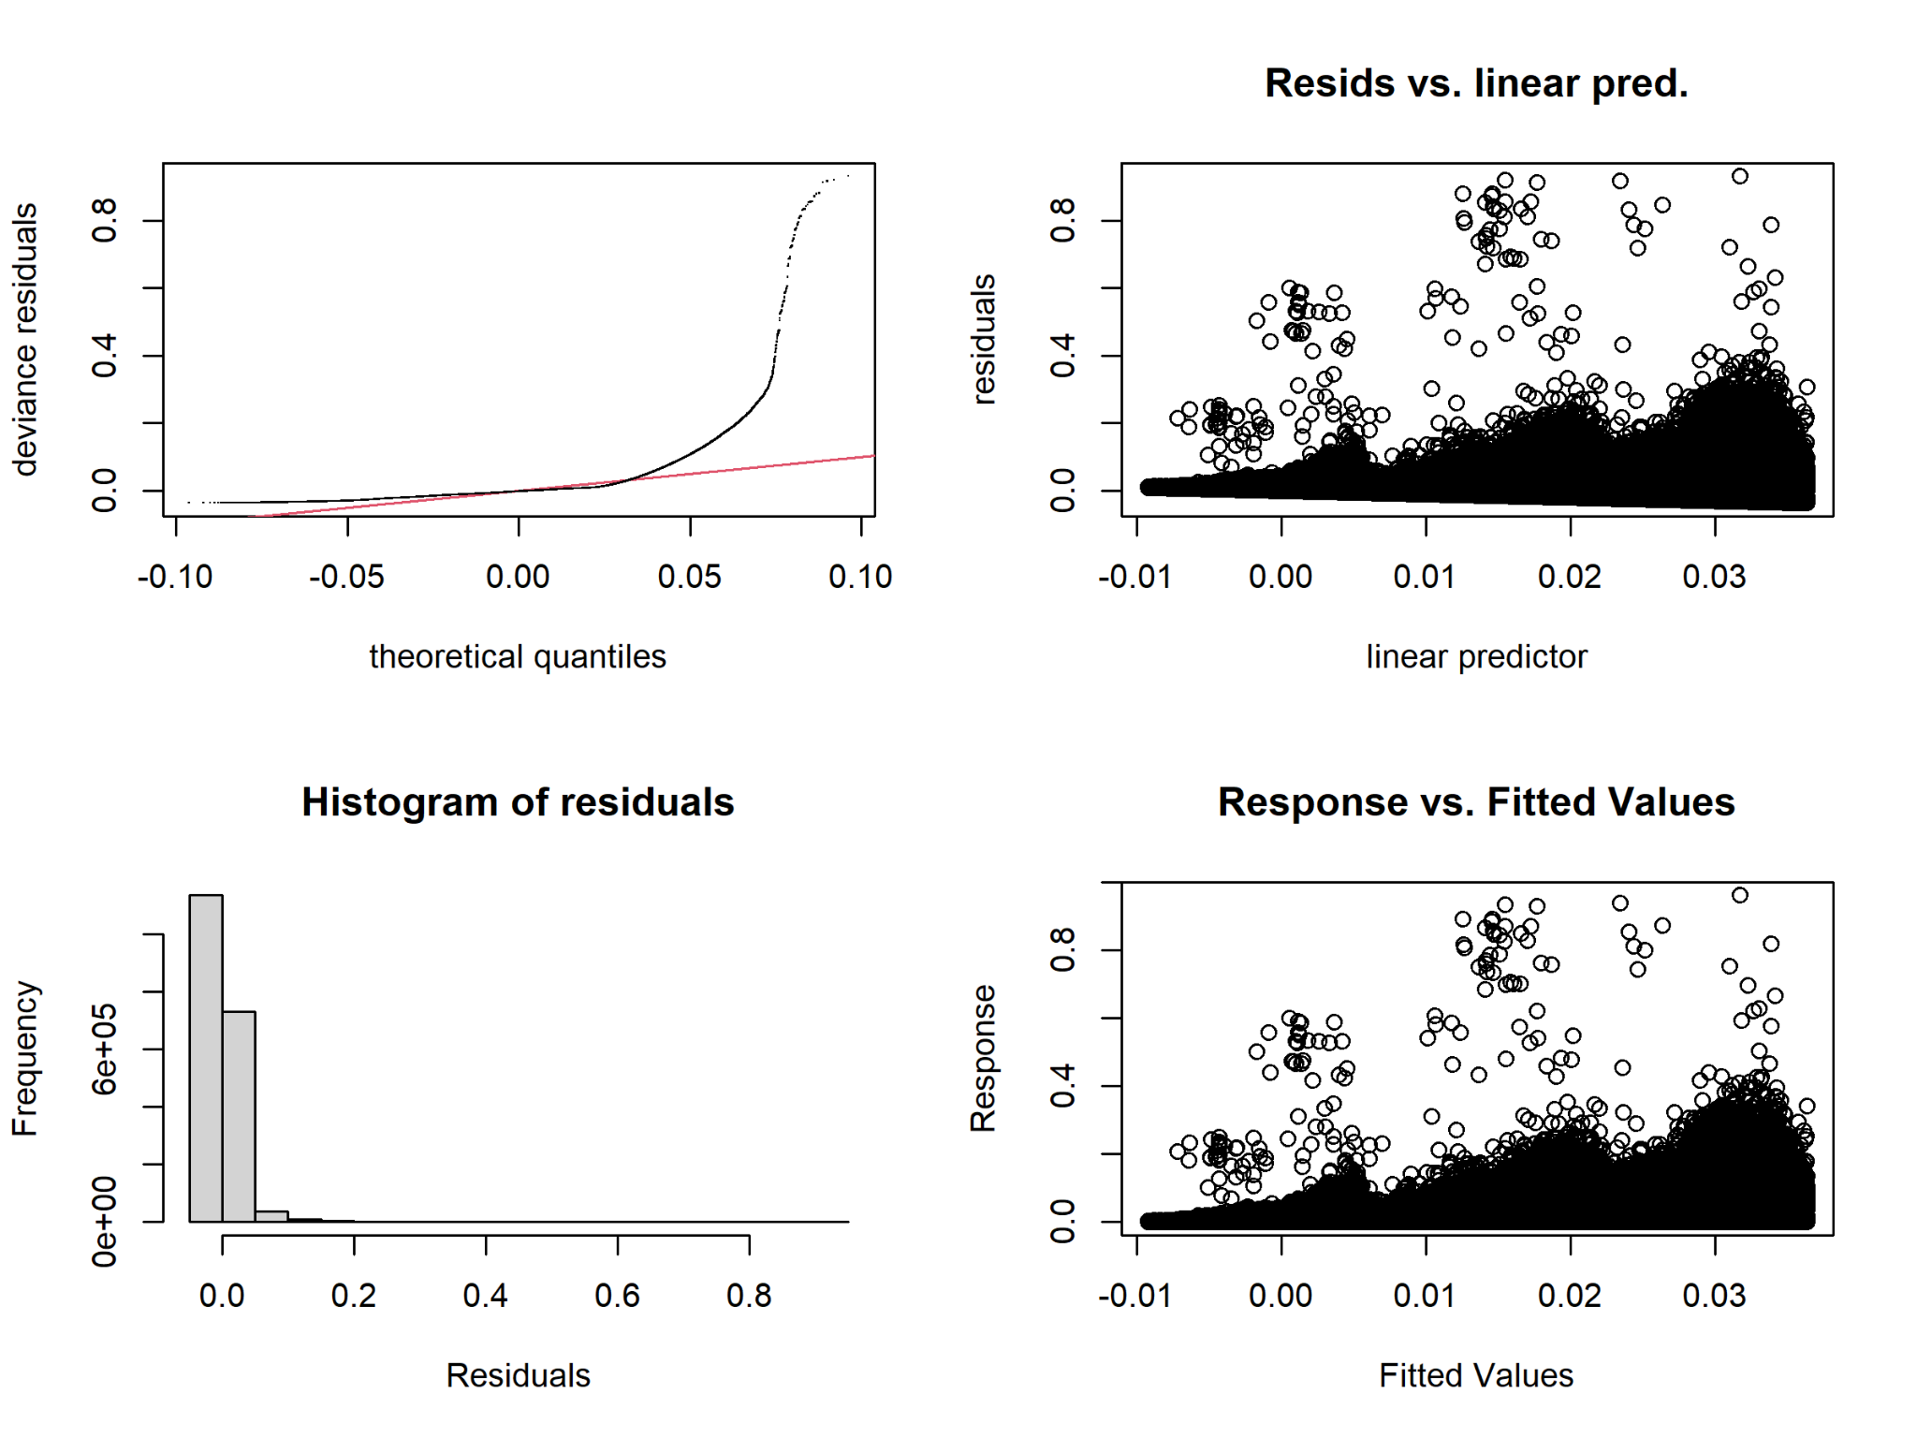
Figure 5 Difference GAM diagnostics. Strong right skew, near-zero concentration, and heteroscedasticity limit Gaussian inference.
Recommended sensitivity analyses. Refit the global model with a location-scale or robust family where computationally feasible; obtain uncertainty by cluster bootstrap over simplex units; and compare surfaces under stratified residual diagnostics by metric and method. For direct v-versus-iii inference, model the signed log-ratio log[(error_v + epsilon)/(error_iii + epsilon)] and report pointwise or simultaneous confidence bands. If many paired differences equal zero, a two-part model for zero versus positive gap plus positive magnitude is preferable to a single Gaussian model.

8 Integrated Conclusions
- Method comparison: v and iii are the leading estimators. v is strongest for L1 and Linf at the reference condition, while iii has the strongest RMSE contrast. ii has the highest fitted error for every metric.
- Robustness: method v has the least composition-dependent behavior; its p1-p2 smooth is nonsignificant. Method i is the most composition-sensitive.
- Factor hierarchy: after metric, G and sigma are the main experimental drivers, followed by mean sample size, theta true, design block, and theta CV.
- Basis adequacy: k = 30 is sufficient. No edf approaches k' = 29, and the k-index results do not provide coherent evidence of an underspecified basis.
- v-versus-iii specialization: the absolute gap varies nonlinearly for L1 and Linf but not RMSE. Sigma most strongly increases this separation.
- Inference limitation: the unsigned gap is not a log-ratio and cannot identify local reversals or a composition-specific winner.
- Model diagnostics: residual tails and heteroscedasticity warrant robust or cluster-bootstrap uncertainty for confirmatory inference.
Overall, method v is the most robust general-purpose choice, combining low fitted error with minimal p1-p2 sensitivity. Method iii is a close alternative and may be preferable for RMSE. A definitive composition-specific superiority map requires a signed log-ratio model rather than the current absolute-gap formulation.

