Formal Statistical Analysis of GAM Estimation Accuracy
Method-specific simplex surfaces, basis diagnostics, comparative performance, and model adequacy
Analysis source: results-code-E.txt and diagnostic plots | Script source: code-E.R | Prepared 28 August 2026
Central finding. The GAM identifies a leading cluster of methods iii, iv, and v; method ii has the highest adjusted error and method i is intermediate. Sigma and G dominate the global response, while every method has a statistically clear nonlinear p1-p2 surface. The basis dimension k = 30 is adequate, but strong right skew and heteroscedasticity show that the Gaussian likelihood is not adequate. In addition, the v-versus-iii model analyzes an unsigned absolute raw difference, not a signed log-ratio, and therefore cannot establish which method is locally superior.

Executive synthesis
Code E fits two large-sample generalized additive models using mgcv::bam with fast restricted maximum likelihood. The global model uses 500,000 sampled rows and analyzes log(1 + accuracy) across five methods and three metrics. The comparison model uses 144,342 complete matched rows and analyzes log(1 + |accuracy_v - accuracy_iii|). Both models use method- or metric-specific thin-plate regression spline surfaces over p1 and p2 with k = 30.
The global model explains 38.8% of deviance (adjusted R-squared = 0.388). Metric, method, their interaction, every listed design term, and all five p1-p2 smooths are significant at p < 2 x 10^-16. F-based influence is concentrated in sigma (F = 76,107.9; approximate partial-R-squared analog 0.132) and G (F = 52,251.7; analog 0.095). Mean sample size, design block, and theta_true form a smaller second tier; theta_CV and the method-by-metric interaction are statistically detectable but practically small.
The significant metric-by-method interaction (F[8] = 104.4, p < 2 x 10^-16) means that method contrasts depend on the error definition. At the centered smooth and reference covariate settings, method iii has the smallest fitted L1 response, while method iv has the smallest fitted Linf and RMSE responses. Methods iii, iv, and v are tightly grouped; method ii is worse under all three metrics. These are conditional model contrasts, not population-wide marginal rankings.
The p1-p2 surfaces have substantial shape. All methods show an interior region of increased error and lower error toward portions of the simplex boundary, but the amplitude and topography differ. Method iii has the strongest surface test (F = 87.97), method ii the weakest (F = 35.08), and methods iv and v are intermediate. A weaker smooth for method ii does not imply good performance: its entire fitted surface is shifted upward.
For the absolute v-versus-iii gap, sigma is the dominant linear driver (t = 159.1), and the gap is largest in an interior zone near p1 and p2 of approximately 0.3-0.4. The metric-specific surface is strongest for L1, followed by Linf and RMSE. Mean sample size has no detectable linear association with gap magnitude (p = 0.364). Because the sign is discarded before modeling, none of these results indicates whether v or iii is better within a region.
Scale correction. The supplied narrative describes log-ratios, but Code E does not fit log(error_v/error_iii). The global response is log1p(error), and the comparison response is log1p(abs(error_v - error_iii)). Exponentiated coefficients therefore describe changes in 1 + error or 1 + absolute gap, not percentage improvements in error itself. A signed log-ratio surface must be fitted for relative-efficiency claims.

1. Statistical formulation and audit

1.1 Global accuracy GAM
The global model is a Gaussian identity-link BAM fitted by fREML with discrete computation. In compact notation, the response and systematic component are
Y = log(1 + accuracy) = metric x method + f_method(p1,p2) + design_block + G + theta_true + theta_CV + sigma + mean_nsamp + error
The five by-factor smooths allow the p1-p2 morphology to differ among methods. The parametric metric-by-method interaction allows method contrasts to differ among L1, Linf, and RMSE. The reference categories are L1, method i, and the lognormal design block. Smooths are centered, so method coefficients apply at the average smooth contribution and reference settings.

1.2 v-versus-iii separation GAM
The second model first calculates diff = accuracy_v - accuracy_iii, discards the sign through |diff|, and fits log(1 + |diff|). It quantifies the magnitude of separation, not relative direction. The metric-specific p1-p2 smooths test whether the size of the v-versus-iii gap changes over the simplex differently for L1, Linf, and RMSE.
Component | Implementation
Global sample | 500,000 rows sampled from 61 partitions; seed 20,731
Difference sample | 144,342 complete v-versus-iii matched rows
Global response | log1p(accuracy)
Gap response | log1p(abs(accuracy_v - accuracy_iii))
Smooth basis | Two-dimensional thin-plate regression spline; k = 30 for each by-level
Estimation | bam, Gaussian identity link, fREML, discrete = TRUE
Linear coding | G, theta_true, theta_CV, sigma, and mean_nsamp entered as one-df numeric slopes

Factorial-design qualification. The five experimental variables are not fitted as three-level factors; they are fitted as linear numeric terms. Consequently, the reported one-df tests evaluate linear trends only. Curvature or non-monotone level effects cannot be detected and should be checked with factor coding or prespecified nonlinear trends.

1.3 Inferential scale and dependence
For a coefficient delta in the global model, 100[exp(delta) - 1] is the percentage change in 1 + accuracy. It is not the percentage change in accuracy unless a baseline fitted value is supplied. The corresponding raw-error contrast is exp(eta + delta) - exp(eta), where eta is the baseline linear predictor. The same limitation applies to the absolute-gap model.
Rows sharing an example_id, method, or metric are matched and potentially dependent, but no random effect or residual correlation is fitted. With hundreds of thousands of rows, nominal standard errors may therefore be optimistic. A matched-example bootstrap or random-effect formulation is needed for fully defensible inferential uncertainty.

2. Global GAM results

2.1 Hierarchy of influence
Term | df | F | F-based partial R2 | Interpretation
sigma | 1 | 76,107.9 | 0.132 | Dominant experimental driver
G | 1 | 52,251.7 | 0.095 | Second dominant driver
metric | 2 | 16,656.9 | 0.062 | Large scale difference among metrics
mean_nsamp | 1 | 3,943.6 | 0.0078 | Smaller but clear
design_block | 2 | 1,247.6 | 0.0050 | Smaller block effect
theta_true | 1 | 1,576.5 | 0.0031 | Small linear trend
method | 4 | 293.7 | 0.0023 | Small after conditioning
metric x method | 8 | 104.4 | 0.0017 | Small but scientifically important
theta_CV | 1 | 111.0 | 0.00022 | Least influential tested term

The partial-R-squared values are descriptive analogs calculated as df x F / (df x F + residual df), using approximately 499,833 residual degrees of freedom. The mgcv F tests are approximate, so these quantities should be treated as influence summaries rather than exact variance partitions. Nevertheless, the separation between sigma and G and the remaining experimental factors is too large to be an artifact of rounding.

2.2 Direction of experimental trends
Term | Coefficient | Conditional interpretation
sigma | +0.04107 | Higher noise increases fitted error
G | -0.03407 | Higher G decreases fitted error
mean_nsamp | -0.00934 | Larger mean sample size decreases error
theta_true | -0.00591 | Higher theta_true decreases error
theta_CV | +0.00157 | Higher heterogeneity slightly increases error
Negative binomial vs lognormal | -0.01246 | Lower fitted error
Poisson vs lognormal | -0.01330 | Lower fitted error

All coefficients in this table have p < 2 x 10^-16. Their scientific interpretation should focus on sign and fitted contrasts across observed levels, not on isolated one-unit changes. The design variables are uncentered numeric covariates, and the magnitude of a coefficient depends on the coding scale.

2.3 Method-by-metric decomposition
Metric | Method vs i | Link contrast | Change in 1 + error | Conclusion
L1 | ii | +0.031664 | +3.217% | Worse than i
L1 | iii | -0.007959 | -0.793% | Best conditional L1
L1 | iv | -0.007194 | -0.717% | Leading cluster
L1 | v | -0.007645 | -0.762% | Leading cluster
Linf | ii | +0.019862 | +2.006% | Worse than i
Linf | iii | -0.003691 | -0.368% | Leading cluster
Linf | iv | -0.004044 | -0.404% | Best conditional Linf
Linf | v | -0.003450 | -0.344% | Leading cluster
RMSE | ii | +0.015439 | +1.556% | Worse than i
RMSE | iii | -0.002154 | -0.215% | Leading cluster
RMSE | iv | -0.002762 | -0.276% | Best conditional RMSE
RMSE | v | -0.002314 | -0.231% | Leading cluster

These contrasts combine each method main effect with the relevant method-by-metric interaction. The interaction is decisively significant, so a single method main effect is incomplete. The top-three numerical differences are very small on the log1p scale and were not supplied with direct pairwise covariance-based tests; they should not be described as definitive pairwise superiority. Method ii, by contrast, is consistently displaced toward higher error.

3. Method-specific p1-p2 smooth surfaces
Method | edf | F | k-index | k-check p | Surface assessment
i | 21.71 | 75.96 | 1.02 | 0.90 | Complex, comparatively strong
ii | 19.46 | 35.08 | 1.02 | 0.90 | Flatter modulation at a higher error level
iii | 20.09 | 87.97 | 1.02 | 0.90 | Strongest p1-p2 sensitivity
iv | 19.57 | 60.44 | 1.02 | 0.88 | Moderate sensitivity
v | 19.83 | 58.78 | 1.02 | 0.89 | Moderate sensitivity

All five smooths are highly significant, but their morphology is more informative than their p-values. The partial-effect panels show a broad positive interior dome and negative effects toward several boundary regions. Methods iii, iv, and v share a broadly similar interior peak, while method i is more irregular and method ii has a broad plateau. Method iii has the greatest statistical sensitivity to location on the simplex, whereas method ii varies least across p1-p2 after its higher overall level is accounted for.
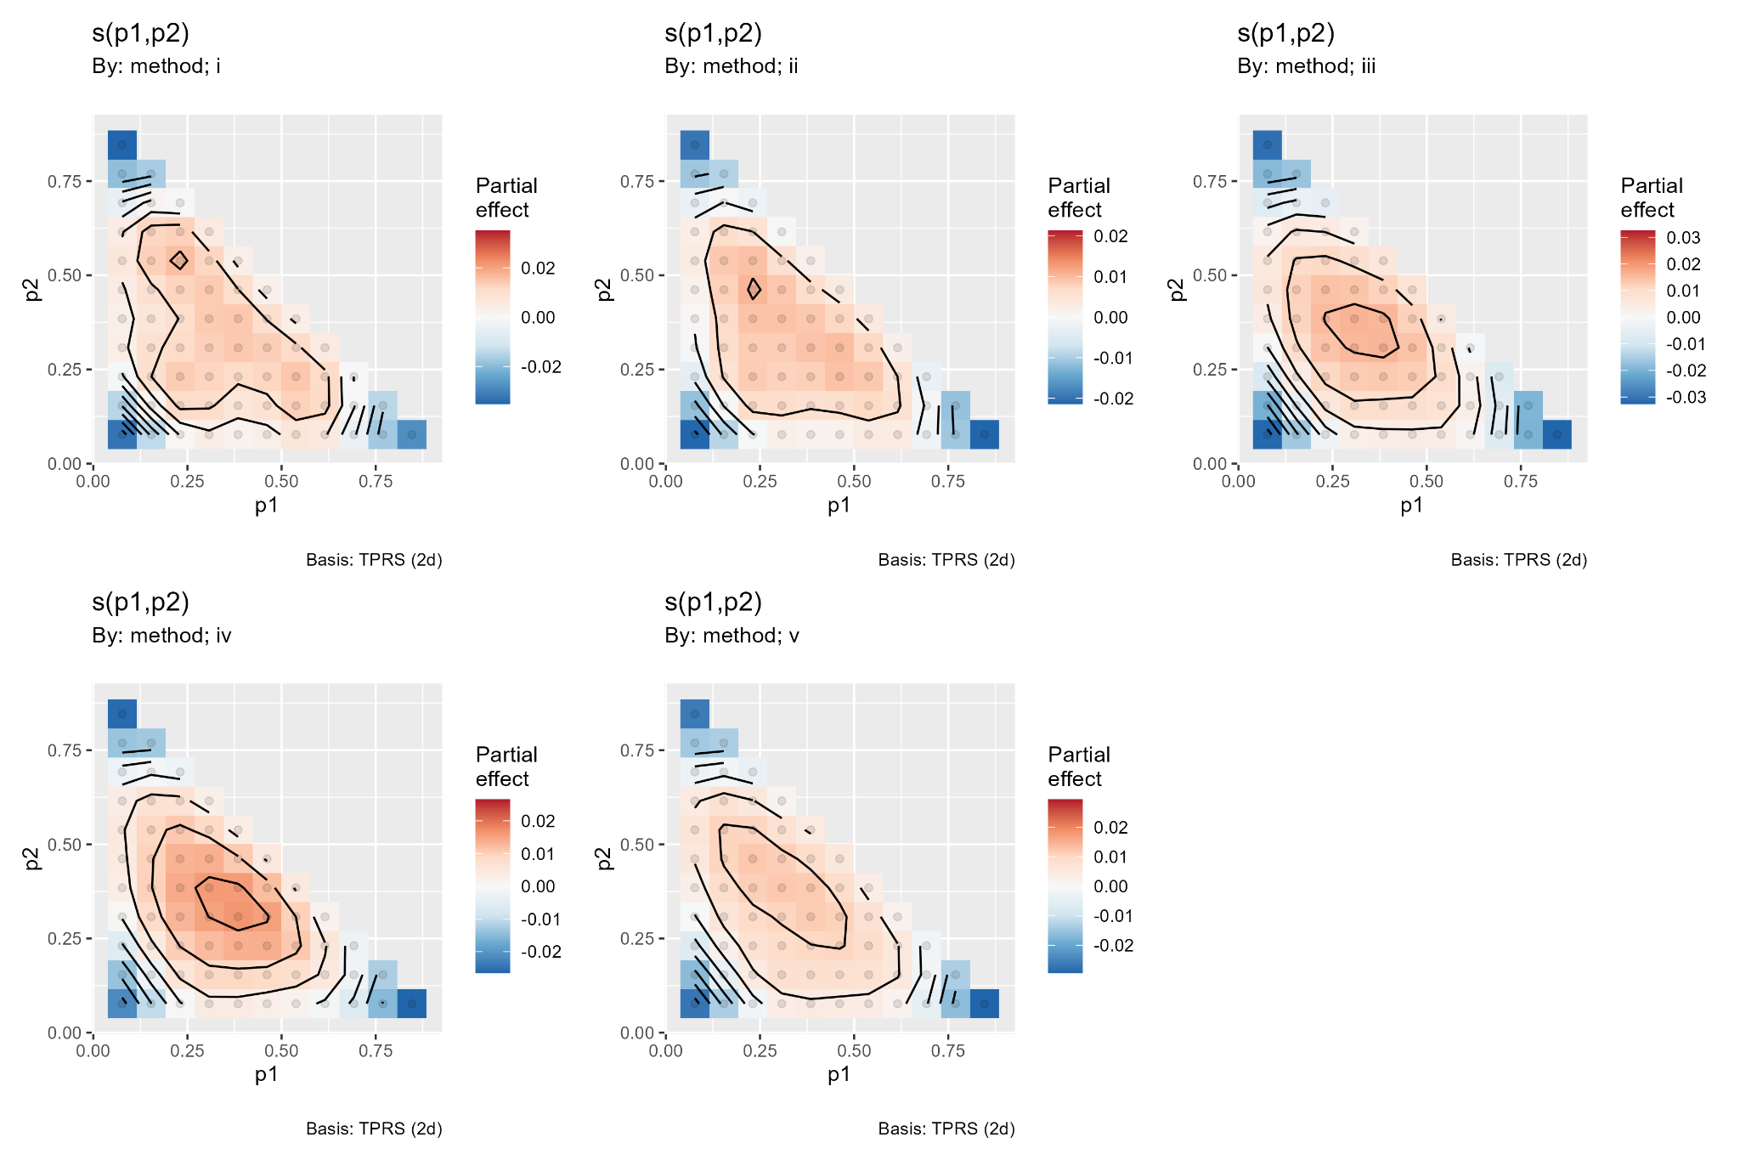
Figure 1. Method-specific partial p1-p2 smooths from gratia::draw. Red indicates increased log1p error relative to each centered smooth; blue indicates decreased error.

3.1 Conditional fitted surfaces
The vis.gam panels combine the parametric and smooth components at default conditioning values. Method ii is visibly elevated across the surface, with central fitted values near 0.22-0.225 on the log1p scale, compared with approximately 0.19-0.20 for the other methods. Methods iii, iv, and v form a close low-error group; method i is intermediate. These plots support the coefficient-based hierarchy but are conditional rather than marginal summaries.
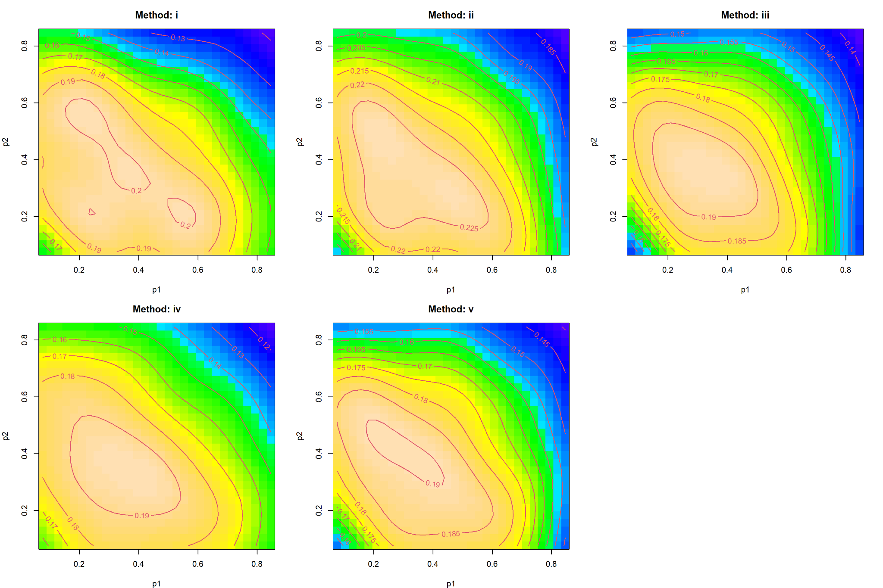
Figure 2. Conditional fitted log1p-accuracy surfaces from vis.gam for methods i-v.
Simplex-domain warning. Valid three-part compositions require p1 >= 0, p2 >= 0, and p1 + p2 <= 1. The rectangular vis.gam grids extend into the impossible region p1 + p2 > 1. Apparent features in that region are extrapolations and must not be interpreted. The gratia panels, which show the observed triangular support, are the safer basis for morphological conclusions.

4. Absolute v-versus-iii gap

4.1 Parametric effects on gap magnitude
Term | Coefficient | t | p | Interpretation
sigma | +0.006597 | 159.09 | <2 x 10^-16 | Dominant widening of absolute gap
theta_true | -0.001197 | -28.87 | <2 x 10^-16 | Gap narrows as theta_true increases
Negative binomial vs lognormal | -0.001880 | -22.67 | <2 x 10^-16 | Smaller gap than lognormal
Poisson vs lognormal | -0.001760 | -21.23 | <2 x 10^-16 | Smaller gap than lognormal
theta_CV | +0.000264 | 6.37 | 1.90 x 10^-10 | Very small widening
G | +0.000188 | 4.54 | 5.64 x 10^-6 | Very small widening
mean_nsamp | +0.000038 | 0.91 | 0.364 | No detectable linear effect

Sigma is overwhelmingly the largest parametric driver of the separation between v and iii. The positive coefficient means the magnitude of their raw-error difference increases with noise, but it does not identify the winner. Mean sample size is the least influential factor in this model and is the only reported parametric term without statistical support.

4.2 Metric-specific gap surfaces
Metric | edf | F | k-index | k-check p | Assessment
L1 | 20.33 | 29.42 | 0.98 | 0.34 | Largest and most structured gap
Linf | 16.40 | 8.24 | 0.98 | 0.26 | Intermediate gap
RMSE | 14.03 | 4.77 | 0.98 | 0.28 | Smallest, least structured gap

The common morphological feature is a central peak near p1 = 0.3-0.4 and p2 = 0.3-0.4. Approximate conditional contour values at that peak are 0.0185 for L1, 0.0095 for Linf, and 0.0074 for RMSE on the log1p-gap scale; back-transformation changes these only slightly because the gaps are small. The L1 peak is nearly twice the Linf peak, consistent with the structural relation L1 = 2 x Linf for three-part zero-sum compositional errors.
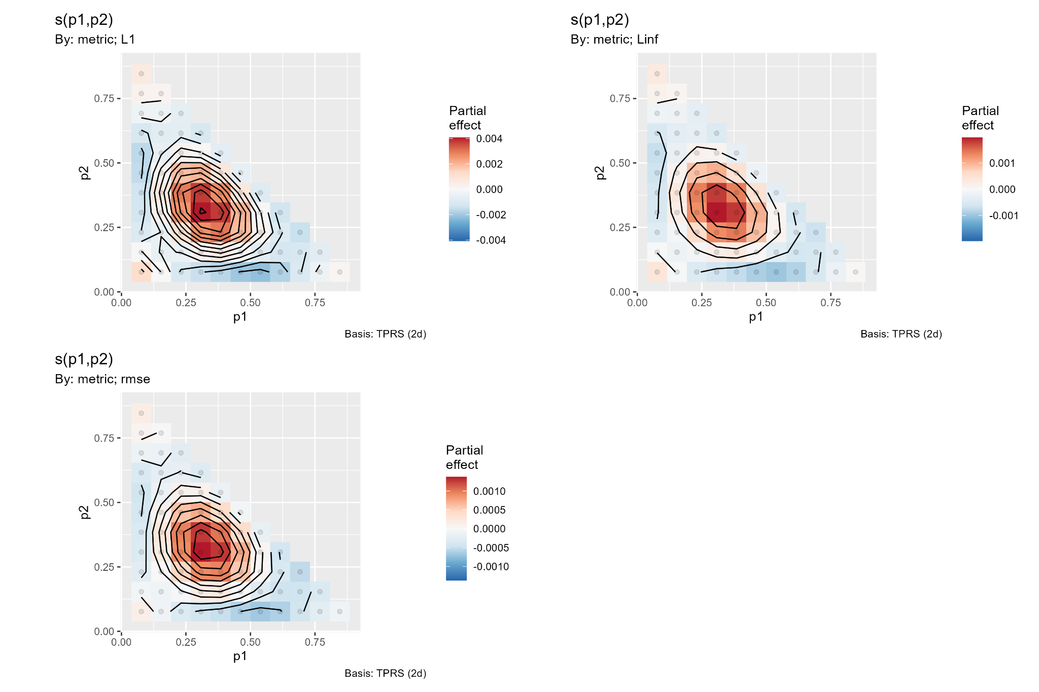
Figure 3. Metric-specific partial p1-p2 smooths for the magnitude of the v-versus-iii accuracy gap.

4.3 Conditional gap contours
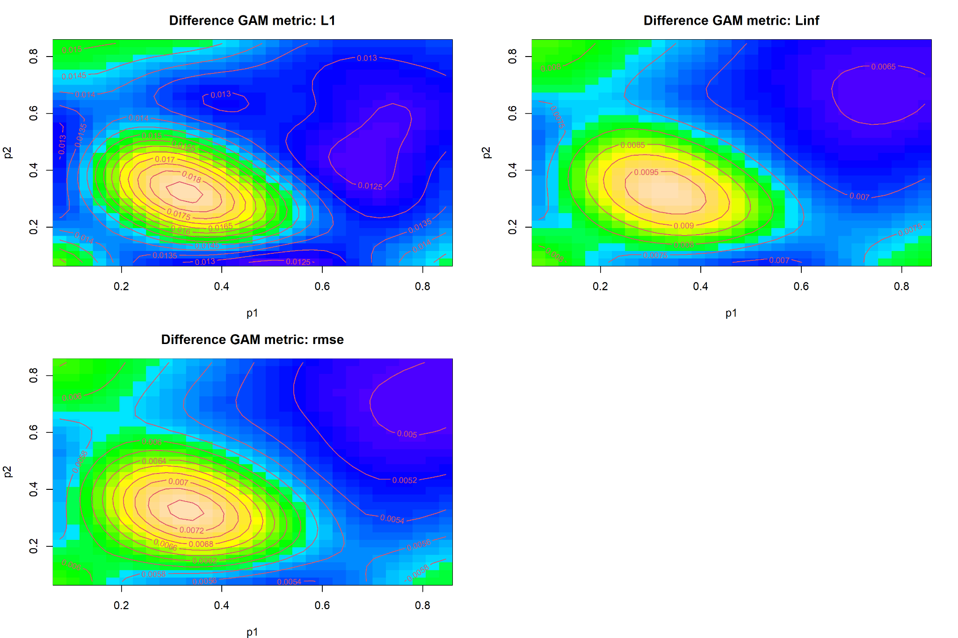
Figure 4. Conditional fitted log1p absolute-gap surfaces for L1, Linf, and RMSE.
The rectangular contour panels again contain predictions outside the valid simplex and should be read only within p1 + p2 <= 1. Within that domain, the greatest separation occurs in the interior and the smallest gaps occur along much of the lower boundary and toward high p1. The high-p1/high-p2 islands lie outside compositional support and have no scientific interpretation.
Direction is not recoverable. A large modeled absolute gap can mean v is better or iii is better. For a directional analysis, replace the response with log[(error_v + epsilon)/(error_iii + epsilon)]. Negative fitted values would favor v, positive values would favor iii, and zero contours would directly identify possible crossover regions.

5. Model adequacy and diagnostics
Diagnostic | Judgment | Evidence
Basis dimension | Supported | Global k-index 1.02, p = 0.88-0.90; gap k-index 0.98, p = 0.26-0.34
Smooth saturation | No evidence | All edf values are well below k-prime = 29
Optimization | Supported | Near-zero gradients and full model ranks 167/167 and 97/97
Global fit | Moderate | Adjusted R-squared and deviance explained both 38.8%
Gap fit | Limited | Adjusted R-squared and deviance explained both 21.4%
Normality | Violated | Strong upper-tail departure and right-skewed residual histograms
Constant variance | Violated | Triangular/fan-shaped residual patterns and increasing spread
Outliers | Material | Large positive residuals, especially for absolute gaps

The k checks answer only whether the basis has enough dimension to represent the fitted surface. They do not validate the Gaussian likelihood. Both diagnostic suites show a sharp floor near zero, a widening residual envelope, and a heavy positive tail. With n = 500,000, formal p-values are exceptionally sensitive; the residual structure and effect magnitudes are more important than significance alone.
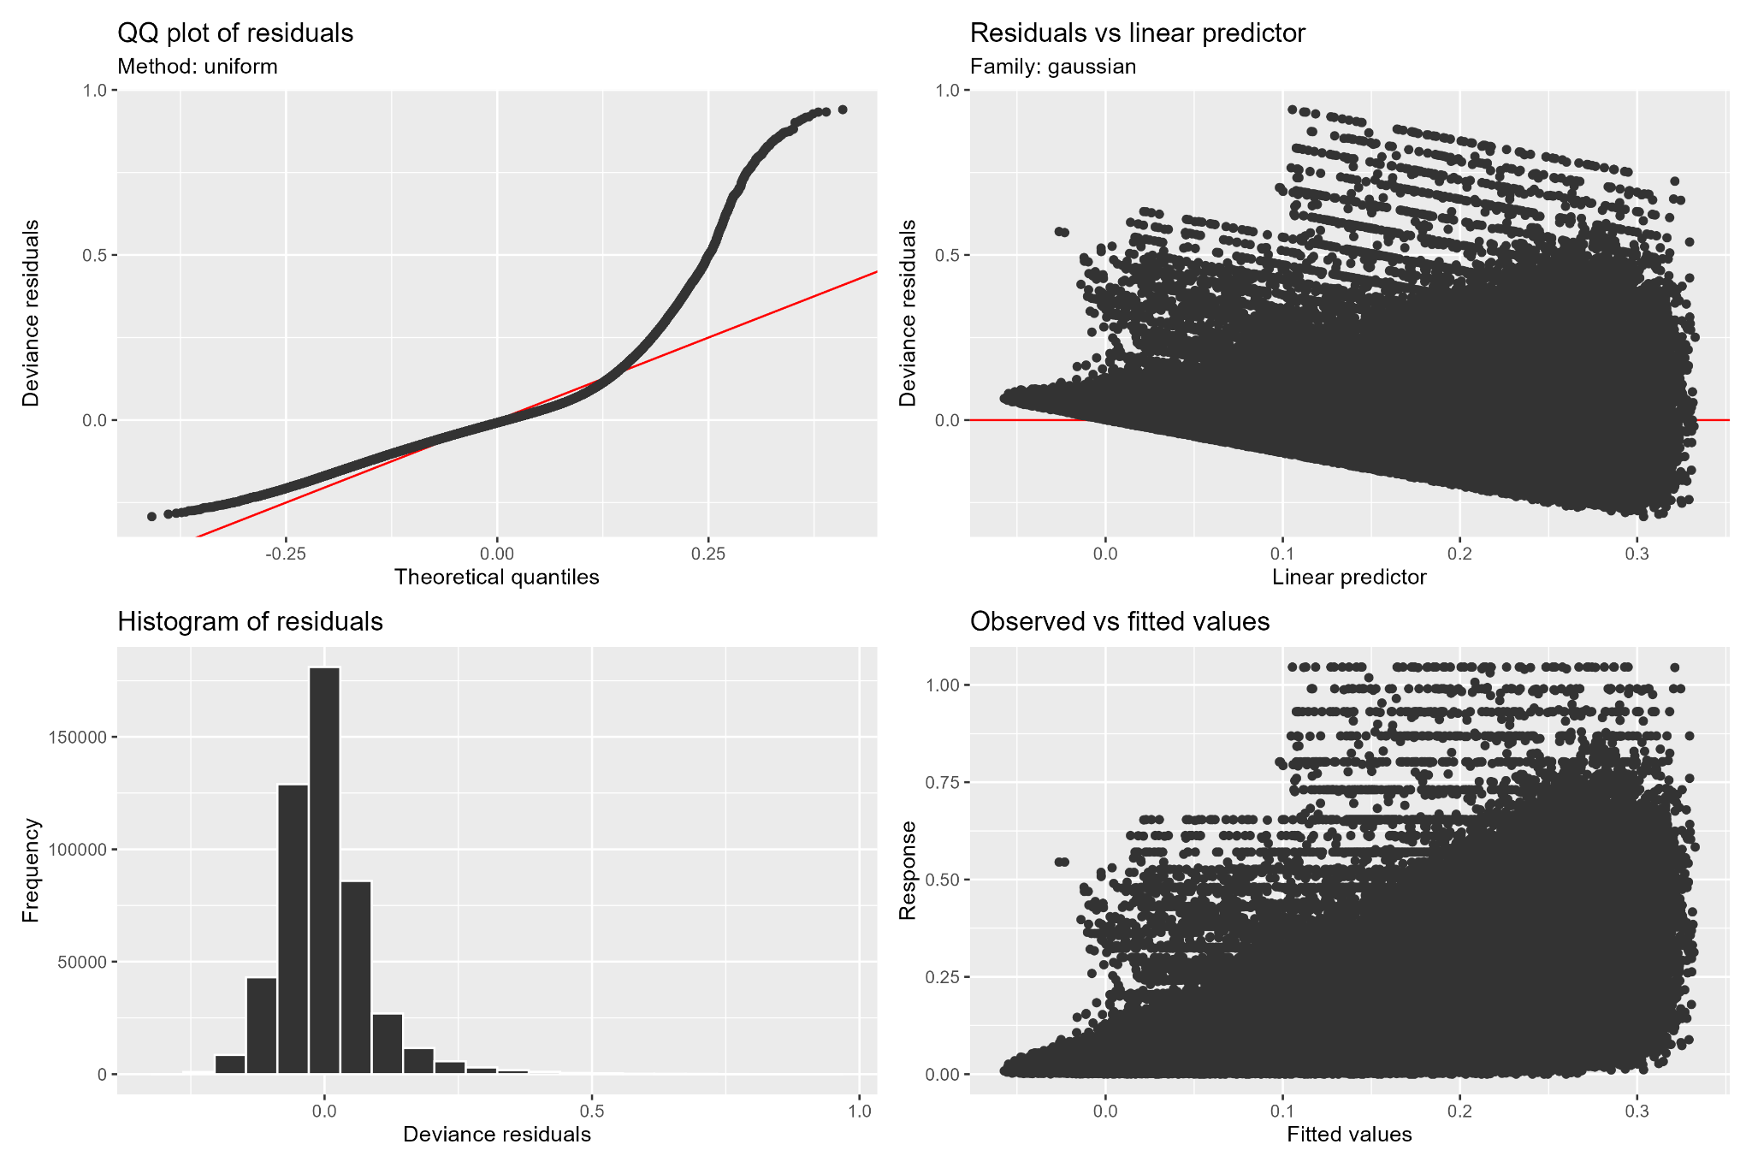
Figure 5. Global-model diagnostic suite from gratia::appraise.

5.1 Absolute-gap diagnostics
The gap model has a particularly severe zero-boundary problem. Most observations are tightly concentrated near zero, while a small fraction extend above 0.30. A Gaussian identity-link model cannot accommodate this mixture of near-zero mass and extreme positive values without strong heteroscedasticity. The moderate 21.4% deviance explained also indicates that the reported smooth and linear effects leave substantial variation unresolved.
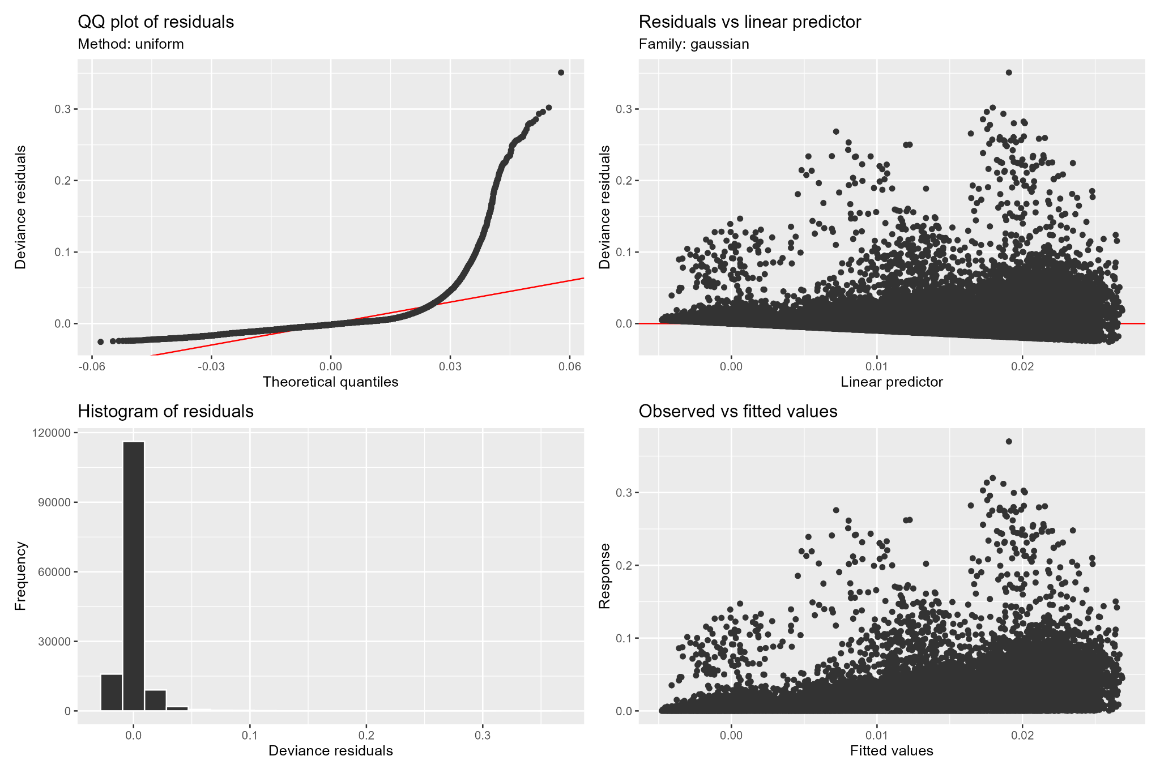
Figure 6. Diagnostic suite for the v-versus-iii absolute-gap GAM.

6. Proportion-specific and metric diagnostics

6.1 Simplex geometry
The coordinates are compositional: p3 = 1 - p1 - p2 and the support is triangular. A Euclidean thin-plate spline in p1 and p2 is usable as a descriptive surface inside the observed triangle, but its geometry is not invariant to the choice of omitted component and it extrapolates poorly near or outside boundaries. Prediction grids should explicitly exclude p1 + p2 >= 1 and cells unsupported by data.
For component-level modeling, componentwise arcsine or logit transformations do not respect closure and can create incompatible fitted proportions. Isometric log-ratio coordinates provide a more coherent unconstrained representation of the simplex. For the nonnegative error distances themselves, a log transform with a documented offset, Gamma/log GAM, Tweedie GAM, or two-part model is more directly relevant than arcsine transformation.

6.2 Dependence among accuracy metrics
For differences between three-part compositions, component errors sum to zero and the largest absolute component equals half the total absolute error; hence L1 = 2 x Linf. L1 and Linf are therefore deterministically redundant before nonlinear transformation. Their separate highly significant tests should not be interpreted as independent replication. A joint or stacked model should explicitly account for within-example metric dependence.

6.3 Boundary and variance behavior
Near simplex boundaries, some components approach zero and estimation errors become asymmetric and variance-dependent. The observed fan shapes are consistent with a response whose attainable spread increases with its mean and with occasional difficult simulation cells. Diagnostics should therefore be stratified by method, metric, design block, and distance to the simplex boundary, rather than assessed only in a pooled plot.

7. Comparative performance and robustness
Method | Conditional performance | Surface behavior | Robustness interpretation
i | Intermediate | Irregular, relatively strong p1-p2 dependence | Not preferred when iii-iv-v are available
ii | Highest error for every metric | Flattest smooth but elevated surface | Stable at an unfavorable error level
iii | Best conditional L1 | Strongest simplex-location sensitivity | Specialized L1 leader; check boundary robustness
iv | Best conditional Linf and RMSE | Moderate surface sensitivity | Strong cross-metric candidate
v | Very close to iii and iv | Moderate surface sensitivity | Strong general candidate; direction vs iii unresolved

Code E does not support a universal winner. It supports a leading class consisting of iii, iv, and v and consistently excludes ii as a default. Method iv has the strongest conditional cross-metric profile in this model because it leads for RMSE and Linf and remains close for L1. Method iii is the conditional L1 leader but is most sensitive to p1-p2 location. Method v is consistently close to the leaders, but the unsigned comparison model cannot establish whether it is locally better or worse than iii.
Practical recommendation. Treat iii, iv, and v as the candidate set, with iv as the provisional cross-metric choice from Code E alone. Do not declare a final winner until signed log-ratio surfaces and simplex-valid marginal contrasts are computed. Method ii should not be recommended for general use, and method i offers no evident advantage over the leading cluster.

7.1 Recommended revised analysis
Objective | Recommended implementation
Relative efficiency | Fit signed log[(error_A + epsilon)/(error_B + epsilon)] surfaces; report zero contours and simultaneous intervals
Response family | Use Gamma/log, Tweedie, scaled-t, or a two-part near-zero model; compare by residual diagnostics and out-of-sample scores
Factorial effects | Fit G, theta_true, theta_CV, sigma, and mean_nsamp as factors or prespecified nonlinear trends
Dependence | Resample complete example_id clusters or fit random effects/correlation for matched methods and metrics
Simplex support | Use ilr coordinates or mask predictions to p1 + p2 <= 1 with data-supported exclusion distances
Uncertainty | Report simultaneous smooth intervals, cellwise pairwise contrasts, and multiplicity-controlled crossover probabilities
Sampling sensitivity | Repeat partition sampling across seeds and verify that rankings and surfaces are stable

8. Integrated conclusion
Question | Conclusion | Numerical basis
Global fit | 38.8% deviance explained | Useful descriptive structure; incomplete predictive model
Dominant factors | sigma, then G | Approximate influence analogs 0.132 and 0.095
Least influential factor | theta_CV | Approximate influence analog 0.00022
Metric interaction | Decisive but small | Ranking within leading group changes by metric
Leading methods | iii, iv, and v | Tightly grouped conditional contrasts
Weakest method | ii | Higher fitted response for L1, Linf, and RMSE
Basis adequacy | Supported | k-index 0.98-1.02; no low-k signal
Likelihood adequacy | Not supported | Heavy tails and heteroscedasticity
v vs iii direction | Unresolved | Absolute value removes the sign

The main scientific result is a clear separation between design sensitivity and method sensitivity. Sigma and G govern far more of the fitted accuracy variation than the adjusted method main effect. Nevertheless, method choice matters: method ii is consistently inferior, method i is intermediate, and methods iii, iv, and v form the competitive set. Within that set, method performance is metric-dependent and varies over the simplex.
The smooth-surface analysis adds important structure beyond summary tables. Errors tend to be elevated in interior regions of the simplex and reduced toward several edges, while the absolute v-versus-iii gap is maximized near p1 and p2 of 0.3-0.4. Method iii is the most location-sensitive, method ii the least, and methods iv and v are intermediate. These conclusions apply only within observed compositional support.
The numerical significance is unquestionable, but the current likelihood and transformation prevent a final relative-efficiency claim. The appropriate next step is a simplex-valid, signed log-ratio GAM with robust mean-variance treatment, matched-example uncertainty, and factor-level contrasts. Until that analysis is available, method iv is the best provisional cross-metric choice from Code E, while iii and v remain statistically and practically competitive alternatives.

