Guam BioSampling Species Summaries

Eva Schemmel

Updated April 2023 (BioSampling data pulled 4-10-2023)

The following species were sampled through the Territory Commercial Fisheries BioSampling Program and NOAA life history cruises and are reviewed in this appendix for completeness of sampling to assess regional life history parameters for age, growth, and reproduction.

Bottomfish Management Unit Species (MUS):  
Aphareus rutilans  
Caranx ignobilis  
Caranx lugubris  
Etelis carbunculus  
Etelis coruscans  
Lethrinus rubrioperculatus  
Lutjanus kasmira  
Pristipomoides auricilla  
Pristipomoides filamentosus  
Pristipomoides flavipinnis  
Pristipomoides sieboldii  
Pristipomoides zonatus  
Variola louti

These species summaries are a guide to inform future sampling collection efforts and life history assessments. Species with completed life history assessments for the territory are excluded unless continued sample collection is recommended for additional research to meet fisheries science and management needs. All BMUS species with a sample size greater or equal to 50 are included in this appendix. Sample sizes should be considered as approximate, as there is not always an otolith and gonad for every entry in the database due to otoliths breaking or gonads not being collected on occasion.

Data for each species is reviewed across four categories: fish size distribution, monthly sample distribution, relationship between gonadosomatic index (GSI) and fish length, and mean female GSI by month. Each of these categories allows for a review of the sample collection progress to meet the needs of the life history assessments for age, growth, spawning season, and size/age at maturity.

Size Distribution: The length frequency distribution is a proxy for looking at the sampling coverage to estimate age and growth. It also allows for a first look at the size distribution of females and males. This is a proxy and histological assessment is recommended to confirm gender and to identify unknowns.

Monthly Sample Distribution: The total number of samples per month are plotted. A sample size of 20 individuals per month is recommended (red dashed line).

GSI and Fish Length: Gonadosomatic index (gonad weight/fish weight *100) is plotted against fish size to visualize the sample distribution as a proxy for size at maturity.

Spawning Season: Female Gonadosomatic Index (GSI) is plotted by month to visualize if sampling is adequate to determine spawning seasonality.

# Management Unit Species

# *Aphareus rutilans*

A total of 205 *Aphareus rutilans* samples (females=72, males=68, unknown/na=65) have been collected to date (2023-04-10). Median fork length is 48.6 cm (min=15.8 cm, max=96.7 cm).

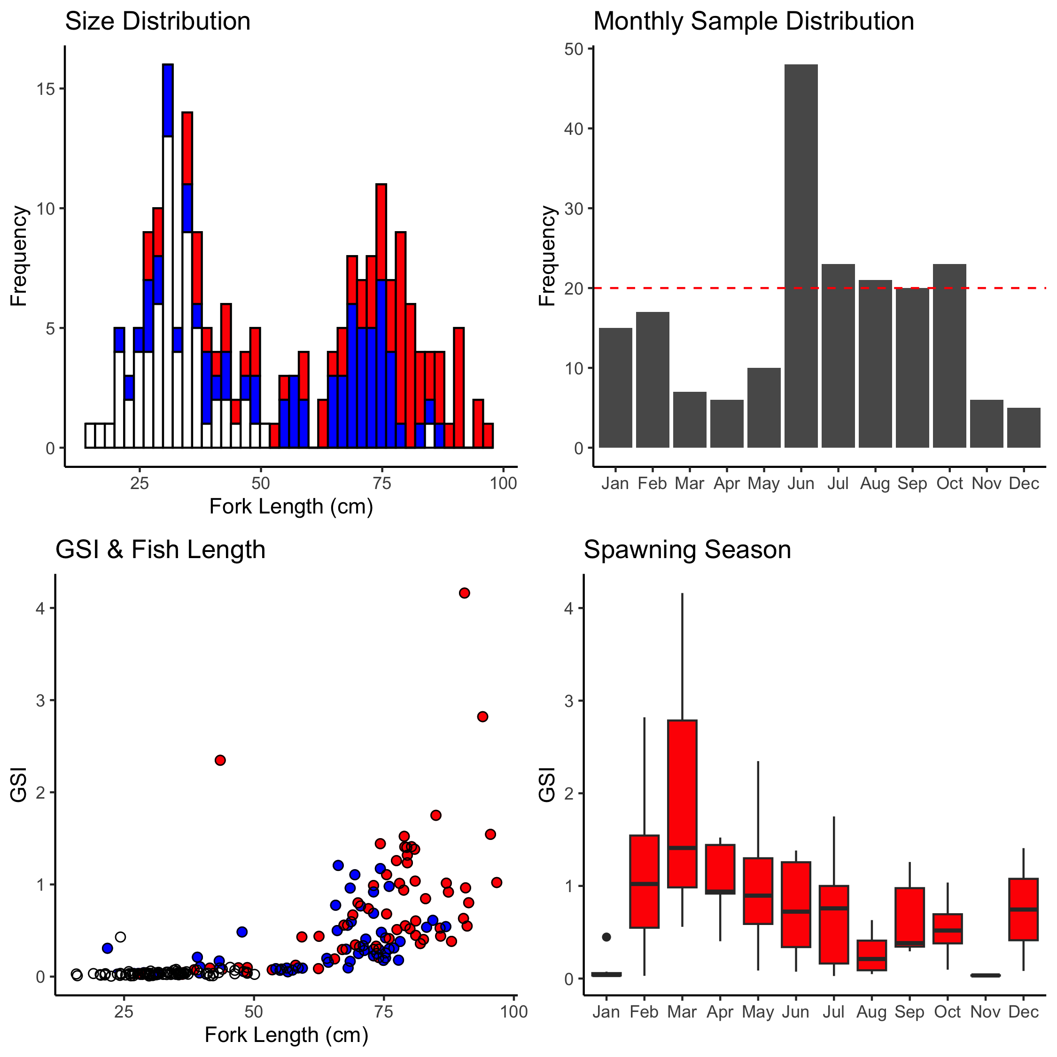

Figure A-1. *A. rutilans* sampling summaries for size distribution, monthly sample collection, GSI and fish length, and spawning season. Females are red (circles), males are blue (circles), unknown sex is blank (circles).

# *Caranx ignobilis*

A total of 92 *Caranx ignobilis* samples (females=36, males=31, unknown/na=25) have been collected to date (2023-04-10). Median fork length is 65.2 cm (min=15 cm, max=99.7 cm).

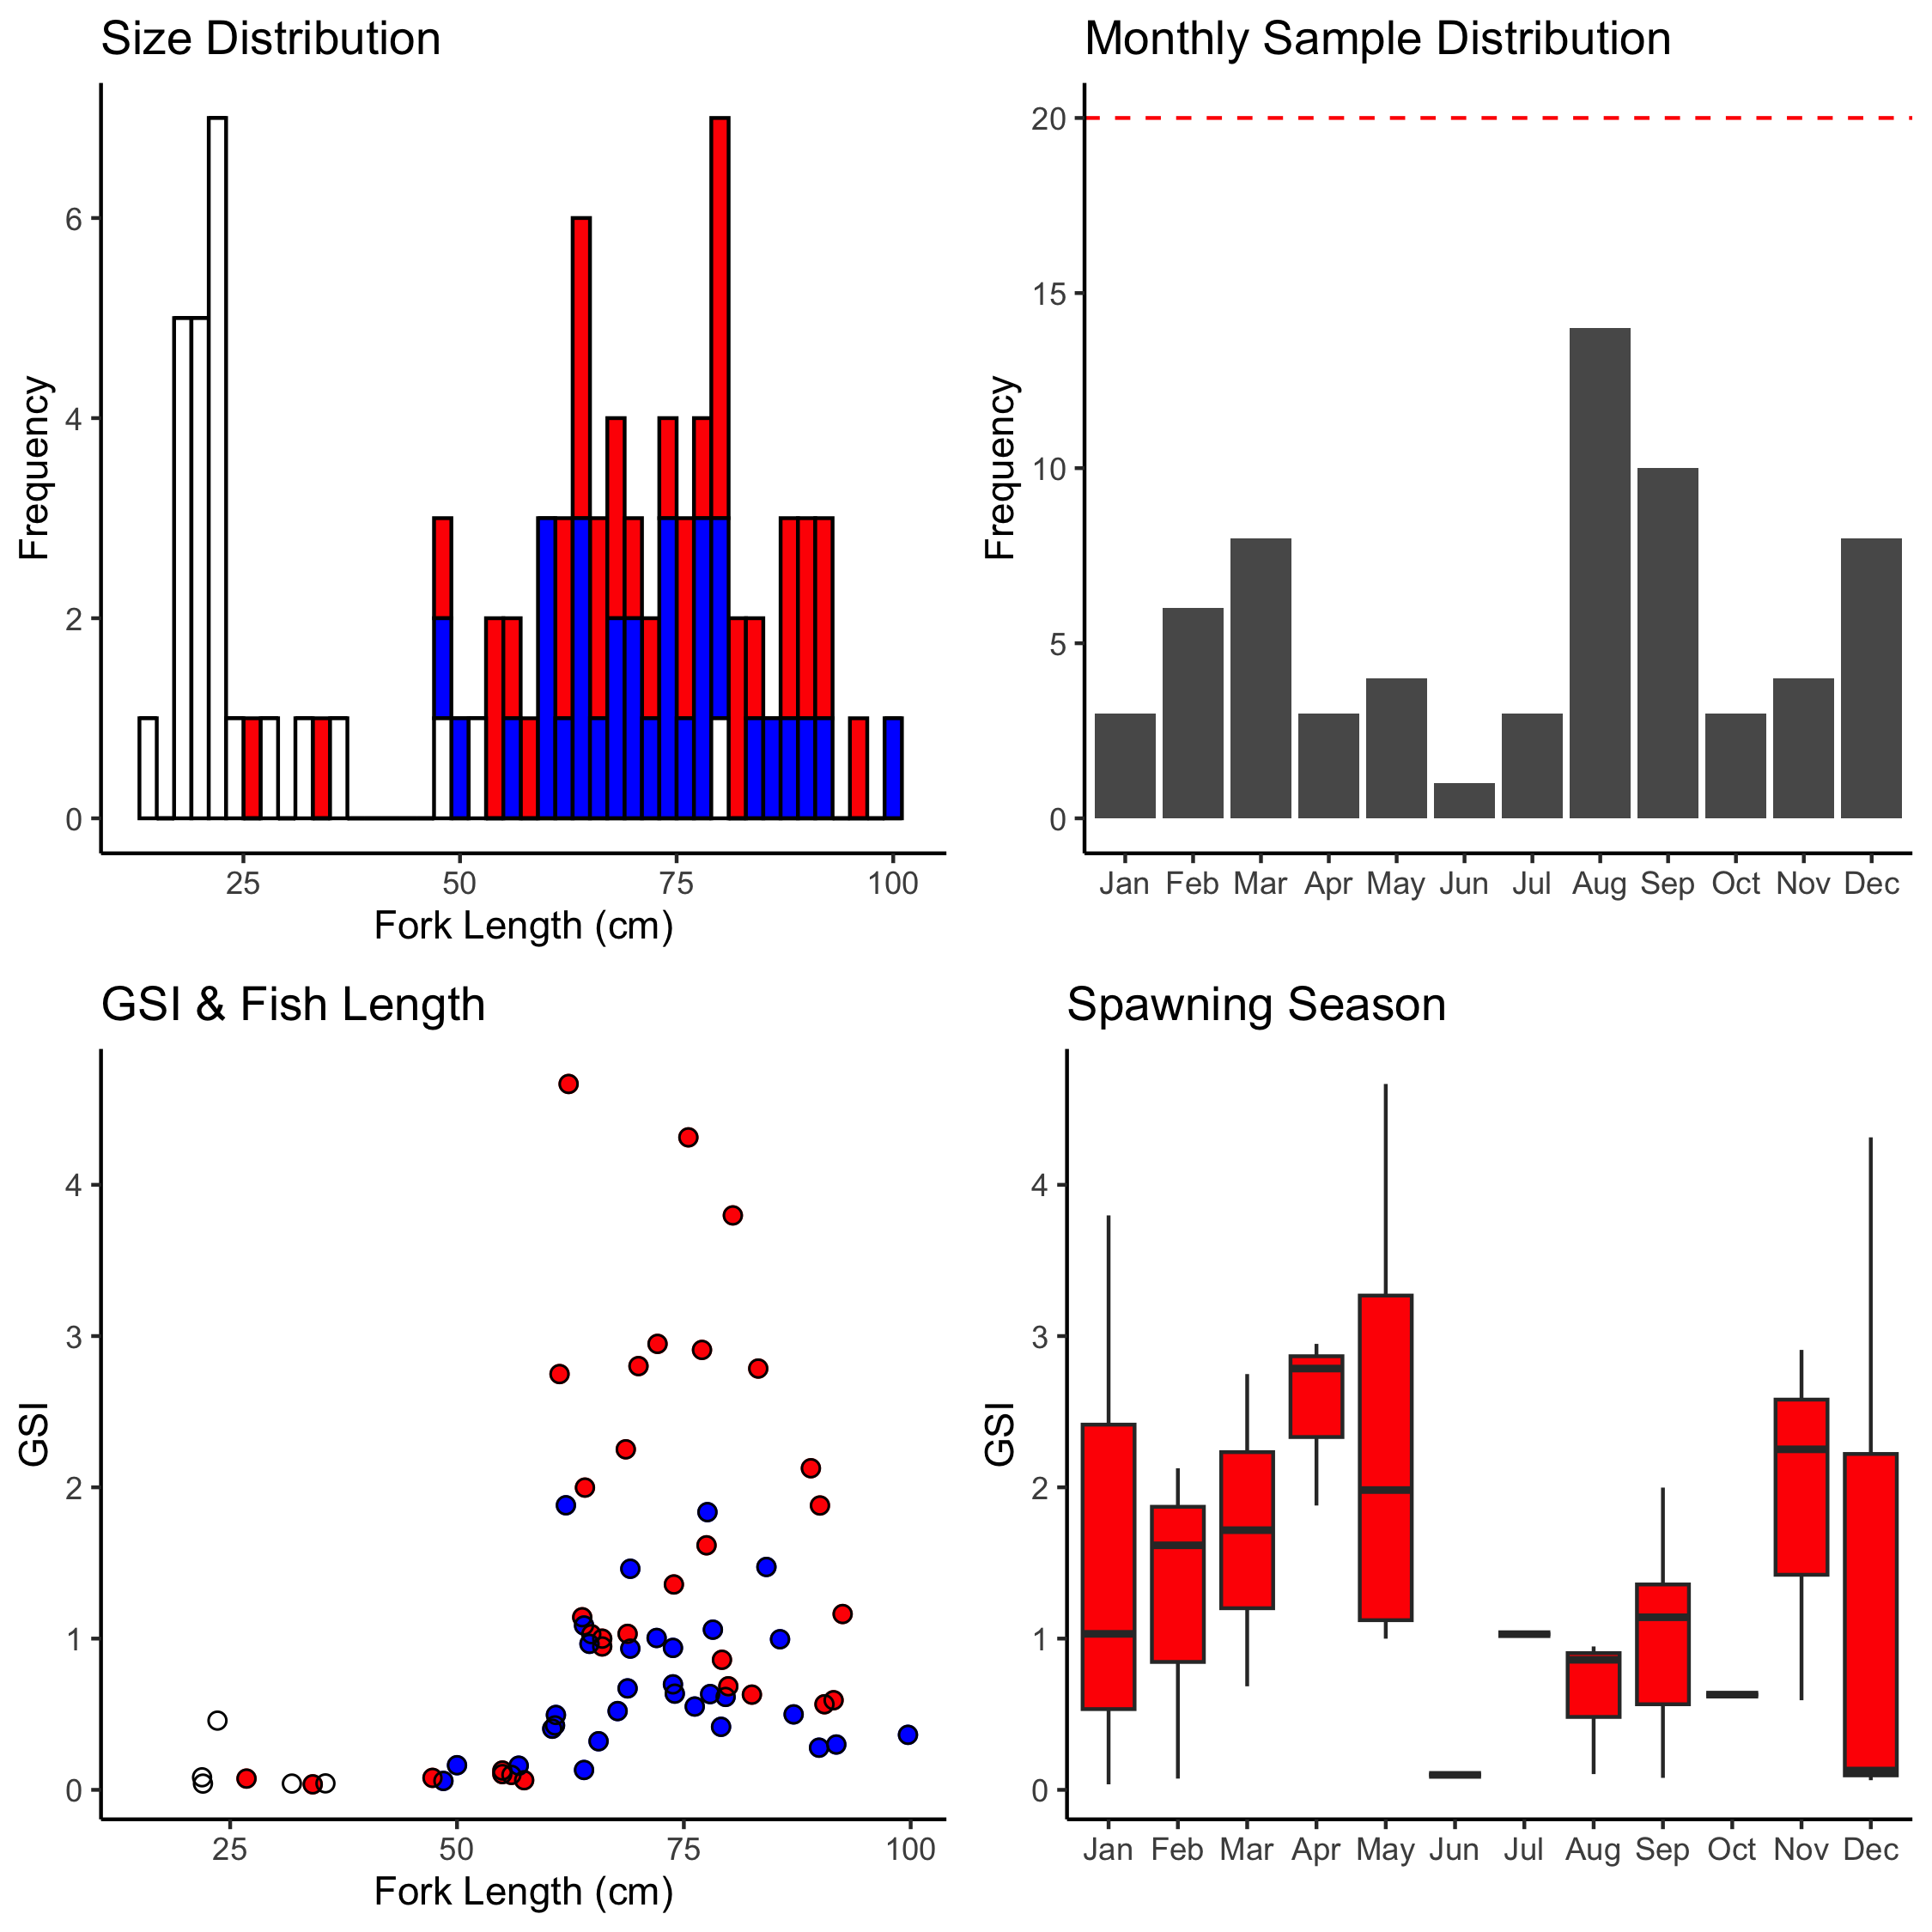

Figure A-2. *C. ignobilis* sampling summaries for size distribution, monthly sample collection, GSI and fish length, and spawning season. Females are red (circles), males are blue (circles), unknown sex is blank (circles).

# *Caranx lugubris*

A total of 64 *Caranx lugubris* samples (females=25, males=20, unknown/na=19) have been collected to date (2023-04-10). Median fork length is 37.25 cm (min=10.6 cm, max=76.2 cm).

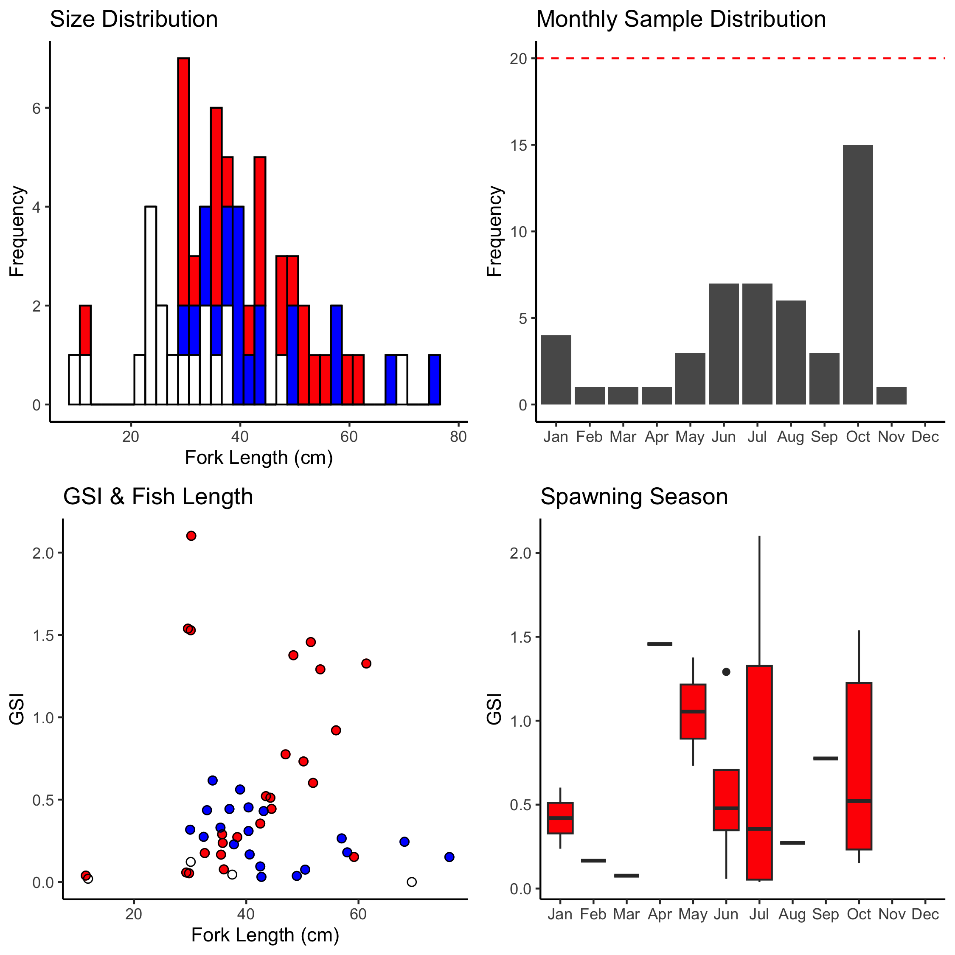

Figure A-3. *C. lugubris* sampling summaries for size distribution, monthly sample collection, GSI and fish length, and spawning season. Females are red (circles), males are blue (circles), unknown sex is blank (circles).

# *Etelis carbunculus*

A total of 280 *Etelis carbunculus* samples (females=163, males=82, unknown/na=35) have been collected to date (2023-04-10). Median fork length is 30.15 cm (min=15.9 cm, max=84 cm).

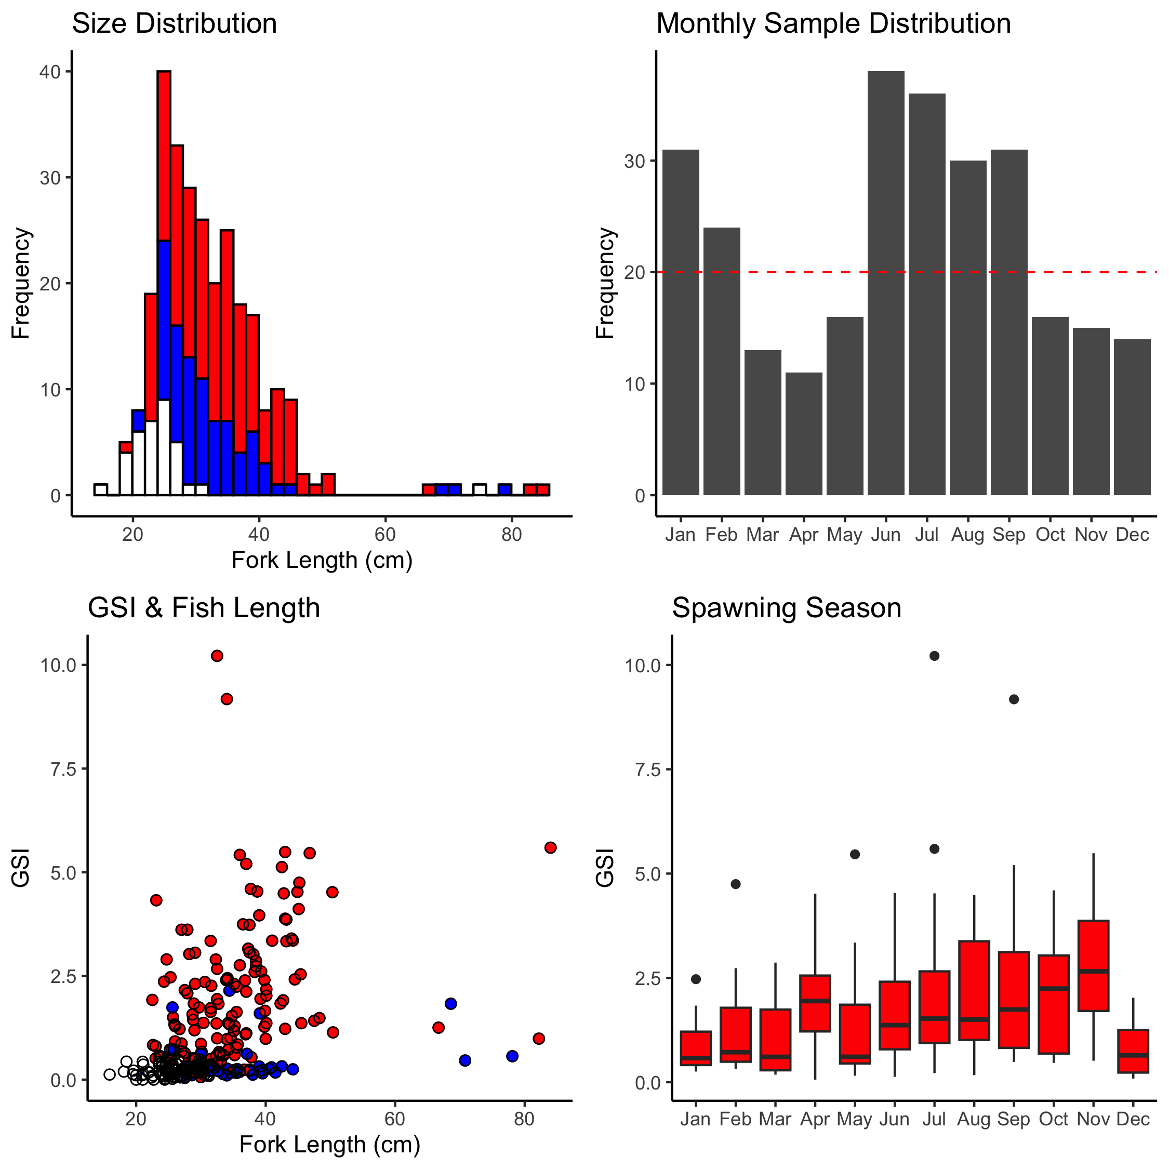

Figure A-4. *E. carbunculus* sampling summaries for size distribution, monthly sample collection, GSI and fish length, and spawning season. Females are red (circles), males are blue (circles), unknown sex is blank (circles).

# *Etelis coruscans*

A total of 615 *Etelis coruscans* samples (females=299, males=274, unknown/na=42) have been collected to date (2023-04-10). Median fork length is 71.1 cm (min=28.6 cm, max=99 cm).

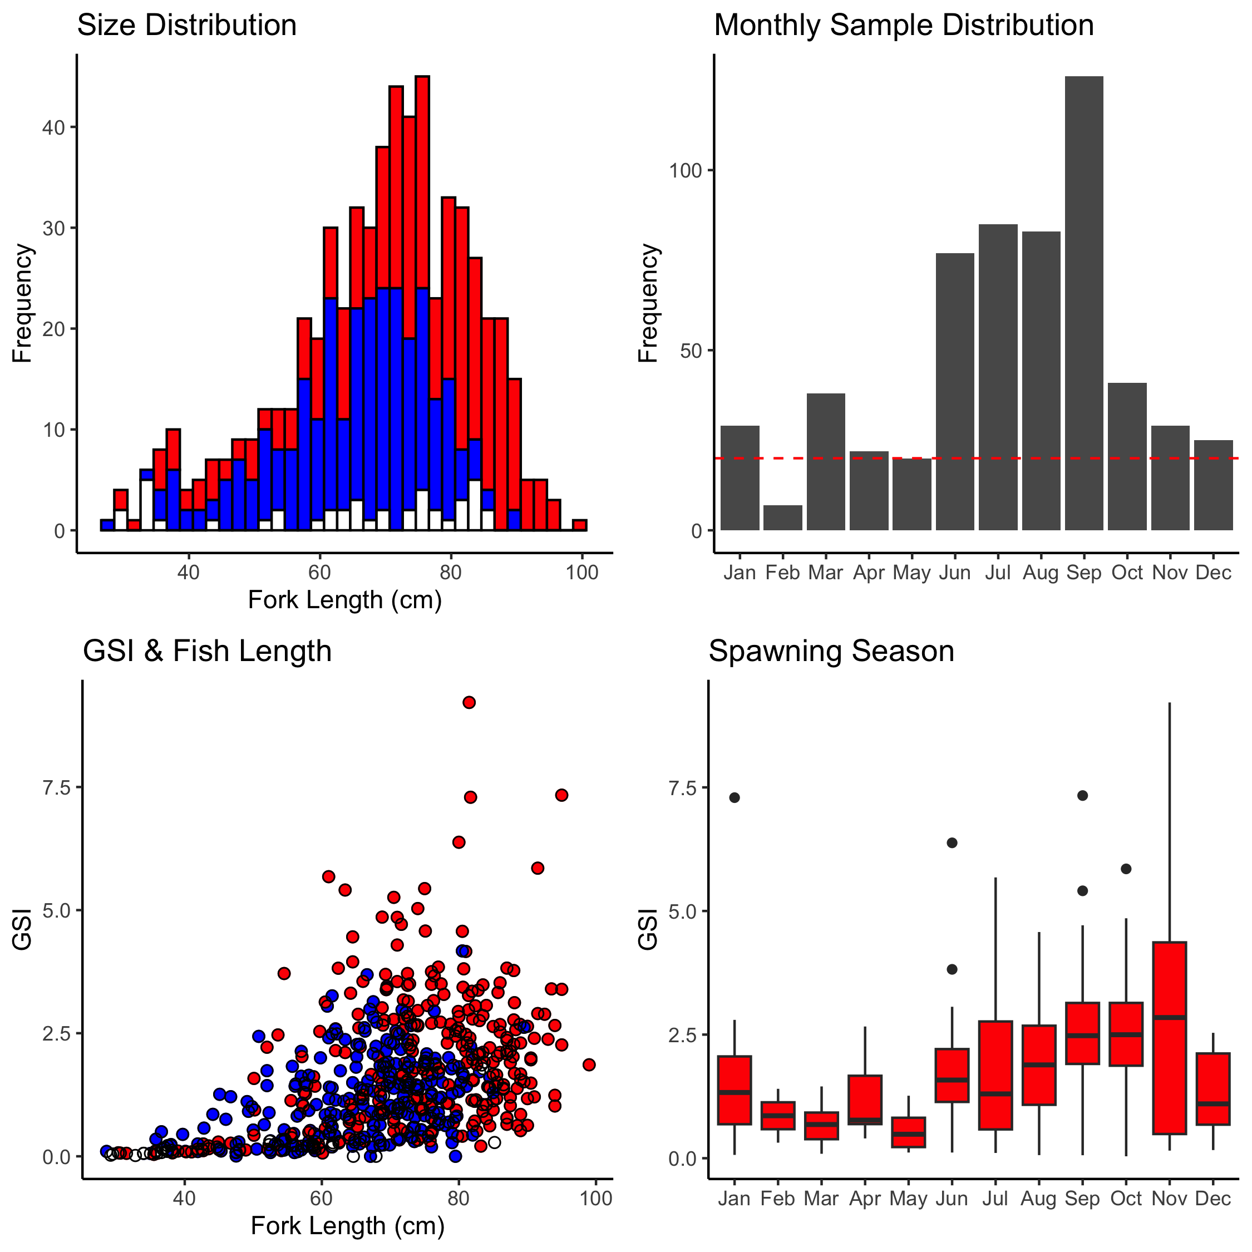

Figure A-5. *E. coruscans* sampling summaries for size distribution, monthly sample collection, GSI and fish length, and spawning season. Females are red (circles), males are blue (circles), unknown sex is blank (circles).

# *Lethrinus rubrioperculatus*

A total of 12 *Lethrinus rubrioperculatus* samples (females=7, males=3, unknown/na=2) have been collected to date (2023-04-10). Median fork length is 25.1 cm (min=18.1 cm, max=44.7 cm).

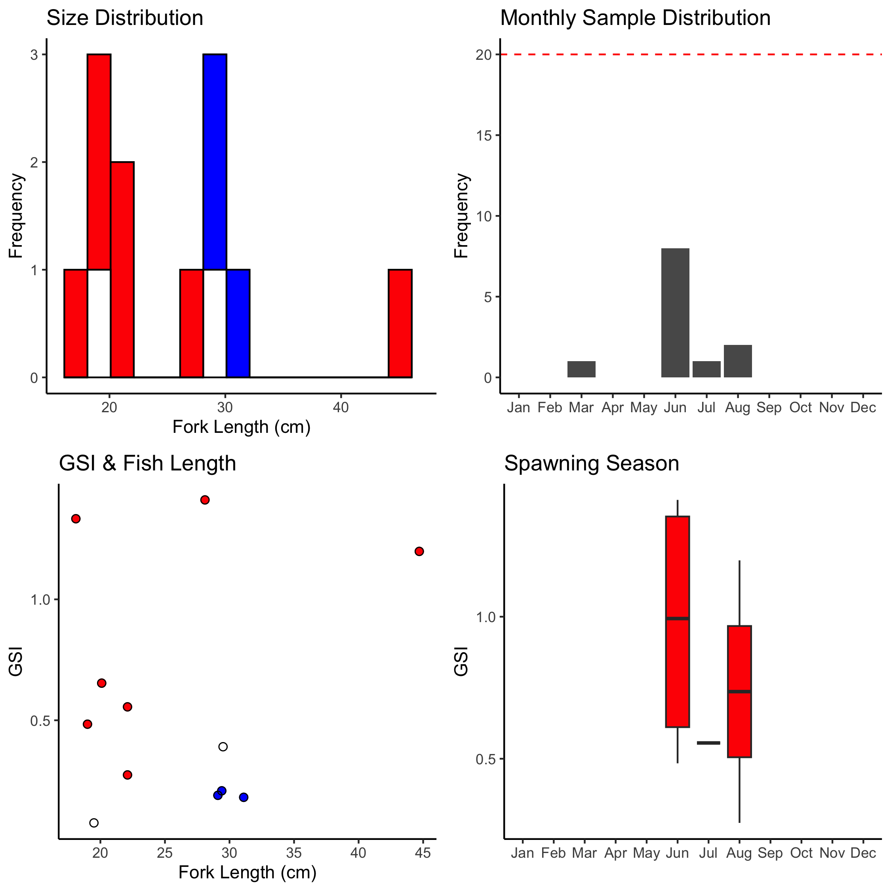

Figure A-6. *L rubrioperculatus* sampling summaries for size distribution, monthly sample collection, GSI and fish length, and spawning season. Females are red (circles), males are blue (circles), unknown sex is blank (circles).

# *Lutjanus kasmira*

A total of 58 *Lutjanus kasmira* samples (females=8, males=23, unknown/na=27) have been collected to date (2023-04-10). Median fork length is 18.7 cm (min=7.5 cm, max=27.3 cm).

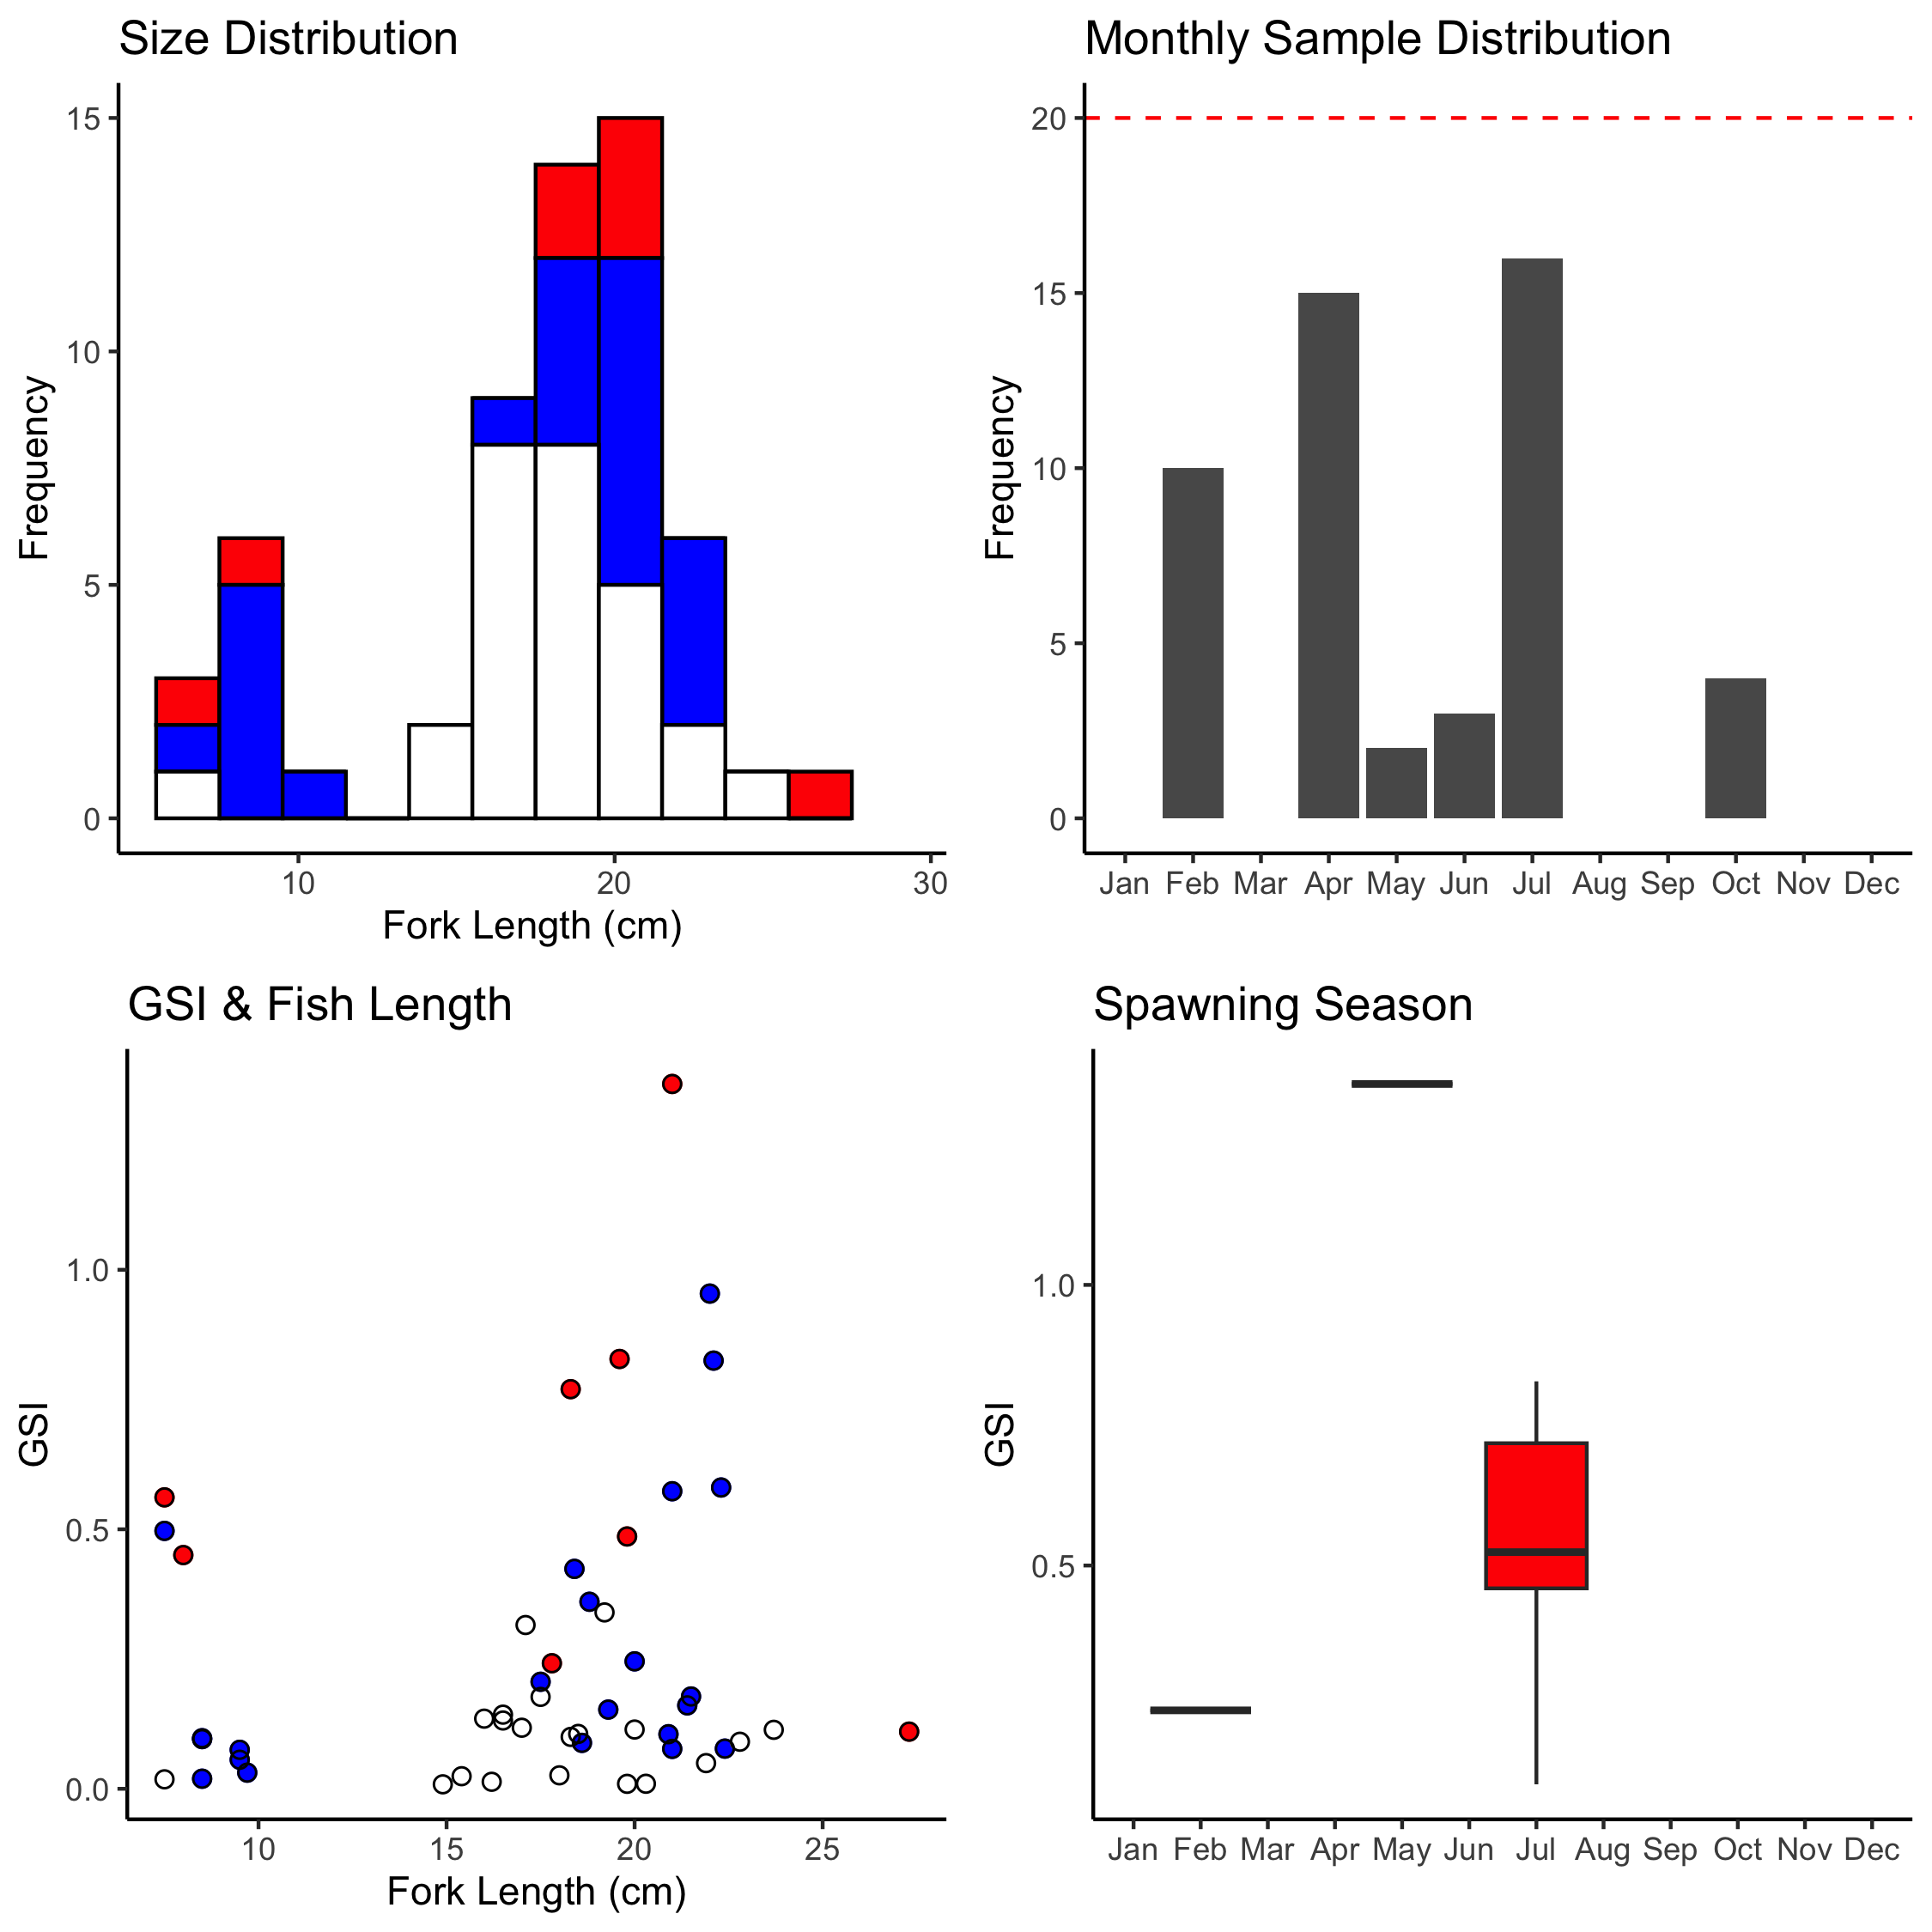

Figure A-7. *L. kasmira* sampling summaries for size distribution, monthly sample collection, GSI and fish length, and spawning season. Females are red (circles), males are blue (circles), unknown sex is blank (circles).

# *Pristipomoides auricilla*

A total of 487 *Pristipomoides auricilla* samples (females=190, males=152, unknown/na=145) have been collected to date (2023-04-10). Median fork length is 26.9 cm (min=13.5 cm, max=37.7 cm).

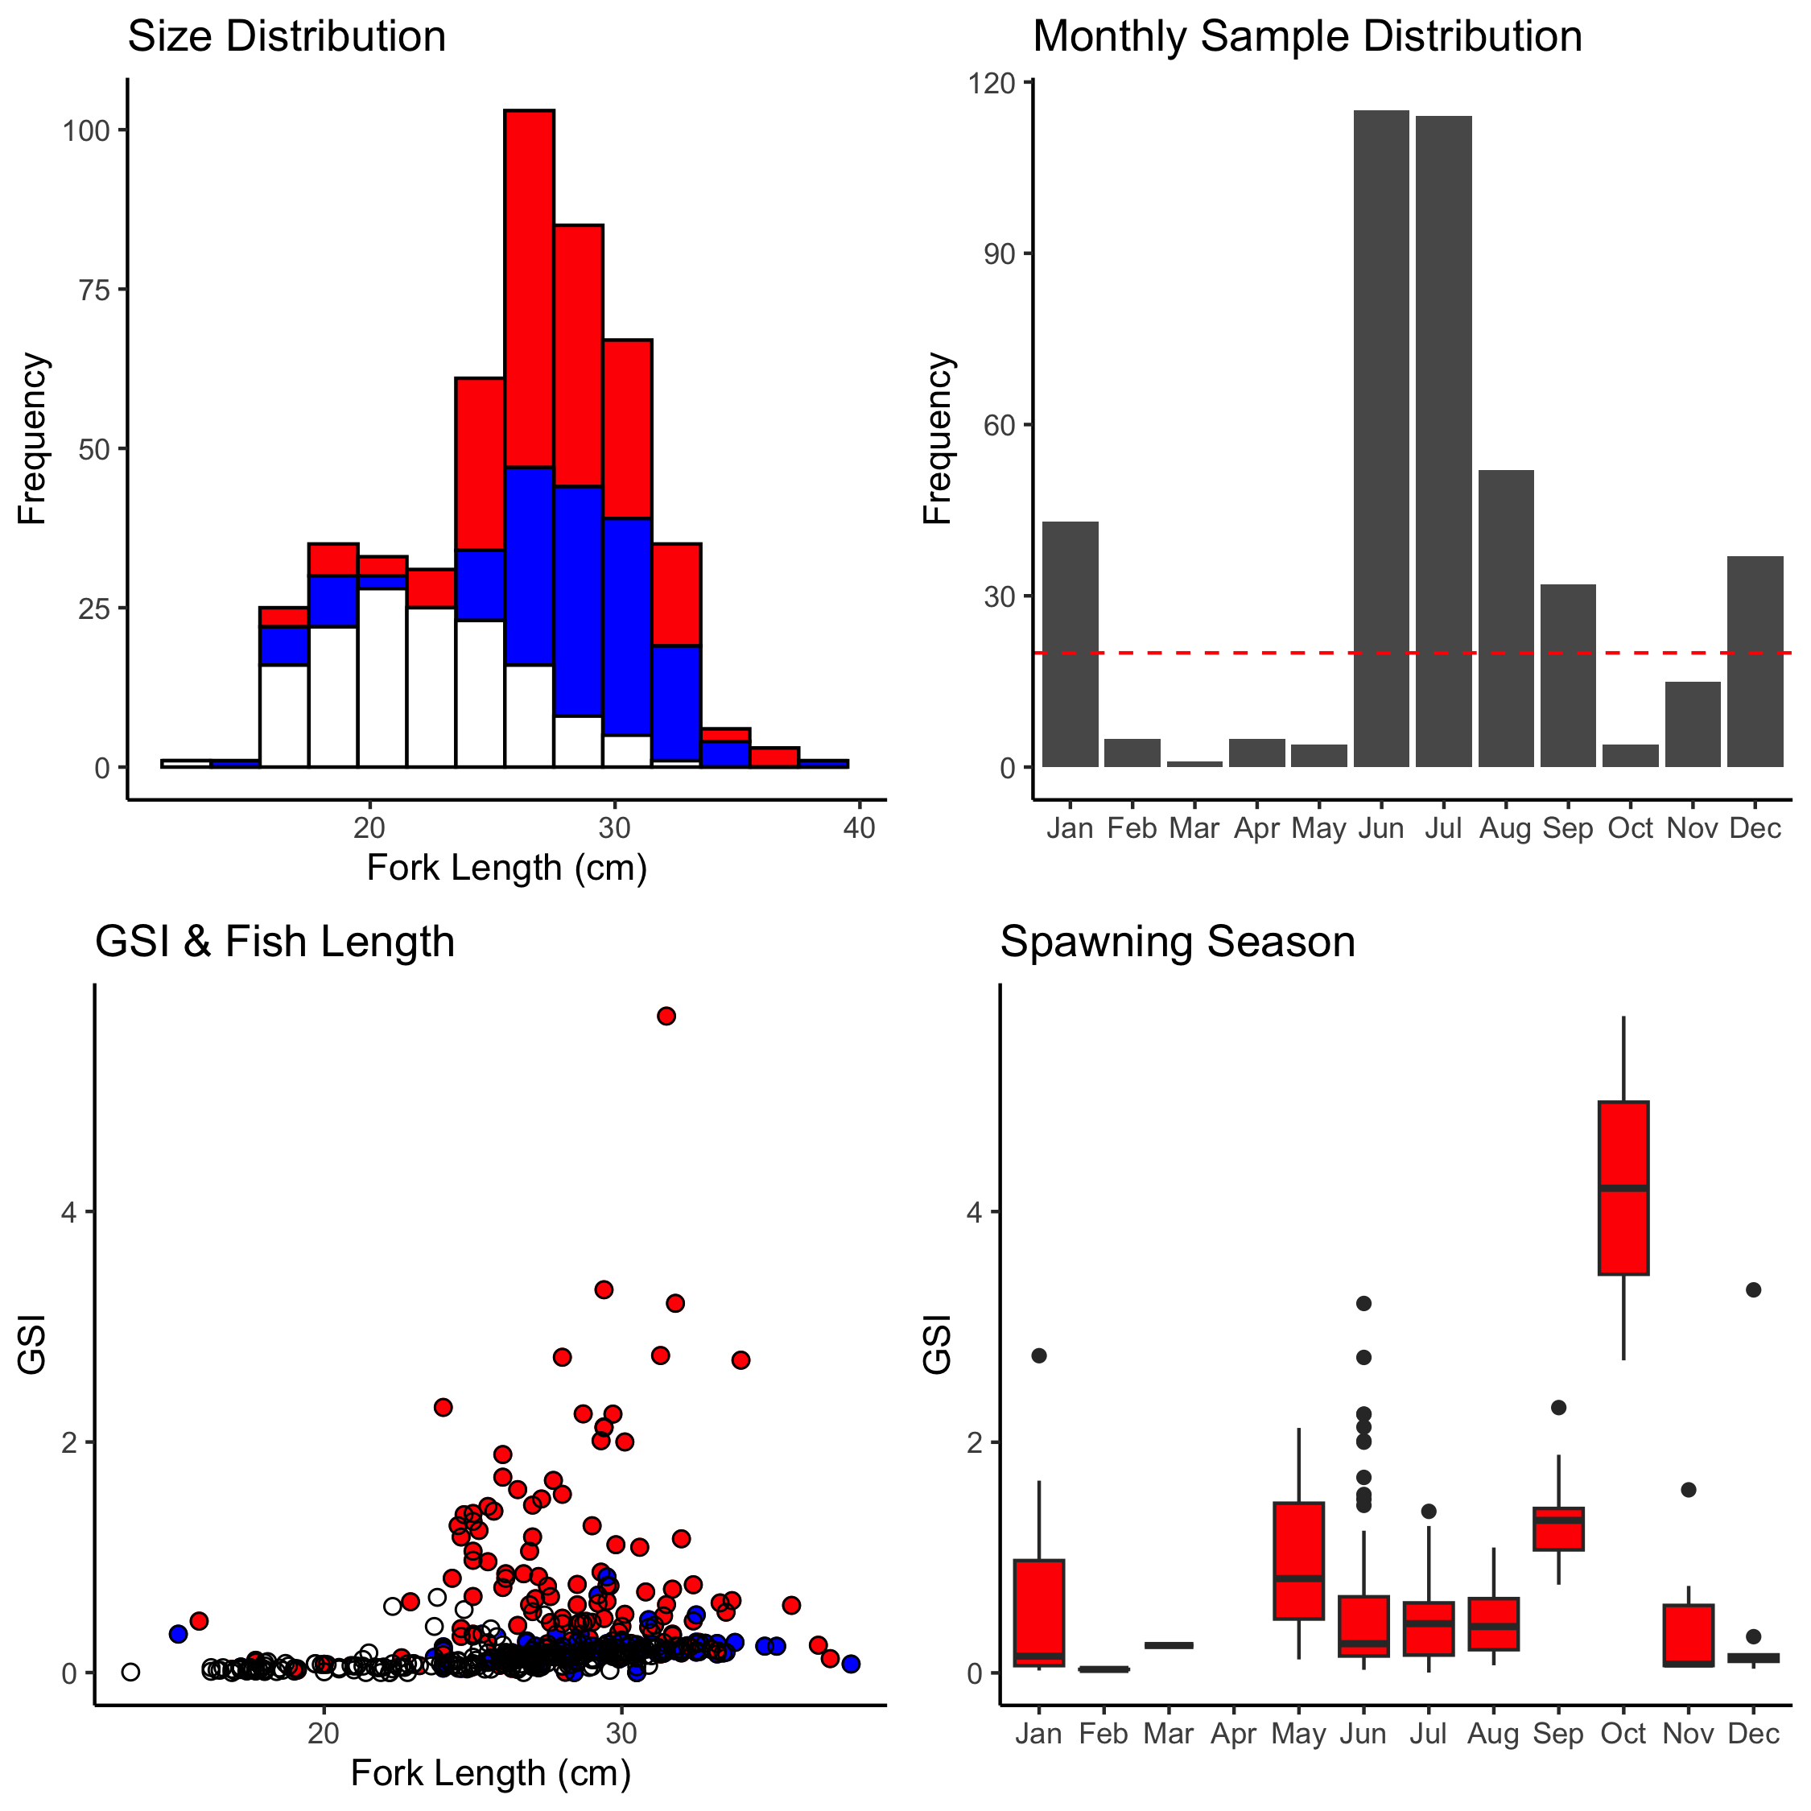

Figure A-8. *P. auricilla* sampling summaries for size distribution, monthly sample collection, GSI and fish length, and spawning season. Females are red (circles), males are blue (circles), unknown sex is blank (circles).

# *Pristipomoides filamentosus*

A total of 90 *Pristipomoides filamentosus* samples (females=34, males=21, unknown/na=35) have been collected to date (2023-04-10). Median fork length is 33.05 cm (min=22.6 cm, max=65.5 cm).

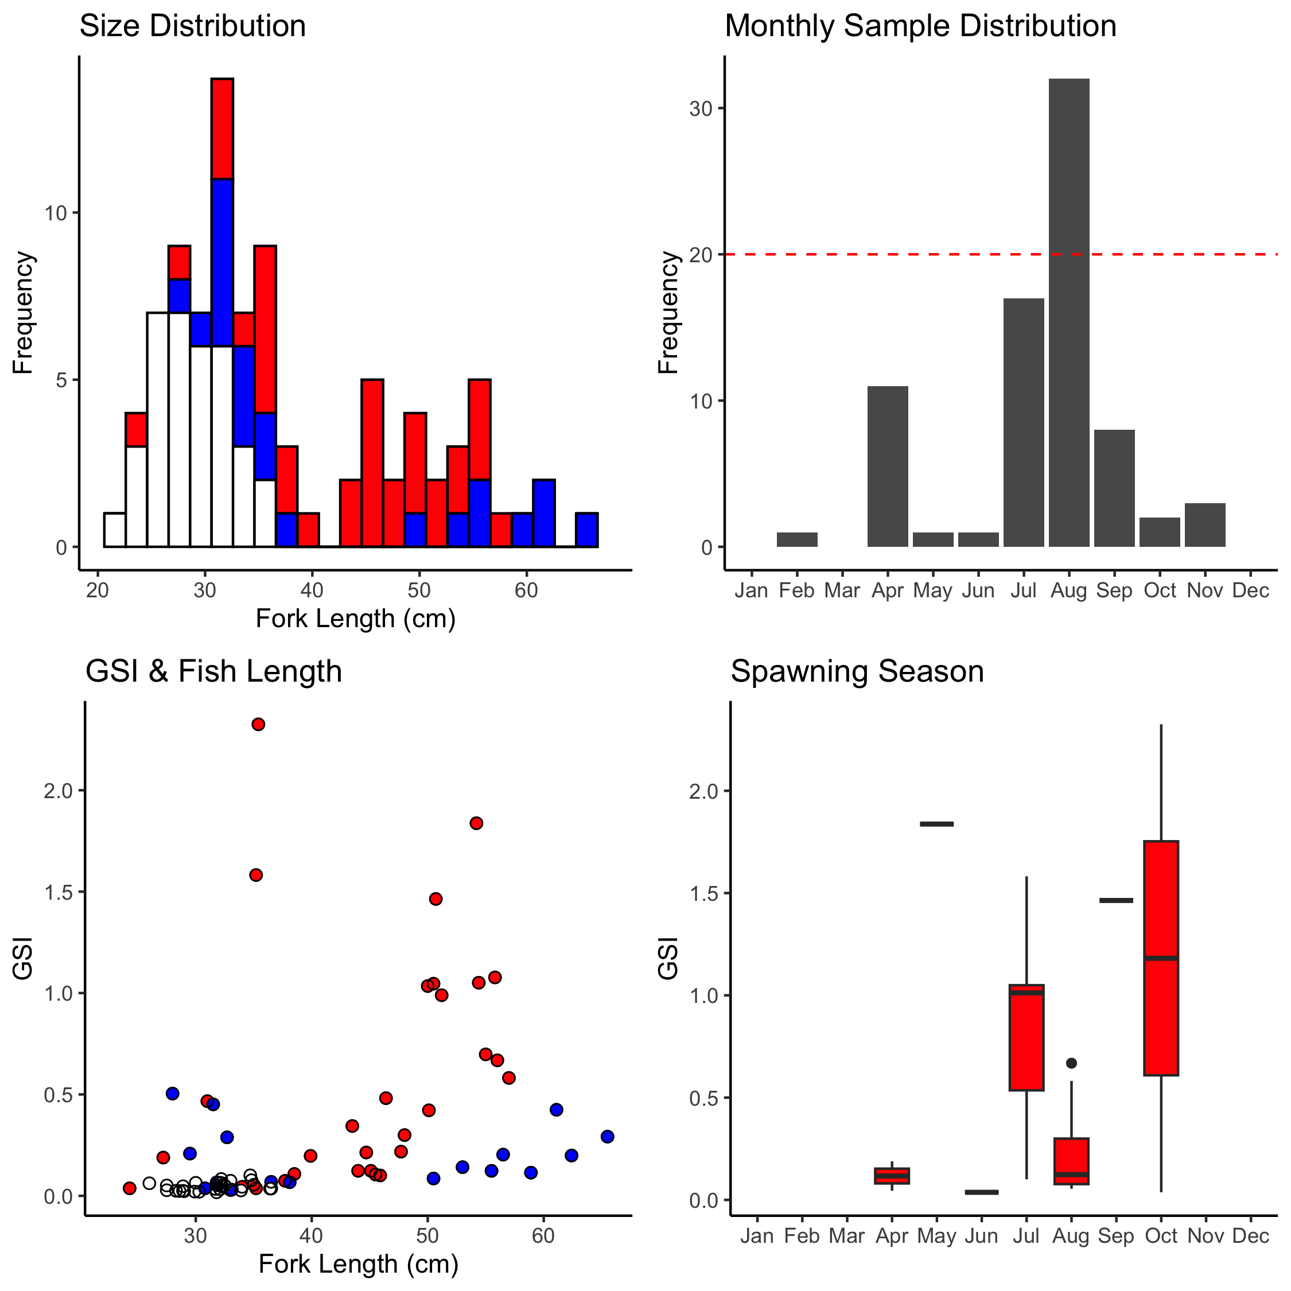

Figure A-9. *P. filamentosus* sampling summaries for size distribution, monthly sample collection, GSI and fish length, and spawning season. Females are red (circles), males are blue (circles), unknown sex is blank (circles).

# *Pristipomoides flavipinnis*

A total of 254 *Pristipomoides flavipinnis* samples (females=84, males=84, unknown/na=86) have been collected to date (2023-04-10). Median fork length is 29.4 cm (min=16.5 cm, max=67 cm).

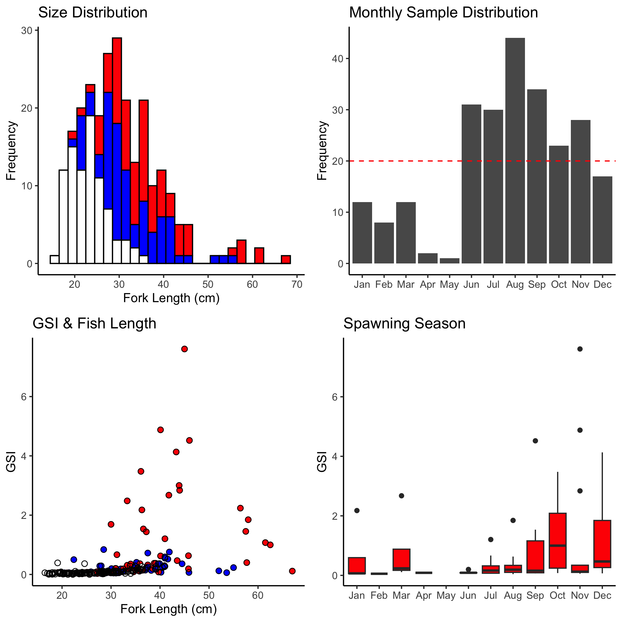

Figure A-10. *P. flavipinnis* sampling summaries for size distribution, monthly sample collection, GSI and fish length, and spawning season. Females are red (circles), males are blue (circles), unknown sex is blank (circles).

# *Pristipomoides sieboldii*

A total of 77 *Pristipomoides sieboldii* samples (females=38, males=33, unknown/na=6) have been collected to date (2023-04-10). Median fork length is 31.4 cm (min=18.7 cm, max=59.8 cm).

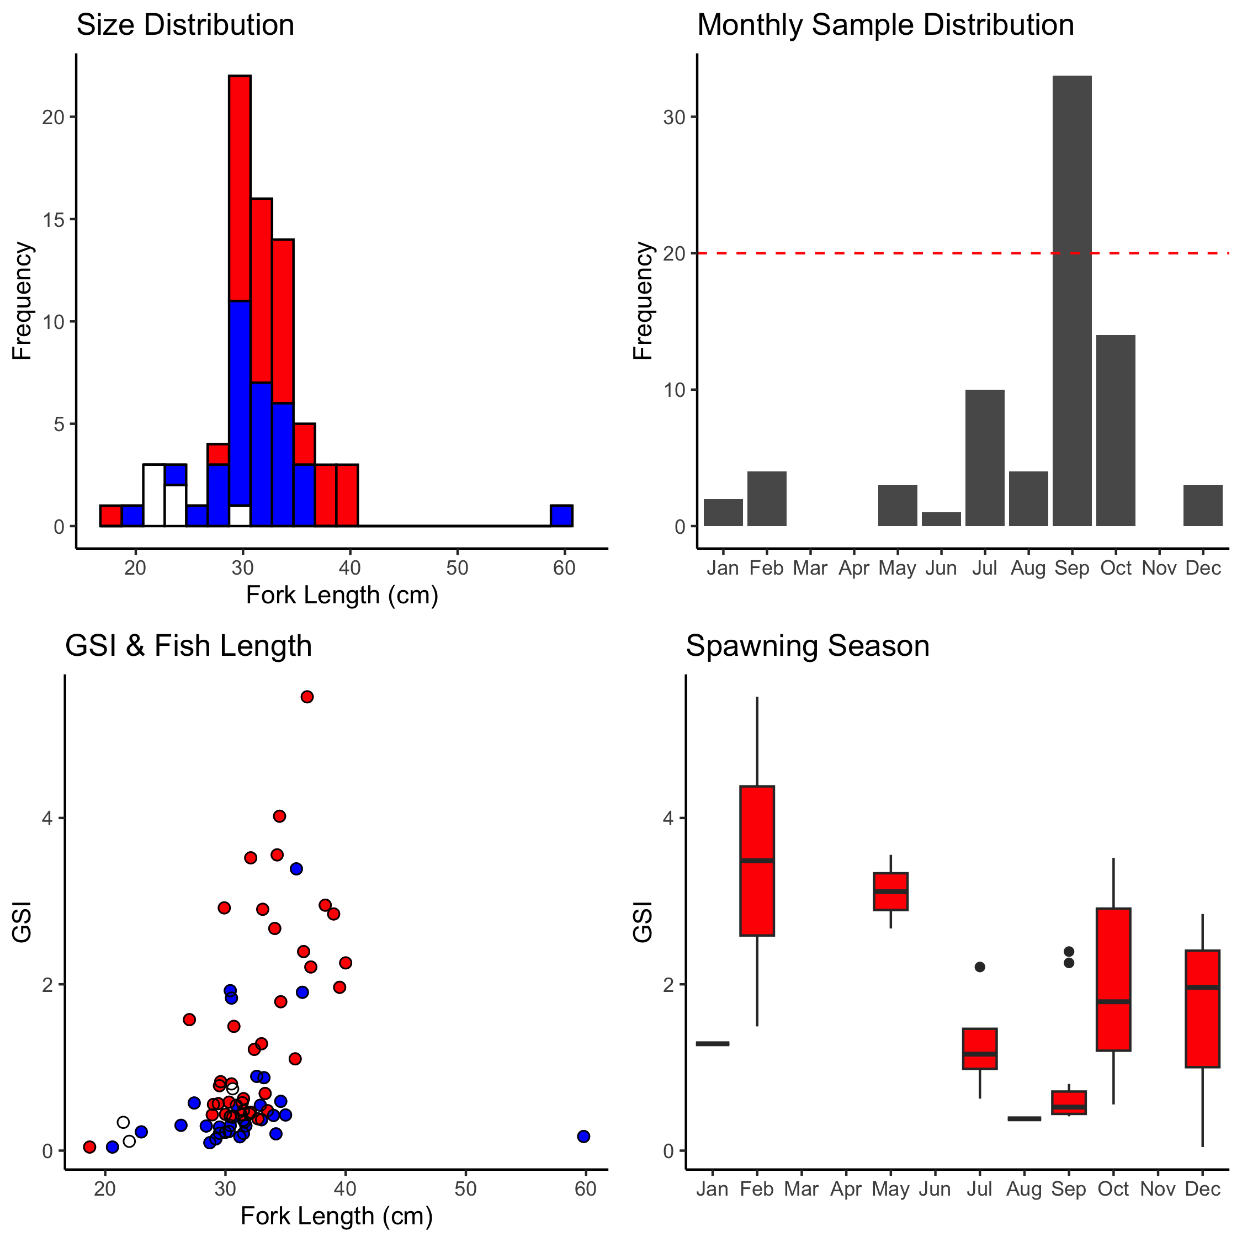

Figure A-11. *P. sieboldii* sampling summaries for size distribution, monthly sample collection, GSI and fish length, and spawning season. Females are red (circles), males are blue (circles), unknown sex is blank (circles).

# *Pristipomoides zonatus*

A total of 621 *Pristipomoides zonatus* samples (females=262, males=59, unknown/na=300) have been collected to date (2023-04-10). Median fork length is 25.8 cm (min=11.4 cm, max=40.5 cm).

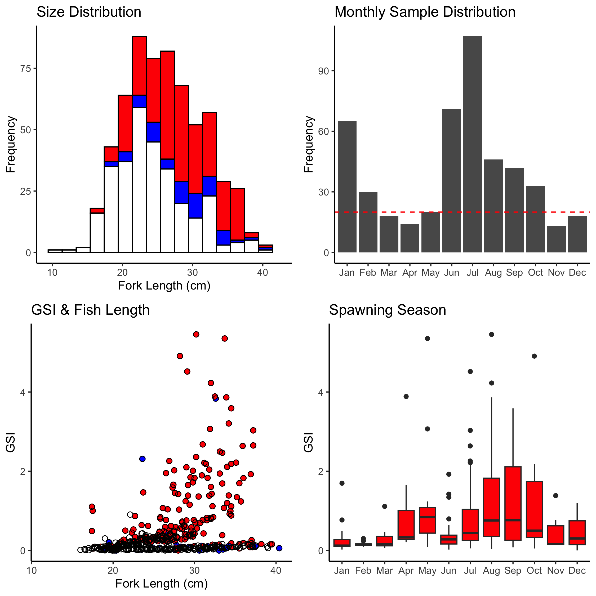

Figure A-12. *P. zonatus* sampling summaries for size distribution, monthly sample collection, GSI and fish length, and spawning season. Females are red (circles), males are blue (circles), unknown sex is blank (circles).

# *Variola louti*

A total of 324 *Variola louti* samples (females=156, males=63, unknown/na=105) have been collected to date (2023-04-10). Median fork length is 33.7 cm (min=19.4 cm, max=49.7 cm).

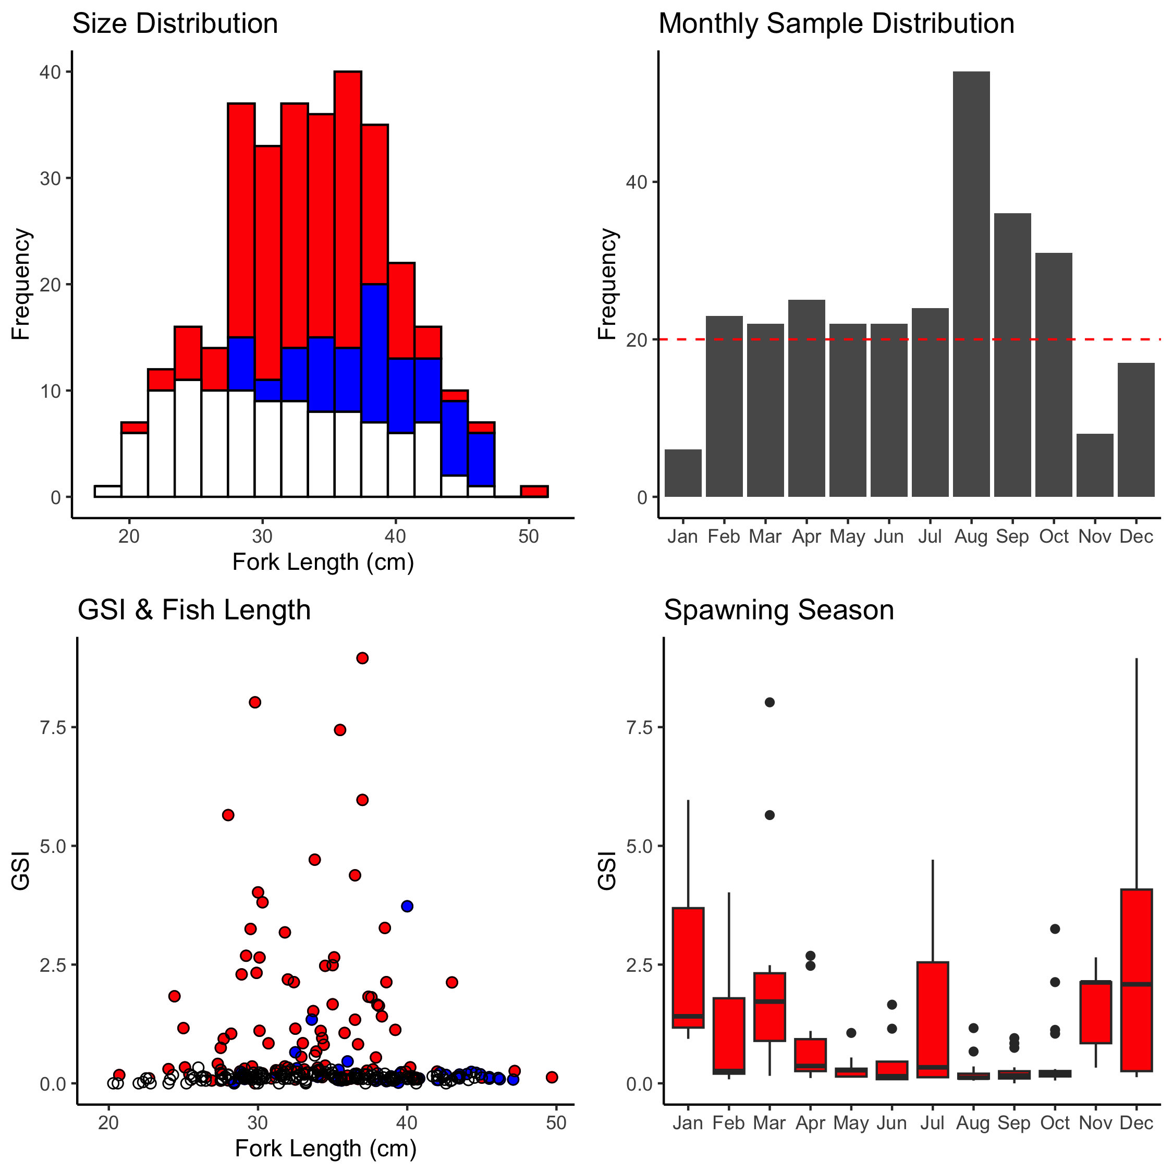

Figure A-13. *V. louti* sampling summaries for size distribution, monthly sample collection, GSI and fish length, and spawning season. Females are red (circles), males are blue (circles), unknown sex is blank (circles).