## *Aphareus rutilans* / APRU

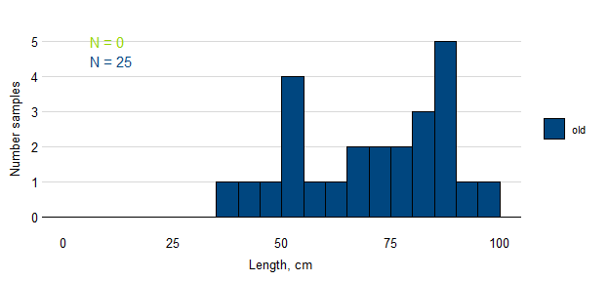

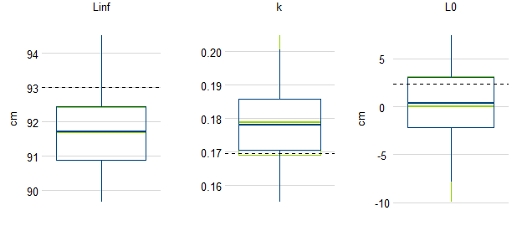

Figure. Samples of APRU by length and simulated estimates of von Bertalanffy growth parameters based on samples available before the Sette 04 cruise (blue) and updated to include fish lengths observed during the cruise (green). The true population value for each parameter is shown as a broken black line.

## *Etelis carbunculus* / ETCA

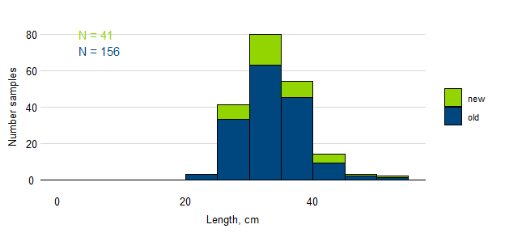

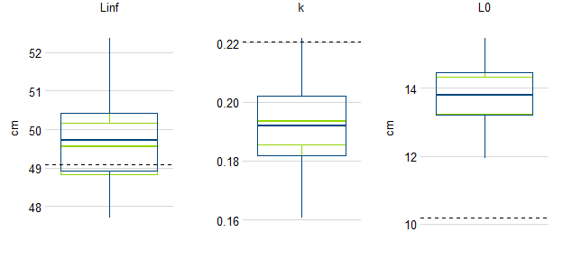

Figure. Samples of ETCA by length and simulated estimates of von Bertalanffy growth parameters based on samples available before the Sette 04 cruise (blue) and updated to include fish lengths observed during the cruise (green). The true population value for each parameter is shown as a broken black line.

## *Etelis coruscans* / ETCO

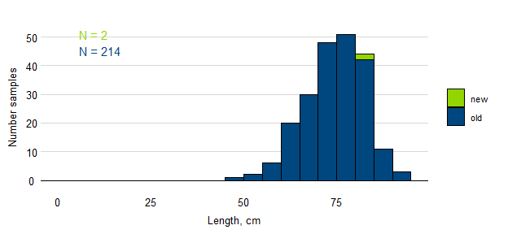

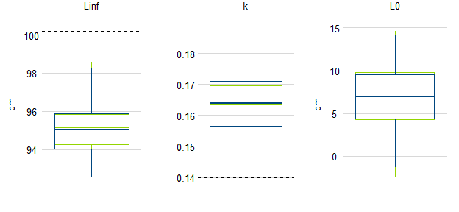

Figure. Samples of ETCO by length and simulated estimates of von Bertalanffy growth parameters based on samples available before the Sette 04 cruise (blue) and updated to include fish lengths observed during the cruise (green). The true population value for each parameter is shown as a broken black line.

## *Pristipomoides auricilla* / PRAU

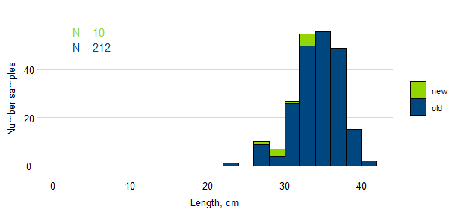

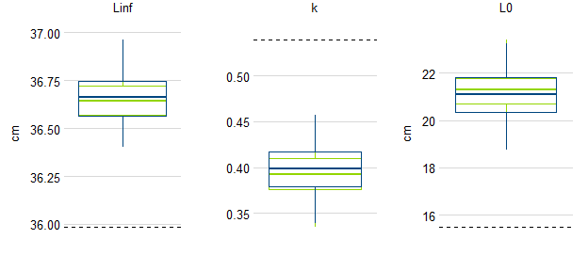

Figure. Samples of PRAU by length and simulated estimates of von Bertalanffy growth parameters based on samples available before the Sette 04 cruise (blue) and updated to include fish lengths observed during the cruise (green). The true population value for each parameter is shown as a broken black line.

## *Pristipomoides filamentosus* / PRFI

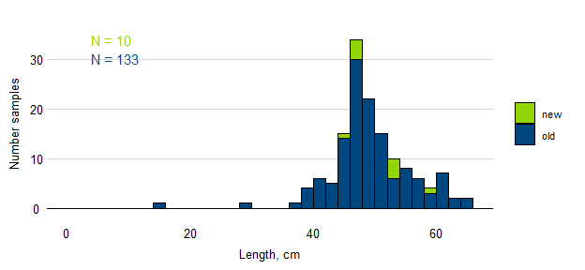

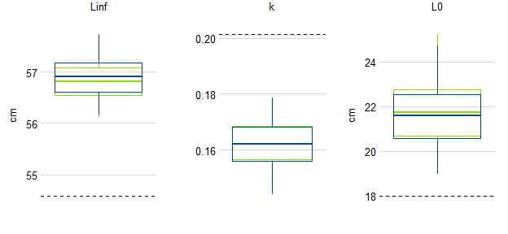

Figure. Samples of PRFI by length and simulated estimates of von Bertalanffy growth parameters based on samples available before the Sette 04 cruise (blue) and updated to include fish lengths observed during the cruise (green). The true population value for each parameter is shown as a broken black line.

## *Pristipomoides flavipinnis* / PRFL

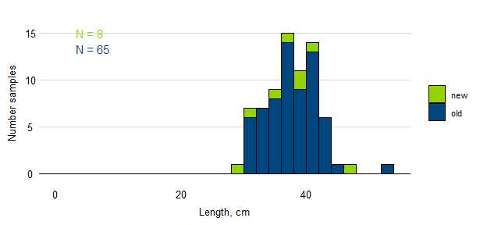

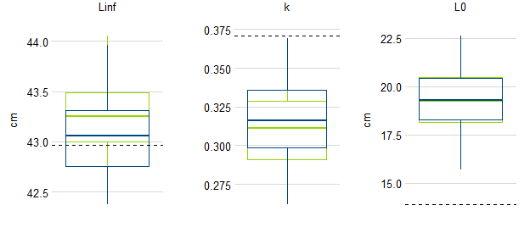

Figure. Samples of PRFL by length and simulated estimates of von Bertalanffy growth parameters based on samples available before the Sette 04 cruise (blue) and updated to include fish lengths observed during the cruise (green). The true population value for each parameter is shown as a broken black line.

## *Pristipomoides zonatus* / PRZO

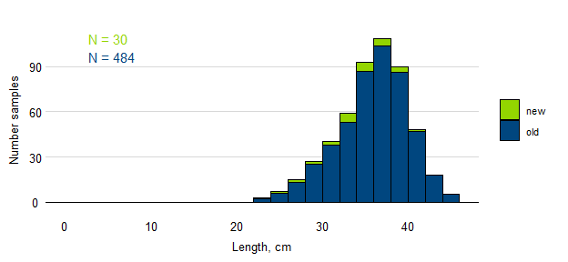

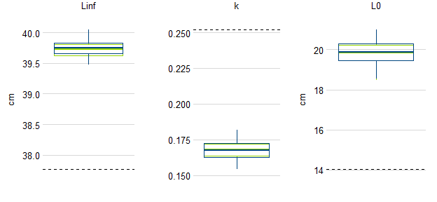

Figure. Samples of PRZO by length and simulated estimates of von Bertalanffy growth parameters based on samples available before the Sette 05 cruise (blue) and updated to include fish lengths observed during the cruise (green). The true population value for each parameter is shown as a broken black line.