## *Aphareus rutilans* / APRU / Lehi

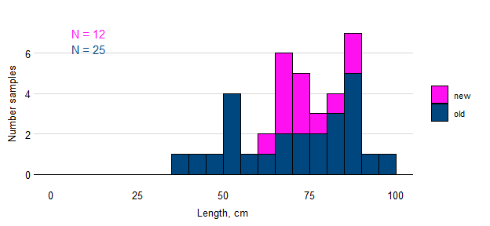

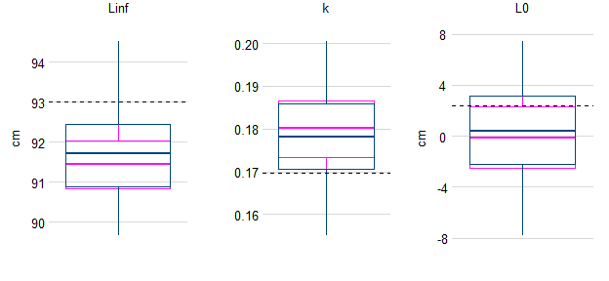

Figure. Samples of APRU by length and simulated estimates of von Bertalanffy growth parameters based on samples available before Sette-2025-04 (blue) and updated to include fish lengths observed during the cruise (pink). The true population value for each parameter is shown as a broken black line.

## *Caranx lugubris* / CALU / Black Jack

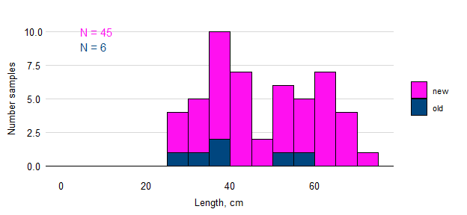

## *Etelis carbunculus* / ETCA / Ehu

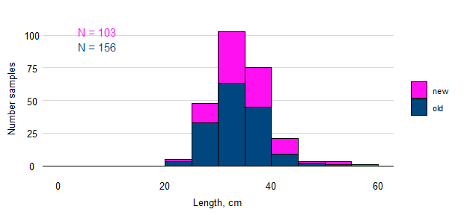

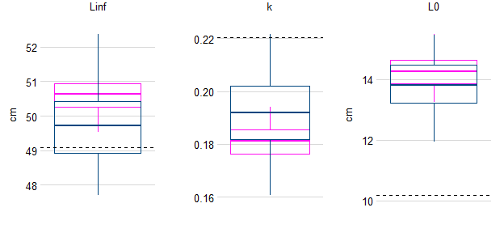

Figure. Samples of ETCA by length and simulated estimates of von Bertalanffy growth parameters based on samples available before Sette-2025-04 (blue) and updated to include fish lengths observed during the cruise (pink). The true population value for each parameter is shown as a broken black line.

## *Etelis coruscans* / ETCO / Onaga

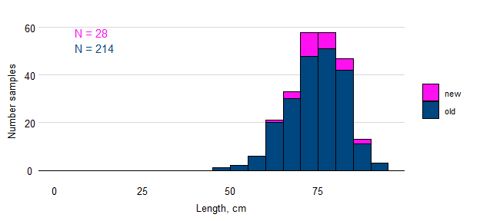

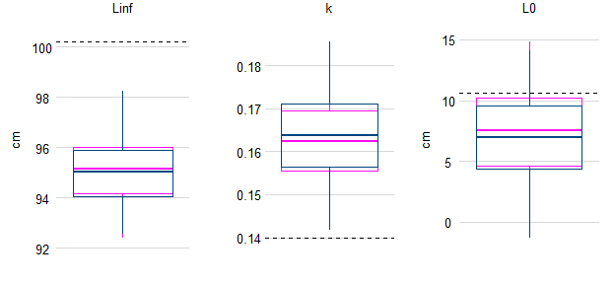

Figure. Samples of ETCO by length and simulated estimates of von Bertalanffy growth parameters based on samples available before Sette-2025-04 (blue) and updated to include fish lengths observed during the cruise (pink). The true population value for each parameter is shown as a broken black line.

## *Pristipomoides auricilla* / PRAU / Kalekale

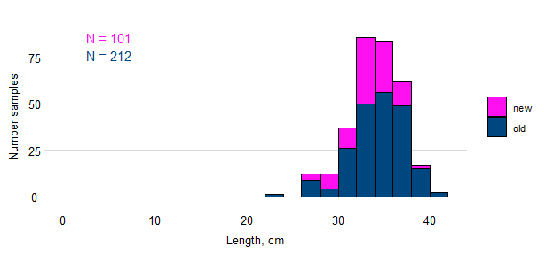

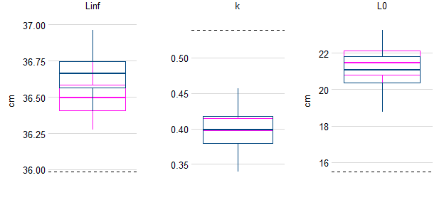

Figure. Samples of PRAU by length and simulated estimates of von Bertalanffy growth parameters based on samples available before Sette-2025-04 (blue) and updated to include fish lengths observed during the cruise (pink). The true population value for each parameter is shown as a broken black line.

## *Pristipomoides filamentosus* / PRFI / Opakapaka / Brown paka

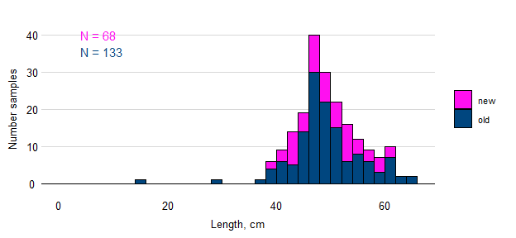

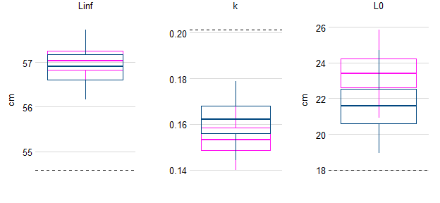

Figure. Samples of PRFI by length and simulated estimates of von Bertalanffy growth parameters based on samples available before Sette-2025-04 (blue) and updated to include fish lengths observed during the cruise (pink). The true population value for each parameter is shown as a broken black line.

## *Pristipomoides flavipinnis* / PRFL / Yellow-eye paka

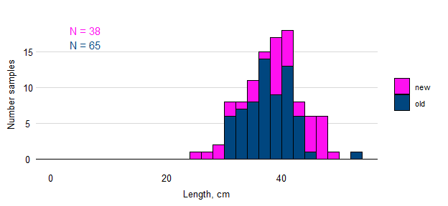

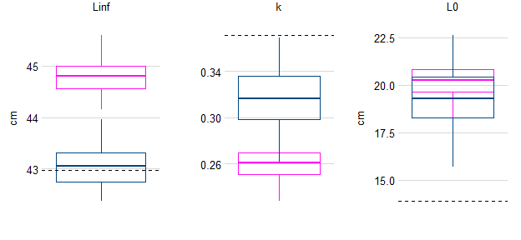

Figure. Samples of PRFL by length and simulated estimates of von Bertalanffy growth parameters based on samples available before Sette-2025-04 (blue) and updated to include fish lengths observed during the cruise (pink). The true population value for each parameter is shown as a broken black line.

## *Pristipomoides zonatus* / PRZO / Gindai

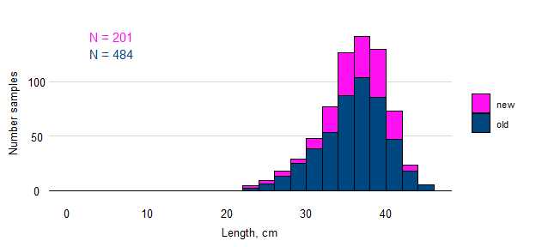

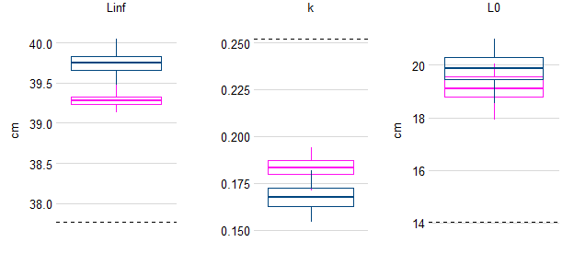

Figure. Samples of PRZO by length and simulated estimates of von Bertalanffy growth parameters based on samples available before Sette-2025-04 (blue) and updated to include fish lengths observed during the cruise (pink). The true population value for each parameter is shown as a broken black line.