## *Aphareus rutilans* / APRU / Lehi

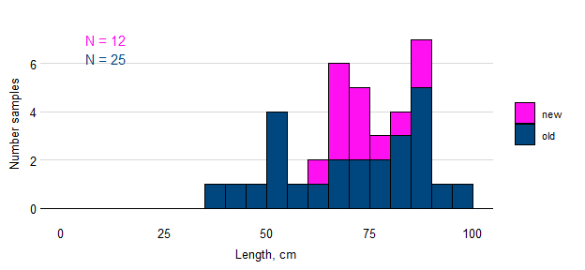

Figure. Samples of APRU by length and simulated estimates of von Bertalanffy growth parameters based on samples available before the Sette 04 cruise (blue) and updated to include fish lengths observed during the cruise (green). The true population value for each parameter is shown as a broken black line.

## *Caranx lugubris* / CALU / Black Jack

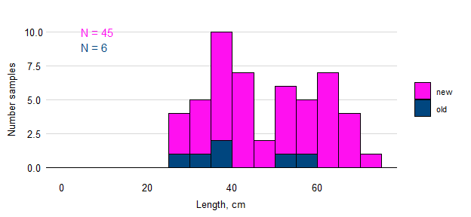

## *Etelis carbunculus* / ETCA / Ehu

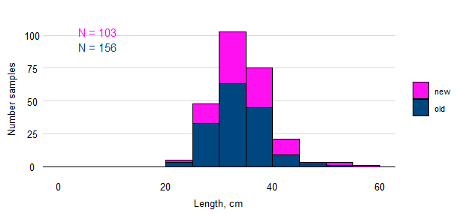

Figure. Samples of ETCA by length and simulated estimates of von Bertalanffy growth parameters based on samples available before the Sette 04 cruise (blue) and updated to include fish lengths observed during the cruise (green). The true population value for each parameter is shown as a broken black line.

## *Etelis coruscans* / ETCO / Onaga

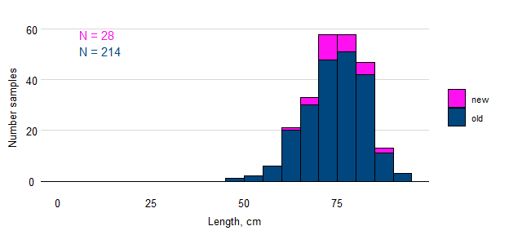

Figure. Samples of ETCO by length and simulated estimates of von Bertalanffy growth parameters based on samples available before the Sette 04 cruise (blue) and updated to include fish lengths observed during the cruise (green). The true population value for each parameter is shown as a broken black line.

## *Pristipomoides auricilla* / PRAU / Kalekale

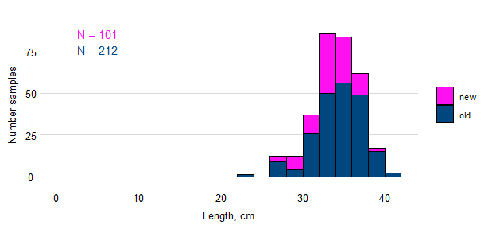

Figure. Samples of PRAU by length and simulated estimates of von Bertalanffy growth parameters based on samples available before the Sette 04 cruise (blue) and updated to include fish lengths observed during the cruise (green). The true population value for each parameter is shown as a broken black line.

## *Pristipomoides filamentosus* / PRFI / Opakapaka / Brown paka

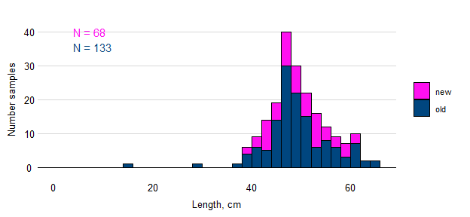

Figure. Samples of PRFI by length and simulated estimates of von Bertalanffy growth parameters based on samples available before the Sette 04 cruise (blue) and updated to include fish lengths observed during the cruise (green). The true population value for each parameter is shown as a broken black line.

## *Pristipomoides flavipinnis* / PRFL / Yellow-eye paka

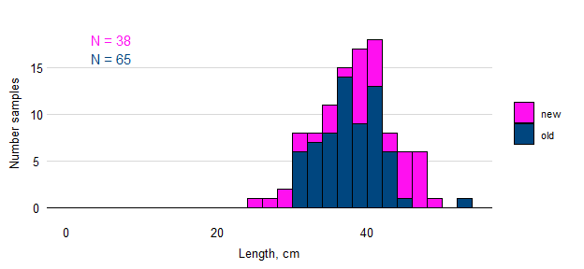

Figure. Samples of PRFL by length and simulated estimates of von Bertalanffy growth parameters based on samples available before the Sette 04 cruise (blue) and updated to include fish lengths observed during the cruise (green). The true population value for each parameter is shown as a broken black line.

## *Pristipomoides zonatus* / PRZO / Gindai

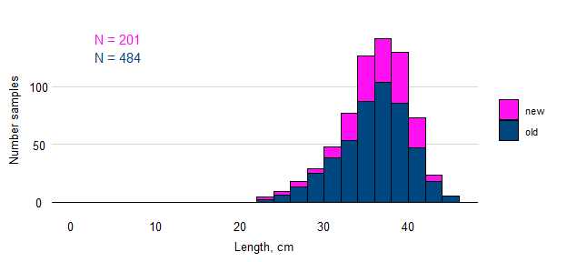

Figure. Samples of PRZO by length and simulated estimates of von Bertalanffy growth parameters based on samples available before the Sette 05 cruise (blue) and updated to include fish lengths observed during the cruise (green). The true population value for each parameter is shown as a broken black line.