## *Aphareus rutilans* / APRU / Lehi

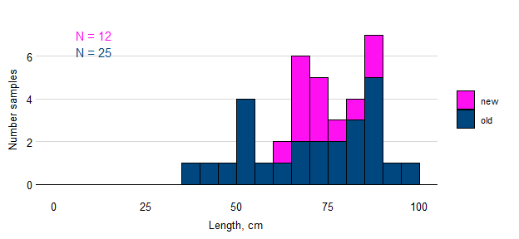

Figure. Samples of APRU by length.

## *Caranx lugubris* / CALU / Black Jack

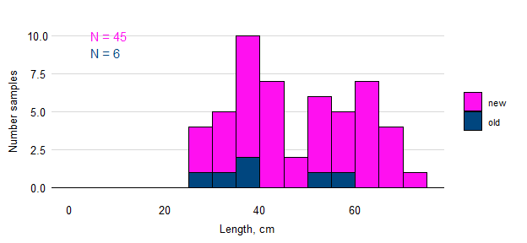

Figure. Samples of CALU by length.

## *Etelis carbunculus* / ETCA / Ehu

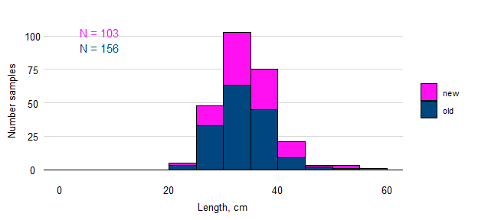

Figure. Samples of ETCA by length.

## *Etelis coruscans* / ETCO / Onaga

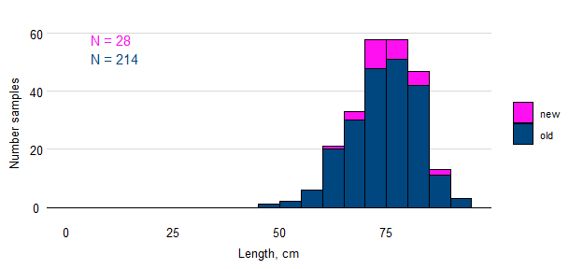

Figure. Samples of ETCO.

## *Pristipomoides auricilla* / PRAU / Kalekale

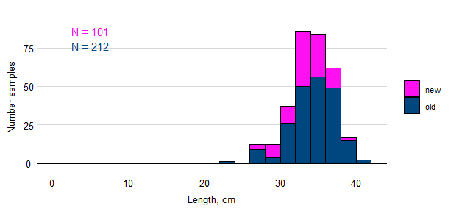

Figure. Samples of PRAU by length.

## *Pristipomoides filamentosus* / PRFI / Opakapaka / Brown paka

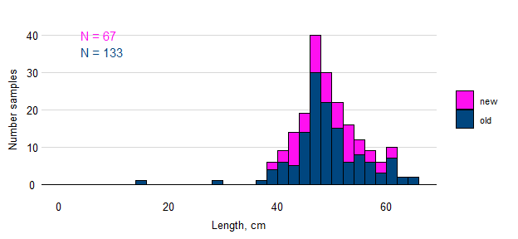

Figure. Samples of PRFI by length.

## *Pristipomoides flavipinnis* / PRFL / Yellow-eye paka

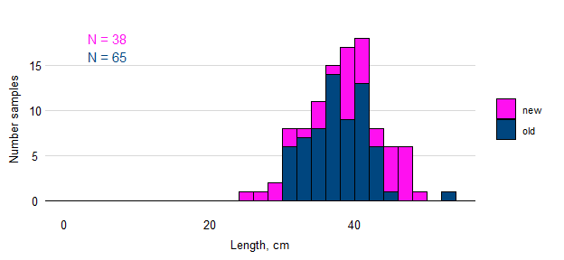

Figure. Samples of PRFL by length.

## *Pristipomoides zonatus* / PRZO / Gindai

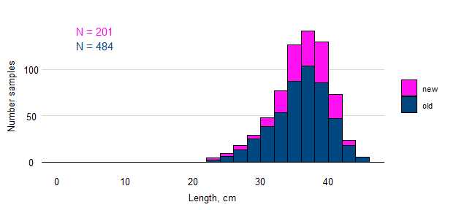

Figure. Samples of PRZO by length.