## *Aphareus rutilans* / APRU

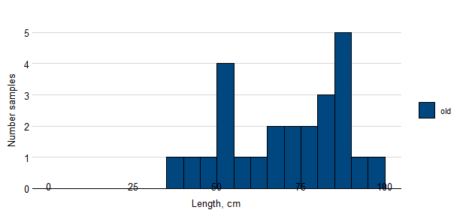

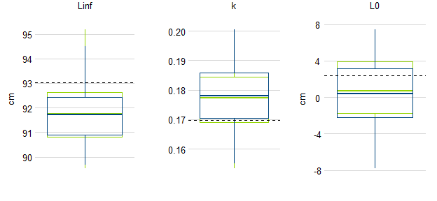

Figure. Samples of APRU by length and simulated estimates of von Bertalanffy growth parameters based on samples available before the Sette 05 cruise (blue) and updated to include fish lengths observed during the cruise (green). The true population value for each parameter is shown as a broken black line.

## *Pristipomoides zonatus* / PRZO

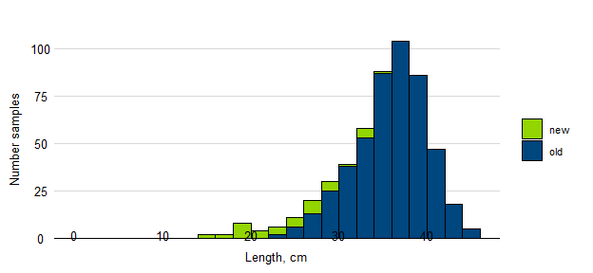

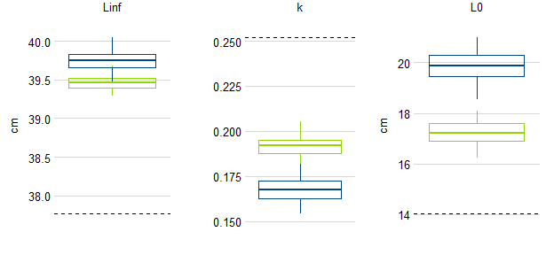

Figure. Samples of PRZO by length and simulated estimates of von Bertalanffy growth parameters based on samples available before the Sette 05 cruise (blue) and updated to include fish lengths observed during the cruise (green). The true population value for each parameter is shown as a broken black line.