# Heading 1

Each section can be used for things like Methods, Results, Discussion, etc. This is meant to be a versatile template to fit the needs of your report.

## Heading 2

This is text in heading 2.

### Heading 3

All Headings Use Title Case.

#### Heading 4

heading 4 text.

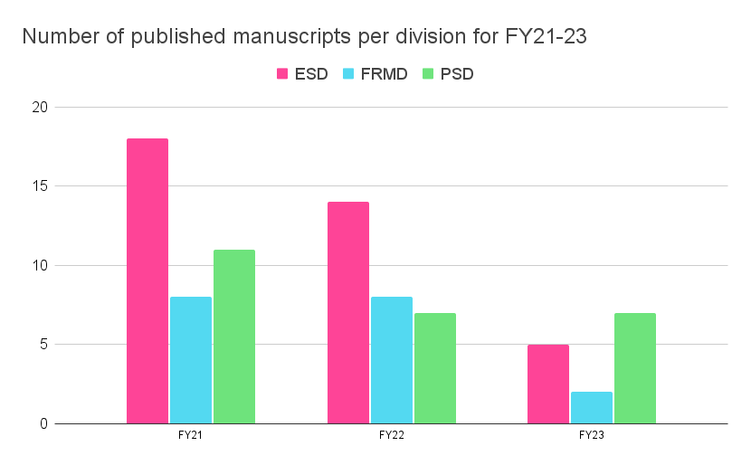

Figure . A figure.

Table 1. Here's a caption for a table.

| **Variables (Style: Tables, left aligned, top-anchored, bold)** | **Descriptive Text (Style: Tables, left aligned, top-anchored, Bold)** | **Numerical Data (Style: Tables, left aligned, top-anchored, Bold)** |
| --- | --- | --- |
| (Left-aligned, bottom anchored, Style: Tables) | (Left-aligned, bottom-anchored, Style: Tables) | (Right-aligned, bottom-anchored, Style: Tables) |
| Year 2 | Lorem ipsum | 67.89 |
| Year 32 | Lorem ipsum | 123.45 |
| Year 33 | Lorem ipsum | 67.89 |
| Year 34 | Lorem ipsum | 1.00 |

(Style: Table Descriptive Text) Descriptive text, footnotes, and sources. I.e., *c.d.* denotes confidential data.