## *A. rutilans* / APRU

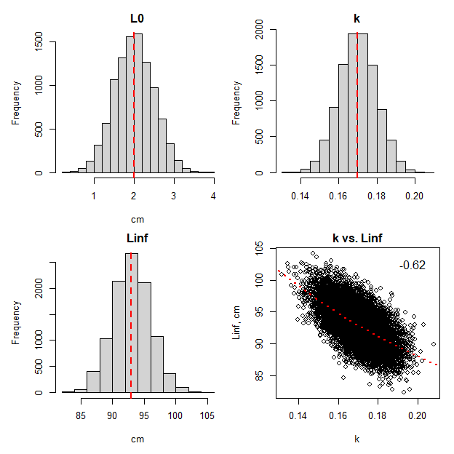

Figure. Simulated population von Bertalanffy growth parameters for APRU. Natural mortality is dependent on length via Lorenzen, overall **M = 0.194**. Max age is **34 years**. Vertical line is the population median for each parameter. The value of the correlation coefficient is printed on the lower right plot where the theoretical relationship between Linf and k is denoted by the broken red line.

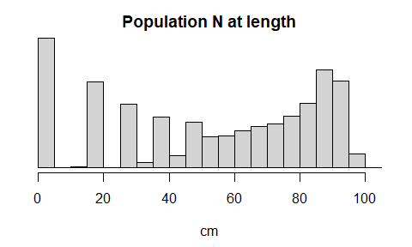

Figure. Simulated APRU unfished population length composition.

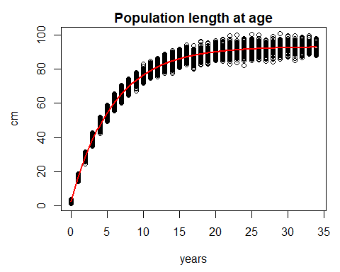

Figure. Simulated APRU unfished population with the fitted von Bertalanffy growth function.

## *E. carbunculus* / ETCA

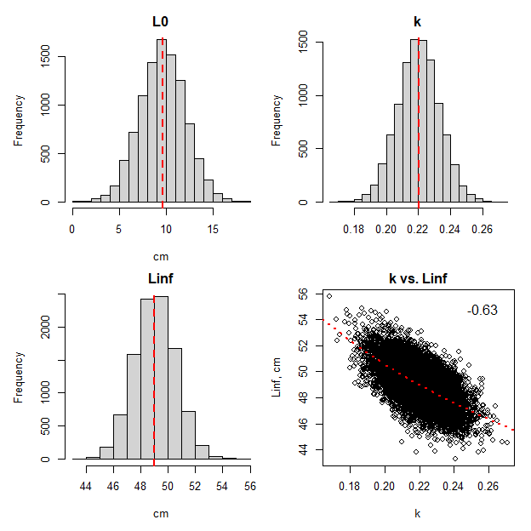

Figure. Simulated population von Bertalanffy growth parameters for ETCA. Natural mortality is dependent on length via Lorenzen, overall **M = 0.2**. Max age is **33 years**. Vertical line is the population median for each parameter. The value of the correlation coefficient is printed on the lower right plot where the theoretical relationship between Linf and k is denoted by the broken red line.

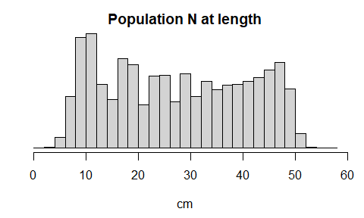

Figure. Simulated ETCA unfished population length composition.

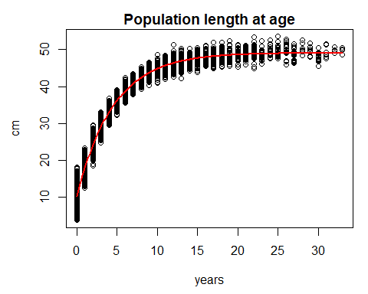

Figure. Simulated ETCA unfished population with the fitted von Bertalanffy growth function.

## *E. coruscans* / ETCO

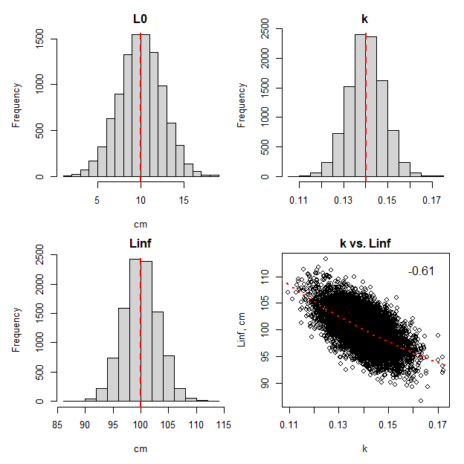

Figure. Simulated population von Bertalanffy growth parameters for ETCO. Natural mortality is dependent on length via Lorenzen, overall **M = 0.125**. Max age is **55 years**. Vertical line is the population median for each parameter. The value of the correlation coefficient is printed on the lower right plot where the theoretical relationship between Linf and k is denoted by the broken red line.

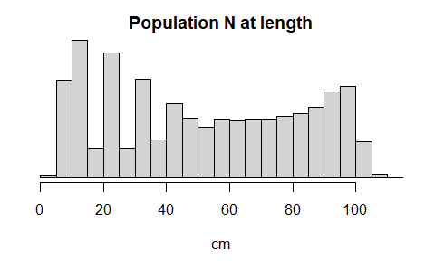

Figure. Simulated ETCO unfished population length composition.

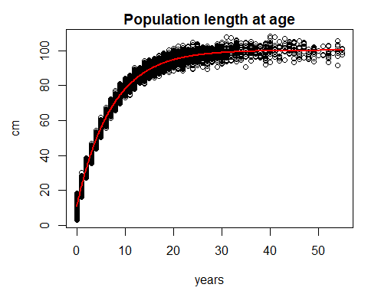

Figure. Simulated ETCO unfished population with the fitted von Bertalanffy growth function.

## *P. auricilla* / PRAU

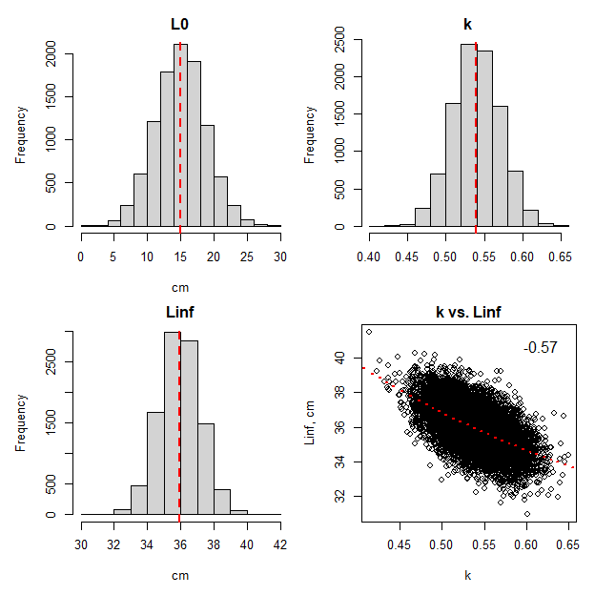

Figure. Simulated population von Bertalanffy growth parameters for PRAU. Natural mortality is dependent on length via Lorenzen, overall **M = 0.205**. Max age is **32 years**. Vertical line is the population median for each parameter. The value of the correlation coefficient is printed on the lower right plot where the theoretical relationship between Linf and k is denoted by the broken red line.

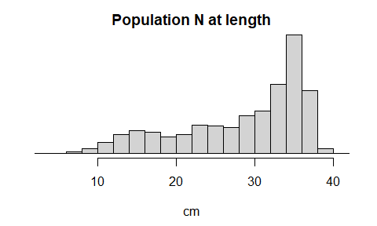

Figure. Simulated PRAU unfished population length composition.

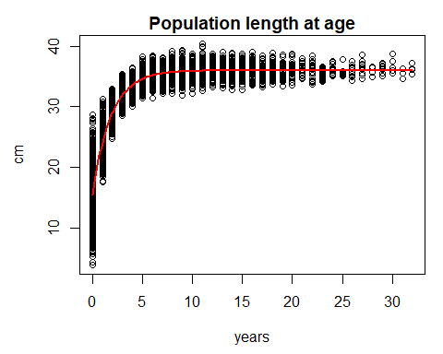

Figure. Simulated PRAU unfished population with the fitted von Bertalanffy growth function.

## *P. filamentosus* / PRFI

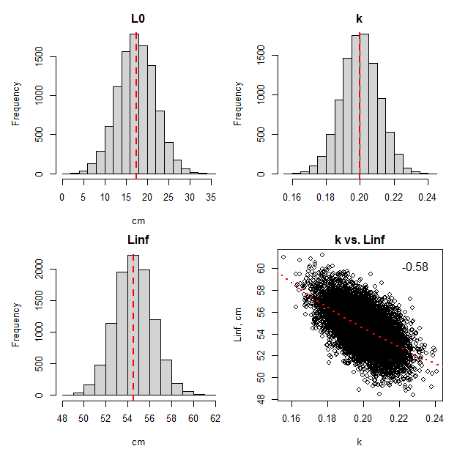

Figure. Simulated population von Bertalanffy growth parameters for PRFI. Natural mortality is dependent on length via Lorenzen, overall **M = 0.136**. Max age is **50 years**. Vertical line is the population median for each parameter. The value of the correlation coefficient is printed on the lower right plot where the theoretical relationship between Linf and k is denoted by the broken red line.

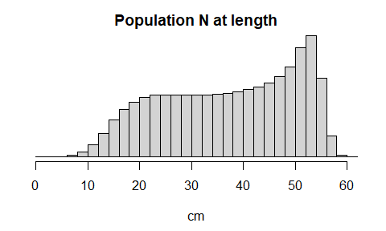

Figure. Simulated PRFI unfished population length composition.

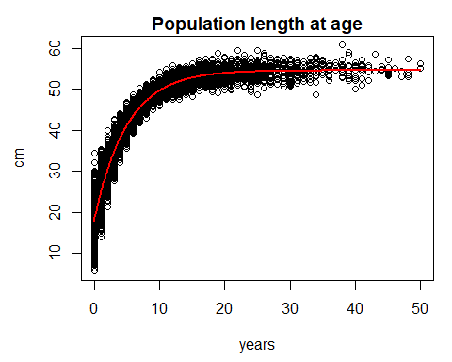

Figure. Simulated PRFI unfished population with the fitted von Bertalanffy growth function.

## *P. flavipinnis* / PRFL

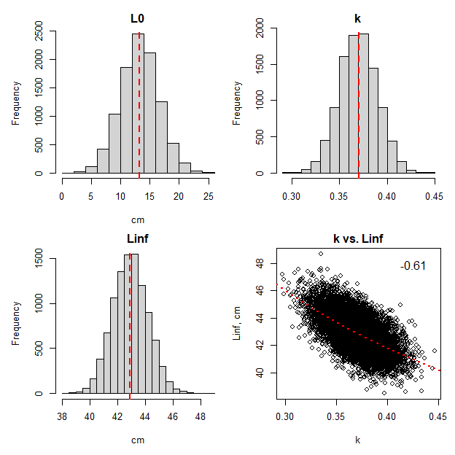

Figure. Simulated population von Bertalanffy growth parameters for PRFL. Natural mortality is dependent on length via Lorenzen, overall **M = 0.231**. Max age is **28 years**. Vertical line is the population median for each parameter. The value of the correlation coefficient is printed on the lower right plot where the theoretical relationship between Linf and k is denoted by the broken red line.

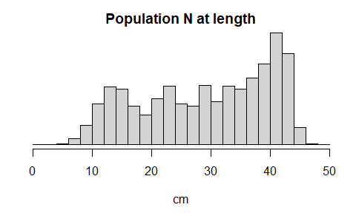

Figure. Simulated PRFL unfished population length composition.

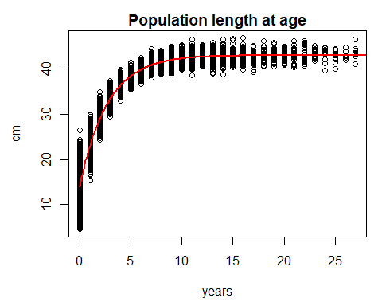

Figure. Simulated PRFL unfished population with the fitted von Bertalanffy growth function.

## *P. zonatus* / PRZO

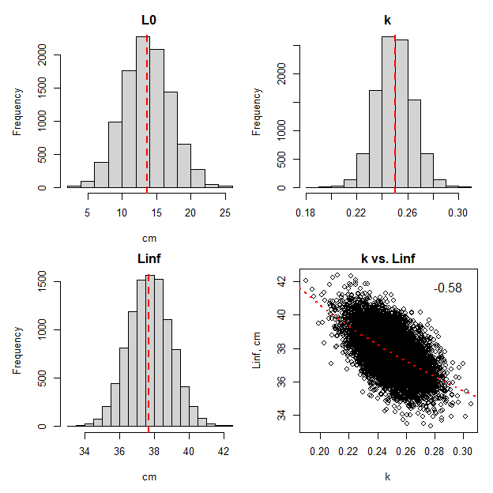

Figure. Simulated population von Bertalanffy growth parameters for PRZO. Natural mortality is dependent on length via Lorenzen, overall **M = 0.175**. Max age is **38 years**. Vertical line is the population median for each parameter. The value of the correlation coefficient is printed on the lower right plot where the theoretical relationship between Linf and k is denoted by the broken red line.

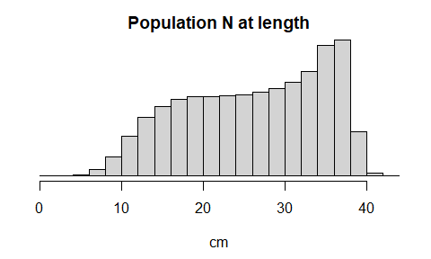

Figure. Simulated PRZO unfished population length composition.

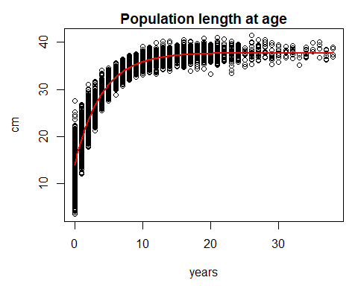

Figure. Simulated PRZO unfished population with the fitted von Bertalanffy growth function.