 | Meteorological Development Laboratory | 

SLOSH
Sea, Lake, and Overland Surges from Hurricanes
User & Technical Software Documentation

Silver Spring, Md.
October 2006


Forward

SLOSH was originally developed in the mid 1960's by Chester P. Jelesnianski from the Institute for Oceanography, ESSA (now NOAA), with collaboration by the Weather Bureau's (now National Weather Service) D. Lee Harris and Albion Taylor. Since then, methods, software, and the operational use have evolved by the efforts of many people. The preparation of this document was a team effort led by Mark A. McInerney of the Meteorological Development Laboratory. Those making significant contributions are listed below:

Wilson Shaffer
NWS Meteorological Development Laboratory

Arthur Taylor
NWS Meteorological Development Laboratory

Karen A. Sandell
NWS Meteorological Development Laboratory

Brian Jarvinen
NWS Tropical Prediction Center

Stephen Baig
NWS Tropical Prediction Center

Gloria Lockett
NWS Tropical Prediction Center

Joan David
NWS Tropical Prediction Center

LT Jennifer Pralgo
NWS Tropical Prediction Center

Jerry Putland
NOAA Atlantic Oceanographic and Meteorological Laboratory

Heather Hauser
NWS Eastern Region Headquarters

______________________________________
Harry R. Glahn
Director - NWS Meteorological Development Laboratory

TABLE OF CONTENTS
- GENERAL OVERVIEW 6

2.0 SLOSH Development Environment 9
2.1 System Requirements 10
2.2 Building the Development Environment 10
2.2.1 Installing Cygwin Environment 10

3.0 SLOSH Model Software Architecture 14
3.1 “Base” Model Context Diagram 14
3.1.1 High Level Context Diagram 14
3.1.2 First Decomposition 15
3.1.3 Second Decomposition - Base Model & DOS Wrapper 16
3.1.4 Third Decomposition - slosh2.c 17
3.1.5 Fourth Decomposition - tendian.c, pack.c 18
3.1.6 Fifth Decomposition - complex.c, savellx.c 19
3.1.7 Sixth Decomposition – myUtil.c, myassert.c 20
3.1.8 Seventh Decomposition – tio3.c 21
3.1.9 Eighth Decomposition – cstart.c 22
3.1.10 Ninth Decomposition – runslhg.f, interface.f, smooth.f 23
3.2 Model Subroutine Call Diagram 24
3.2.1 First Decomposition – DOS Wrapper (C) 24
3.2.2 Second Decomposition – Base Model (FORTRAN) 25
3.3 Base Model Source Tree 25
3.3.1 Source file “runslhg.f” Subroutines 26
3.3.2 Source file “smooth.f” Subroutines 68
3.3.3 Source file “interface.f” Subroutines 71
3.4 DOS Wrapper Source Tree 77
3.4.1 Source file “clock.c / cloch.h” Subroutines 78
3.4.2 Source file “complex.c / complex.h” Subroutines 90
3.4.3 Source file “cstart.c” Subroutines 96
3.4.4 Source file “myassert.c / myassert.h” Subroutines 99
3.4.5 Source file “myutil.c / myutil.h” Subroutines 100
3.4.6 Source file “pack.c / pack.h” Subroutines 105
3.4.7 Source file “savellx.c / savellx.h” Subroutines 111
3.4.8 Source file “slosh2.c / slosh2.h” Subroutines 117
3.4.9 Source file “tendian.c / tendian.h” Subroutines 121
3.4.10 Source file “tio3.c / tio3.h” Subroutines 129

4.0 Executing the SLOSH MODEL 137
4.1 Execution Commands for SLOSH 137
4.2 Creating a TRK Data File 137

5.0 SLOSH DISPLAY PROGRAM GRAPHICAL USER INTERFACE 139
5.1 SLOSH sloshdsp.ini Edit Graphical User Interface 145
5.2 Select Storm 146
5.2.1 Display Historical SLOSH Model Data 146
5.2.2 Display MEOW SLOSH Model Data 148
5.2.3 Display MOM SLOSH Model Data 149
5.3 Inquire All 151
5.4 Animate Historical Rex Data 154
5.5 Importing a Rex File 157
5.6 Generating PCX Based Animated GIF Images 157
5.7 Astronomical Tide Prediction 160
5.8 Storm Surge Time History 166
5.8.1 Storm Surge Time History Features and Functionality 166

Appendix A. Acronyms 169

LIST OF FIGURES
Figure 1 – Storm Surge, Tide, and Wave Representation 6
Figure 2 – Shallow (Left) and Steep (Right) Continental Shelf 6
Figure 3 – SLOSH Display Program Map and Grid Example 7
Figure 4 – Individual SLOSH Grid 7
Figure 5 – SLOSH Model Grid Representing Land and Sea Elevation Averages 8
Figure 6 – SLOSH Basin Chart 9
Figure 7 – System Requirements Chart 9
Figure 8 – High Level SLOSH Context Diagram 14
Figure 9 – First Decomposition SLOSH Context Diagram 15
Figure 10 – Second Decomposition SLOSH Context Diagram 16
Figure 11 – Third Decomposition SLOSH Context Diagram 17
Figure 12 – Fourth Decomposition SLOSH Context Diagram 18
Figure 13 – Fifth Decomposition SLOSH Context Diagram 19
Figure 14 – Sixth Decomposition SLOSH Context Diagram 20
Figure 15 – Seventh Decomposition SLOSH Context Diagram 21
Figure 16 – Eighth Decomposition SLOSH Context Diagram 22
Figure 17 – Ninth Decomposition SLOSH Context Diagram 23
Figure 18 – First Decomposition SLOSH Subroutine Call Diagram 24
Figure 19 – Second Decomposition SLOSH Subroutine Call Diagram 25
Figure 20 – Base SLOSH Modules/Overlays 27
Figure 21 – 5 Point Grid Scheme 48
Figure 22 – Surge Offset Computations From Momentum 49
Figure 23 – Channel Flow Equation 51
Figure 24 – Computed 1-Dimension Flow Across Channel Of Interlocking Squares 52
Figure 25 – Interior/Exterior Calculated Flow For Individual Grid Cell 53
Figure 26 – Elevation on Interior/Exterior Calculated Flow for Individual Grid Cells 53
Figure 27 – Momentum Boundary Between Land and Deep Water 58
Figure 28 – Single Grid Cell Smoothing (Filter Function) 65
Figure 29 – Multiple Grid Cell Smoothing (Filter Function) 66
Figure 30 – Single Grid Cell Smoothing (Smoothing Function) 70
Figure 31 – Multiple Grid Cell Smoothing (Smoothing Function) 70
Figure 32 – TRK File Break Down 138
Figure 33 – SLOSH Display Program Initial Graphical User Interface 139
Figure 34 – Change Color GUI 140
Figure 35 – Change- Basin Graphical User Interface 144
Figure 36 – sloshdsp.ini Edit User Interface 145
Figure 37 – SLOSH Historical Storm Data Chart 146
Figure 38 – Select Storm “Historical” Interface 147
Figure 39 – Select Storm “Historical” Display 148
Figure 40 – Select Storm “MEOW” Interface 148
Figure 41 – Select Storm “MOM” Interface 150
Figure 42 – Example: Cat 5 MOM Display for Biscayne Bay Basin 151
Figure 43 – Inquire All User Interface 152
Figure 44 – Inquire All, Grid Specific, Text Output 153
Figure 45 – SLOSH Historical Rex Datafile On Install CD 154
Figure 46 – SLOSH Display Program’s Animation Setup Interface 155
Figure 47 – SLOSH I/J Coordinates 156
Figure 48 – .txt Tide Data 160
Figure 49 – Astronomical Tide Prediction or Tide Display Program 161
Figure 50 – Modify Graph GUI 162
Figure 51 – Tide Data User Interface, View Data 162
Figure 52 – Tide Stations in SLOSH 164
Figure 53 – Change Current Station / Edit Station Tide Display Interface 164
Figure 54 – Tide Display Program Highlighting Inquire Functionality 165
Figure 55 – Time History Interface 166
Figure 56 – ASCII Text File format of Time History Program Data 167
Figure 57 – Modify Time History Graph Parameters Interface 167
Figure 58 – Saffir-Simpson Scale 169
Figure 59 – Continental Shelf 170
Figure 60 – Tidal Datums 171

1.0 GENERAL OVERVIEW

The National Weather Service (NWS) conducts research and issues storm surge forecasts for hurricane and extratropical storms that threaten U.S. coastlines. This is done in support of public interest; local, state, and federal emergency manager evacuation procedures, and in support of the NWS mission to protect life and property. The NWS’s solution to better understand, forecast, and protect U.S. coastlines from storm surge is based on over 40 years of ongoing research and development of the SLOSH model. This document serves as the user and technical manual for the SLOSH.

Storm surge is water pushed toward the shore by wind generated from synoptic scale tropical cyclones, although of most interest to NWS operations is hurricane and extratropical systems. This advancing surge combines with normal tides to create a hurricane storm tide capable of increasing the mean water level to more than 25 feet along the shore or 27.8 feet as in the case of hurricane Katrina in 2005. In addition, wind driven waves can be superimposed onto the storm tide increasing water levels to a point of causing severe flooding for coastal areas, particularly when this coincides with the normal high tides – figure 1.

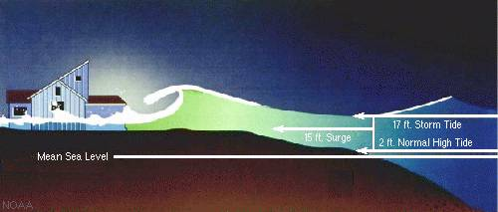
Figure 1- Storm Surge, Tide, and Wave Representation

The level of surge is also determined by the slope of the continental shelf as shown in figure 2. A shallow slope tends to produce a larger surge where a steeper continental shelf does not.


Figure 2 – Shallow (Left) and Steep (Right) Continental Shelf

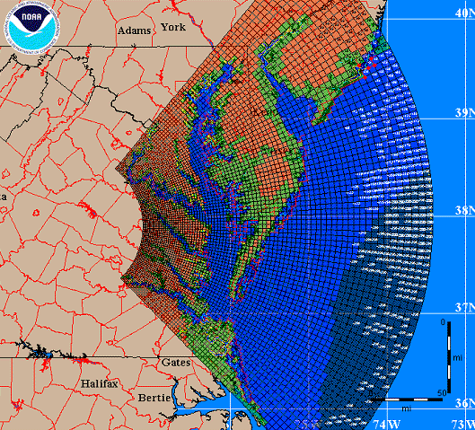

Figure 3 – SLOSH Display Program Map and Grid Example

SLOSH is a gridded based model where individual elements of the grid are used to calculate storm surge values along the coast and inland based on basin configuration – figure 3 and 6. The design contains barriers used in calculating water flow through each sub-grid element where water is allowed to completely flow: 1) through a barrier, 2) cuts in barriers, 3) one dimensional flow in rivers and streams, and 4) restricted due to trees and mangroves. The water depth is then calculated based on the elevation of the grid cell and the amount of water that is able to flow into that cell – see figure 4.

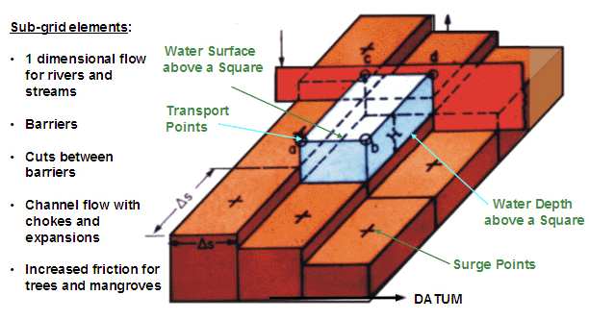

Figure 4 – Individual SLOSH Grid
The elevation for each grid cell is the average of the ground surface elevation found in a particular cell – see figure 5. This is represented by a number in the center of each cell and the water surface elevation is determined the same manner.

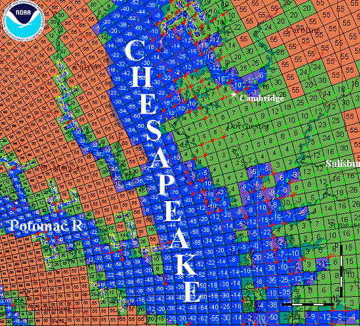
Figure 5 – SLOSH Model Grid Representing Land and Sea Elevation Averages

Operationally, SLOSH is used to forecast storm surge values which are incorporated into National Hurricane Center (NHC) forecast products. Moreover, the NHC also conducts simulation studies for evacuation planning used by emergency managers. Such studies are based on thousands of hypothetical hurricane tracks where the resulting water levels are categorized and stored by basin – for basin chart see figure 6. From these tracks, composite imagery is generated for each basin representing the Maximum Envelope of Water (MEOW). A MEOW is based on the highest surge values which include storm direction, forward speed, and simulated tide level at individual grid points for each storm category from the Saffir-Simpson Hurricane Scale. – Appendix A. In similar respect, Maximum of MEOWs, or MOMs, are composites generated from the maximum storm surge height for all hurricanes of a given category. MOMs also do not include forward speed, landfall direction, and land fall location.

For a more in-depth scientific understanding of SLOSH and storm surge readers are encouraged to reference:

- C.P.Jelesnianski, J.Chen, and W.A.Shaffer, 1992: SLOSH: Sea, Lake, and Overland Surges from Hurricanes, NOAA Technical Report NWS 48, April 1992, Silver Spring, Maryland.

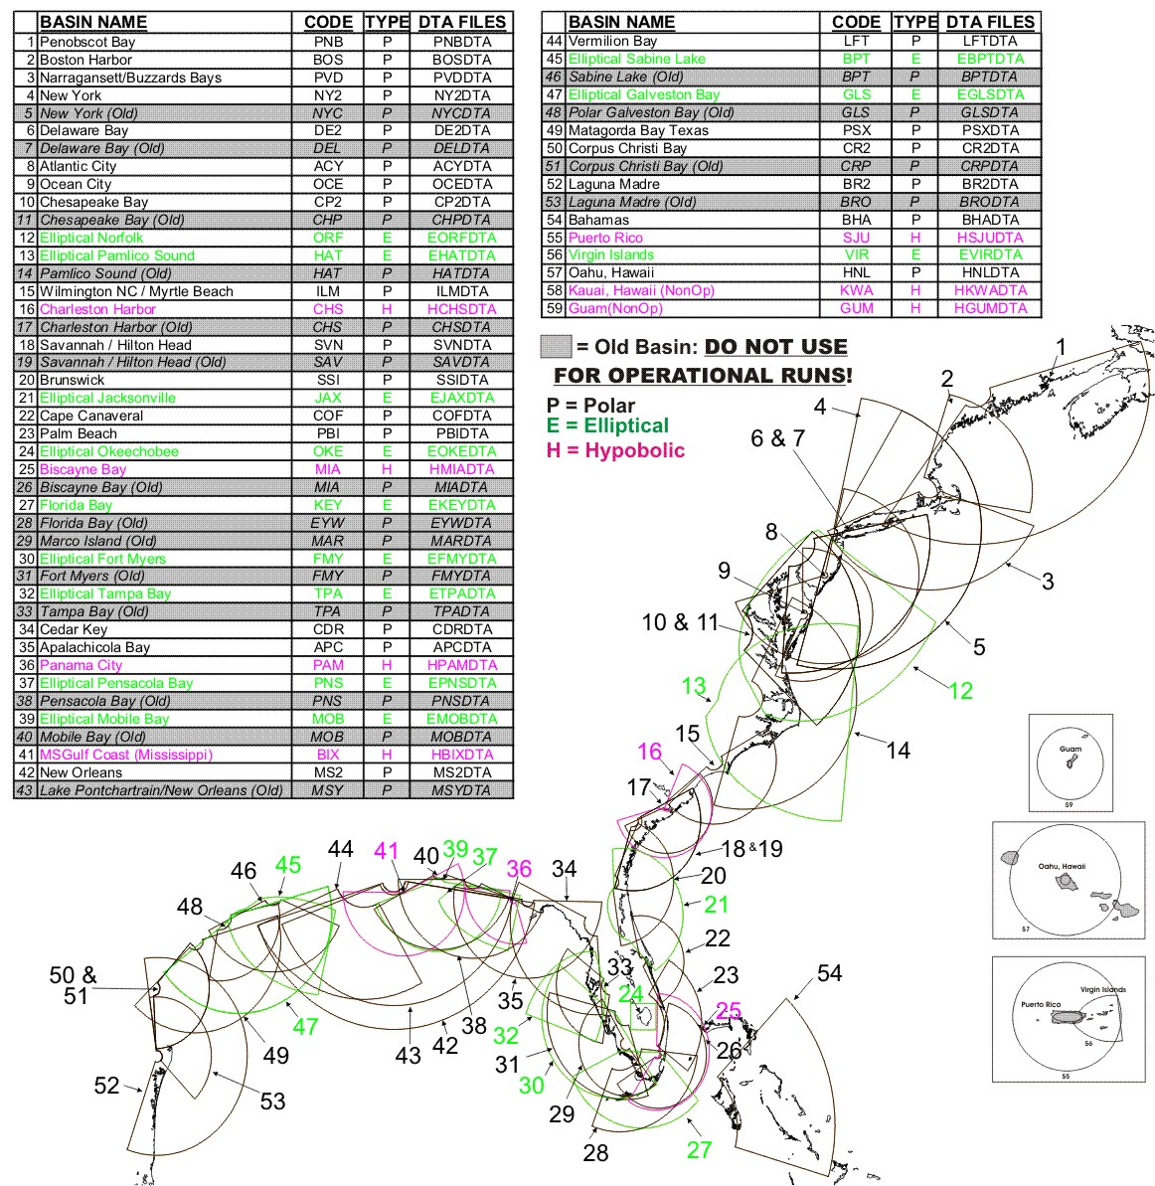
Figure 6 – SLOSH Basin Chart

2.0 SLOSH DEVELOPMENT ENVIRONMENT

This section describes in detail how to configure, execute, and utilize the SLOSH command line (DOS) based forecast model. The subsequent chapters provide the needed detail, however as a quick summary there are the major components required by the development environment.

Requirement | Solution | More Info
Operating System | Windows XP | www.Microsoft.com
Compilers (C/Fortran) | MinGW | www.MinGW.org
Development Environment | Cygwin | www.cygwin.com
Figure 7 – System Requirements Chart

2.1 System Requirements

Recommended system requirements are as follows, however no endorsement of specific software is expressed or implied:
- Microsoft Windows XP Professional or Home Edition
- Intel Pentium processor
- 256MB of RAM
- 4GB of available hard-disk space
- Microsoft Internet Explorer 5.5 (or higher), Netscape 7.1 (or 8.0), Firefox 1.0, or Mozilla 1.7
2.2 Building the Development Environment

The first step in building the SLOSH development environment is to create a SLOSH directory and unbundled the provided SLOSH software. The recommended location, name, and instructions are:

1) Open Windows Explorer interface
► Right click on start from the XP taskbar, then left click on Explore

2) Create SLOSH folder on root (EG, C) drive:
► In the Explorer interface left click on the root drive ( C: ) in the left navigation window
► In the right pain of Windows Explorer right click on background of the right window pane to display dropdown menu
► In the displayed dropdown menu select: New->Folder
► Name folder: slosh

3) Copy SLOSH_FOIAv1.0.zip bundle into created SLOSH directory

4) Unbundle SLOSH_FOIAv1.0.zip using your favorite unzip software.
Note: Most systems come with software to bundle or unbundle .zip files. However, if software is needed, a popular application is winzip and can be downloaded at http://www.winzip.com

2.2.1 Installing Cygwin Environment

The latest instructions to install the Cygwin development environment can be found at http://www.cygwin.com or http://cygwin.com/cygwin-ug-net/setup-net.html. At the time of creating this document the Cygwin install instructions are as follows:

Internet Setup
To install the Cygwin net release, go to http://cygwin.com/ and click on "Install Cygwin Now!". This will download a GUI installer called setup.exe which can be run to download a complete cygwin installation via the internet. Follow the instructions on each screen to install Cygwin.
The setup.exe installer is designed to be easy for new users to understand while remaining flexible for the experienced. The volunteer development team is constantly working on setup.exe; before requesting a new feature, check the wishlist in the CVS README . It may already be present in the CVS version!
Since the default value for each option is the logical choice for most installations, you can get a working minimal Cygwin environment installed by simply clicking the Next button at each page. The only exception to this is choosing a Cygwin mirror, which you can choose by experimenting with those listed at http://cygwin.com/mirrors.html . For more details about each of page of the setup.exe installation, read on below. Please note that this guide assumes that you have a basic understanding of Unix (or a Unix-like OS). If you are new to Unix, you will also want to make use of other resources.

Download Source
Cygwin uses packages to manage installing various software. When the default Install from Internet option is chosen, setup.exe creates a local directory to store the packages before actually installing the contents. Download from Internet performs only the first part (storing the packages locally), while Install from Local Directory performs only the second (installing the contents of the packages).
The Download from Internet option is mainly for creating a base Cygwin package tree on one computer for installation on several machines with Install from Local Directory; copy the entire local package tree to another machine with the directory tree intact. For example, you might create a C:\cache\ directory and place setup.exe in it. Run setup.exe to Install from Internet or Download from Internet, then copy the whole C:\cache\ to each machine and instead choose Install from Local Directory. Unfortunately setup.exe does not yet support unattended installs.
Though this provides some basic mirroring functionality, if you are managing a wide Cygwin installation, to keep up to date we recommend using a mirroring tool such as wget. A helpful user on the Cygwin mailing list created a simple demonstration script to accomplish this; search the list for mkcygwget for ideas.

Selecting an Install Directory
The Root Directory for Cygwin (default C:\cygwin) will become / within your Cygwin installation. You must have write access to the parent directory, and any ACLs on the parent directory will determine access to installed files.
The Install For options of All Users or Just Me should always be left on the default All Users, unless you do not have write access to HKEY_LOCAL_MACHINE in the registry or the All Users Start Menu. This is true even if you are the only user planning to use Cygwin on the machine. Selecting Just Me will cause problems for programs such as crond and sshd. If you do not have the necessary permissions, but still want to use these programs, consult the Cygwin mailing list archives about others' experiences.
The Default Text File Type should be left on Unix (that is, \n) unless you have a very good reason to switch it to DOS (that is, \r\n).

Local Package Directory
The Local Package Directory is the cache where setup.exe stores the packages before they are installed. The cache must not be the same folder as the Cygwin root. Within the cache, a separate directory is created for each Cygwin mirror, which allows setup.exe to use multiple mirrors and custom packages. After installing Cygwin, the cache is no longer necessary, but you may want to retain the packages as backups, for installing Cygwin to another system, or in case you need to reinstall a package.

Connection Method
The Direct Connection method of downloading will directly download the packages, while the IE5 method will leverage your IE5 cache for performance. If your organization uses a proxy server or auto-configuration scripts, the IE5 method also uses these settings. If you have a proxy server, you can manually type it into the Use Proxy section. Unfortunately, setup.exe does not currently support password authorization for proxy servers.

Choosing Mirrors
Since there is no way of knowing from where you will be downloading Cygwin, you need to choose at least one mirror site. Cygwin mirrors are geographically distributed around the world; check the list at http://cygwin.com/mirrors.html to find one near you. You can select multiple mirrors by holding down CTRL and clicking on each one. If you have the URL of an unlisted mirror (for example, if your organization has an internal Cygwin mirror) you can add it.

Choosing Packages
For each selected mirror site, setup.exe downloads a small text file called setup.bz2 that contains a list of packages available from that site along with some basic information about each package which setup.exe parses and uses to create the chooser window. For details about the format of this file, see the setup.exe homepage.
The chooser is the most complex part of setup.exe. Packages are grouped into categories, and one package may belong to multiple categories (assigned by the volunteer package maintainer). Each package can be found under any of those categories in the heirarchial chooser view. By default, setup.exe will install only the packages in the Base category and their dependencies, resulting in a minimal Cygwin installation. However, this will not include many commonly used tools such as gcc (which you will find in the Devel category). Since setup.exe automatically selects dependencies, be careful not to unselect any required packages. In particular, everything in the Base category is required.
You can change setup.exe's view style, which is helpful if you know the name of a package you want to install but not which category it is in. Click on the View button and it will rotate between Category (the default), Full (all packages), and Partial (only packages to be upgraded). If you are familiar with Unix, you will probably want to at least glance through the Full listing for your favorite tools.
Once you have an existing Cygwin installation, the setup.exe chooser is also used to manage your Cygwin installation. Information on installed packages is kept in the /etc/setup/ directory of your Cygwin installation; if setup.exe cannot find this directory it will act just like you had no Cygwin installation. If setup.exe finds a newer version of an installed package available, it will automatically mark it to be upgraded. To Uninstall, Reinstall, or get the Source for an existing package, click on Keep to toggle it. Also, to avoid the need to reboot after upgrading, make sure to close all Cygwin windows and stop all Cygwin processes before setup.exe begins to install the upgraded package.
The final feature of the setup.exe chooser is for Previous and Experimental packages. By default the chooser shows only the current version of each package, though mirrors have at least one previous version and occasionally there is a testing or beta version of a package available. To see these package, click on the Prev or Exp radio button. Be warned, however, that the next time you run setup.exe it will try to replace old or experimental versions with the current stable version.

Download and Installation Progress
First, setup.exe will download all selected packages to the local directory chosen earlier. Before installing, setup.exe performs a checksum on each package. If the local directory is a slow medium (such as a network drive) this can take a long time. During the download and installation, setup.exe show progress bars for the current task and total remaining disk space.

Icons
You may choose to install shortcuts on the Desktop and/or Start Menu to start a bash shell. If you prefer to use a different shell or the native Windows version of rxvt, you can use these shortcuts as a guide to creating your own.

Post-Install Scripts
Last of all, setup.exe will run any post-install scripts to finish correctly setting up installed packages. Since each script is run separately, several windows may pop up. If you are interested in what is being done, see the Cygwin Package Contributor's Guide at http://cygwin.com/setup.html When the last post-install script is completed, setup.exe will display a box announcing the completion. A few packages, such as the OpenSSH server, require some manual site-specific configuration. Relevant documentation can be found in the /usr/doc/Cygwin/ or /usr/share/doc/Cygwin/ directory.

3.0 SLOSH MODEL SOFTWARE ARCHITECTURE

3.1 Model Context Diagram

The context diagrams presented in this section were developed from existing slosh software, associated by function calls and returns.

    - High Level Context Diagram

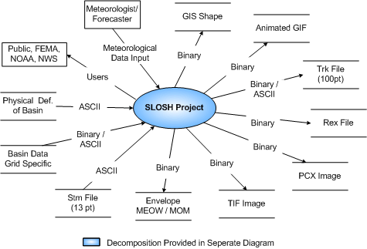
Figure 8 – High Level SLOSH Context Diagram

3.1.2 First Decomposition

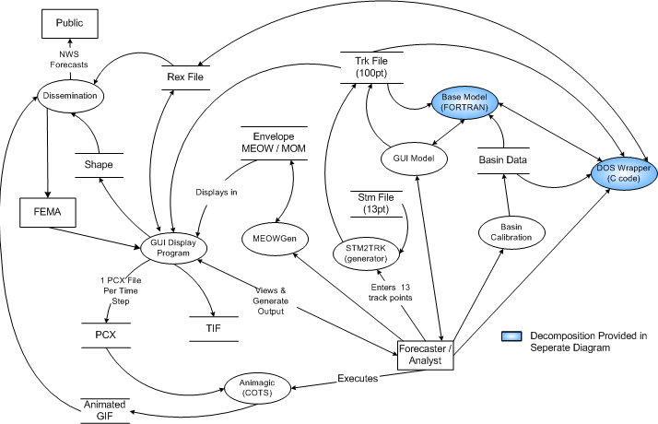

Figure 9 – First Decomposition SLOSH Context Diagram

    - Second Decomposition – Base Model & DOS Wrapper

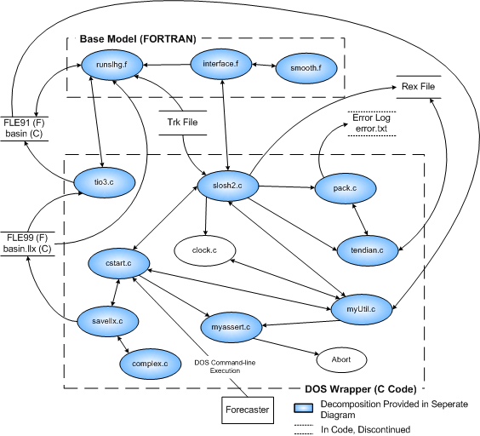

Figure 10 – Second Decomposition SLOSH Context Diagram

3.1.4 Third Decomposition – slosh.c

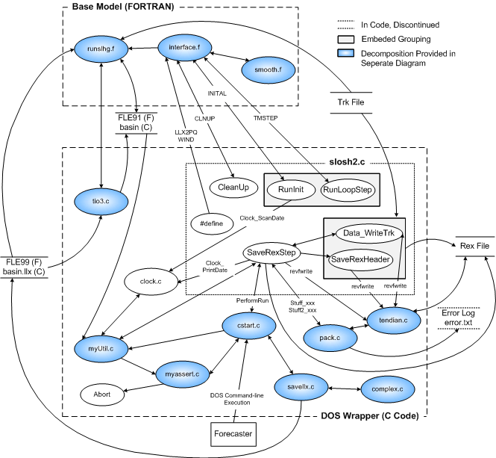

Figure 11 – Third Decomposition SLOSH Context Diagram

3.1.5 Fourth Decomposition – tendian.c, pack.c

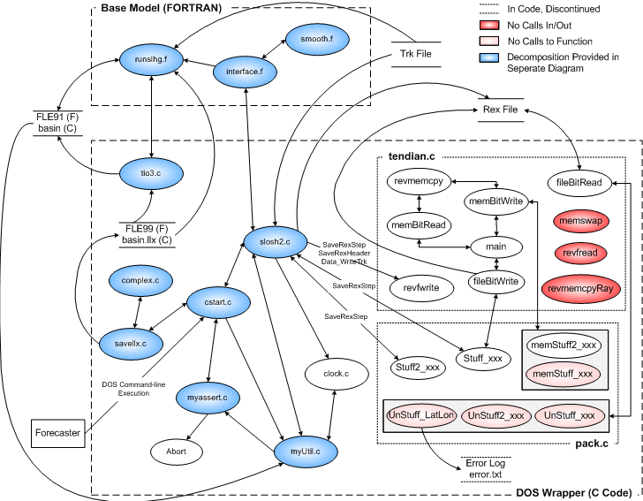

Figure 12 – Fourth Decomposition SLOSH Context Diagram

3.1.6 Fifth Decomposition – complex, savellx.c

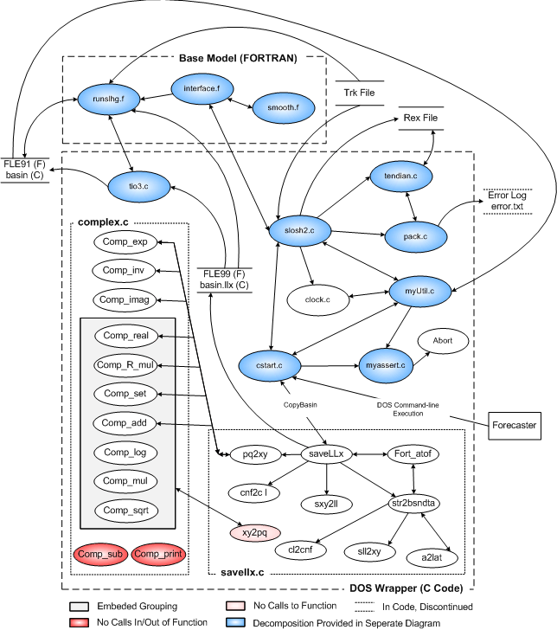

Figure 13 – Fifth Decomposition SLOSH Context Diagram

3.1.7 Sixth Decomposition – myUtil.c, myassert.c

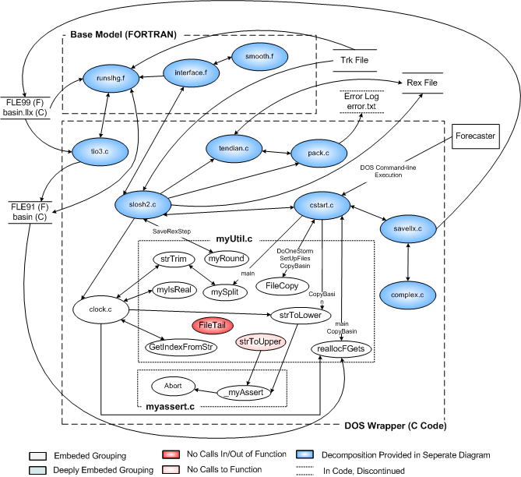

Figure 14 – Sixth Decomposition SLOSH Context Diagram

3.1.8 Seventh Decomposition – tio3.c

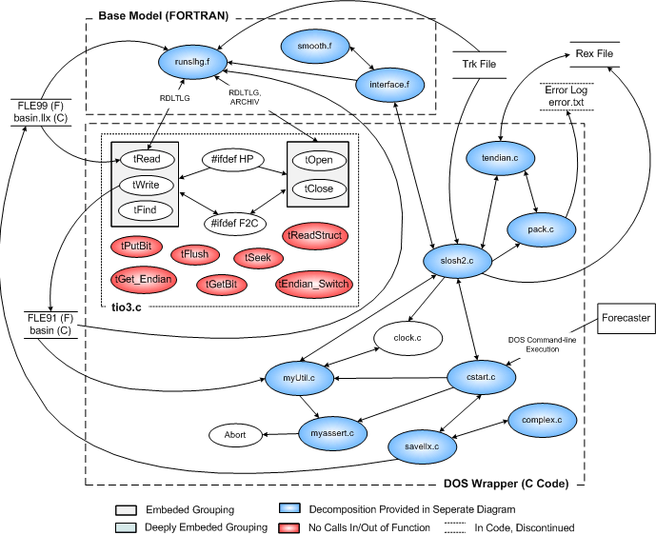

Figure 15 – Seventh Decomposition SLOSH Context Diagram

3.1.9 Eighth Decomposition – cstart.c

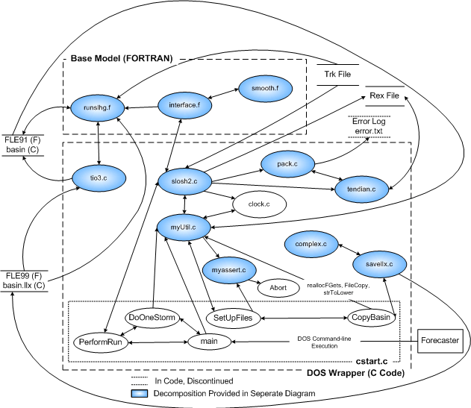

Figure 16 – Eighth Decomposition SLOSH Context Diagram

3.1.10 Ninth Decomposition – runslhg.f, interface.f, smooth.f
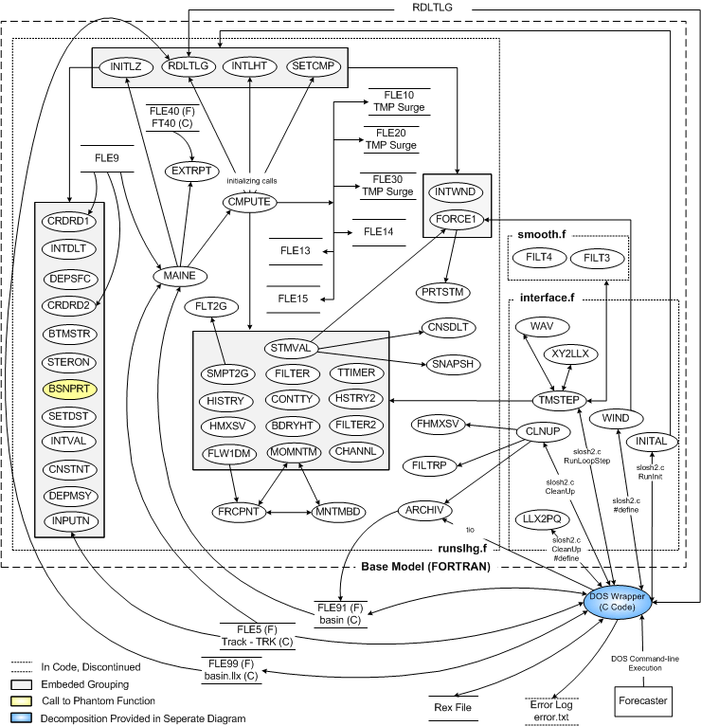

Figure 17 – Ninth Decomposition SLOSH Context Diagram

3.2 Subroutine Call Diagram

3.2.1 First Decomposition – DOS Wrapper (C)

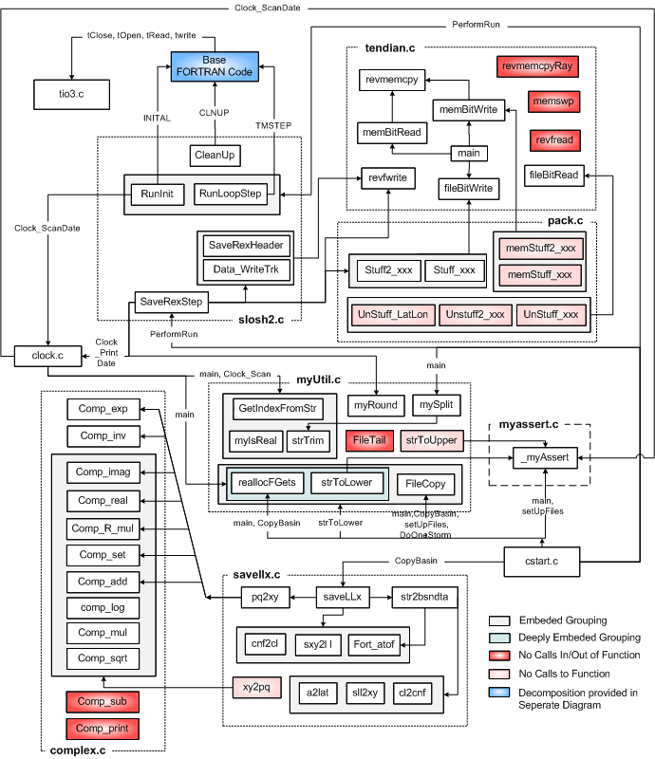
Figure 18 – First Decomposition SLOSH Subroutine Diagram
3.2.2 Second Decomposition – Base Model (FORTRAN)

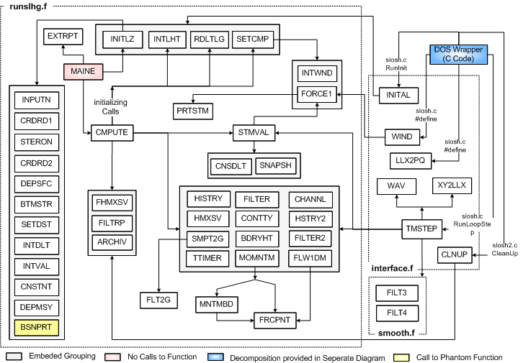
Figure 19 – Second Decomposition SLOSH Subroutine Diagram

3.3 Base Model Source Tree

The base SLOSH model is Fortran 77 with file tags ending in .f and associated include files ending in .for. There is C based wrapper software used in the command line execution of the SLOSH model, however this section focuses only on the base model. Below is a brief summary of the source files that make up the model, followed by detailed subroutine breakdown in the subsequent sections.

- runslhg.f : Main SLOSH model
- smooth.f : FILTER subroutine pulled from “runslhg.f” to remove dependency from common block element HB, instead passed variable HHB
- interface.f : FORTRAN code providing link between model and C code used to execute model.
- parmmsy.for : FORTRAN header file containing variable definitions used in SLOSH model
- parm.for : FORTRAN header file containing variable definitions used in SLOSH model
3.3.1 Source file “runslhg.f” Sub-function Breakdown

runslhg.f: Author
Jelesnianski/Chen, July 1998 TDL/MDL

Source
FORTRAN 77

Purpose
Data Initialization / Global Variables

Comments
This member resides in the root overlay

Includes
parm.for

Variables Passed In
None

Local Variables
IP(4) JP(4) : Shift subscripts to 4 adjacent momentum points
IH(4) JH(4) : Shift subscripts to 4 adjacent surge points about a momentum point
IIH(4) JJH(4) : Shift subscripts to 4 adjacent surge points about a surge point.
IOPERL : 2 as default in operational mode
MAPIN(HR) : Specifies the print hour, before and after the nearest approach of storm, for snapshot output
G : Gravity
C7 : Slip coefficient
C17 : Air density
C19 : Friction coefficient
C25 : Eddy viscosity
MONTH(12) : Accumulated days at monthly increments (-1, 30, 58, 89, 119 …)

Return
None

runslhg.f: Subroutines

MAINE: Author
Jelesnianski/Chen, July 1992 TDL/MDL

Purpose
This is the main program, also called root overlay which is calls 4 overlays as shown, member name is main.

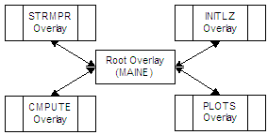

Figure 20 – Base SLOSH Modules/Overlays

Comments
1) This code works in conjunction with VSGL0T21.FOR to generate load module for evacuation study. Let (MAIN, PLOTS, CMPUTE) supersede those in VSGL0T21.FOR.

2) Major Changes include 1) Surge histories at 10N grid points, 2) Input format for hourly press, and 3) radius archive max of surges & max winds.

3) If no archive points are given (KHSPT=0), NOARCH takes the default value, X. In a non-archived run default 10 points and time histories are in 10-15 minute intervals.

4) If archive envelope is desired use blank data for Archive Points. This will then overwrite the default value of X NOARCH to NULL, telling the software ARCHIEV is active.

Data Set Use
None

Includes
parm.for

Variables Passed In
None

Local Variables
NA

Subroutines Calling Function (File:Subroutine):
None

Subroutine Calls (File:Subroutines)
runslhg.f: NITLZ, EXTRP, CMPUTE

Return
None

EXTRPT: Author
Unknown

Purpose
Unknown

Comments
None

Data Set Use
None

Variables Passed In
FILE40 : Unknown

Local Variables
TBD

Subroutines Calling Function (File:Subroutine):
runslhg.f: MAINE

Subroutine Calls (File:Subroutines)
None

Return
None

INTDLT: Author
Jelesnianski, August 1980 TDL/MDL

Purpose
Subroutine ascertains time step DELT for computations, initializes storm at subscript IBGNT and sets INEND for ending computations after nearest storm approach.

Comments
None

Data Set Use
None

Variables Passed In
None

Local Variables
DELT : Time interval for explicit finite differencing
DLTB : The smallest reduction of DELT in model run
RLNGTH : Distance of storm from nearest approach
JHR : Subscript for nearest approach to basin center
P(100) : Hourly pressure drops
X(100) Y(100): Hourly components for storm position
R(100) : Hourly storm sizes
XMOUTH : X-distance from pole to basin center
YMOUTH : Y-distance (usually equal to 0)
IBGNT : Tabulated subscript for storm initialization
ITEND : Tabulated subscript for storm termination IBGS : Number of hours for computations before nearest storm approach
ITMS : Number of remaining hours, after nearest approach
DLTINS(3) : Time steps for 3 categories of storms from data

Subroutines Calling Function (File:Subroutine):
runslhg.f: INITLZ

Subroutine Calls (File:Subroutines)
None

Return
None

INTVAL: Author
Jelesnianski, August 1980 TDL/MDL

Purpose
This subroutine sets initial storm parameters; some fixed constants for initialization and output times

Comments
1) Use only time steps divisible by 600 s(10 min), or 900 s(15min)

Data Set Use
None

Variables Passed In
None

Local Variables
DELT : Time interval for explicit finite differencing
NDLTHR : Number of time steps in 1 hour
NDLTH2 : Number of time steps in ½ hour
IPRTSV : Time print of historical surges (10 points)
IBGNT : Subscript for storm initialization
SP(100) : Hourly forward storm speeds
DIR(100) : Hourly Storm azimuths
R(100) : Hourly storm sizes
IBGS : Number of hours for computations before nearest approach
ITMS : Number of hours for computations after nearest approach
MHALT : Number of time steps for total computations
ITEND : Tabulated subscript for storm termination
IC19 : Growth time to mature storm
MAPIN(10) : Printout time for envelope snapshot
IOPERL : Sets operational mode if value is “2”
ISTMAP : At this time, print a snapshot of surges
NUMBER : Closet hour to nearest approach

Subroutines Calling Function (File:Subroutine):
runslhg.f: INITLZ

Subroutine Calls (File:Subroutines)
None

Return
None

CNSTNT: Author
Jelesnianski, August 1980 TDL/MDL

Purpose
This Subroutine fixes some program constants

Comments
None

Data Set Use
None

Variables Passed In
None

Local Variables
X1(50) : array of constants
DELTA : Time increment for finite differencing, set in subroutine INTDLT
COR : Coriolis (1/sec), set in subroutine INTVAL
IMXB JMXB : Number of grid points along a ray/circle, in CRDRD1
IMXB1 : IMXB less 1,
JMXB1 : JMXB less 1
IMXB2 : IMXB less 2,
JMXB2 : JMXB less 2
DEGREE : Angle between two rays, red in CRDRRD1
DELA : Value of DEGREE in radians RAD : Radian measure
X1B(10) : Array of constants
G : Gravity = 32.2 FT/SEC-2
AMAN->AGB13: Fixed constant for subroutine CHANNL

Subroutines Calling Function (File:Subroutine):
runslhg.h: INITLZ

Subroutine Calls (File:Subroutines)
None

Return
None

BTMSTR: Author
Jelesnianski, August 1980 TDL/MDL

Purpose
Computes bottom stress coefficients at 1 foot intervals, from 1 to 300 feet. Equations are defined in: Jelesnianski, “Numerical Computations of Storm Surges with Bottom Stress”, monthly weather review, VOL 95, NO. 11 Nov 1967, pp 740-756

Comments
This member BTMSTR resides in overlay. Program rewritten (1980) replacing SINH by SIN and COSH by COS.

Data Set Use
None

Variables Passed In
ZLATO : Latitude in degrees

Local Variables
COR : Coriolis parameter
E : Ekman parameter, DEPTH*SQRT(COR/2*C25)
C25 : Eddy viscosity coefficient, .25 FT**2/SEC
C7 : Slip coefficient, .006 FT/SEC
AR(300) : Bottom friction coefficients for coriolis
AI(300) : Bottom friction coefficients for coriolis terms
BR(300) : Bottom friction coefficients for surface gradient terms
BI(300) : Bottom friction coefficients for surface gradient terms
CR(300) : Bottom friction coefficients for surface stress terms
CI(300) : Bottom friction coefficients for surface stress terms

Subroutines Calling Function (File:Subroutine):
runslhg.f: INITLZ

Subroutine Calls (File:Subroutines)
None

Return
None

SETCMP: Author
Jelesnianski, August 1980 TDL/MDL

Purpose
Sets the first hourly meteorological and track data for computations and also sets changes in data for the first incremental time step.

Comments
This subroutine resides in overlay CMPUTE.

Data Set Use
None

Variables Passed In
None

Local Variables
INTIME : Number of time steps; initialized to zero.
NDLTHR : Number of time steps in one hour
HHRAD : Accumulative time steps on the hour
IBGNT : Tabulated subscript for storm initialization
PT(100) : Hourly pressure HROPS
PDROP : Dummy value for 1st hour pressure drop
YDELP : Pressure drop at present time step
ZDELP : Pressure drop at present time step
PN : Pressure drop at present time
PNN : Pressure drop at previous time
R(100) : Hourly storm sizes
YC24 : Storm size at present time step
C24 : Storm size at previous time step
C21 : Dummy value for speed of storm 1st hour C21 initially set TVAL
X12(7) : Speed of storm in ft/sec, 1st hour
X12(20) : Direction of storm motion for 1st hour, set in INTVAL
X12(21) : Direction of storm motion for 1st hour, set in INTVAL
X12(9) : Components of forward speed, 1st hour
X12(10) : Components of forward speed, 1st hour
DELTA : Unit time step
X12(11) : Components of storm motion unit time step, 1st hour
X12(12 : Components of storm motion unit time step, 1st hour
C22 : Direction of storm motion, 1st hour, set in INTVAL
X12(17) : Friction coefficient (3x10-6) times square of storm size
X12(23) : Components of wind distortion (lake winds), 1st hour
X12(24) : Components of wind distortion (lake winds), 1st hour
PTENCY : Change in pressure drop for 1st hour
RTENCY : Change in storm size for 1st hour
ITMADV : Counter for hourly time, 1st hour
AX AY : Components of total storm traverse with time
W1218 : Twice the maximum winds (lake or ocean)
C(800) S(800) : COS/SIN of inflow angles, mile intervals from storm center (sea winds), computed in FORCE1
CW(800) : COS/SIN inflow angle (lake winds), from FORCE1
SW(800) : COS/SIN inflow angle (lake winds), from FORCE1

Subroutines Calling Function (File:Subroutine):
runslhg.f: CMPUTE
interfae.f: INITAL

Subroutine Calls (File:Subroutines)
runslhg.f: INTWND, FORCE1

Return
None

STMVAL: Author:
Jelesnianski, August 1980 TDL/MDL

Purpose:
Tests for incremental hours and sets hourly track and meteorology values. Also tests for 1-MB change in pressure drop, or 1 mile change in storm size for each advance in time. Preparatory values are set for later advancing in time.

Comments
Subroutine resides in overlay CMPUTE.

Data Set Use
None

Variables Passed In
None

Local Variables
ITIME : Cumulate time counter
N1 : Time steps at hourly intervals, set in SETCMP
NDLTHR : Number of time steps in one hour
ITMADV : Counter for hourly time set in SETCMP
C22 : Dummy value for hourly direction of storm motion
DIR(100) : Hourly direction of storm movement
X12(20) : Directions of storm motion, hourly value
X12(21) : Directions of storm motion, hourly value
SP(100) : Hourly forward speed of storm
C21 : Dummy value for storm’s hourly forward speed
X12(7) : Speed of storm in ft/sec, hourly values
X12(11) : Components of forward storm speed
X12(10) : Components of forward storm speed
DELTA : Unit time step
X12(11) : Storm movement in X/Y-DIR for unit time step
X12(12) : Storm movement in X/Y-DIR for unit time step
X12(17) : Friction coefficient (3x10-6) Ties square of Storm Size
PT(100) : Hourly pressure HROPS
R(100) : Hourly storm sizes
PTENCY : Change in pressure drop for one hour
RTENCY : Change in storm size for one hour
YC24 : Storm size for present time
YDELP : Pressure drop for present time
AX AY : Components of total storm traverse with time
ZDELP : Pressure drop at previous MB step
PN : Integer value of pressure drop at present time
PNN : Integer value of pressure drop at previous time
WMAX(2) : Max wind speed over inland water bodies or ocean
IGBNT : Subscript for storm initialization
JHR : Subscript for nearest storm approach
ZC24 : Storm size at previous mile step
VMAX : Dummy value for maximum winds
W1218(2) : Twice the maximum wind (lake or ocean)
C(800) S(800) : Cosine-sine of inflow angle, mile intervals from storm center (sea winds)
CW(800) : Cosine-sine of inflow angle (lake winds)
SW(800) : Cosine-sine of inflow angle (lake winds)
ISTMAP : Printout time for snapshots, set in BLCKDT
MAPIN(10) : Printout time for snapshots, set in BLCKDT
Number : Subscript for printout of above set in INTVAL
IPRHR : 1, when on the hour; 2, when half hour in between; 3, otherwise.
IPRTSV : Time to save historical surges, 10 points, set INTVAL.
IPRTAD : Update time of IPRTSV, set in INTVAL
IOPERL : 2 if in operational mode

Subroutines Calling Function (File:Subroutine):
runslhg.f: CMPUTE
interface.f: TMSTEP

Subroutine Calls (File:Subroutines)
runslhg.f: SNAPSH, CNSDLT, FORCE1

Return
None

CNSDLT: Author
J Chen, August 1982 TDL/MDL

Purpose
Fixes coefficients depending on time step for variations in the course of computation

Comments
None

Data Set Use
None

Variables Passed In
None

Local Variables
X1(50) : Array of constants
DELT : Time increment for finite differencing, set in INTDLT
COR : Coriolis (1/sec), Set in INTVAL
Degree : Angle between two rays, read in CRDRD1
DELA : Value of DEGREE in radians
RAD : Radian measure
X1B(10) : Stored array of constants
G : Gravity = 32.2 ft/sec-2

Subroutines Calling Function (File:Subroutine):
runslhg.f: STMVAL

Subroutine Calls (File:Subroutines)
None

Return
None

FORCE1: Author
Jelesnianski, September 1980 TDL/MDL

Purpose
Computes at mile interfals from the storm center, for 800 miles
- SINE of the inflow angle
- COSINE of the inflow angle
- Surface pressure
- Static height

Comments
Subroutine resides in overlay CMPUTE.

Data Set Use
None

Variables Passed In
PDROP : Input pressure drop
RMAX : Dummy value for storm size
VMAX : Dummy value for maximum winds
ALTO : Latitude of basin mouth point
NCATG : TBD
IPRT : 1 to printout storm profile, otherwise = 0

Local Variables
XKS XKN : Wind friction values
CFRIC : Friction faction, = 1. In ocean, =4*SQRT(22/RMAX)
JSET : Distance beyond which approx by constant inflow angles
COR : Coriolis (1/sec)
C(800) S(800) : COS/SIN of inflow angle, mile intervals
DELP(800) : Static heights, mile intervals
P(800) : Pressure gradient, mile intervals
RHOA : Air density (MB HR**2 MILE**-2)
RHOW : Water density (MB HR**2 FT**-1 MILE**-1)
RHOWG : Water density*gravity (MB ft**-1)
PADD : Pressure from a radius to infinity
PINFT : Pressure drop from iteration

Subroutines Calling Function (File:Subroutine):
runslhg.f: SETCMP, STMVAL
interface.f: WIND

Subroutine Calls (File:Subroutines)
runslhg.f: PRTSTM

Return
None

INTWND: Author
Jelesnianski, August 1980 TDL/MDL

Purpose
Sets up an initial guess for the max wind of a stationary storm using initial input storm parameters. The initial guess is an entry value to subroutine FORCE1 for iteration to exact maximum winds

Comments
1) This subroutine is in overlay STRMPR
2) For a given pressure drop P(100), the max wind varies almost linearly with storm size R(100)

The slope and intercept of the pressure line varies weakly with latitude or coriolis. The given WM, WB are for latitude 30 degrees; The entry pressure at time IBGNT is doctored to correct for latitude other than 30 degrees.

Data Set Use
None

Variables Passed In
PDROP : Pressure drop for 1st hour
RMAX : Radius of maximum wind
ALTO : Latitude of basin center
VMAX : Maximum wind

Local Variables
KPRES : Doctored pressure drop for lat other than 30 degrees
WM(150) : Array for slope of linear slope formula
WB(150) : Array for intercept of linear slope formula

Subroutines Calling Function (File:Subroutine):
runslhg.f: SETCMP
interface.f: WIND

Subroutine Calls (File:Subroutines)
None

Return
None

PRTSTM: Author
Unknown

Purpose
Prints out, at the time of nearest approach, the two storm systems for lake and ocean. The storm values are incremented at regular intervals from the storm center.

Comments
Subroutine resides in overlay CMPUTE

Data Set Use
None

Variables Passed In
PADD : Pressure drop from a radius to infinity
PINFT : Pressure drop from iteration
VMAX : Dummy value for maximum winds
RMAX : Radius of maximum wind
ALTO : Latitude of basin center
NCATG : 1 for lake winds, =2 for ocean

Local Variables
P(800) : pressure gradient
S(800) : SINE of inflow angle
DELP(800) : Static heights from storm center
RHOWG : Water density*gravity (MB SEC**2 FT**-1 MILE**-1)
PHI : Inflow angle
IBEG(3) : Begin loop
IEND(3) : End loop
IN(3) : Increment of do loop

Subroutines Calling Function (File:Subroutine):
runslhg.f: FORCE1

Subroutine Calls (File:Subroutines)
None

Return
None

CRDRD1: Author
Jye Chen, May 1990 TDL/MDL

Purpose
Reads in basin projection data, as input data to the SLOSH program. Each basin data is on a separate file, and called in by name.

Comments
None

Data Set Use
FT09F001

Variables Passed In
None

Local Variables
STA : Alphameric name of a basin (10 letters)
EBSN : “$” Indicates type I elliptic coordinates
“+” Indicates type II elliptic coordinates
otherwise polar coordinates
DOLLAR : “$” used for island, otherwise for regular basin
AZMTH : Slant of X-Axis from north
ALTO ALNO : Latitude/Longitude of basin center or origin
DEGREE : Angle between two rays of a polar grid
IRB IRE : Total grid points in -+P direction from tangent PT
NDB NDE : Total grid points in -+Q direction from tangent PT
XMOUTH : X-Coordinate from tangent point to (X,Y)=(P,Q)=(0,
YMOUTH : Y-Coordinate from tangent point to (X,Y)=P,Q)=(0,
PHI : Slant from X-AXIT to N/S-AXIS
IMXB JMXB : Total grid spacing in P/Q directions
IMXB1 : IMXB less1
JMXB1 : JMXB less 1

Subroutines Calling Function (File:Subroutine):
runslhg.f: INITLZ

Subroutine Calls (File:Subroutines)
None

Return
None

TTIMER: Author
Jelesnianski/Chen, July 1989 TDL/MDL

Purpose
Keeps track of time and accumulates time steps. Function also updates the storm position at each time step on a Cartesian grid and computes growth factor to update a storm to maturity.

Comments
This subroutine resides in the root overlay

Data Set Use
None

Variables Passed In
None

Local Variables
IC19 : Storm growth time to maturity, set in INTVAL
ITIME : Increases by one for each time step
BT : Storm growth coefficient, 0<BT<=1
Subroutines Calling Function (File:Subroutine):
runslhg.f: CMPUTE,

Subroutine Calls (File:Subroutines)
None

Return
None

CMPUTE: Author
Jelesnianski, September 1980 MDL/TDL

Updated: Sung Kim, January 1992

To save data, press “P”
To pause run, press “S”
Saved data: integer*2 of 1/10th of surge height
10000th power of transport normalized by depth

Purpose
This 2nd overlay CMPUTE uses subroutine CMPUTE as a direct calling sequence for 12 subroutines. The purpose of the overlay is to compute surge heights using algorithms for partial differential equations of motion. Surges are stored for later print out.

Comments
This subroutine resides in overlay CMPUTE.

Data Set Use
None

Variables Passed In
None

Local Variables
ITIME : Cumulative time counter
MHALT : Halt computations at this time step
NPSS : Number of channels
NCUT : Number of cuts along barriers
NSQRWC : Number of squares for 1D flow plus flow cuts
NDLTHR : Number of time steps in one hour
IPRTSV : Time to save historical surges, 10 points, set INTVAL
IPRTAD : Update time of IPRTSV, set in INTVAL

Subroutines Calling Function (File:Subroutine):
runslhg.f: MAINE

Subroutine Calls (File:Subroutines)
runslhg.f: SETCMP, INTLHT, RDLTLG, TIMER, CONTTY, SMPT2G, BDRYHT, FLW1DM, HMXSV, HISTRY, HISTRY2, FLTER2, FILTER, MOMNTM, STMVAL FILTRP, FHMXSV, ARCHIV

Return
None

INITLZ: Author
Jelesnianski, September 1980 MDL/TDL

Purpose
This second overlay INITLZ uses subroutine INITLZ as a calling sequence for 5 subroutines. The purpose of the overlay is to fix some program constants, some polar grid constants; to set bathy/topo and barrier heights, and to initialize a timing sequence.

Comments
This subroutine resides in overlay INITLZ

Data Set Use
None

Variables Passed In
None

Local Variables
ALTO(DEG) : Latitude of basin center or origin

Subroutines Calling Function (File:Subroutine):
runslhg.f: MAINE
interface.f: INITAL

Subroutine Calls (File:Subroutines)
runslhg.f: INPUTN, CRDRD1, STERON, CRDRD2, DEPMSY, DEPSFC, BSNPRT, BTMSTR, SETDST, INTDLT, INTVAL, CNSTNT

Return
None

INPUTN: Author
Unknown

Purpose
Unknown

Comments
None

Data Set Use
None

Variables Passed In
None

Local Variables
None

Subroutines Calling Function (File:Subroutine):
runslhg.f: INITLZ

Subroutine Calls (File:Subroutines)
None

Return
None

STERON: Author
Jelesnianski/Chen, October 1989 MDL/TDL

Purpose
This subroutine changes hourly storm track positions (latitude and longitude) to positions on (X,Y) plane and records hourly speeds and directions in (X,Y) plane.

Comments
None

Data Set Use
None

Variables Passed In
None

Local Variables
XLAT() YLONG() : LAT/LON of hourly storm positions
X() Y() : Components of hourly storm positions
ALTO ALNO : LAT/LON of basin origin
PHI : Slant from N/S axis to Y axis; EG; “AZMTH+270”
ERAD : Radius of earth (Spherical)
FTPNM : No of fee in a nautical mile
XMOUTH YMOUTH: Mouth coordinates in X-Y plane

Subroutines Calling Function (File:Subroutine):
runslhg.f: INITLZ

Subroutine Calls (File:Subroutines)
None

Return
None

SETDST: Author
Jelesnianski, September 1980 MDL/TDL

Purpose
This subroutine computes size specifics of the polar grid, as well as the orientation of the (P,Q) polar system versus the (X,Y) system. The end results are used for driving forces transformed from the (X,Y) to (P,Q) systems. Print out of polar specifics are effected.

Comments
Subroutine resides in overlay INITLZ.

Data Set Use
None

Variables Passed In
None

Local Variables
DELA : Radian measure between contiguous rays
IMXB JMXB : Total grid spacing, set in CRDRD1
IRB JRB : Total grid points in +-DIRCTN from origin
NDB NDE : Total grid points in +-Q direction from origin
RMOUTH : Distance from pole to basin origin in miles
SIDEHZ() : Arch length between contiguous grid points in feet
ARESQ() : Area of squares, between concentric circles in FT- 2
SIDEVT() : Distance between concentric circles in miles and feet.
DEGREE : Angle between 2 contiguous rays
ANGD() : Angle between P-AXIS and any ray, in degrees
RAD : Radian measure
COST() SINT() : Ray projections through momentum points, on (x,y) axis
COSL() SINL() : Ray projections through surge points, on (x,y) axis
Subroutines Calling Function (File:Subroutine):
runslhg.f: INITLZ

Subroutine Calls (File:Subroutines)
None

Return
None

DEPMSY: Author
Unknown

Purpose
Unknown

Comments
None

Data Set Use
None

Variables Passed In
None

Local Variables
None

Subroutines Calling Function (File:Subroutine):
runslhg.f: INITLZ

Subroutine Calls (File:Subroutines)
None

Return
None

INTLHT: Author
Jelesnianski, September 1980 MDL/TDL

Purpose
Initializes the sea with quiescent water levels plus static heights with the storm in deep water. Static heights are not added to inland water bodies and inland water heights are initialized in subroutine DEPTHB

Comments
This subroutine resides in overlay CMPUTE.

Data Set Use
None

Variables Passed In
None

Local Variables
IMXB1 JMXB1 : Max subscripts for HT points
MF() : Momentum P subscript, for end of lake winds
AX AY : Components of storm traverse for 1st unit of time
C1, C2 : Components of storm position, time=0, set in INTVAL
COSL() SINL() : Components of azimuth on height points
GRIDRH() : RADII of concentric circles through height points
SEADTM : initial, quiescent, sea surface height
DTMLAK : Initial water height (interior water bodies)
DELP(800) : Static heights at mile intervals from storm center
HB( , ) : Surge heights
UB VB( , ) : Transport components
HMX( , ) : Max surge heights
ZB( , ) : Depth values on two dimensional stair steps

Subroutines Calling Function (File:Subroutine):
runslhg.f: CMPUTE
interface.f: INITAL

Subroutine Calls (File:Subroutines)
None

Return
None

RDLTLG: Author
Uknown

Purpose
Unknown

Comments
None

Data Set Use
None

Variables Passed In
None

Local Variables
None

Subroutines Calling Function (File:Subroutine):
runslhg.f: CMPUTE
interface.f: INITAL

Subroutine Calls (File:Subroutines)
None

Return
None

CRDRD2: Author
Uknown

Purpose
Read boundary types along left, right, top, and bottom boundaries along momentum points

Comments
None

Data Set Use
None

Variables Passed In
None

Local Variables
None

Subroutines Calling Function (File:Subroutine):
runslhg.f: INITLZ

Subroutine Calls (File:Subroutines)
None

Return
None

DEPSFO: Author
Jelesnianski, September 1980 MDL/TDL

Purpose
Initializes inland surface waters to lake datum (sea water to sea datum is done in subroutine INILHT). Barriers and their heights are placed at selected momentum grid points. For 1-DIM flow, depths and lateral boundaries are set. Boundaries are temporarily set as a 100 foot wall. Print outs are made of the depth field, and highest land value at momentum grid points are set.

Comments
Subroutine resides in overlay INITLZ.

Data Set Use
None

Variables Passed In
None

Local Variables
IMXB JMXB : Total grid spacing, set in CRDRD1
IMXB1 JMXB1 : IMXB less 1, JMXB less 1
DOLLAR : $ for island, otherwise for regular basin
ZB( , ) : Bathymetry/topographic heights, relative to NGVD
ZBM( , ) : Highest elevation at a momentum point or values indicating boundary types
NSQRW : Number of squares with 1-DIM flow
ISQR JSQR() : Subscripts for squares with 1-DIM flow
IIH(4) JJH(4) : Shift subscripts to 4 momentum points on a square
HWEIR() : Lowest barrier elevation at ISIDE()
IZ1(4) IZ2(4) : Set P subscripts on 4 sides of ISIDE()
JZ1(4) JZ2(4) : Set Q subscripts on 4 sides of ISIDE()
ZBMIN() : Lowest depth of two squares bounding ISIDE(30)
MGPT : Total number of mangrove points
IMG() JMG() : I/J coordinates of mangrove points
ITREE ( , ) : 0 for no tree, 1 for tree on a grid point

Subroutines Calling Function (File:Subroutine):
runslhg.f: INITLZ

Subroutine Calls (File:Subroutines)
None

Return
None

CONTTY: Author
Jelesnianski, September 1980 MDL/TDL

Purpose
This subroutine is an algorithm for the continuity equation, for an image plane; polar coordinates are transformed onto the image plane. The system axis are (P,Q), but the subroutine uses (I,J) for integer subscripting two levels in time (forward in CONTTY plus backward in MOMN) are used. The grid (See Diagram below is staggered in space a 5-point scheme (4 corners of a square) are used for the momentum space gradient.

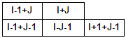
Figure 21 – 5 Point Grid Scheme

When water descends below square (I,J), the momentum on 4 surrounding corners is reduced to allow square to become dry. The previously computed surges on the 4-surrounding squares are updated according to the revised momentums on the 4-corner points of (I,J)

Comments
1) This subroutine resides in overlay CMPUTE.
2) The system routine ERRSET is used to isolate variables if an under/overflow occurs; Variable printout is aided via HELP and the COMMON/CHELP/
3) The subscript for computations of surges are offset (.5, .5) from the momentum points – see below.

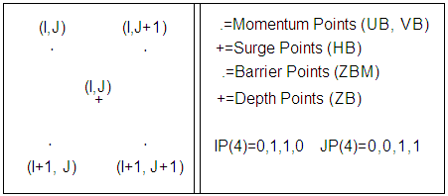

Figure 22 – Surge offset Computations From Momentum

Data Set Use
None

Variables Passed In
None

Local Variables
IMXB1 JMXB1 : Max subscripts for surge squares
HB( , ) : Surge heights
HSUB( , ) : Storage for a second copy of HB
IS() : Start loop, exclude high terrain, set in CRDRD2
IB IFN : Beginning/Ending a “Do Loop” in I-direction
ISKIP : 1, for J=1, check ZBM at 2 boundary corners for skipping static condition
2, and I=IMXB1 for bottom boundary
3, for J=JMXB1 for right boundary
JUMP : Conditional integer for standard loop or retrieval of previously computed surges, see diagram above for affected squares
LEAP : Conditional “GO TO” to dry an (I,J) square, see diagram above for an (I,J) square
IFST ISND : Begin/End I subscript on updated (J-1) squares
IPASS : Conditional integer, to set a square dry
ZB( , ) : Depths at center of surge squares
IP(4) JP(4) : Shift subscripts to 4 momentum points
UB VB( , ) : Components of momentum fields
HPST : Dummy value for surge values
FCT : Factor to multiply momentum gradient
CHNG : Surge plus depths (to test for dry square)
DENM : Change in surge, on the time iteration
ANUM : Change in surge ht, to dry a square
RFCT : Ratio, < 1, of ANUM to DENM, reduction factor
ISET : I-subscript for dried square

Subroutines Calling Function (File:Subroutine):
runslhg.f: CMPUTE
interface.f: TMSTEP

Subroutine Calls (File:Subroutines)
None

Return
None

BDRYHT: Author
Jelesnianski, September 1980 MDL/TDL

Purpose
Computes static heights on deep water boundaries only. Deep water can be on one, tow or neither of the two side boundaries, but it will exist at least on a segment of the circle with largest radius of the polar grid.

Comments
1) This subroutine resides in overlay CMPUTE

Data Set Use
None

Variables Passed In
None

Local Variables
AX AY : Comps of total storm motion, advanced in STMVAL
C1 C2 : Initial components storm, set in INTVAL
COSL() SINL() : CO-SINE of angle, rays to X-AXIS, (Height points
IMXB1 : Max I-Subscript for height points
SEADTM : Initial height of the sea (no static heights)
DELP(800) : Static heights at mile intervals from storm center
HB ( , ) : Surge heights
ITREE( , ) : A, on at least one boundary corner as static height is used

Subroutines Calling Function (File:Subroutine):
runslhg.f: CMPUTE
interface.f: TMSTEP

Subroutine Calls (File:Subroutines)
None

Return
None

CHANNL: Author
Jelesnianski, September 1980 MDL/TDL

Purpose
Computes total flow through a prism, invariant in space. The prism bed is horizontal. The head between the two ends is the driving force to pass water through the channel. See image below:

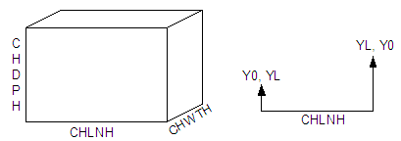

The equation used for the channel flow is:
Q**2=(C1(YL**13/3-Y0**13/3))/(C2(YL**4/3-Y0**4/3)+CHLNH)

Figure 23 – Channel Flow Equation

Comments
This subroutine resides in overlay CMPUTE

Data Set Use
None

Variables Passed In
None
Local Variables
NPSS : Number of passes
CHLNH(5) : Length of channels
G : Gravity
Y0 YL : Surge at end of channel
IPTO JPTO(2,5) : Positions for 2-squares at one channel end
HB( , ) : Surge height
CHDPH(5) : Channel depths
IPTL JPTL(2,5) : Positions of 2-squares at other channel end
JPTL(2,5) : J-Subscript for 2-squares at other channel end
SIG : Sign , + or –
CDELY : Cut-off height of .1 foot for the head
AMAN-AGB13 : Fixed constants
Q(5) : Flow
DELT : Unit time step
CHWTH(5) : Width of channels
EXTEXT(5) : Total flow through channel

Subroutines Calling Function (File:Subroutine):
runslhg.f: CMPUTE
interface.f: TMSTEP

Subroutine Calls (File:Subroutines)
None

Return
None

FLW1DM: Author
Jelesnianski, September 1980 MDL/TDL

Purpose
This subroutine computes 1-dimension flow across channel sides of interlocking squares. Water passes only through OPEN sides of a 1- dimension flow channel, see diagram below.
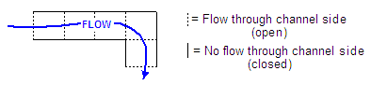

Figure 24 – Computed 1-Dimension Flow Across Channel of Interlocking Squares

The loop of the continuity equation fills/depletes two adjoining squares with flow through an open side, one side at a time. If water drops below a square from the action of an open side, then the flow through the side id reduced to exhaust water only to a dry square.

Each open side has an interior and an exterior square. Subroutine CRDRD2 reads the subscripts for interior squares and sets up procedures to isolate the adjoining exterior squares and open sides via COMMON/DUMB18/. The present subroutine isolates the two interior/exterior squares and the adjoining side for 1-dimenstion flow. A 1-dimension flow square can be either an int/ext square, or both, 1-4 times, depending on the amount of open sides bounding a square

I,J shifts about an (I,J) interior square for 4 possible exterior squares which are as shown:

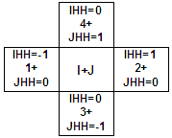

Figure 25 – Interior/Exterior Calculated Flow For Individual Grid Cell

Comments
1) This is a version for 2-step scheme (July 1981).
2) Subroutine resides in overlay CMPUTE.

The diagram below shows some (not all) elevations on interior/exterior squares at present time:

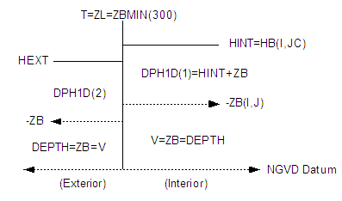

Figure 26 – Elevation on Interior/Exterior Calculated Flow For Individual Grid Cell

Data Set Use
None

Variables Passed In
None

Local Variables
AI(800) : Bottom friction, at one foot intervals
NSQRW : Number of squares with 1-dimension flow possible
ISQR*L) JSQRL(L) : I/J-subscript for square with 1-dimension flow
HB( , ) : Surge field
ISIDE(300) : Side of flow relative to interior 1-dimsension flow square
IHH(4) JHH(4) : Shift I/J-subscript for contiguous square
HINT HEXT : Interior/Exterior surge for surface gradient
HINT1 HEXT1 : Interior/Exterior surge heights on squares
ZBMIN(300) : Lowest barrier value at end of an open side
ZL : Dummy value for ZBMIN(300)
ZB( , ) : Depth field
HWEIR(300) : highest depth of Interior/Exterior squares or WEIR height
HOVT : Dummy value for HWEIR(300)
FLWSQR(300) : Transport across an open side, two time levels
GRIDR2() : Jacobean for polar coordinates
SIGA(4) : Sign for flow across sides of squares
DPH1D : Depth + Surge at interior/exterior squares, present time
CHNGHI CHGHE : Surge increase on interior/exterior squares from open side
DEPLI DEPLE : Total depth of interior/exterior squares, future time
CII : Accumulated water from open sides, interior square
SUBE : Surge from external square to prevent water below interior square
CEE : Accumulated water from open sides, exterior square
ID DPH : Mean total depth of interior/exterior squares, present time
DZL : Height of HWEIR above mean depths
FXB FYB : Components of surface stress
X1B(N) : Fixed coefficients for finite differencing
BR(300) BI(300) : Friction coefficients at 1-foot intervals
JUMP : 2 for stress computations, 1 for no stress

Subroutines Calling Function (File:Subroutine):
runslhg.f: CMPUTE
interface.f: TMSTEP

Subroutine Calls (File:Subroutines)
None

Return
None

FRCPNT: Author
Jelesnianski, September 1980 MDL/TDL

Purpose
Computes components of surface driving forces at a momentum grid point. Entry values for computations are through COMMON/MF/. The lake winds are distorted according to forward speed along track; Ocean winds are not distorted.

Comments
1) Subroutine lies in overlay CMPUTE

Data Set Use
None

Variables Passed In
X : See below
Y : TBD
FXB : Components of surface forces on image plane
FYB : Components of surface forces on image plane
NCATG : TBD
CHLSTR : Extinction coefficient of stress for water less than 1 ft.
NPLS : TBD

Local Variables
AX AY : Components of total storm traverse
C1 C2 : Initial (X,Y) storm position, set in INTVAL
X12(4) : Radius of max wind in feet
X12(5) : Square of X12(4)
X12(9) X12(10) : Components of forward speed, 1st hour
C19 : Friction coefficient (3x10-6)
W1218(2) : Twice the maximum winds, set in CMPUTE
CW(800) SW(800) : Inflow angle, mile increment, lake winds
C(800) S(800) : Inflow angle, mile increment, ocean winds
BI BR CI CR(800) : Friction factions
P(800) : Pressure gradient, mile intervals
FXX FYY : Components of stress
PXX PYY : Components of surface pressure gradient force
FXBP FYBP : Components of surface driving forces in (X,Y)
FXB FYB : Components of surface forces on image plane

Subroutines Calling Function (File:Subroutine):
runslhg.f: MOMNTM, FLW1DM, MNTMBD

Subroutine Calls (File:Subroutines)
None

Return
None

MOMNTM: Author
Jelesnianski/Chen, September 1980 MDL/TDL

Purpose
Computes future momentum components on all interior grid points, after first computing future surge by subroutine CONTTY. It checks if MOMNTM can exist at a grid point; EG., Overtopping the grid point. . Future surges updated from subroutine CONTTY are used to compute height gradients and to check for eligible momentum points---backward scheme--- Checks are made if momentum is to be computed at open boundary points.

Comments
1) Subroutine resides in overlay CMPUTE

Data Set Use
None

Variables Passed In
None

Local Variables
NCATG : 1 for lake winds, 2 for ocean winds
NPLS : 0 Remove static pressure term in forcing(INT.B.C.), otherwise 1.
JMXB1 : Max number of j-points, less a boundary point
JUMP : 1, fully flooded; 2, partially flooded (no stress)
MS() : Begin I-subscript on a J-line
ITREE( , ) : Indicator array for lake/ocean, tree/no tree A, B, C, D for boundary types.
ZBM( , ) : Maximum barrier HT at a surge points to 4 MOM. Corners
IH(4) JH(4) : Shift I/J-subscripts to 4 surrounding surge points
IP(4) JH(4) : Shift I/J-subscripts from surge points to 4 MOM. Corners
HB( , ) : Surge heights
ZB( , ) : Depths
HF(4) : Storage for 4 surrounding surge points
HPD(4) : Storage for 4 surrounding total depth points
UB VB( , ) : Components of transport
DHX DHY : Components of surface gradient
ID DPH : Mean total depth
AI(300) AR(300) : Friction coefficients on transports
FXB FYB : Components of driving forces
X1B(4) : DEL*CORIOLIS parameters
CSHLTR : Extinction coefficient of stress for water less than 1 foot
ISKIP : 1, compute momentum on J=1 boundary
2, compute momentum on I=2 boundary
3, compute momentum on J=JMXB boundary
4, compute momentum on I=IMXB boundary
IJUMP : 1, shallow water boundary computation
ISBS JSBS(4) : Shift subscripts from interior to boundary point MOM-points for all 4 corners
ISHF(3,4) : Subscripts shift from interior to 3 corner MOM- points for all 4 corners

Subroutines Calling Function (File:Subroutine):
runslhg.f: CMPUTE
interface.f: TMSTEP

Subroutine Calls (File:Subroutines)
runslhg.f: MNTMBD, FRCPNT

Return
None

MNTMBD: Author
Jelesnianski, October 1980 MDL/TDL

Purpose
Computes transports on momentum boundary points, between land and deep waters. In shallow waters the boundary conditions equals surface gradient at boundary and nearest interior point. In intermediate water the boundary conditions ignores time variations and equates surge gradient as static height gradient at a boundary point. Below is arrangement of momentum boundary line and nearest interior line.

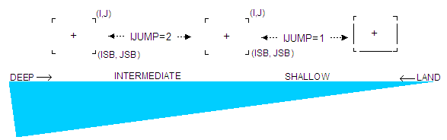
Figure 27 – Momentum Boundary Between Land and Deep Water

Comments
1) Subroutine resides in overlay CMPUTE.

Data Set Use
None

Variables Passed In
JUMP : 1 FOR surface forcing, 2 for no surface forcing
IJUMP : 1 for shallow water boundary computations
2 for interior depth boundary computations
ISB : Revised subscripts for I boundary point
JSB : Revised subscripts for J boundary point
ARJ : Pre-computed values in MOMNTM
AII : TBD
I : TBD
J : TBD
UBJ VBJ : Transports at (I,J) at present time, saved before
updated
VBJ : Transports
FXB : Component of driving force
FYB : Component of driving force
NCATG : TBD
CSHLTR : TBD
NPLS : TBD

Local Variables
ISKIP : 1, to compute momentum on J=1 boundary
2, to compute momentum on I=IMXB boundary
3, to compute momentum on J=JMXB boundary
AIT AII AIU : Pre-computed values on MOMNTM
AIV, XTT : Pre-computed values on MOMNTM AINTRP : Pre-computed values on MOMNTM
X1B(10) : Fixed constants

Subroutines Calling Function (File:Subroutine):
runslhg.f: MOMNTM

Subroutine Calls (File:Subroutines)
runslhg.f: FRCPNT

Return
None

FHMXSV: Author
Uknown

Purpose
Uknown

Comments
None

Data Set Use
None

Variables Passed In
None

Local Variables
None

Subroutines Calling Function (File:Subroutine):
runslhg.f: CMPUTE
interface.f: CLNUP
Subroutine Calls (File:Subroutines)
None

Return
None

ARCHIV: Author
Uknown

Purpose
Read boundary types along left, right, top, and bottom boundaries along momentum points

Comments
None

Data Set Use
None

Variables Passed In
None

Local Variables
None

Subroutines Calling Function (File:Subroutine):
runslhg.f: CMPUTE
interface.f: CLNUP

Subroutine Calls (File:Subroutines)
None

Return
None

HISTRY: Author
Jelesnianski/Chen, September 1980 MDL/TDL

Purpose
Smooths the surface at 10 pre-selected grid points and saves them on disk for future printout. Also, wind speed and direction are also saved at the same 10 points.

Comments
1) Subroutine resides in overlay CMPUTE.

Data Set Use
FT 10, temporary scratch disk for surge storage
FT 20, temporary scratch disk for surge storage
FT 30, temporary scratch disk for surge storage

Variables Passed In
None

Local Variables
IPN(10) IPL(10) : Subscripts for 10 selected points
HB( , ) : Surge field
ZB( , ) : Depth field
IP(4) JP(4) : Shift subscripts to 4 adjacent momentum points
ZBM( , ) : Maximum barrier height at a momentum point
COST() SINT() : Ray projections through MOMNTM points, on (X,Y) axis
GRIDRF() : Radial distances to momentum points
AX AY : Components of total storm traverse, advanced in STMVAL
C1 C2 : Components of initial storm position
NCATG : 1 for lake winds, 2 for ocean winds
W1218 (2) : Twice the maximum winds, land/ocean winds
CW(800) SW(800) : Inflow angle for lake winds
C(800) S(800) : Inflow angle for ocean winds
X12(50) : Fixed coefficients
X12(9) X12(10) : Components of forward speed, 1st hour
WIND(10) : Wind speed at 10 selected points
TDIR(10) : Wind direction at 10 selected points
PHI : Slant, Y-Axis to N/S direction, AZMTH+270
RAD : Radian Measure
IPRHR : 1, when on the hour; 2, when half hour in between; 3, otherwise

Subroutines Calling Function (File:Subroutine):
runslhg.f: CMPUTE
interface.f: TMSTEP

Subroutine Calls (File:Subroutines)
None

Return
None

HSTRY2: Author
Unknown

Purpose
Modified SLOSH HSTRY function for evacuation study.

Comments
See HSTRY subroutine

Data Set Use
See HSTRY subroutine

Variables Passed In
See HSTRY subroutine

Local Variables
See HSTRY subroutine

Subroutines Calling Function (File:Subroutine):
runslhg.f: CMPUTE
interface.f: TMSTEP

Subroutine Calls (File:Subroutines)
None

Return
None

FILTRP: Author
Jelesnianski, October 1980, MDL

Purpose
Smooths the computed surge envelope of highest waters, in space. The procedures are the sillier in FILTER and HMXSV, 2 passes of 3-point smoother. It is for cosmetic appearance. No smoothing across the non- overtopped barriers is allowed.

Comments
Subroutine resides in overlay PLOTS.

Data Set Use
None

Variables Passed In
None

Local Variables
IMAX JMAX : Maximum grid points in the basin
IMXB1 JMXB1 : IMAX less 1, JMXB less 1
HMX( , ) : Surge envelope
HZ( , 3) : Dummy storage for 2 lines
ZB( , ) : Depth field
IIH(4) JJH(4) : Shift subscripts to 4 adjoining momentum points
IP(4) JP(4) : Shift subscripts to 4 adjoining surge points
ZBM( , ) : Max barrier heights at momentum points

Subroutines Calling Function (File:Subroutine):
runslhg.f: CMPUTE
interface.f: CLNUP

Subroutine Calls (File:Subroutines)
None

Return
None

HMXSV: Author
Jye Chen, September 1980, MDL

Purpose
Stores maximum surge as advancing in time at each grid point, into array HMX( , ). The smoothed surge value is computed and compared locally against previously saved HMX. The reason is to avoid temporary noise entering the final envelop.

Comments
1) Subroutine resides in overlay CMPUTE.
2) A 5-point smoothing operator similar to one in subroutine FILTER is used, see FILTER.

Data Set Use
None

Variables Passed In
None

Local Variables
HMX( , ) : Maximum surge at each grid point
IP(4) JP(4) : Shifts of I J from height point to 4 MOMNTN corners
IBB(6, M) : Ranges and increments for 3 do-loops of I,J
M=1 interior, M=2 Horizontal body
M=3 vertical boundary ranges on three basin segments are – see FILTER
HB( , ) : Surge field
ZB( , ) : Depth field
IIH(4) JJH(4) : I/J- Shift subscripts for surge points

Subroutines Calling Function (File:Subroutine):
runslhg.f: CMPUTE
interface.f: TMSTEP

Subroutine Calls (File:Subroutines)
None

Return
None

SMPT2G: Author
Jye Chen, August 22, 1984, MDL

Purpose
To collect momentum grid points adjacent to any interior boundaries (U=V=0) ten convert to height points. Repetition is avoided. Special points, one of TH 4 is dry, are tagged as 888. For heavier smoothing. Cal subroutine FLT2G for smoothing.

Comments
None

Data Set Use
None

Variables Passed In
None

Local Variables
HSUB( , ) : Temporary storage space for height field

Subroutines Calling Function (File:Subroutine):
runslhg.f: CMPUTE
interface.f: TMSTEP

Subroutine Calls (File:Subroutines)
runslhg.f: FLT2G

Return
None

FLT2G: Author
Jye Chen, August 22, 1984, MDL

Purpose
To eliminate 2-grid computational noise nearby land-water boundaries. Grid points nearby interior boundaries are picked out from testing in subroutine SMP2G. Smoothing does conserve mass by assuming outside the selected points do not interact with the points to be smoothed.

Comments
None

Data Set Use
None

Variables Passed In
None

Local Variables
MM2G : Total number of points to be smoothed
MCMX : Special smoothing points
I2G() J2G() : I, J Coordinates of grid points for smoothing
HB( , ) : Surge height field
ZB( , ) : Terrain heights
ZBM( , ) : Barrier heights
HCT : Cutoff depth, 1 ft except the special points which 0 ft is used

Subroutines Calling Function (File:Subroutine):
runslhg.f: SMPT2G

Subroutine Calls (File:Subroutines)
None

Return
None

FILTER: Author
Jye Chen, September 1980, MDL

Purpose
To smooth the surge heights once an hour to eliminate 2-interval noises in the field. The (I,J) shifts to momentum points, VIA IP(4) and JP(4) on corner points k=1 to 4 are:

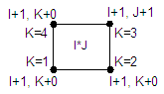

Figure 28 – Single Grid Cell Smoothing (Filter Function)

Comments
1) This subroutine resides in overlay CMPUTE.
2) A 5-point smoothing operator is used, neighboring grids weighted conditionally if they are dry or blocked by barriers.
3) Shifts of (I, J) to adjacent squares are set VIA IIH(4) and JJH(4). IIH/0, 1, 0, -1/, JJH/-1, 0, 1, 0/

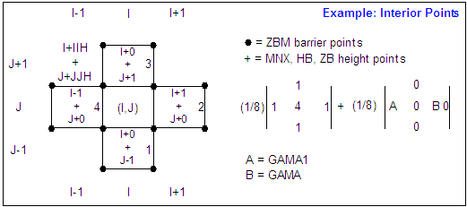

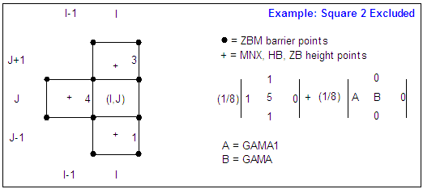

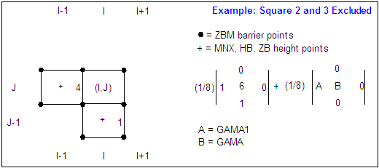

Figure 29 – Multiple Grid Cell Smoothing (Filter Function)

Data Set Use
None

Variables Passed In
None

Local Variables
HSUB( , ) : Scratch spaces
IP(4) : Shifts of I J from height point to 4 MOMNTN corners
IBB(6,M) : Ranges and increments for 3 do-loops of I, J. M=1 interior, M=2 horizontal body, M=3 vertical boundary ranges on three basin segments

222222222……..22222222
311111111……..11111113
311111111…......11111113
. . J
. . J
311111111…......11111113 J
311111111…......11111113 J
222222222……..22222222 → I

J2(J) J(C) : Shift J-subscript to present time of surge field
HB( , ) : Surge field
ZB( , ) : Depth field
IIH(4) JJH(4) : I/J-shift subscripts for surge points
IP(4) JP(4) : I/J-shift subscripts for MOMNTM points in BLCKDT
ZBM( , ) : Max barrier heights at momentum points

Subroutines Calling Function (File:Subroutine):
runslhg.f: CMPUTE
interface.f: TMSTEP

Subroutine Calls (File:Subroutines)
None

Return
None

FLTER2: Author
Unknown

Purpose
Unknown

Comments
None

Data Set Use
None

Variables Passed In
None

Local Variables
TBD

Subroutines Calling Function (File:Subroutine):
runslhg.f: CMPUTE
interface.f: TMSTEP

Subroutine Calls (File:Subroutines)
None

Return
None

SNAPSH: Author
Unknown

Purpose
Convert surge envelop data with 999 for dry squares so that ZB() can be free from memory

Comments
None

Data Set Use
None

Variables Passed In
None

Local Variables
TBD

Subroutines Calling Function (File:Subroutine):
runslhg.f: STMVAL

Subroutine Calls (File:Subroutines)
None

Return
None

3.3.2 Source file “smooth.f” Sub-function Breakdown
FILT3: Author
1) Jye Chen, September 1980, MDL/TDL FILTER in “runslhg.f” (see section 2.3.1)
2) Modified: Arthur Taylor, Date Missing, MDL/TDL

Purpose
To smooth the surge heights once an hour to eliminate 2-interval noise in field

Comments
None

Data Set Use
None

Variables Passed In
None

Local Variables
HSUB( , ) : Scratch spaces
IP(4) : Shifts of I J from height point to 4 MOMNTN corners
IBB(6,M) : Ranges and increments for 3 do-loops of I, J. M=1 interior, M=2 horizontal body, M=3 vertical boundary ranges on three basin segments

222222222……..22222222
311111111……..11111113
311111111…......11111113
. . J
. . J
311111111…......11111113 J
311111111…......11111113 J
222222222……..22222222 → I

J2(J) J(C) : Shift J-subscript to present time of surge field
HB( , ) : Surge field
ZB( , ) : Depth field
IIH(4) JJH(4) : I/J-shift subscripts for surge points
IP(4) JP(4) : I/J-shift subscripts for MOMNTM points in BLCKDT
ZBM( , ) : Max barrier heights at momentum points

The (I,J) shifts to momentum points, VIA IP(4) and JP(4) on corner points k=1 to 4 are:

Figure 30 – Single Grid Cell Smoothing (Smoothing Function)

Comments
1) This subroutine resides in overlay CMPUTE.
2) A 5-point smoothing operator is used, neighboring grids weighted conditionally if they are dry or blocked by barriers.
3) Shifts of (I, J) to adjacent squares are set VIA IIH(4) and JJH(4). IIH/0, 1, 0, -1/, JJH/-1, 0, 1, 0/

Figure 31 – Multiple Grid Cell Smoothing (Smoothing Function)

Subroutines Calling Function (File:Subroutine):
interface.f: TMSTEP

Subroutine Calls (File:Subroutines)
None

Return
HHB

FLTER4: Author
Unknown

Modified: Arthur Taylor, Date Unknown MDL

Purpose
Originally filter 2 in “runslhg.f”, otherwise unknown

Comments
None

Data Set Use
None

Variables Passed In
None

Local Variables
TBD

Subroutines Calling Function (File:Subroutine):
interface.f: TMSTEP

Subroutine Calls (File:Subroutines)
None

Return
HHB

3.3.3 Source file “interface.f” Sub-function Breakdown

INITAL: Author
Unknown

Purpose
This subroutine calls all the FORTRAN subroutines which are needed to initialize the FORTRAN variables before we enter into the compute loop. Originally this was done in program main and CMPUT. The code is the same except cut and was pasted here. This function also returns to C the various initial variables needed so that it can properly control the execution of the program.

Comments
None

Data Set Use
None

Variables Passed In
MMHALT : TBD
IIMXB : TBD
JJMXB : TBD
ZZB : TBD
MBHR : TBD
MMIN : TBD
MBDY : TBD
MBNT : TBD
MYR : TBD
YYLT : TBD
FFLE5 : TBD
FFLE9 : TBD
FFLE91 : TBD
FFLE99 : TBD
FFLE40 : TBD

Local Variables
TBD

Subroutines Calling Function (File:Subroutine):
Slosh2.c: RunInit

Subroutine Calls (File:Subroutines)
runslhg.f: INITLZ, INTLHT, RDLTLG, SETCMP

Return
MMHALT, IIMXB, JJMXB, ZZB, MBHR, MBDY, MBNT, MYR, YYLT, YYLG

WIND: Author
This procedure is from Jye Chen’s wind2.for (first 3 pages). Modified by Arthur Taylor 6/9/97

Purpose
Procedure calculates the SLOSH wind grid on a lat/long grid. Results are returned in MPH.
Comments
1) Storm center is at center of grid and may not actually need to call force1

Data Set Use
None

Variables Passed In
IU(0) : MPH wind in U direction at location I, J (Max:200x200)
IV(0) : MPH wind in V direction at location I,J
IP(0) : Pressure at location I,J
DELSNM(I) : DELTA in nautical miles on grid (usual:5)
N0(I) : Number of grid elements in 2D array (max:199) (usual: 95)
WSPEED(I) : The storms speed in MPH
WDIRCT(I) : The storms direction (0 for north)

Local Variables
TBD

Subroutines Calling Function (File:Subroutine):
Slosh2.c: #define

Subroutine Calls (File:Subroutines)
runslhg.f: FORCE1

Return
MMHALT, IIMXB, JJMXB, ZZB, MBHR, MBDY, MBNT, MYR, YYLT, YYLG

WAV: Author
Unknown

Purpose
Unknown

Comments
None

Data Set Use
None

Variables Passed In
None

Local Variables
TBD

Subroutines Calling Function (File:Subroutine):
interface.f: TMSTEP

Subroutine Calls (File:Subroutines)
None

Return
None

TMSTEP: Author
Unknown

Purpose
This subroutine calls all the FORTRAN subroutines which are needed to do one time step. Originally this was done in CMPUT between 100 and 99. The code is the same except for cut and paste here. This also returns to C the various variables needed so that it can update the graphics.

Comments
None

Data Set Use
None

Variables Passed In
IITIME : TBD
MMHALT : TBD
HHB : TBD
DDELT : TBD
XXLT : TBD
XXLG : TBD
YYDELP : TBD
YYC24 : TBD
1WSPEED : TBD
WDIRCT : TBD
FLAG : TBD
SMOOTH : TBD
FPASS : TBD

Local Variables
TBD

Subroutines Calling Function (File:Subroutine):
slosh2.c: RunLoopStep

Subroutine Calls (File:Subroutines)
runslhg.f: TTIMER, CONTTY, SMPT2G, BDRYHT, CHANNL, FLW1DM, HMXSV, HISTRY HSTRY2, FLTER2, FILTER, MOMNTM, STMVAL
interface.f: WAV, XY2LLX
smooth.f: FILT4, FILT3

Return
IITIME, MMHALT, HHB, DDELT, YYDELP, YYC24, WSPEED, WDIRECT

CLNUP: Author
Unknown

Purpose
This subroutine calls the FORTRAN subroutines needed to save the max envelop and to clean up execution of the code. Originally this was done at the end of CMPUT (after 999) and the end of the program main. The code is the same except cut and pasted here. This also returns to C the various variables needed so that it can display the max envelop.

Comments
None

Data Set Use
None

Variables Passed In
HHB : TBD
iENV : TBD

Local Variables
TBD

Subroutines Calling Function (File:Subroutine):
Slosh2.c: CleanUp

Subroutine Calls (File:Subroutines)
runslhg.f: FILTRP, FHMXSV, ARCHIV

Return
HHB

LLX2PQ: Author
Unknown

Purpose
Unknown

Comments
None

Data Set Use
None

Variables Passed In
XLTL : TBD
YLNL : TBD
INP : TBD
INQ : TBD

Local Variables
TBD

Subroutines Calling Function (File:Subroutine):
Slosh2.c: #define

Subroutine Calls (File:Subroutines)
None

Return
YLNL, INP, INQ

XY2LLX: Author
Unknown

Purpose
Unknown

Comments
None

Data Set Use
None

Variables Passed In
XA : TBD
YA : TBD
XLT : TBD
XLG : TBD

Local Variables
TBD

Subroutines Calling Function (File:Subroutine):
interface.f: TMSTEP

Subroutine Calls (File:Subroutines)
None

Return
XLT, XLG

3.4 DOS Wrapper Source Tree

The SLOSH DOS model simply stated is C based “wrapper” software used to interact with the “base” code to execute the model from a Microsoft DOS command-line.

1. clock.c / clock.h
- Module provides various clock functions to manipulate time for SLOSH model runs. Standard libraries not robust enough.
2. complex.c / complex.h
- Module containing basic complex mathematical equations/calculation subroutines. EG, Square root, log functions etc.
3. cstart.c
- Main program, starting point for command-line (base) software
4. myassert.c / myassert.h
- Code to handle assert statements, There is no actual code unless DEBUG is defined
5. myutil.c / myutil.h
- Utility software to conduct a variety of tasks, among them: reallocating memory space, split character strings, file copies, string trimming functions, and more
6. pack.c / pack.h
- Functions to fill or remove data for selected basin. Compression algorithms for REX files and encoding/decoding REX data files
7. savellx.c / savellx.h
- Functions to support generation of llx files used by Fortran code
8. slosh2.c / slosh2.h
- Main control routines for running SLOSH
9. tendian.c / tendian.h
- Utility functions used to solve big/little endian related issues
10. tio3.c / tio3.h
- Implements binary file I/O in an endian independent manner (ie specify if the file was created on an Intel machine or not, when you open the file, and then ignore), and in such a way that is can be called from FORTRAN 77.
- If using FORTRAN generated files, they sometimes stick extra bytes at the beginning and end of a record. These are hidden from the FORTRAN user, but not from this library. They usually contain the record length. Example, in UNIX it usually stores an int*4, and in Microsoft Fortran, an int*1 with 129 being a continuation flag.
11. type.h
- Type delectations between operating systems, ie 64bit, 32 bit
- System DIFF definitions

3.4.1 Source file “clock.c / clock.h” Subroutine

Global Variables: enum : Array of time related ASCII characters represented in Boolean format. EG: WT_COLON = “:” or with (WT) colon
stackType : Struct
val : value of int from time string
len : length of time string in memory
relType : Struct
relUnit : TBD
f_negate : TBD
amount : TBD

main: Author
Unknown

Purpose
clock.c manipulates time to assist SLOSH model for desired time outputs.

Variables Passed In
argc & argv : Command line arguments

Local Variables
f_timeAdj : Numeric representation of local standard or local daylight time adjustments
0 = no adjustment
1 = adjust as LDT
2 = adjust as LST
d_clock : TBD
d_amount : TBD
i : TBD
TimeZone : TBD
F_dayLight : TBD
formatPtr : TBD
ans : TBD
buffer : TBD
lenBuffer : TBD
year : TBD
month : TBD
day : TBD
totDay : TBD
d_remain : TBD
d_remain : TBD
f_isyear : TBD

Subroutine Calls (File:Subroutines)
myUtil.c: reallocFGets, myIsReal, strTrim, strToLower
clock.c: Clock_Epoch2YearDay, Clock_MonthNum, Clock_NumDay, Clock_GetTimeZone,
Clock_IsDaylightSaving, Clock_Seconds,
Clock_ScanZone, Clock_ScanDate

Return
None

Clock_Epock2YearDay: Author
Arthur Taylor, September 2002 MDL/RSIS
AAT, June 2004, (MDL) <Updated>

Purpose
To convert the days since the beginning of the epoch to days since beginning of the year and years since the beginning of the epoch.

Variables Passed In
totDay : Number of days since the beginning of the epoch
Day : The days since the beginning of the year.
Yr : The years since the epoch.

Local Variables
None

Subroutine Calls (File:Subroutines)
None

Return
None

Clock_MonthNum: Author
Arthur Taylor, September 2002 MDL/RSIS
AAT, June 2004, (MDL) <Updated>

Purpose
Determine which numbered month given the day beginning of the year and the year since the beginning of each epoch.

Variables Passed In
Day : Day since the beginning of the year
year : Year since the beginning of the epoch

Local Variables
None

Subroutine Calls (File:Subroutines)
None

Return
int : Determined month

Clock_NumDay: Author
Arthur Taylor, September 2002 MDL/RSIS

Purpose
Returns either the number of days in the month or the number of days since the beginning of the year

Variables Passed In
month : Month in question
day : Day of month in question
year : Years since the epoch
f_tot : 1 for total days from beginning of year
2 for total days in the month

Local Variables
None

Subroutine Calls (File:Subroutines)
None

Return
int : Either the number of days in the month, or the number of days since the beginning of the year.

Clock_FormatParase: Author
Arthur Taylor, September 2002, MDL/RSIS
ATT, June 2004, MDL <updated>

Purpose
To format part of the output clock string

Variables Passed In
buffer : The output string to write to
sec : Seconds since the beginning of day
floatSec : Part of a second since beginning of second
totDay : Days since the beginning of the epoch
year : Years since the beginning of the epoch
month : Days since the beginning of the year
day : Days since the beginning of the year
format : Which part of the format string being worked on

Local Variables
MonthName : Array of month names
DayName : Array of day names
dy : Number of days from start of year to start of month
temp : Array to help parse the %D, %T, %r, and %R options

Subroutine Calls (File:Subroutines)
clock.c: Clock_NumDay, Clock_FormatParse

Return
None

Clock_GetTimeZone: Author
Arthur Taylor, June 2004, MDL

Purpose
Returns the time zone offset in hours to adjust to UTC

Variables Passed In
None

Local Variables
buff : Character strong holding time
tm time : Standard C time function struct variable
ansTime : time_t variable
timeZone : Number of hours to adjust the clock due to the time zone

Subroutine Calls (File:Subroutines)
None

Return
int : Determined time zone

Clock_IsDaylightSaving: Author
Arthur Taylor, September 2002, MDL/RSIS
ATT, June 2004, MDL <updated>

Purpose
Determine if daylight savings is in effect. Daylight savings
is in effect from the first Sunday in April to the last Suncay in October.
At 2 AM ST in April -> 3 AM DT (return 1)
At 2 AM DT in October -> 1 AM ST (return 0)

Variables Passed In
clock : The time stored as a double
TimeZone : Number of hours to adjust the clock due to the time zone

Local Variables
totDay : Days since the beginning of the epoch
year : Years since the beginning of the epoch
sec : Seconds since the beginning of day
day : Days since the beginning of the year
first : Determines day (mon, tue, wed, …) of first of year Jan 1

Subroutine Calls (File:Subroutines)
clock.c: Clock_Epoch2YearDay

Return
int : 0 not daylight savings time
: 1 if is daylight savings time

Clock_PrintDate: Author
Unknown

Purpose
Determines printable date

Variables Passed In
clock : The time stored as a double
month : Months since the beginning of the year
hour : Days since the beginning of the epoch
min : Minutes since the beginning of the epoch
year : Years since the beginning of the epoch
sec : Seconds since the beginning of day
day : Days since the beginning of the year

Local Variables
totDay : Days since the beginning of the epoch
intsec : Seconds since the beginning of day

Subroutine Calls (File:Subroutines)
None

Subroutine Calls (File:Subroutines)
clock.c: Clock_Epoch2YearDay, Clock_MonthNum, Clock_NumDay

Return
None

Clock_Print: Author
Arthur Taylor, September 2002, MDL/RSIS
ATT, June 2004, MDL <updated>

Purpose
To create formatted output from a time structure that is stored as a double

Variables Passed In
buffer : Destination to write the format to
n : The number of characters in the buffer (Input)
clock : The time stored as a double
format : The desired output format
f_gmt : 0 output GMT, 1 output LDT, 2 output LST (Input)

Local Variables
totDay : Days since the beginning of the epoch
year : Years since the beginning of the epoch
sec : Seconds since the beginning of day
floatSec : Seconds since the beginning of the day
month : Numeric month
day : Numeric day
i, j : For loop counting numbers
f_perc : Case statement switch bit
locBuff : Character array containing time
timeZone : Number of hours to adjust the clock by due to time zone
clock.c: Clock_Epoch2YearDay, Clock_MonthNum, Clock_FormatParse, Clock_GetTimeZone, Clock_IsDaylightSavings
Return
None

Clock_Clicks: Author
Arthur Taylor, June 2002, MDL/RSIS

Purpose
Returns the number of time/clock click since the program started running.

Variables Passed In
None

Local Variables
ans : Determined clock clicks

Subroutine Calls (File:Subroutines)
None

Return
double : number of clock clicks in var ans

Clock_Seconds: Author
Arthur Taylor, June 2002, MDL/RSIS

Purpose
To returns the current number of seconds since the beginning of the epoch. Using the local system time zone

Variables Passed In
None

Local Variables
ans : Determined number of seconds

Return
None

Clock_ScanZone: Author
Arthur Taylor, September 2002, MDL/RSIS
ATT, June 2004, MDL <updated>

Purpose
Scans a character string to determine the time zone

Variables Passed In
ptr : The character string to scan
TimeZone : Number of hours to shift from UTC
f_day : True if we are dealing with daylight savings

Local Variables
ans : Determined clock clicks

Subroutine Calls (File:Subroutines)
None

Return
int : 0 if time zone found, -1 if not

Clock_ScanMonth: Author
Arthur Taylor, September 2002, MDL/RSIS
ATT, June 2004, MDL <updated>

Purpose
Scans a string for a month word and assumes string is all caps

Variables Passed In
ptr : The character string to scan

Local Variables
None

Subroutine Calls (File:Subroutines)
None

Return
int : Returns the month number read, or -1 if no month would found

Clock_ScanWeekday: Author
Arthur Taylor, September 2002, MDL/RSIS
ATT, June 2004, MDL <updated>

Purpose
Scans a string looking for a day word and assumes string is in all caps

Variables Passed In
ptr : The character string to scan

Local Variables
None
Subroutine Calls (File:Subroutines)
None

Return
int : Returns the month number read, or -1 if no month would found
Clock_ScanColon: Author
Arthur Taylor, September 2002, MDL/RSIS
ATT, June 2004, MDL <updated>

Purpose
Parses a word assuming it is “:” separated and is dealing with hours:minutes:seconds or hours:minutes. Returns the resulting time as a double

Variables Passed In
ptr : The character string to scan

Local Variables
hour : Days since the beginning of the epoch
min : Minutes since the beginning of the epoch
sec : Retrieved time in seconds
ptr3 : Temp variable

Subroutine Calls (File:Subroutines)
None

Return
double : The time after converting the “:” delineated string

Clock_ScanSlash: Author
Arthur Taylor, September 2002, MDL/RSIS
ATT, June 2004, MDL <updated>

Purpose
Parses a word assuming it is delineated by a forward slash “/” and is in a string format months/days/years or months/days

Variables Passed In
word : The character string to scan
mon : The month that was seen
day : Numeric day of month
year : Numeric year
f_year : true or 1 if year is valid, 0 if not

Local Variables
ptr3 : Temp string pointer
ptr : Pointer to “word” variable defined above

Subroutine Calls (File:Subroutines)
None

Return
int : -1 if month or day is out of range
0 if no problems or success

Clock_ScanDate: Author
Unknown

Purpose
Scan for date in “clock” variable

Variables Passed In
clock : The time stored as a double
year : Years since the beginning of the epoch
mon : Numeric day of month
day : Numeric year

Local Variables
i : Undefined variable
delt : Difference between 1970 (temp variable) and current year
temp : Year 1970 start of clock time
totDay : Days since the beginning of the epoch

Subroutine Calls (File:Subroutines)
myassert.c: myAssert
clock.c: Clock_NumDay

Return
None : However “clock” variable pointer passed in is altered (global) through routine

Clock_GetWord: Author
Unknown

Purpose
Getting 30 character value for “word” variable. Exact process: 1) Start at $start, advance start until it is at first non-space, non- ‘,’ non-‘,’ character. Move to end of first space, ‘,’ or ‘.’ After new start location. Copy up to 30 characters (in caps) into word.

Variables Passed In
start : Pointer to start of string
end : Pointer to end of string
word : 30 character array of determined word/value
wordtype : 0 = none
1 = “:” word
2 = “/”
3 = integer word
4 = AM/PM word
5 = timeZone word
6 = month word
7 = weekday word
8 = Preceding to a relativeDate word
9 = Post to a relativeDate word
10 = relativeDate word unit
11 = Adjust Day word

Local Variables
ptr : TBD
cnt : TBD
f_integer : TBD

Subroutine Calls (File:Subroutines)
None

Return
int : -1 if no next word
0 if there is or success

Clock_Scan: Author
Unknown

Purpose
TBD

Variables Passed In
clock : Pointer to the time stored as a double
buffer : TBD
f_gmt : TBD

Local Variables
ptr : TBD
ptr2 : TBD
word : 30 character array of determined word/value
wordtype : 0 = none
1 = “:” word
2 = “/”
3 = integer word
4 = AM/PM word
5 = timeZone word
6 = month word
7 = weekday word
8 = Preceding to a relativeDate word
9 = Post to a relativeDate word
10 = relativeDate word unit
11 = Adjust Day word
TimeZone : TBD
lastwordType : TBD
f_dayLight : TBD
month : TBD
day : TBD
year : TBD
f_year : TBD
index : TBD
ans : TBD
Stack : struct of StackType
Rel : struct of relType
lenRel : TBD
lenStack : TBD
PreRel : Static char array containing LAST, THIS, NEXT, NULL words used during product generation printouts
PreUnit : Static char array containing YEAR, YEARS, MONTH, MONTHS FORTNIGHT, FORTNIGHTS, WEEK, WEEKS, DAY, DAYS, HOUR, HOURS, MIN, MINS, MINUTE, MINUTES, SEC, SEC, SECOND, SECONDS, NULL used during product generation printouts. AdjDay : Static char array containing YESTERDAY, TODAY, TOMORROW, NULL used as adjusted day for product generation printouts
f_ampm : TBD
f_timeZone : TBD
f_time : TBD
f_date : TBD
f_slashWord : TBD
f_dateWord : TBD
f_monthWord : TBD
f_dayword : TBD
curTime : Variable containing current time
sec : TBD
i : TBD
monthAdj : TBD
yearAdj : TBD

Subroutine Calls (File:Subroutines)
myUtil.c: GetIndexFromStr,
clock.c: Clock_Epoch2YearDay, Clock_MonthNum , Clock_NumDay, Clock_GetTimeZone, Clock_Seconds, Clock_ScanZone, Clock_ScanMonth, Clock_ScanWeekday, Clock_ScanColon, Clock_ScnSlash, Clock_ScanDate, Clock_GetWord, Clock_IsDaylightSaving

Return
None

3.4.2 Source file “complex.c / complex.h” Subroutine

Comp_sqrt: Author
Unknown

Purpose
Calculate square root of given number

Variables Passed In
z : complex_type struct of x & y double values defined in “Global Variables” section

Local Variables
ans : Calculated answer of complex_type struct
r : Summation of x & y squares

Subroutine Calls (File:Subroutines)
None

Return
Complex_type : TBD

Comp_log: Author
Unknown

Purpose
TBD

Variables Passed In
z : complex_type struct of x & y double values defined in “Global Variables” section

Local Variables
ans : Calculated answer of complex_type struct

Subroutine Calls (File:Subroutines)
None

Return
Complex_type : TBD

Comp_exp: Author
Unknown

Purpose
TBD

Variables Passed In
z : complex_type struct of x & y double values defined in “Global Variables” section

Local Variables
ans : Calculated answer of complex_type struct
Subroutine Calls (File:Subroutines)
None

Return
Complex_type : TBD

Comp_mul: Author
Unknown

Purpose
TBD

Variables Passed In
z : complex_type struct of x & y double values defined in “Global Variables” section

Local Variables
ans : Calculated answer of complex_type struct

Subroutine Calls (File:Subroutines)
None

Return
Complex_type : TBD

Comp_R_mul: Author
Unknown

Purpose
TBD

Variables Passed In
z1 : complex_type struct of x & y double values defined in “Global Variables” section
z2 : complex_type struct of x & y double values defined in “Global Variables” section

Local Variables
ans : Calculated answer of complex_type struct

Subroutine Calls (File:Subroutines)
None

Return
Complex_type : TBD

Comp_inv: Author
Unknown

Purpose
TBD

Variables Passed In
z : complex_type struct of x & y double values defined in “Global Variables” section

Local Variables
ans : Calculated answer of complex_type struct

Subroutine Calls (File:Subroutines)
None

Return
Complex_type : TBD

Comp_add: Author
Unknown

Purpose
Add like variables x & y provided in 2 complex type structs

Variables Passed In
z1 : complex_type struct of x & y double values defined in “Global Variables” section
z2 : complex_type struct of x & y double values defined in “Global Variables” section

Local Variables
ans : Calculated answer of complex_type struct
Subroutine Calls (File:Subroutines)
None

Return
Complex_type : TBD

Comp_set: Author
Unknown

Purpose
Subtract to like variables x & y provided in 2 complex type structs

Variables Passed In
x : x coordinate
y : y coordinate

Local Variables
ans : Calculated answer of complex_type struct

Subroutine Calls (File:Subroutines)
None

Return
Complex_type : TBD

Comp_real: Author
Unknown

Purpose
Return x variable value in a provided complex_type struct

Variables Passed In
z : complex_type struct of x & y double values defined in “Global Variables” section

Local Variables
None

Subroutine Calls (File:Subroutines)
None

Return
Complex_type : Value of x in provided complex_type structure
Comp_imag: Author
Unknown

Purpose
Return y variable value in a provided complex_type struct

Variables Passed In
z : complex_type struct of x & y double values defined in “Global Variables” section

Local Variables
None

Subroutine Calls (File:Subroutines)
None

Return
Complex_type : Value of y in provided complex_type structure

Comp_print: Author
Unknown

Purpose
Print to standard out x & y variable values in provided complex_type structure.

Variables Passed In
z : complex_type struct of x & y double values defined in “Global Variables” section

Local Variables
None

Subroutine Calls (File:Subroutines)
None

Return
None

3.4.3 Source file “cstart.c” Subroutine

main: Author
Unknown

Purpose
TBD

Variables Passed In
Argc : TBD
Argv : TBD

Local Variables
fp : TBD
buffer : TBD
lenPtr : TBD
cnt : TBD
i : TBD
lineArgc : TBD
lineArgv : TBD
bsnAbrev : TBD
f_DoIt : TBD
imxb : TBD
jmxb : TBD
grid : TBD
rexName : TBD
envName : TBD

Subroutine Calls (File:Subroutines)
NA

Return
TBD

CopyBasin: Author
Unknown

Purpose
TBD

Variables Passed In
bsnAbrev : TBD
bsnDataDir : TBD
dtaName : TBD
llxName : TBD
imxb : TBD
jbxb : TBD

Local Variables
len : TBD
type : TBD
nameLen : TBD
fileName : TBD
fp : TBD
buffer : TBD
lenPtr : TBD
bsnRoot : TBD
lineRoot : TBD
f_found : TBD

Subroutine Calls (File:Subroutines)
myUtil.c: reallocFGets, FileCopy, strToLower
savellx.c: saveLLX
myassert.c: myAssert

Return
TBD

setUpFiles: Author
Unknown

Purpose
TBD

Variables Passed In
bsn : TBD
track : TBD
rex : TBD
bsnAbrev : TBD
slshBsnDir : TBD
trkName : TBD
dtaName : TBD
llxName : TBD
rexName : TBD
imxb : TBD
jmxb : TBD

Local Variables
None

Subroutine Calls (File:Subroutines)
myUtil.c: FileCopy, CopyBasin
myassert.c: myAssert

Return
TBD

PreformRun: Author
Unknown

Purpose
TBD

Variables Passed In
bsnAbrev : TBD
dtaName : TBD
llxName : TBD
trkName : TBD
xxxName : TBD
rexName : TBD
imxb : TBD
jmxb : TBD

Local Variables
st : TBD
mhalt : End interval
clock : TBD
etime : TBD
rextime : TBD
f40Name : TBD
f_RexReset : TBD
f_env : TBD
itime : Interval time
f_first : TBD
rexFp : TBD
del_t : TBD
csflag : Flag to do CS computations
f_graphics : Copy data/stuff, but don’t copy graphics
f_passdata : TBD
f_smooth : TBD
f_saveEnv : TBD

Subroutine Calls (File:Subroutines)
Slosh2.c: SaveRexStep, RunLoopStep, RunInit
Return
TBD

DoOneStorm: Author
Unknown

Purpose
TBD

Variables Passed In
bsn : TBD
slshBsnDir : TBD
track : TBD
rex : TBD

Local Variables
i : TBD
imxb : TBD
jmxb : TBD
grid : TBD
rexName : TBD
bsnAbrev : TBD

Subroutine Calls (File:Subroutines)
myUtil.c: FileCopy
csstart.c: PerformRun

Return
TBD

3.4.4 Source file “myassert.c / myassert.h” Subroutine

_myAssert: Author
Arthur Taylor, Agust 2003, MDL/RSIS

Purpose
This is an assert routine from “Writing Solid Code” by Steve Maguire.

Advantages of this over C’s “assert” function is that assert stores the expression string for printing. Storing is believe to be done in a global data value, but that means assert is using memory space that the SLOSH program may need for read advantages. If you trigger assert, you’re ok to integrate the file and see the code.

Variables Passed In
file : Filename that assert was in
lineNum : Line number in file of assert

Local Variables
None

Subroutine Calls (File:Subroutines)
None

Return
None

3.4.5 Source file “myutil.c / myutil.h” Subroutine

Global Variables: POWERS_ONE : Array of “powers of” values from 1e0 to 1e17

reallocFGets: Author
Arthur Taylor, December 2002, MDL/RSIS

Purpose
Read file a passed in until end of line \n char reached. Reallocate memory as needed. Similar to fgets, except we don’t know ahead of time that the line is a specific length. Assumes that Ptr is either NULL, or points to lenBuff memory. Responsibility of caller to free the memory

Notes:
1) Based on getline (see K&R C book (2nd edition) p 29) and on the behavior of TCL’s get routine
2) Chose MIN_STEPSIZE = 80 because pages are usually 90 columns
3) could switch lenBuff = I + 1 / lenBuff = I to always true. Rather not…less allocs… This way code behaves almost the same as fgets except it can expand as needed.

Variables Passed In
Ptr : An array of data that is of size LenBuff
LenBuff : The allocated length of Ptr
fp : Input file stream, file pointer.

Local Variables
buffer : Local copy of Ptr as passed into routine
lenBuff : Local copy of LenBuff as passed into routine
c : Current char read in from the data stream (file)
i : Array increment, where to store character written to variable “c”

Subroutine Calls (File:Subroutines)
None

Return
int : strlen (buffer)…
0 for read only EOF
1 for “’\nEOF” or “<char>EOF”

mySplit: Author
Arthur Taylor, May 2004, MDL/RSIS

Purpose
Split a character array according to a given symbol. Responsibility of caller to free allocated memory.

Variables Passed In
Data : Character string to process
Symbol : Character to split string at
Argc : Number of groupings found
Argv : Characters in each grouping
f_trim : Set to true (1) if white space exists in string and needing to be trimmed

Local Variables
head : Pointer to beginning of integrated string
ptr : Used to mark the position of any existing symbols passed by the user in variable “Symbol”
argc : Local copy of Argc
argv : Local copy of Argv

Subroutine Calls (File:Subroutines)
myUtil.c: strTrim

Return
None

MyIsReal: Author
Arthur Taylor, July 2004, MDL/RSIS

Purpose
Returns 0 if all characters are digits except a trailing “,”, or leading character of “-“. Value is set to atof (ptr)

Variables Passed In
ptr : Character string to integrate
value : The converted value of ptr, if ptr is a number

Local Variables
len : Length of string pointer ptr
i : for loop counter

Subroutine Calls (File:Subroutines)
None

Return
int : 0 if it is not a real number
1 if it is a real number

FileCopy: Author
Arthur Taylor, May 2004, MDL/RSIS

Purpose
Copy a file from one location to another

Variables Passed In
fileIn : Source file to read from
fileOut : Destination file

Local Variables
ifp : FILE in file pointer
ofp : FILE output pointer
c : Temp character holder from reading to writing
Subroutine Calls (File:Subroutines)
None

Return
int : -1 if error
0 for success

FileTail: Author
Arthur Taylor, May 2004, MDL/RSIS

Purpose
Returns the characters in a filename after the last directory separator. Responsibility of call to free memory.

Variables Passed In
fileName : Filename to read from
tail : end of filename

Local Variables
ptr : Navigation pointer, moving through string based on static symbols “\\” or “\”

Subroutine Calls (File:Subroutines)
None

Return
None

MyRound: Author
Arthur Taylor, May 2003, MDL/RSIS

Purpose
Round a number to a given number of decimal places
Variables Passed In
data : Number to round
place : Rounding decimal place

Local Variables
None

Subroutine Calls (File:Subroutines)
None

Return
double : Rounded value passed into routine

strTrim: Author
Arthur Taylor, October 2003, MDL/RSIS

Purpose
To trim white spaces from both sides of a character string
Variables Passed In
str : Character string pointer to integrate

Local Variables
i : Loop counter to traverse string
j : Loup counter to traverse string
len : String length

Subroutine Calls (File:Subroutines)
None

Return
None

strToUpper: Author
Arthur Taylor, October 2003, MDL/RSIS

Purpose
To convert a string to all uppercase characters
Variables Passed In
str : Character string pointer to integrate

Local Variables
ptr : Pointer containing converted character string

Subroutine Calls (File:Subroutines)
Myassert.c: myAssert

Return
None

GetIndexFromStr: Author
Arthur Taylor, October 2003, MDL/RSIS

Purpose
Given a search word/key parse provided string and return index of word/key location

Variables Passed In
arg : The string to integrate, parsed string
Opt : The word/key to find in string
Index : The location of arg in Opt (or -1 if not located)

Local Variables
ptr : local pointer navigation pointer initialized to Opt variable
cnt : Beginning location of word/key found

Subroutine Calls (File:Subroutines)
None

Return
None

strToLower: Author
Arthur Taylor, May 2004, MDL/RSIS

Purpose
To convert a string to all lower case characters
Variables Passed In
Str : The string to adjust

Local Variables
ptr : local pointer containing result of converted string in lower case characters

Subroutine Calls (File:Subroutines)
myassert.c: myAssert

Return
None

3.4.6 Source file “pack.c / pack.h” Subroutine

Global Variables ltln_ray : TBD
Ltln_val : TBD

main: Author
Arthur Taylor, April 2003, MDL/RSIS

Purpose
To test the memBitRead and memBitWrite routines, to make sure that they function correctly on some sample data

Variables Passed In
argc : Number of command line arguments
argv : Command line arguments – non passed

Local Variables
buff : TBD
buff2 : TBD
bufLoc : TBD
ptr, ptr2 : TBD
numUsed : TBD

Subroutine Calls (File:Subroutines)
NA

Return
int : 1 for error, 0 for success

Stuff_xxx: Author
Arthur Taylor, April, 20 1998, MDL/RSIS

Purpose
To stuff/fill basin data, using current scheme for basin.

Note:
Uses a pcx like encoding scheme. Huffman codes are only good if we have a delta? A better method might use delta’s for non-land flags. Also use huff codes for run lengths. Simple scheme… Always print 8 bit fixed run [1..256] followed by fixed 9 bit literal –15.0..36.0] literal 999 = 36.1. for speed sake may want entire array passed in.
Variables Passed In
fp : File pointer of opened binary file, using TIO.c
pbuf : Character pointer buffer to hold file contents when reading pubfLoc : Location of the bit buffer
val : The slosh value to short (10*height or 999)
f_flag : 0 => normal 1-> flush the stream and bit_buffer

Local Variables
prev : Data to write to file
run : Data to write to file
count : Stores number of bits saved or -1 if error

Subroutine Calls (File:Subroutines)
tedian.c: fileBitWrite

Return
int : Value of count, number of bits saved or -1 if error

memStuff_xxx: Author
unknown

Purpose
Determine which bits of a data structure to write, actual writing is done in memBitWrite
Variables Passed In
ptr : Character buffer to write to
bufLoc : How many bites to write
val : The slosh value to short (10*height or 999)
f_flag : 0 => normal 1-> flush the stream and bit_buffer

Local Variables
prev : Data to write to file
run : Data to write to file
count : Stores number of bits saved or -1 if error
numUsed : How many bytes were written to Dst variable (output char buffer)

Subroutine Calls (File:Subroutines)
tedian.c: memBitWrite

Return
int : Value of count, number of bits saved or -1 if error

Stuff2_xxx: Author
Arthur Taylor, April, 20 1998, MDL/RSIS

Purpose
To stuff/fill basin data, using current scheme for basin.

Note:
Uses a pcx like encoding scheme. Huffman codes are only good if we have a delta? A better method might use delta’s for non-land flags. Also use huff codes for run lengths. Simple scheme… Always print 8 bit fixed run [1..256] followed by fixed 10 bit literal [-32.0..70.0] literal 999 = 70.1. for speed sake may want entire array passed in.
Variables Passed In
fp : File pointer of opened binary file, using TIO.c
pbuf : Character pointer buffer to hold file contents when reading pubfLoc : Location of the bit buffer
val : The slosh value to short (10*height or 999)
f_flag : 0 => normal 1-> flush the stream and bit_buffer

Local Variables
prev : Data to write to file
run : Data to write to file
count : Stores number of bits saved or -1 if error

Subroutine Calls (File:Subroutines)
tendian.c: fileBitWrite

Return
int : Value of count, number of bits saved or -1 if error

memStuff2_xxx: Author
unknown

Purpose
Determine which bits of a data structure to write, actual writing is done in memBitWrite
Variables Passed In
ptr : Character buffer to write to
bufLoc : How many bites to write
val : The slosh value to short (10*height or 999)
f_flag : 0 => normal 1-> flush the stream and bit_buffer

Local Variables
prev : Data to write to file
run : Data to write to file
count : Stores number of bits saved or -1 if error
numUsed : How many bytes were written to Dst variable (output char buffer)

Subroutine Calls (File:Subroutines)
tendian.c: memBitWrite

Return
int : Value of count, number of bits saved or -1 if error

UnStuff_xxx: Author
Arthur Taylor, April, 20 1998, MDL/RSIS

Purpose
To unstuffy the basin with data, remove data from initialized basin

Note:
Uses a pcx like encoding scheme. Huffman codes are only good if we have a delta? A better method might use delta’s for non-land flags. Also use huff codes for run lengths. Simple scheme… Always print 8 bit fixed run [1..256] followed by fixed 9 bit literal –15.0..36.0] literal 999 = 36.1. for speed sake may want entire array passed in.
Variables Passed In
fp : File pointer of opened binary file, using TIO.c
gbuf : Character pointer buffer to hold file contents when reading
gbufLoc : Location of the bit buffer
val : The slosh value to short (10*height or 999)
f_flag : 0 => normal 1-> flush the stream and bit_buffer

Local Variables
prev : Data read from buffer
run : Data read from buffer
temp : Temp data read from buffer

Subroutine Calls (File:Subroutines)
tendian.c: fileBitRead

Return
int : 1 success, 0 fail

UnStuff2_xxx: Author
Arthur Taylor, April, 20 1998, MDL/RSIS

Purpose
To unstuffy the basin with data, remove data from initialized basin

Note:
Uses a pcx like encoding scheme. Huffman codes are only good if we have a delta? A better method might use delta’s for non-land flags. Also use huff codes for run lengths. Simple scheme… Always print 8 bit fixed run [1..256] followed by fixed 10 bit literal [–32.0..70.0] literal 999 = 70.1. for speed sake may want entire array passed in.
Variables Passed In
fp : File pointer of opened binary file, using TIO.c
gbuf : Character pointer buffer to hold file contents when reading
gbufLoc : Location of the bit buffer
val : The slosh value to short (10*height or 999)
f_flag : 0 => normal 1-> flush the stream and bit_buffer

Local Variables
prev : Data read from buffer
run : Data read from buffer
temp : Temp data read from buffer

Subroutine Calls (File:Subroutines)
tendian.c: fileBitRead

Return
int : 1 success, 0 fail

UnStuff_LatLon: Author
Arthur Taylor, April, 20 1998, MDL/RSIS

Purpose
This routine uses the Huffman code chosen for lat/lon files, and methods such as [10000] for exchange in sign, [0][5bit+extra] for literal [1][4bits+extra][4bits+extra] for length, distance pair

Variables Passed In
fp : File pointer of opened binary file, using TIO.c
gbuf : Character pointer buffer to hold file contents when reading
gbufLoc : Location of the bit buffer
x : TBD
sgn : TBD
f_flag : 0 normal, 1 flush, 2 stream

Local Variables
lit : The storage place for the data read from file
index : TBD
lit2 : The storage place for the data read from file
first : TBD
second : TBD
enc_x : TBD
last : TBD
len : -1 if sistance is leteral

Subroutine Calls (File:Subroutines)
tendian.c: fileBitRead

Return
int : 0 for success, -1 fail

3.4.7 Source file “savellx.c / savellx.h” Subroutine

cl2cnf: Author
Arthur Taylor, January, 29 1998, MDL/RSIS

Purpose
Convert a latitude on the Clarke sphere (regular earth latitude) to one on the conformal sphere (a perfect sphere from the clarke sphere by pulling on the poles)
Variables Passed In
clk : The Clarke latitude
cnf : The conformal latitude
scale : The local scale of the map between spheroids

Local Variables
sin_clk : TBD
temp0 : TBD
temp1 : TBD
temp2 : TBD

Subroutine Calls (File:Subroutines)
None

Return
None

cnf2cl: Author
Arthur Taylor, January, 29 1998, MDL/RSIS

Purpose
Convert a latitude on the conformal sphere (a perfect sphere from the Clarke sphere by pulling on the poles) to the clarke sphere (regular earth latitude. Also returns a local scale of the map between spheroids. The scale should be a ration of distance on conformal sphere to clarke sphere and should be >= 1.0.

Variables Passed In
clk : The Clarke latitude
cnf : The conformal latitude
scale : The local scale of the map between spheroids

Local Variables
sin_clk : TBD
temp0 : TBD
temp1 : TBD
temp2 : TBD
temp_lat : TBD
grad : TBD
i : TBD

Subroutine Calls (File:Subroutines)
None

Return
None

Sll2xy: Author
Arthur Taylor, January, 29 1998, MDL/RSIS

Purpose
Convert a latitude on the conformal sphere (a perfect sphere from the Clarke sphere by pulling on the poles) to the clarke sphere (regular earth latitude. Also returns a local scale of the map between spheroids. The scale should be a ration of distance on conformal sphere to clarke sphere and should be >= 1.0.

Variables Passed In
clk : The Clarke latitude
cnf : The conformal latitude
scale : The local scale of the map between spheroids

Local Variables
sin_clk : TBD
temp0 : TBD
temp1 : TBD
temp2 : TBD
temp_lat : TBD
grad : TBD
i : TBD

Subroutine Calls (File:Subroutines)
None

Return
None

pq2xy: Author
Arthur Taylor, January, 29 1998, MDL/RSIS

Purpose
Converts p, q coordinates to x, y coordinates on the SLOSH tangent plane

Variables Passed In
p, q : The p, q coordinates in the SLOSH grid
x, y : The x, y coordinates on the SLOSH tangent plane
bsn : The defining parameters of the basin

Local Variables
Z1 : TBD
Z2 : TBD
xa : TBD
ya : TBD
x1 : TBD
y1 : TBD
cs : TBD
ss : TBD

Subroutine Calls (File:Subroutines)
complex.c: Comp_exp, Comp_R_Mul, Comp_inv, Comp_add, Comp_Set, Comp_real, Comp_imag

Return
None

xy2pq: Author
Arthur Taylor, January, 30 1998, MDL/RSIS

Purpose
Converts x, y coordinates on the SLOSH tangent plane to SLOSH p, q coordinates

Variables Passed In
p, q : The p, q coordinates in the SLOSH grid
x, y : The x, y coordinates on the SLOSH tangent plane
bsn : The defining parameters of the basin

Local Variables
Z1 : TBD
Z2 : TBD
xa : TBD
ya : TBD
x1 : TBD
y1 : TBD
cs : TBD
ss : TBD

Subroutine Calls (File:Subroutines)
clock.c: Comp_sqrt, comp_log, Comp_mul, Comp_R_mul, Comp_add, Comp_set, Comp_real, Comp_imag

Return
None

Fort_atof: Author
Arthur Taylor, January, 29 1998, MDL/RSIS

Purpose
Converts a string to a double using FORTRAN conventions

Note:
1) Apparently FORTRAN does not put zeros in the blanks if it is reading an integer into a F4.1 statement. Also, F4.5 is allowed. This was checked with both Lahey and Microsoft DOS FORTRAN compilers

Variables Passed In
s : The string to extract the double from
w : The FORTRAN field width
d : The FORTRAN decimal field

Local Variables
c : TBD
ans : TBD

Subroutine Calls (File:Subroutines)
None

Return
double : Returns variable “s” using FORTRAN conventions

a2lat: Author
Arthur Taylor, January 1998, MDL/RSIS
Arthur Taylor, January 1999, MDL <updated>
Arthur Taylor, May 2004, MDL <updated>

Purpose
Converts a string containing deg min sec for latitude to a double

Variables Passed In
s : The string to get latitude from

Local Variables
deg : TBD
min : TBD
sec : TBD
ans : TBD
buffer : TBD
c : TBD
tmp : TBD

Subroutine Calls (File:Subroutines)
None

Return
double : Determined latitude string

str2bsndta: Author
Arthur Taylor, January 1998, MDL/RSIS
Arthur Taylor, May 2004, MDL <updated>

Purpose
Converts a NULL terminated string containing a line from asins.dta file into the bsndta type. Also, converts this read at/long from Clarke spheroid to conformal sphere, and alizes the tangent plane

Variables Passed In
s : The NULL terminated string (assumed lowercase)
bsn : The resulting bsndta type
slsh : Holds the math for the SLOSH tangent plane

Local Variables
temp : TBD

Subroutine Calls (File:Subroutines)
savellx.c: cl2cnf, sll2xy, Fort_atof, a2lat

Return
None

saveLLx: Author
Arthur Taylor, January 1998, MDL/RSIS

Purpose
TBD

Variables Passed In
buffer : Contains the line from (‘’, e/h) basins.dta
filename : is where to save the llx file data to
Header : TBD
Imxb : TBD
Jmxb : TBD

Local Variables
bsm : TBD
slsh : TBD
temp1 : TBD
temp2 : TBD
fp : TBD
header : TBD
temp : TBD
scale : TBD
x1 : TBD
y2 : TBD
inxb : TBD
jmxb : TBD
DX : TBD
i : TBD
j : TBD

Subroutine Calls (File:Subroutines)
savellx.c: cnf2cl, sxy2ll, pq2xy, str2bsndta

Return
int : -1 fail, 0 success

3.4.8 Source file “slosh2.c / slosh2.h” Subroutine

Data_WriteTrk: Author
Unknown

Purpose
TBD

Variables Passed In
Fp2 : TBD
trk_name : File name string/pointer

Local Variables
buff1 : TBD
buff2 : TBD
fp : File pointer for trk_name file name
lat : TBD
long : TBD
spd : TBD
dir : TBD
delp : TBD
rmax : radius of maximum (storm) winds
I : TBD
j : TBD
k : TBD
c_temp : TBD
f_temp : TBD

Subroutine Calls (File:Subroutines)
tendian.c: revfwrite

Return
TBD

SaveRexHeader: Author
Unknown

Purpose
TBD

Variables Passed In
fp : TBD
imxb : TBD
jmxb : TBD
f_type : TBD
offset : TBD
track_name : TBD
abrev : TBD
min : TBD
max : TBD

Local Variables
fp2 : TBD
i
str_len : TBD
name_len : TBD
si_temp : TBD
sj_temp : TBD
s_temp : TBD
c_temp : TBD
temp : TBD
l_temp : TBD

Subroutine Calls (File:Subroutines)
tendian.c: revfwrite

Return
TBD

SaveRexStep: Author
Unknown

Purpose
TBD

Variables Passed In
f_restoffset : TBD
fp : TBD
gt : TBD
imxb : TBD
jmxb : TBD
grid : TBD
f_type : TBD
trkName : TBD
bsnAbrev : TBD
f_env : TBD
clock : TBD

Local Variables
offset : TBD
trkoffset
i : TBD
j : TBD
val : TBD
bits : TBD
l_temp : TBD
min_h : TBD
max_h : TBD
year : TBD
mon : Numeric (int) of the month
day : Numeric (int) day of the month
hour : Numeric (int 24 clock TBD?) hour
min : Numeric int minutes
sec : Numeric double seconds (full time)
si_temp : TBD
c_temp : TBD
f_temp : TBD

Subroutine Calls (File:Subroutines)
myUtil.c: myRound,
tendian.c: Stuff_xxx, Sutff2_xxx
slosh2.c: Data_WriteTrk, SaveRexHeader
clock.c: Clock_PrintDate

Return
TBD

RunLoopStep: Author
Unknown

Purpose
TBD

Variables Passed In
gt : TBD
imxb : TBD
jmxb : TBD
grid : TBD
itime : TBD
mhalt : TBD
csflag : TBD
f_smooth : TBD
f_graphics : TBD
f_passdata : TBD
del_t : TBD

Local Variables
i : TBD
j : TBD

Subroutine Calls (File:Subroutines)
interface.f: TMSTEP

Return
TBD

CleanUp: Author
Unknown

Purpose
TBD

Variables Passed In
gt : TBD
imxb : TBD
jmxb : TBD
grid : TBD
f_saveEnv : TBD

Local Variables
i : TBD
j : TBD

Subroutine Calls (File:Subroutines)
interface.f: CLNUP

Return
TBD

RunInit: Author
Unknown

Purpose
TBD

Variables Passed In
gt : TBD
trkName : TBD
dtaName : TBD
xxxName : TBD
llxName : TBD
ft40Name : TBD
mhalt : TBD
clock : TBD

Local Variables
imxb : TBD
jmxb : TBD
ylt[][] : TBD
ylg[][] : TBD
year : TBD
mon : Numeric (int) of the month
day : Numeric (int) day of the month
hour : Numeric (int 24 clock TBD?) hour
min : Numeric int minutes

Subroutine Calls (File:Subroutines)
interface.f: INITAL

Return
TBD

3.4.9 Source file “tendian.c / tendian.h” Subroutine

main: Author
Arthur Taylor, April 2003, MDL/RSIS

Purpose
To test the memBitRead, and memBitWrite routines making sure they function correctly on sample data.

Variables Passed In
argc : TBD
argv : TBD
Local Variables
buff : TBD
buff2 : TBD
bufLoc : TBD
ptr : TBD
ptr2 : TBD
numUsed : TBD

Subroutine Calls (File:Subroutines)
tendian.c: memBitRead, memBitWrite

Return
int : 1 for error, 0 for success

memswp: Author
Arthur Taylor, September 2002, MDL/RSIS

Purpose
To swap memory in the Data array based on the knowledge that there are “num_elem” elements, each of size “elem_size”

Note:
1) A similar routine was provided with the GRIB2 library. It called “unpk_swap”. Since it had the restriction that it only dealt with long ints, this function was created as more flexibility was needed. In addition this procedure may be more efficient. Tests show an operation count for swapping an array that consists of 1 long int. “unpk_swap” = 46 operations, “memswp” = 33.

Variables Passed In
Data : Pointer to the data being swapped
elem_size : The size of an individual element
num_elem : The number of elements to swap

Local Variables
h : Element count
data : Used to treat data as a char array
temp : Temporary holder of a byte when swapping
ptr, ptr2 : Pointers to the two bytes to swap

Subroutine Calls (File:Subroutines)
None

Return
None

revmemcpy: Author
Arthur Taylor, September 2002, MDL/RSIS

Purpose
To copy memory similar to memcpy, but in a reverse manner. In order to have the same arguments as memcpy, this can not handle arrays… For arrays use revmemcpyRay() function.

Note:
1) This function came about as an improvement to improve memcpy. It was assumed this function would run faster than memcpy followed by memswp.
2) Assumes that Dst is allocated to a size of Src
3) Problems with MEMCPY if len != sizeof(dst)… Is it left or right justified.

Variables Passed In
Dst : The destination for data output
Src : The source of the data
len : The length of Src in bytes

Local Variables
J : Byte count
src : Allows Src to be treated as arrary src
dst : Allows Dst to be treated an arrary dst

Subroutine Calls (File:Subroutines)
None

Return
Dst : (Void) Data destination pointer

revmemcpyRay: Author
Arthur Taylor, September 2002, MDL/RSIS

Purpose
To copy memory similar to memcpy, but in a reverse manner. This handles the case when we need to reverse memcpy an array of data

Note:
1) Assumes that Dst is allocated to a size of Src

Variables Passed In
Dst : The destination for data output
Src : The source of the data
len : The length of Src in bytes

Local Variables
J : Byte count
src : Allows Src to be treated as arrary src
dst : Allows Dst to be treated an arrary dst

Subroutine Calls (File:Subroutines)
None

Return
Dst : (Void) Data destination pointer

revfread: Author
Arthur Taylor, September 2002, MDL/RSIS

Purpose
To do an “fread”, but in a reverse manner

Variables Passed In
Dst : The destination for data output
elem_size : The size of a single element
num_elem : The number of elements in Src
fp : File pointer, file to read from

Local Variables
ans : the answer from “fread”
j : Byte count
Dst : Allows Dst to be treated as array of characters
temp : Temporary holder of a byte when swapping
ptr, ptr2 : Pointers to the two bytes to swap

Subroutine Calls (File:Subroutines)
None

Return
size_t : Number of elements read

revfwrite: Author
Arthur Taylor, September 2002, MDL/RSIS
Arthur Taylor, November 2002, MDL <updated>

Purpose
To do an “fwrite”, but in a reverse manner

Note:
1) It is assumed that file is already open and in the correct place
2) Decided to write using a bunch of fput, since this is buffered. The thought here, is that it’s faster than swapping memory and then writing. This is the exact opposite method as revfread.

Variables Passed In
Dst : The destination for data output
elem_size : The size of a single element
num_elem : The number of elements in Src
fp : File pointer to wtire to

Local Variables
ans : the answer from “fread”
j : Byte count
Dst : Allows Dst to be treated as array of characters
temp : Temporary holder of a byte when swapping
ptr, ptr2 : Pointers to the two bytes to swap

Subroutine Calls (File:Subroutines)
None

Return
size_t : Number of elements read

memBitRead: Author
Arthur Taylor, April 2003, MDL/RSIS
ATT, May 2003 <updated>

Purpose
To read bits from an unsigned char buffer array of memory. Assumes BufLoc is valid before first call. Typically this means do a bufLoc = 8” before the first call

Note:
1) Assumes binary bit stream is “big endian”. Resulting in no byte boundaries ie 00100110101101 => 00101101

Variables Passed In
Dst : Where to write results
dstLen : Length in bytes of Dst
Src : The data to read bits from
numBits : How many bits to read
BufLoc : Which bit to start reading from in Src. Starts at 8 goes to 1.
numUsed : How many bytes from Src were used while reading

Local Variables
src : Allows Src to be treated as array of chars
dst : Allows Dst to be treated as array of chars
numBytes : How many bytes are needed in dst
dstLoc : Where we are writing to in dst
ptr : current byte we are writing to in dst
BitMask : TBD

Subroutine Calls (File:Subroutines)
tendian.c: revmemcpy/memcpy (MEMCPY_BIG)

Return
int : 1 for error, 0 for success

memBitWrite: Author
Arthur Taylor, April 2003, MDL/RSIS

Purpose
To write bits from a data structure to an unsigned char buffer array of memory. Assumes that the part of Dst we don’t write to have been correctly initialized. Typically this means do a “memset (dst, 0, sizeof(dst));” before the first call. Also assumes BufLoc is valid before first call. Typically this means do a “bufLoc = 8;” before the first call.

Note:
1) Assumes binary bit stream should be “big endian” Resulting in no byte boundaries ie 00100110101101 => 001001 | 1010110
2) Assumes that Dst is already zero’ed out

Variables Passed In
Src : The data to read from
srcLen : Length in bytes of Src
Dst : the char buffer to write the bits to
numBits : How many bits to write
BufLoc : Which bit is Dst to start writing to. Starts at 8 goes to 1
Local Variables
src : Allows Src to be treated as array of chars
dst : Allows Dst to be treated as array of chars
numBytes : How many bytes are needed in dst
srcLoc : Which bit we are reading from (location) in src
BitMask : TBD

Subroutine Calls (File:Subroutines)
tendian.c: revmemcpy/memcpy (MEMCPY_BIG)

Return
int : 1 for error, 0 for success

fileBitRead: Author
Arthur Taylor, April 2003, MDL/RSIS

Purpose
To get bits from the file. Stores the current byte, and passes the bits that were requested to the user. Leftover bits, are stored in a gbuf, which should be passed in for future reads. If numBits == 0, then flush the gbuf

Variables Passed In
Dst : The storage place for the data read from file
dstLen : The size of dst in bytes
num_bits : The number of bits to read from the file
fp : The open file to read from
gbuf : The current bit buffer
gbufLoc : Pointer location of current position in bit buffer

Local Variables
BitRay : TBD
buf_loc : TBD
buf : TBD
ptr : TBD

Subroutine Calls (File:Subroutines)
None

Return
int : 1 for error, 0 for success

fileBitRead: Author
Arthur Taylor, August 2004, MDL/RSIS

Purpose
To wirte bits from src out to file. First writs out any leftover bits in pbuf, then bits from src. Any leftover bits that aren’t on a full byte boundary, are stored in pbuf. If numBits == 0, then flush pbuf.

Variables Passed In
Src : The data to write to file
srcLen : Length in bytes of src
numBits : The number of bits to write to file
fp : The opened file ptr to write to
pbuf : the extra bit buffer
pBufLoc : The location in the bit buffer

Local Variables
buf_loc : TBD
buf : TBD
ptr : TBD
src : Pointer to SRC
num_bytes : TBD
src_loc : Pointer of current location in src data

Subroutine Calls (File:Subroutines)
tendian.c: revmemcpy/memcpy (MEMCPY_BIG)

Return
int : 1 for error, 0 for success

fileBitRead: Author
Arthur Taylor, August 2004, MDL/RSIS

Purpose
To wirte bits from src out to file. First writs out any leftover bits in pbuf, then bits from src. Any leftover bits that aren’t on a full byte boundary, are stored in pbuf. If numBits == 0, then flush pbuf.

Variables Passed In
Src : The data to write to file
srcLen : Length in bytes of src
numBits : The number of bits to write to file
fp : The opened file ptr to write to
pbuf : the extra bit buffer
pBufLoc : The location in the bit buffer

Local Variables
buf_loc : TBD
buf : TBD
ptr : TBD
src : Pointer to SRC
num_bytes : TBD
src_loc : Pointer of current location in src data

Subroutine Calls (File:Subroutines)
None

Return
int : 1 for error, 0 for success

3.4.10 Source file “tio3.c / tio3.h” Subroutine

tOpen: (Exported) Author
Arthur Taylor, August 2004, MDL/RSIS

Purpose
Opens new file

Variables Passed In
fid : The file ID associated with open file
name : File name to open
access : What kind of file access to open it with
sys : Some endian 0 or opposite 1 as system. Alternatively…2 file made on intel, 3 file not made on intel.

Local Variables
ptr : Navigation pointer, init to head.
fp : file pointer to open file

Subroutine Calls (File:Subroutines)
None

Return
Null on error, or pointer to valid structure

tFind: (Exported) Author
Unknown

Purpose
Returns a pointer to an already opened TIO_type given a file ID

Variables Passed In
fid : The file ID associated with open file

Local Variables
ptr : Navigation pointer, init to head.

Subroutine Calls (File:Subroutines)
None

Return
Null on error, or pointer to valid structure

tClose: (Exported) Author
Unknown

Purpose
Close a TIO file, and free related data structures
Variables Passed In
tio : The opened file ptr to close

Local Variables
ptr : Navigation pointer, init to head
pt2 : Temporary navigation pointer

Subroutine Calls (File:Subroutines)
None

Return
1 if error, 0 if successful

tEndian_Switch (Exported) Author
Unknown

Purpose
Toggles the endian’ness of a file

Variables Passed In
tio : The opened file ptr to adjust

Local Variables
None

Subroutine Calls (File:Subroutines)
None

Return
1 “true” if opposite endian, 0 “false” otherwise

tGet_Endian: (Exported) Author
Unknown

Purpose
Returns a Boolean as to whether to treat the file as opposite endian to the operating system

Variables Passed In
tio : The opened file ptr to inquire from

Local Variables
None

Subroutine Calls (File:Subroutines)
None

Return
1 “true” if opposite endian, 0 “false” otherwise

tFlush: (Exported) Author
Unknown

Purpose
Clears the bit buffer for tGetBit function

Variables Passed In
f_put : True, flush the put byte, false flush the get byte
tio : The opened file ptr to flush
Local Variables
None

Subroutine Calls (File:Subroutines)
None

Return
Number of bits put into the stream

tSeek: (Exported) Author
Unknown

Purpose
To seek to specific locations in the file (see fseek)

Variables Passed In
tio : The opened file ptr to adjust
offset : distance from the origin
origin : SEEK_SET (0) from beginning
SEEK_CUR (0) from current
SEEK_END (2) from end

Local Variables
None

Subroutine Calls (File:Subroutines)
None

Return
0 if successful, non-zero on error

tGetBit: (Exported) Author
Unknown

Purpose
To get bits (instead of bytes) from the file. Stores the current byte, and passes the bits that were requested to the user. Leftover bits, are stored in a char associated with the file, for future reads.

Variables Passed In
tio : The opened file ptr to read from
Dst : The storage place for the data read from file
dst_len : The size of dst (in bytes)
num_bits : The number of bits to read from the file

Local Variables
BitRay : TBD
buf_loc : TBD
buf : TBD
ptr : TBD
dst : Local pointer copy of Dst variable
num_bytes : TBD
dst_loc : TBD
c : TBD

Subroutine Calls (File:Subroutines)
None

Return
EOF if EOF, 1 if error, otherwise 0.

tRead: (Exported) Author
Unknown

Purpose
To read into dst, which is an array of variables each of which is of elem_size. It does appropriate endian swapping as it reads

Variables Passed In
Dst : The storage place for the data read from file
elem_size : The size of a given element of Dst (bytes)
num_elem : The number of elements to read
tio : The opened file ptr to read from

Local Variables
ans : TBD
j : TBD
tmp : TBD
dst : TBD
ptr : TBD
ptr2 : TBD

Subroutine Calls (File:Subroutines)
None

Return
Number of elements read. Slows down to check for EOF

tReadStruct: (Exported) Author
Unknown

Purpose
To read from file into dst which is a structure of some sort. It also does appropriate endian swapping

Note:
1) specs of elem_sizes: example "1,4,2,8" => 1 char, 1 long, 1 short, 1 double Types larger than 9 (ascii 48..57) should be A..Z (ascii 65..90). (This is to reduce the calls to "atoi") "4*20," => 20 long ints. So you might have: "2,G,1,1*20,2". There is no "0*20" as the "same" endian machine wouldn't see it, so if I skipped either in dst or the file, it would only work on the other" endian machine.
1) It was felt that 1 call to fread with n/2 swaps is faster than n calls to fgetc.
2) Don't check tio->access, because user should be smart enough not to call this when inappropriate, and if they do, fread will put an error they can see by calling ferror.
3) If you have pointers, put them at the end, and decrease dst_len, or put them at the beginning and adjust both Dst and dst_len.
4) For 3 byte ints stored as longs, put them at front or back (same as pointers), then use tRead to fill them

Variables Passed In
Dst : The storage place for the data read from file
elem_size : The size of a given element of Dst (bytes)
dst_len : The length of the dst in bytes
tio : The opened file ptr to read from

Local Variables
ptr1 : TBD
temp : TBD
dst1 : TBD
dst2 : TBD
dst : TBD
array_size : TBD
j : TBD

Subroutine Calls (File:Subroutines)
None

Return
1 for true if an error occurred, otherwise 0 for success. See feof and ferror for EOF/errors

tPutBit: (Exported) Author
Unknown

Purpose
To write bits from “src” out to a file. Leftover bits that aren’t on a full byte boundary are stored in buffer. Make sure to remember a flush buffer call when finished with the last PutBit call…call tFlush.

Note:
1) does not check tio->access
2) Don’t try to write more bits than you have
3) src is usually not an array of elements
4) Call tFlush (tio, 1) to flush the bit buffer

Variables Passed In
tio : The opened file ptr to read from
src : The data written to file
src_len : The size of a src (bytes)
num_bites : The number of bits to write to file

Local Variables
buf_loc : TBD
buf : TBD
ptr : TBD
src : Pointer to “Src” variable passed in
num_bytes : TBD

Subroutine Calls (File:Subroutines)
None

Return
Int : 1 error, 0 success

tWrite: (Exported) Author
Unknown

Purpose
To write from “src” to file and “src” may be an array of variables of size “elem_size”. Endian swapping is not conducted during writing.

Note:
1) Arguments are ordered identically to fwrite command arguments
2) Example call:
int buff[100]
twrite (&buff, sizeof (int), sizeof(buff/sizeof(int), tio);
3) Couldn’t do n/2 swaps and 1 call to fread because we would either corrupt the user’s “src”, or need to call malloc. Instead use n calls to fgetc.
4) Don’t check tio-access

Variables Passed In
Src : Data source to wire to file
elem_size : Size of a given element of “src” (bytes)
num_elem : Number of elements to write
tio : The opened file “ptr” to write to

Local Variables
buf_loc : TBD
buf : TBD
ptr : TBD
src : Pointer to “Src” variable passed in
num_bytes : TBD

Subroutine Calls (File:Subroutines)
None

Return
size_t : number of elements written. (see feof and ferror for EOF/errors)

f2c Calls: Author
Arthur Taylor, October, 3 1997 MDL

Purpose
A serious of I/O definitions enabling “base SLOSH model” FORTRAN code access through f2c to the exported C procedures defined in tio3.c module

Subroutine Calls (File:Subroutines)
tio3.c: tFind, tRead, tWrite, tOpen, tClose

HP Calls: Author
Arthur Taylor, October, 3 1997 MDL

Purpose
A serious of I/O definitions enabling “base SLOSH model” FORTRAN code access through f2c to the exported C procedures defined in tio3.c module…FOR HP SYSTEMS.

Subroutine Calls (File:Subroutines)
tio3.c: tFind, tRead, tWrite, tOpen, tClose

4.0 EXECUTING THE SLOSH MODEL

4.1 Execution Commands for SLOSH

To execute the SLOSH model from the command line use the following:

slosh3 hchs ./sloshbsn hugo.trk hugo.rex hugo.env
1 2 3 4 5 6

1. Compiled SLOSH model executable
2. Desired/selected basin – see figure 6
3. Location of basin data file
4. TRK input file - section 4.2
5. REX output file
6. Envelop of high water output file

4.2 Creating a TRK Data File

The SLOSH TRK file is data input that contains 100 track points of data as broken down below – see figure 32.

Header:
- Must have 2 lines for program, however free form, actual content not used by program.
- Storm name & forecaster initials : HUR HUGO BEST TRK BY BRJ
- Datums : DATUMS = 2.1/2.1 FT
- Forecast pressure change : DELTA-P = 76MB
- Saffir-Simpson Category : CAT4
- Radius of maximum winds (statute miles): RMW = 13 ST MI
- Storm motion : NW/28MPH

Data: (100 data points - 8 colums)
- Col 1 - Track point 1-100
- Col 2 - Latitude
- Col 3 - Longitude
- Col 4 - Wind speed (mph)
- Col 5 - Storm direction & speed (knots)
- Col 6 - Delta-P (mb)
- Col 7 – RMW (mph)
- Col 8 – Actual STM points for human reference not used by program
- NAP = Nearest Approach Point (ie land fall, typically at point #70)

Footer:
- Three line footer necessary, format specific, used by SLOSH program
- Line 1: 59 76 70
    - 59 = IBGNT = Beginning hour, starting point, 59th point in the 100pt track file
    - 76 = INTEND = End hour, end point, 76th point in the 100 pt track file
    - 70 = JHR = Near approach / landfall point. Typically 70th point in the 100 pt track file
- Model run GMT: HR0000 22 SEP 1989
- 2.1 2.1 – Sea and lake datum in feet. Initial water level height

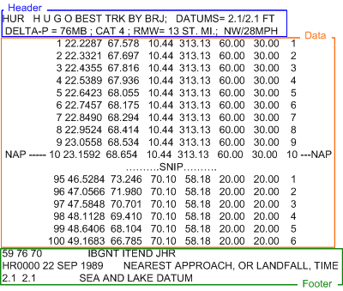

Figure 32 – TRK Data File Breakdown

5.0 SLOSH DISPLAY PROGRAM GRAPHICAL USER INTERFACE

This section breaks down each component of the SLOSH Display Program’s Graphical User Interface (GUI). When first launched the initial state of the SLOSH Display will either be the most recently selected SLOSH basin or a map of the Washington D.C. region – Figure 33.

The SLOSH Display Program menu bar options are as follows, label 1, Figure 33:

Menu Bar Option: File:

Save to PCX: Saves SLOSH Display as a .pcx graphic image.

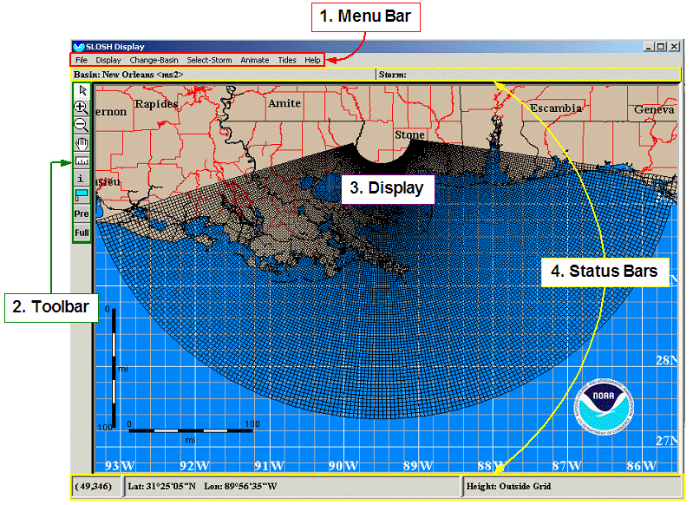
Figure 33 – SLOSH Display Program Initial Graphical User Interface

Save to TIF: Saves “SLOSH Display” as a graphical image, TIF format.

Update Basin Table: Function to ingest or update the SLOSH database (sloshdsp.ini) with new basins added post install. New .bnt (.bnt = basin name table) files are placed in the default directory c:\slosh.pkg\data and then this function is selected to import/update.
Update Data Root Directories: Function allowing users to edit default path information defining where SLOSH looks to ingest Rex and MEOW/MOM files and also identifies where output data will be stored.

Quit: Exit SLOSH Display Program

Menu Bar Option: Display:

Label Counties: Toggle to display counties on map background.

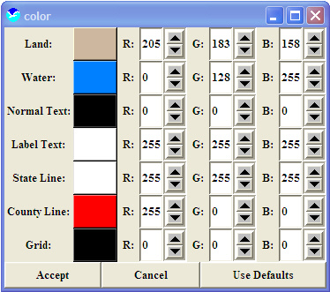
Label Locations: Toggle to display town/city names on map background.

Label Buoys: Toggle to display ocean buoys on map background.

Label Surge: Toggle to display surge data.

Tracks: Option to display hurricane tracks associated with an Envelop or a MEOW, the latitude and longitude storms pass through.

Notes about tracks: Figure 34 – Change Color GUI

- With MOMs there would be too many tracks to display so they are excluded. Rex file tracks are always on, however when pausing an animation and then clicking on Tracks option, the tracks and circle of maximum winds will be removed. Resuming the animation will redraw the tracks and wind.

SLOSH Grid: The SLOSH model uses a polar, elliptical, or hyperbolic grid for its computations, depending on the slosh basin. The reason for not using a Cartesian grid is for finer resolution near the shore.

Entire Grid: Toggle to display entire SLOSH storm surge grid. Default shortens the extreme outer grids

Fixed Color Scale: The default color scale for storm surge heights customizes itself for each storm and basin chosen. The scale can be modified the up and down arrow buttons located to the right of the color spectrum on the surge height legend. The Fixed Color Scale then enables the user to keep the color scale from changing when different storms are loaded, making it easier to visually compare storms.

Change Colors: This option opens a color selection window used to change the colors of the land, water, text coastline, or grid on the SLOSH Display. Colors can be modified by clicking the up and down arrows for red (R), green (G), and blue (B) – figure 34.

Cascading Menu: Lat/Lon Grid:

No Lat/Lon Grid: Toggle to display latitude and longitude overlay on SLOSH map background. Radio box with No Lat/Long Grid, Grid & SubGrid, Grid, and Lattice selections.

Grid & SubGrid: Displays SLOSH basin grid and Latitude/Longitude graph on SLOSH Display. Radio box with No Lat/Long Grid, Grid & SubGrid, Grid, and Lattice selections.

Grid: Displays only SLOSH basin grid on SLOSH Display. Radio box with No Lat/Long Grid, Grid & SubGrid, Grid, and Lattice selections.

Lattice: Toggle between Lat/Lon line grid to Lat/Lon corner marker grid. Radio box with No Lat/Long Grid, Grid & SubGrid, Grid, and Lattice selections.

Automatic: SLOSH software assigns latitude/longitude and sub grid spacing to default map background of selected image, one degree equals 60 nm. Toggle with 1 degree (.2 subgrid), 1 degree (1.25 subgrid), 5 degree blocks, 10 degree blocks, 15 degree blocks functions.

1 degree (.2 subgrid): Sets latitude and longitude to 1 degree spacing and the graphical subgrid to .2 degrees on the map background. Toggle with Automatic, 1 degree (1.25 subgrid), 5 degree blocks, 10 degree blocks, 15 degree blocks functions.

1 degree (1.25 subgrid): Sets latitude and longitude to 1 degree spacing and the graphical subgrid to 1.25 degrees on the map background. Toggle with Automatic, 1 degree (.2 subgrid), 5 degree blocks, 10 degree blocks, 15 degree blocks functions.

5 degree blocks: Sets latitude and longitude to 5 degree spacing. Toggle with Automatic, 1 degree (.2 subgrid), 1 degree (1.25 subgrid), 10 degree blocks, 15 degree blocks functions.

10 degree blocks: Sets latitude and longitude to 10 degree spacing. Toggle with Automatic, 1 degree (.2 subgrid), 1 degree (1.25 subgrid), 5 degree blocks, 15 degree blocks functions.

15 degree blocks: Sets latitude and longitude to 15 degree spacing. Toggle with Automatic, 1 degree (.2 subgrid), 1 degree (1.25 subgrid), 5 degree blocks, 10 degree blocks functions.

Grid over land & water: Selection covers both land and water map regions with latitude/longitude and subgrid graphics. Toggle with Grid over land function.
Grid over land: Selection to display latitude/longitude and subgrid graphics over land only. Toggle with Grid over land & water function.

Cascading Menu: Units:

Surge (Feet): Toggle storm surge data in feet. Toggle with Surge (Meters) selection.

Surge (Meters): Toggle storm surge data in meters. Toggle with Surge (Feet) selection.
Distance (Statute Miles): Toggle calculated distance in Statute Miles. Toggle with Distance (Kilometers) and Distance (Nautical Miles) selections.

Distance (Kilometers): Toggle calculated distance in Kilometers. Toggle with Distance (Statute Miles) and Distance (Nautical Miles) selections.

Distance (Nautical Miles): Toggle calculated distance in nautical miles. Toggle with Distance (Statute Miles) and Distance (Kilometers).

Degrees (minutes/seconds): Toggle Lat/Lon status bar display (label 4,
Figure 33) to minute/second format

Degrees (decimal): Toggle Lat/Long status bar display (label 4, Figure 33) to decimal format

Quad: Toggle degree in status bar to SLOSH grid quadrant (label 4, Figure 33)

Cascading Menu: Zoom:

None: (arrow) in the tool bar, turns all Zoom commands off and enables users to move the labels/map keys.

Zoom In: (+) in the tool bar, zoom into desired map location. Select function, left mouse click and release over map, drag box over desired area on map, left mouse click to zoom. Slight lag expected. Function must be reselected every time to repeat.

Zoom Out: (-) in the tool bar, zoom out map view. To use: Select function, left mouse click anyplace over map. Slight lag expected. To repeat simply left click mouse button over map until desired map perspective.

Pan: (hand) in the tool bar, function to reset the map center point. To use: Select function, left mouse click and hold, move pointer as desired, release mouse button.

Ruler: (ruler) in the tool bar, function to measure distance between desired points. To use: Select function, left mouse click and release over first location point, move cursor to next point, left mouse click, and repeat as desired. Top measurement reflects most recent point-to-point measurement and the bottom is the total measurement from most recent point to last point. To remove line measurements click right mouse button.

Inquire All: (i) in the tool bar, functionality to display MEOW graphics on the SLOSH map background also providing users a method to interrogate MEOW on a individual cell basis. For more detail about Inquire All reference section 5.3

Probe: (flag) in the tool bar, determines height of storm surge by placing “measurement” flags in desired locations. Not intended for overland use. To use: Select function, left mouse click over desired “water” location, repeat placement as desired.

Previous Zoom: (pre) in the tool bar, enables the user to go back to the last zoom level, all the way back when the SLOSH basin was last changed.

Full Zoom: (Full) in the tool bar, enables the user to redraw the SLOSH basin in its original size.

Cascading Menu: View:

Full Window: Restores the SLOSH Display to it’s original position.

Window A, B, C: Selections to enlarge the SLOSH display to predefined zoom levels for selected basin.

Discrete Color Scale: Allows users to display the storm surge using one color for a set of values. Usually this is one color for (0,1] feet, another for (1,2] feet (or 0, 1] meter).

Value Follow Mouse: Displays storm surge values at the cursor location. Values are also displayed at the bottom of the screen in the Height Label – label 4, Figure 33.

Menu Bar: Change-Basin:

Change-Basin: Change the selected basin view. To switch basins double click on the desired basin from the presented list – Figure 35.

Cascading Menu: Which Coast?:

Atlantic: While in the Change-Basin mode as shown in figure 35 selecting Atlantic will switch the map background to an Atlantic view.

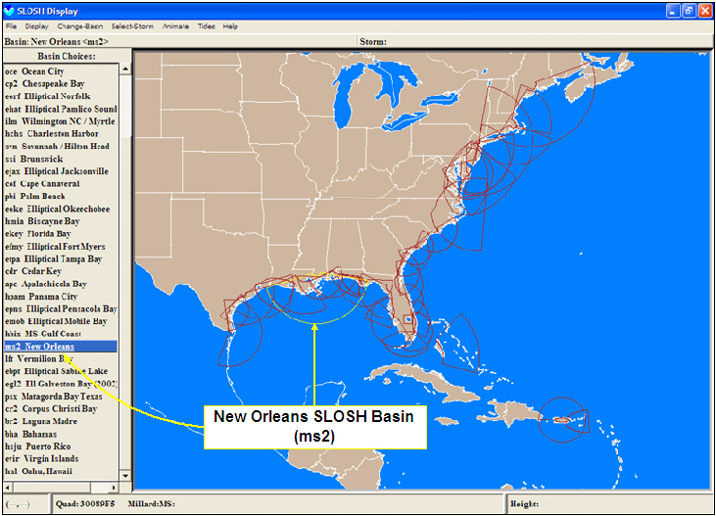
Figure 35 – Change-Basin Graphical User Interface

Pacific: While in the Change-Basin mode as shown in figure 35 selecting Pacific will switch the map background to a Pacific view.

Cascading Menu: Which Basins?

Installed: While in the Change-Basin mode as shown in figure 35 selecting Installed will displayed all default basins originally installed.

All: While in the Change-Basin mode as shown in figure 35 selecting All will display every basin recognized by SLOSH, including installed defaults and post-installed basins.

Menu Bar: Select Storm:

Select Storm: Functions to simulate various storm surge measurements (Historical, MEOW, MOM) reference 5.2 for full detail.

Inquire All: Functionality to display MEOW graphics on the SLOSH map background also providing users a method to interrogate MEOW on a individual cell basis. For more detail about Inquire All reference section 5.3.

Menu Bar: Animate:

Animate .rex File: Time-lapsed animated “movies” of historical SLOSH based storm surge data, representing actual storm surge water level information. For instructions to use this function reference section 5.4.

Import .rex File: Import a .rex file SLOSH Display Program. New files are copied into c:\slosh.pkg\data\rexfiles – section 5.5.

No Wind: Check box toggling wind barbs display on or off of rex image.

Wind (follow track): Check button to sets wind barbs to follow selected storm loop
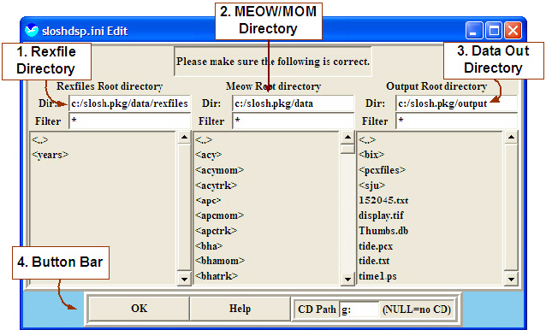
Wind (fixed points): Check button to sets wind barbs to remain stationary to map background as storm loops

Pressure Contours: Check button to display pressure contours around selected storm.

Wind Grid (l x w): Sets the size (the square, length x width) of the wind grid around a storm, default is 21x21.

Anim to .pcx files: Function Figure 36 – sloshdsp.ini Edit User Interface
allowing users to generate and export
animated GIF images.

5.1 SLOSH sloshdsp.ini Edit Graphical User Interface

The sloshdsp.ini file provides path and other configuration parameters used by the SLOSH Display program. The sloshdsp.ini GUI allows users an interface to edit the most commonly used paths for: 1) rex riles, 2) MEOW/MOM files, and 3) output data. The default paths are c:\ slosh.pk\data\rexfiles, c:\slosh.pk\data, and c:\slosh.pkg\data\ respectively as set during the install process.

The sloshdsp.ini Edit interface breaks down very simply as shown in figure 36:

1) Rexfile directory: default is c:\slosh.pkg\data\rexfiles. Users can change this path by navigating to the desired directory from the “Rexfiles Root directory” directory list box.

2) Meow/MOM Directory: default is c:\slosh\pkg\data. Users can change this path by navigating to the desired directory from the “Meow Root directory” as shown. Note: Although MOMs are not described they will also be associated with this listing/directory.

3) Data Out Directory: default is c:\slosh.pkg\output. Users can change this path by navigating to the desired directory from the “Output Root directory”

4) Button Bar: There are three components to the button bar:
- OK – Will save and close the sloshdsp.ini Edit interface
- Help – Launches help interface providing instruction to the sloshdsp.ini Edit interface, similar to this section.
- CD Path – Defines the CD-ROM drive with the initial default as “g:”. If no CD-ROM exists users will receive a pop-up window to define a path on the local drive to retrieve data.

5.2 Storm Selection

From the SLOSH Display program’s menu bar option “Select Storm -> Select Storm” a separate user interface is launched allowing users to simulate storm surge related measurements from Historical, MEOW, and MOM based perspectives.

5.2.1 Display Historical SLOSH Model Data

The SLOSH Display program provides an option where users can display historical storm data but only for the following seven storms. To use the historical display:

Basin | Storm File
Apalachicola Bay | agnes.apc
Bahamas | andrwnhc.bha
Sabine Lak | audrey.ebp
Fort Myers | andrew.fmy
Virgin Island | h1928.vir
Oahu, Hawaii | oahu1.hnl
Puerto Rico | h1928.sju

Figure 37 – SLOSH Historical Storm Data Chart

1) In the SLOSH Display Program select desired basin – see figure 35.
► Menu Bar: Change-Basin -> Change Basin
► In the Change Basin interface double click on the desired based in list box

2) Launch the Select Storm user interface.
► Menu Bar: Select Storm -> Select Storm
3) Select the Historical option of the Select Storm interface – label 1, figure 38
► Select Historical radio button, top center

4) Select desired Historical storm from list – label 3, figure 38:
► Select from list box as shown
Note: Historical storm file naming breaks down as follows
- E10510.ms2:
  - E = direction: east storm motion
  - 1 = Category: Cat 1-5
  - 05 = Forward Speed: mph
  - I0 = Mean or High Tide: Number other than 0 is high tide (EG., I2 means high tide of 2ft NGVD29 or I0 means mean tide of 0ft NGVD29)
  - .ms2 = basin

5) Generate Historical display – see figure 38:
► Select Apply Button

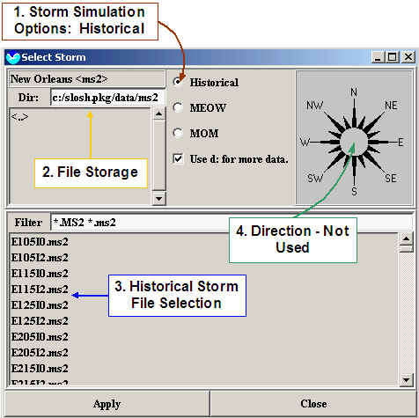

Figure 38 – Select Storm “Historical” Interface

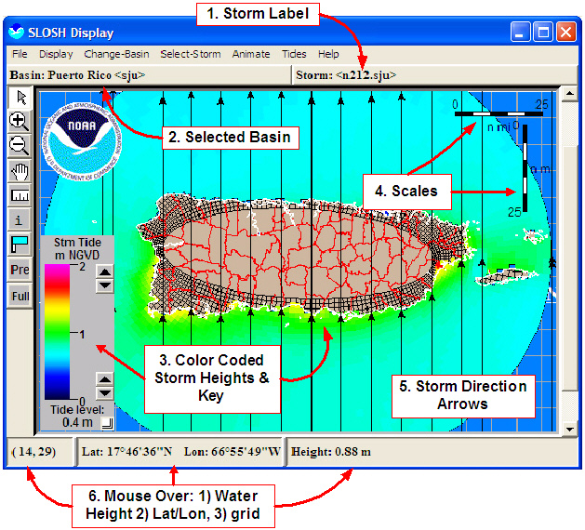

Figure 39 – Selected Storm “Historical” Display

5.2.2 Display MEOW SLOSH Model Data

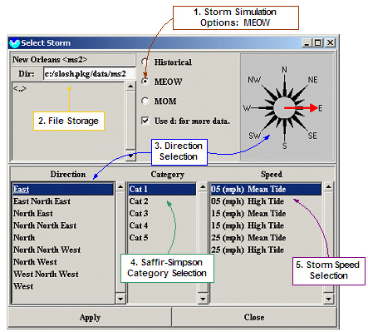

Figure 40 – Select Storm “MEOW” Interface
The Maximum Envelope of Water (MEOW) is a composite of maximum storm surge heights at each SLOSH grid cell using hypothetical hurricane runs with the same: 1) category, 2) forward speed, 3) landfall direction, 4) initial tide level, and 5) radius of maximum winds. Users can view MEOWs in two ways: 1) Using the Inquire tool described in section 5.3, or 2) through the Select-Storm Interface steps described in this section.

1) In the SLOSH Display Program select desired basin – see figure 35.
► Menu Bar: Change-Basin -> Change Basin
► In the Change Basin interface double click on the desired basin in list box

2) Launch the Select Storm user interface.
► Menu Bar: Select Storm -> Select Storm

3) Open the MEOW option of the Select Storm interface – label 1, figure 40:
► Select MEOW radio button, top center
4) Select desired storm motion (from) – label 3, figure 40:
► Use list box selection or compass as shown

5) Select storm category/strength (Saffir-Simpson) – label 4, figure 40:
► Select category 1-5 as desired from list box

6) Select desired storm speed and tide information – label 5, figure 40:
► Select from list box as shown
Note: 1) Selecting high tide option is recommended to generate a conservative estimate as high tide selections create greater storm surge.
7) Generate MEOW Image:
► Select Apply Button

After generating the MEOW in the SLOSH display it should look similar to figure 42. The storm direction arrows represent each hypothetical hurricane track used to generate the MEOW. The arrow indicates storm movement, the category and direction are constant and the MEOW is generated by taking, in each grid cell, the maximum of the hypothetical storm surge/storm tide envelopes.

5.2.3 Display MOM SLOSH Model Data

The Maximum of MEOWs (MOM) is a composite of the maximum storm surge/storm tide for all hurricanes of a given category. Only one storm per category or five MOMs per basin are produced which disregards forward speed, landfall direction and landfall locations. The following instructions will assist users in displaying a MOM for any desired basin:

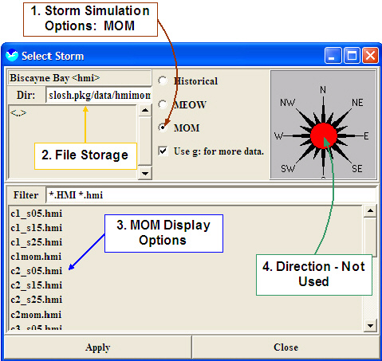

Figure 41 – Select Storm “MOM” Interface

1) In the SLOSH Display Program select desired basin – see figure 35
► Menu Bar: Change-Basin -> Change Basin
► In the Change Basin interface double click on the desired basin in list box

2) Launch the Select Storm user interface.
► Menu Bar: Select Storm -> Select Storm

3) Open the MOM option of the Select Storm interface – label 1, figure 41
► Select MOM radio button, top center
4) Select the desired filename in the Select Storm interface – label 1, figure 41
► Select from file list box as shown
Note: 1) File naming conventions vary between basins, however each name will follow similar naming conventions as the examples below:
- c2_s25.hmi = Cat 2, Direction South at 25 kts, Basin hmi
- HI1_MOM.MS2 = High Tide, Cat 1, MOM, Basin MS2
- C5_MEAN.MS2 = Cat 5, Mean Tide, Basin MS2
2) For offices from Pamlico Sound south, MOMs are listed as fast, slow, or mom; the Norfolk basin to the Atlantic City basin MOMs are listed as mean or HIx – where x is the category number and HI means high tide; and the New York City basin to the Pemobscot basin are listed as mean (me or mean) or high (hi) along with a category number.

5) Generate MOM Image – see figure 42
► Select Apply Button

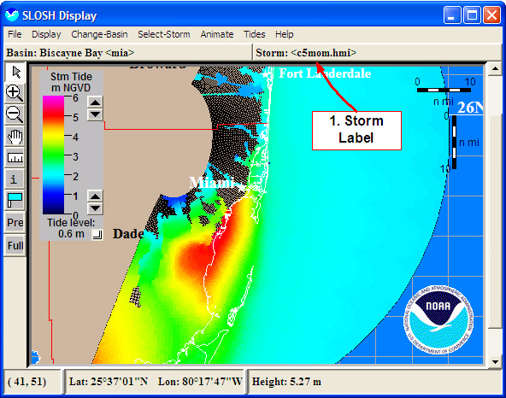
The only obvious difference between MOM and MEOW output is the storm label as shown in figure 42, label 1. Notice the absence of storm direction arrows? Since the MOM is the maximum of the MEOWs with no direction associated it is therefore missing in the display

Figure 42 – Example Cat 5 MOM Display for Biscayne Bay Basin

5.3 Inquire All

The SLOSH Display Program’s Inquire All functionality allows users to display all available Maximum Envelope of Water (MEOWs) images, similar to the Selected Storm MEOW method found in section 52.2. What makes this functionality unique is that individual cells that comprise a MEOW image can be interrogated independently. This data then shows how different combinations of storm category, wind speed, and forward speed affects the maximum potential storm surge/storm tide of the selected location.

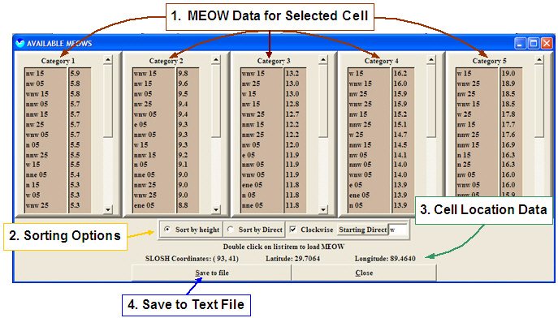
Figure 43 – Inquire All User Interface

The Inquire All user interface breaks down into 4 major components as shown in figure 43. Label one represents five Saffir-Simpson category list boxes providing users detailed MEOW data of the selected cell based on direction, speed, and category. Users can also graphically display related list box data by double clicking on the desired field which is then displayed on the SLOSH map background. To ease searching for the desired MEOW data list sorting functions are provided allowing users to sort list box data by height and direction as shown in label 2. Label 3 highlights the cell location by grid reference and Latitude/Longitude. Finally label 4 points out the Save to File option to save grid data in a text file – see figure 44. When using the Save to File function note that files will be stored in c:\slosh.pkg\output\<basin id> and by grid number ending in .hgt unless otherwise changed. Below are steps to use the Inquire All Functionality.

1) In the SLOSH Display Program select desired basin – see figure 35:
► Menu Bar: Change-Basin -> Change Basin
► In the Change Basin interface double click on the desired based in list box

2) Select the desired grid to analyze:
► Menu Bar: Display -> Zoom -> Inquire All
► Place “question mark” cursor over grid to analyze
► Over desired grid select with left mouse button
Note: May be necessary to zoom to select desired grid

3) In the launched Inquire All interface expand window, view and/or save data.
Note: 1) To view graphical image of desired data point in list box, double click with left mouse button. 2) saved files will be stored in c:\slosh.pkg\output\<basin id> and by grid number ending in .hgt unless otherwise changed.
4) Close Inquire All interface
► Select close button

Surge heights at a given point for all available MEOWS

Basin = sju

SLOSH grid reference (I,J) = (4,146)
Approximate Lat = 18.503184 Long = 66.778931

Category 1 Category 2 Category 3

dir sp surge dir sp surge dir sp surge

n 12 1.8 n 12 2.4 n 12 3.0
nne 12 1.8 nne 12 2.4 nne 12 3.0
ne 12 1.7 ne 12 2.3 ne 12 2.9
nnw 12 1.7 nnw 12 2.3 nnw 12 2.9
nw 12 1.7 nw 12 2.3 nw 12 2.8
w 12 1.7 w 12 2.2 w 12 2.8
wnw 12 1.7 wnw 12 2.2 wnw 12 2.8
wsw 12 1.6 wsw 12 2.0 wsw 12 2.5

Category 4 Category 5 Historical

dir sp surge dir sp surge dir sp surge

n 12 3.6 n 12 4.2 h1928 1.8
nne 12 3.6 nne 12 4.2
ne 12 3.5 ne 12 4.1
nnw 12 3.5 nnw 12 4.1
nw 12 3.4 nw 12 4.0
w 12 3.3 w 12 3.9
wnw 12 3.3 wnw 12 3.8
wsw 12 2.9 wsw 12 3.4

Figure 44 – Inquire All, Grid Specific, Text Output

5.4 Animate Historical Rex Data

This section describes the necessary features and functionality to display and animate Rex data in the SLOSH Display program. The provided historical Rex data files delivered with the SLOSH CDrom are as follows:

Rex Filename | Basin Name |  | Rex Filename | Basin Name
bret.rex | cr2: Corpus Christi Bay |  | eloise.rex | epns: Elliptical Pensacola Bay
dennis_1.rex | ehat: Elliptical Pamlico Sound |  | agnes.rex | apc: Apalachicola Bay
dennis_2.rex | ehat: Elliptical Pamlico Sound |  | camilbix.rex | hbix: MS-Gulf Coast
floydbha.rex | bha: Bahamas |  | camilms2.rex | ms2: New Orleans
floydchp.rex | cp2: Chesapeake Bay |  | betsy.rex | ms2: New Orleans
floydeht.rex | ehat: Elliptical Pamlico Sound |  | carla.rex | psx: Matagorda Bay Texas
floydilm.rex | ilm: Wilmington NC / Myrtle Beach |  | donnafmy.rex | efmy: Elliptical Fort Myers
bonnie.rex | ehat: Elliptical Pamlico Sound |  | gracie.rex | hchs: Charleston Harbor
earl.rex | apc: Apalachicola Bay |  | audrey.rex | ebpt: Elliptical Sabine Lake
geor_mob.rex | emob: Elliptical Mobile Bay |  | hazel.rex | ilm: Wilmington NC / Myrtle Beach
geor_ms2.rex | ms2: New Orleans |  | oke1949.rex | eoke: Elliptical Okeechobee
Georg_la.rex | hbix: MS-Gulf Coast |  | ms2-1947.rex | ms2: New Orleans
Georg_sj.rex | hsju: Puerto Rico |  | ms2-1947.rex | ms2: New Orleans
Georg_vi.rex | evir: Virgin Islands |  | bos1944.rex | box: Boston Harbor
ERIN.rex | cof: Cape Canaveral |  | nyc1944.rex | ny2: New York
opal.rex | epns: Elliptical Pensacola Bay |  | pvd1938.rex | pvd: Narragansett/Buzzard Bays
andr_ms2.rex | ms2: New Orleans |  | chp1033.rex | cp2: Chesapeake Bay
andrew_b.rex | bha: Bahamas |  | sju1928.rex | hsju: Puerto Rico
andrewfl.rex | hmia: Biscayne Bay |  | eky1926 | ekey: Florida Bay
andrewla.rex | lft: Vermilion Bay |  | mia1926.rex | hmia: Biscayne Bay
iniki.rex | hkwa: Kauai, Hawaii (Non-Op) |  | tpa1921.rex | etpa: Elliptical Tampa Bay
bob.rex | ny2: New York |  | ms2-1915.rex | ms2: New Orleans
hugo.rex | hchs: Charleston Harbor |  | ms2-1909.rex | ms2: New Orleans
florence.rex | ms2: New Orleans |  | ms2_1909.rex | ms2: New Orleans
gloranyc.rex | ny2: New York |  | gls1900.rex | egl2: Ell Galveston Bay (2002)
Alicia.rex | egl2: Ell Galveston Bay (2002) |  | allen.rex | br2: Laguna Madre

Figure 45 – SLOSH Historical Rex DataFiles on Install CD

The basic instruction to display historical rex file data is described below:

1) In the SLOSH Display Program launch the Animation Setup interface:
► Menu Bar: Animate -> Animate .rex file

2) Select the desired storm and basin
► Bullet 1: <from provided list>

3) Animate selected storm
► Bullet 6: Start

The features and functionality of the Animation Setup interface shown in figure 46:

1. Storm & Basin Selection: Selectable Animation Filename and Basin Name list box of predefined, historical, .rex data files. Listed files are stored on the local drive at: C:\slosh.pkg\data\rexfiles\years\<year>. File naming conventions vary, however most common used is in the format described by example below:
- c:\slosh.pkg\data\rexfiles\years\1999\geor_ms2.rex
  - geor = Storm Name or partial name
  - ms2 = basin (New Orleans)
  - rex = rex file identification tag
- c:\slosh.pkg\data\rexfiles\years\1999\K27_ms2.rex
  - K = Storm name noted by first letter
  - 27 = Forecast advisory #
  - ms2 = basin (New Orleans)

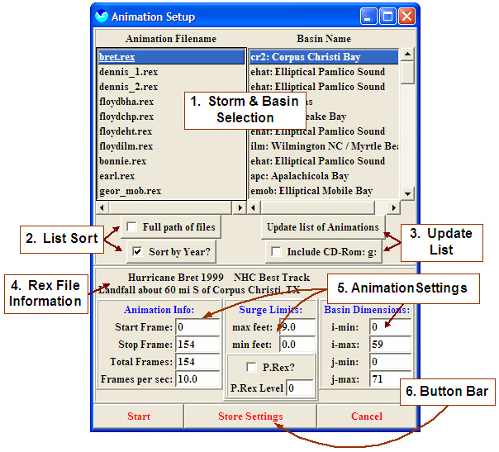
Figure 46 – SLOSH Display Program’s Animation Setup Interface

2. Sort List: To assist user in finding the desired storm selection two sorting features are provided: 1) Full path of files – adding the .rex full directory path information to Animation File list box data, default directory is C:\slosh.pkg\data\rexfiles\years\<year>, and 2) Sort by year – which orders Animation File list box data by earliest year of storm data.

3. Update List: Update list button allows users to retrieve imported .rex file storm data placed in the C:\slosh.pkg\data\rexfiles\years directory a CD-Rom search for .rex file will also be made if the Include CD-Rom option is checked. Updated results will be included in the Animation File and Basin Name list boxes.

4. Rex File Information: Information label describing the selected storm as reflected in the Rex file.

5. Animation Settings: Rex files have default animation settings, set by the person who created the original file. These parameters were selected to best represent the selected storm data, however users can temporarily adjust these values or permanently for the local copy by selecting Store after making any changes.
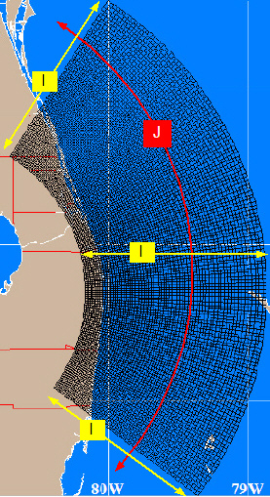
- Animation Info:
  - Start Frame: Begin loop at frame #
  - Stop Frame: End loop at frame #
  - Total Frames: Total number of individual frames that comprise rex image loop
  - Frames per second: Number of frames displayed in loop per second

- Surge Limits:
  - max feet: Maximum storm surge values on SLOSH map
  - min feet: Minimum storm surge values to display on SLOSH map
  - P.Rex & P.Rex Level: Future probabilistic storm surge settings to be fully defined at a later date.

- Basin Dimensions:
  - SLOSH grid dimensions closely resemble lat/lon, however due to the curvature SLOSH coordinates use a I/J representation as shown in figure 47.

6. Button Bar: The button bar consists of 3 buttons; 1) Start - Figure 47 – SLOSH I/J Coordinates
begin animation of selected storm on SLOSH display, 2) Store
Settings – will save, overwrite, original rex file animations parameters of selected Rex file.

Consider the following when displaying an animated .rex file:
- The storm surge will automatically be displayed on the animation. To view the animation without storm surge turn off the Surge option under Animate on the menu bar.
- Wind directions can also be displayed along with the animation. The winds can be activated by turning on the Winds option under Animate on the menu bar. These winds are the winds that the SLOSH model used in its computations and are approximately the ten minute average winds
- A new toolbar will appear:
  - Stop Sign / Exit Animation Button – will quit the animation function and restore the slosh display.
  - Pause button – will pause the animation.
  - Time History – function for users to interrogate grid cell specific storm surge data over time – see section 5.8.1.
  - Forward To End – advances the animation to the last frame when paused.
  - Forward 1 Frame – advances the animation one frame when paused.
  - Rewind 1 Frame – backs up the animation by one frame
  - Rewind To Beginning – backs the animation to the starting frame

5.5 Importing a Rex File

It is sometimes necessary to import actual National Hurricane Center (NHC) Rex based SLOSH forecasts or Rex files shared between storm surge researchers. The following steps can be used to import a Rex file into the SLOSH Display Program:

1) Launch the “SLOSH Display Program” application

2) Launch “Import REX” GUI:
► Menu Bar: Animate -> Import .rex file
► Click “OK” to message:
- “This allows you to import a .rex file from an arbitrary place, copy it to c:/slosh.pkg/data/rexfiles and let the SLOSH display program know you did so. First step…select the files to import. Continue?

3) In the Import REX Files interface:
► Navigate to desired directory
► Select desired REX file
► Select Done
► Click “OK” to several message boxes displayed:

4) Done

5.6 Generating PCX Based Animated GIF Images

1) Launch the “SLOSH Display Program” application

2) Launch “Import REX” GUI:
► Menu Bar: Animate -> Import .rex file
► Click “OK” to message:
- “This allows you to import a .rex file from an arbitrary place, copy it to c:/slosh.pkg/data/rexfiles and let the SLOSH display program know you did so. First step…select the files to import. Continue?

3) In the Import REX Files interface:
► Navigate to desired directory
► Select “all” desired REX files
► Select Done

4) Animate REX files:
► Menu Bar: Animate -> Animate .rex file -> select file
► Select: Just Import -> Start
Note: Allow loop to run through once before moving on to step 5
5) Remove Wind & Basin grids:
► Menu Bar: Animate -> No Wind
► Menu Bar: Display -> SLOSH Grid

6) Resize map, zoom as needed, for best centering:
► Vertical Menu Bar: <Magnify Glass Button>

7) Place map keys in appropriate locations as desired:
► Drag & Drop with left mouse

8) Place appropriate “Probe Flags” to determine water level for desired locations. Ensure flags are over water rather than over land:
► Left mouse selection, flag on left vertical button bar.
► On the map, move curser over desired area, single click left mouse to
place
► Repeat flag placement as desired

9) Save to SHP:
► Menu Bar: File -> Save to SHP

10) In “Save As” GUI select folder to save in:
At TPC use the following steps:
► Change Directory: w:\
► Select Drive Folder: G-LOCKET
► Select Storm Folder: <Katrina2005>
► Name File:
<run>_<basin>_<added water in feet>_<RMAX>_<SLOSH Version>_<Date>.rex
EG: final_ms2_2_4-rmw_3-5slosh_01_24_2006.rex
► Select: Done

11) In “Ship Query” GUI displayed, do nothing:
► Select: Done

12) Animate:
► Menu Bar: Animate -> Animate to PCX
► In GUI Select: OK
At TPC use the following steps
Keep Default Directory
► “Deleting Old” message box Select: OK
Long Processing

13) Load “Anamagic Software”:
► At TPC: Desktop Icon

14) Open New Session:
► Menu Bar: File -> Open

15) Change file type to PCX:
► Bottom Dropdown Menu Select: PCX

16) Select PCX Files:
Steps for < 191 PCX Files
► Hold “Shift Key”, Left mouse select first image
► Select the last PCX file
Will highlight the first through the last
► Select: OK
Steps for > 191 PCX Files
► Hold “Shift Key”, Left mouse select first image
► Select the 191th PCX file
The first 191 files will be highlighted
► Select: OK
► Menu Bar: File -> Append Frames…
► Hold “Shift Key”, Left mouse select first image
► Select the 191th PCX file, or last
► Select: OK
► Repeat “Append Frames…” steps until all desired PCX files have been loaded

17) Set Animation Frame Rate:
► Menu Bar: Animation -> Frame Rate
► Set: 100 <milliseconds>

18) Test Animation, Visually inspect for bad or undesired frames:
► Vertical Button Bar Select: Play

19) Delete bad or undesired frames as needed:

20) Repeat Steps 18 & 19 until loop/animation is desirable:

21) Set Frame Rate Animation:
► Menu Bar: Animation -> Frame Rate
► Set “First Frame” to: 15
► Set “Last Frame” to: 25

22) Watch Animation again for accuracy, make changes as needed

23) Save File:
► Menu Bar: File -> Save Optimized
► Select Desired Directory
► Name File: <use same name in step 10>
► Select: Save

24) Done

5.7 Astronomical Tide Prediction

Tides are generated by the gravitational attraction between both the earth and the moon and the earth and the sun. Tides vary significantly in amplitude, maxima/day, and minima/day along the U.S. coastline depending on latitude, geographic location, and bathymetry. Astronomical tide computations use mathematical expressions containing unique constituents for each location. Tidal constituents are determined by analyzing tide guage data from anywhere between several months to the ideal period of 19 years (or a tidal epoch). Tide elevations are evaluated assuming the bathymetry of the location remains unchanged since the constituents were derived.

Tides play an important role in determining the total water level experienced during a hurricane. SLOSH currently computes the wind-induced storm surge above a constant tide level. Generally, SLOSH MOMs and MEOWs were formed using high-tide water conditions. The Astronomical Tide Prediction or Tide Display program allows forecasters and emergency managers to view the range of predicted tides for a given period.
Woods Hole, MA
date hr height (Feet)
03/01/2006 00 -0.24
03/01/2006 01 -0.63
03/01/2006 02 -1.13
< snip >

Stamford, CN
date hr height (Feet)
03/01/2006 00 4.99
03/01/2006 01 4.14
03/01/2006 02 2.21
< snip >

Bar Harbor, ME
date hr height (Feet)
03/01/2006 00 6.36
03/01/2006 01 3.99
03/01/2006 02 0.54
< snip >

The Computations used in the Tide Display Program were created by Art Pore and modified by Kurt W. Hess. Tide computations should be checked periodically for accuracy against the NOS tide tables, especially for critical situations. To further understand how tides interact with storm surge heights reference the extratropical storm surge website at: http://nws.noaa.gov/mdl/etsurge. This site is an extremely useful source of information about the predicted total water level at a given station. Figure 49 is a snapshot of the Tide Display interface launched from the SLOSH Display menu bar under Tide -> Tide Display, the features and functionality break down as follows: Figure 48 - .txt Tide Data

Menu Bar Option: File:

Save (.ps): Save Tide Display as PostScript image file.

Save (.pcx): Save Tide Display as a standard .pcx image file

Save (.txt): Save hourly tide data of selected stations to an ASCII text file – see figure 48

Print: Print Tide Display Image – Deactivated.

Exit: Exit Tide Display Program
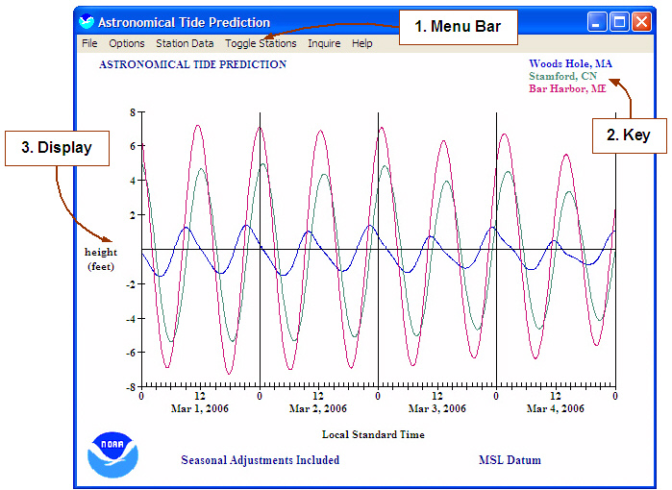
Figure 49 – Astronomical Tide Prediction or Tide Display Program

Menu Bar Option: Options:

View Data: Graphical User Interface display of hourly tide data of
selected stations. Similar to Save (.txt) function.

Units: Selections to toggle displayed data between feet and meters.

Grid: Selection to toggle “whole number” x, y grid on data display. Default is inactive, not shown in figure 50.

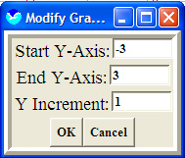
Change Background Color: Launches a color pallet allowing user to change the Tide Display background from default white to any selected color.

Change Station Colors: Color pallet to change selected side station colors.
Figure 50 - Modify Graph GUI
Restore Default Colors: Restores Default colors for both the
display background and selected tide stations.

Modify Graph Parameters: Allows users to adjust the X-Axis, Y-Axis, and Y Increment parameters of the tide display – see figure 50.

Restore Parameters: Function to reset defaults of the tide display altered by Modify Graph Parameters function.

Restore Label Positions: Label positions can be moved with left mouse button, this option places this key data back to the default placement as shown.
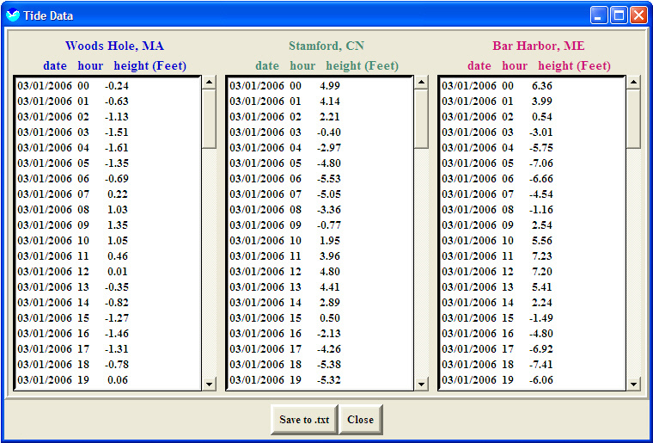
Figure 51 – Tide Data User Interface, View Data

Menu Bar Option: Station Data:

Change Current Stations: Provides a list of 179 selectable tide stations to plot on the Tide Display (see table below) and a max of three stations can be selected at one time see figure 51 for snapshot of interface. All or some of the stations can be changed by first double clicking on the desired station and then clicking ok. If duplicate stations are chosen, the graphs will be drawn overlapping.

North East:
1 Eastport, ME | 12 Providence, RI | 23 Willets Point, NY
2 Bar Hbr, Frenchman Bay, ME | 13 New Bedford, MA | 24 New York (Battery), NY
3 Bar Harbor, ME | 14 Newport, RI | 25 Albany, NY
4 Portland, ME | 15 Block Island, RI | 26 Bayonne Br., Staten Is. NY
5 Rockland, ME | 16 New London, CN | 27 Bay Shore, L.I., NY
6 Portsmouth, NH | 17 Bridgeport, CN | 28 Spuyten Cr., Hudson R., NY
7 Boston, MA | 18 Stamford, CN | 29 Sandy Hook, NJ
8 Cape Cod, Sandwich, Ma | 19 Old Saybrook Point, CN | 30 Atlantic City, NJ
9 Cape Cod, Buzzards Bay, MA | 20 Montauk Point, NY | 31 Cape May, NJ
10 Nantucket, MA | 21 Montauk, Ft. Pond Bay, NY | 32 Trenton, Del R., NJ
11 Woods Hole, MA | 22 Port Jefferson, NY | 33 Tuckahoe River, NJ
Mid-Atlantic:
1 Philadelphia, PA | 10 Chesapeake Beach, MD | 19 Chincoteague Channel, VA
2 Philadelphia, Del R., PA | 11 Havre De Grace, Susq R, MD | 20 Colonial Beach, VA
3 Reedy Point, DE | 12 Tolchester Beach, MD | 21 Clouchester Pt, VA
4 Breakwater Harbor, DE | 13 Washington, DC | 22 Kiptopeke Beach, VA
5 Indian River Inlet, DE | 14 Solomons Is, MD | 23 Lewisetta, Potomac R, VA
6 Ocean City, MD | 15 Old Point Comfort, VA | 24 Wachapreague, VA
7 Baltimore, MD | 16 Hampton Roads, VA | 25 Wallops Is., VA
8 Annapolis, MD | 17 Chesapke Bay Br Tunnel VA | 26 Windmill Pt, Ches Bay, VA
9 Cambridge, MD | 18 Portsmouth, VA | 27 Virginia Beach, VA
Southeast:
1 Duck Pier, NC | 10 Myrtle Bch (Springmd P), SC | 19 Daytona Beach, (Ocean) FL
2 Avon, NC | 11 Myrtle Beach, SC | 20 Daytona Bch, (Sunglo P.) FL
3 Cape Hatteras (Pier), NC | 12 Charleston, SC | 21 Canaveral Harbor Ent, FL
4 Morehead City, NC | 13 Cooper River, SC | 22 Lake Worth Pier, FL
5 Wilmington, NC | 14 Savannah, GA | 23 Haulover Pier, FL
6 Wrightsville Beach, NC | 15 Savannah R. Entrance, GA | 24 Miami, FL
7 Holden Beach, NC | 16 Kings Bay, Cumberland GA | 25 Vaca Key, Florida Bay, FL
8 Beaufort, Duke, NC | 17 Fernandina, FL | 26 Key West, FL
9 Ocracoke, NC | 18 Mayport, FL
Gulf of Mexico:
1 Naples, FL | 23 Ozello, St Martines R. FL | 45 Eugene Island, LA
2 Punta Rasa, FL | 24 Panama City Beach, FL | 46 Weeks Bay, LA
3 Anna Maria, FL | 25 Red Bay Pt. St Johns R. FL | 47 Calcasieu Pass, LA
4 St. Petersburg, FL | 26 Shell Is., Crystal R. FL | 48 Terrebonne Bay, LA
5 Indian Bay, FL | 27 Shell Point, FL | 49 Cypremort Pt, LA
6 Cedar Key, FL | 28 St. Augustine Beach, FL | 50 Southwest Pass (Delta) LA
7 St. Marks R. Entrance, FL | 29 Port Canaveral, FL | 51 Venice, Grand Pass, LA
8 Apalachicola, FL | 30 Tuckers Is, Homosassa, FL | 52 Sabine Pass, TX
9 Aligator Bayou, FL | 31 Turkey Point, FL | 53 Gilchrist, TX
10 Pensacola, FL | 32 Twin R Marina, Crystl R FL | 54 Galveston, TX
11 Chassahowitzka R., FL | 33 Virginia Key, Bear Cut, FL | 55 Galveston, TX Pleasure P.
12 Clearwater Beach, FL | 34 Mobile, AL | 56 Freeport, TX
13 Dixie Bay, Salt R., FL | 35 Dauphin IS., AL | 57 Pt O’Connor, Matagorda TX
14 Fort Myers, FL | 36 Bay St. Louis, MS | 58 Port Aransas, TX
15 Halls River, FL | 37 Waveland, Bay St. Louis MS | 59 Port Isabel, TX
16 Chassahowitzka Bay, FL | 38 Gulfport Harbor, MS | 60 Padre Island, TX
17 Key Colony Beach, FL | 39 Waveland, MS sound, MS | 61 Aransas Channel, TX
18 Kings Bay, Crystal R. FL | 40 South pass, LA | 62 Corpus Christi, TX
19 Mangrove Pt, Crystal R. FL | 41 Grand Is, East Pt, LA | 63 Nueces Bay, TX
20 Homosassa Bay, FL | 42 Bayou Rigaud, LA | 64 Lynchburg, TX
21 Navarre Beach, FL | 43 Humble Oil Platform, LA | 65 Pt Lavaca, Matagorda TX
22 Ozello N., Crystal Bay FL | 44 Timbalier Island, LA | 66 Rockport, Aransas Bay TX
Caribbean:
1 San Juan, PR | 4 Mangueyes Island, PR | 7 Charolette Amali, VI
2 Boca De Cangrejos, PR | 5 Punta Tuna, PR | 8 St Croix, Lime Tree, VI
3 Mangueyes Island, PR | 6 Brenner Bay, St Thomas VI
Pacific:
1 Hilo Bay, HI | 8 Kaneohe Bay, Oahu HI | 15 Malakal Harbor, palau Is
2 Honolulu, Oahu Is, HI | 9 Nawiliwili, HI | 16 Moen Is, Truk Atoll, Pac Oce
3 Kahului Harbor, HI | 10 Sand Is, Midway Islands | 17 Pago Pago, American Samoa
4 Kahului, Maui Is, HI | 11 Guam, Marianas | 18 Ponape Hbr, Caroline Is
5 Kawaihae, Hawaii Is, HI | 12 Johnston Atoll, Pac Ocean | 19 Mcmurdo Sound, Antarctic
6 Kaneohe Bay, Oahu HI | 13 Wake Is, Pacific Ocean
7 Kaneohe Bay, Oahu HI | 14 Kwajalein Atoll, Marshl Is

Figure 52 – Tide Stations in SLSOH

Change Starting Date: Produces a window containing four X-axis parameters: 1) Starting Year, 2) Starting Month, 3) Starting Day, and 4) Number of Days Shown. Each of these parameters may be modified by entering the desired number (within the boundaries given in parenthesis) and then clicking on OK. The Change Starting Date window contains an error check for leap years.

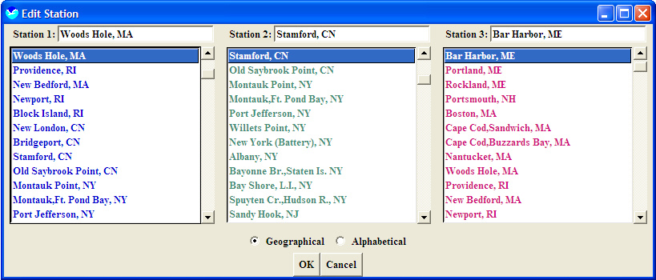
Figure 53 – Change Current Station / Edit Station Tide Display Interface

Adjust Reference Levels: The default reference level (or 0) for all tide data is set at Mean Sea Level (MSL). This option allows users to set a reference level above or below MSL. To restore back to ML users can select the Restore MSL Datum option.
Include Seasonal Adjustments (SA and SSA): The Tide Display Program automatically includes seasonal adjustments (SA & SSA) in its tide constituent data. Normal tide values always include these constants. If unselected this function allows users to view tide data adjustments.

Menu Bar Option: Toggle Stations:

Station 1,2,3: Toggle display of selected stations 1, 2, and 3.

Menu Bar Option: Inquire:

Inquire: Allows users to view station x and y data by hour . Launching this application produces a red (or white pending background color) vertical line in the middle of the tide graph, bullet 3. The graph can be traced using the [Left] and [Right] arrow keys or the mouse. Y-coordinate (height) points are displayed next to the station name labels, label 2. Updated date and time labels are also displayed in the top center, label 1.
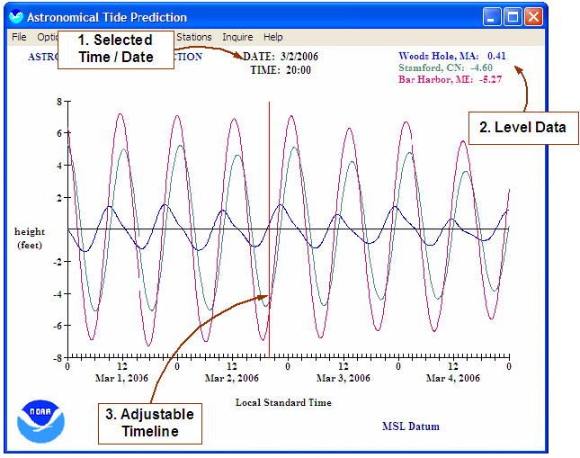

Figure 54 - Tide Display Program Highlighting Inquire Functionality

Menu Bar Option: Help:

Help: The Tide Display Program help function launches an HTML based interface providing help on select SLSOH topics.

Credits: SLOSH Version, Launch date, and disclaimer statements.

5.8 Storm Surge Time History

The Time History function allows users to interrogate grid cell specific storm surge data over time – see figure 55. The following step-by-step instructions describe the basic use.

1) Launch the “SLOSH Display Program” application.

2) Animate a Rex file see section 5.4.

3) Select the Time History button, last button on the vertical button bar of the SLOSH Display Program.

4) Place the mouse over desired area on map display and select the left mouse button and repeat as needed

5) Modify data parameters as desired.

5.8.1 Storm Surge Time History Features and Functionality
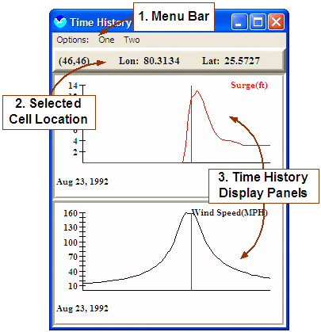

Figure 55 – Time History Interface

This section describes a detailed look at the features and functionality provided in the Time History program – see figure 55.

Menu Bar Option (Label 1): Options:

Close: Close the Time History interface

Save to .txt: Save Time History data in a tab delimited ASCII text file format. Data saved to file when using this function is: 1) surge, 2) storm speed, 3) Storm Delta P, 4) Storm Rmax, and 5) Distance - See figure 56 for example format.

Basin=eht Elliptical Pamlico Sound
RexFile=c:/slosh.pkg/data/rexfiles/years/1999/floydeht.rex
Grid Refrence (152,45) Lat= 34.5351 Lon= 77.0956
Date Time Surge WindSpeed Center_Lat Center_Lon Del_P R_Max
09/15/1999 18:01:00 2.3 26.57 30.608034 79.099098 62.983330 39.988998
09/15/1999 18:15:00 2.3 26.84 30.664261 79.092804 62.866638 39.911987
09/15/1999 18:30:00 2.3 27.13 30.724510 79.086067 62.741611 39.829475
09/15/1999 18:45:00 2.3 27.43 30.784760 79.079308 62.616585 39.746964
09/15/1999 19:00:00 2.3 27.55 30.845110 79.072197 62.491665 39.664333
<…snip…>

Figure 56 – ASCII Text File Format of Time History Program Data

Save to .ps: Save Time History display to standard postScript image format.

Save to .pcx: Saves Time History display as standard .pcx graphic image.

Number of graphs: Cascading menu allowing users to select up to five x and y panels which also expands the menu bar by the number of selected graphs/panels. By default two graphs are selected. It may be necessary to increase the computers display resolution to view all graphs depending on the existing display resolution setting. You will know if this is necessary because the Time History interface will run off the screen.

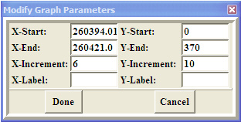
Menu Bar Option (Label 1): One … Five: Provides on/off toggle of the described parameters below. Note: By default the
menu bar will have two “graph
display” options which is expandable
as described in the Number of graphs function above. Whether one or five, the functionality presented under the menu bar is the same as described below.
Figure 57 – Modify Time History Graph Surge: Display time graph of storm Parameters Interface
surge values for selected cell.

Speed: Display time graph of the one minute average wind speed (sustained/mph) at the selected location.

Delta P: Change in pressure (mb) at selected cell location.

Storm Rmax: Static Rmax value (STM file) as provided by forecaster creating model run.
Distance: Distance storm eye is from the selected point in miles.

Modify Parameters: Provides users an interface (figure 57) to modify the parameters of thee selected panel/cell as described below:
- X-Start – Define the value to which the x-axis begins
- X-End – Define the ending value of the x-axis
- X-Increment – Define the increment between values for the x-axis
- X-Label – Label the x-axis as desired, no label by default
- Y-Start – Define the value to which the y-axis begins
- Y-End – Define the ending value of the y-axis
- Y-Increment – Define the increment between values for the y-axis
- Y-Label – Label the y-axis as described, no label by default.

Selected Cell Location: Highlights the location of the selected cell by SLOSH grid and Lat/Lon locations.

Time History Display Panels: Highlighting two of five possible display panels for time height data. X-axis is time in hours and the Y-axis are generic units supporting mixed type depending on overlays.

Appendix A

Acronyms / Definitions

- SLOSH:
Sea Lake and Overland Surges from Hurricanes
- SLOSH Model:
The model generating hurricane storm surge given a SLOSH Basin and Hurricane Track, also generating an Envelope of high water and Rex File
- SLOSH grid:
The SLOSH model uses a polar, elliptical, or hyperbolic grid for its computations. Cartesian grids are not used.
- SLOSH Basin:
A geographic region as defined by the SLOSH grid with known values for topography, and bathymetry in addition to grid properties and barriers, on which the SLOSH model is run.
- Hurricane Track:
A set of parameters used to approximate the hurricane which includes: 1) Pressure, Radius of Maximum Winds (RMAX), Location, Forward Speed, and Forward Direction.
- Envelope:
Maximum water level at any given point at every grid cell in the SLOSH basin.
- Rex file:
The water level height at every grid cell, in a defined SLOSH Basin, at a specific interval of time. The SLOSH display program displays Rex files as time-lapsed animated “movies”.
- Maximum Envelope of Water (MEOW):
Composite of maximum storm surge heights at each grid cell using hypothetical hurricane runs with the same: 1) category, 2) forward speed, 3) landfall direction, 4) initial tide level, and 5) radius of maximum wind. Composite achieved by reviewing parallel tracks that make landfall at different locations.
- Category: The category of hurricane, based on the Saffir-Simpson Scale:

 | Maximum Wind Speed
Type | Knots | MPH | Pressure mb
Depression | < 34 | < 39 | ---
Tropical Storm | 34-63 | 39-73 | ---
Category 1 | 64-82 | 74-95 | > 980
Category 2 | 83-95 | 96-110 | 965-980
Category 3 | 96-112 | 111-130 | 945-965
Category 4 | 113-134 | 131-155 | 920-945
Category 5 | > 134 | > 155 | < 920
Figure 58 - Saffir-Simpson Scale

- Maximum of MEOWs (MOM):
Composite of the maximum storm surge height for all hurricanes of a given category. Disregards forward speed, landfall direction, land fall location. Typically only five MOMs per basin. For example, one per storm category; may be doubled with more than one tide level.
- Evaluation Branch (EB):
MDL Branch responsible for developing and maintaining SLOSH Software models.
- Meteorological Development Laboratory (MDL):
NWS Division under the OST responsible for developing techniques (programs) to aid WFOs and NCEP National Centers.
- Mean Lower Low Water (MLLW)
The average height of the lower low waters over a 19-year period. For shorter periods of observation, corrections are applied to eliminate known variations and reduce the result to the equivalent of a mean 19-year value. (http://www.ecy.wa.gov/)
- Mean Seal Level (MSL)
The average height of the surface of the sea for all stages of the tide over a 19- year period, usually determined from hourly height readings (http://www.ecy.wa.gov/)
- National Hurricane Center (NHC) / Tropical Prediction Center (TPC):
NWS NCEP agency charged with tropical storm prediction. http://www.nhc.noaa.gov
- National Weather Service (NWS):
One of 5 NOAA line offices. NWS is charged with weather prediction and warning to protect life and property. http://nws.noaa.gov
- National Oceanic And Atmospheric Administration (NOAA):
DOC agency focused on Ocean and Atmospheric concerns
- Department of Commerce:
Government agency focused on US Commerce. http://www.doc.gov
- Continental Shelf:
The extended perimeter of each continent.

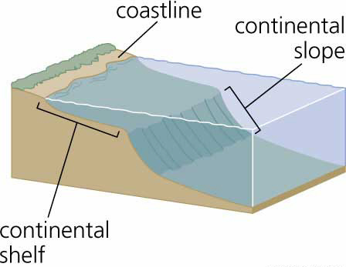
Figure 59 – Continental Shelf

- Title Datum: Image and definitions from NOS http://www.co-ops.nos.noaa.gov/datum_order.shtml

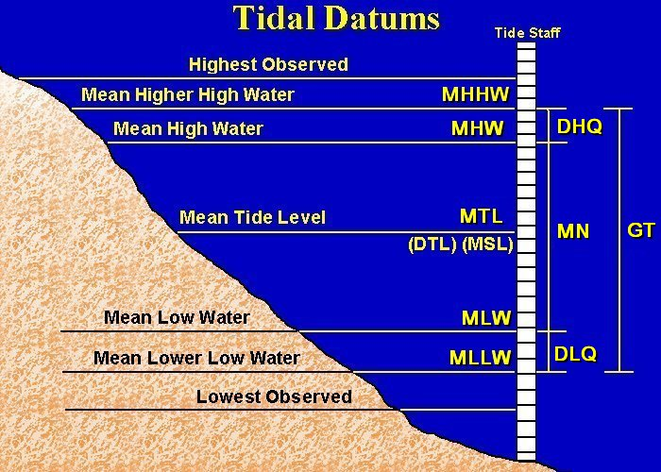
MHHW - Mean Higher High Water
MHW - Mean High Water
DTL - Mean of MHHW and MLLW
MTL - Mean of MHW and MLW
MSL - Mean Sea Level
MLLW - Mean Lower Low Water
GT - Difference between MHHW and MLLW
MN - Difference between MHW and MLW
DHQ - Difference between MHHW and MHW
DLQ - Difference between MLW and MLLW
HWI - Greenwich Mean High Water Interval in Hours
LWI - Greenwich Mean Low Water Interval in Hours
Figure 60 – Tidal Datums

