Title

# Heading 1

Normal text

## Heading 2

### Heading 3

#### Heading 4

###### Heading 6 (for table and figure captions)

**Strong (for table and caption numbering)**

**Table 1.** Sightings of *Epynisiastes Eximia*.

| Date | Time (UTC) | Expedition |
| --- | --- | --- |
| Use Heading 5 for table text | Text and column headings should be left aligned |  |

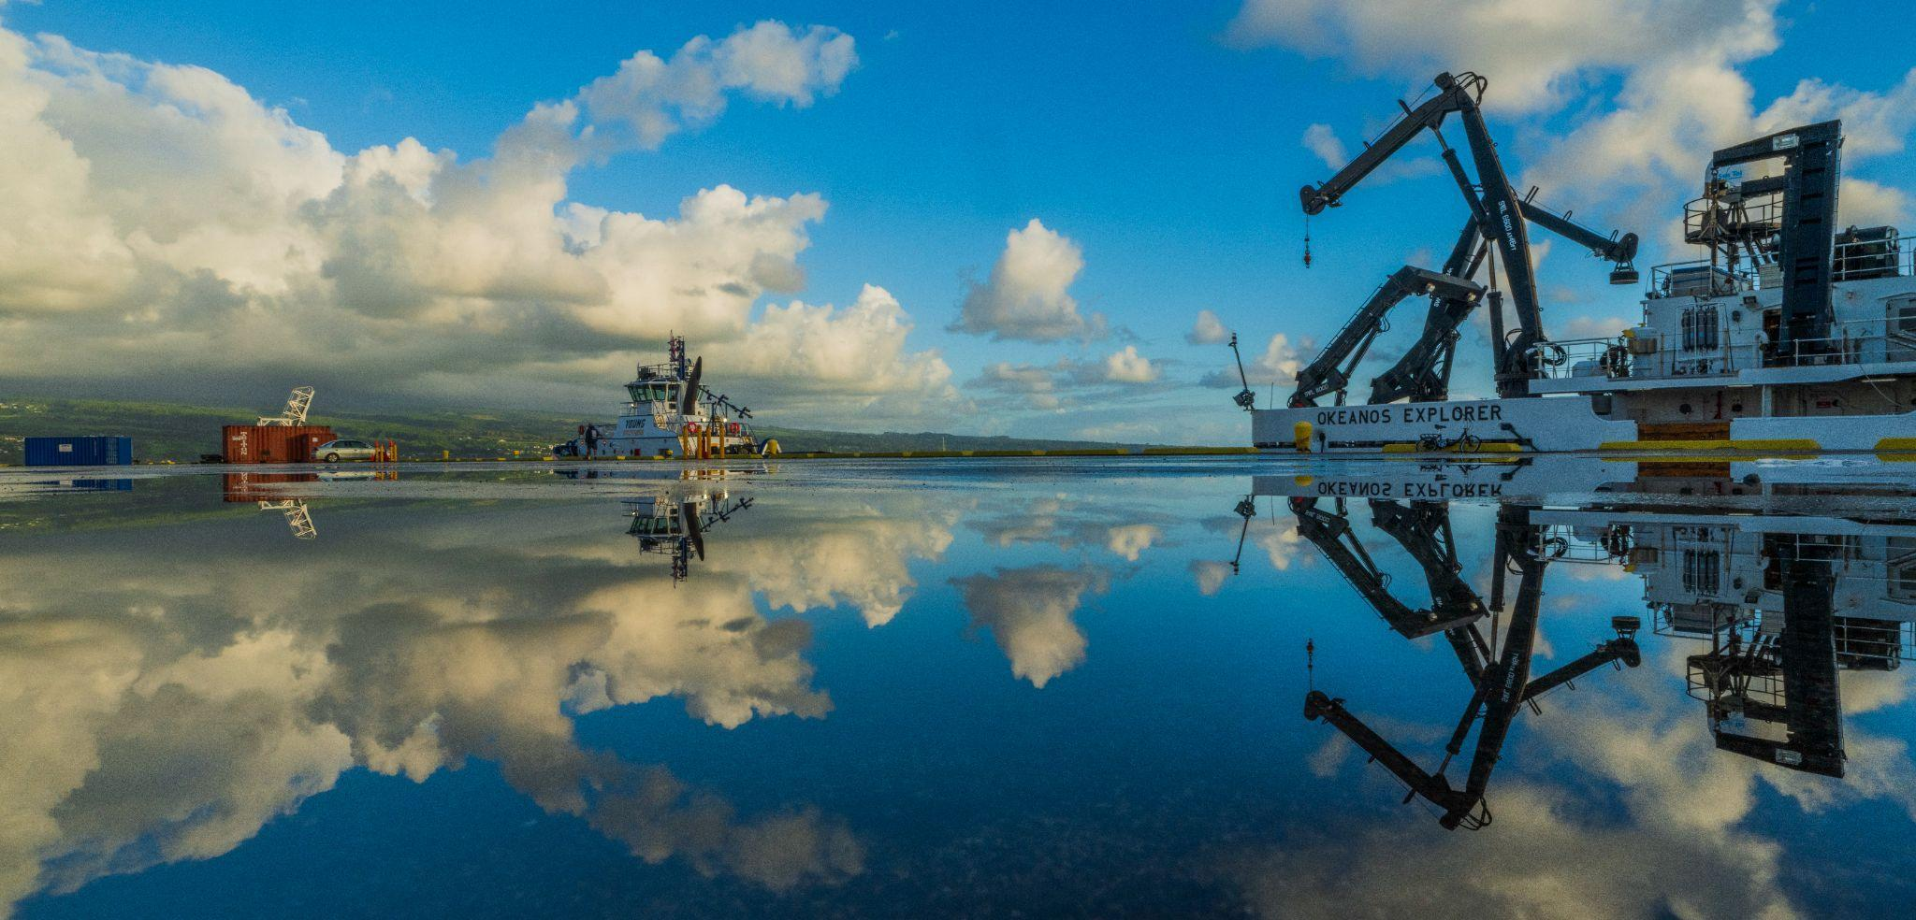

**Figure 1.** Pretty picture. *Image courtesy of [source].*

[Hyperlink](https://oceanexplorer.noaa.gov/)