Valve Automation Program User Guide

Matt Casari  
PMEL Engineering  
1/26/2018

# Overview

This program was designed to control the custom valve automation enclosure developed in December 2017 – Jan 2018. The enclosure has the ability to cycle through eight separate calibration gases with a user configured flow and dwell time.

The automation program has the following (basic) order of operations:

1. Establish Serial Port
2. Load Configuration File
3. Establish Serial Connection
4. Zero the Licor
5. Span the Licor
6. Sample all gases
7. Repeat 6 for requested number of samples (if required)
8. Save File
9. Close Serial port
10. Exit

# Configuration File

In the python program directory, there is a file named “config.json”. This JSON file holds the values for all timing and valve cycles to be used in the test. See Figure 1 for an example file.

Within the JSON Object, these are the following field definitions:

“automate” - Parent object

“Path” - Save file path  
“NumCycles” – Number of repetitions of the test  
“CycleDelay” – Delay between each repetition (HH:MM:SS)  
“Gases” – The gases (valves) used in each test (see below)

The Gases objects are broken into the following:

“Valve” – Valve number on enclosure  
“Concentration” – Gas concentration (in PPM)  
“Flowtime” – Length of time to open the valve for  
“Dwelltime” – Length of time the gas dwells in the sensor after the valve has closed  
“Prep” – Length of time to flow the zero or span gas for calibration. ZERO AND SPAN ONLY  
“Cal” – Length of time to dwell before starting the zero or span calibration. ZERO AND SPAN ONLY

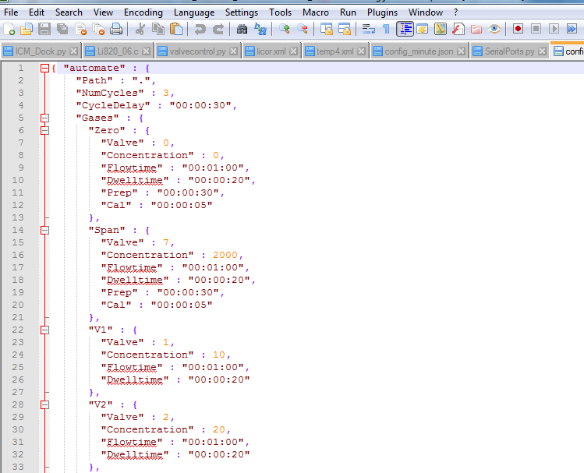

Figure . Configuration File JSON Object

# Command line interface

The program can be commanded from the command line using the following:

python CO2_automate [COM_PORT]

where COM port is the Serial port on the host pc connected to the Licor and has the form “COM1”, etc.

# Running from IDE

If you are running from Spyder (or another IDE) load the CO2_automate Project into your workspace. Load the “__main__.py” file and run.